This text was adapted by The Saylor Foundation under a Creative Commons Attribution-NonCommercial-ShareAlike 3.0 License without attribution as requested by the work’s original creator or licensee.

Preface
Business English for Success is a creative solution to a common challenge across Business Communication courses: Business English or Business Presentations? Some classes place an equal emphasis on oral and written communication, and if that is the case for you please let me direct you to our free online text Business Communication for Success. If, however, your class places the emphasis squarely on written communication and writing proficiency then this book is for you.
The Business English course and corresponding text often starts with a solid foundation in written communication with several opportunities to both review the fundamentals as well as to demonstrate mastery and move on to more challenging assignments. Our students are sometimes learning English as they enter a business program and benefit from the attention to the basics. At the same time this course often articulates as a course-equivalent for English or fulfills a writing requirement for a degree program. This range provides the instructor with both challenges and opportunities that Business English for Success can address.
We open the text with a discussion on the sentence and then break it down into its elemental components, before reconstructing them into effective sentences with paragraphs and larger assignments. This step-by-step approach, with many exercises and opportunities for reinforcement along the way, provide a clear path to student-centered learning.

A note to the instructor
Business English for Success provides instruction in steps, builds writing, reading, and critical thinking, and combines comprehensive grammar review with an introduction to paragraph writing and composition.
Beginning with the sentence and its essential elements, this book addresses each concept with clear, concise, and effective examples that are immediately reinforced with exercises and opportunities to demonstrate learning. If you start your course with a quick familiarization of reference materials, including a dictionary, thesaurus, and grammar manuals, I encourage you to go to the Online Writing Lab at Purdue University for the free tutorial here: http://owl.english.purdue.edu/owl/resource/738/02/
Each chapter that follows allows students to demonstrate mastery of the principles of quality writing. With its incremental approach, this book can address a range of writing levels and abilities, helping each student prepare for the next writing or university course. Constant reinforcement is provided through examples and exercises, and the text involves students in the learning process through reading, problem solving, practicing, listening, and experiencing the writing process.
Each chapter also has integrated examples that unify the discussion and form a common, easy-to-understand basis for discussion and exploration. This will put students at ease and allow for greater understand and demonstration of mastery of the material.
Tips for effective writing are included in every chapter, as well. Thought-provoking scenarios provide challenges and opportunities for collaboration and interaction. These exercises are especially helpful for working with groups of students. Clear exercises teach sentence and paragraph writing skills that lead to common English composition and business documents.
Business English for Success also offers a separate chapter for English Language Learners. This chapter focuses on word order, negative statements, count and noncount nouns and articles, verb tenses, modal auxiliaries, prepositions, slang and idioms.
Starting in Chapter 9 "Effective Business Writing": Effective Business Writing, the discussion applies lessons learned from the previous foundational chapters into common business issues and applications. From paraphrasing and plagiarism to style to the research process, the expectations increase as several common business documents are presented, including text messages and e-mail (and netiquette), memorandums and letters, the business proposal, business report, resume, and the sales message. Business English for Success provides a range of discussion, examples, and exercises, from writing development to mastery of the academic essay, that serve both student and instructor.

A note to the student
Writing is often a challenge. If you were ever challenged to express yourself via the written word, this book is for you. I encourage you to explore it, use the exercises as opportunities to learn new skills, and most of all, to be successful in your achievement of your course objectives and goals. This text is available free online and is the result of the dedication of many professionals who share the common goal of increasing access to educational materials for all students. Please thank your instructor for choosing an open source text.

Features
- Exercises are integrated in each segment. Each concept is immediately reinforced as soon as it is introduced to keep students on track.
- Exercises are designed to facilitate interaction and collaboration. This allows for peer-peer engagement, development of interpersonal skills, and promotion of critical-thinking skills.
- Exercises that involve self-editing and collaborative writing are featured. This feature develops and promotes student interest in the knowledge areas and content.
- There are clear internal summaries and effective displays of information. This contributes to ease of access to information and increases students’ ability to locate desired content.
- Rule explanations are simplified with clear, relevant, and theme-based examples. This feature provides context that will facilitate learning and increase knowledge retention.
- There is an obvious structure to the chapter and segment level. This allows for easy adaptation to existing and changing course needs or assessment outcomes.

Chapter 1 Writing Basics: What Makes a Good Sentence?

1.1 Sentence Writing

Learning Objectives
- Identify the components of a basic sentence.
- Identify the four most serious writing errors.
Imagine you are reading a book for school. You need to find important details that you can use for an assignment. However, when you begin to read, you notice that the book has very little punctuation. Sentences fail to form complete paragraphs and instead form one block of text without clear organization. Most likely, this book would frustrate and confuse you. Without clear and concise sentences, it is difficult to find the information you need.
For both students and professionals, clear communication is important. Whether you are typing an e-mail or writing a report, it is your responsibility to present your thoughts and ideas clearly and precisely. Writing in complete sentences is one way to ensure that you communicate well. This section covers how to recognize and write basic sentence structures and how to avoid some common writing errors.

Components of a Sentence
Clearly written, complete sentences require key information: a subject, a verb and a complete idea. A sentence needs to make sense on its own. Sometimes, complete sentences are also called independent clauses. A clause is a group of words that may make up a sentence. An independent clause is a group of words that may stand alone as a complete, grammatically correct thought. The following sentences show independent clauses.
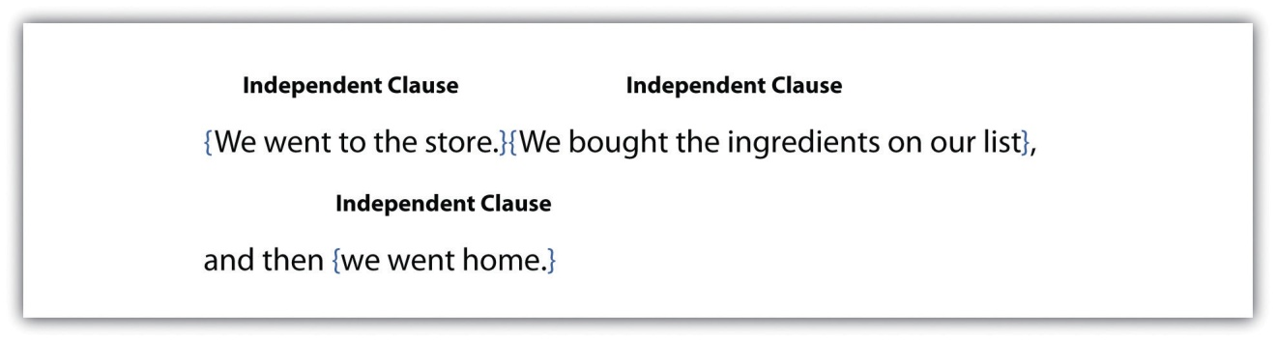
All complete sentences have at least one independent clause. You can identify an independent clause by reading it on its own and looking for the subject and the verb.

Subjects
When you read a sentence, you may first look for the subject, or what the sentence is about. The subject usually appears at the beginning of a sentence as a noun or a pronoun. A noun is a word that identifies a person, place, thing, or idea. A pronoun is a word that replaces a noun. Common pronouns are I, he, she, it, you, they, and we. In the following sentences, the subject is underlined once.
In these sentences, the subject is a person: Malik. The pronoun He replaces and refers back to Malik.
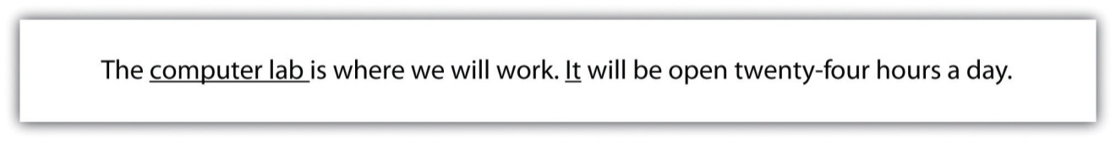
In the first sentence, the subject is a place: computer lab. In the second sentence, the pronoun It substitutes for computer lab as the subject.
In the first sentence, the subject is a thing: project. In the second sentence, the pronoun It stands in for the project.

Tip
In this chapter, please refer to the following grammar key:
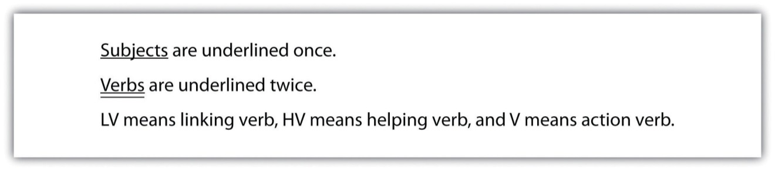

Compound Subjects
A sentence may have more than one person, place, or thing as the subject. These subjects are called compound subjects. Compound subjects are useful when you want to discuss several subjects at once.
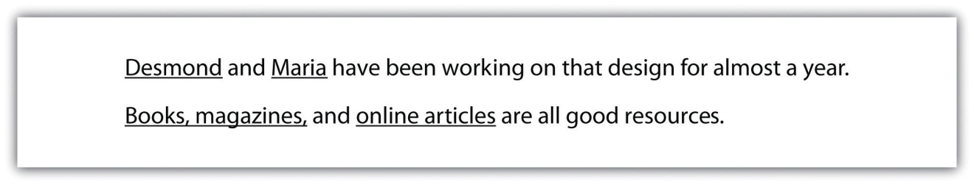

Prepositional Phrases
You will often read a sentence that has more than one noun or pronoun in it. You may encounter a group of words that includes a preposition with a noun or a pronoun. Prepositions connect a noun, pronoun, or verb to another word that describes or modifies that noun, pronoun, or verb. Common prepositions include in, on, under, near, by, with, and about. A group of words that begin with a preposition is called a prepositional phrase. A prepositional phrase begins with a preposition and modifies or describes a word. It cannot act as the subject of a sentence. The following circled phrases are examples of prepositional phrases.
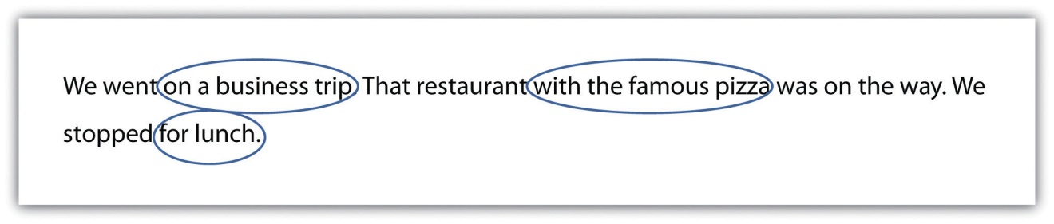

Exercise 1
Read the following sentences. Underline the subjects, and circle the prepositional phrases.
- The gym is open until nine o’clock tonight.
- We went to the store to get some ice.
- The student with the most extra credit will win a homework pass.
- Maya and Tia found an abandoned cat by the side of the road.
- The driver of that pickup truck skidded on the ice.
- Anita won the race with time to spare.
- The people who work for that company were surprised about the merger.
- Working in haste means that you are more likely to make mistakes.
- The soundtrack has over sixty songs in languages from around the world.
- His latest invention does not work, but it has inspired the rest of us.

Verbs
Once you locate the subject of a sentence, you can move on to the next part of a complete sentence: the verb. A verb is often an action word that shows what the subject is doing. A verb can also link the subject to a describing word. There are three types of verbs that you can use in a sentence: action verbs, linking verbs, or helping verbs.

Action Verbs
A verb that connects the subject to an action is called an action verb. An action verb answers the question what is the subject doing? In the following sentences, the words underlined twice are action verbs.

Linking Verbs
A verb can often connect the subject of the sentence to a describing word. This type of verb is called a linking verb because it links the subject to a describing word. In the following sentences, the words underlined twice are linking verbs.
If you have trouble telling the difference between action verbs and linking verbs, remember that an action verb shows that the subject is doing something, whereas a linking verb simply connects the subject to another word that describes or modifies the subject. A few verbs can be used as either action verbs or linking verbs.
Although both sentences use the same verb, the two sentences have completely different meanings. In the first sentence, the verb describes the boy’s action. In the second sentence, the verb describes the boy’s appearance.

Helping Verbs
A third type of verb you may use as you write is a helping verb. Helping verbs are verbs that are used with the main verb to describe a mood or tense. Helping verbs are usually a form of be, do, or have. The word can is also used as a helping verb.
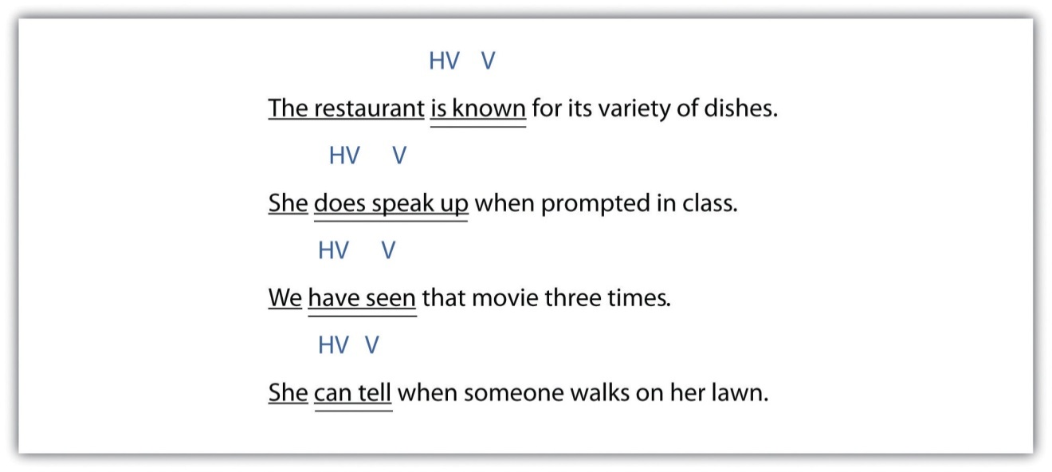

Tip
Whenever you write or edit sentences, keep the subject and verb in mind. As you write, ask yourself these questions to keep yourself on track:
Subject: Who or what is the sentence about?
Verb: Which word shows an action or links the subject to a description?

Exercise 2
Copy each sentence onto your own sheet of paper and underline the verb(s) twice. Name the type of verb(s) used in the sentence in the space provided (LV, HV, or V).
- The cat sounds ready to come back inside. ________
- We have not eaten dinner yet. ________
- It took four people to move the broken-down car. ________
- The book was filled with notes from class. ________
- We walked from room to room, inspecting for damages. ________
- Harold was expecting a package in the mail. ________
- The clothes still felt damp even though they had been through the dryer twice. ________
- The teacher who runs the studio is often praised for his restoration work on old masterpieces. ________

Sentence Structure, Including Fragments and Run-ons
Now that you know what makes a complete sentence—a subject and a verb—you can use other parts of speech to build on this basic structure. Good writers use a variety of sentence structures to make their work more interesting. This section covers different sentence structures that you can use to make longer, more complex sentences.

Sentence Patterns
Six basic subject-verb patterns can enhance your writing. A sample sentence is provided for each pattern. As you read each sentence, take note of where each part of the sentence falls. Notice that some sentence patterns use action verbs and others use linking verbs.

Subject–Verb

Subject–Linking Verb–Noun

Subject–Linking Verb–Adjective

Subject–Verb–Adverb

Subject–Verb–Direct Object
When you write a sentence with a direct object (DO), make sure that the DO receives the action of the verb.

Subject–Verb–Indirect Object–Direct Object
In this sentence structure, an indirect object explains to whom or to what the action is being done. The indirect object is a noun or pronoun, and it comes before the direct object in a sentence.

Exercise 3
Use what you have learned so far to bring variety in your writing. Use the following lines or your own sheet of paper to write six sentences that practice each basic sentence pattern. When you have finished, label each part of the sentence (S, V, LV, N, Adj, Adv, DO, IO).
- ________________________________________________________________
- ________________________________________________________________
- ________________________________________________________________
- ________________________________________________________________
- ________________________________________________________________
- ________________________________________________________________

Collaboration
Find an article in a newspaper, a magazine, or online that interests you. Bring it to class or post it online. Then, looking at a classmate’s article, identify one example of each part of a sentence (S, V, LV, N, Adj, Adv, DO, IO). Please share or post your results.

Fragments
The sentences you have encountered so far have been independent clauses. As you look more closely at your past writing assignments, you may notice that some of your sentences are not complete. A sentence that is missing a subject or a verb is called a fragment. A fragment may include a description or may express part of an idea, but it does not express a complete thought.
Fragment: Children helping in the kitchen.
Complete sentence: Children helping in the kitchen often make a mess.
You can easily fix a fragment by adding the missing subject or verb. In the example, the sentence was missing a verb. Adding often make a mess creates an S-V-N sentence structure.

Figure 1.1 Editing Fragments That Are Missing a Subject or a Verb
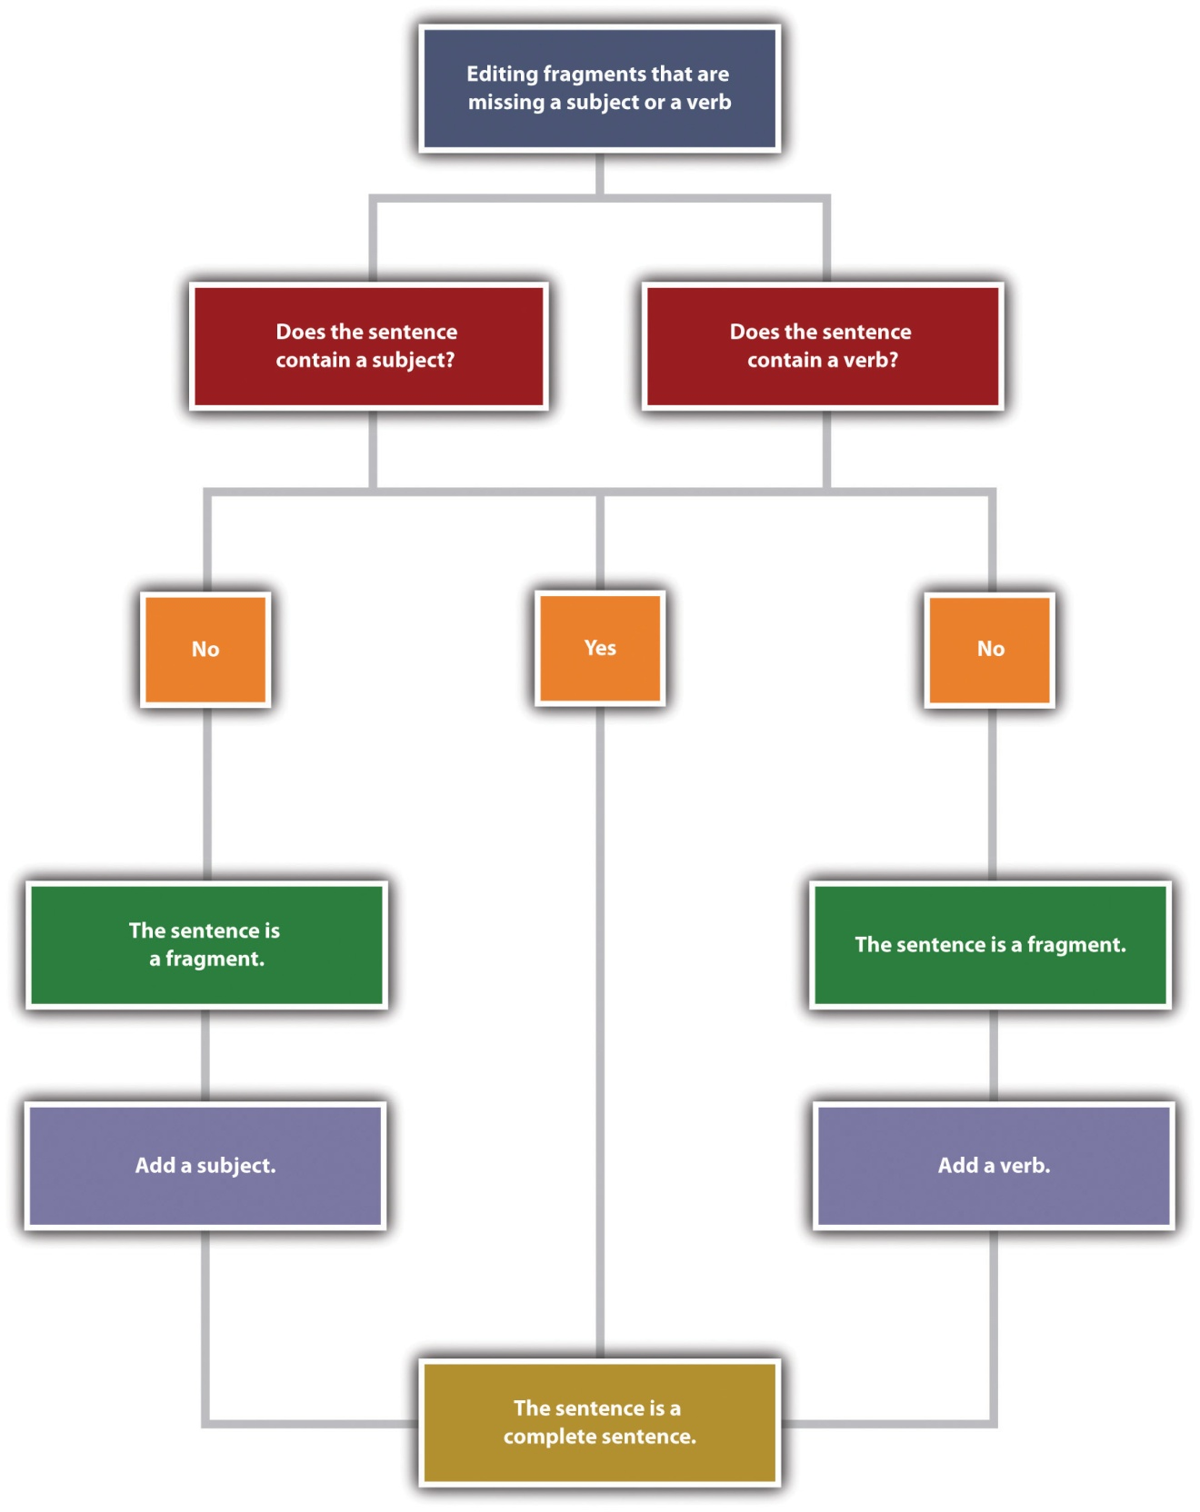

See whether you can identify what is missing in the following fragments.
Fragment: Told her about the broken vase.
Complete sentence: I told her about the broken vase.
Fragment: The store down on Main Street.
Complete sentence: The store down on Main Street sells music.

Common Sentence Errors
Fragments often occur because of some common error, such as starting a sentence with a preposition, a dependent word, an infinitive, or a gerund. If you use the six basic sentence patterns when you write, you should be able to avoid these errors and thus avoid writing fragments.
When you see a preposition, check to see that it is part of a sentence containing a subject and a verb. If it is not connected to a complete sentence, it is a fragment, and you will need to fix this type of fragment by combining it with another sentence. You can add the prepositional phrase to the end of the sentence. If you add it to the beginning of the other sentence, insert a comma after the prepositional phrase.

Figure 1.2 Editing Fragments That Begin with a Preposition
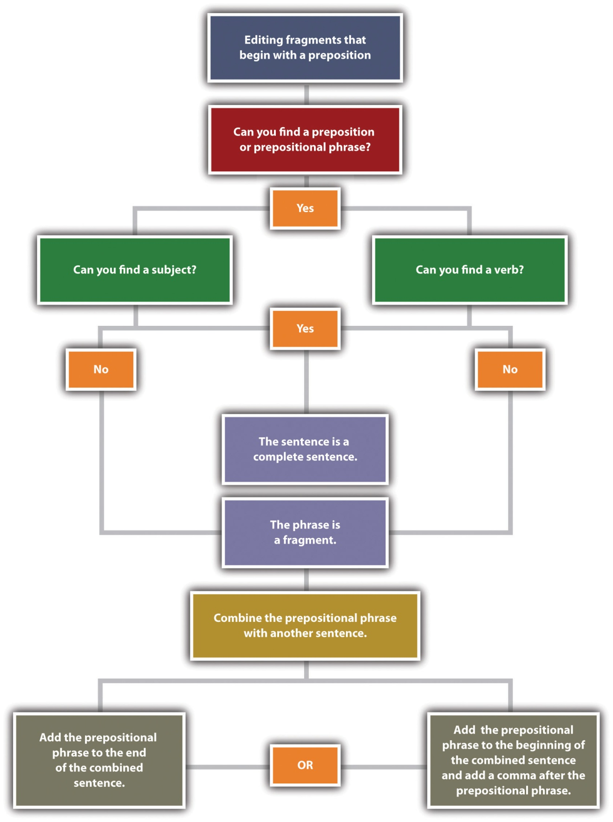

Example A
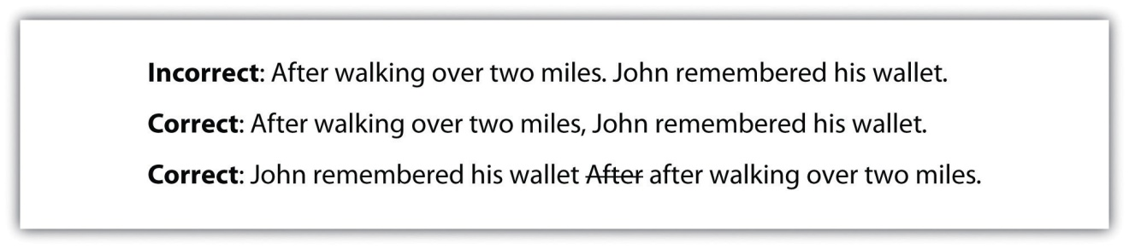
Example B
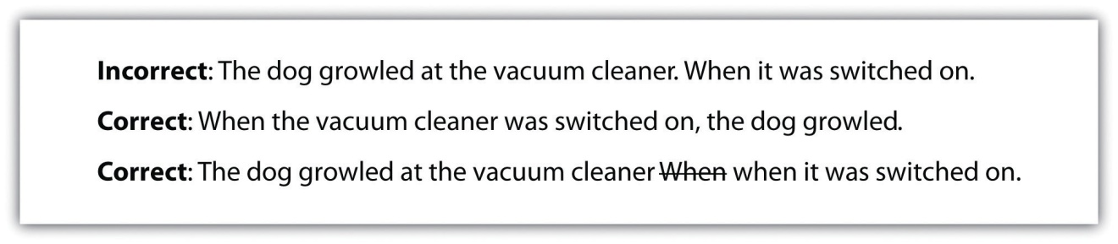
Clauses that start with a dependent word—such as since, because, without, or unless—are similar to prepositional phrases. Like prepositional phrases, these clauses can be fragments if they are not connected to an independent clause containing a subject and a verb. To fix the problem, you can add such a fragment to the beginning or end of a sentence. If the fragment is added at the beginning of a sentence, add a comma.
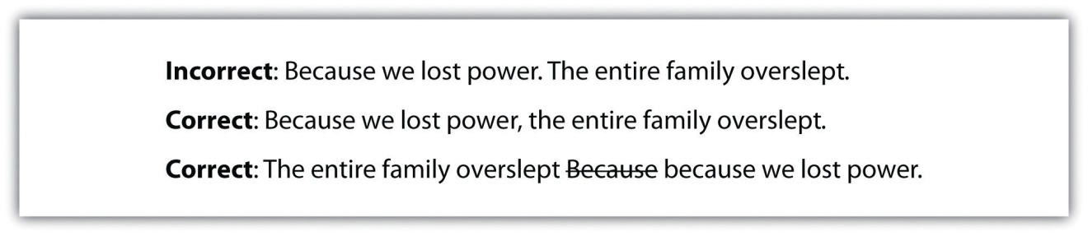
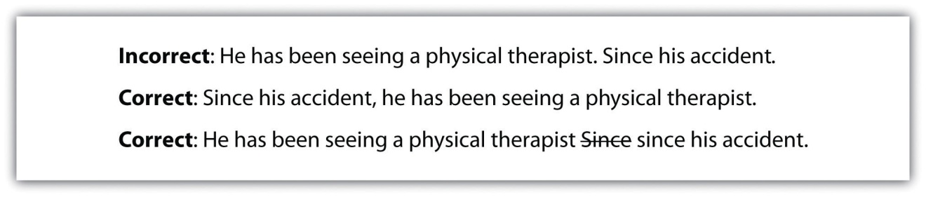
When you encounter a word ending in -ing in a sentence, identify whether or not this word is used as a verb in the sentence. You may also look for a helping verb. If the word is not used as a verb or if no helping verb is used with the -ing verb form, the verb is being used as a noun. An -ing verb form used as a noun is called a gerund.
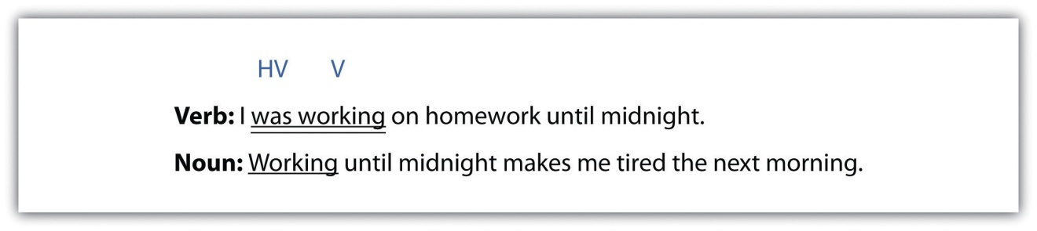
Once you know whether the -ing word is acting as a noun or a verb, look at the rest of the sentence. Does the entire sentence make sense on its own? If not, what you are looking at is a fragment. You will need to either add the parts of speech that are missing or combine the fragment with a nearby sentence.

Figure 1.3 Editing Fragments That Begin with Gerunds
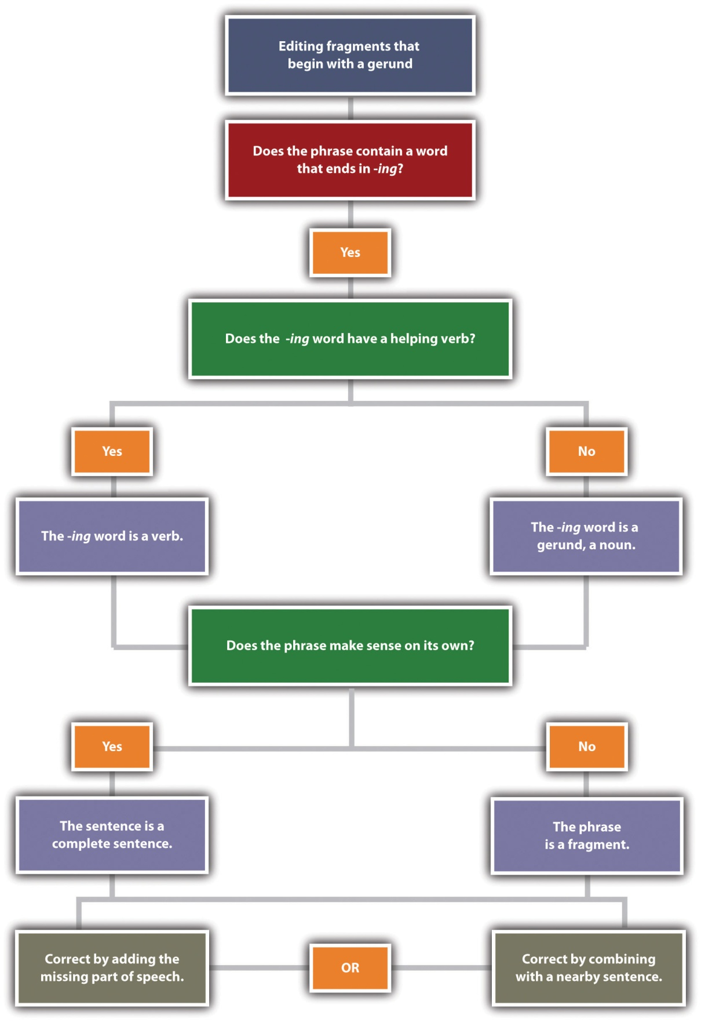

Incorrect: Taking deep breaths. Saul prepared for his presentation.
Correct: Taking deep breaths, Saul prepared for his presentation.
Correct: Saul prepared for his presentation. He was taking deep breaths.
Incorrect: Congratulating the entire team. Sarah raised her glass to toast their success.
Correct: She was congratulating the entire team. Sarah raised her glass to toast their success.
Correct: Congratulating the entire team, Sarah raised her glass to toast their success.
Another error in sentence construction is a fragment that begins with an infinitive. An infinitive is a verb paired with the word to; for example, to run, to write, or to reach. Although infinitives are verbs, they can be used as nouns, adjectives, or adverbs. You can correct a fragment that begins with an infinitive by either combining it with another sentence or adding the parts of speech that are missing.
Incorrect: We needed to make three hundred more paper cranes. To reach the one thousand mark.
Correct: We needed to make three hundred more paper cranes to reach the one thousand mark.
Correct: We needed to make three hundred more paper cranes. We wanted to reach the one thousand mark.

Exercise 4
Copy the following sentences onto your own sheet of paper and circle the fragments. Then combine the fragment with the independent clause to create a complete sentence.
- Working without taking a break. We try to get as much work done as we can in an hour.
- I needed to bring work home. In order to meet the deadline.
- Unless the ground thaws before spring break. We won’t be planting any tulips this year.
- Turning the lights off after he was done in the kitchen. Robert tries to conserve energy whenever possible.
- You’ll find what you need if you look. On the shelf next to the potted plant.
- To find the perfect apartment. Deidre scoured the classifieds each day.

Run-on Sentences
Just as short, incomplete sentences can be problematic, lengthy sentences can be problematic too. Sentences with two or more independent clauses that have been incorrectly combined are known as run-on sentences. A run-on sentence may be either a fused sentence or a comma splice.

Fused sentence: A family of foxes lived under our shed young foxes played all over the yard.
Comma splice: We looked outside, the kids were hopping on the trampoline.
When two complete sentences are combined into one without any punctuation, the result is a fused sentence. When two complete sentences are joined by a comma, the result is a comma splice. Both errors can easily be fixed.

Punctuation
One way to correct run-on sentences is to correct the punctuation. For example, adding a period will correct the run-on by creating two separate sentences.
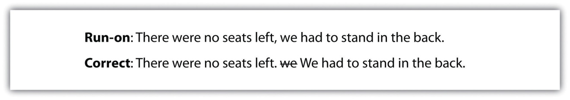
Using a semicolon between the two complete sentences will also correct the error. A semicolon allows you to keep the two closely related ideas together in one sentence. When you punctuate with a semicolon, make sure that both parts of the sentence are independent clauses. For more information on semicolons, see .
Run-on: The accident closed both lanes of traffic we waited an hour for the wreckage to be cleared.
Complete sentence: The accident closed both lanes of traffic; we waited an hour for the wreckage to be cleared.
When you use a semicolon to separate two independent clauses, you may wish to add a transition word to show the connection between the two thoughts. After the semicolon, add the transition word and follow it with a comma. For more information on transition words, see .
Run-on: The project was put on hold we didn’t have time to slow down, so we kept working.
Complete sentence: The project was put on hold; however, we didn’t have time to slow down, so we kept working.

Coordinating Conjunctions
You can also fix run-on sentences by adding a comma and a coordinating conjunction. A coordinating conjunction acts as a link between two independent clauses.

Tip
These are the seven coordinating conjunctions that you can use: for, and, nor, but, or, yet, and so. Use these words appropriately when you want to link the two independent clauses. The acronym FANBOYS will help you remember this group of coordinating conjunctions.
Run-on: The new printer was installed, no one knew how to use it.
Complete sentence: The new printer was installed, but no one knew how to use it.

Dependent Words
Adding dependent words is another way to link independent clauses. Like the coordinating conjunctions, dependent words show a relationship between two independent clauses.
Run-on: We took the elevator, the others still got there before us.
Complete sentence: Although we took the elevator, the others got there before us.
Run-on: Cobwebs covered the furniture, the room hadn’t been used in years.
Complete sentence: Cobwebs covered the furniture because the room hadn’t been used in years.

Writing at Work

Figure 1.4 Sample e-mail
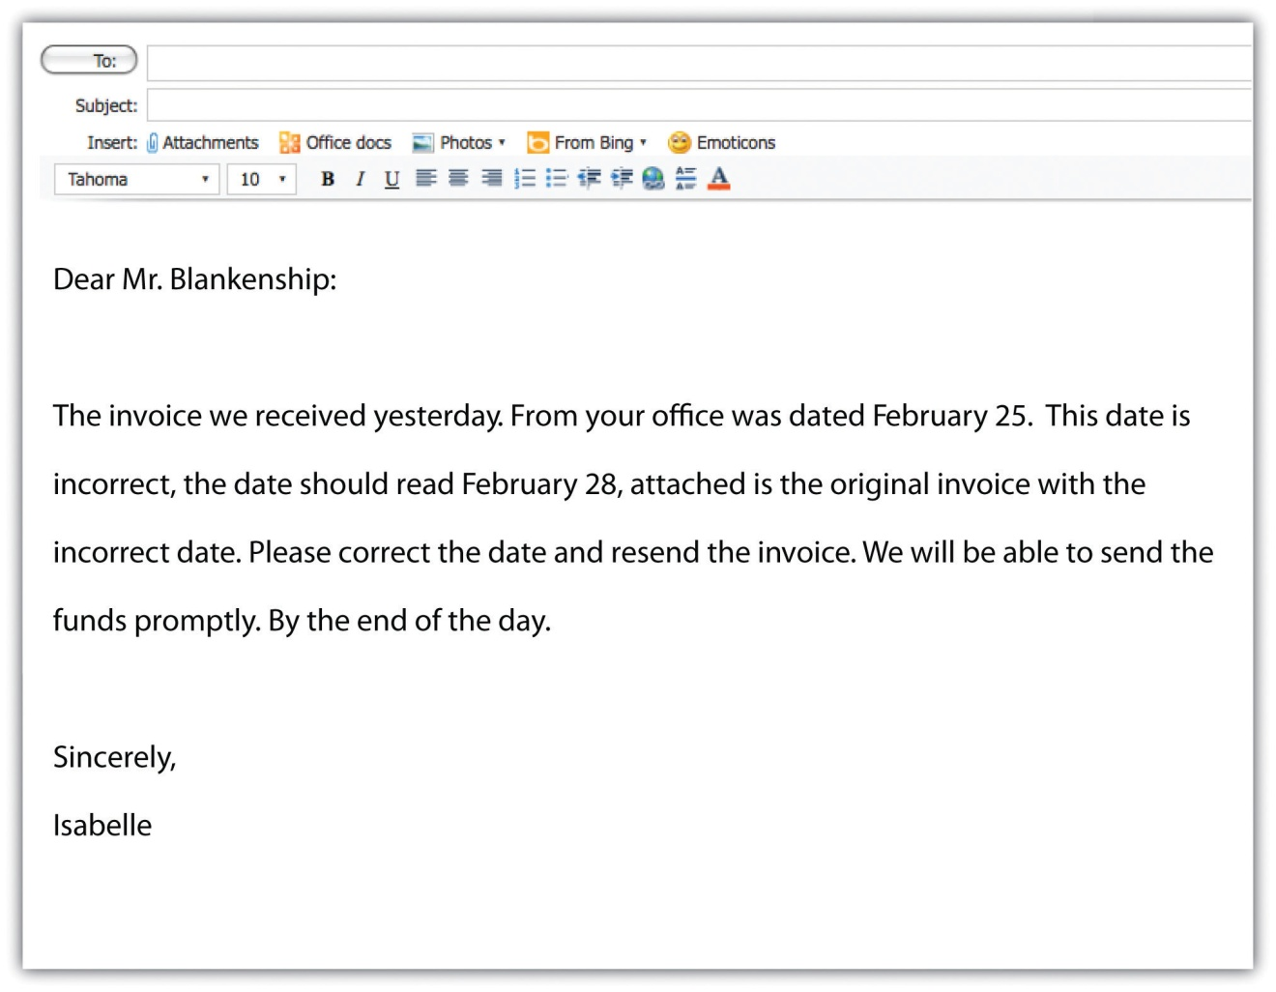
Isabelle’s e-mail opens with two fragments and two run-on sentences containing comma splices. The e-mail ends with another fragment. What effect would this e-mail have on Mr. Blankenship or other readers? Mr. Blankenship or other readers may not think highly of Isaebelle’s communication skills or—worse—may not understand the message at all! Communications written in precise, complete sentences are not only more professional but also easier to understand. Before you hit the “send” button, read your e-mail carefully to make sure that the sentences are complete, are not run together, and are correctly punctuated.

Exercise 5
A reader can get lost or lose interest in material that is too dense and rambling. Use what you have learned about run-on sentences to correct the following passages:
- The report is due on Wednesday but we’re flying back from Miami that morning. I told the project manager that we would be able to get the report to her later that day she suggested that we come back a day early to get the report done and I told her we had meetings until our flight took off. We e-mailed our contact who said that they would check with his boss, she said that the project could afford a delay as long as they wouldn’t have to make any edits or changes to the file our new deadline is next Friday.
- Anna tried getting a reservation at the restaurant, but when she called they said that there was a waiting list so she put our names down on the list when the day of our reservation arrived we only had to wait thirty minutes because a table opened up unexpectedly which was good because we were able to catch a movie after dinner in the time we’d expected to wait to be seated.
- Without a doubt, my favorite artist is Leonardo da Vinci, not because of his paintings but because of his fascinating designs, models, and sketches, including plans for scuba gear, a flying machine, and a life-size mechanical lion that actually walked and moved its head. His paintings are beautiful too, especially when you see the computer enhanced versions researchers use a variety of methods to discover and enhance the paintings’ original colors, the result of which are stunningly vibrant and yet delicate displays of the man’s genius.

Key Takeaways
- A sentence is complete when it contains both a subject and verb. A complete sentence makes sense on its own.
- Every sentence must have a subject, which usually appears at the beginning of the sentence. A subject may be a noun (a person, place, or thing) or a pronoun.
- A compound subject contains more than one noun.
- A prepositional phrase describes, or modifies, another word in the sentence but cannot be the subject of a sentence.
- A verb is often an action word that indicates what the subject is doing. Verbs may be action verbs, linking verbs, or helping verbs.
- Variety in sentence structure and length improves writing by making it more interesting and more complex.
- Focusing on the six basic sentence patterns will enhance your writing.
- Fragments and run-on sentences are two common errors in sentence construction.
- Fragments can be corrected by adding a missing subject or verb. Fragments that begin with a preposition or a dependent word can be corrected by combining the fragment with another sentence.
- Run-on sentences can be corrected by adding appropriate punctuation or adding a coordinating conjunction.

Writing Application
Using the six basic sentence structures, write one of the following:
- A work e-mail to a coworker about a presentation.
- A business letter to a potential employer.
- A status report about your current project.
- A job description for your résumé.

1.2 Subject-Verb Agreement

Learning Objectives
- Define subject-verb agreement.
- Identify common errors in subject-verb agreement.
In the workplace, you want to present a professional image. Your outfit or suit says something about you when meeting face-to-face, and your writing represents you in your absence. Grammatical mistakes in your writing or even in speaking make a negative impression on coworkers, clients, and potential employers. Subject-verb agreement is one of the most common errors that people make. Having a solid understanding of this concept is critical when making a good impression, and it will help ensure that your ideas are communicated clearly.

Agreement
Agreement in speech and in writing refers to the proper grammatical match between words and phrases. Parts of sentences must agree, or correspond with other parts, in number, person, case, and gender.
- Number. All parts must match in singular or plural forms.
- Person. All parts must match in first person (I), second person (you), or third person (he, she, it, they) forms.
- Case. All parts must match in subjective (I, you, he, she, it, they, we), objective (me, her, him, them, us), or possessive (my, mine, your, yours, his, her, hers, their, theirs, our, ours) forms. For more information on pronoun case agreement, see Section 1.5.1 "Pronoun Agreement".
- Gender. All parts must match in male or female forms.
Subject-verb agreement describes the proper match between subjects and verbs.
Because subjects and verbs are either singular or plural, the subject of a sentence and the verb of a sentence must agree with each other in number. That is, a singular subject belongs with a singular verb form, and a plural subject belongs with a plural verb form. For more information on subjects and verbs, see Section 1.1 "Sentence Writing".

Regular Verbs
Regular verbs follow a predictable pattern. For example, in the third person singular, regular verbs always end in -s. Other forms of regular verbs do not end in -s. Study the following regular verb forms in the present tense.
 | Singular Form | Plural Form
First Person | I live. | We live.
Second Person | You live. | You live.
Third Person | He/She/It lives. | They live.

Tip
Add an -es to the third person singular form of regular verbs that end in -sh, -x, -ch, and -s. (I wish/He wishes, I fix/She fixes, I watch/It watches, I kiss/He kisses.)
In these sentences, the verb form stays the same for the first person singular and the first person plural.
In these sentences, the verb form stays the same for the second person singular and the second person plural. In the singular form, the pronoun you refers to one person. In the plural form, the pronoun you refers to a group of people, such as a team.
In this sentence, the subject is mother. Because the sentence only refers to one mother, the subject is singular. The verb in this sentence must be in the third person singular form.
In this sentence, the subject is friends. Because this subject refers to more than one person, the subject is plural. The verb in this sentence must be in the third person plural form.

Tip
Many singular subjects can be made plural by adding an -s. Most regular verbs in the present tense end with an -s in the third person singular. This does not make the verbs plural.
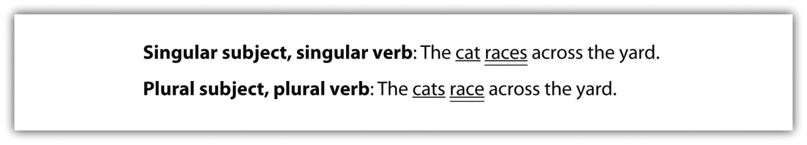

Exercise 1
On your own sheet of paper, write the correct verb form for each of the following sentences.
- I (brush/brushes) my teeth twice a day.
- You (wear/wears) the same shoes every time we go out.
- He (kick/kicks) the soccer ball into the goal.
- She (watch/watches) foreign films.
- Catherine (hide/hides) behind the door.
- We (want/wants) to have dinner with you.
- You (work/works) together to finish the project.
- They (need/needs) to score another point to win the game.
- It (eat/eats) four times a day.
- David (fix/fixes) his own motorcycle.

Irregular Verbs
Not all verbs follow a predictable pattern. These verbs are called irregular verbs. Some of the most common irregular verbs are be, have, and do. Learn the forms of these verbs in the present tense to avoid errors in subject-verb agreement.

Be
Study the different forms of the verb to be in the present tense.
 | Singular Form | Plural Form
First Person | I am. | We are.
Second Person | You are. | You are.
Third Person | He/She/It is. | They are.

Have
Study the different forms of the verb to have in the present tense.
 | Singular Form | Plural Form
First Person | I have. | We have.
Second Person | You have. | You have.
Third Person | He/She/It has. | They have.

Do
Study the different forms of the verb to do in the present tense.
 | Singular Form | Plural Form
First Person | I do. | We do.
Second Person | You do. | You do.
Third person | He/She/It does. | They do.

Exercise 2
Complete the following sentences by writing the correct present tense form of be, have, or do. Use your own sheet of paper to complete this exercise.
- I ________ sure that you will succeed.
- They ________ front-row tickets to the show.
- He ________ a great Elvis impersonation.
- We ________ so excited to meet you in person!
- She ________ a fever and a sore throat.
- You ________ not know what you are talking about.
- You ________ all going to pass this class.
- She ________ not going to like that.
- It ________ appear to be the right size.
- They ________ ready to take this job seriously.

Errors in Subject-Verb Agreement
Errors in subject-verb agreement may occur when
- a sentence contains a compound subject;
- the subject of the sentence is separate from the verb;
- the subject of the sentence is an indefinite pronoun, such as anyone or everyone;
- the subject of the sentence is a collective noun, such as team or organization;
- the subject appears after the verb.
Recognizing the sources of common errors in subject-verb agreement will help you avoid these errors in your writing. This section covers the subject-verb agreement errors in more detail.

Compound Subjects
A compound subject is formed by two or more nouns and the coordinating conjunctions and, or, or nor. A compound subject can be made of singular subjects, plural subjects, or a combination of singular and plural subjects.
Compound subjects combined with and take a plural verb form.
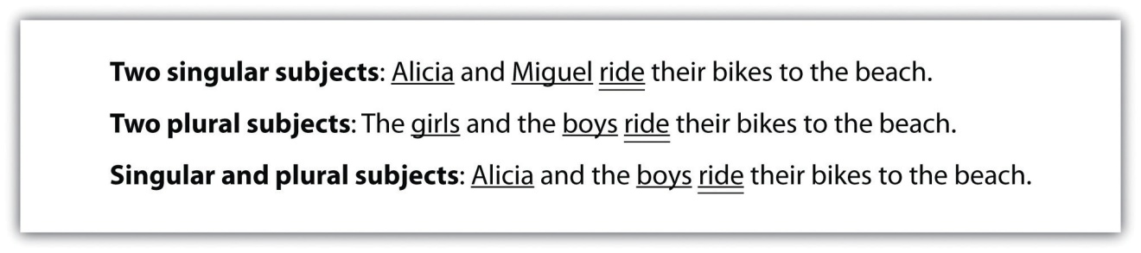
Compound subjects combined with or and nor are treated separately. The verb must agree with the subject that is nearest to the verb.
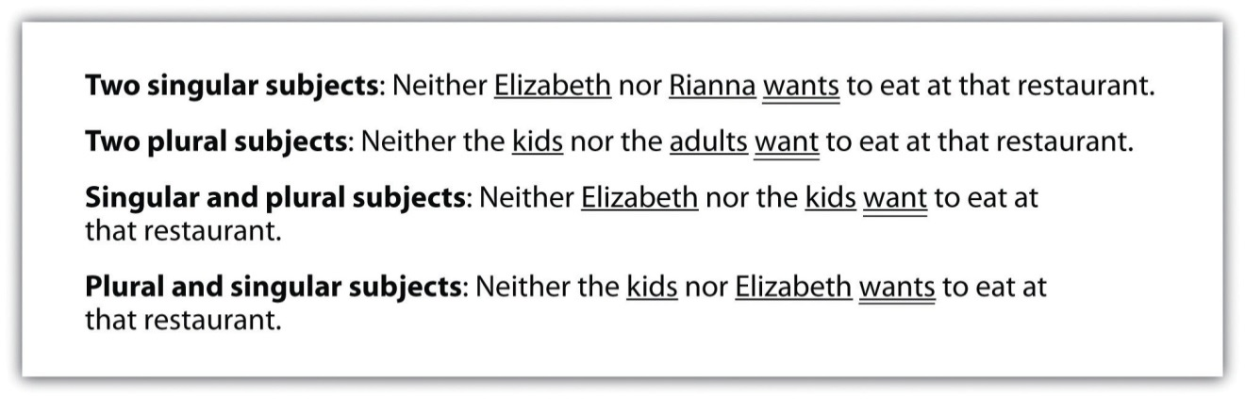
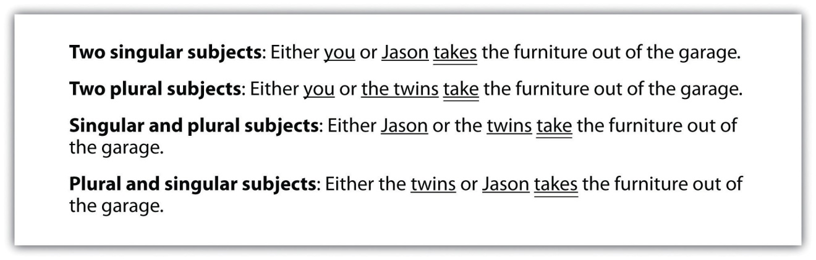

Tip
If you can substitute the word they for the compound subject, then the sentence takes the third person plural verb form.

Separation of Subjects and Verbs
As you read or write, you may come across a sentence that contains a phrase or clause that separates the subject from the verb. Often, prepositional phrases or dependent clauses add more information to the sentence and appear between the subject and the verb. However, the subject and the verb must still agree.
If you have trouble finding the subject and verb, cross out or ignore the phrases and clauses that begin with prepositions or dependent words. The subject of a sentence will never be in a prepositional phrase or dependent clause.
The following is an example of a subject and verb separated by a prepositional phrase:
The following is an example of a subject and verb separated by a dependent clause:

Indefinite Pronouns
Indefinite pronouns refer to an unspecified person, thing, or number. When an indefinite pronoun serves as the subject of a sentence, you will often use a singular verb form.
However, keep in mind that exceptions arise. Some indefinite pronouns may require a plural verb form. To determine whether to use a singular or plural verb with an indefinite pronoun, consider the noun that the pronoun would refer to. If the noun is plural, then use a plural verb with the indefinite pronoun. View the chart to see a list of common indefinite pronouns and the verb forms they agree with.
Indefinite Pronouns That Always Take a Singular Verb | Indefinite Pronouns That Can Take a Singular or Plural Verb
anybody, anyone, anything | All
each | Any
everybody, everyone, everything | None
much | Some
many
nobody, no one, nothing
somebody, someone, something
The indefinite pronoun everybody takes a singular verb form because everybody refers to a group performing the same action as a single unit.
The indefinite pronoun all takes a plural verb form because all refers to the plural noun people. Because people is plural, all is plural.
In this sentence, the indefinite pronoun all takes a singular verb form because all refers to the singular noun cake. Because cake is singular, all is singular.

Collective Nouns
A collective noun is a noun that identifies more than one person, place, or thing and considers those people, places, or things one singular unit. Because collective nouns are counted as one, they are singular and require a singular verb. Some commonly used collective nouns are group, team, army, flock, family, and class.
In this sentence, class is a collective noun. Although the class consists of many students, the class is treated as a singular unit and requires a singular verb form.

The Subject Follows the Verb
You may encounter sentences in which the subject comes after the verb instead of before the verb. In other words, the subject of the sentence may not appear where you expect it to appear. To ensure proper subject-verb agreement, you must correctly identify the subject and the verb.

Here or There
In sentences that begin with here or there, the subject follows the verb.
If you have trouble identifying the subject and the verb in sentences that start with here or there; it may help to reverse the order of the sentence so the subject comes first.

Questions
When you ask questions, a question word (who, what, where, when, why, or how) appears first. The verb and then the subject follow.

Tip
If you have trouble finding the subject and the verb in questions, try answering the question being asked.
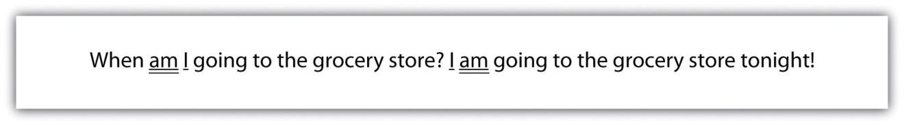

Exercise 3
Correct the errors in subject-verb agreement in the following sentences. If there are no errors in subject-verb agreement, write OK. Copy the corrected sentence or the word OK on your own sheet of notebook paper.
- My dog and cats chases each other all the time.
________________________________________________________________
- The books that are in my library is the best I have ever read.
________________________________________________________________
- Everyone are going to the concert except me.
________________________________________________________________
- My family are moving to California.
________________________________________________________________
- Here is the lake I told you about.
________________________________________________________________
- There is the newspapers I was supposed to deliver.
________________________________________________________________
- Which room is bigger?
________________________________________________________________
- When are the movie going to start?
________________________________________________________________
- My sister and brother cleans up after themselves.
________________________________________________________________
- Some of the clothes is packed away in the attic.
________________________________________________________________

Exercise 4
Correct the errors in subject-verb agreement in the following paragraph. Copy the paragraph on a piece of notebook paper and make corrections.
Dear Hiring Manager,
I feels that I am the ideal candidate for the receptionist position at your company. I has three years of experience as a receptionist in a company that is similar to yours. My phone skills and written communication is excellent. These skills, and others that I have learned on the job, helps me understand that every person in a company helps make the business a success. At my current job, the team always say that I am very helpful. Everyone appreciate when I go the extra mile to get the job done right. My current employer and coworkers feels that I am an asset to the team. I is efficient and organized. Is there any other details about me that you would like to know? If so, please contact me. Here are my résumé. You can reach me by e-mail or phone. I looks forward to speaking with you in person.
Thanks,
Felicia Fellini

Writing at Work
Figure 1.5 Advertisement
Imagine that you are a prospective client and that you saw this ad online. Would you call Terra Services to handle your next project? Probably not! Mistakes in subject-verb agreement can cost a company business. Paying careful attention to grammatical details ensures professionalism that clients will recognize and respect.

Key Takeaways
- Parts of sentences must agree in number, person, case, and gender.
- A verb must always agree with its subject in number. A singular subject requires a singular verb; a plural subject requires a plural verb.
- Irregular verbs do not follow a predictable pattern in their singular and plural forms. Common irregular verbs are to be, to have, and to do.
- A compound subject is formed when two or more nouns are joined by the words and, or, or nor.
- In some sentences, the subject and verb may be separated by a phrase or clause, but the verb must still agree with the subject.
- Indefinite pronouns, such as anyone, each, everyone, many, no one, and something, refer to unspecified people or objects. Most indefinite pronouns are singular.
- A collective noun is a noun that identifies more than one person, place, or thing and treats those people, places, or things one singular unit. Collective nouns require singular verbs.
- In sentences that begin with here and there, the subject follows the verb.
- In questions, the subject follows the verb.

Writing Application
Use your knowledge of subject-verb agreement to write one of the following:
- An advertisement for a potential company
- A memo to all employees of a particular company
- A cover letter describing your qualifications to a potential employer
Be sure to include at least the following:
- One collective noun
- One irregular verb
- One question

1.3 Verb Tense

Learning Objectives
- Use the correct regular verb tense in basic sentences.
- Use the correct irregular verb tense in basic sentences.
Suppose you must give an oral presentation about what you did last summer. How do you make it clear that you are talking about the past and not about the present or the future? Using the correct verb tense can help you do this.
It is important to use the proper verb tense. Otherwise, your listener might judge you harshly. Mistakes in tense often leave a listener or reader with a negative impression.

Regular Verbs
Verbs indicate actions or states of being in the past, present, or future using tenses. Regular verbs follow regular patterns when shifting from the present to past tense. For example, to form a past-tense or past-participle verb form, add -ed or -d to the end of a verb. You can avoid mistakes by understanding this basic pattern.
Verb tense identifies the time of action described in a sentence. Verbs take different forms to indicate different tenses. Verb tenses indicate
- an action or state of being in the present,
- an action or state of being in the past,
- an action or state of being in the future.
Helping verbs, such as be and have, also work to create verb tenses, such as the future tense.
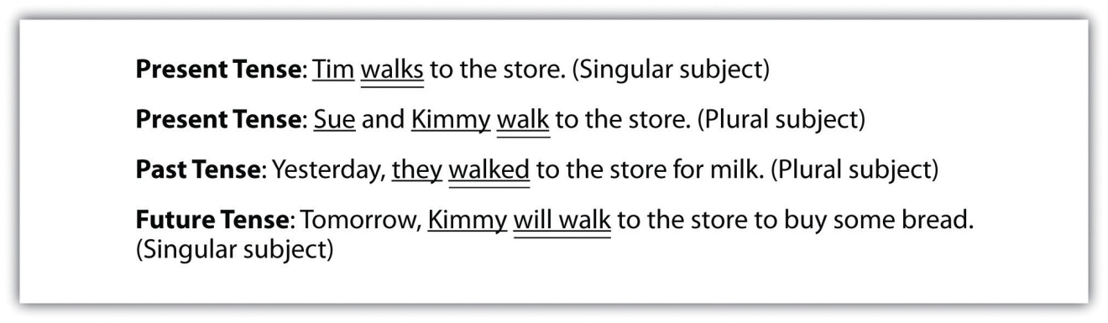

Exercise 1
Complete the following sentences by selecting the correct form of the verb in simple present, simple past, or simple future tenses. Write the corrected sentence on your own sheet of paper.
- The Dust Bowl (is, was, will be) a name given to a period of very destructive dust storms that occurred in the United States during the 1930s.
- Historians today (consider, considered, will consider) The Dust Bowl to be one of the worst weather of events in American history.
- The Dust Bowl mostly (affects, affected, will affect) the states of Kansas, Colorado, Oklahoma, Texas, and New Mexico.
- Dust storms (continue, continued, will continue) to occur in these dry regions, but not to the devastating degree of the 1930s.
- The dust storms during The Dust Bowl (cause, caused, will cause) irreparable damage to farms and the environment for a period of several years.
- When early settlers (move, moved, will move) into this area, they (remove, removed, will remove) the natural prairie grasses in order to plant crops and graze their cattle.
- They did not (realize, realized, will realize) that the grasses kept the soil in place.
- There (is, was, will be) also a severe drought that (affects, affected, will affect) the region.
- The worst dust storm (happens, happened, will happen) on April 14, 1935, a day called Black Sunday.
- The Dust Bowl era finally came to end in 1939 when the rains (arrive, arrived, will arrive).
- Dust storms (continue, continued, will continue) to affect the region, but hopefully they will not be as destructive as the storms of the 1930s.

Irregular Verbs
The past tense of irregular verbs is not formed using the patterns that regular verbs follow. Study , which lists the most common irregular verbs.

Tip
The best way to learn irregular verbs is to memorize them. With the help of a classmate, create flashcards of irregular verbs and test yourselves until you master them.

Table 1.1 Irregular Verbs
Simple Present | Past | Simple Present | Past
be | was, were | lose | lost
become | became | make | made
begin | began | mean | meant
blow | blew | meet | met
break | broke | pay | paid
bring | brought | put | put
build | built | quit | quit
burst | burst | read | read
buy | bought | ride | rode
catch | caught | ring | rang
choose | chose | rise | rose
come | came | run | ran
cut | cut | say | said
dive | dove (dived) | see | saw
do | did | seek | sought
draw | drew | sell | sold
drink | drank | send | sent
drive | drove | set | set
eat | ate | shake | shook
fall | fell | shine | shone (shined)
feed | fed | shrink | shrank (shrunk)
feel | felt | sing | sang
fight | fought | sit | sat
find | found | sleep | slept
fly | flew | speak | spoke
forget | forgot | spend | spent
forgive | forgave | spring | sprang
freeze | froze | stand | stood
get | got | steal | stole
give | gave | strike | struck
go | went | swim | swam
grow | grew | swing | swung
have | had | take | took
hear | heard | teach | taught
hide | hid | tear | tore
hold | held | tell | told
hurt | hurt | think | thought
keep | kept | throw | threw
know | knew | understand | understood
lay | laid | wake | woke
lead | led | wear | wore
leave | left | win | won
let | let | wind | wound

Here we consider using irregular verbs.

Exercise 2
Complete the following sentences by selecting the correct form of the irregular verb in simple present, simple past, or simple future tense. Copy the corrected sentence onto your own sheet of paper.
- Marina finally (forgived, forgave, will forgive) her sister for snooping around her room.
- The house (shook, shaked, shakes) as the airplane rumbled overhead.
- I (buyed, bought, buy) several items of clothing at the thrift store on Wednesday.
- She (put, putted, puts) the lotion in her shopping basket and proceeded to the checkout line.
- The prized goose (layed, laid, lay) several golden eggs last night.
- Mr. Batista (teached, taught, taughted) the class how to use correct punctuation.
- I (drink, drank, will drink) several glasses of sparkling cider instead of champagne on New Year’s Eve next year.
- Although Hector (growed, grew, grows) three inches in one year, we still called him “Little Hector.”
- Yesterday our tour guide (lead, led, will lead) us through the maze of people in Times Square.
- The rock band (burst, bursted, bursts) onto the music scene with their catchy songs.

Exercise 3
On your own sheet of paper, write a sentence using the correct form of the verb tense shown below.
- Throw (past)
- Paint (simple present)
- Smile (future)
- Tell (past)
- Share (simple present)

Maintaining Consistent Verb Tense
Consistent verb tense means the same verb tense is used throughout a sentence or a paragraph. As you write and revise, it is important to use the same verb tense consistently and to avoid shifting from one tense to another unless there is a good reason for the tense shift. In the following box, see whether you notice the difference between a sentence with consistent tense and one with inconsistent tense.
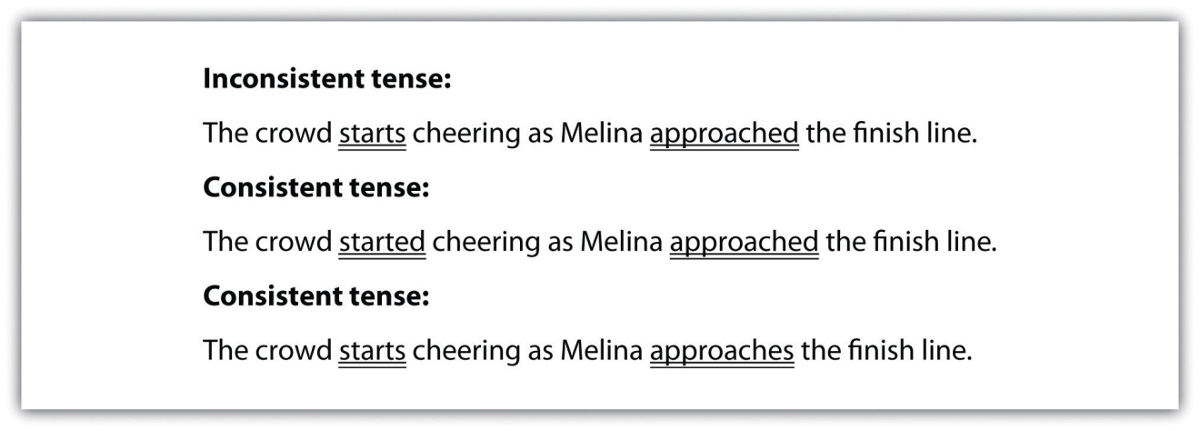

Tip
In some cases, clear communication will call for different tenses. Look at the following example:
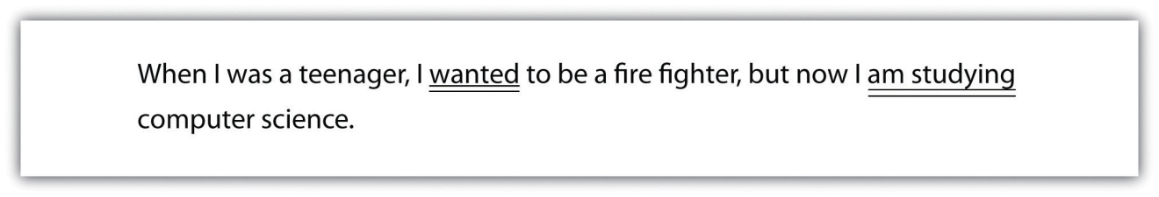
If the time frame for each action or state is different, a tense shift is appropriate.

Exercise 4
Edit the following paragraph by correcting the inconsistent verb tense. Copy the corrected paragraph onto your own sheet of paper.
In the Middle Ages, most people lived in villages and work as agricultural laborers, or peasants. Every village has a “lord,” and the peasants worked on his land. Much of what they produce go to the lord and his family. What little food was leftover goes to support the peasants’ families. In return for their labor, the lord offers them protection. A peasant’s day usually began before sunrise and involves long hours of backbreaking work, which includes plowing the land, planting seeds, and cutting crops for harvesting. The working life of a peasant in the Middle Ages is usually demanding and exhausting.

Writing at Work
Read the following excerpt from a work e-mail:
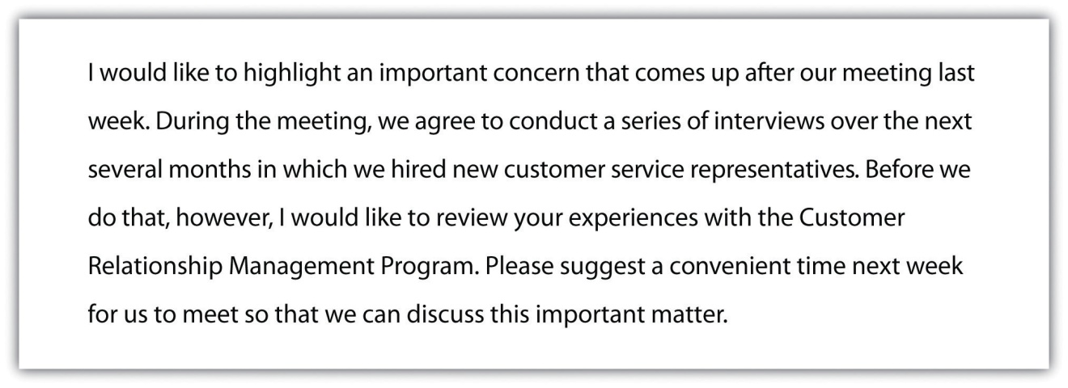
The inconsistent tense in the e-mail will very likely distract the reader from its overall point. Most likely, your coworkers will not correct your verb tenses or call attention to grammatical errors, but it is important to keep in mind that errors such as these do have a subtle negative impact in the workplace.

Key Takeaways
- Verb tense helps you express when an event takes place.
- Regular verbs follow regular patterns when shifting from present to past tense.
- Irregular verbs do not follow regular, predictable patterns when shifting from present to past tense.
- Using consistent verb tense is a key element to effective writing.

Writing Application
Tell a family story. You likely have several family stories to choose from, but pick the one that you find most interesting to write about. Use as many details as you can in the telling. As you write and proofread, make sure your all your verbs are correct and the tenses are consistent.

1.4 Capitalization

Learning Objectives
- Learn the basic rules of capitalization.
- Identify common capitalization errors.
Text messages, casual e-mails, and instant messages often ignore the rules of capitalization. In fact, it can seem unnecessary to capitalize in these contexts. In other, more formal forms of communication, however, knowing the basic rules of capitalization and using capitalization correctly gives the reader the impression that you choose your words carefully and care about the ideas you are conveying.

Capitalize the First Word of a Sentence
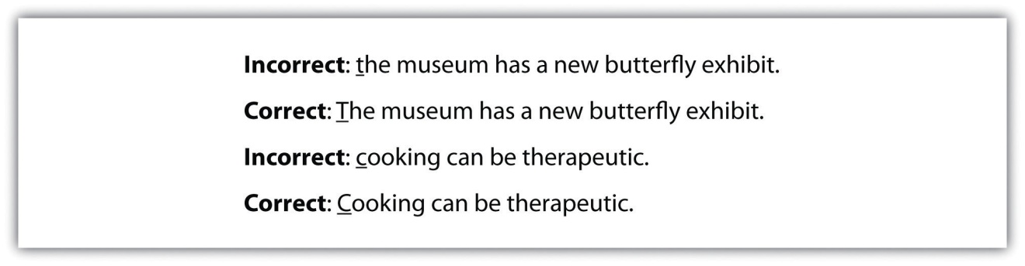

Capitalize Proper Nouns
Proper nouns—the names of specific people, places, objects, streets, buildings, events, or titles of individuals—are always capitalized.
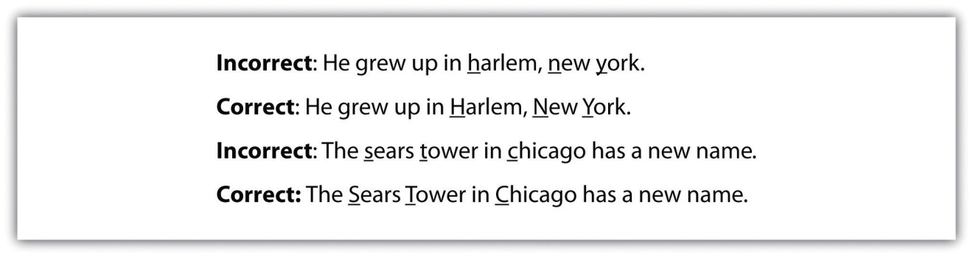

Tip
Always capitalize nationalities, races, languages, and religions. For example, American, African American, Hispanic, Catholic, Protestant, Jewish, Muslim, Hindu, Buddhist, and so on.
Do not capitalize nouns for people, places, things, streets, buildings, events, and titles when the noun is used in general or common way. See the following chart for the difference between proper nouns and common nouns.
Common Noun | Proper Noun
museum | The Art Institute of Chicago
theater | Apollo Theater
country | Malaysia
uncle | Uncle Javier
doctor | Dr. Jackson
book | Pride and Prejudice
college | Smith College
war | the Spanish-American War
historical event | The Renaissance

Exercise 1
On your own sheet of paper, write five proper nouns for each common noun that is listed. The first one has been done for you.
Common noun: river
- Nile River

Common noun: musician

Common noun: magazine

Collaboration
Please share with a classmate and compare your answers.

Capitalize Days of the Week, Months of the Year, and Holidays
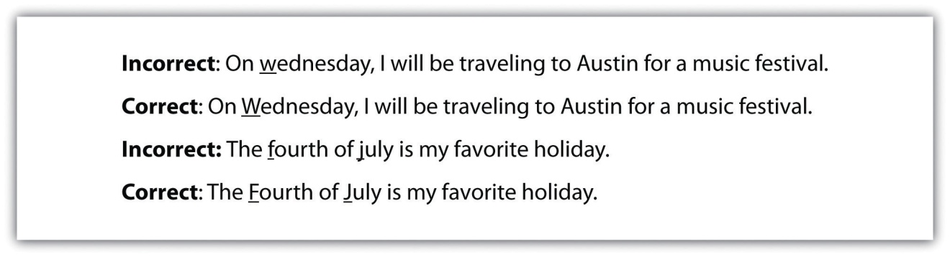

Capitalize Titles
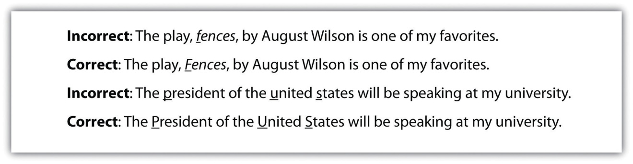

Tip
Computer-related words such as “Internet” and “World Wide Web” are usually capitalized; however, “e-mail” and “online” are never capitalized.

Exercise 2
Edit the following sentences by correcting the capitalization of the titles or names.
- The prince of england enjoys playing polo.
- “Ode to a nightingale” is a sad poem.
- My sister loves to read magazines such as the new yorker.
- The house on Mango street is an excellent novel written by Sandra Cisneros.
- My physician, dr. alvarez, always makes me feel comfortable in her office.

Exercise 3
Edit the following paragraphs by correcting the capitalization.
david grann’s the lost City of Z mimics the snake-like winding of the amazon River. The three distinct Stories that are introduced are like twists in the River. First, the Author describes his own journey to the amazon in the present day, which is contrasted by an account of percy fawcett’s voyage in 1925 and a depiction of James Lynch’s expedition in 1996. Where does the river lead these explorers? the answer is one that both the Author and the reader are hungry to discover.
The first lines of the preface pull the reader in immediately because we know the author, david grann, is lost in the amazon. It is a compelling beginning not only because it’s thrilling but also because this is a true account of grann’s experience. grann has dropped the reader smack in the middle of his conflict by admitting the recklessness of his decision to come to this place. the suspense is further perpetuated by his unnerving observation that he always considered himself A Neutral Witness, never getting personally involved in his stories, a notion that is swiftly contradicted in the opening pages, as the reader can clearly perceive that he is in a dire predicament—and frighteningly involved.

Writing at Work
Did you know that, if you use all capital letters to convey a message, the capital letters come across like shouting? In addition, all capital letters are actually more difficult to read and may annoy the reader. To avoid “shouting” at or annoying your reader, follow the rules of capitalization and find other ways to emphasize your point.

Key Takeaways
- Learning and applying the basic rules of capitalization is a fundamental aspect of good writing.
- Identifying and correcting errors in capitalization is an important writing skill.

Writing Application
Write a one-page biography. Make sure to identify people, places, and dates and use capitalization correctly.

1.5 Pronouns

Learning Objectives
- Identify pronouns and their antecedents.
- Use pronouns and their antecedents correctly.
If there were no pronouns, all types of writing would be quite tedious to read. We would soon be frustrated by reading sentences like Bob said that Bob was tired or Christina told the class that Christina received an A. Pronouns help a writer avoid constant repetition. Knowing just how pronouns work is an important aspect of clear and concise writing.

Pronoun Agreement
A pronoun is a word that takes the place of (or refers back to) a noun or another pronoun. The word or words a pronoun refers to is called the antecedent of the pronoun.
- Lani complained that she was exhausted.
  - She refers to Lani.
  - Lani is the antecedent of she.
- Jeremy left the party early, so I did not see him until Monday at work.
  - Him refers to Jeremy.
  - Jeremy is the antecedent of him.
- Crina and Rosalie have been best friends ever since they were freshman in high school.
  - They refers to Crina and Rosalie.
  - Crina and Rosalie is the antecedent of they.
Pronoun agreement errors occur when the pronoun and the antecedent do not match or agree with each other. There are several types of pronoun agreement.

Agreement in Number
If the pronoun takes the place of or refers to a singular noun, the pronoun must also be singular.
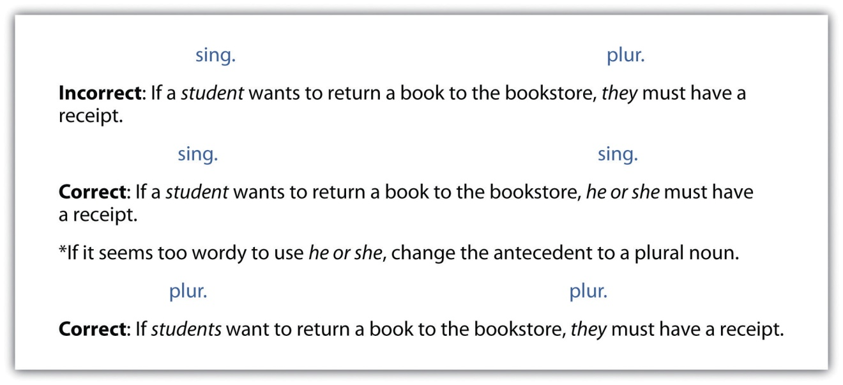

Agreement in Person
 | Singular Pronouns |  |  | Plural Pronouns
First Person | I | me | my (mine) | we | us | our (ours)
Second Person | you | you | your (yours) | you | you | your (your)
Third Person | he, she, it | him, her, it | his, her, its | they | them | their (theirs)
If you use a consistent person, your reader is less likely to be confused.
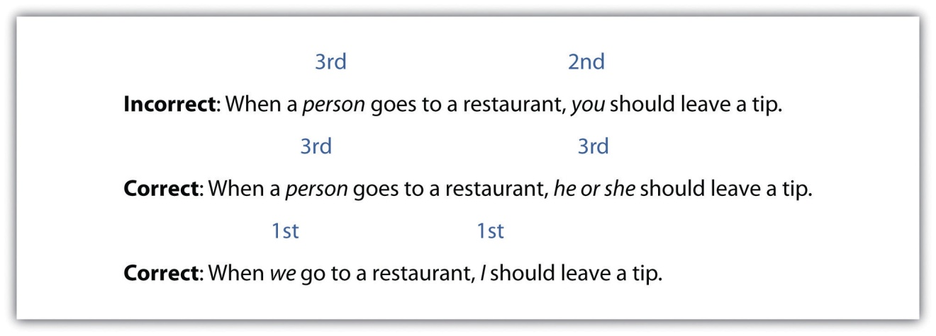

Exercise 1
Edit the following paragraph by correcting pronoun agreement errors in number and person.
Over spring break I visited my older cousin, Diana, and they took me to a butterfly exhibit at a museum. Diana and I have been close ever since she was young. Our mothers are twin sisters, and she is inseparable! Diana knows how much I love butterflies, so it was their special present to me. I have a soft spot for caterpillars too. I love them because something about the way it transforms is so interesting to me. One summer my grandmother gave me a butterfly growing kit, and you got to see the entire life cycle of five Painted Lady butterflies. I even got to set it free. So when my cousin said they wanted to take me to the butterfly exhibit, I was really excited!

Indefinite Pronouns and Agreement
Indefinite pronouns do not refer to a specific person or thing and are usually singular. Note that a pronoun that refers to an indefinite singular pronoun should also be singular. The following are some common indefinite pronouns.
Common Indefinite Pronouns
all | each one | few | nothing | several
any | each other | many | one | some
anybody | either | neither | one another | somebody
anything | everybody | nobody | oneself | someone
both | everyone | none | other | something
each | everything | no one | others | anyone
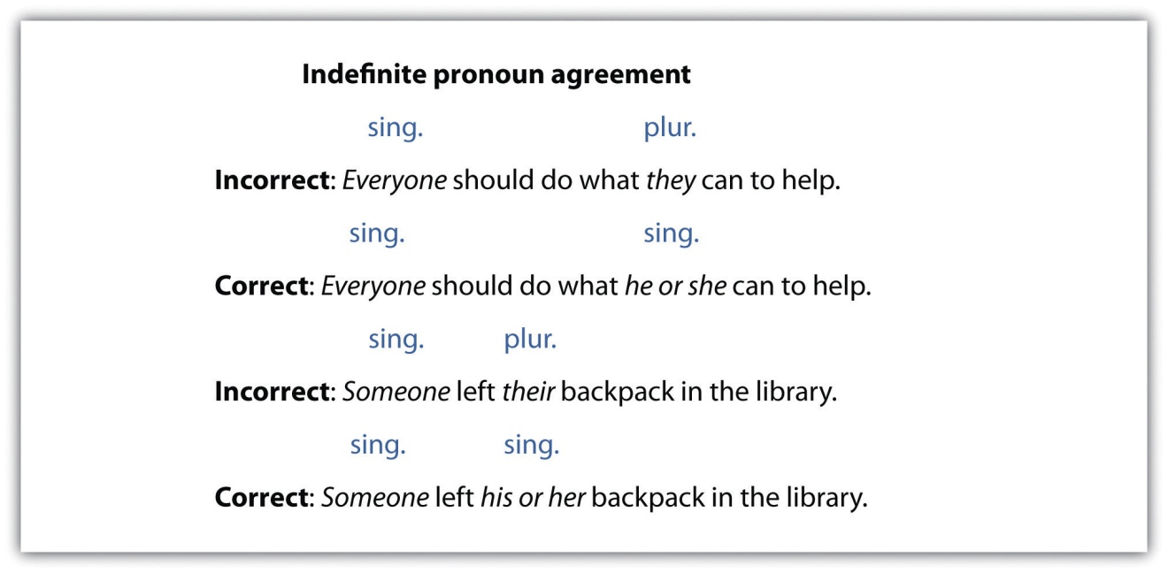

Collective Nouns
Collective nouns suggest more than one person but are usually considered singular. Look over the following examples of collective nouns.
Common Collective Nouns
audience | faculty | public
band | family | school
class | government | society
committee | group | team
company | jury | tribe
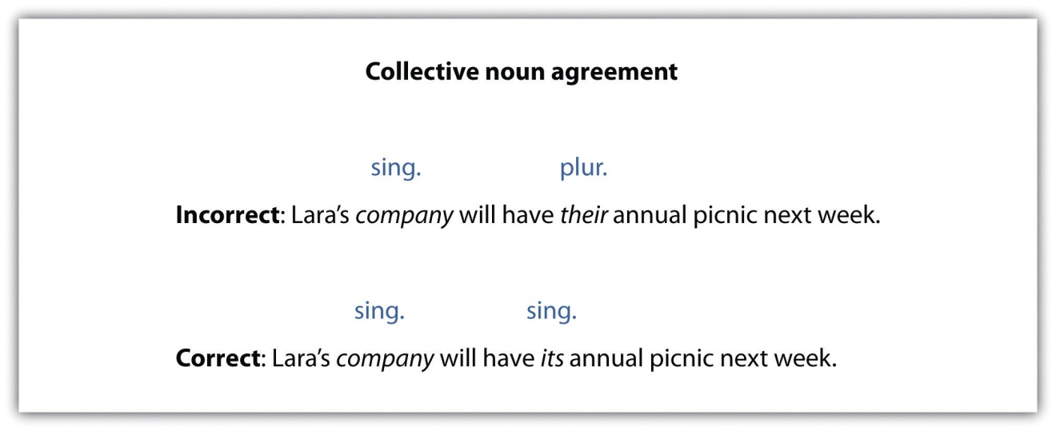

Exercise 2
Complete the following sentences by selecting the correct pronoun. Copy the completed sentence onto your own sheet of paper. Then circle the noun the pronoun replaces.
- In the current economy, nobody wants to waste ________ money on frivolous things.
- If anybody chooses to go to medical school, ________ must be prepared to work long hours.
- The plumbing crew did ________ best to repair the broken pipes before the next ice storm.
- If someone is rude to you, try giving ________ a smile in return.
- My family has ________ faults, but I still love them no matter what.
- The school of education plans to train ________ students to be literacy tutors.
- The commencement speaker said that each student has a responsibility toward ________.
- My mother’s singing group has ________ rehearsals on Thursday evenings.
- No one should suffer ________ pains alone.
- I thought the flock of birds lost ________ way in the storm.

Subject and Object Pronouns
Subject pronouns function as subjects in a sentence. Object pronouns function as the object of a verb or of a preposition.
Singular Pronouns |  | Plural Pronouns
Subject | Object | Subject | Object
I | me | we | us
you | you | you | you
he, she, it | him, her, it | they | them
The following sentences show pronouns as subjects:
- She loves the Blue Ridge Mountains in the fall.
- Every summer, they picked up litter from national parks.
The following sentences show pronouns as objects:
- Marie leaned over and kissed him.
- Jane moved it to the corner.

Tip
Note that a pronoun can also be the object of a preposition.
Near them, the children played.
My mother stood between us.
The pronouns us and them are objects of the prepositions near and between. They answer the questions near whom? And between whom?
Compound subject pronouns are two or more pronouns joined by a conjunction or a preposition that function as the subject of the sentence.
The following sentences show pronouns with compound subjects:
Incorrect:Me and Harriet visited the Grand Canyon last summer.
Correct:Harriet and I visited the Grand Canyon last summer.
Correct: Jenna accompanied Harriet and me on our trip.

Tip
Note that object pronouns are never used in the subject position. One way to remember this rule is to remove the other subject in a compound subject, leave only the pronoun, and see whether the sentence makes sense. For example, Me visited the Grand Canyon last summer sounds immediately incorrect.
Compound object pronouns are two or more pronouns joined by a conjunction or a preposition that function as the object of the sentence.
Incorrect: I have a good feeling about Janice and I.
Correct: I have a good feeling about Janice and me.

Tip
It is correct to write Janice and me, as opposed to me and Janice. Just remember it is more polite to refer to yourself last.

Writing at Work
In casual conversation, people sometimes mix up subject and object pronouns. For instance, you might say, “Me and Donnie went to a movie last night.” However, when you are writing or speaking at work or in any other formal situation, you need to remember the distinctions between subject and object pronouns and be able to correct yourself. These subtle grammar corrections will enhance your professional image and reputation.

Exercise 3
Revise the following sentences in which the subject and object pronouns are used incorrectly. Copy the revised sentence onto your own sheet of paper. Write a C for each sentence that is correct.
- Meera and me enjoy doing yoga together on Sundays.
________________________________________________________________
- She and him have decided to sell their house.
________________________________________________________________
- Between you and I, I do not think Jeffrey will win the election.
________________________________________________________________

- Us and our friends have game night the first Thursday of every month.
________________________________________________________________
- They and I met while on vacation in Mexico.
________________________________________________________________
- Napping on the beach never gets boring for Alice and I.
________________________________________________________________
- New Year’s Eve is not a good time for she and I to have a serious talk.
________________________________________________________________
- You exercise much more often than me.
________________________________________________________________
- I am going to the comedy club with Yolanda and she.
________________________________________________________________
- The cooking instructor taught her and me a lot.
________________________________________________________________

Who versus Whom
Who or whoever is always the subject of a verb. Use who or whoever when the pronoun performs the action indicated by the verb.
Who won the marathon last Tuesday?
I wonder who came up with that terrible idea!
On the other hand, whom and whomever serve as objects. They are used when the pronoun does not perform an action. Use whom or whomever when the pronoun is the direct object of a verb or the object of a preposition.
Whom did Frank marry the third time? (direct object of verb)
From whom did you buy that old record player? (object of preposition)

Tip
If you are having trouble deciding when to use who and whom, try this trick. Take the following sentence:
Who/Whom do I consider my best friend?
Reorder the sentence in your head, using either he or him in place of who or whom.
I consider him my best friend.
I consider he my best friend.
Which sentence sounds better? The first one, of course. So the trick is, if you can use him, you should use whom.

Exercise 4
Complete the following sentences by adding who or whom. Copy the completed sentence onto your own sheet of paper.
- ________ hit the home run?
- I remember ________ won the Academy Award for Best Actor last year.
- To ________ is the letter addressed?
- I have no idea ________ left the iron on, but I am going to find out.
- ________ are you going to recommend for the internship?
- With ________ are you going to Hawaii?
- No one knew ________ the famous actor was.
- ________ in the office knows how to fix the copy machine?
- From ________ did you get the concert tickets?
- No one knew ________ ate the cake mom was saving.

Key Takeaways
- Pronouns and their antecedents need to agree in number and person.
- Most indefinite pronouns are singular.
- Collective nouns are usually singular.
- Pronouns can function as subjects or objects.
- Subject pronouns are never used as objects, and object pronouns are never used as subjects.
- Who serves as a subject of a verb.
- Whom serves as an object of a sentence or the object of a preposition.

Writing Application
Write about what makes an ideal marriage or long-term relationship. Provide specific details to back up your assertions. After you have written a few paragraphs, go back and proofread your paper for correct pronoun usage.

1.6 Adjectives and Adverbs

Learning Objectives
- Identify adjectives and adverbs.
- Use adjectives and adverbs correctly.
Adjectives and adverbs are descriptive words that bring your writing to life.

Adjectives and Adverbs
An adjective is a word that describes a noun or a pronoun. It often answers questions such as which one, what kind, or how many?
- The green sweater belongs to Iris.
- She looks beautiful.
  - In sentence 1, the adjective green describes the noun sweater.
  - In sentence 2, the adjective beautiful describes the pronoun she.
An adverb is a word that describes a verb, an adjective, or another adverb. Adverbs frequently end in -ly. They answer questions such as how, to what extent, why, when, and where.
- Bertrand sings horribly.
- My sociology instructor is extremely wise.
- He threw the ball very accurately.
  - In sentence 3, horribly describes the verb sings. How does Bertrand sing? He sings horribly.
  - In sentence 4, extremely describes the adjective wise. How wise is the instructor? Extremely wise.
  - In sentence 5, very describes the adverb accurately. How accurately did he throw the ball? Very accurately.

Exercise 1
Complete the following sentences by adding the correct adjective or adverb from the list in the previous section. Identify the word as an adjective or an adverb (Adj, Adv).
- Frederick ________ choked on the piece of chicken when he saw Margaret walk through the door.
- His ________ eyes looked at everyone and everything as if they were specimens in a biology lab.
- Despite her pessimistic views on life, Lauren believes that most people have ________ hearts.
- Although Stefan took the criticism ________, he remained calm.
- The child developed a ________ imagination because he read a lot of books.
- Madeleine spoke ________ while she was visiting her grandmother in the hospital.
- Hector’s most ________ possession was his father’s bass guitar from the 1970s.
- My definition of a ________ afternoon is walking to the park on a beautiful day, spreading out my blanket, and losing myself in a good book.
- She ________ eyed her new coworker and wondered if he was single.
- At the party, Denise ________ devoured two pieces of pepperoni pizza and a several slices of ripe watermelon.

Comparative versus Superlative
Comparative adjectives and adverbs are used to compare two people or things.
- Jorge is thin.
- Steven is thinner than Jorge.
  - Sentence 1 describes Jorge with the adjective thin.
  - Sentence 2 compares Jorge to Steven, stating that Steven is thinner. So thinner is the comparative form of thin.
Form comparatives in one of the following two ways:
- If the adjective or adverb is a one syllable word, add -er to it to form the comparative. For example, big, fast, and short would become bigger, faster, and shorter in the comparative form.
- If the adjective or adverb is a word of two or more syllables, place the word more in front of it to form the comparative. For example, happily, comfortable, and jealous would become more happily, more comfortable, and more jealous in the comparative.
Superlative adjectives and adverbs are used to compare more than two people or two things.
- Jackie is the loudest cheerleader on the squad.
- Kenyatta was voted the most confident student by her graduating class.
  - Sentence 1 shows that Jackie is not just louder than one other person, but she is the loudest of all the cheerleaders on the squad.
  - Sentence 2 shows that Kenyatta was voted the most confident student of all the students in her class.

Form superlatives in one of the following two ways:
- If the adjective or adverb is a one-syllable word, add -est to form the superlative. For example, big, fast, and short would become biggest, fastest, and shortest in the superlative form.
- If the adjective or adverb is a word of two or more syllables, place the word most in front of it. For example, happily, comfortable, and jealous would become most happily, most comfortable, and most jealous in the superlative form.

Tip
Remember the following exception: If the word has two syllables and ends in -y, change the -y to an -i and add -est. For example, happy would change to happiest in the superlative form; healthy would change to healthiest.

Exercise 2
Edit the following paragraph by correcting the errors in comparative and superlative adjectives.
Our argument started on the most sunny afternoon that I have ever experienced. Max and I were sitting on my front stoop when I started it. I told him that my dog, Jacko, was more smart than his dog, Merlin. I could not help myself. Merlin never came when he was called, and he chased his tail and barked at rocks. I told Max that Merlin was the most dumbest dog on the block. I guess I was angrier about a bad grade that I received, so I decided to pick on poor little Merlin. Even though Max insulted Jacko too, I felt I had been more mean. The next day I apologized to Max and brought Merlin some of Jacko’s treats. When Merlin placed his paw on my knee and licked my hand, I was the most sorry person on the block.
Collaboration
Share and compare your answers with a classmate.

Irregular Words: Good, Well, Bad, and Badly
Good, well, bad, and badly are often used incorrectly. Study the following chart to learn the correct usage of these words and their comparative and superlative forms.
 |  | Comparative | Superlative
Adjective | good | better | best
Adverb | well | better | best
Adjective | bad | worse | worst
Adverb | badly | worse | worst

Good versus Well
Good is always an adjective—that is, a word that describes a noun or a pronoun. The second sentence is correct because well is an adverb that tells how something is done.
Incorrect: Cecilia felt that she had never done so good on a test.
Correct: Cecilia felt that she had never done so well on a test.
Well is always an adverb that describes a verb, adverb, or adjective. The second sentence is correct because good is an adjective that describes the noun score.
Incorrect: Cecilia’s team received a well score.
Correct: Cecilia’s team received a good score.

Bad versus Badly
Bad is always an adjective. The second sentence is correct because badly is an adverb that tells how the speaker did on the test.
Incorrect: I did bad on my accounting test because I didn’t study.
Correct: I did badly on my accounting test because I didn’t study.
Badly is always an adverb. The second sentence is correct because bad is an adjective that describes the noun thunderstorm.
Incorrect: The coming thunderstorm looked badly.
Correct: The coming thunderstorm looked bad.

Better and Worse
The following are examples of the use of better and worse:
Tyra likes sprinting better than long distance running.
The traffic is worse in Chicago than in Atlanta.

Best and Worst
The following are examples of the use of best and worst:
Tyra sprints best of all the other competitors.
Peter finished worst of all the runners in the race.

Tip
Remember better and worse compare two persons or things. Best and worst compare three or more persons or things.

Exercise 3
Write good, well, bad, or badly to complete each sentence. Copy the completed sentence onto your own sheet of paper.
- Donna always felt ________ if she did not see the sun in the morning.
- The school board president gave a ________ speech for once.
- Although my dog, Comet, is mischievous, he always behaves ________ at the dog park.
- I thought my back injury was ________ at first, but it turned out to be minor.
- Steve was shaking ________ from the extreme cold.
- Apple crisp is a very ________ dessert that can be made using whole grains instead of white flour.
- The meeting with my son’s math teacher went very ________.
- Juan has a ________ appetite, especially when it comes to dessert.
- Magritte thought the guests had a ________ time at the party because most people left early.
- She ________ wanted to win the writing contest prize, which included a trip to New York.

Exercise 4
Write the correct comparative or superlative form of the word in parentheses. Copy the completed sentence onto your own sheet of paper.
- This research paper is ________ (good) than my last one.
- Tanaya likes country music ________ (well) of all.
- My motorcycle rides ________ (bad) than it did last summer.
- That is the ________ (bad) joke my father ever told.
- The hockey team played ________ (badly) than it did last season.
- Tracey plays guitar ________ (well) than she plays the piano.
- It will go down as one of the ________ (bad) movies I have ever seen.
- The deforestation in the Amazon is ________ (bad) than it was last year.
- Movie ticket sales are ________ (good) this year than last.
- My husband says mystery novels are the ________ (good) types of books.

Writing at Work
The irregular words good, well, bad, and badly are often misused along with their comparative and superlative forms better, best, worse, and worst. You may not hear the difference between worse and worst, and therefore type it incorrectly. In a formal or business-like tone, use each of these words to write eight separate sentences. Assume these sentences will be seen and judged by your current or future employer.

Key Takeaways
- Adjectives describe a noun or a pronoun.
- Adverbs describe a verb, adjective, or another adverb.
- Most adverbs are formed by adding -ly to an adjective.
- Comparative adjectives and adverbs compare two persons or things.
- Superlative adjectives or adverbs compare more than two persons or things.
- The adjectives good and bad and the adverbs well and badly are unique in their comparative and superlative forms and require special attention.

Writing Application
Using the exercises as a guide, write your own ten-sentence quiz for your classmate(s) using the concepts covered in this section. Try to include two questions from each subsection in your quiz. Exchange papers and see whether you can get a perfect score.

1.7 Misplaced and Dangling Modifiers

Learning Objectives
- Identify modifiers.
- Learn how to correct misplaced and dangling modifiers.
A modifier is a word, phrase, or clause that clarifies or describes another word, phrase, or clause. Sometimes writers use modifiers incorrectly, leading to strange and unintentionally humorous sentences. The two common types of modifier errors are called misplaced modifiers and dangling modifiers. If either of these errors occurs, readers can no longer read smoothly. Instead, they become stumped trying to figure out what the writer meant to say. A writer’s goal must always be to communicate clearly and to avoid distracting the reader with strange sentences or awkward sentence constructions. The good news is that these errors can be easily overcome.

Misplaced Modifiers
A misplaced modifier is a modifier that is placed too far from the word or words it modifies. Misplaced modifiers make the sentence awkward and sometimes unintentionally humorous.
Incorrect: She wore a bicycle helmet on her head that was too large.
Correct: She wore a bicycle helmet that was too large on her head.
- Notice in the incorrect sentence it sounds as if her head was too large! Of course, the writer is referring to the helmet, not to the person’s head. The corrected version of the sentence clarifies the writer’s meaning.
Look at the following two examples:
Incorrect: They bought a kitten for my brother they call Shadow.
Correct: They bought a kitten they call Shadow for my brother.
- In the incorrect sentence, it seems that the brother’s name is Shadow. That’s because the modifier is too far from the word it modifies, which is kitten.
Incorrect: The patient was referred to the physician with stomach pains.
Correct: The patient with stomach pains was referred to the physician.
- The incorrect sentence reads as if it is the physician who has stomach pains! What the writer means is that the patient has stomach pains.

Tip
Simple modifiers like only, almost, just, nearly, and barely often get used incorrectly because writers often stick them in the wrong place.
Confusing: Tyler almost found fifty cents under the sofa cushions.
Repaired: Tyler found almost fifty cents under the sofa cushions.
- How do you almost find something? Either you find it or you do not. The repaired sentence is much clearer.

Exercise 1
On a separate sheet of paper, rewrite the following sentences to correct the misplaced modifiers.
- The young lady was walking the dog on the telephone.
- I heard that there was a robbery on the evening news.
- Uncle Louie bought a running stroller for the baby that he called “Speed Racer.”
- Rolling down the mountain, the explorer stopped the boulder with his powerful foot.
- We are looking for a babysitter for our precious six-year-old who doesn’t drink or smoke and owns a car.
- The teacher served cookies to the children wrapped in aluminum foil.
- The mysterious woman walked toward the car holding an umbrella.
- We returned the wine to the waiter that was sour.
- Charlie spotted a stray puppy driving home from work.
- I ate nothing but a cold bowl of noodles for dinner.

Dangling Modifiers
A dangling modifier is a word, phrase, or clause that describes something that has been left out of the sentence. When there is nothing that the word, phrase, or clause can modify, the modifier is said to dangle.
Incorrect:Riding in the sports car, the world whizzed by rapidly.
Correct: As Jane was riding in the sports car, the world whizzed by rapidly.
- In the incorrect sentence, riding in the sports car is dangling. The reader is left wondering who is riding in the sports car. The writer must tell the reader!

Incorrect:Walking home at night, the trees looked like spooky aliens.
Correct: As Jonas was walking home at night, the trees looked like spooky aliens.
Correct: The trees looked like spooky aliens as Jonas was walking home at night.
- In the incorrect sentence walking home at night is dangling. Who is walking home at night? Jonas. Note that there are two different ways the dangling modifier can be corrected.
Incorrect: To win the spelling bee, Luis and Gerard should join our team.
Correct: If we want to win the spelling bee this year, Luis and Gerard should join our team.
- In the incorrect sentence, to win the spelling bee is dangling. Who wants to win the spelling bee? We do!

Tip
The following three steps will help you quickly spot a dangling modifier:
- Look for an -ing modifier at the beginning of your sentence or another modifying phrase:
Painting for three hours at night, the kitchen was finally finished by Maggie. (Painting is the -ing modifier.)
- Underline the first noun that follows it:
Painting for three hours at night, the kitchen was finally finished by Maggie.
- Make sure the modifier and noun go together logically. If they do not, it is very likely you have a dangling modifier.
After identifying the dangling modifier, rewrite the sentence.
Painting for three hours at night, Maggie finally finished the kitchen.

Exercise 2
Rewrite the following the sentences onto your own sheet of paper to correct the dangling modifiers.
- Bent over backward, the posture was very challenging.
- Making discoveries about new creatures, this is an interesting time to be a biologist.
- Walking in the dark, the picture fell off the wall.
- Playing a guitar in the bedroom, the cat was seen under the bed.
- Packing for a trip, a cockroach scurried down the hallway.
- While looking in the mirror, the towel swayed in the breeze.
- While driving to the veterinarian’s office, the dog nervously whined.
- The priceless painting drew large crowds when walking into the museum.
- Piled up next to the bookshelf, I chose a romance novel.
- Chewing furiously, the gum fell out of my mouth.

Exercise 3
Rewrite the following paragraph correcting all the misplaced and dangling modifiers.
I bought a fresh loaf of bread for my sandwich shopping in the grocery store. Wanting to make a delicious sandwich, the mayonnaise was thickly spread. Placing the cold cuts on the bread, the lettuce was placed on top. I cut the sandwich in half with a knife turning on the radio. Biting into the sandwich, my favorite song blared loudly in my ears. Humming and chewing, my sandwich went down smoothly. Smiling, my sandwich will be made again, but next time I will add cheese.
Collaboration
Please share with a classmate and compare your answers.

Key Takeaways
- Misplaced and dangling modifiers make sentences difficult to understand.
- Misplaced and dangling modifiers distract the reader.
- There are several effective ways to identify and correct misplaced and dangling modifiers.

Writing Application
See how creative and humorous you can get by writing ten sentences with misplaced and dangling modifiers. This is a deceptively simple task, but rise to the challenge. Your writing will be stronger for it. Exchange papers with a classmate, and rewrite your classmate’s sentences to correct any misplaced modifiers.

1.8 Writing Basics: End-of-Chapter Exercises

Learning Objectives
- Use the skills you have learned in the chapter.
- Work collaboratively with other students.

Exercises
- On your own sheet of paper, identify each sentence as a fragment, a run-on, or correct (no error). Then rewrite the paragraph by correcting the sentence fragments and run-ons.
My favorite book is Brave New World by Aldous Huxley, he was born in 1894 and died in 1963 ________. Written in 1931 ________. A futuristic society where humans are born out of test tubes and kept in rigid social classes ________. This may not seem like a humorous premise for a novel, but Huxley uses satire, which is a type of humor that is used to make a serious point ________. The humans in Brave New World learn through sleep teaching, Huxley calls this “hypnopedia” ________. Everyone is kept “happy” in the brave new world by taking a pill called soma, there is one character named John the Savage who does not take soma ________. because he comes from a different part of the world where there is no technology, and he believes in natural ways of living ________. It turns out that John has a big problem with the brave new world and how people live there ________. Will he be able to survive living there, well you will have to read the novel to find out ________. Brave New World is considered a classic in English literature, it is one of the best novels I have ever read ________.
- Each sentence contains an error in subject-verb agreement, irregular verb form, or consistent verb tense. Identify the type of error. Then, on your own sheet of paper, rewrite the sentence correctly.
  - Maria and Ty meets me at the community center for cooking classes on Tuesdays.
________________________________________________________________
  - John’s ability to laugh at almost anything amaze me.
________________________________________________________________
  - Samantha and I were walking near the lake when the large, colorful bird appears.
________________________________________________________________
  - I builded my own telescope using materials I bought at the hardware store.
________________________________________________________________
  - My mother freezed the remaining tomatoes from her garden so that she could use them during the winter.
________________________________________________________________
  - Bernard asked the stranger sitting next to him for the time, and she says it was past midnight.
________________________________________________________________
  - My mother and brother wears glasses, but my father and sister do not.
________________________________________________________________
  - We held our noses as the skunk runs away.
________________________________________________________________
  - Neither Soren nor Andrew are excited about the early morning swim meet.
________________________________________________________________
  - My hands hurted at the thought of transcribing all those notes.
________________________________________________________________
  - The police questioned the suspect for hours but she gives them no useful information.
________________________________________________________________
  - Terry takes short weekend trips because her job as a therapist was very emotionally draining.
________________________________________________________________
  - She criticize delicately, making sure not to hurt anyone’s feelings.
________________________________________________________________
  - Davis winded the old clock and set it atop his nightstand.
________________________________________________________________
  - Cherie losed four poker hands in a row before realizing that she was playing against professionals.
________________________________________________________________
  - Janis and Joan describes their trip to the Amazon in vivid detail.
________________________________________________________________
  - You should decides for yourself whether or not to reduce the amount of processed foods in your diet.
________________________________________________________________
  - The oil rig exploded and spills millions of gallons of oil into the ocean.
________________________________________________________________
  - The handsome vampire appeared out of nowhere and smiles at the smitten woman.
________________________________________________________________
  - The batter swinged at the ball several times but never hit it.
________________________________________________________________
- Correct the capitalization errors in the following fictional story. Copy the corrected paragraph onto your own sheet of paper.
lance worthington signed a Recording Contract with Capitol records on june 15, 2007. Despite selling two million copies of his Debut Album, nothing to lose, lance lost quite a bit as his tax returns from the irs revealed. lance did not think it was fair that the Record Company kept so much of his earnings, so he decided to hire robert bergman, a prominent music Attorney with a Shark-like reputation. bergman represented lance all the way to the supreme court, where lance won the case against capitol records. Lance worthington was instrumental in changing intellectual property rights and long standing Record Company practices. All artists and musicians can thank him for his brave stance against record companies. Lance subsequently formed his own independent record label called worthy records. worthy is now a successful Label based out of chicago, illinois, and its Artists have appeared on well known shows such as The tonight show and Saturday night live. Lance worthington is a model for success in the do-it-yourself World that has become the Music Industry.
Collaboration
Please share with a classmate and compare your answers.
- Complete the following sentences by selecting the correct comparative or superlative adjective or adverb. Then copy the completed sentence onto your own sheet of paper.
  - Denise has a (cheerful) ________ outlook on life than her husband.
  - I don’t mean to brag, but I think I am the (good) ________ cook in my family.
  - Lydia is the (thoughtful) ________ person I know.
  - Italy experienced the (bad) ________ heat wave in its history last year.
  - My teacher, Ms. Beckett, is the (strange) ________ person I know, and I like that.
  - Dorian’s drawing skills are (good) ________ this semester than last.
  - My handwriting is the (sloppy) ________ of all my classmates.
  - Melvin’s soccer team played (badly) ________ than it did last season.
  - Josie’s pen writes (smooth) ________ than mine.
  - I felt (lucky) ________ than my sister because I got in to the college of my choice.

Chapter 2 Punctuation
Suppose you are presenting a speech. If you speak too quickly, your audience will not be able to understand what you are saying. It is important to stop and take a breath a few times as you read from your notes. But how do you know where to pause, where to change your voice, and where to stop? The answer is easy. You can use the punctuation marks you encounter as a guide for your pacing.
Punctuation marks provide visual clues to readers, telling them how they should read the sentence. Some punctuation marks tell you that you are reading a list of items while other marks tell you that a sentence contains two independent ideas. Punctuation marks tell you not only when a sentence ends but also what kind of sentence you have read. This chapter covers different types of punctuation and the meanings they convey.

2.1 Commas

Learning Objectives
- Identify the uses of commas.
- Correctly use commas in sentences.
One of the punctuation clues to reading you may encounter is the comma. The comma is a punctuation mark that indicates a pause in a sentence or a separation of things in a list. Commas can be used in a variety of ways. Look at some of the following sentences to see how you might use a comma when writing a sentence.
- Introductory word: Personally, I think the practice is helpful.
- Lists: The barn, the tool shed, and the back porch were destroyed by the wind.
- Coordinating adjectives: He was tired, hungry, and late.
- Conjunctions in compound sentences: The bedroom door was closed, so the children knew their mother was asleep.
- Interrupting words: I knew where it was hidden, of course, but I wanted them to find it themselves.
- Dates, addresses, greetings, and letters: The letter was postmarked December 8, 1945.

Commas after an Introductory Word or Phrase
You may notice a comma that appears near the beginning of the sentence, usually after a word or phrase. This comma lets the reader know where the introductory word or phrase ends and the main sentence begins.
Without spoiling the surprise, we need to tell her to save the date.
In this sentence, without spoiling the surprise is an introductory phrase, while we need to tell her to save the date is the main sentence. Notice how they are separated by a comma. When only an introductory word appears in the sentence, a comma also follows the introductory word.
Ironically, she already had plans for that day.

Exercise 1
Look for the introductory word or phrase. On your own sheet of paper, copy the sentence and add a comma to correct the sentence.
- Suddenly the dog ran into the house.
- In the blink of an eye the kids were ready to go to the movies.
- Confused he tried opening the box from the other end.
- Every year we go camping in the woods.
- Without a doubt green is my favorite color.
- Hesitating she looked back at the directions before proceeding.
- Fortunately the sleeping baby did not stir when the doorbell rang.
- Believe it or not the criminal was able to rob the same bank three times.

Commas in a List of Items
When you want to list several nouns in a sentence, you separate each word with a comma. This allows the reader to pause after each item and identify which words are included in the grouping. When you list items in a sentence, put a comma after each noun, then add the word and before the last item. However, you do not need to include a comma after the last item.
We’ll need to get flour, tomatoes, and cheese at the store.
The pizza will be topped with olives, peppers, and pineapple chunks.

Commas and Coordinating Adjectives
You can use commas to list both adjectives and nouns. A string of adjectives that describe a noun are called coordinating adjectives. These adjectives come before the noun they modify and are separated by commas. One important thing to note, however, is that unlike listing nouns, the word and does not always need to be before the last adjective.
It was a bright, windy, clear day.
Our kite glowed red, yellow, and blue in the morning sunlight.

Exercise 2
On your own sheet of paper, use what you have learned so far about comma use to add commas to the following sentences.
- Monday Tuesday and Wednesday are all booked with meetings.
- It was a quiet uneventful unproductive day.
- We’ll need to prepare statements for the Franks Todds and Smiths before their portfolio reviews next week.
- Michael Nita and Desmond finished their report last Tuesday.
- With cold wet aching fingers he was able to secure the sails before the storm.
- He wrote his name on the board in clear precise delicate letters.

Commas before Conjunctions in Compound Sentences
Commas are sometimes used to separate two independent clauses. The comma comes after the first independent clause and is followed by a conjunction, such as for, and, or but. For a full list of conjunctions, see Chapter 1 "Writing Basics: What Makes a Good Sentence?".
He missed class today, and he thinks he will be out tomorrow, too.
He says his fever is gone, but he is still very tired.

Exercise 3
On your own sheet of paper, create a compound sentence by combining the two independent clauses with a comma and a coordinating conjunction.
- The presentation was scheduled for Monday. The weather delayed the presentation for four days.
________________________________________________________________
- He wanted a snack before bedtime. He ate some fruit.
________________________________________________________________
- The patient is in the next room. I can hardly hear anything.
________________________________________________________________
- We could go camping for vacation. We could go to the beach for vacation.
________________________________________________________________
- I want to get a better job. I am taking courses at night.
________________________________________________________________
- I cannot move forward on this project. I cannot afford to stop on this project.
________________________________________________________________
- Patrice wants to stop for lunch. We will take the next exit to look for a restaurant.
________________________________________________________________
- I’ve got to get this paper done. I have class in ten minutes.
________________________________________________________________
- The weather was clear yesterday. We decided to go on a picnic.
________________________________________________________________

- I have never dealt with this client before. I know Leonardo has worked with them. Let’s ask Leonardo for his help.
________________________________________________________________

Commas before and after Interrupting Words
In conversations, you might interrupt your train of thought by giving more details about what you are talking about. In a sentence, you might interrupt your train of thought with a word or phrase called interrupting words. Interrupting words can come at the beginning or middle of a sentence. When the interrupting words appear at the beginning of the sentence, a comma appears after the word or phrase.
If you can believe it, people once thought the sun and planets orbited around Earth.
Luckily, some people questioned that theory.
When interrupting words come in the middle of a sentence, they are separated from the rest of the sentence by commas. You can determine where the commas should go by looking for the part of the sentence that is not essential for the sentence to make sense.
An Italian astronomer, Galileo, proved that Earth orbited the sun.
We have known, for hundreds of years now, that the Earth and other planets exist in a solar system.

Exercise 4
On your own sheet of paper, copy the sentence and insert commas to separate the interrupting words from the rest of the sentence.
- I asked my neighbors the retired couple from Florida to bring in my mail.
- Without a doubt his work has improved over the last few weeks.
- Our professor Mr. Alamut drilled the lessons into our heads.
- The meeting is at noon unfortunately which means I will be late for lunch.
- We came in time for the last part of dinner but most importantly we came in time for dessert.
- All of a sudden our network crashed and we lost our files.
- Alex hand the wrench to me before the pipe comes loose again.
Collaboration
Please share with a classmate and compare your answers.

Commas in Dates, Addresses, and the Greetings and Closings of Letters
You also use commas when you write the date, such as in cover letters and e-mails. Commas are used when you write the date, when you include an address, and when you greet someone.
If you are writing out the full date, add a comma after the day and before the year. You do not need to add a comma when you write the month and day or when you write the month and the year. If you need to continue the sentence after you add a date that includes the day and year, add a comma after the end of the date.
The letter is postmarked May 4, 2001.
Her birthday is May 5.
He visited the country in July 2009.
I registered for the conference on March 7, 2010, so we should get our tickets soon.
You also use commas when you include addresses and locations. When you include an address in a sentence, be sure to place a comma after the street and after the city. Do not place a comma between the state and the zip code. Like a date, if you need to continue the sentence after adding the address, simply add a comma after the address.
We moved to 4542 Boxcutter Lane, Hope, Missouri 70832.
After moving to Boston, Massachusetts, Eric used public transportation to get to work.
Greetings are also separated by commas. When you write an e-mail or a letter, you add a comma after the greeting word or the person’s name. You also need to include a comma after the closing, which is the word or phrase you put before your signature.
Hello,
I would like more information about your job posting.
Thank you,
Anita Al-Sayf
Dear Mrs. Al-Sayf,
Thank you for your letter. Please read the attached document for details.
Sincerely,
Jack Fromont

Exercise 5
On your own sheet of paper, use what you have learned about using commas to edit the following letter.

March 27 2010
Alexa Marché
14 Taylor Drive Apt. 6
New Castle Maine 90342
Dear Mr. Timmons
Thank you for agreeing to meet with me. I am available on Monday the fifth. I can stop by your office at any time. Is your address still 7309 Marcourt Circle #501? Please get back to me at your earliest convenience.
Thank you
Alexa

Exercise 6
On your own sheet of paper, use what you have learned about comma usage to edit the following paragraphs.
- My brother Nathaniel is a collector of many rare unusual things. He has collected lunch boxes limited edition books and hatpins at various points of his life. His current collection of unusual bottles has over fifty pieces. Usually he sells one collection before starting another.
- Our meeting is scheduled for Thursday March 20. In that time we need to gather all our documents together. Alice is in charge of the timetables and schedules. Tom is in charge of updating the guidelines. I am in charge of the presentation. To prepare for this meeting please print out any e-mails faxes or documents you have referred to when writing your sample.
- It was a cool crisp autumn day when the group set out. They needed to cover several miles before they made camp so they walked at a brisk pace. The leader of the group Garth kept checking his watch and their GPS location. Isabelle Raoul and Maggie took turns carrying the equipment while Carrie took notes about the wildlife they saw. As a result no one noticed the darkening sky until the first drops of rain splattered on their faces.
- Please have your report complete and filed by April 15 2010. In your submission letter please include your contact information the position you are applying for and two people we can contact as references. We will not be available for consultation after April 10 but you may contact the office if you have any questions. Thank you HR Department.
Collaboration
Please share with a classmate and compare your answers.

Key Takeaways
- Punctuation marks provide visual cues to readers to tell them how to read a sentence. Punctuation marks convey meaning.
- Commas indicate a pause or a list in a sentence.
- A comma should be used after an introductory word to separate this word from the main sentence.
- A comma comes after each noun in a list. The word and is added before the last noun, which is not followed by a comma.
- A comma comes after every coordinating adjective except for the last adjective.
- Commas can be used to separate the two independent clauses in compound sentences as long as a conjunction follows the comma.
- Commas are used to separate interrupting words from the rest of the sentence.
- When you write the date, you add a comma between the day and the year. You also add a comma after the year if the sentence continues after the date.
- When they are used in a sentence, addresses have commas after the street address, and the city. If a sentence continues after the address, a comma comes after the zip code.
- When you write a letter, you use commas in your greeting at the beginning and in your closing at the end of your letter.

2.2 Semicolons

Learning Objectives
- Identify the uses of semicolons.
- Properly use semicolons in sentences.
Another punctuation mark that you will encounter is the semicolon (;). Like most punctuation marks, the semicolon can be used in a variety of ways. The semicolon indicates a break in the flow of a sentence, but functions differently than a period or a comma. When you encounter a semicolon while reading aloud, this represents a good place to pause and take a breath.

Semicolons to Join Two Independent Clauses
Use a semicolon to combine two closely related independent clauses. Relying on a period to separate the related clauses into two shorter sentences could lead to choppy writing. Using a comma would create an awkward run-on sentence.
Correct: Be sure to wear clean, well-pressed clothes to the interview; appearances are important.
Choppy: Be sure to wear clean, well-pressed clothes to the interview. Appearances are important.
Incorrect: Be sure to wear clean, well-pressed clothes to the interview, appearances are important.
In this case, writing the independent clauses as two sentences separated by a period is correct. However, using a semicolon to combine the clauses can make your writing more interesting by creating a variety of sentence lengths and structures while preserving the flow of ideas.

Semicolons to Join Items in a List
You can also use a semicolon to join items in a list when the items in the list already require commas. Semicolons help the reader distinguish between items in the list.
Correct: The color combinations we can choose from are black, white, and grey; green, brown, and black; or red, green, and brown.
Incorrect: The color combinations we can choose from are black, white, and grey, green, brown, and black, or red, green, and brown.
By using semicolons in this sentence, the reader can easily distinguish between the three sets of colors.

Tip
Use semicolons to join two main clauses. Do not use semicolons with coordinating conjunctions such as and, or, and but.

Exercise 1
On your own sheet of paper, correct the following sentences by adding semicolons. If the sentence is correct as it is, write OK.
- I did not notice that you were in the office I was behind the front desk all day.
- Do you want turkey, spinach, and cheese roast beef, lettuce, and cheese or ham, tomato, and cheese?
- Please close the blinds there is a glare on the screen.
- Unbelievably, no one was hurt in the accident.
- I cannot decide if I want my room to be green, brown, and purple green, black, and brown or green, brown, and dark red.
- Let’s go for a walk the air is so refreshing.

Key Takeaways
- Use a semicolon to join two independent clauses.
- Use a semicolon to separate items in a list when those items already require a comma.

2.3 Colons

Learning Objectives
- Identify the uses of colons.
- Properly use colons in sentences.
The colon (:) is another punctuation mark used to indicate a full stop. Use a colon to introduce lists, quotes, examples, and explanations. You can also use a colon after the greeting in business letters and memos.
Dear Hiring Manager:
To: Human Resources
From: Deanna Dean

Colons to Introduce a List
Use a colon to introduce a list of items. Introduce the list with an independent clause.
The team will tour three states: New York, Pennsylvania, and Maryland.
I have to take four classes this semester: Composition, Statistics, Ethics, and Italian.

Colons to Introduce a Quote
You can use a colon to introduce a quote.
Mark Twain said it best: “When in doubt, tell the truth.”
If a quote is longer than forty words, skip a line after the colon and indent the left margin of the quote five spaces. Because quotations longer than forty words use line spacing and indentation to indicate a quote, quotation marks are not necessary.
My father always loved Mark Twain’s words:
There are basically two types of people. People who accomplish things, and people who claim to have accomplished things. The first group is less crowded.

Tip
Long quotations, which are forty words or more, are called block quotations. Block quotations frequently appear in longer essays and research papers. For more information about block quotations, see Chapter 10 "Writing Preparation".

Colons to Introduce Examples or Explanations
Use a colon to introduce an example or to further explain an idea presented in the first part of a sentence. The first part of the sentence must always be an independent clause; that is, it must stand alone as a complete thought with a subject and verb. Do not use a colon after phrases like such as or for example.
Correct: Our company offers many publishing services: writing, editing, and reviewing.
Incorrect: Our company offers many publishing services, such as: writing, editing, and reviewing.

Tip
Capitalize the first letter following a colon for a proper noun, the beginning of a quote, or the first letter of another independent clause. Do NOT capitalize if the information following the colon is not a complete sentence.
Proper noun: We visited three countries: Belize, Honduras, and El Salvador.
Beginning of a quote: My mother loved this line from Hamlet: “To thine own self be true.”
Two independent clauses: There are drawbacks to modern technology: My brother’s cell phone died and he lost a lot of phone numbers.
Incorrect: The recipe is simple: Tomato, basil, and avocado.

Exercise 1
On your own sheet of paper, correct the following sentences by adding semicolons or colons where needed. If the sentence does not need a semicolon or colon, write OK.
- Don’t give up you never know what tomorrow brings.
________________________________________________________________
- Our records show that the patient was admitted on March 9, 2010 January 13, 2010 and November 16, 2009.
________________________________________________________________
- Allow me to introduce myself I am the greatest ice-carver in the world.
________________________________________________________________
- Where I come from there are three ways to get to the grocery store by car, by bus, and by foot.
________________________________________________________________
- Listen closely you will want to remember this speech.
________________________________________________________________
- I have lived in Sedona, Arizona Baltimore, Maryland and Knoxville, Tennessee.
________________________________________________________________
- The boss’s message was clear Lateness would not be tolerated.
________________________________________________________________
- Next semester, we will read some more contemporary authors, such as Vonnegut, Miller, and Orwell.
________________________________________________________________
- My little sister said what we were all thinking “We should have stayed home.”
________________________________________________________________
- Trust me I have done this before.
________________________________________________________________

Key Takeaways
- Use a colon to introduce a list, quote, or example.
- Use a colon after a greeting in business letters and memos.

2.4 Quotes

Learning Objectives
- Identify the uses of quotes.
- Correctly use quotes in sentences.
Quotation marks (“ ”) set off a group of words from the rest of the text. Use quotation marks to indicate direct quotations of another person’s words or to indicate a title. Quotation marks always appear in pairs.

Direct Quotations
A direct quotation is an exact account of what someone said or wrote. To include a direct quotation in your writing, enclose the words in quotation marks. An indirect quotation is a restatement of what someone said or wrote. An indirect quotation does not use the person’s exact words. You do not need to use quotation marks for indirect quotations.
Direct quotation: Carly said, “I’m not ever going back there again.”
Indirect quotation: Carly said that she would never go back there.

Writing at Work
Most word processsing software is designed to catch errors in grammar, spelling, and punctuation. While this can be a useful tool, it is better to be well acquainted with the rules of punctuation than to leave the thinking to the computer. Properly punctuated writing will convey your meaning clearly. Consider the subtle shifts in meaning in the following sentences:
- The client said he thought our manuscript was garbage.
- The client said, “He thought our manuscript was garbage.”
The first sentence reads as an indirect quote in which the client does not like the manuscript. But did he actually use the word “garbage”? (This would be alarming!) Or has the speaker paraphrased (and exaggerated) the client’s words?
The second sentence reads as a direct quote from the client. But who is “he” in this sentence? Is it a third party?
Word processing software would not catch this because the sentences are not grammatically incorrect. However, the meanings of the sentences are not the same. Understanding punctuation will help you write what you mean, and in this case, could save a lot of confusion around the office!

Punctuating Direct Quotations
Quotation marks show readers another person’s exact words. Often, you will want to identify who is speaking. You can do this at the beginning, middle, or end of the quote. Notice the use of commas and capitalized words.
Beginning: Madison said, “Let’s stop at the farmers market to buy some fresh vegetables for dinner.”
Middle: “Let’s stop at the farmers market,” Madison said, “to buy some fresh vegetables for dinner.”
End: “Let’s stop at the farmers market to buy some fresh vegetables for dinner,” Madison said.
Speaker not identified: “Let’s stop at the farmers market to buy some fresh vegetables for dinner.”
Always capitalize the first letter of a quote even if it is not the beginning of the sentence. When using identifying words in the middle of the quote, the beginning of the second part of the quote does not need to be capitalized.
Use commas between identifying words and quotes. Quotation marks must be placed after commas and periods. Place quotation marks after question marks and exclamation points only if the question or exclamation is part of the quoted text.
Question is part of quoted text: The new employee asked, “When is lunch?”
Question is not part of quoted text: Did you hear her say you were “the next Picasso”?
Exclamation is part of quoted text: My supervisor beamed, “Thanks for all of your hard work!”
Exclamation is not part of quoted text: He said I “single-handedly saved the company thousands of dollars”!

Quotations within Quotations
Use single quotation marks (‘ ’) to show a quotation within in a quotation.
Theresa said, “I wanted to take my dog to the festival, but the man at the gate said, ‘No dogs allowed.’”
“When you say, ‘I can’t help it,’ what exactly does that mean?”
“The instructions say, ‘Tighten the screws one at a time.’”

Titles
Use quotation marks around titles of short works of writing, such as essays, songs, poems, short stories, and chapters in books. Usually, titles of longer works, such as books, magazines, albums, newspapers, and novels, are italicized.
“Annabelle Lee” is one of my favorite romantic poems.
The New York Times has been in publication since 1851.

Writing at Work
In many businesses, the difference between exact wording and a paraphrase is extremely important. For legal purposes, or for the purposes of doing a job correctly, it can be important to know exactly what the client, customer, or supervisor said. Sometimes, important details can be lost when instructions are paraphrased. Use quotes to indicate exact words where needed, and let your coworkers know the source of the quotation (client, customer, peer, etc.).

Exercise 1
Copy the following sentences onto your own sheet of paper, and correct them by adding quotation marks where necessary. If the sentence does not need any quotation marks, write OK.
- Yasmin said, I don’t feel like cooking. Let’s go out to eat.
________________________________________________________________
- Where should we go? said Russell.
________________________________________________________________
- Yasmin said it didn’t matter to her.
________________________________________________________________
- I know, said Russell, let’s go to the Two Roads Juice Bar.
________________________________________________________________
- Perfect! said Yasmin.
________________________________________________________________
- Did you know that the name of the Juice Bar is a reference to a poem? asked Russell.
________________________________________________________________
- I didn’t! exclaimed Yasmin. Which poem?
________________________________________________________________
- The Road Not Taken, by Robert Frost Russell explained.
________________________________________________________________
- Oh! said Yasmin, Is that the one that starts with the line, Two roads diverged in a yellow wood?
________________________________________________________________
- That’s the one said Russell.
________________________________________________________________

Key Takeaways
- Use quotation marks to enclose direct quotes and titles of short works.
- Use single quotation marks to enclose a quote within a quote.
- Do not use any quotation marks for indirect quotations.

2.5 Apostrophes

Learning Objectives
- Identify the uses of apostrophes.
- Correctly use apostrophes in sentences.
An apostrophe (’) is a punctuation mark that is used with a noun to show possession or to indicate where a letter has been left out to form a contraction.

Possession
An apostrophe and the letter s indicate who or what owns something. To show possession with a singular noun, add ’s.
Jen’s dance routine mesmerized everyone in the room.
The dog’s leash is hanging on the hook beside the door.
Jess’s sister is also coming to the party.
Notice that singular nouns that end in s still take the apostrophe s (’s) ending to show possession.
To show possession with a plural noun that ends in s, just add an apostrophe (’). If the plural noun does not end in s, add an apostrophe and an s (’s).
Plural noun that ends ins: The drummers’ sticks all moved in the same rhythm, like a machine.
Plural noun that does not end ins: The people’s votes clearly showed that no one supported the management decision.

Contractions
A contraction is a word that is formed by combining two words. In a contraction, an apostrophe shows where one or more letters have been left out. Contractions are commonly used in informal writing but not in formal writing.
I do not like ice cream.
I don’t like ice cream.
Notice how the words do and not have been combined to form the contraction don’t. The apostrophe shows where the o in not has been left out.
We will see you later.
We’ll see you later.
Look at the chart for some examples of commonly used contractions.
aren’t | are not
can’t | cannot
doesn’t | does not
don’t | do not
isn’t | is not
he’ll | he will
I’ll | I will
she’ll | she will
they’ll | they will
you’ll | you will
it’s | it is, it has
let’s | let us
she’s | she is, she has
there’s | there is, there has
who’s | who is, who has

Tip
Be careful not to confuse it’s with its. It’s is a contraction of the words it and is. Its is a possessive pronoun.
It’s cold and rainy outside. (It is cold and rainy outside.)
The cat was chasing its tail. (Shows that the tail belongs to the cat.)
When in doubt, substitute the words it is in a sentence. If sentence still makes sense, use the contraction it’s.

Exercise 1
On your own sheet of paper, correct the following sentences by adding apostrophes. If the sentence is correct as it is, write OK.
- “What a beautiful child! She has her mothers eyes.”
- My brothers wife is one of my best friends.
- I couldnt believe it when I found out that I got the job!
- My supervisors informed me that I wouldnt be able to take the days off.
- Each of the students responses were unique.
- Wont you please join me for dinner tonight?

Key Takeaways
- Use apostrophes to show possession. Add ’s to singular nouns and plural nouns that do not end in s. Add ’ to plural nouns that end in s.
- Use apostrophes in contractions to show where a letter or letters have been left out.

2.6 Parentheses

Learning Objectives
- Identify the uses of parentheses.
- Properly use parentheses in sentences.
Parentheses ( ) are punctuation marks that are always used in pairs and contain material that is secondary to the meaning of a sentence. Parentheses must never contain the subject or verb of a sentence. A sentence should make sense if you delete any text within parentheses and the parentheses.
Attack of the Killer Potatoes has to be the worst movie I have seen (so far).
Your spinach and garlic salad is one of the most delicious (and nutritious) foods I have ever tasted!

Exercise 1
On your own sheet of paper, clarify the following sentences by adding parentheses. If the sentence is clear as it is, write OK.
- Are you going to the seminar this weekend I am?
- I recommend that you try the sushi bar unless you don’t like sushi.
- I was able to solve the puzzle after taking a few moments to think about it.
- Please complete the questionnaire at the end of this letter.
- Has anyone besides me read the assignment?
- Please be sure to circle not underline the correct answers.

Key Takeaways
- Parentheses enclose information that is secondary to the meaning of a sentence.
- Parentheses are always used in pairs.

2.7 Dashes

Learning Objectives
- Identify the uses of dashes.
- Correctly use dashes in sentences.
A dash (—) is a punctuation mark used to set off information in a sentence for emphasis. You can enclose text between two dashes, or use just one dash. To create a dash in Microsoft Word, type two hyphens together. Do not put a space between dashes and text.
Arrive to the interview early—but not too early.
Any of the suits—except for the purple one—should be fine to wear.

Exercise 1
On your own sheet of paper, clarify the following sentences by adding dashes. If the sentence is clear as it is, write OK.
- Which hairstyle do you prefer short or long?
- I don’t know I hadn’t even thought about that.
- Guess what I got the job!
- I will be happy to work over the weekend if I can have Monday off.
- You have all the qualities that we are looking for in a candidate intelligence, dedication, and a strong work ethic.

Key Takeaways
- Dashes indicate a pause in text.
- Dashes set off information in a sentence to show emphasis.

2.8 Hyphens

Learning Objectives
- Identify the uses of hyphens.
- Properly use hyphens in sentences.
A hyphen (-) looks similar to a dash but is shorter and used in different ways.

Hyphens between Two Adjectives That Work as One
Use a hyphen to combine words that work together to form a single description.
The fifty-five-year-old athlete was just as qualified for the marathon as his younger opponents.
My doctor recommended against taking the medication, since it can be habit-forming.
My study group focused on preparing for the midyear review.

Hyphens When a Word Breaks at the End of a Line
Use a hyphen to divide a word across two lines of text. You may notice that most word-processing programs will do this for you. If you have to manually insert a hyphen, place the hyphen between two syllables. If you are unsure of where to place the hyphen, consult a dictionary or move the entire word to the next line.
My supervisor was concerned that the team meet-
ing would conflict with the client meeting.

Key Takeaways
- Hyphens join words that work as one adjective.
- Hyphens break words across two lines of text.

2.9 Punctuation: End-of-Chapter Exercises

Learning Objectives
- Use the skills you have learned in this chapter.
- Work collaboratively with other students.

Exercises
- Each sentence contains a punctuation error. On your own sheet of paper, correct each sentence by adding the correct punctuation. The headings will let you know which type of punctuation mistakes to look for. If the sentence does not need corrections, write OK.
Commas
  - The wedding will be July 13 2012.
  - The date by the way is the anniversary of the day that they met.
  - The groom the bride and their parents are all planning the event.
  - Actually all of their friends and relatives are involved in the planning.
  - The bride is a baker so she will be making the wedding cake herself.
  - The photography the catering and the music will all be friends.
Semicolons
  - Some people spend a lot of money hiring people for wedding services they are lucky to have such talented friends.
  - The flowers will be either roses, daisies, and snapdragons orchids, tulips, and irises or peonies and lilies.
Colons
  - There will be three colors for the wedding: white, black, and gold.
  - They’ve finally narrowed down the dinner choices salmon, steak, and a vegan stew.
  - Their wedding invitations contained the following quote from the Roman poet Ovid If you want to be loved, be lovable.
Quotes
  - The invitations said that the wedding would be “outdoor casual.”
  - “What exactly does ‘outdoor casual’ mean?” I asked the bride.
  - She told me to dress comfortably and wear shoes that do not sink into the ground.

Apostrophes
  - On the day of the wedding, were going to rent a limo.
  - My brothers wife will make the arrangements.
  - Shes a great party organizer.
Parentheses
  - On the day of the wedding, the bride looked more beautiful than ever and I’ve known her for fifteen years.
  - All the details were perfect in my opinion.
Dashes
  - Everyone danced at the wedding except my mother.
  - It was to be expected she just had hip surgery.
Hyphens
  - The groom danced with his new mother in law.
  - It was a spectacular, fun filled day for everyone.
- Each sentence contains a punctuation error. On your own sheet of paper, correct each sentence by adding commas, semicolons, colons, apostrophes, parentheses, hyphens, and dashes as needed.
  - My mothers garden is full of beautiful flowers.
  - She has carefully planted several species of roses peonies and irises.
  - She is especially proud of her thirty year old Japanese maple tree.
  - I am especially proud of the sunflowers I planted them!
  - You should see the birds that are attracted to the garden hummingbirds, finches, robins, and sparrows.
  - I like to watch the hummingbirds they are my favorite.
  - We spend a lot of time in the garden planting weeding and just enjoying the view.
  - Each flower has its own personality some seem shy and others seem bold.
  - Arent gardens wonderful?
  - You should come visit sometime Do you like to garden?

- The following paragraph contains errors in punctuation. On your own sheet of paper, correct the paragraph by adding commas, semicolons, colons, apostrophes, parentheses, hyphens, and dashes as needed. There may be more than one way to correct the paragraph.
May 18 2011
Dear Hiring Manager
Allow me to introduce myself in my previous position I was known as the King of Sales. I hope to earn the same title within your company. My name is Frances Fortune. I have thirteen years experience in corporate sales and account management. I have been the top rated seller for two years in a row in my previous position. Clients recognize me as dependable honest and resourceful. I have a strong work ethic and great interpersonal skills. I excel at goal setting and time management. However you don’t have to take my word for it I will be happy to provide personal and professional references upon request. Youre welcome to contact my previous employer to inquire about my work performance. I look forward to speaking with you in person in the near future.
Sincerely
Frances Fortune
- Read the following paragraph. Edit by adding apostrophes, parentheses, dashes, and hyphens where needed. There may be more than one correct way to edit some sentences. Consider how the punctuation you choose affects the meaning of the sentence.
I was a little nervous about the interview it was my first in years. I had to borrow my roommates suit, but it fit me well. A few days ago, I started to research the companys history and mission. I felt like I was well qualified for the job. When I arrived, I shook hands with the interviewer she had a strong grip! It nearly caught me off guard, but I did my best to smile and relax. I was a little distracted by all the books in the womans office she must have had a hundred books in that tiny room. However, I think my responses to her questions were good. Ill send her an e-mail to thank her for her time. Hopefully shell call me soon about the position.
Collaboration
Please share with a classmate and compare your answers.

Writing Application
Review some of the recent or current assignments you have completed for school or work. Look through recent business and personal e-mails. Does your work contain any errors in punctuation? Correct the errors and compile a list of the types of errors you are correcting (commas, semicolons, colons, apostrophes, quotation marks, parentheses, dashes, hyphens, etc.). Use this list as a reference for the types of punctuation marks that you should review and practice.
If you do not find many errors—great! You can still look for ways to add interest to your writing by using dashes, semicolons, colons, and parentheses to create a variety of sentence lengths and structures.

Chapter 3 Working with Words: Which Word Is Right?

3.1 Commonly Confused Words

Learning Objectives
- Identify commonly confused words.
- Use strategies to avoid commonly confused words.
Just as a mason uses bricks to build sturdy homes, writers use words to build successful documents. Consider the construction of a building. Builders need to use tough, reliable materials to build a solid and structurally sound skyscraper. From the foundation to the roof and every floor in between, every part is necessary. Writers need to use strong, meaningful words from the first sentence to the last and in every sentence in between.
You already know many words that you use everyday as part of your writing and speaking vocabulary. You probably also know that certain words fit better in certain situations. Letters, e-mails, and even quickly jotted grocery lists require the proper selection of vocabulary. Imagine you are writing a grocery list to purchase the ingredients for a recipe but accidentally write down cilantro when the recipe calls for parsley. Even though cilantro and parsley look remarkably alike, each produces a very different effect in food. This seemingly small error could radically alter the flavor of your dish!
Having a solid everyday vocabulary will help you while writing, but learning new words and avoiding common word errors will make a real impression on your readers. Experienced writers know that deliberate, careful word selection and usage can lead to more polished, more meaningful work. This chapter covers word choice and vocabulary-building strategies that will improve your writing.

Commonly Confused Words
Some words in English cause trouble for speakers and writers because these words share a similar pronunciation, meaning, or spelling with another word. These words are called commonly confused words. For example, read aloud the following sentences containing the commonly confused words new and knew:
I liked her new sweater.
I knew she would wear that sweater today.
These words may sound alike when spoken, but they carry entirely different usages and meanings. New is an adjective that describes the sweater, and knew is the past tense of the verb to know. To read more about adjectives, verbs, and other parts of speech see Chapter 1 "Writing Basics: What Makes a Good Sentence?".

Recognizing Commonly Confused Words
New and knew are just two of the words that can be confusing because of their similarities. Familiarize yourself with the following list of commonly confused words. Recognizing these words in your own writing and in other pieces of writing can help you choose the correct word.

Commonly Confused Words
A, An, And
- A (article). Used before a word that begins with a consonant.
a key, a mouse, a screen
- An (article). Used before a word that begins with a vowel.
an airplane, an ocean, an igloo
- And (conjunction). Connects two or more words together.
peanut butter and jelly, pen and pencil, jump and shout
Accept, Except
- Accept (verb). Means to take or agree to something offered.
They accepted our proposal for the conference.
- Except (conjunction). Means only or but.
We could fly there except the tickets cost too much.
Affect, Effect
- Affect (verb). Means to create a change.
Hurricane winds affect the amount of rainfall.
- Effect (noun). Means an outcome or result.
The heavy rains will have an effect on the crop growth.

Are, Our
- Are (verb). A conjugated form of the verb to be.
My cousins are all tall and blonde.
- Our (pronoun). Indicates possession, usually follows the pronoun we.
We will bring our cameras to take pictures.
By, Buy
- By (preposition). Means next to.
My glasses are by the bed.
- Buy (verb). Means to purchase.
I will buy new glasses after the doctor’s appointment.
Its, It’s
- Its (pronoun). A form of it that shows possession.
The butterfly flapped its wings.
- It’s (contraction). Joins the words it and is.
It’s the most beautiful butterfly I have ever seen.
Know, No
- Know (verb). Means to understand or possess knowledge.
I know the male peacock sports the brilliant feathers.
- No. Used to make a negative.
I have no time to visit the zoo this weekend.

Loose, Lose
- Loose (adjective). Describes something that is not tight or is detached.
Without a belt, her pants are loose on her waist.
- Lose (verb). Means to forget, to give up, or to fail to earn something.
She will lose even more weight after finishing the marathon training.
Of, Have
- Of (preposition). Means from or about.
I studied maps of the city to know where to rent a new apartment.
- Have (verb). Means to possess something.
I have many friends to help me move.
- Have (linking verb). Used to connect verbs.
I should have helped her with that heavy box.
Quite, Quiet, Quit
- Quite (adverb). Means really or truly.
My work will require quite a lot of concentration.
- Quiet (adjective). Means not loud.
I need a quiet room to complete the assignments.
- Quit (verb). Means to stop or to end.
I will quit when I am hungry for dinner.

Right, Write
- Right (adjective). Means proper or correct.
When bowling, she practices the right form.
- Right (adjective). Also means the opposite of left.
The ball curved to the right and hit the last pin.
- Write (verb). Means to communicate on paper.
After the team members bowl, I will write down their scores.
Set, Sit
- Set (verb). Means to put an item down.
She set the mug on the saucer.
- Set (noun). Means a group of similar objects.
All the mugs and saucers belonged in a set.
- Sit (verb). Means to lower oneself down on a chair or another place
I’ll sit on the sofa while she brews the tea.
Suppose, Supposed
- Suppose (verb). Means to think or to consider
I suppose I will bake the bread, because no one else has the recipe.
- Suppose (verb). Means to suggest.
Suppose we all split the cost of the dinner.
- Supposed (verb). The past tense form of the verb suppose, meaning required or allowed.
She was supposed to create the menu.

Than, Then
- Than (conjunction). Used to connect two or more items when comparing
Registered nurses require less schooling than doctors.
- Then (adverb). Means next or at a specific time.
Doctors first complete medical school and then obtain a residency.
Their, They’re, There
- Their (pronoun). A form of they that shows possession.
The dog walker feeds their dogs everyday at two o’clock.
- They’re (contraction). Joins the words they and are.
They’re the sweetest dogs in the neighborhood.
- There (adverb). Indicates a particular place.
The dogs’ bowls are over there, next to the pantry.
- There (pronoun). Indicates the presence of something
There are more treats if the dogs behave.
To, Two, Too
- To (preposition). Indicates movement.
Let’s go to the circus.
- To. A word that completes an infinitive verb.
to play, to ride, to watch.
- Two. The number after one. It describes how many.
Two clowns squirted the elephants with water.
- Too (adverb). Means also or very.
The tents were too loud, and we left.
Use, Used
- Use (verb). Means to apply for some purpose.
We use a weed whacker to trim the hedges.
- Used. The past tense form of the verb to use
He used the lawnmower last night before it rained.
- Used to. Indicates something done in the past but not in the present
He used to hire a team to landscape, but now he landscapes alone.
Who’s, Whose
- Who’s (contraction). Joins the words who and either is or has.
Who’s the new student? Who’s met him?
- Whose (pronoun). A form of who that shows possession.
Whose schedule allows them to take the new student on a campus tour?
Your, You’re
- Your (pronoun). A form of you that shows possession.
Your book bag is unzipped.
- You’re (contraction). Joins the words you and are.
You’re the girl with the unzipped book bag.
The English language contains so many words; no one can say for certain how many words exist. In fact, many words in English are borrowed from other languages. Many words have multiple meanings and forms, further expanding the immeasurable number of English words. Although the list of commonly confused words serves as a helpful guide, even these words may have more meanings than shown here. When in doubt, consult an expert: the dictionary!

Exercise 1
Complete the following sentences by selecting the correct word.
- My little cousin turns ________(to, too, two) years old tomorrow.
- The next-door neighbor’s dog is ________(quite, quiet, quit) loud. He barks constantly throughout the night.
- ________(Your, You’re) mother called this morning to talk about the party.
- I would rather eat a slice of chocolate cake ________(than, then) eat a chocolate muffin.
- Before the meeting, he drank a cup of coffee and ________(than, then) brushed his teeth.
- Do you have any ________(loose, lose) change to pay the parking meter?
- Father must ________(have, of) left his briefcase at the office.
- Before playing ice hockey, I was ________(suppose, supposed) to read the contract, but I only skimmed it and signed my name quickly, which may ________(affect, effect) my understanding of the rules.
- Tonight she will ________(set, sit) down and ________(right, write) a cover letter to accompany her résumé and job application.
- It must be fall, because the leaves ________(are, our) changing, and ________(it’s, its) getting darker earlier.

Strategies to Avoid Commonly Confused Words
When writing, you need to choose the correct word according to its spelling and meaning in the context. Not only does selecting the correct word improve your vocabulary and your writing, but it also makes a good impression on your readers. It also helps reduce confusion and improve clarity. The following strategies can help you avoid misusing confusing words.
- Use a dictionary. Keep a dictionary at your desk while you write. Look up words when you are uncertain of their meanings or spellings. Many dictionaries are also available online, and the Internet’s easy access will not slow you down. Check out your cell phone or smartphone to see if a dictionary app is available.
- Keep a list of words you commonly confuse. Be aware of the words that often confuse you. When you notice a pattern of confusing words, keep a list nearby, and consult the list as you write. Check the list again before you submit an assignment to your instructor.
- Study the list of commonly confused words. You may not yet know which words confuse you, but before you sit down to write, study the words on the list. Prepare your mind for working with words by reviewing the commonly confused words identified in this chapter.

Tip
Figure 3.1 A Commonly Misused Word on a Public Sign
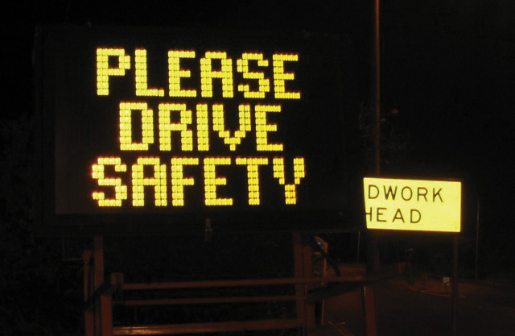
Commonly confused words appear in many locations, not just at work or at school. Be on the lookout for misused words wherever you find yourself throughout the day. Make a mental note of the error and remember its correction for your own pieces of writing.

Writing at Work
All employers value effective communication. From an application to an interview to the first month on the job, employers pay attention to your vocabulary. You do not need a large vocabulary to succeed, but you do need to be able to express yourself clearly and avoid commonly misused words.
When giving an important presentation on the effect of inflation on profit margins, you must know the difference between effect and affect and choose the correct word. When writing an e-mail to confirm deliveries, you must know if the shipment will arrive in to days, too days, or two days. Confusion may arise if you choose the wrong word.
Consistently using the proper words will improve your communication and make a positive impression on your boss and colleagues.

Exercise 2
The following paragraph contains eleven errors. Find each misused word and correct it by adding the proper word.
The original United States Declaration of Independence sets in a case at the Rotunda for the Charters of Freedom as part of the National Archives in Washington, DC. Since 1952, over one million visitors each year of passed through the Rotunda too snap a photograph to capture they’re experience. Although signs state, “No Flash Photography,” forgetful tourists leave the flash on, an a bright light flickers for just a millisecond. This millisecond of light may not seem like enough to effect the precious document, but supposed how much light could be generated when all those milliseconds are added up. According to the National Archives administrators, its enough to significantly damage the historic document. So, now, the signs display quit a different message: “No Photography.” Visitors continue to travel to see the Declaration that began are country, but know longer can personal pictures serve as mementos. The administrators’ compromise, they say, is a visit to the gift shop for a preprinted photograph.
Collaboration
Please share with a classmate and compare your answers.

Key Takeaways
- In order to write accurately, it is important for writers to be aware of commonly confused words.
- Although commonly confused words may look alike or sound alike, their meanings are very different.
- Consulting the dictionary is one way to make sure you are using the correct word in your writing. You may also keep a list of commonly confused words nearby when you write or study the chart in this book.
- Choosing the proper words leaves a positive impression on your readers.

Writing Application
Review the latest assignment you completed for school or for work. Does it contain any commonly confused words? Circle each example and use the circled words to begin your own checklist of commonly confused words. Continue to add to your checklist each time you complete an assignment and find a misused word.

3.2 Spelling

Learning Objectives
- Identify common spelling rules.
- Identify commonly misused homonyms.
- Identify commonly misspelled words.
One essential aspect of good writing is accurate spelling. With computer spell checkers, spelling may seem simple, but these programs fail to catch every error. Spell checkers identify some errors, but writers still have to consider the flagged words and suggested replacements. Writers are still responsible for the errors that remain.
For example, if the spell checker highlights a word that is misspelled and gives you a list of alternative words, you may choose a word that you never intended even though it is spelled correctly. This can change the meaning of your sentence. It can also confuse readers, making them lose interest. Computer spell checkers are useful editing tools, but they can never replace human knowledge of spelling rules, homonyms, and commonly misspelled words.

Common Spelling Rules
The best way to master new words is to understand the key spelling rules. Keep in mind, however, that some spelling rules carry exceptions. A spell checker may catch these exceptions, but knowing them yourself will prepare you to spell accurately on the first try. You may want to try memorizing each rule and its exception like you would memorize a rhyme or lyrics to a song.
Write i before e except after c, or when pronounced ay like “neighbor” or “weigh.”
- achieve, niece, alien
- receive, deceive
When words end in a consonant plus y, drop the y and add an i before adding another ending.
- happy + er = happier
- cry + ed = cried
When words end in a vowel plus y, keep the y and add the ending.
- delay + ed = delayed
Memorize the following exceptions to this rule: day, lay, say, pay = daily, laid, said, paid

When adding an ending that begins with a vowel, such as -able, -ence, -ing, or -ity, drop the last e in a word.
- write + ing = writing
- pure + ity = purity
When adding an ending that begins with a consonant, such as -less, -ment, or -ly, keep the last e in a word.
- hope + less = hopeless
- advertise + ment = advertisement
For many words ending in a consonant and an o, add -s when using the plural form.
- photo + s = photos
- soprano + s = sopranos
Add -es to words that end in s, ch, sh, and x.
- church + es = churches
- fax + es = faxes

Exercise 1
Identify and correct the nine misspelled words in the following paragraph.
Sherman J. Alexie Jr. was born in October 1966. He is a Spokane/Coeur d’Alene Indian and an American writer, poet, and filmmaker. Alexie was born with hydrocephalus, or water on the brain. This condition led doctors to predict that he would likly suffer long-term brain damage and possibly mental retardation. Although Alexie survived with no mental disabilitys, he did suffer other serious side effects from his condition that plagud him throughout his childhood. Amazingly, Alexie learned to read by the age of three, and by age five he had read novels such as John Steinbeck’s The Grapes of Wrath. Raised on an Indian reservation, Alexie often felt aleinated from his peers due to his avid love for reading and also from the long-term effects of his illness, which often kept him from socializeing with his peers on the reservation. The reading skills he displaid at such a young age foreshadowed what he would later become. Today Alexie is a prolific and successful writer with several story anthologeis to his credit, noteably The Lone Ranger and Tonto Fistfight in Heaven and The Toughest Indian in the World. Most of his fiction is about contemporary Native Americans who are influenced by pop culture and pow wows and everything in between. His work is sometimes funny but always thoughtful and full of richness and depth. Alexie also writes poetry, novels, and screenplays. His latest collection of storys is called War Dances, which came out in 2009.
Collaboration
Please share with a classmate and compare your answers.

Tip
Eight Tips to Improve Spelling Skills
- Read the words in your assignment carefully, and avoid skimming over the page. Focusing on your written assignment word by word will help you pay close attention to each word’s spelling. Skimming quickly, you may overlook misspelled words.
- Use mnemonic devices to remember the correct spelling of words. Mnemonic devices, or memory techniques and learning aids, include inventive sayings or practices that help you remember. For example, the saying “It is important to be a beautiful person inside and out” may help you remember that beautiful begins with “be a.” The practice of pronouncing the word Wednesday Wed-nes-day may help you remember how to spell the word correctly.
- Use a dictionary. Many professional writers rely on the dictionary—either in print or online. If you find it difficult to use a regular dictionary, ask your instructor to help you find a “poor speller’s dictionary.”
- Use your computer’s spell checker. The spell checker will not solve all your spelling problems, but it is a useful tool. See the introduction to this section for cautions about spell checkers.
- Keep a list of frequently misspelled words. You will often misspell the same words again and again, but do not let this discourage you. All writers struggle with the spellings of certain words; they become aware of their spelling weaknesses and work to improve. Be aware of which words you commonly misspell, and you can add them to a list to learn to spell them correctly.
- Look over corrected papers for misspelled words. Add these words to your list and practice writing each word four to five times each. Writing teachers will especially notice which words you frequently misspell, and it will help you excel in your classes if they see your spelling improve.
- Test yourself with flashcards. Sometimes the old-fashioned methods are best, and for spelling, this tried and true technique has worked for many students. You can work with a peer or alone.
- Review the common spelling rules explained in this chapter. Take the necessary time to master the material; you may return to the rules in this chapter again and again, as needed.

Tip
Remember to focus on spelling during the editing and revising step of the writing process. Start with the big ideas such as organizing your piece of writing and developing effective paragraphs, and then work your way down toward the smaller—but equally important—details like spelling and punctuation. To read more about the writing process and editing and revising, see Chapter 7 "The Writing Process: How Do I Begin?".

Homonyms
Homonyms are words that sound like one another but have different meanings.

Commonly Misused Homonyms
Principle, Principal
- Principle (noun). A fundamental concept that is accepted as true.
The principle of human equality is an important foundation for all nations.
- Principal (noun). The original amount of debt on which interest is calculated.
The payment plan allows me to pay back only the principal amount, not any compounded interest.
- Principal (noun). A person who is the main authority of a school.
The principal held a conference for both parents and teachers.
Where, Wear, Ware
- Where (adverb). The place in which something happens.
Where is the restaurant?
- Wear (verb). To carry or have on the body.
I will wear my hiking shoes when go on a climb tomorrow morning.
- Ware (noun). Articles of merchandise or manufacture (usually, wares).
When I return from shopping, I will show you my wares.
Lead, Led
- Lead (noun). A type of metal used in pipes and batteries.
The lead pipes in my homes are old and need to be replaced.
- Led (verb). The past tense of the verb lead.
After the garden, she led the patrons through the museum.

Which, Witch
- Which (pronoun). Replaces one out of a group.
Which apartment is yours?
- Witch (noun). A person who practices sorcery or who has supernatural powers.
She thinks she is a witch, but she does not seem to have any powers.
Peace, Piece
- Peace (noun). A state of tranquility or quiet.
For once, there was peace between the argumentative brothers.
- Piece (noun). A part of a whole.
I would like a large piece of cake, thank you.
Passed, Past
- Passed (verb). To go away or move.
He passed the slower cars on the road using the left lane.
- Past (noun). Having existed or taken place in a period before the present.
The argument happened in the past, so there is no use in dwelling on it.
Lessen, Lesson
- Lessen (verb). To reduce in number, size, or degree.
My dentist gave me medicine to lessen the pain of my aching tooth.
- Lesson (noun). A reading or exercise to be studied by a student.
Today’s lesson was about mortgage interest rates.

Patience, Patients
- Patience (noun). The capacity of being patient (waiting for a period of time or enduring pains and trials calmly).
The novice teacher’s patience with the unruly class was astounding.
- Patients (plural noun). Individuals under medical care.
The patients were tired of eating the hospital food, and they could not wait for a home-cooked meal.
Sees, Seas, Seize
- Sees (verb). To perceive with the eye.
He sees a whale through his binoculars.
- Seas (plural noun). The plural of sea, a great body of salt water.
The tidal fluctuation of the oceans and seas are influenced by the moon.
- Seize (verb). To possess or take by force.
The king plans to seize all the peasants’ land.
Threw, Through
- Threw (verb). The past tense of throw.
She threw the football with perfect form.
- Through (preposition). A word that indicates movement.
She walked through the door and out of his life.

Exercise 2
Complete the following sentences by selecting the correct homonym.
- Do you agree with the underlying ________(principle, principal) that ensures copyrights are protected in the digital age?
- I like to ________(where, wear, ware) unique clothing from thrift stores that do not have company logos on them.
- Marjorie felt like she was being ________(led, lead) on a wild goose chase, and she did not like it one bit.
- Serina described ________(witch, which) house was hers, but now that I am here, they all look the same.
- Seeing his friend without a lunch, Miguel gave her a ________(peace, piece) of his apple.
- Do you think that it is healthy for mother to talk about the ________(passed, past) all the time?
- Eating healthier foods will ________(lessen, lesson) the risk of heart disease.
- I know it sounds cliché, but my father had the ________(patients, patience) of a saint.
- Daniela ________(sees, seas, seize) possibilities in the bleakest situations, and that it is why she is successful.
- Everyone goes ________(through, threw) hardships in life regardless of who they are.

Commonly Misspelled Words
Below is a list of commonly misspelled words. You probably use these words every day in either speaking or writing. Each word has a segment in bold type, which indicates the problem area of the word that is often spelled incorrectly. If you can, use this list as a guide before, during, and after you write.

Tip
Use the following two tricks to help you master these troublesome words:
- Copy each word a few times and underline the problem area.
- Copy the words onto flash cards and have a friend test you.

Table 3.1 Commonly Misspelled Words
across | disappoint | integration | particular | separate
address | disapprove | intelligent | perform | similar
answer | doesn’t | interest | perhaps | since
argument | eighth | interfere | personnel | speech
athlete | embarrass | jewelry | possess | strength
beginning | environment | judgment | possible | success
behavior | exaggerate | knowledge | prefer | surprise
calendar | familiar | maintain | prejudice | taught
career | finally | mathematics | privilege | temperature
conscience | government | meant | probably | thorough
crowded | grammar | necessary | psychology | thought
definite | height | nervous | pursue | tired
describe | illegal | occasion | reference | until
desperate | immediately | opinion | rhythm | weight
different | important | optimist | ridiculous | written

Exercise 3
Identify and correct the ten commonly misspelled words in the following paragraph.
Brooklyn is one of the five boroughs that make up New York City. It is located on the eastern shore of Long Island directly accross the East River from the island of Manhattan. Its beginings stretch back to the sixteenth century when it was founded by the Dutch who originally called it “Breuckelen.” Immedietely after the Dutch settled Brooklyn, it came under British rule. However, neither the Dutch nor the British were Brooklyn’s first inhabitants. When European settlers first arrived, Brooklyn was largely inhabited by the Lenapi, a collective name for several organized bands of Native American people who settled a large area of land that extended from upstate New York through the entire state of New Jersey. They are sometimes referred to as the Delaware Indians. Over time, the Lenapi succumbed to European diseases or conflicts between European settlers or other Native American enemies. Finalley they were pushed out of Brooklyn completely by the British.
In 1776, Brooklyn was the site of the first importent battle of the American Revolution known as the Battle of Brooklyn. The colonists lost this battle, which was led by George Washington, but over the next two years they would win the war, kicking the British out of the colonies once and for all.
By the end of the nineteenth century, Brooklyn grew to be a city in its own right. The completion of the Brooklyn Bridge was an ocasion for celebration; transportation and commerce between Brooklyn and Manhattan now became much easier. Eventually, in 1898, Brooklyn lost its seperate identity as an independent city and became one of five boroughs of New York City. However, in some people’s opinien, the intagration into New York City should have never happened; they though Brooklyn should have remained an independent city.
Collaboration
Please share with a classmate and compare your answers.

Writing at Work
In today’s job market, writing e-mails has become a means by which many people find employment. E-mails to prospective employers require thoughtful word choice, accurate spelling, and perfect punctuation. Employers’ inboxes are inundated with countless e-mails daily. If even the subject line of an e-mail contains a spelling error, it will likely be overlooked and someone else’s e-mail will take priority.
The best thing to do after you proofread an e-mail to an employer and run the spell checker is to have an additional set of eyes go over it with you; one of your teachers may be able to read the e-mail and give you suggestions for improvement. Most colleges and universities have writing centers, which may also be able to assist you.

Key Takeaways
- Accurate, error-free spelling enhances your credibility with the reader.
- Mastering the rules of spelling may help you become a better speller.
- Knowing the commonly misused homonyms may prevent spelling errors.
- Studying the list of commonly misspelled words in this chapter, or studying a list of your own, is one way to improve your spelling skills.

Writing Application
What is your definition of a successful person? Is it based on a person’s profession or is it based on his or her character? Perhaps success means a combination of both. In one paragraph, describe in detail what you think makes a person successful. When you are finished, proofread your work for spelling errors. Exchange papers with a partner and read each other’s work. See if you catch any spelling errors that your partner missed.

3.3 Word Choice

Learning Objectives
- Identify the reasons why using a dictionary and thesaurus is important when writing.
- Identify how to use proper connotations.
- Identify how to avoid using slang, clichés, and overly general words in your writing.
Effective writing involves making conscious choices with words. When you prepare to sit down to write your first draft, you likely have already completed some freewriting exercises, chosen your topic, developed your thesis statement, written an outline, and even selected your sources. When it is time to write your first draft, start to consider which words to use to best convey your ideas to the reader.
Some writers are picky about word choice as they start drafting. They may practice some specific strategies, such as using a dictionary and thesaurus, using words and phrases with proper connotations, and avoiding slang, clichés, and overly general words.
Once you understand these tricks of the trade, you can move ahead confidently in writing your assignment. Remember, the skill and accuracy of your word choice is a major factor in developing your writing style. Precise selection of your words will help you be more clearly understood—in both writing and speaking.

Using a Dictionary and Thesaurus
Even professional writers need help with the meanings, spellings, pronunciations, and uses of particular words. In fact, they rely on dictionaries to help them write better. No one knows every word in the English language and their multiple uses and meanings, so all writers, from novices to professionals, can benefit from the use of dictionaries.
Most dictionaries provide the following information:
- Spelling. How the word and its different forms are spelled.
- Pronunciation. How to say the word.
- Part of speech. The function of the word.
- Definition. The meaning of the word.
- Synonyms. Words that have similar meanings.
- Etymology. The history of the word.
Look at the following sample dictionary entry and see which of the preceeding information you can identify:
myth, mith, n. [Gr. mythos, a word, a fable, a legend.] A fable or legend embodying the convictions of a people as to their gods or other divine beings, their own beginnings and early history and the heroes connected with it, or the origin of the world; any invented story; something or someone having no existence in fact.—myth • ic, myth • i • cal
Like a dictionary, a thesaurus is another indispensable writing tool. A thesaurus gives you a list of synonyms, words that have the same (or very close to the same) meaning as another word. It also lists antonyms, words with the opposite meaning of the word. A thesaurus will help you when you are looking for the perfect word with just the right meaning to convey your ideas. It will also help you learn more words and use the ones you already know more correctly.
precociousadj, She’s such a precocious little girl!: uncommonly smart, mature, advanced, smart, bright, brilliant, gifted, quick, clever, apt.
Ant. slow, backward, stupid.

Using Proper Connotations
A denotation is the dictionary definition of a word. A connotation, on the other hand, is the emotional or cultural meaning attached to a word. The connotation of a word can be positive, negative, or neutral. Keep in mind the connotative meaning when choosing a word.
Scrawny
- Denotation: Exceptionally thin and slight or meager in body or size.
- Word used in a sentence: Although he was a premature baby and a scrawny child, Martin has developed into a strong man.
- Connotation: (Negative) In this sentence the word scrawny may have a negative connotation in the readers’ minds. They might find it to mean a weakness or a personal flaw; however, the word fits into the sentence appropriately.
Skinny
- Denotation: Lacking sufficient flesh, very thin.
- Word used in a sentence: Skinny jeans have become very fashionable in the past couple of years.
- Connotation: (Positive) Based on cultural and personal impressions of what it means to be skinny, the reader may have positive connotations of the word skinny.
Lean
- Denotation: Lacking or deficient in flesh; containing little or no fat.
- Word used in a sentence: My brother has a lean figure, whereas I have a more muscular build.
- Connotation: (Neutral) In this sentence, lean has a neutral connotation. It does not call to mind an overly skinny person like the word scrawny, nor does imply the positive cultural impressions of the word skinny. It is merely a neutral descriptive word.
Notice that all the words have a very similar denotation; however, the connotations of each word differ.

Exercise 1
In each of the following items, you will find words with similar denotations. Identify the words’ connotations as positive, negative, or neutral by writing the word in the appropriate box. Copy the chart onto your own piece of paper.
- curious, nosy, interested
- lazy, relaxed, slow
- courageous, foolhardy, assured
- new, newfangled, modern
- mansion, shack, residence
- spinster, unmarried woman, career woman
- giggle, laugh, cackle
- boring, routine, prosaic
- noted, notorious, famous
- assertive, confident, pushy
Positive | Negative | Neutral

Avoiding Slang
Slang describes informal words that are considered nonstandard English. Slang often changes with passing fads and may be used by or familiar to only a specific group of people. Most people use slang when they speak and in personal correspondences, such as e-mails, text messages, and instant messages. Slang is appropriate between friends in an informal context but should be avoided in formal academic writing.

Writing at Work
Frequent exposure to media and popular culture has desensitized many of us to slang. In certain situations, using slang at work may not be problematic, but keep in mind that words can have a powerful effect. Slang in professional e-mails or during meetings may convey the wrong message or even mistakenly offend someone.

Exercise 2
Edit the following paragraph by replacing the slang words and phrases with more formal language. Rewrite the paragraph on your own sheet of paper.
I felt like such an airhead when I got up to give my speech. As I walked toward the podium, I banged my knee on a chair. Man, I felt like such a klutz. On top of that, I kept saying “like” and “um,” and I could not stop fidgeting. I was so stressed out about being up there. I feel like I’ve been practicing this speech 24/7, and I still bombed. It was ten minutes of me going off about how we sometimes have to do things we don’t enjoy doing. Wow, did I ever prove my point. My speech was so bad I’m surprised that people didn’t boo. My teacher said not to sweat it, though. Everyone gets nervous his or her first time speaking in public, and she said, with time, I would become a whiz at this speech giving stuff. I wonder if I have the guts to do it again.
Collaboration
Please share with a classmate and compare your answers.

Avoiding Clichés
Clichés are descriptive expressions that have lost their effectiveness because they are overused. Writing that uses clichés often suffers from a lack of originality and insight. Avoiding clichés in formal writing will help you write in original and fresh ways.
- Clichéd: Whenever my brother and I get into an argument, he always says something that makes my blood boil.
- Plain: Whenever my brother and I get into an argument, he always says something that makes me really angry.
- Original: Whenever my brother and I get into an argument, he always says something that makes me want to go to the gym and punch the bag for a few hours.

Tip
Think about all the cliché phrases that you hear in popular music or in everyday conversation. What would happen if these clichés were transformed into something unique?

Exercise 3
On your own sheet of paper, revise the following sentences by replacing the clichés with fresh, original descriptions.
- She is writing a memoir in which she will air her family’s dirty laundry.
- Fran had an ax to grind with Benny, and she planned to confront him that night at the party.
- Mr. Muller was at his wit’s end with the rowdy class of seventh graders.
- The bottom line is that Greg was fired because he missed too many days of work.
- Sometimes it is hard to make ends meet with just one paycheck.
- My brain is fried from pulling an all-nighter.
- Maria left the dishes in the sink all week to give Jeff a taste of his own medicine.
- While they were at the carnival Janice exclaimed, “Time sure does fly when you are having fun!”
- Jeremy became tongue-tied after the interviewer asked him where he saw himself in five years.
- Jordan was dressed to the nines that night.

Avoiding Overly General Words
Specific words and images make your writing more interesting to read. Whenever possible, avoid overly general words in your writing; instead, try to replace general language with particular nouns, verbs, and modifiers that convey details and that bring yours words to life. Add words that provide color, texture, sound, and even smell to your writing.
- General: My new puppy is cute.
- Specific: My new puppy is a ball of white fuzz with the biggest black eyes I have ever seen.
- General: My teacher told us that plagiarism is bad.
- Specific: My teacher, Ms. Atwater, created a presentation detailing exactly how plagiarism is illegal and unethical.

Exercise 4
Revise the following sentences by replacing the overly general words with more precise and attractive language. Write the new sentences on your own sheet of paper.
- Reilly got into her car and drove off.
- I would like to travel to outer space because it would be amazing.
- Jane came home after a bad day at the office.
- I thought Milo’s essay was fascinating.
- The dog walked up the street.
- The coal miners were tired after a long day.
- The tropical fish are pretty.
- I sweat a lot after running.
- The goalie blocked the shot.
- I enjoyed my Mexican meal.

Key Takeaways
- Using a dictionary and thesaurus as you write will improve your writing by improving your word choice.
- Connotations of words may be positive, neutral, or negative.
- Slang, clichés, and overly general words should be avoided in academic writing.

Writing Application
Review a piece of writing that you have completed for school. Circle any sentences with slang, clichés, or overly general words and rewrite them using stronger language.

3.4 Prefixes and Suffixes

Learning Objectives
- Identify the meanings of common prefixes.
- Become familiar with common suffix rules.
The English language contains an enormous and ever-growing number of words. Enhancing your vocabulary by learning new words can seem overwhelming, but if you know the common prefixes and suffixes of English, you will understand many more words.
Mastering common prefixes and suffixes is like learning a code. Once you crack the code, you can not only spell words more correctly but also recognize and perhaps even define unfamiliar words.

Prefixes
A prefix is a word part added to the beginning of a word to create a new meaning. Study the common prefixes in Table 3.2 "Common Prefixes".

Tip
The main rule to remember when adding a prefix to a word is not to add letters or leave out any letters. See Table 3.2 "Common Prefixes" for examples of this rule.
Table 3.2 Common Prefixes
Prefix | Meaning | Example
dis | not, opposite of | dis + satisfied = dissatisfied
mis | wrongly | mis + spell = misspell
un | not | un + acceptable = unacceptable
re | again | re + election = reelection
inter | between | inter + related = interrelated
pre | before | pre + pay = prepay
non | not | non + sense = nonsense
super | above | super + script = superscript
sub | under | sub + merge = submerge
anti | against, opposing | anti + bacterial = antibacterial

Exercise 1
Identify the five words with prefixes in the following paragraph, and write their meanings on a separate sheet of paper.
At first, I thought one of my fuzzy, orange socks disappeared in the dryer, but I could not find it in there. Because it was my favorite pair, nothing was going to prevent me from finding that sock. I looked all around my bedroom, under the bed, on top of the bed, and in my closet, but I still could not find it. I did not know that I would discover the answer just as I gave up my search. As I sat down on the couch in the family room, my Dad was reclining on his chair. I laughed when I saw that one of his feet was orange and the other blue! I forgot that he was color-blind. Next time he does laundry I will have to supervise him while he folds the socks so that he does not accidentally take one of mine!
Collaboration
Please share with a classmate and compare your answers.

Exercise 2
Add the correct prefix to the word to complete each sentence. Write the word on your own sheet of paper.
- I wanted to ease my stomach ________comfort, so I drank some ginger root tea.
- Lenny looked funny in his ________matched shirt and pants.
- Penelope felt ________glamorous at the party because she was the only one not wearing a dress.
- My mother said those ________aging creams do not work, so I should not waste my money on them.
- The child’s ________standard performance on the test alarmed his parents.
- When my sister first saw the meteor, she thought it was a ________natural phenomenon.
- Even though she got an excellent job offer, Cherie did not want to ________locate to a different country.
- With a small class size, the students get to ________act with the teacher more frequently.
- I slipped on the ice because I did not heed the ________cautions about watching my step.
- A ________combatant is another word for civilian.

Suffixes
A suffix is a word part added to the end of a word to create a new meaning. Study the suffix rules in the following boxes.
Rule 1
When adding the suffixes -ness and -ly to a word, the spelling of the word does not change.
Examples:
- dark + ness = darkness
- scholar + ly = scholarly
Exceptions to Rule 1
When the word ends in y, change the y to i before adding -ness and -ly.
Examples:
- ready + ly = readily
- happy + ness = happiness
Rule 2
When the suffix begins with a vowel, drop the silent e in the root word.
Examples:
- care + ing = caring
- use + able = usable
Exceptions to Rule 2
When the word ends in ce or ge, keep the silent e if the suffix begins with a or o.
Examples:
- replace + able = replaceable
- courage + ous = courageous
Rule 3
When the suffix begins with a consonant, keep the silent e in the original word.
Examples:
- care + ful = careful
- care + less = careless
Exceptions to Rule 3
Examples:
- true + ly = truly
- argue + ment = argument
Rule 4
When the word ends in a consonant plus y, change the y to i before any suffix not beginning with i.
Examples:
- sunny + er = sunnier
- hurry + ing = hurrying
Rule 5
When the suffix begins with a vowel, double the final consonant only if (1) the word has only one syllable or is accented on the last syllable and (2) the word ends in a single vowel followed by a single consonant.
Examples:
- tan + ing = tanning (one syllable word)
- regret + ing = regretting (The accent is on the last syllable; the word ends in a single vowel followed by a single consonant.)
- cancel + ed = canceled (The accent is not on the last syllable.)
- prefer + ed = preferred

Exercise 3
On your own sheet of paper, write correctly the forms of the words with their suffixes.
- refer + ed
- refer + ence
- mope + ing
- approve + al
- green + ness
- benefit + ed
- resubmit + ing
- use + age
- greedy + ly
- excite + ment

Key Takeaways
- A prefix is a word part added to the beginning of a word that changes the word’s meaning.
- A suffix is a word part added to the end of a word that changes the word’s meaning.
- Learning the meanings of prefixes and suffixes will help expand your vocabulary, which will help improve your writing.

Writing Application
Write a paragraph describing one of your life goals. Include five words with prefixes and five words with suffixes. Exchange papers with a classmate and circle the prefixes and suffixes in your classmate’s paper. Correct each prefix or suffix that is spelled incorrectly.

3.5 Synonyms and Antonyms

Learning Objectives
- Recognize how synonyms improve writing.
- Identify common antonyms to increase your vocabulary.
As you work with your draft, you will want to pay particular attention to the words you have chosen. Do they express exactly what you are trying to convey? Can you choose better, more effective words? Familiarity with synonyms and antonyms can be helpful in answering these questions.

Synonyms
Synonyms are words that have the same, or almost the same, meaning as another word. You can say an “easy task” or a “simple task” because easy and simple are synonyms. You can say Hong Kong is a “large city” or a “metropolis” because city and metropolis are synonyms.
However, it is important to remember that not all pairs of words in the English language are so easily interchangeable. The slight but important differences in meaning between synonyms can make a big difference in your writing. For example, the words boring and insipid may have similar meanings, but the subtle differences between the two will affect the message your writing conveys. The word insipid evokes a scholarly and perhaps more pretentious message than boring.
The English language is full of pairs of words that have subtle distinctions between them. All writers, professionals and beginners alike, face the challenge of choosing the most appropriate synonym to best convey their ideas. When you pay particular attention to synonyms in your writing, it comes across to your reader. The sentences become much more clear and rich in meaning.

Writing at Work
Any writing you do at work involves a careful choice of words. For example, if you are writing an e-mail to your employer regarding your earnings, you can use the word pay, salary, or hourly wage. There are also other synonyms to choose from. Just keep in mind that the word you choose will have an effect on the reader, so you want to choose wisely to get the desired effect.

Exercise 1
Replace the underlined words in the paragraph with appropriate synonyms. Write the new paragraph on your own sheet of paper.
When most people think of the Renaissance, they might think of artists like Michelangelo, Raphael, or Leonardo da Vinci, but they often overlook one of the very important figures of the Renaissance: Filippo Brunelleschi. Brunelleschi was born in Florence, Italy in 1377. He is considered the very best architect and engineer of the Renaissance. His impressive accomplishments are a testament to following one’s dreams, persevering in the face of obstacles, and realizing one’s vision.
The most difficult undertaking of Brunelleschi’s career was the dome of Florence Cathedral, which took sixteen years to construct. A major blow to the progress of the construction happened in 1428. Brunelleschi had designed a special ship to carry the one hundred tons of marble needed for the dome. He felt this would be the most inexpensive way to transport the marble, but the unthinkable happened. The ship went down to the bottom of the water, taking all the marble with it to the bottom of the river. Brunelleschi was really sad. Nevertheless, he did not give up. He held true to his vision of the completed dome. Filippo Brunelleschi completed construction of the dome of Florence Cathedral in 1446. His influence on artists and architects alike was felt strongly during his lifetime and can still be felt in this day and age.
Collaboration
Please share with a classmate and compare your answers.

Exercise 2
On your own sheet of paper, write a sentence with each of the following words that illustrates the specific meaning of each synonym.
- leave, abandon
- mad, insane
- outside, exterior
- poor, destitute
- quiet, peaceful
- riot, revolt
- rude, impolite
- talk, conversation
- hug, embrace
- home, residence
Collaboration
Please share with a classmate and compare your answers.

Antonyms
Antonyms are words that have the opposite meaning of a given word. The study of antonyms will not only help you choose the most appropriate word as you write; it will also sharpen your overall sense of language. lists common words and their antonyms.

Table 3.3 Common Antonyms
Word | Antonym | Word | Antonym
absence | presence | frequent | seldom
accept | refuse | harmful | harmless
accurate | inaccurate | horizontal | vertical
advantage | disadvantage | imitation | genuine
ancient | modern | inhabited | uninhabited
abundant | scarce | inferior | superior
artificial | natural | intentional | accidental
attractive | repulsive | justice | injustice
borrow | lend | knowledge | ignorance
bravery | cowardice | landlord | tenant
create | destroy, demolish | likely | unlikely
bold | timid, meek | minority | majority
capable | incapable | miser | spendthrift
combine | separate | obedient | disobedient
conceal | reveal | optimist | pessimist
common | rare | permanent | temporary
decrease | increase | plentiful | scarce
definite | indefinite | private | public
despair | hope | prudent | imprudent
discourage | encourage | qualified | unqualified
employer | employee | satisfactory | unsatisfactory
expand | contract | tame | wild
forget | remember | vacant | occupied

Tip
Learning antonyms is an effective way to increase your vocabulary. Memorizing words in combination with or in relation to other words often helps us retain them.

Exercise 3
Correct the following sentences by replacing the underlined words with an antonym. Write the antonym on your own sheet of paper.
- The pilot who landed the plane was a coward because no one was injured.
- Even though the botany lecture was two hours long, Gerard found it incredibly dull.
- My mother says it is impolite to say thank you like you really mean it.
- Although I have learned a lot of information through textbooks, it is life experience that has given me ignorance.
- When our instructor said the final paper was compulsory, it was music to my ears!
- My only virtues are coffee, video games, and really loud music.
- Elvin was so bold when he walked in the classroom that he sat in the back row and did not participate.
- Maria thinks elephants who live in freedom have a sad look in their eyes.
- The teacher filled her students’ minds with gloomy thoughts about their futures.
- The guest attended to every one of our needs.

Key Takeaways
- Synonyms are words that have the same, or almost the same, meaning as another word.
- Antonyms are words that have the opposite meaning of another word.
- Choosing the right synonym refines your writing.
- Learning common antonyms sharpens your sense of language and expands your vocabulary.

Writing Application
Write a paragraph that describes your favorite dish or food. Use as many synonyms as you can in the description, even if it seems too many. Be creative. Consult a thesaurus, and take this opportunity to use words you have never used before. Be prepared to share your paragraph.

3.6 Using Context Clues

Learning Objectives
- Identify the different types of context clues.
- Practice using context clues while reading.
Context clues are bits of information within a text that will assist you in deciphering the meaning of unknown words. Since most of your knowledge of vocabulary comes from reading, it is important that you recognize context clues. By becoming more aware of particular words and phrases surrounding a difficult word, you can make logical guesses about its meaning. The following are the different types of context clues:
- Brief definition or restatement
- Synonyms and antonyms
- Examples

Brief Definition or Restatement
Sometimes a text directly states the definition or a restatement of the unknown word. The brief definition or restatement is signaled by a word or a punctuation mark. Consider the following example:
If you visit Alaska, you will likely see many glaciers, or slow moving masses of ice.
In this sentence, the word glaciers is defined by the phrase that follows the signal word or, which is slow moving masses of ice.
In other instances, the text may restate the meaning of the word in a different way, by using punctuation as a signal. Look at the following example:
Marina was indignant—fuming mad—when she discovered her brother had left for the party without her.
Although fuming mad is not a formal definition of the word indignant, it does serve to define it. These two examples use signals—the word or and the punctuation dashes—to indicate the meaning of the unfamiliar word. Other signals to look for are the words is, as, means, known as, and refers to.

Synonyms and Antonyms
Sometimes a text gives a synonym of the unknown word to signal the meaning of the unfamiliar word:
When you interpret an image, you actively question and examine what the image connotes and suggests.
In this sentence the word suggests is a synonym of the word connotes. The word and sometimes signals synonyms.
Likewise, the word but may signal a contrast, which can help you define a word by its antonym.
I abhor clothes shopping, but I adore grocery shopping.
The word abhor is contrasted with its opposite: adore. From this context, the reader can guess that abhor means to dislike greatly.

Examples
Sometimes a text will give you an example of the word that sheds light on its meaning:
I knew Mark’s ailurophobia was in full force because he began trembling and stuttering when he saw my cat, Ludwig, slink out from under the bed.
Although ailurophobia is an unknown word, the sentence gives an example of its effects. Based on this example, a reader could confidently surmise that the word means a fear of cats.

Tip
Look for signal words like such as, for instance, and for example. These words signal that a word’s meaning may be revealed through an example.

Exercise 1
Identify the context clue that helps define the underlined words in each of the following sentences. Write the context clue on your own sheet of paper.
- Lucinda is very adroit on the balance beam, but Constance is rather clumsy.
- I saw the entomologist, a scientist who studies insects, cradle the giant dung beetle in her palm.
- Lance’s comments about politics were irrelevant and meaningless to the botanist’s lecture on plant reproduction.
- Before I left for my trip to the Czech Republic, I listened to my mother’s sage advice and made a copy of my passport.
- His rancor, or hatred, for socializing resulted in a life of loneliness and boredom.
- Martin was mortified, way beyond embarrassment, when his friends teamed up to shove him into the pool.
- The petulant four-year-old had a baby sister who was, on the contrary, not grouchy at all.
- The philosophy teacher presented the students with several conundrums, or riddles, to solve.
- Most Americans are omnivores, people that eat both plants and animals.
- Elena is effervescent, as excited as a cheerleader, for example, when she meets someone for the first time.

Exercise 2
On your own sheet of paper, write the name of the context clue that helps to define the underlined words.
Maggie was a precocious child to say the least. She produced brilliant watercolor paintings by the age of three. At first, her parents were flabbergasted—utterly blown away—by their daughter’s ability, but soon they got used to their little painter. Her preschool teacher said that Maggie’s dexterity, or ease with which she used her hands, was something she had never before seen in such a young child. Little Maggie never gloated or took pride in her paintings; she just smiled contentedly when she finished one and requested her parents give it to someone as a gift. Whenever people met Maggie for the first time they often watched her paint with their mouths agape, but her parents always kept their mouths closed and simply smiled over their “little Monet.”
Collaboration
Please share with a classmate and compare your answers.

Tip
In addition to context clues to help you figure out the meaning of a word, examine the following word parts: prefixes, roots, and suffixes.

Writing at Work
Jargon a type of shorthand communication often used in the workplace. It is the technical language of a special field. Imagine it is your first time working as a server in a restaurant and your manager tells you he is going to “eighty-six” the roasted chicken. If you do not realize that “eighty-six” means to remove an item from the menu, you could be confused.
When you first start a job, no matter where it may be, you will encounter jargon that will likely be foreign to you. Perhaps after working the job for a short time, you too will feel comfortable enough to use it. When you are first hired, however, jargon can be baffling and make you feel like an outsider. If you cannot decipher the jargon based on the context, it is always a good policy to ask.

Key Takeaways
- Context clues are words or phrases within a text that help clarify vocabulary that is unknown to you.
- There are several types of context clues including brief definition and restatement, synonyms and antonyms, and example.

Writing Application
Write a paragraph describing your first job. In the paragraph, use five words previously unknown to you. These words could be jargon words or you may consult a dictionary or thesaurus to find a new word. Make sure to provide a specific context clue for understanding each word. Exchange papers with a classmate and try to decipher the meaning of the words in each other’s paragraphs based on the context clues.

3.7 Working with Words: End-of-Chapter Exercises

Learning Objectives
- Use the skills you have learned in the chapter.
- Work collaboratively with other students.

Exercises
- Proofread the paragraph and correct any commonly confused words and misspelled words.
Grunge, or the Seattle sound, is a type of rock music that became quiet popular in the late 1980s and early 1990s. It began in Seattle, Washington. Grunge musicians rejected the dramatic an expensive stage productions that were trendy at the time. There music was striped down with an emphasis on distorted electric guitars. Grunge musicians did not ware makeup or sport extravagent hairstyles like many of the day’s rock musicians and bands. Many grunge musicians would by they’re clothes from secondhand stores. The lyrics too grunge songs were also quit different compared two what was populer at the time. Grunge lyrics are charecterized by dark or socially conscience themes. Grunge music is still admired today buy music lovers of all ages.
- Complete the following sentences by filling in the blank line with the correct homonym or frequently misspelled word.
  - Kevin asked me a serious question and ________(then, than) interrupted me when I attempted to answer.
  - A hot compress will ________(lessen, lesson) the pain of muscle cramps.
  - Jason was not a graceful ________(looser, loser) because he knocked his chair over and stormed off the basketball court.
  - Please consider the ________(effects, affects) of not getting enough green vegetables in your diet.
  - ________(Except, Accept) for Ajay, we all had our tickets to the play.
  - I am ________(threw, through) with this magazine, so you can read it if you like.
  - I don’t care ________(whose, who’s) coming to the party and ________(whose, who’s) not.
  - Crystal could ________(sea, see) the soaring hawk through her binoculars.
  - The ________(principal, principle) gave the students a very long lecture about peer pressure.
  - Dr. Frankl nearly lost his ________(patience, patients) with one of his ________(patience, patients).

- Rewrite the following personal essay by replacing the slang, clichés, and overly general language with stronger, more precise language.
My biggest regret happened in high school. I had always felt like a fish out of water, so during my sophomore year I was determined to fit in with the cool people. Man, was that an uphill battle. I don’t even know why I tried, but hindsight is 20/20 I guess. The first thing I did was change the way I dressed. I went from wearing clothes I was comfortable in to wearing stuff that was so not me. Then I started wearing a ton of makeup, and my brother was all like, “What happened to your face?” Not only did my looks change, my personality changed a lot too. I started to act all stuck up and bossy with my friends, and they didn’t know how to respond to this person that used to be me. Luckily, this phase didn’t last more than a couple of months. I decided it was more fun to be me than to try to be someone else. I guess you can’t fit a square peg in a round hole after all.
- Write the correct synonym for each word.
  - lenient ________(relaxed, callous)
  - abandon ________(vacate, deceive)
  - berate ________(criticize, encourage)
  - experienced ________(callow, matured)
  - spiteful ________(malevolent, mellow)
  - tame ________(subdued, wild)
  - tasty ________(savory, bland)
  - banal ________(common, interesting)
  - contradict ________(deny, revolt)
  - vain ________(boastful, simple)

Chapter 4 Help for English Language Learners

4.1 Word Order

Learning Objectives
- Identify the basic structures of sentences.
- Determine ways to turn sentences into questions.
- Define adjectives and how they are used.
If your first language is not English, you will most likely need some extra help when writing in Standard, or formal, English. New students of Standard English often make similar kinds of errors. Even if you have been speaking English for a long time, you may not feel as confident in your written English skills. This chapter covers the most common errors made by English language learners and helps you avoid similar mistakes in your writing.

Basic Sentence Structures
The most basic sentence structure in English is a subject plus a verb. A subject performs the action in the sentence, and the verb identifies the action. Keep in mind that in some languages, such as Spanish and Italian, an obvious subject does not always perform the action in a sentence; the subject is often implied by the verb. However, every sentence in English must have a subject and a verb to express a complete thought.
Not all sentences are as simple as a subject plus a verb. To form more complex sentences, writers build upon this basic structure. Adding a prepositional phrase to the basic sentence creates a more complex sentence. A preposition is a part of speech that relates a noun or a pronoun to another word in a sentence. It also introduces a prepositional phrase. If you can identify a preposition, you will be able to identify a prepositional phrase.
On is the preposition. On the couch is the prepositional phrase.

Common Prepositions
about | beside | off
above | between | on
across | by | over
after | during | through
against | except | to
along | for | toward
among | from | under
around | in | until
at | into | up
before | like | with
behind | of | without

Exercise 1
Copy the following sentences onto your own sheet of paper and underline the prepositional phrases.
- Linda and Javier danced under the stars.
- Each person has an opinion about the topic.
- The fans walked through the gates.
- Jamyra ran around the track.
- Maria celebrated her birthday in January.
Another sentence structure that is important to understand is subject + verb + object. There are two types of objects: direct objects and indirect objects.
A direct object receives the action of the verb.
The letter directly receives the action of the verb writes.

Tip
A quick way to find the direct object is to ask what? or who?
Sentence: Maurice kicked the ball.
What did Maurice kick? The direct object, ball.
Sentence: Maurice kicked Tom by accident.
Who did Maurice kick? The direct object, Tom.
An indirect object does not receive the action of the verb.
The action (writes) is performed for or to the indirect object (me).

Tip
Even though the indirect object is not found after a preposition in English, it can be discovered by asking to whom? or for whom? after the verb.
Sentence: Dad baked the children some cookies.
For whom did Dad bake the cookies? The indirect object, children.

Exercise 2
On a separate sheet of paper, identify the subject, verb, direct object, and indirect object in the following sentences.
- Captain Kirk told the crew a story.
- Jermaine gave his girlfriend a dozen yellow tulips.
- That hospital offers nurses better pay.
- Dad served Grandma a delicious dinner.
- Mom bought herself a new car.

Exercise 3
On a separate sheet of paper, rewrite the sentences in the correct order. If the sentence is correct as it is, write OK.
- The pizza Jeannine burnt.
- To the Mexican restaurant we had to go for dinner.
- Jeannine loved the food.
- So full were we during the walk home.
- I will make the pizza next time.

Questions
English speakers rely on the following two common ways to turn sentences into questions:
- Move the helping verb and add a question mark.
- Add the verb do, does, or did and add a question mark.
Move the helping verb and add a question mark.
Sentence: Sierra can pack these boxes.
Question: Can Sierra pack these boxes?
Add the verb do, does, or did, and add a question mark:
Sentence: Jolene skated across the pond.
Question: Did Jolene skate across the pond?

Exercise 4
On a separate sheet of paper, create questions from the following sentences.
- Slumdog Millionaire is a film directed by Danny Boyle.
- The story centers on a character named Jamal Malik.
- He and his older brother find different ways to escape the slums.
- His brother, Salim, pursues a life of crime.
- Jamal ends up on the game show Who Wants to Be a Millionaire?

Adjectives
An adjective is a kind of descriptive word that describes a noun or a pronoun. It tells which one, what kind, and how many. Adjectives make your writing more lively and interesting. Keep in mind, a common error that English language learners make is misplacing the adjectives in a sentence. It is important to know where to place the adjective in a sentence so that readers are not confused.
If you are using more than one adjective to describe a noun, place the adjectives in the following order before the noun:
- Opinion: an interesting book, a boring movie, a fun ride
- Size: a large box, a tiny turtle, a tall woman
- Shape: a round ball, a long hose, a square field
- Age: a new day, an old horse, a modern building
- Color: an orange sunset, a green jacket, a red bug
- Ethnicity: Italian cheese, French wine, Chinese tea
- Material: silk shirt, wool socks, a cotton dress

Tip
Adjectives can also be placed at the end of a sentence if they describe the subject of a sentence and appear after the verb.
Sentence: My English teacher is excellent.

Exercise 5
On a separate sheet of paper, place the following sets of adjectives in the correct order before the noun. The first one has been done for you.
- book: old, small, Spanish
a small old Spanish book (age, size, ethnicity)
- photograph: new, strange
- suit: wool, green, funny
- opinion: refreshing, new
- dress: fashionable, purple

Key Takeaways
- The most basic sentence structure is a subject plus a verb that expresses a complete thought.
- Adding a prepositional phrase or a direct or indirect object to a sentence makes it more complex.
- English speakers change a sentence into a question in one of the following two ways: moving the helping verb and adding a question mark or adding the verb do, does, or did and adding a question mark.
- Adjectives follow a particular order before the noun they describe. The order is opinion, size, shape, age, color, ethnicity, and material.

Writing Application
Write a paragraph about a memorable family trip. Use at least two adjectives to describe each noun in your paragraph. Proofread your paragraph, and then exchange papers with a classmate. Check your classmate’s use of adjectives to make sure they are correct.

4.2 Negative Statements

Learning Objectives
- Identify a negative statement.
- Write negative statements.
Negative statements are the opposite of positive statements and are necessary to express an opposing idea. The following charts list negative words and helping verbs that can be combined to form a negative statement.

Negative Words
never | no | hardly
nobody | none | scarcely
no one | not | barely
nowhere |  | rarely
Common Helping Verbs
am | is | are
was | were | be
being | been | have
has | had | do
does | did | can
could | may | might
must | will | should
would | ought to | used to

The following examples show several ways to make a sentence negative in the present tense.
- A helping verb used with the negative word not.
Sentence: My guests are arriving now.
Negative: My guests are not arriving now.
- The negative word no.
Sentence: Jennie has money.
Negative: Jennie has no money.

- The contraction n’t.
Sentence: Janetta does miss her mom.
Negative: Janetta doesn’t miss her mom.
- The negative adverb rarely.
Sentence: I always go to the gym after work.
Negative: I rarely go to the gym after work.
- The negative subject nobody.
Sentence: Everybody gets the day off.
Negative: Nobody gets the day off.

Exercise 1
On a separate sheet of paper, rewrite the positive sentences as negative sentences. Be sure to keep the sentences in the present tense.
- Everybody is happy about the mandatory lunch.
- Deborah likes to visit online dating sites.
- Jordan donates blood every six months.
- Our writing instructor is very effective.
- That beautiful papaya is cheap.
The following sentences show you the ways to make a sentence negative in the past tense.
Sentence: Paul called me yesterday.
Negative: Paul did not call me yesterday.
Sentence: Jamilee went to the grocery store.
Negative: Jamilee never went to the grocery store.
Sentence: Gina laughed when she saw the huge pile of laundry.
Negative: Gina did not laugh when she saw the huge pile of laundry.
Notice that when forming a negative in the past tense, the helping verb did is what signals the past tense, and the main verb laugh does not have an -ed ending.

Exercise 2
Rewrite the following paragraph by correcting the errors in the past-tense negative sentences.
Celeste no did call me when she reached North Carolina. I was worried because she not drove alone before. She was going to meet her friend, Terry, who lived in a town called Asheville, North Carolina. I did never want to worry, but she said she was going to call when she reached there. Finally, four hours later, she called and said, “Mom, I’m sorry I did not call. I lost track of time because I was so happy to see Terry!” I was relieved.
Collaboration
Once you have found all the errors you can, please share with a classmate and compare your answers. Did your partner find an error you missed? Did you find an error your partner missed? Compare with your instructor’s answers.
Double negatives are two negatives used in the same phrase or sentence. They are considered incorrect in Standard English. You should avoid using double negatives in all formal writing. If you want to say something negative, use only one negative word in the sentence. Return to the beginning of this section for a list of negative words, and then study the following examples.
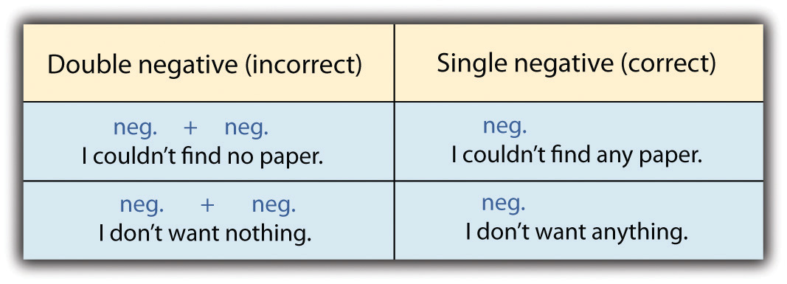

Tip
Ain’t is considered a contraction of am not. Although some may use it in everyday speech, it is considered incorrect in Standard English. Avoid using it when speaking and writing in formal contexts.

Exercise 3
On your own sheet of paper, correct the double negatives and rewrite the following sentences.
- Jose didn’t like none of the choices on the menu.
- Brittany can’t make no friends with nobody.
- The Southwest hardly had no rain last summer.
- My kids never get into no trouble.
- I could not do nothing about the past.

Key Takeaways
- Negatives are usually formed using a negative word plus a helping verb.
- Double negatives are considered incorrect in Standard English.
- Only one negative word is used to express a negative statement.

Writing Application
Write a paragraph describing your favorite meal. Use rich, colorful language to describe the meal. Exchange papers with a classmate and read his or her paragraph. Then rewrite each sentence of your classmate’s paragraph using negatives. Be sure to avoid double negatives. Share your negative paragraphs with each other.

4.3 Count and Noncount Nouns and Articles

Learning Objectives
- Define and use count and noncount nouns.
- Recognize and use definite and indefinite articles.
Nouns are words that name things, places, people, and ideas. Right now, you may be surrounded by desks, computers, and notebooks. These are called count nouns because you can count the exact number of desks, computers, and notebooks—three desks, one computer, and six notebooks, for example.
On the other hand, you may be carrying a small amount of money in your wallet and sitting on a piece of furniture. These are called noncount nouns. Although you can count the pieces of furniture or the amount of money, you cannot add a number in front of money or furniture and simply add -s to the end of the noun. Instead, you must use other words and phrases to indicate the quantity of money and furniture.
Incorrect: five moneys, two furnitures
Correct: some money, two pieces of furniture
By the end of , you will grasp the difference between the two types of nouns and be able to use them confidently in speaking and writing.

Count and Noncount Nouns
A count noun refers to people, places, and things that are separate units. You make count nouns plural by adding -s.
Table 4.1 Count Nouns
Count Noun | Sentence
Quarter | It takes six quarters to do my laundry.
Chair | Make sure to push in your chairs before leaving class.
Candidate | The two candidates debated the issue.
Adult | The three adults in the room acted like children.
Comedian | The two comedians made the audience laugh.

A noncount noun identifies a whole object that cannot separate and count individually. Noncount nouns may refer to concrete objects or abstract objects. A concrete noun identifies an object you can see, taste, touch, or count. An abstract noun identifies an object that you cannot see, touch, or count. There are some exceptions, but most abstract nouns cannot be made plural, so they are noncount nouns. Examples of abstract nouns include anger, education, melancholy, softness, violence, and conduct.
Table 4.2 Types of Noncount Nouns
Type of Noncount Noun | Examples | Sentence
Food | sugar, salt, pepper, lettuce, rice | Add more sugar to my coffee, please.
Solids | concrete, chocolate, silver, soap | The ice cream was covered in creamy chocolate.
Abstract Nouns | peace, warmth, hospitality, information | I need more information about the insurance policy.

Exercise 1
On a separate sheet of paper, label each of the following nouns as count or noncount.
- Electricity ________
- Water ________
- Book ________
- Sculpture ________
- Advice ________

Exercise 2
On a separate sheet of paper, identify whether the italicized noun in the sentence is a count or noncount noun by writing C or NC above the noun.
- The amount of traffic on the way home was terrible.
- Forgiveness is an important part of growing up.
- I made caramel sauce for the organic apples I bought.
- I prefer film cameras instead of digital ones.
- My favorite subject is history.

Definite and Indefinite Articles
The word the is a definite article. It refers to one or more specific things. For example, the woman refers to not any woman but a particular woman. The definite article the is used before singular and plural count nouns.
The words a and an are indefinite articles. They refer to one nonspecific thing. For example, a woman refers to any woman, not a specific, particular woman. The indefinite article a or an is used before a singular count noun.
Definite Articles (The) and Indefinite Articles (A/An) with Count Nouns
I saw the concert. (singular, refers to a specific concert)
I saw the concerts. (plural, refers to more than one specific concert)
I saw the U2 concert last night. (singular, refers to a specific concert)
I saw a concert. (singular, refers to any nonspecific concert)

Exercise 3
On a separate sheet of paper, write the correct article in the blank for each of the following sentences. Write OK if the sentence is correct.
- (A/An/The) camel can live for days without water. ________
- I enjoyed (a/an/the) pastries at the Bar Mitzvah. ________
- (A/An/The) politician spoke of many important issues. ________
- I really enjoyed (a/an/the) actor’s performance in the play. ________
- (A/An/The) goal I have is to run a marathon this year. ________

Exercise 4
Correct the misused or missing articles and rewrite the paragraph.
Stars are large balls of spinning hot gas like our sun. The stars look tiny because they are far away. Many of them are much larger than sun. Did you know that a Milky Way galaxy has between two hundred billion and four hundred billion stars in it? Scientists estimate that there may be as many as five hundred billion galaxies in an entire universe! Just like a human being, the star has a life cycle from birth to death, but its lifespan is billions of years long. The star is born in a cloud of cosmic gas and dust called a nebula. Our sun was born in the nebula nearly five billion years ago. Photographs of the star-forming nebulas are astonishing.

Collaboration
Once you have found all the errors you can, share with a classmate and compare your answers. Did your partner find an error you missed? Did you find an error your partner missed? Compare with your instructor’s answers.

Key Takeaways
- You can make count nouns plural by adding -s.
- Count nouns are individual people, places, or things that can be counted, such as politicians, deserts, or candles.
- Noncount nouns refer to whole things that cannot be made plural, such as salt, peace, or happiness.
- The is a definite article and is used to refer to a specific person, place, or thing, such as the Queen of England.
- A and an are indefinite articles, and they refer to nonspecific people, places, or things, such as an apple or a bicycle.

Writing Application
Write five sentences using the definite article the. Write five sentences using the indefinite article a or an. Exchange papers with a classmate and check each other’s work.

4.4 Pronouns

Learning Objectives
- Recognize subject and object pronouns.
- Identify possessive pronouns.
- Determine common pronoun errors.
A pronoun is a word that can be used in place of the noun. We use pronouns so we do not have to repeat words. For example, imagine writing the following sentence: Afrah put her scarf on because Afrah was cold. The sentence sounds a bit strange because Afrah is named twice; however, if you use a pronoun, the sentence will be shorter and less repetitive. You might rewrite the sentence to something similar to the following: Afrah put her scarf on because she was cold. She refers to Afrah, so you do not have to write the name twice.

Types of Pronouns
Subject pronouns are often the subject of a sentence—“who” and “what” the sentence is about.
Sentence: She loves the desserts in France.
She is the subject.
Sentence: By lunch time, they were hungry.
They is the subject.
Object pronouns are often the object of the verb— “who” or “what” was acted upon.
Sentence: Melanie’s thoughtfulness touched him.
Him is the object of the verb touched.
Sentence: We lifted it.
It is the object of the verb lifted.

Tip
The masculine subject pronoun is he, and the masculine object pronoun is him. The feminine subject pronoun is she, and the feminine object pronoun is her.
A pronoun that shows possession or ownership is called a possessive pronoun.
Sentence: The teacher took her apple and left.
The pronoun her shows the teacher owns the apple.
Sentence: The hikers spotted their guide on the trail.
The pronoun their shows the hikers follow the guide who was assigned to the hikers.
Table 4.3 Pronouns
Subject Pronouns | I, you, he, she, it, we, they
Object Pronouns | me, you, him, her, it, us, them
Possessive Pronouns | my (mine), your(s), his, hers, its, our(s), their(s)

Exercise 1
On a separate sheet of paper, complete the following sentences by circling the correct pronoun.
- Unfortunately, the house was too expensive for (we, us, they).
- I completed (mine, my, your) research paper, and she completed (his, hers, theirs).
- My dog Buster is old, but (he, it, them) is very playful.
- That ring belongs to my father, so it is (hers, his, theirs).
- I cannot find my textbook, so I think (they, it, he) is lost.

Common Pronoun Errors
English language learners often make the same errors when using pronouns. The following examples illustrate common errors.
Incorrect: Me and Daniela went to the restaurant for lunch.
This sentence is incorrect because an object pronoun (me) is used instead of a subject pronoun.
Correct: Daniela and I went to the restaurant for lunch.
This sentence is now correct because a subject pronoun (I) is used.
Incorrect: Mark put her grocery bag on the counter.
This sentence is incorrect because the pronoun her refers to a female, and Mark is a male.
Correct: Mark put his grocery bag on the counter.
This sentence is now correct because the male pronoun his refers to the male person, Mark.
Incorrect: The woman she went to work earlier than usual.
This sentence is incorrect because the subject the woman is repeated by the pronoun she.
Correct: The woman went to work earlier than usual.
Correct: She went to work earlier than usual.
These sentences are now correct because the unnecessary repeated subject has been removed.

Exercise 2
On a separate sheet of paper, correct the following sentences that have pronoun errors. If the sentence is correct as it is, write OK.
- Us are going to the county fair this weekend.
- Steven did not want to see a movie because she had a headache.
- The teacher congratulated Maria and me.
- The eighth grade students they were all behaving mysteriously well.
- Derrick and he received the best grade on the grammar test.

Relative Pronouns
A relative pronoun is a type of pronoun that helps connect details to the subject of the sentence and may often combine two shorter sentences. The relative pronouns are who, whom, whose, which or that.
Sentence: A relative pronoun is a type of pronoun.
The subject of this sentence is a relative pronoun. The clause is a type of pronoun gives some information about the subject.
The relative pronoun that may be added to give more details to the subject.
Sentence using a relative pronoun: A relative pronoun is a type of pronoun that helps connect details to the subject of the sentence.

Tip
Remember the following uses of relative pronouns:
- Who, whom, and whose refer only to people.
- Which refers to things.
- That refers to people or things.
The following examples show how a relative pronoun may be used to connect two sentences and to connect details to the subject.
Sentence 1: Gossip is a form of communication.
Sentence 2: It is a waste of time and energy.
Combination of 1 and 2: Gossip is a form of communication that is a waste of time and energy.
Notice how the relative pronoun that replaces the subject it in sentence 2.
That is called a relative pronoun because it connects the details (is a waste of time and energy) to the subject (Gossip).
Sentence 1: My grandmother is eighty years old.
Sentence 2: She collects seashells.
Combination of 1 and 2: My grandmother, who is eighty years old, collects seashells.
Notice how the relative pronoun who replaces the subject she in sentence 2.
Who is called a relative pronoun because it connects the details (is eighty years old) to the subject (My grandmother).

Exercise 3
On a separate sheet of paper, complete the following sentences by selecting the correct relative pronoun.
- He showed me a photo (who, that) upset me.
- Soccer is a fast moving game (who, that) has many fans worldwide.
- Juan is a man (which, who) has high standards for everything.
- Jamaica is a beautiful country (that, who) I would like to visit next year.
- My mother only eats bananas (who, that) are green.

Exercise 4
On a separate sheet of paper, combine the two sentences into one sentence using a relative pronoun.
- Jeff is a dependable person. He will never let you down.
- I rode a roller coaster. It was scary.
- At the beach, I always dig my feet into the sand. It protects them from the hot sun.
- Jackie is trying not to use so many plastic products. They are not good for the environment.
- My Aunt Sherry is teaching me how to drive. She has never been in accident or gotten a ticket.

Key Takeaways
- A pronoun is used in place of a noun.
- There are several types of pronouns, including subject and object pronouns, possessive pronouns, and relative pronouns.
- Subject pronouns are the “who” and “what” the sentence is about.
- Object pronouns are the “who” and “what” that receives the action.
- A possessive pronoun is a pronoun showing ownership.
- Common pronoun errors include mixing up subject, object, and gender pronouns, and repeating the subject of a sentence with a pronoun.
- Relative pronouns help combine two separate sentences.

Writing Application
Proofread a piece of your writing for the types of pronoun errors discussed in this section. Correct any errors you come across.

4.5 Verb Tenses

Learning Objectives
- Identify simple verb tenses.
- Recognize to be, to have, and to do verbs.
- Use perfect verb tenses.
- Apply progressive verb tenses.
- Define gerunds and infinitives.
You must always use a verb in every sentence you write. Verbs are parts of speech that indicate actions or states of being. The most basic sentence structure is a subject followed by a verb.

Simple Verb Tenses
Verb tenses tell the reader when the action takes place. The action could be in the past, present, or future.
Past | ← Present → | Future
Yesterday I jumped. | Today I jump. | Tomorrow I will jump.

Simple present verbs are used in the following situations:
- When the action takes place now
I drink the water greedily.
- When the action is something that happens regularly
I always cross my fingers for good luck.
- When describing things that are generally true
College tuition is very costly.

Table 4.4 Regular Simple Present Tense Verbs
Verb | I | He/She/It | You | We | They
ask | ask | asks | ask | ask | ask
bake | bake | bakes | bake | bake | bake
cook | cook | cooks | cook | cook | cook
cough | cough | coughs | cough | cough | cough
clap | clap | claps | clap | clap | clap
dance | dance | dances | dance | dance | dance
erase | erase | erases | erase | erase | erase
kiss | kiss | kisses | kiss | kiss | kiss
push | push | pushes | push | push | push
wash | wash | washes | wash | wash | wash
When it is he, she, or it doing the present tense action, remember to add -s, or -es to the end of the verb or to change the y to -ies.
Simple past verbs are used when the action has already taken place and is now finished:
- I washed my uniform last night.
- I asked for more pie.
- I coughed loudly last night.

Table 4.5 Regular Simple Past Tense Verbs
Verb | I | He/She/It | You | We | They
ask | asked | asked | asked | asked | asked
bake | baked | baked | baked | baked | baked
cook | cooked | cooked | cooked | cooked | cooked
cough | coughed | coughed | coughed | coughed | coughed
clap | clapped | clapped | clapped | clapped | clapped
dance | danced | danced | danced | danced | danced
erase | erased | erased | erased | erased | erased
kiss | kissed | kissed | kissed | kissed | kissed
push | pushed | pushed | pushed | pushed | pushed
wash | washed | washed | washed | washed | washed
When he, she, or it is doing the action in the past tense, remember to add -d or -ed to the end of regular verbs.
Simple future verbs are used when the action has not yet taken place:
- I will work late tomorrow.
- I will kiss my boyfriend when I see him.
- I will erase the board after class.

Table 4.6 Regular Simple Future Tense Verbs
Verb | I | He/She/It | You | We | They
ask | will ask | will ask | will ask | will ask | will ask
bake | will bake | will bake | will bake | will bake | will bake
cook | will cook | will cook | will cook | will cook | will cook
cough | will cough | will cough | will cough | will cough | will cough
clap | will clap | will clap | will clap | will clap | will clap
dance | will dance | will dance | will dance | will dance | will dance
erase | will erase | will erase | will erase | will erase | will erase
kiss | will kiss | will kiss | will kiss | will kiss | will kiss
push | will push | will push | will push | will push | will push
wash | will wash | will wash | will wash | will wash | will wash
Going to can also be added to the main verb to make it future tense:
- I am going to go to work tomorrow.

Exercise 1
On a separate sheet of paper, complete the following sentences by adding the verb in the correct simple tense.
- Please do not (erase, erased, will erase) what I have written on the board.
- They (dance, danced, will dance) for hours after the party was over.
- Harrison (wash, washed, will wash) his laundry after several weeks had passed.
- Yesterday Mom (ask, asked, will ask) me about my plans for college.
- I (bake, baked, will bake) several dozen cookies for tomorrow’s bake sale.

Exercise 2
Correct the verb tense mistakes in the following paragraph.
Last summer, I walk around Walden Pond. Walden Pond is in Concord, Massachusetts. It is where the philosopher Henry David Thoreau will live during the mid-nineteenth century. During his time there, he wrote a book called Walden. Walden is a book of Thoreau’s reflections on the natural environment. It will be consider a classic in American literature. I did not know that Walden Pond is consider the birthplace of the environmental movement. It was very relaxing there. I will listen to birds, frogs, and crickets, not to mention the peaceful sound of the pond itself.
Collaboration
Once you have found all the errors you can, please share with a classmate and compare your answers. Did your partner find an error you missed? Did you find an error your partner missed? Compare with your instructor’s answers.

To Be, To Do, and To Have
There are some irregular verbs in English that are formed in special ways. The most common of these are the verbs to be, to have, and to do.
Table 4.7 Verb Forms of To Be, To Do, and To Have
Base Form | Present Tense Form | Past Tense Form | Future Tense Form
be | am/is/are | was/were | will be
do | do/does | did | will do
have | have/has | had | will have

Tip
Memorize the present tense forms of to be, to do, and to have. A song or rhythmic pattern will make them easier to memorize.
Review these examples of to be, to do, and to have used in sentences.
Past | ← Present → | Future
To Be
Yesterday I was angry. | Today I am not angry. | Tomorrow I will be angry.
To Do
I did my best yesterday. | I do my best every day. | Tomorrow I will do my best.
To Have
Yesterday I had ten dollars. | Today I have ten dollars. | Tomorrow I will have ten dollars.

Remember the following uses of to be, to have and to do:
To Be
- I → am/was/will be
- you/we/they → are/were/will be
- he/she/it → is/was/will be
To Have
- I/you/we/they → have/had/will have
- he/she/it → has/had/will have
To Do
- I/you/we/they → do/did/will do
- he/she/it → does/did/will do

Tip
Remember, if you have a compound subject like Marie and Jennifer, think of the subject as they to determine the correct verb form.
- Marie and Jennifer (they) have a house on Bainbridge Island.
Similarly, single names can be thought of as he, she, or it.
- LeBron (he) has scored thirty points so far.

Exercise 3
On a separate sheet of paper, complete the following sentences by circling the correct form of the verbs to be, to have, and to do in the three simple tenses.
- Stefan always (do, does, will do) his taxes the day before they are due.
- We (are, is, was) planning a surprise birthday party for my mother.
- Turtles (have, had, has) the most beautiful patterns on their shells.
- I always (do, did, will do) my homework before dinner, so I can eat in peace.
- You (is, are, was) so much smarter than you think!

Perfect Verb Tenses
Up to this point, we have studied the three simple verb tenses—simple present, simple past, and simple future. Now we will add three more tenses, which are called perfect tenses. They are present perfect, past perfect, and future perfect. These are the three basic tenses of English. A past participle is often called the -ed form of a verb because it is formed by adding -d or -ed to the base form of regular verbs. Past participles can also end in -t or -en. Keep in mind, however, the past participle is also formed in various other ways for irregular verbs. The past participle can be used to form the present perfect tense.
Review the following basic formula for the present perfect tense:
Subject | + | has or have | + | past participle
I |  | have |  | helped

The present perfect tense has a connection with the past and the present.
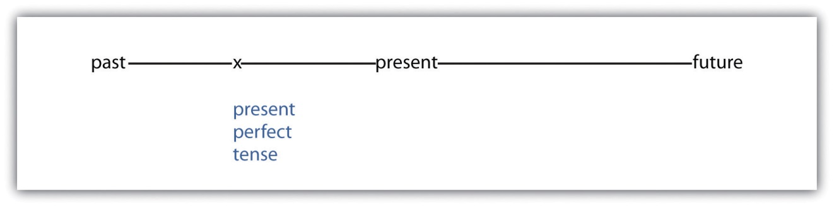
Use the present perfect tense to describe a continuing situation and to describe an action that has just happened.
- I have worked as a caretaker since June.
This sentence tells us that the subject has worked as a caretaker in the past and is still working as a caretaker in the present.
- Dmitri has just received an award from the Dean of Students.
This sentence tells us that Dmitri has very recently received the award. The word just emphasizes that the action happened very recently.
Study the following basic formula for the past perfect tense:
Subject | + | had or have | + | past participle
I |  | had |  | listened

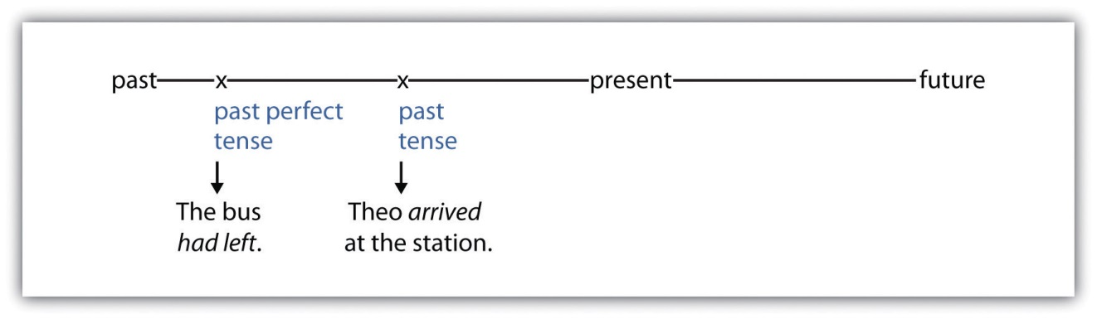
- The bus had left by the time Theo arrived at the station.
Notice that both actions occurred entirely in the past, but one action occurred before the other. At some time in the past, Theo arrived (simple past tense) at the station, but at some time before that, the bus had left (past perfect).
Look at the following basic formula for the future perfect tense:
Subject | + | will have | + | past participle
I |  | will have |  | graduated

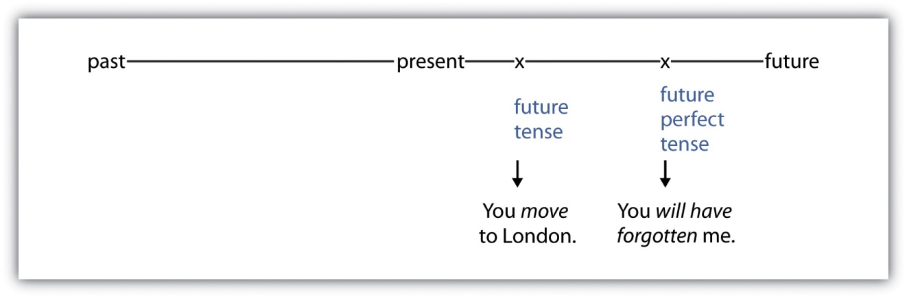
The future perfect tense describes an action from the past in the future, as if the past event has already occurred. Use the future perfect tense when you anticipate completing an event in the future, but you have not completed it yet.
- You will have forgotten me after you move to London.
Notice that both actions occur in the future, but one action will occur before the other. At some time in the future, the subject (you) will move (future tense) to London, and at some time after that, the subject will have forgotten (future perfect tense) the speaker, me.

Exercise 4
On a separate sheet of paper, complete the following sentences by using the correct perfect verb tense for the verb in parentheses.
- I plan to start a compost bin because I ________ (to want) one for a long time now.
- My brother told me he ________ (to argue) with his friend about politics.
- By the time we reach the mountain top the sun ________ (to set).
- Denise ________ (to walk) several miles in the past three hours.
- His mother ________ (to offer) to pay him to work in her office.

Progressive Verb Tenses
Progressive verb tenses describe a continuing or unfinished action, such as I am going, I was going, or I will be going.
The present progressive tense describes an action or state of being that takes place in the present and that continues to take place.
To make verbs in the present progressive tense, combine these two parts:
Present tense form of to be | + | -ing (present participle)
am/is/are | help | helping

You should use the present progressive tense to describe a planned activity, to describe an activity that is recurring right now, and to describe an activity that is in progress, although not actually occurring at the time of speaking:
- Preeti is starting school on Tuesday.
This sentence describes a planned activity.
- Janetta is getting her teeth cleaned right now.
This sentence describes an activity that is occurring right now.
- I am studying ballet at school.
This sentence describes an activity that is in progress but not actually occurring at the time of speaking.
The past progressive tense describes an action or state of being that took place in the past and that continues to take place.
To make verbs in the past progressive tense, combine these two parts:
Past tense form of to be | + | -ing (present participle)
was/were |  | helping

You should use the past progressive tense to describe a continuous action in the past, to describe a past activity in progress while another activity occurred, or to describe two past activities in progress at the same time:
- Ella and I were planning a vacation.
This sentence describes a continuous action in the past.
- I was helping a customer when I smelled delicious fried chicken.
This sentence describes a past activity in progress while another activity occurred.
- While I was finishing my homework, my wife was talking on the phone.
This sentence describes two past activities in progress at the same time.
The future progressive tense describes an action or state of being that will take place in the future and that will continue to take place. The action will have started at that future moment, but it will not have finished at that moment.
To make verbs in the future progressive tense, combine these parts:
Future tense form of to be | + | -ing (present participle)
will be |  | helping

Use the future progressive tense to describe an activity that will be in progress in the future:
- Samantha and I will be dancing in the school play next week.
- Tomorrow Agnes will be reading two of her poems.

Exercise 5
On a separate sheet of paper, revise the following sentences, written in simple tenses, using the progressive tenses indicated in parentheses.
- He prepared the food while I watched. (past progressive tense)
- Jonathan will speak at the conference. (future progressive)
- Josie traveled to Egypt last July. (past progressive tense)
- My foot aches, so I know it will rain. (present progressive tense)
- Micah will talk a lot when I see him. (future progressive)
- I yawn a lot because I feel tired. (present progressive tense)
Similar to the present perfect tense, the present perfect progressive tense is used to indicate an action that was begun in the past and continues into the present. However, the present perfect progressive is used when you want to stress that the action is ongoing.
To make verbs in the present perfect progressive tense, combine the following parts:
Present tense form of to have | + | Been | + | -ing (present participle)
has or have |  | been |  | helping

- She has been talking for the last hour.
This sentence indicates that she started talking in the past and is continuing to talk in the present.
- I have been feeling tired lately.
This sentence indicates that I started feeling tired in the past, and I continue to feel tired in the present. Instead of indicating time, as in the first sentence, the second sentence uses the adverb lately. You can also use the adverb recently when using the present perfect progressive tense.
Similar to the past perfect tense, the past perfect progressive tense is used to indicate an action that was begun in the past and continued until another time in the past. The past perfect progressive does not continue into the present but stops at a designated moment in the past.
To make verbs in the past perfect progressive tense, combine the following parts:
Past tense form of to have | + | been | + | -ing (present participle)
had |  | been |  | helping

- The employees had been talking until their boss arrived.
This sentence indicates that the employees were talking in the past and they stopped talking when their boss arrived, which also happened in the past.
- I had been working all day.
This sentence implies that I was working in the past. The action does not continue into the future, and the sentence implies that the subject stopped working for unstated reasons.
The future perfect progressive tense is rarely used. It is used to indicate an action that will begin in the future and will continue until another time in the future.
To make verbs in the future perfect progressive tense, combine the following parts:
Future tense form of to have | + | been | + | -ing (present participle)
will have |  | Been |  | helping

- By the end of the meeting, I will have been hearing about mortgages and taxes for eight hours.
This sentence indicates that in the future I will hear about mortgages and taxes for eight hours, but it has not happened yet. It also indicates the action of hearing will continue until the end of the meeting, something that is also in the future.

Gerunds
A gerund is a form of a verb that is used as a noun. All gerunds end in -ing. Since gerunds function as nouns, they occupy places in a sentence that a noun would, such as the subject, direct object, and object of a preposition.
You can use a gerund in the following ways:
- As a subject
Traveling is Cynthia’s favorite pastime.
- As a direct object
I enjoy jogging.

- As an object of a proposition
The librarian scolded me for laughing.
Often verbs are followed by gerunds. Study for examples.
Table 4.8 Gerunds and Verbs
Gerund | Verb Followed by a Gerund
moving | Denise considered moving to Paris.
cleaning | I hate cleaning the bathroom.
winning | Nate imagines winning an Oscar one day.
worrying | Mom says she has stopped worrying.
taking | She admitted taking the pumpkin.

Infinitives
An infinitive is a form of a verb that comes after the word to and acts as a noun, adjective, or adverb.
to + verb = infinitive
Examples of infinitives include to move, to sleep, to look, to throw, to read, and to sneeze.
Often verbs are followed by infinitives. Study for examples.
Table 4.9 Infinitives and Verbs
Infinitive | Verb Followed by Infinitive
to help | Jessica offered to help her move.
to arrive | Mick expects to arrive early.
to win | Sunita wants to win the writing contest.
to close | He forgot to close the curtains.
to eat | She likes to eat late.

You may wonder which verbs can be followed by gerunds and which verbs can be followed by infinitives. With the following verbs, you can use either a gerund or an infinitive.
Table 4.10 Infinitives and Gerunds Verbs
Base Form of Verb | Sentences with Verbs Followed by Gerunds and Infinitives
begin | 1. John began crying.
 | 2. John began to cry.
hate | 1. Marie hated talking on the phone.
 | 2. Marie hated to talk on the phone.
forget | 1. Wendell forgot paying the bills.
 | 2. Wendell forgot to pay the bills.
like | 1. I liked leaving messages.
 | 2. I liked to leave messages.
continue | 1. He continued listening to the news.
 | 2. He continued to listen to the news.
start | 1. I will start recycling immediately.
 | 2. I will start to recycle immediately.
try | 1. Mikhail will try climbing the tree.
 | 2. Mikhail will try to climb the tree.
prefer | 1. I prefer baking.
 | 2. I prefer to bake.
love | 1. Josh loves diving.
 | 2. Josh loves to dive.

Exercise 6
On your own sheet of paper, complete the following sentences by choosing the correct infinitive or gerund.
- I meant ________ (to kiss, kissing) my kids before they left for school.
- The children hoped (to go, going) to a restaurant for dinner.
- Do you intend ________ (to eat, eating) the entire pie?
- Crystal postponed ________ (to get dressed, getting dressed) for the party.
- When we finish ________ (to play, playing) this game, we will go home.

Key Takeaways
- Verb tenses tell the reader when the action takes place.
- Actions could be in the past, present, or future.
- There are some irregular verbs in English that are formed in special ways. The most common of these irregular verbs are the verbs to be, to have, and to do.
- There are six main verb tenses in English: simple present, simple past, simple future, present perfect, past perfect, and future perfect.
- Verbs can be followed by either gerunds or infinitives.

Writing Application
Write about a lively event that is either remembered or imagined. Ask yourself the following three questions: What happened during the event? What happened after the event? Looking back, what do you think of the event now? Answer each question in a separate paragraph to keep the present, past, and future tense verbs separate.

4.6 Modal Auxiliaries

Learning Objectives
- Define and identify modal auxiliaries.
- Learn how and when to use modal auxiliaries.
We all need to express our moods and emotions, both in writing and in our everyday life. We do this by using modal auxiliaries.

Modal Auxiliaries
Modal auxiliaries are a type of helping verb that are used only with a main verb to help express its mood.
The following is the basic formula for using a modal auxiliary:
Subject | + | modal auxiliary | + | main verb
James |  | may |  | call

There are ten main modal auxiliaries in English.

Table 4.11 Modal Auxiliaries
Modal Auxiliary | Use | Modal Auxiliary + Main Verb
can | Expresses an ability or possibility | I can lift this forty-pound box. (ability)
 |  | We can embrace green sources of energy. (possibility)
could | Expresses an ability in the past; a present possibility; a past or future permission | I could beat you at chess when we were kids. (past ability)
 |  | We could bake a pie! (present possibility)
 |  | Could we pick some flowers from the garden? (future permission)
may | Expresses uncertain future action; permission; ask a yes-no question | I may attend the concert. (uncertain future action)
 |  | You may begin the exam. (permission)
 |  | May I attend the concert? (yes-no questions)
might | Expresses uncertain future action | I might attend the concert (uncertain future action—same as may)
shall | Expresses intended future action | I shall go to the opera. (intended future action)
should | Expresses obligation; ask if an obligation exists | I should mail my RSVP. (obligation, same as ought to)
 |  | Should I call my mother? (asking if an obligation exists)
will | Expresses intended future action; ask a favor; ask for information | I will get an A in this class. (intended future action)
 |  | Will you buy me some chocolate? (favor)
 |  | Will you be finished soon? (information)
would | States a preference; request a choice politely; explain an action; introduce habitual past actions | I would like the steak, please. (preference)
 |  | Would you like to have breakfast in bed? (request a choice politely)
 |  | I would go with you if I didn’t have to babysit tonight. (explain an action)
 |  | He would write to me every week when we were dating. (habitual past action)
must | Expresses obligation | We must be on time for class.
ought to | Expresses obligation | I ought to mail my RSVP. (obligation, same as may)

Tip
Use the following format to form a yes-no question with a modal auxiliary:
Modal auxiliary | + | subject | + | main verb
Should |  | I |  | drive?

Be aware of these four common errors when using modal auxiliaries:
- Using an infinitive instead of a base verb after a modal
Incorrect: I can to move this heavy table.
Correct: I can move this heavy table.
- Using a gerund instead of an infinitive or a base verb after a modal
Incorrect: I could moving to the United States.
Correct: I could move to the United States.
- Using two modals in a row
Incorrect: I should must renew my passport.
Correct: I must renew my passport.
Correct: I should renew my passport.

- Leaving out a modal
Incorrect: I renew my passport.
Correct: I must renew my passport.

Exercise 1
Edit the following paragraph by correcting the common modal auxiliary errors.
I may to go to France on vacation next summer. I shall might visit the Palace of Versailles. I would to drive around the countryside. I could imagining myself living there; however, I will not move to France because my family should miss me very much.

Modals and Present Perfect Verbs
In the previous section, we defined present perfect verb tense as describing a continuing situation or something that has just happened.
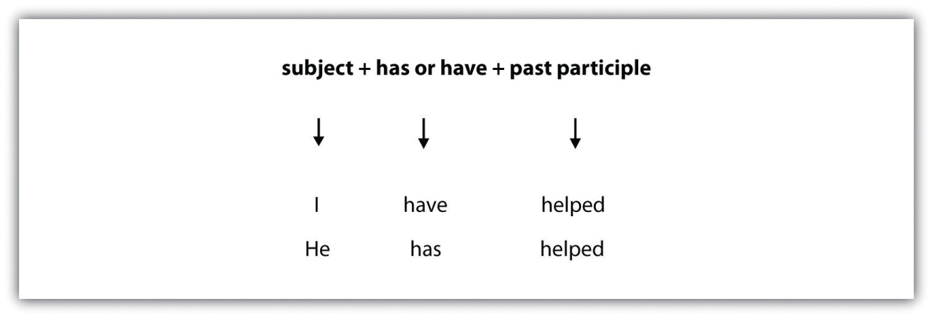
Remember, when a sentence contains a modal auxiliary before the verb, the helping verb is always have.
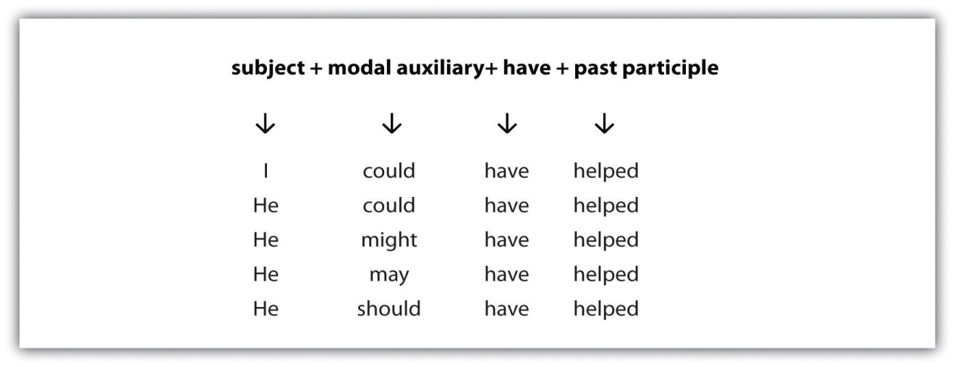
Be aware of the following common errors when using modal auxiliaries in the present perfect tense:
- Using had instead of have
Incorrect: Jamie would had attended the party, but he was sick.
Correct: Jamie would have attended the party, but he was sick.
- Leaving out have
Incorrect: Jamie would attended the party, but he was sick.
Correct: Jamie would have attended the party, but he was sick.

Exercise 2
On a separate sheet of paper, complete the following sentences by changing the given verb form to a modal auxiliary in present perfect tense.
- The man ________ (laugh).
- The frogs ________ (croak).
- My writing teacher ________ (smile).
- The audience ________ (cheer) all night.
- My best friend ________ (giggled).

Key Takeaways
- The basic formula for using a modal auxiliary is
subject | + | modal auxiliary | + | main verb

- There are ten main modal auxiliaries in English: can, could, may, might, shall, should, will, would, must, and ought to.
- The four common types of errors when using modals include the following: using an infinitive instead of a base verb after a modal, using a gerund instead of an infinitive or a base verb after a modal, using two modals in a row, and leaving out a modal.
- In the present perfect tense, when a sentence has a modal auxiliary before the verb, the helping verb is always have.
- The two common errors when using modals in the present perfect tense include using had instead of have and leaving out have.

Writing Application
On a separate sheet of paper, write ten original sentences using modal auxiliaries.

4.7 Prepositions

Learning Objectives
- Identify prepositions.
- Learn how and when to use prepositions.
A preposition is a word that connects a noun or a pronoun to another word in a sentence. Most prepositions such as above, below, and behind usually indicate a location in the physical world, but some prepositions such as during, after, and until show location in time.

In, At, and On
The prepositions in, at, and on are used to indicate both location and time, but they are used in specific ways. Study Table 4.12 " ", Table 4.13 " ", and Table 4.14 " " to learn when to use each one.
Table 4.12 In
Preposition | Time | Example | Place | Example
in | year | in 1942 | country | in Zimbabwe
 | month | in August | state | in California
 | season | in the summer | city | in Chicago
 | time of day (not with night) | in the afternoon

Table 4.13 On
Preposition | Time | Example | Place | Example
on | day | on Monday | surfaces | on the table
 | date | on May 23 | streets | on 124th Street
 | specific days/dates | on Monday | modes of transportation | on the bus

Table 4.14 At
Preposition | Time | Example | Place | Example
at | time | at five o’clock | addresses | at 1600 Pennsylvania Avenue
 | with night | at night | location | at Rooney’s Grill

Exercise 1
Edit the following letter from a resident to her landlord by correcting errors with in, at, and on.
Dear Mrs. Salazar,
I am writing this letter to inform you that I will be vacating apartment 2A in 356 Maple Street at Wednesday, June 30, 2010. I will be cleaning the apartment at the Monday before I leave. I will return the keys to you on 5 p.m., sharp, at June 30. If you have any questions or specific instructions for me, please contact me in my office. I have enjoyed living at Austin, Texas, but I want to explore other parts of the country now.
Sincerely,
Milani Davis

Prepositions after Verbs
Prepositions often follow verbs to create expressions with distinct meanings. These expressions are sometimes called prepositional verbs. It is important to remember that these expressions cannot be separated.

Table 4.15 Verbs + Prepositions
Verb + Preposition | Meaning | Example
agree with | to agree with something or someone | My husband always agrees with me.
apologize for | to express regret for something, to say sorry about something | I apologize for being late.
apply for | to ask for something formally | I will apply for that job.
believe in | to have a firm conviction in something; to believe in the existence of something | I believe in educating the world’s women.
care about | to think that someone or something is important | I care about the health of our oceans.
hear about | to be told about something or someone | I heard about the teachers’ strike.
look after | to watch or to protect someone or something | Will you look after my dog while I am on vacation?
talk about | to discuss something | We will talk about the importance of recycling.
speak to, with | to talk to/with someone | I will speak to his teacher tomorrow.
wait for | to await the arrival of someone or something | I will wait for my package to arrive.

Tip
It is a good idea to memorize these combinations of verbs plus prepositions. Write them down in a notebook along with the definition and practice using them when you speak.

Exercise 2
On a separate sheet of paper, complete the following sentences by writing the correct preposition after the verb.
- Charlotte does not ________ (apologize for, believe in) aliens or ghosts.
- It is impolite to ________ (hear about, talk about) people when they are not here.
- Herman said he was going to ________ (believe in, apply for) the internship.
- Jonas would not ________ (talk about, apologize for) eating the last piece of cake.
- I ________ (care about, agree with) the environment very much.

Prepositions after Adjectives
Similar to prepositions after verbs, prepositions after adjectives create expressions with distinct meanings unique to English. Remember, like prepositional verbs, these expressions also cannot be separated.
Table 4.16 Adjectives + Prepositions

Adjective + Preposition | Meaning | Example
angry at, about | to feel or show anger toward (or about) someone or something | I am angry about the oil spill in the ocean.
confused about | to be unable to think with clarity about someone or something. | Shawn was confused about the concepts presented at the meeting.
disappointed in, with | to feel dissatisfaction with someone or something | I was disappointed in my husband because he voted for that candidate.
dressed in | to clothe the body | He was dressed in a pin-striped suit.
happy for | to show happiness for someone or something | I was happy for my sister who graduated from college.
interested in | giving attention to something, expressing interest | I am interested in musical theater.
jealous of | to feel resentful or bitter toward someone or something (because of their status, possessions, or ability) | I was jealous of her because she always went on vacation.
thankful for | to express thanks for something | I am thankful for my wonderful friends.
tired of | to be disgusted with, have a distaste for | I was tired of driving for hours without end.
worried about | to express anxiety or worry about something | I am worried about my father’s health.

Exercise 3
On a separate sheet of paper, complete the following sentences by writing the correct preposition after the verb.
- Meera was deeply ________ (interested in, thankful for) marine biology.
- I was ________ (jealous of, disappointed in) the season finale of my favorite show.
- Jordan won the race, and I am ________ (happy for, interested in) him.
- The lawyer was ________ (thankful for, confused about) the details of the case.
- Chloe was ________ (dressed in, tired of) a comfortable blue tunic.

Tip
The following adjectives are always followed by the preposition at:
- Good
She is really good at chess.
- Excellent
Henry is excellent at drawing.
- Brilliant
Mary Anne is brilliant at playing the violin.

Key Takeaways
- The prepositions in, at, and on are used to indicate both location and time, but they are used in specific ways.
- The preposition in is used when expressing the following: year, month, season, time of day (not with night), country, state, and city.
- The preposition on is used to express day, date, and specific days or dates and surfaces, streets, and transportation modes.
- The preposition at is used for expressions of time, with night, and with addresses and locations.
- Prepositions often follow verbs to create expressions with distinct meanings that are unique to English.
- Prepositions also follow adjectives to create expressions with distinct meanings that are unique to English.

Writing Application
Write about a happy childhood memory using as many prepositions followed by verbs and adjectives as you can. Use at least ten. When you are finished, exchange papers with a classmate and correct any preposition errors you find.

4.8 Slang and Idioms

Learning Objectives
- Recognize slang and idioms.
- Learn to avoid using slang and idioms in formal writing.
Words are the basis of how a reader or listener judges you, the writer and speaker. When you write an academic paper or speak in a business interview, you want to be sure to choose your words carefully. In our casual, everyday talk, we often use a lot of “ums,” “likes,” “yeahs,” and so on. This everyday language is not appropriate for formal contexts, such as academic papers and business interviews. You should switch between different ways of speaking and writing depending on whether the context is formal or informal.

Slang
Hey guys, let’s learn about slang and other cool stuff like that! It will be awesome, trust me. This section is off the hook!
What do you notice about the previous paragraph? You might notice that the language sounds informal, or casual, like someone might talk with a friend or family member. The paragraph also uses a lot of slang. Slang is a type of language that is informal and playful. It often changes over time. The slang of the past is different than the slang of today, but some slang has carried over into the present. Slang also varies by region and culture. The important thing to understand is that slang is casual talk, and you should avoid using it in formal contexts. There are literally thousands of slang words and expressions. Table 4.17 "Slang Expressions" explains just a few of the more common terms.
Table 4.17 Slang Expressions
Slang Word or Phrase | Meaning
check it out, check this out | v. look at, watch, examine
chocoholic, workaholic, shopaholic | n. a person who loves, is addicted to chocolate/work/shopping
stuff | n. things (used as a singular, noncount noun)
taking care of business | doing things that need to be done
pro | n. a person who is a professional
crack up | v. to laugh uncontrollably
veg (sounds like the veg in vegetable) | v. relax and do nothing
dude, man | n. person, man
all-nighter | n. studying all night
cool | adj. good, fashionable
gross, nasty | adj. disgusting
pig out | v. eat a lot, overeat
screw up | v. make a mistake
awesome | adj. great

Exercise 1
Edit the business e-mail by replacing any slang words and phrases with more formal language.
Dear Ms. O’Connor:
I am writing to follow up on my interview from last week. First of all, it was awesome to meet you. You are a really cool lady. I believe I would be a pro at all the stuff you mentioned that would be required of me in this job. I am not a workaholic, but I do work hard and “take care of business.” Haha. Please contact me if you have any questions or concerns.
Sincerely,
M. Ernest Anderson

Idioms
Idioms are expressions that have a meaning different from the dictionary definitions of the individual words in the expression. Because English contains many idioms, nonnative English speakers have difficulties making logical sense of idioms and idiomatic expressions. The more you are exposed to English, however, the more idioms you will come to understand. Until then, memorizing the more common idioms may be of some help.
Table 4.18 Idioms
Idiom | Definition
a blessing in disguise | a good thing you do not recognize at first
a piece of cake | easy to do
better late than never | it is better to do something late than not at all
get over it | recover from something (like a perceived insult)
I have no idea | I don’t know
not a chance | it will definitely not happen
on pins and needles | very nervous about something that is happening
on top of the world | feeling great
pulling your leg | making a joke by tricking another person
the sky is the limit | the possibilities are endless
What if you come across an idiom that you do not understand? There are clues that can help you. They are called context clues. Context clues are words or phrases around the unknown word or phrase that may help you decipher its meaning.
- Definition or explanation clue. An idiom may be explained immediately after its use.
Sentence: I felt like I was sitting on pins and needles I was so nervous.
- Restatement or synonym clues. An idiom may be simplified or restated.
Sentence: The young girl felt as though she had been sent to the dog house when her mother punished her for fighting in school.
- Contrast or Antonym clues. An idiom may be clarified by a contrasting phrase or antonym that is near it.
Sentence: Chynna thought the 5k marathon would be a piece of cake, but it turned out to be very difficult.
Pay attention to the signal word but, which tells the reader that an opposite thought or concept is occurring.

Key Takeaways
- Informal language is not appropriate in formal writing or speaking contexts.
- Slang and idioms might not make logical sense to nonnative speakers of English.
- It is good to be aware of slang and idioms so they do not appear in your formal writing.

Writing Application
Write a short paragraph about yourself to a friend. Write another paragraph about yourself to an employer. Examine and discuss the differences in language between the two paragraphs.

4.9 Help for English Language Learners: End-of-Chapter Exercises

Learning Objectives
- Use the skills you have learned in the chapter.
- Work collaboratively with other students.

Exercises
- On a separate sheet of paper, create questions from the following sentences.
  - My daughter will have to think about her college options.
  - Otto is waiting in the car for his girlfriend.
  - The article talks about conserving energy.
  - We need to reduce our needs.
  - Rusha is always complaining about her work.
- Underline the prepositional phrase in each of the following sentences.
  - Monica told us about her trip.
  - I hope we have sunshine throughout the summer.
  - The panther climbed up the tree.
  - The little boy was standing behind his mother’s legs.
  - We stayed awake until dawn.
- Place the following sets of adjectives in the correct order before the noun.
  - eyes: black, mesmerizing
  - jacket: vintage, orange, suede
  - pineapple: ripe, yellow, sweet
  - vacation: fun, skiing
  - movie: hilarious, independent
- On a separate sheet of paper, rewrite the positive sentences as negative sentences. Be sure to keep the sentences in the present tense.
  - Sometimes I work on Saturdays.
  - The garden attracts butterflies and bees.
  - He breathes loudly at night.
  - I chew on blades of grass in the summer time.
  - I communicate well with my husband.
- On a separate sheet of paper, rewrite the following paragraph by correcting the double negatives.
That morning it was so hot Forrest felt like he couldn’t hardly breathe. Ain’t nothing would get him out the door into that scorching heat. Then he remembered his dog, Zeus, who started whining right then. Zeus was whining and barking so much that Forrest didn’t have no choice but to get off the couch and face the day. That dog didn’t do nothing but sniff around the bushes and try to stay in the shade while Forrest was sweating in the sun holding the leash. He couldn’t not wait for winter to come.

Collaboration
Once you have found all the errors you can, please share with a classmate and compare your answers. Did your partner find an error you missed? Did you find an error your partner missed? Compare with your instructor’s answers.

Chapter 5 Writing Paragraphs: Separating Ideas and Shaping Content

5.1 Purpose, Audience, Tone, and Content

Learning Objectives
- Identify the four common academic purposes.
- Identify audience, tone, and content.
- Apply purpose, audience, tone, and content to a specific assignment.
Imagine reading one long block of text, with each idea blurring into the next. Even if you are reading a thrilling novel or an interesting news article, you will likely lose interest in what the author has to say very quickly. During the writing process, it is helpful to position yourself as a reader. Ask yourself whether you can focus easily on each point you make. One technique that effective writers use is to begin a fresh paragraph for each new idea they introduce.
Paragraphs separate ideas into logical, manageable chunks. One paragraph focuses on only one main idea and presents coherent sentences to support that one point. Because all the sentences in one paragraph support the same point, a paragraph may stand on its own. To create longer assignments and to discuss more than one point, writers group together paragraphs.
Three elements shape the content of each paragraph:
- Purpose. The reason the writer composes the paragraph.
- Tone. The attitude the writer conveys about the paragraph’s subject.
- Audience. The individual or group whom the writer intends to address.
Figure 5.1 Purpose, Audience, Tone, and Content Triangle
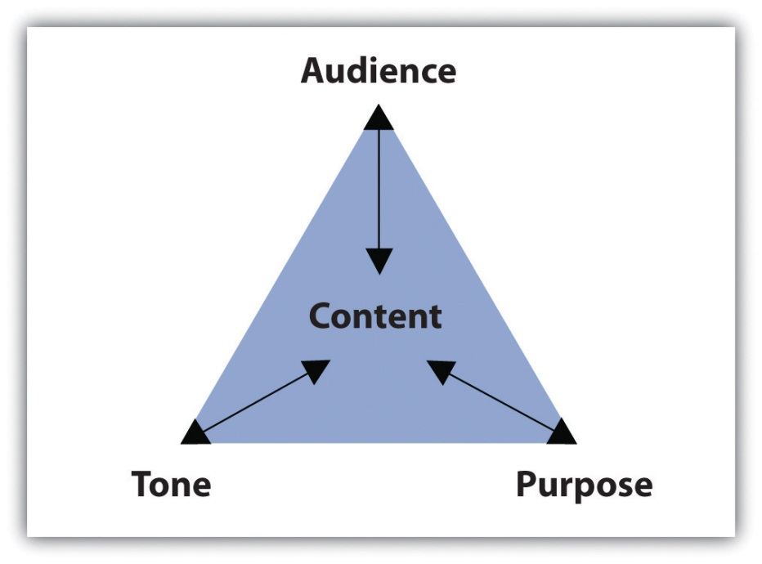
The assignment’s purpose, audience, and tone dictate what the paragraph covers and how it will support one main point. This section covers how purpose, audience, and tone affect reading and writing paragraphs.

Identifying Common Academic Purposes
The purpose for a piece of writing identifies the reason you write a particular document. Basically, the purpose of a piece of writing answers the question “Why?” For example, why write a play? To entertain a packed theater. Why write instructions to the babysitter? To inform him or her of your schedule and rules. Why write a letter to your congressman? To persuade him to address your community’s needs.
In academic settings, the reasons for writing fulfill four main purposes: to summarize, to analyze, to synthesize, and to evaluate. You will encounter these four purposes not only as you read for your classes but also as you read for work or pleasure. Because reading and writing work together, your writing skills will improve as you read. To learn more about reading in the writing process, see Chapter 7 "The Writing Process: How Do I Begin?".
Eventually, your instructors will ask you to complete assignments specifically designed to meet one of the four purposes. As you will see, the purpose for writing will guide you through each part of the paper, helping you make decisions about content and style. For now, identifying these purposes by reading paragraphs will prepare you to write individual paragraphs and to build longer assignments.

Summary Paragraphs
A summary shrinks a large amount of information into only the essentials. You probably summarize events, books, and movies daily. Think about the last blockbuster movie you saw or the last novel you read. Chances are, at some point in a casual conversation with a friend, coworker, or classmate, you compressed all the action in a two-hour film or in a two-hundred-page book into a brief description of the major plot movements. While in conversation, you probably described the major highlights, or the main points in just a few sentences, using your own vocabulary and manner of speaking.
Similarly, a summary paragraph condenses a long piece of writing into a smaller paragraph by extracting only the vital information. A summary uses only the writer’s own words. Like the summary’s purpose in daily conversation, the purpose of an academic summary paragraph is to maintain all the essential information from a longer document. Although shorter than the original piece of writing, a summary should still communicate all the key points and key support. In other words, summary paragraphs should be succinct and to the point.
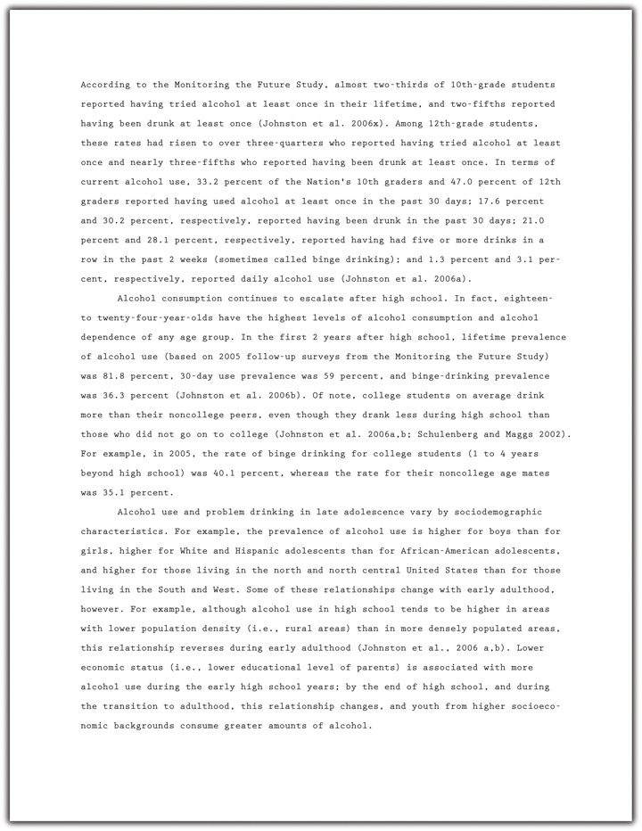
A summary of the report should present all the main points and supporting details in brief. Read the following summary of the report written by a student:
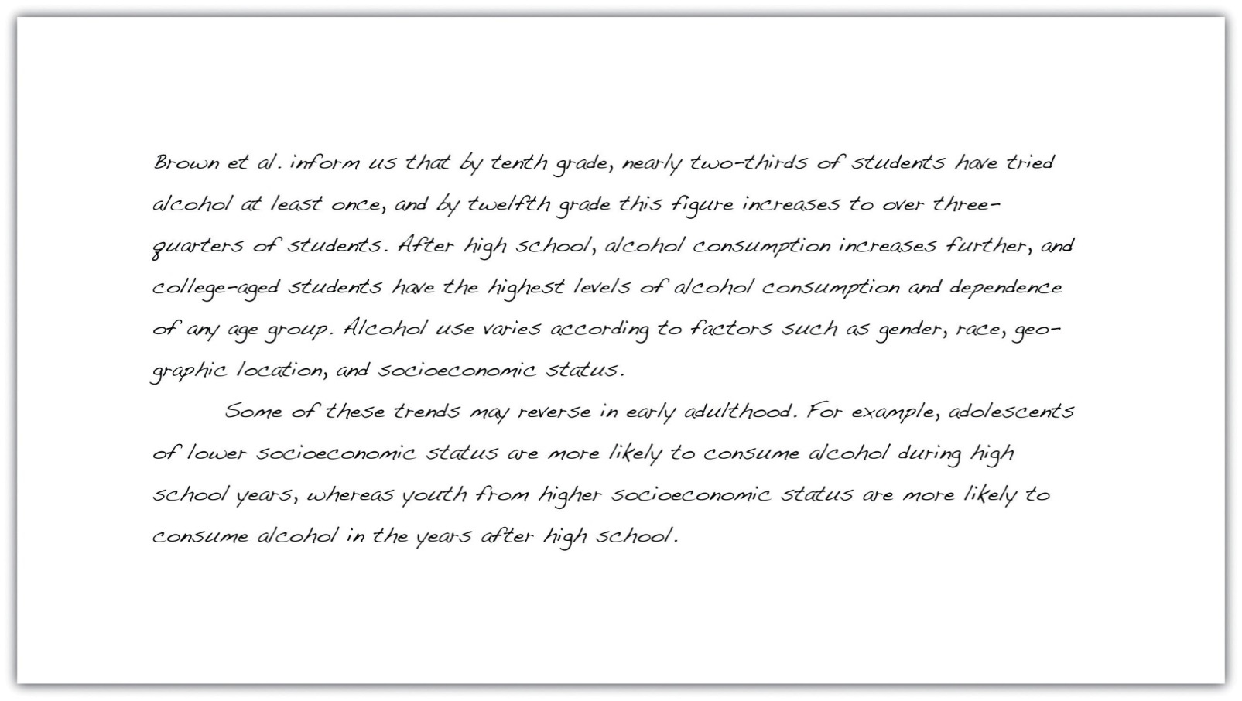
Notice how the summary retains the key points made by the writers of the original report but omits most of the statistical data. Summaries need not contain all the specific facts and figures in the original document; they provide only an overview of the essential information.

Analysis Paragraphs
An analysis separates complex materials in their different parts and studies how the parts relate to one another. The analysis of simple table salt, for example, would require a deconstruction of its parts—the elements sodium (Na) and chloride (Cl). Then, scientists would study how the two elements interact to create the compound NaCl, or sodium chloride, which is also called simple table salt.
Analysis is not limited to the sciences, of course. An analysis paragraph in academic writing fulfills the same purpose. Instead of deconstructing compounds, academic analysis paragraphs typically deconstruct documents. An analysis takes apart a primary source (an essay, a book, an article, etc.) point by point. It communicates the main points of the document by examining individual points and identifying how the points relate to one another.

Take a look at a student’s analysis of the journal report.
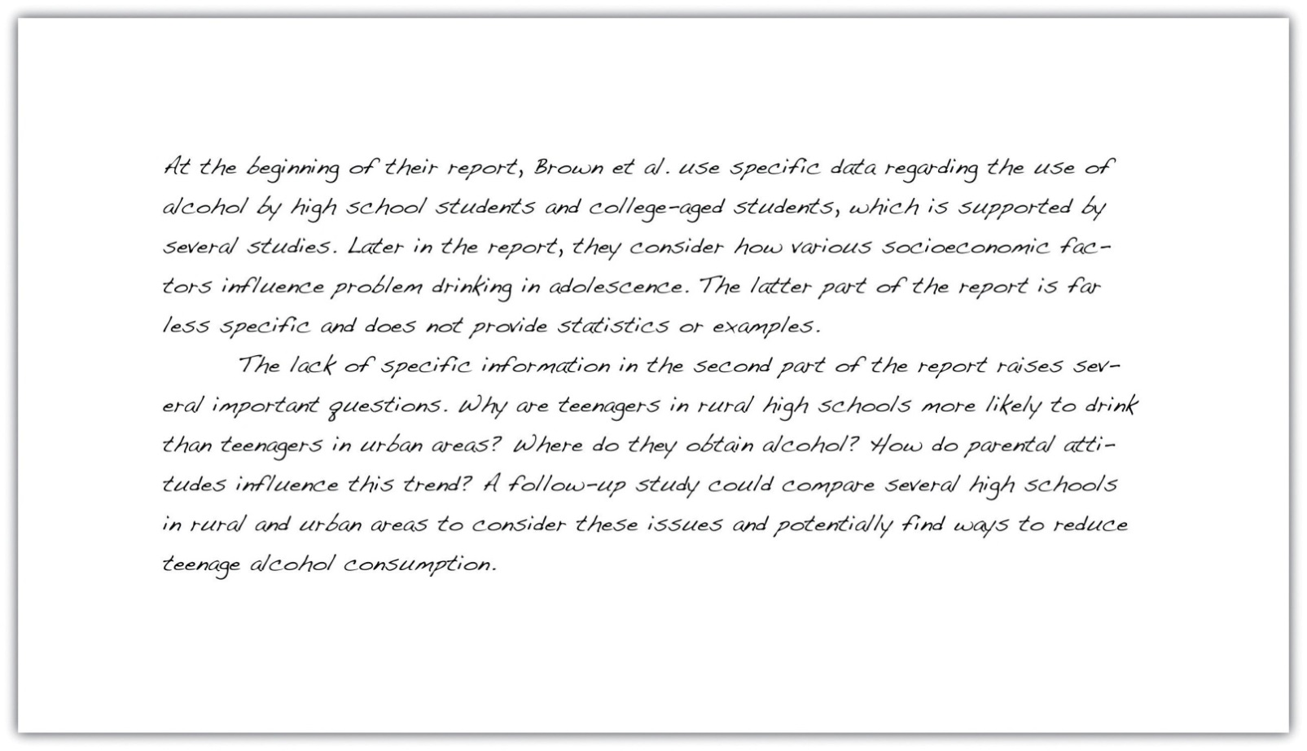
Notice how the analysis does not simply repeat information from the original report, but considers how the points within the report relate to one another. By doing this, the student uncovers a discrepancy between the points that are backed up by statistics and those that require additional information. Analyzing a document involves a close examination of each of the individual parts and how they work together.

Synthesis Paragraphs
A synthesis combines two or more items to create an entirely new item. Consider the electronic musical instrument aptly named the synthesizer. It looks like a simple keyboard but displays a dashboard of switches, buttons, and levers. With the flip of a few switches, a musician may combine the distinct sounds of a piano, a flute, or a guitar—or any other combination of instruments—to create a new sound. The purpose of the synthesizer is to blend together the notes from individual instruments to form new, unique notes.
The purpose of an academic synthesis is to blend individual documents into a new document. An academic synthesis paragraph considers the main points from one or more pieces of writing and links the main points together to create a new point, one not replicated in either document.

Take a look at a student’s synthesis of several sources about underage drinking.
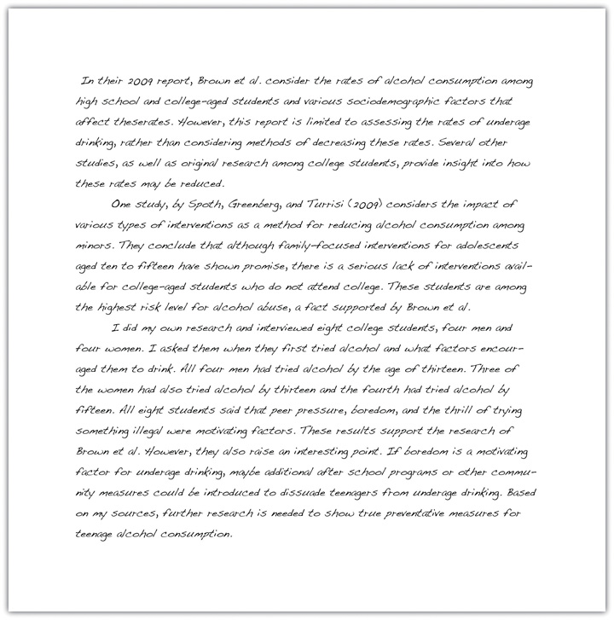
Notice how the synthesis paragraphs consider each source and use information from each to create a new thesis. A good synthesis does not repeat information; the writer uses a variety of sources to create a new idea.

Evaluation Paragraphs
An evaluation judges the value of something and determines its worth. Evaluations in everyday experiences are often not only dictated by set standards but also influenced by opinion and prior knowledge. For example, at work, a supervisor may complete an employee evaluation by judging his subordinate’s performance based on the company’s goals. If the company focuses on improving communication, the supervisor will rate the employee’s customer service according to a standard scale. However, the evaluation still depends on the supervisor’s opinion and prior experience with the employee. The purpose of the evaluation is to determine how well the employee performs at his or her job.
An academic evaluation communicates your opinion, and its justifications, about a document or a topic of discussion. Evaluations are influenced by your reading of the document, your prior knowledge, and your prior experience with the topic or issue. Because an evaluation incorporates your point of view and reasons for your point of view, it typically requires more critical thinking and a combination of summary, analysis, and synthesis skills. Thus evaluation paragraphs often follow summary, analysis, and synthesis paragraphs. Read a student’s evaluation paragraph.
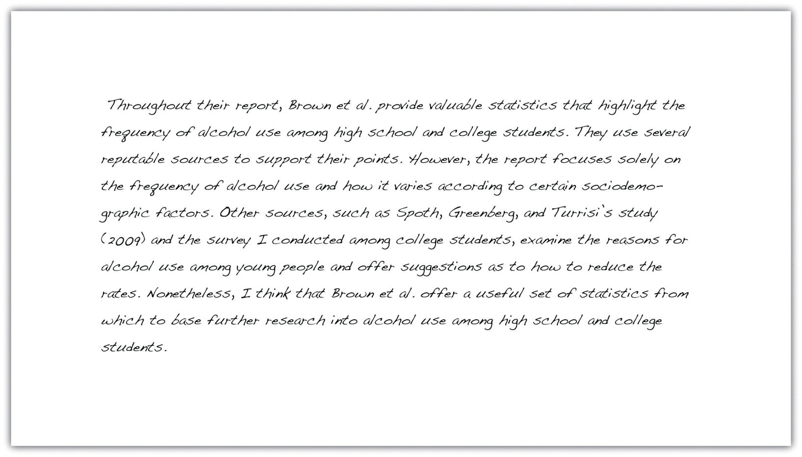
Notice how the paragraph incorporates the student’s personal judgment within the evaluation. Evaluating a document requires prior knowledge that is often based on additional research.

Tip
When reviewing directions for assignments, look for the verbs summarize, analyze, synthesize, or evaluate. Instructors often use these words to clearly indicate the assignment’s purpose. These words will cue you on how to complete the assignment because you will know its exact purpose.

Exercise 1
Read the following paragraphs about four films and then identify the purpose of each paragraph.
- This film could easily have been cut down to less than two hours. By the final scene, I noticed that most of my fellow moviegoers were snoozing in their seats and were barely paying attention to what was happening on screen. Although the director sticks diligently to the book, he tries too hard to cram in all the action, which is just too ambitious for such a detail-oriented story. If you want my advice, read the book and give the movie a miss.
- During the opening scene, we learn that the character Laura is adopted and that she has spent the past three years desperately trying to track down her real parents. Having exhausted all the usual options—adoption agencies, online searches, family trees, and so on—she is on the verge of giving up when she meets a stranger on a bus. The chance encounter leads to a complicated chain of events that ultimately result in Laura getting her lifelong wish. But is it really what she wants? Throughout the rest of the film, Laura discovers that sometimes the past is best left where it belongs.
- To create the feeling of being gripped in a vice, the director, May Lee, uses a variety of elements to gradually increase the tension. The creepy, haunting melody that subtly enhances the earlier scenes becomes ever more insistent, rising to a disturbing crescendo toward the end of the movie. The desperation of the actors, combined with the claustrophobic atmosphere and tight camera angles create a realistic firestorm, from which there is little hope of escape. Walking out of the theater at the end feels like staggering out of a Roman dungeon.
- The scene in which Campbell and his fellow prisoners assist the guards in shutting down the riot immediately strikes the viewer as unrealistic. Based on the recent reports on prison riots in both Detroit and California, it seems highly unlikely that a posse of hardened criminals will intentionally help their captors at the risk of inciting future revenge from other inmates. Instead, both news reports and psychological studies indicate that prisoners who do not actively participate in a riot will go back to their cells and avoid conflict altogether. Examples of this lack of attention to detail occur throughout the film, making it almost unbearable to watch.
Collaboration
Share with a classmate and compare your answers.

Writing at Work
Thinking about the purpose of writing a report in the workplace can help focus and structure the document. A summary should provide colleagues with a factual overview of your findings without going into too much specific detail. In contrast, an evaluation should include your personal opinion, along with supporting evidence, research, or examples to back it up. Listen for words such as summarize, analyze, synthesize, or evaluate when your boss asks you to complete a report to help determine a purpose for writing.

Exercise 2
Consider the essay most recently assigned to you. Identify the most effective academic purpose for the assignment.
My assignment: ____________________________________________
My purpose: ____________________________________________

Identifying the Audience
Imagine you must give a presentation to a group of executives in an office. Weeks before the big day, you spend time creating and rehearsing the presentation. You must make important, careful decisions not only about the content but also about your delivery. Will the presentation require technology to project figures and charts? Should the presentation define important words, or will the executives already know the terms? Should you wear your suit and dress shirt? The answers to these questions will help you develop an appropriate relationship with your audience, making them more receptive to your message.
Now imagine you must explain the same business concepts from your presentation to a group of high school students. Those important questions you previously answered may now require different answers. The figures and charts may be too sophisticated, and the terms will certainly require definitions. You may even reconsider your outfit and sport a more casual look. Because the audience has shifted, your presentation and delivery will shift as well to create a new relationship with the new audience.
In these two situations, the audience—the individuals who will watch and listen to the presentation—plays a role in the development of presentation. As you prepare the presentation, you visualize the audience to anticipate their expectations and reactions. What you imagine affects the information you choose to present and how you will present it. Then, during the presentation, you meet the audience in person and discover immediately how well you perform.
Although the audience for writing assignments—your readers—may not appear in person, they play an equally vital role. Even in everyday writing activities, you identify your readers’ characteristics, interests, and expectations before making decisions about what you write. In fact, thinking about audience has become so common that you may not even detect the audience-driven decisions.
For example, you update your status on a social networking site with the awareness of who will digitally follow the post. If you want to brag about a good grade, you may write the post to please family members. If you want to describe a funny moment, you may write with your friends’ senses of humor in mind. Even at work, you send e-mails with an awareness of an unintended receiver who could intercept the message.
In other words, being aware of “invisible” readers is a skill you most likely already possess and one you rely on every day. Consider the following paragraphs. Which one would the author send to her parents? Which one would she send to her best friend?
Example A
Last Saturday, I volunteered at a local hospital. The visit was fun and rewarding. I even learned how to do cardiopulmonary resuscitation, or CPR. Unfortunately, I think caught a cold from one of the patients. This week, I will rest in bed and drink plenty of clear fluids. I hope I am well by next Saturday to volunteer again.
Example B
OMG! You won’t believe this! My advisor forced me to do my community service hours at this hospital all weekend! We learned CPR but we did it on dummies, not even real peeps. And some kid sneezed on me and got me sick! I was so bored and sniffling all weekend; I hope I don’t have to go back next week. I def do NOT want to miss the basketball tournament!
Most likely, you matched each paragraph to its intended audience with little hesitation. Because each paragraph reveals the author’s relationship with her intended readers, you can identify the audience fairly quickly. When writing your own paragraphs, you must engage with your audience to build an appropriate relationship given your subject. Imagining your readers during each stage of the writing process will help you make decisions about your writing. Ultimately, the people you visualize will affect what and how you write.

Tip
While giving a speech, you may articulate an inspiring or critical message, but if you left your hair a mess and laced up mismatched shoes, your audience would not take you seriously. They may be too distracted by your appearance to listen to your words.
Similarly, grammar and sentence structure serve as the appearance of a piece of writing. Polishing your work using correct grammar will impress your readers and allow them to focus on what you have to say.
Because focusing on audience will enhance your writing, your process, and your finished product, you must consider the specific traits of your audience members. Use your imagination to anticipate the readers’ demographics, education, prior knowledge, and expectations.
- Demographics. These measure important data about a group of people, such as their age range, their ethnicity, their religious beliefs, or their gender. Certain topics and assignments will require these kinds of considerations about your audience. For other topics and assignments, these measurements may not influence your writing in the end. Regardless, it is important to consider demographics when you begin to think about your purpose for writing.
- Education. Education considers the audience’s level of schooling. If audience members have earned a doctorate degree, for example, you may need to elevate your style and use more formal language. Or, if audience members are still in college, you could write in a more relaxed style. An audience member’s major or emphasis may also dictate your writing.
- Prior knowledge. This refers to what the audience already knows about your topic. If your readers have studied certain topics, they may already know some terms and concepts related to the topic. You may decide whether to define terms and explain concepts based on your audience’s prior knowledge. Although you cannot peer inside the brains of your readers to discover their knowledge, you can make reasonable assumptions. For instance, a nursing major would presumably know more about health-related topics than a business major would.
- Expectations. These indicate what readers will look for while reading your assignment. Readers may expect consistencies in the assignment’s appearance, such as correct grammar and traditional formatting like double-spaced lines and legible font. Readers may also have content-based expectations given the assignment’s purpose and organization. In an essay titled “The Economics of Enlightenment: The Effects of Rising Tuition,” for example, audience members may expect to read about the economic repercussions of college tuition costs.

Exercise 3
On your own sheet of paper, generate a list of characteristics under each category for each audience. This list will help you later when you read about tone and content.
- Your classmates
  - Demographics ____________________________________________
  - Education ____________________________________________
  - Prior knowledge ____________________________________________
  - Expectations ____________________________________________
- Your instructor
  - Demographics ____________________________________________
  - Education ____________________________________________
  - Prior knowledge ____________________________________________
  - Expectations ____________________________________________
- The head of your academic department
  - Demographics ____________________________________________
  - Education ____________________________________________
  - Prior knowledge ____________________________________________
  - Expectations ____________________________________________
- Now think about your next writing assignment. Identify the purpose (you may use the same purpose listed in Note 5.12 "Exercise 2"), and then identify the audience. Create a list of characteristics under each category.
My assignment: ____________________________________________
My purpose: ____________________________________________
My audience: ____________________________________________
  - Demographics ____________________________________________
  - Education ____________________________________________
  - Prior knowledge ____________________________________________
  - Expectations ____________________________________________
Collaboration
Please share with a classmate and compare your answers.
Keep in mind that as your topic shifts in the writing process, your audience may also shift. For more information about the writing process, see Chapter 7 "The Writing Process: How Do I Begin?".
Also, remember that decisions about style depend on audience, purpose, and content. Identifying your audience’s demographics, education, prior knowledge, and expectations will affect how you write, but purpose and content play an equally important role. The next subsection covers how to select an appropriate tone to match the audience and purpose.

Selecting an Appropriate Tone
Tone identifies a speaker’s attitude toward a subject or another person. You may pick up a person’s tone of voice fairly easily in conversation. A friend who tells you about her weekend may speak excitedly about a fun skiing trip. An instructor who means business may speak in a low, slow voice to emphasize her serious mood. Or, a coworker who needs to let off some steam after a long meeting may crack a sarcastic joke.
Just as speakers transmit emotion through voice, writers can transmit through writing a range of attitudes, from excited and humorous to somber and critical. These emotions create connections among the audience, the author, and the subject, ultimately building a relationship between the audience and the text. To stimulate these connections, writers intimate their attitudes and feelings with useful devices, such as sentence structure, word choice, punctuation, and formal or informal language. Keep in mind that the writer’s attitude should always appropriately match the audience and the purpose.
Read the following paragraph and consider the writer’s tone. How would you describe the writer’s attitude toward wildlife conservation?
Many species of plants and animals are disappearing right before our eyes. If we don’t act fast, it might be too late to save them. Human activities, including pollution, deforestation, hunting, and overpopulation, are devastating the natural environment. Without our help, many species will not survive long enough for our children to see them in the wild. Take the tiger, for example. Today, tigers occupy just 7 percent of their historical range, and many local populations are already extinct. Hunted for their beautiful pelt and other body parts, the tiger population has plummeted from one hundred thousand in 1920 to just a few thousand. Contact your local wildlife conservation society today to find out how you can stop this terrible destruction.

Exercise 4
Think about the assignment and purpose you selected in Note 5.12 "Exercise 2", and the audience you selected in Note 5.16 "Exercise 3". Now, identify the tone you would use in the assignment.
My assignment: ____________________________________________
My purpose: ____________________________________________
My audience: ____________________________________________
My tone: ____________________________________________

Choosing Appropriate, Interesting Content
Content refers to all the written substance in a document. After selecting an audience and a purpose, you must choose what information will make it to the page. Content may consist of examples, statistics, facts, anecdotes, testimonies, and observations, but no matter the type, the information must be appropriate and interesting for the audience and purpose. An essay written for third graders that summarizes the legislative process, for example, would have to contain succinct and simple content.
Content is also shaped by tone. When the tone matches the content, the audience will be more engaged, and you will build a stronger relationship with your readers. Consider that audience of third graders. You would choose simple content that the audience will easily understand, and you would express that content through an enthusiastic tone. The same considerations apply to all audiences and purposes.

Exercise 5
Match the content in the box to the appropriate audience and purpose. On your own sheet of paper, write the correct letter next to the number.
- Whereas economist Holmes contends that the financial crisis is far from over, the presidential advisor Jones points out that it is vital to catch the first wave of opportunity to increase market share. We can use elements of both experts’ visions. Let me explain how.
- In 2000, foreign money flowed into the United States, contributing to easy credit conditions. People bought larger houses than they could afford, eventually defaulting on their loans as interest rates rose.
- The Emergency Economic Stabilization Act, known by most of us as the humungous government bailout, caused mixed reactions. Although supported by many political leaders, the statute provoked outrage among grassroots groups. In their opinion, the government was actually rewarding banks for their appalling behavior.
- Audience: An instructor
Purpose: To analyze the reasons behind the 2007 financial crisis
Content: ____________________________________________
- Audience: Classmates
Purpose: To summarize the effects of the $700 billion government bailout
Content: ____________________________________________
- Audience: An employer
Purpose: To synthesize two articles on preparing businesses for economic recovery
Content: ____________________________________________
Collaboration
Please share with a classmate and compare your answers.

Exercise 6
Using the assignment, purpose, audience, and tone from Note 5.18 "Exercise 4", generate a list of content ideas. Remember that content consists of examples, statistics, facts, anecdotes, testimonies, and observations.
My assignment: ____________________________________________
My purpose: ____________________________________________
My audience: ____________________________________________
My tone: ____________________________________________
My content ideas: ____________________________________________

Key Takeaways
- Paragraphs separate ideas into logical, manageable chunks of information.
- The content of each paragraph and document is shaped by purpose, audience, and tone.
- The four common academic purposes are to summarize, to analyze, to synthesize, and to evaluate.
- Identifying the audience’s demographics, education, prior knowledge, and expectations will affect how and what you write.
- Devices such as sentence structure, word choice, punctuation, and formal or informal language communicate tone and create a relationship between the writer and his or her audience.
- Content may consist of examples, statistics, facts, anecdotes, testimonies, and observations. All content must be appropriate and interesting for the audience, purpose and tone.

5.2 Effective Means for Writing a Paragraph

Learning Objectives
- Identify characteristics of a good topic sentence.
- Identify the three parts of a developed paragraph.
- Apply knowledge of topic sentences and parts of a developed paragraph in an assignment.
Now that you have identified common purposes for writing and learned how to select appropriate content for a particular audience, you can think about the structure of a paragraph in greater detail. Composing an effective paragraph requires a method similar to building a house. You may have the finest content, or materials, but if you do not arrange them in the correct order, then the final product will not hold together very well.
A strong paragraph contains three distinct components:
- Topic sentence. The topic sentence is the main idea of the paragraph.
- Body. The body is composed of the supporting sentences that develop the main point.
- Conclusion. The conclusion is the final sentence that summarizes the main point.
The foundation of a good paragraph is the topic sentence, which expresses the main idea of the paragraph. The topic sentence relates to the thesis, or main point, of the essay (see Chapter 8 "Writing Essays: From Start to Finish" for more information about thesis statements) and guides the reader by signposting what the paragraph is about. All the sentences in the rest of the paragraph should relate to the topic sentence.
This section covers the major components of a paragraph and examines how to develop an effective topic sentence.

Developing a Topic Sentence
Pick up any newspaper or magazine and read the first sentence of an article. Are you fairly confident that you know what the rest of the article is about? If so, you have likely read the topic sentence. An effective topic sentence combines a main idea with the writer’s personal attitude or opinion. It serves to orient the reader and provides an indication of what will follow in the rest of the paragraph. Read the following example.
Creating a national set of standards for math and English education will improve student learning in many states.
This topic sentence declares a favorable position for standardizing math and English education. After reading this sentence, a reader might reasonably expect the writer to provide supporting details and facts as to why standardizing math and English education might improve student learning in many states. If the purpose of the essay is actually to evaluate education in only one particular state, or to discuss math or English education specifically, then the topic sentence is misleading.

Tip
When writing a draft of an essay, allow a friend or colleague to read the opening line of your first paragraph. Ask your reader to predict what your paper will be about. If he or she is unable to guess your topic accurately, you should consider revising your topic sentence so that it clearly defines your purpose in writing.

Main Idea versus Controlling Idea
Topic sentences contain both a main idea (the subject, or topic that the writer is discussing) and a controlling idea (the writer’s specific stance on that subject). Just as a thesis statement includes an idea that controls a document’s focus (as you will read about in Chapter 7 "The Writing Process: How Do I Begin?"), a topic sentence must also contain a controlling idea to direct the paragraph. Different writers may use the same main idea but can steer their paragraph in a number of different directions according to their stance on the subject. Read the following examples.
- Marijuana is a destructive influence on teens and causes long-term brain damage.
- The antinausea properties in marijuana are a lifeline for many cancer patients.
- Legalizing marijuana would create a higher demand for Class A and Class B drugs.
Although the main idea—marijuana—is the same in all three topic sentences, the controlling idea differs depending on the writer’s viewpoint.

Exercise 1
Circle the main idea and underline the controlling idea in each of the following topic sentences.
- Exercising three times a week is the only way to maintain good physical health.
- Sexism and racism are still rampant in today’s workplace.
- Raising the legal driving age to twenty-one would decrease road traffic accidents.
- Owning a business is the only way to achieve financial success.
- Dog owners should be prohibited from taking their pets on public beaches.

Characteristics of a Good Topic Sentence
Five characteristics define a good topic sentence:
- A good topic sentence provides an accurate indication of what will follow in the rest of the paragraph.
Weak example. People rarely give firefighters the credit they deserve for such a physically and emotionally demanding job. (The paragraph is about a specific incident that involved firefighters; therefore, this topic sentence is too general.)
Stronger example. During the October riots, Unit 3B went beyond the call of duty. (This topic sentence is more specific and indicates that the paragraph will contain information about a particular incident involving Unit 3B.)
- A good topic sentence contains both a topic and a controlling idea or opinion.
Weak example. In this paper, I am going to discuss the rising suicide rate among young professionals. (This topic sentence provides a main idea, but it does not present a controlling idea, or thesis.)
Stronger example. The rising suicide rate among young professionals is a cause for immediate concern. (This topic sentence presents the writer’s opinion on the subject of rising suicide rates among young professionals.)
- A good topic sentence is clear and easy to follow.
Weak example. In general, writing an essay, thesis, or other academic or nonacademic document is considerably easier and of much higher quality if you first construct an outline, of which there are many different types. (This topic sentence includes a main idea and a controlling thesis, but both are buried beneath the confusing sentence structure and unnecessary vocabulary. These obstacles make it difficult for the reader to follow.)
Stronger example. Most forms of writing can be improved by first creating an outline. (This topic sentence cuts out unnecessary verbiage and simplifies the previous statement, making it easier for the reader to follow.)
- A good topic sentence does not include supporting details.
Weak example. Salaries should be capped in baseball for many reasons, most importantly so we don’t allow the same team to win year after year. (This topic sentence includes a supporting detail that should be included later in the paragraph to back up the main point.)
Stronger example. Introducing a salary cap would improve the game of baseball for many reasons. (This topic sentence omits the additional supporting detail so that it can be expanded upon later in the paragraph.)
- A good topic sentence engages the reader by using interesting vocabulary.
Weak example. The military deserves better equipment. (This topic sentence includes a main idea and a controlling thesis, but the language is bland and unexciting.)
Stronger example. The appalling lack of resources provided to the military is outrageous and requires our immediate attention. (This topic sentence reiterates the same idea and controlling thesis, but adjectives such as appalling and immediate better engage the reader. These words also indicate the writer’s tone.)

Exercise 2
Choose the most effective topic sentence from the following sentence pairs.
- a. This paper will discuss the likelihood of the Democrats winning the next election.
b. To boost their chances of winning the next election, the Democrats need to listen to public opinion.
- a. The unrealistic demands of union workers are crippling the economy for three main reasons.
b. Union workers are crippling the economy because companies are unable to remain competitive as a result of added financial pressure.
- a. Authors are losing money as a result of technological advances.
b. The introduction of new technology will devastate the literary world.
- a. Rap music is produced by untalented individuals with oversized egos.
b. This essay will consider whether talent is required in the rap music industry.

Exercise 3
Using the tips on developing effective topic sentences in this section, create a topic sentence on each of the following subjects. Remember to include a controlling idea as well as a main idea. Write your responses on your own sheet of paper.
- An endangered species
____________________________________________
- The cost of fuel
____________________________________________
- The legal drinking age
____________________________________________
- A controversial film or novel
____________________________________________

Writing at Work
When creating a workplace document, use the “top-down” approach—keep the topic sentence at the beginning of each paragraph so that readers immediately understand the gist of the message. This method saves busy colleagues precious time and effort trying to figure out the main points and relevant details.
Headings are another helpful tool. In a text-heavy document, break up each paragraph with individual headings. These serve as useful navigation aids, enabling colleagues to skim through the document and locate paragraphs that are relevant to them.

Developing Paragraphs That Use Topic Sentences, Supporting Ideas, and Transitions Effectively
Learning how to develop a good topic sentence is the first step toward writing a solid paragraph. Once you have composed your topic sentence, you have a guideline for the rest of the paragraph. To complete the paragraph, a writer must support the topic sentence with additional information and summarize the main point with a concluding sentence.
This section identifies the three major structural parts of a paragraph and covers how to develop a paragraph using transitional words and phrases.

Identifying Parts of a Paragraph
An effective paragraph contains three main parts: a topic sentence, the body, and the concluding sentence. A topic sentence is often the first sentence of a paragraph. This chapter has already discussed its purpose—to express a main idea combined with the writer’s attitude about the subject. The body of the paragraph usually follows, containing supporting details. Supporting sentences help explain, prove, or enhance the topic sentence. The concluding sentence is the last sentence in the paragraph. It reminds the reader of the main point by restating it in different words.

Figure 5.2 Paragraph Structure Graphic Organizer
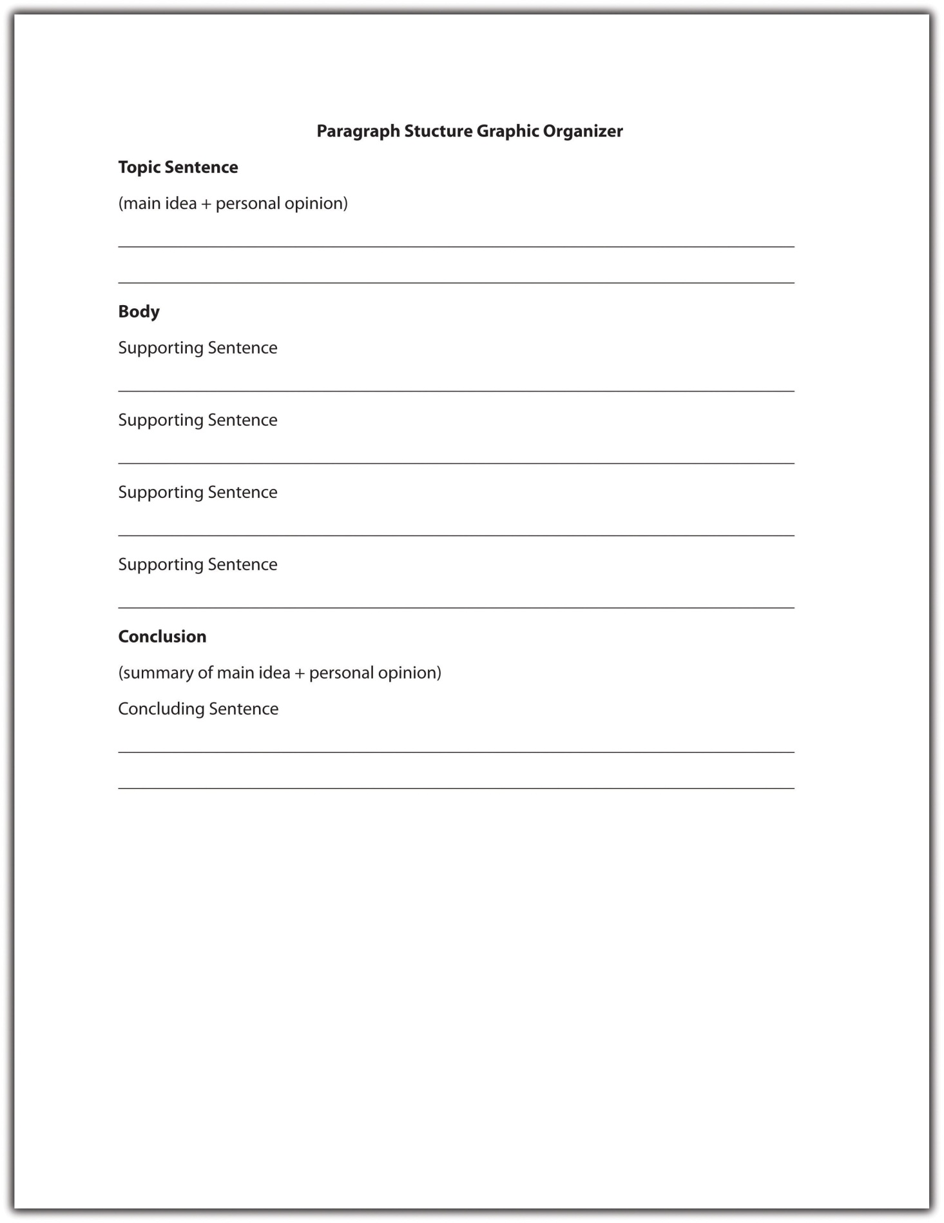
Read the following paragraph. The topic sentence is underlined for you.
After reading the new TV guide this week I had just one thought—why are we still being bombarded with reality shows? This season, the plague of reality television continues to darken our airwaves. Along with the return of viewer favorites, we are to be cursed with yet another mindless creation. Prisoner follows the daily lives of eight suburban housewives who have chosen to be put in jail for the purposes of this fake psychological experiment. A preview for the first episode shows the usual tears and tantrums associated with reality television. I dread to think what producers will come up with next season, but if any of them are reading this blog—stop it! We’ve had enough reality television to last us a lifetime!
The first sentence of this paragraph is the topic sentence. It tells the reader that the paragraph will be about reality television shows, and it expresses the writer’s distaste for these shows through the use of the word bombarded.
Each of the following sentences in the paragraph supports the topic sentence by providing further information about a specific reality television show. The final sentence is the concluding sentence. It reiterates the main point that viewers are bored with reality television shows by using different words from the topic sentence.
Paragraphs that begin with the topic sentence move from the general to the specific. They open with a general statement about a subject (reality shows) and then discuss specific examples (the reality show Prisoner). Most academic essays contain the topic sentence at the beginning of the first paragraph.
Now take a look at the following paragraph. The topic sentence is underlined for you.
Last year, a cat traveled 130 miles to reach its family, who had moved to another state and had left their pet behind. Even though it had never been to their new home, the cat was able to track down its former owners. A dog in my neighborhood can predict when its master is about to have a seizure. It makes sure that he does not hurt himself during an epileptic fit. Compared to many animals, our own senses are almost dull.
The last sentence of this paragraph is the topic sentence. It draws on specific examples (a cat that tracked down its owners and a dog that can predict seizures) and then makes a general statement that draws a conclusion from these examples (animals’ senses are better than humans’). In this case, the supporting sentences are placed before the topic sentence and the concluding sentence is the same as the topic sentence.
This technique is frequently used in persuasive writing. The writer produces detailed examples as evidence to back up his or her point, preparing the reader to accept the concluding topic sentence as the truth.
Sometimes, the topic sentence appears in the middle of a paragraph. Read the following example. The topic sentence is underlined for you.
For many years, I suffered from severe anxiety every time I took an exam. Hours before the exam, my heart would begin pounding, my legs would shake, and sometimes I would become physically unable to move. Last year, I was referred to a specialist and finally found a way to control my anxiety—breathing exercises. It seems so simple, but by doing just a few breathing exercises a couple of hours before an exam, I gradually got my anxiety under control. The exercises help slow my heart rate and make me feel less anxious. Better yet, they require no pills, no equipment, and very little time. It’s amazing how just breathing correctly has helped me learn to manage my anxiety symptoms.
In this paragraph, the underlined sentence is the topic sentence. It expresses the main idea—that breathing exercises can help control anxiety. The preceding sentences enable the writer to build up to his main point (breathing exercises can help control anxiety) by using a personal anecdote (how he used to suffer from anxiety). The supporting sentences then expand on how breathing exercises help the writer by providing additional information. The last sentence is the concluding sentence and restates how breathing can help manage anxiety.
Placing a topic sentence in the middle of a paragraph is often used in creative writing. If you notice that you have used a topic sentence in the middle of a paragraph in an academic essay, read through the paragraph carefully to make sure that it contains only one major topic. To read more about topic sentences and where they appear in paragraphs, see Chapter 7 "The Writing Process: How Do I Begin?".

Implied Topic Sentences
Some well-organized paragraphs do not contain a topic sentence at all. Instead of being directly stated, the main idea is implied in the content of the paragraph. Read the following example:
Heaving herself up the stairs, Luella had to pause for breath several times. She let out a wheeze as she sat down heavily in the wooden rocking chair. Tao approached her cautiously, as if she might crumble at the slightest touch. He studied her face, like parchment; stretched across the bones so finely he could almost see right through the skin to the decaying muscle underneath. Luella smiled a toothless grin.
Although no single sentence in this paragraph states the main idea, the entire paragraph focuses on one concept—that Luella is extremely old. The topic sentence is thus implied rather than stated. This technique is often used in descriptive or narrative writing. Implied topic sentences work well if the writer has a firm idea of what he or she intends to say in the paragraph and sticks to it. However, a paragraph loses its effectiveness if an implied topic sentence is too subtle or the writer loses focus.

Tip
Avoid using implied topic sentences in an informational document. Readers often lose patience if they are unable to quickly grasp what the writer is trying to say. The clearest and most efficient way to communicate in an informational document is to position the topic sentence at the beginning of the paragraph.

Exercise 4
Identify the topic sentence, supporting sentences, and concluding sentence in the following paragraph.
The desert provides a harsh environment in which few mammals are able to adapt. Of these hardy creatures, the kangaroo rat is possibly the most fascinating. Able to live in some of the most arid parts of the southwest, the kangaroo rat neither sweats nor pants to keep cool. Its specialized kidneys enable it to survive on a miniscule amount of water. Unlike other desert creatures, the kangaroo rat does not store water in its body but instead is able to convert the dry seeds it eats into moisture. Its ability to adapt to such a hostile environment makes the kangaroo rat a truly amazing creature.
Collaboration
Please share with a classmate and compare your answers.

Supporting Sentences
If you think of a paragraph as a hamburger, the supporting sentences are the meat inside the bun. They make up the body of the paragraph by explaining, proving, or enhancing the controlling idea in the topic sentence. Most paragraphs contain three to six supporting sentences depending on the audience and purpose for writing. A supporting sentence usually offers one of the following:
- Reason
Sentence: The refusal of the baby boom generation to retire is contributing to the current lack of available jobs.
- Fact
Sentence: Many families now rely on older relatives to support them financially.
- Statistic
Sentence: Nearly 10 percent of adults are currently unemployed in the United States.
- Quotation
Sentence: “We will not allow this situation to continue,” stated Senator Johns.
- Example
Sentence: Last year, Bill was asked to retire at the age of fifty-five.
The type of supporting sentence you choose will depend on what you are writing and why you are writing. For example, if you are attempting to persuade your audience to take a particular position you should rely on facts, statistics, and concrete examples, rather than personal opinions. Read the following example:
There are numerous advantages to owning a hybrid car. (Topic sentence)
First, they get 20 percent to 35 percent more miles to the gallon than a fuel-efficient gas-powered vehicle. (Supporting sentence 1: statistic)
Second, they produce very few emissions during low speed city driving. (Supporting sentence 2: fact)
Because they do not require gas, hybrid cars reduce dependency on fossil fuels, which helps lower prices at the pump. (Supporting sentence 3: reason)
Alex bought a hybrid car two years ago and has been extremely impressed with its performance. (Supporting sentence 4: example)
“It’s the cheapest car I’ve ever had,” she said. “The running costs are far lower than previous gas powered vehicles I’ve owned.” (Supporting sentence 5: quotation)
Given the low running costs and environmental benefits of owning a hybrid car, it is likely that many more people will follow Alex’s example in the near future. (Concluding sentence)
To find information for your supporting sentences, you might consider using one of the following sources:
- Reference book
- Encyclopedia
- Website
- Biography/autobiography
- Map
- Dictionary
- Newspaper/magazine
- Interview
- Previous experience
- Personal research
To read more about sources and research, see Chapter 10 "Writing Preparation".

Tip
When searching for information on the Internet, remember that some websites are more reliable than others. websites ending in .gov or .edu are generally more reliable than websites ending in .com or .org. Wikis and blogs are not reliable sources of information because they are subject to inaccuracies.

Concluding Sentences
An effective concluding sentence draws together all the ideas you have raised in your paragraph. It reminds readers of the main point—the topic sentence—without restating it in exactly the same words. Using the hamburger example, the top bun (the topic sentence) and the bottom bun (the concluding sentence) are very similar. They frame the “meat” or body of the paragraph. Compare the topic sentence and concluding sentence from the previous example:
Topic sentence: There are numerous advantages to owning a hybrid car.
Concluding sentence: Given the low running costs and environmental benefits of owning a hybrid car, it is likely that many more people will follow Alex’s example in the near future.
Notice the use of the synonyms advantages and benefits. The concluding sentence reiterates the idea that owning a hybrid is advantageous without using the exact same words. It also summarizes two examples of the advantages covered in the supporting sentences: low running costs and environmental benefits.
You should avoid introducing any new ideas into your concluding sentence. A conclusion is intended to provide the reader with a sense of completion. Introducing a subject that is not covered in the paragraph will confuse the reader and weaken your writing.
A concluding sentence may do any of the following:
- Restate the main idea.
Example: Childhood obesity is a growing problem in the United States.
- Summarize the key points in the paragraph.
Example: A lack of healthy choices, poor parenting, and an addiction to video games are among the many factors contributing to childhood obesity.
- Draw a conclusion based on the information in the paragraph.
Example: These statistics indicate that unless we take action, childhood obesity rates will continue to rise.
- Make a prediction, suggestion, or recommendation about the information in the paragraph.
Example: Based on this research, more than 60 percent of children in the United States will be morbidly obese by the year 2030 unless we take evasive action.
- Offer an additional observation about the controlling idea.
Example: Childhood obesity is an entirely preventable tragedy.

Exercise 5
On your own paper, write one example of each type of concluding sentence based on a topic of your choice.

Transitions
A strong paragraph moves seamlessly from the topic sentence into the supporting sentences and on to the concluding sentence. To help organize a paragraph and ensure that ideas logically connect to one another, writers use transitional words and phrases. A transition is a connecting word that describes a relationship between ideas. Take another look at the earlier example:
There are numerous advantages to owning a hybrid car. First, they get 20 percent to 35 percent more miles to the gallon than a fuel-efficient gas-powered vehicle. Second, they produce very few emissions during low speed city driving. Because they do not require gas, hybrid cars reduce dependency on fossil fuels, which helps lower prices at the pump. Alex bought a hybrid car two years ago and has been extremely impressed with its performance. “It’s the cheapest car I’ve ever had,” she said. “The running costs are far lower than previous gas-powered vehicles I’ve owned.” Given the low running costs and environmental benefits of owning a hybrid car, it is likely that many more people will follow Alex’s example in the near future.
Each of the underlined words is a transition word. Words such as first and second are transition words that show sequence or clarify order. They help organize the writer’s ideas by showing that he or she has another point to make in support of the topic sentence. Other transition words that show order include third, also, and furthermore.
The transition word because is a transition word of consequence that continues a line of thought. It indicates that the writer will provide an explanation of a result. In this sentence, the writer explains why hybrid cars will reduce dependency on fossil fuels (because they do not require gas). Other transition words of consequence include as a result, so that, since, or for this reason.
To include a summarizing transition in her concluding sentence, the writer could rewrite the final sentence as follows:
In conclusion, given the low running costs and environmental benefits of owning a hybrid car, it is likely that many more people will follow Alex’s example in the near future.
The following chart provides some useful transition words to connect supporting sentences and concluding sentences. See Chapter 7 "The Writing Process: How Do I Begin?" for a more comprehensive look at transitional words and phrases.
Table 5.1 Useful Transitional Words and Phrases
For Supporting Sentences
above all | but | for instance | in particular | moreover | subsequently
also | conversely | furthermore | later on | nevertheless | therefore
aside from | correspondingly | however | likewise | on one hand | to begin with
at the same time | for example | in addition | meanwhile | on the contrary

For Concluding Sentences
after all | all things considered | in brief | in summary | on the whole | to sum up
all in all | finally | in conclusion | on balance | thus

Exercise 6
Using your own paper, write a paragraph on a topic of your choice. Be sure to include a topic sentence, supporting sentences, and a concluding sentence and to use transitional words and phrases to link your ideas together.
Collaboration
Please share with a classmate and compare your answers.

Writing at Work
Transitional words and phrases are useful tools to incorporate into workplace documents. They guide the reader through the document, clarifying relationships between sentences and paragraphs so that the reader understands why they have been written in that particular order.
For example, when writing an instructional memo, it may be helpful to consider the following transitional words and phrases: before you begin, first, next, then, finally, after you have completed. Using these transitions as a template to write your memo will provide readers with clear, logical instructions about a particular process and the order in which steps are supposed to be completed.

Key Takeaways
- A good paragraph contains three distinct components: a topic sentence, body, and concluding sentence.
- The topic sentence expresses the main idea of the paragraph combined with the writer’s attitude or opinion about the topic.
- Good topic sentences contain both a main idea and a controlling idea, are clear and easy to follow, use engaging vocabulary, and provide an accurate indication of what will follow in the rest of the paragraph.
- Topic sentences may be placed at the beginning, middle, or end of a paragraph. In most academic essays, the topic sentence is placed at the beginning of a paragraph.
- Supporting sentences help explain, prove, or enhance the topic sentence by offering facts, reasons, statistics, quotations, or examples.
- Concluding sentences summarize the key points in a paragraph and reiterate the main idea without repeating it word for word.
- Transitional words and phrases help organize ideas in a paragraph and show how these ideas relate to one another.

5.3 Writing Paragraphs: End-of-Chapter Exercises

Exercises
- Select one of the following topics or choose a topic of your choice:
  - Drilling for oil in Alaska
  - Health care reform
  - Introducing a four-day work week
  - Bringing pets to work
  - Charging airline passengers to use the in-flight bathroom
Create a topic sentence based on the topic you chose, remembering to include both a main idea and a controlling idea. Next, write an alternative topic sentence using the same main idea but a different controlling idea. Explain how each fully developed paragraph might differ in tone and content.
Collaboration
Please share with a classmate and compare your answers.
- At some point during your career, you may be asked to write a report or complete a presentation. Imagine that you have been asked to report on the issue of health and safety in the workplace. Using the information in Section 5.1.2 "Identifying the Audience", complete an analysis of your intended audience—your fellow office workers. Consider how demographics, education, prior knowledge, and expectations will influence your report and explain how you will tailor it to your audience accordingly.
Collaboration
Please share with a classmate and compare your answers.
- Group activity. Working in a group of four or five, assign each group member the task of collecting one document each. These documents might include magazine or newspaper articles, workplace documents, academic essays, chapters from a reference book, film or book reviews, or any other type of writing. As a group, read through each document and discuss the author’s purpose for writing. Use the information you have learned in this chapter to decide whether the main purpose is to summarize, analyze, synthesize, or evaluate. Write a brief report on the purpose of each document, using supporting evidence from the text.

- Group activity. Working in a small group, select a workplace document or academic essay that has a clear thesis. Examine each paragraph and identify the topic sentence, supporting sentences, and concluding sentence. Then, choose one particular paragraph and discuss the following questions:
  - Is the topic sentence clearly identifiable or is it implied?
  - Do all the supporting sentences relate to the topic sentence?
  - Does the writer use effective transitions to link his or her ideas?
  - Does the concluding sentence accurately summarize the main point of the paragraph?
As a group, identify the weakest areas of the paragraph and rewrite them. Focus on the relationship among the topic sentence, supporting sentences, and concluding sentence. Use transitions to illustrate the connection between each sentence in the paragraph.
- Peer activity. Using the information you have learned in this chapter, write a paragraph about a current event. Underline the topic sentence in your paragraph. Now, rewrite the paragraph, placing the topic sentence in a different part of the paragraph. Read the two paragraphs aloud to a peer and have him or her identify the topic sentence. Discuss which paragraph is more effective and why.
Collaboration
Please share with a classmate, compare your answers, and discuss the contrasting results.

Chapter 6 Refining Your Writing: How Do I Improve My Writing Technique?

6.1 Sentence Variety

Learning Objectives
- Identify ways to vary sentence structure.
- Write and revise sentence structure at the beginning of sentences.
- Write and revise sentence structure by connecting ideas.
Have you ever ordered a dish in a restaurant and been not happy with its taste, even though it contained most of your favorite ingredients? Just as a meal might lack the finishing touches needed to spice it up, so too might a paragraph contain all the basic components but still lack the stylistic finesse required to engage a reader. Sometimes writers have a tendency to reuse the same sentence pattern throughout their writing. Like any repetitive task, reading text that contains too many sentences with the same length and structure can become monotonous and boring. Experienced writers mix it up by using an assortment of sentence patterns, rhythms, and lengths.
In this chapter, you will follow a student named Naomi who has written a draft of an essay but needs to refine her writing. This section discusses how to introduce sentence variety into writing, how to open sentences using a variety of techniques, and how to use different types of sentence structure when connecting ideas. You can use these techniques when revising a paper to bring life and rhythm to your work. They will also make reading your work more enjoyable.

Incorporating Sentence Variety
Experienced writers incorporate sentence variety into their writing by varying sentence style and structure. Using a mixture of different sentence structures reduces repetition and adds emphasis to important points in the text. Read the following example:
During my time in office I have achieved several goals. I have helped increase funding for local schools. I have reduced crime rates in the neighborhood. I have encouraged young people to get involved in their community. My competitor argues that she is the better choice in the upcoming election. I argue that it is ridiculous to fix something that isn’t broken. If you reelect me this year, I promise to continue to serve this community.
In this extract from an election campaign, the writer uses short, simple sentences of a similar length and style. Writers often mistakenly believe that this technique makes the text more clear for the reader, but the result is a choppy, unsophisticated paragraph that does not grab the audience’s attention. Now read the revised paragraph with sentence variety:
During my time in office, I have helped increase funding for local schools, reduced crime rates in the neighborhood, and encouraged young people to get involved in their community. Why fix what isn’t broken? If you reelect me this year, I will continue to achieve great things for this community. Don’t take a chance on an unknown contender; vote for the proven success.
Notice how introducing a short rhetorical question among the longer sentences in the paragraph is an effective means of keeping the reader’s attention. In the revised version, the writer combines the choppy sentences at the beginning into one longer sentence, which adds rhythm and interest to the paragraph.

Tip
Effective writers often implement the “rule of three,” which is basically the thought that things that contain three elements are more memorable and more satisfying to readers than any other number. Try to use a series of three when providing examples, grouping adjectives, or generating a list.

Exercise 1
Combine each set of simple sentences into a compound or a complex sentence. Write the combined sentence on your own sheet of paper.
- Heroin is an extremely addictive drug. Thousands of heroin addicts die each year.
- Shakespeare’s writing is still relevant today. He wrote about timeless themes. These themes include love, hate, jealousy, death, and destiny.
- Gay marriage is now legal in six states. Iowa, Massachusetts, Connecticut, Vermont, New Hampshire, and Maine all permit same-sex marriage. Other states are likely to follow their example.
- Prewriting is a vital stage of the writing process. Prewriting helps you organize your ideas. Types of prewriting include outlining, brainstorming, and idea mapping.
- Mitch Bancroft is a famous writer. He also serves as a governor on the local school board. Mitch’s two children attend the school.
Collaboration
Please share with a classmate and compare your answers.

Using Sentence Variety at the Beginning of Sentences
Read the following sentences and consider what they all have in common:
John and Amanda will be analyzing this week’s financial report.
The car screeched to a halt just a few inches away from the young boy.
Students rarely come to the exam adequately prepared.
If you are having trouble figuring out why these sentences are similar, try underlining the subject in each. You will notice that the subject is positioned at the beginning of each sentence—John and Amanda, the car, students. Since the subject-verb-object pattern is the simplest sentence structure, many writers tend to overuse this technique, which can result in repetitive paragraphs with little sentence variety.
Naomi wrote an essay about the 2008 government bailout. Read this excerpt from Naomi’s essay:
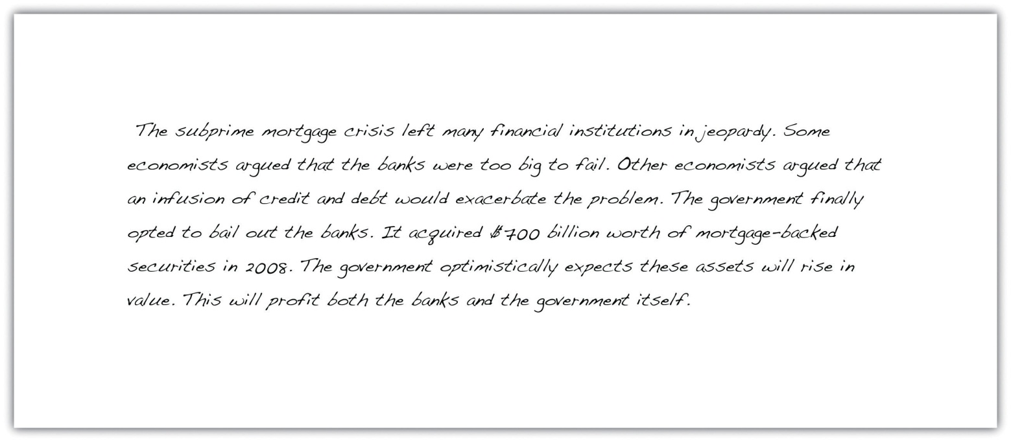
This section examines several ways to introduce sentence variety at the beginning of sentences, using Naomi’s essay as an example.

Starting a Sentence with an Adverb
One technique you can use so as to avoid beginning a sentence with the subject is to use an adverb. An adverb is a word that describes a verb, adjective, or other adverb and often ends in -ly. Examples of adverbs include quickly, softly, quietly, angrily, and timidly. Read the following sentences:
She slowly turned the corner and peered into the murky basement.
Slowly, she turned the corner and peered into the murky basement.
In the second sentence, the adverb slowly is placed at the beginning of the sentence. If you read the two sentences aloud, you will notice that moving the adverb changes the rhythm of the sentence and slightly alters its meaning. The second sentence emphasizes how the subject moves—slowly—creating a buildup of tension. This technique is effective in fictional writing.
Note that an adverb used at the beginning of a sentence is usually followed by a comma. A comma indicates that the reader should pause briefly, which creates a useful rhetorical device. Read the following sentences aloud and consider the effect of pausing after the adverb:
Cautiously, he unlocked the kennel and waited for the dog’s reaction.
Solemnly, the policeman approached the mayor and placed him under arrest.
Suddenly, he slammed the door shut and sprinted across the street.
In an academic essay, moving an adverb to the beginning of a sentence serves to vary the rhythm of a paragraph and increase sentence variety.
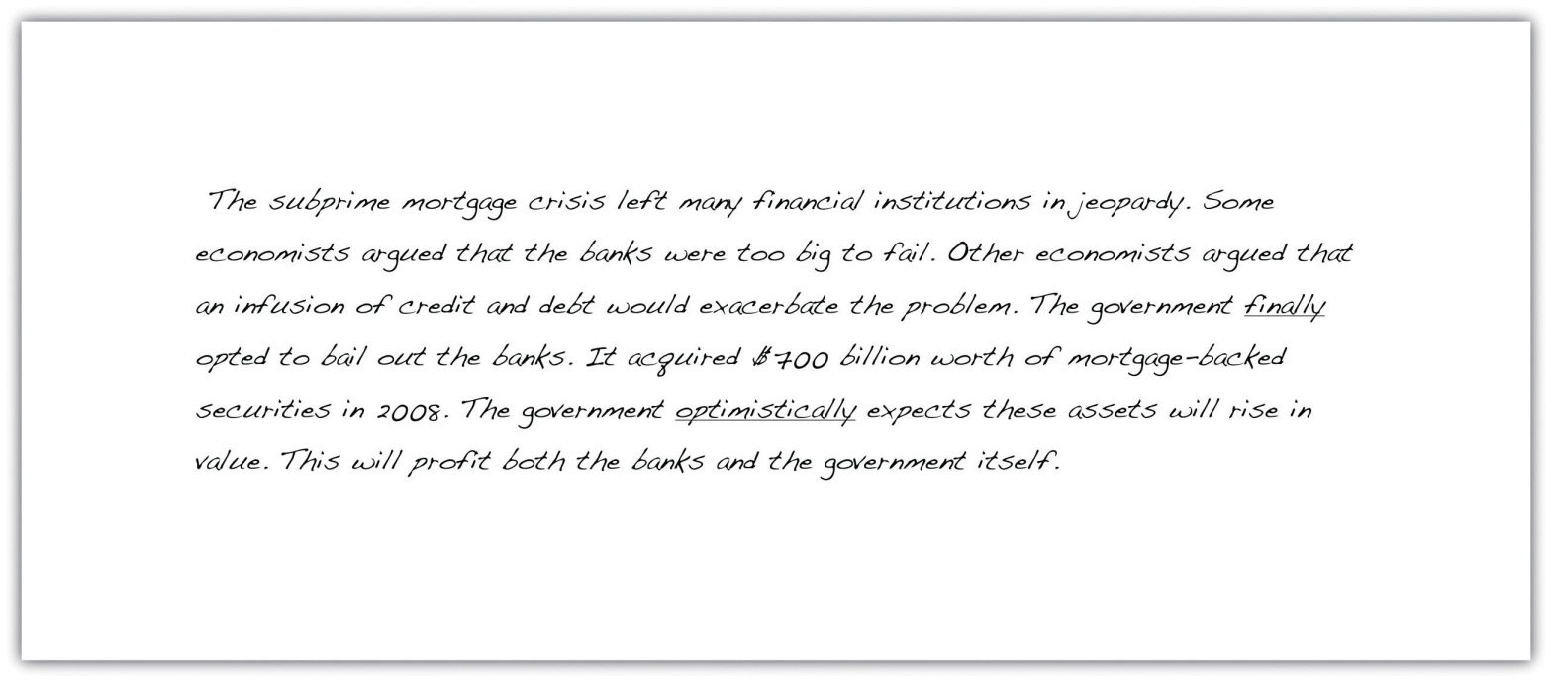
Naomi has used two adverbs in her essay that could be moved to the beginning of their respective sentences. Notice how the following revised version creates a more varied paragraph:
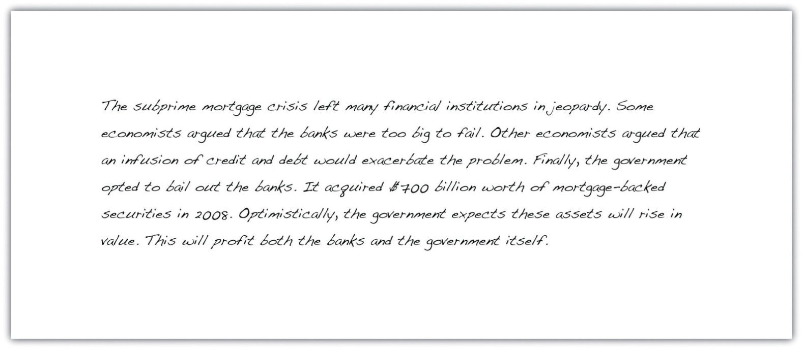

Tip
Adverbs of time—adverbs that indicate when an action takes place—do not always require a comma when used at the beginning of a sentence. Adverbs of time include words such as yesterday, today, later, sometimes, often, and now.

Exercise 2
On your own sheet of paper, rewrite the following sentences by moving the adverbs to the beginning.
- The red truck sped furiously past the camper van, blaring its horn.
- Jeff snatched at the bread hungrily, polishing off three slices in under a minute.
- Underage drinking typically results from peer pressure and lack of parental attention.
- The firefighters bravely tackled the blaze, but they were beaten back by flames.
- Mayor Johnson privately acknowledged that the budget was excessive and that further discussion was needed.
Collaboration
Please share with a classmate and compare your answers.

Starting a Sentence with a Prepositional Phrase
A prepositional phrase is a group of words that behaves as an adjective or an adverb, modifying a noun or a verb. Prepositional phrases contain a preposition (a word that specifies place, direction, or time) and an object of the preposition (a noun phrase or pronoun that follows the preposition).
Table 6.1 Common Prepositions
above | beneath | into | till
across | beside | like | toward
against | between | near | under
after | beyond | off | underneath
among | by | on | until
around | despite | over | up
at | except | past | with
before | for | since | without
behind | from | through
below | inside | throughout
Read the following sentence:
The terrified child hid underneath the table.
In this sentence, the prepositional phrase is underneath the table. The preposition underneath relates to the object that follows the preposition—the table. Adjectives may be placed between the preposition and the object in a prepositional phrase.
The terrified child hid underneath the heavy wooden table.
Some prepositional phrases can be moved to the beginning of a sentence in order to create variety in a piece of writing. Look at the following revised sentence:
Underneath the heavy wooden table, the terrified child hid.
Notice that when the prepositional phrase is moved to the beginning of the sentence, the emphasis shifts from the subject—the terrified child—to the location in which the child is hiding. Words that are placed at the beginning or end of a sentence generally receive the greatest emphasis. Take a look at the following examples. The prepositional phrase is underlined in each:
The bandaged man waited in the doctor’s office.
In the doctor’s office, the bandaged man waited.
My train leaves the station at 6:45 a.m.
At 6:45 a.m., my train leaves the station.
Teenagers exchange drugs and money under the railway bridge.
Under the railway bridge, teenagers exchange drugs and money.

Prepositional phrases are useful in any type of writing. Take another look at Naomi’s essay on the government bailout.
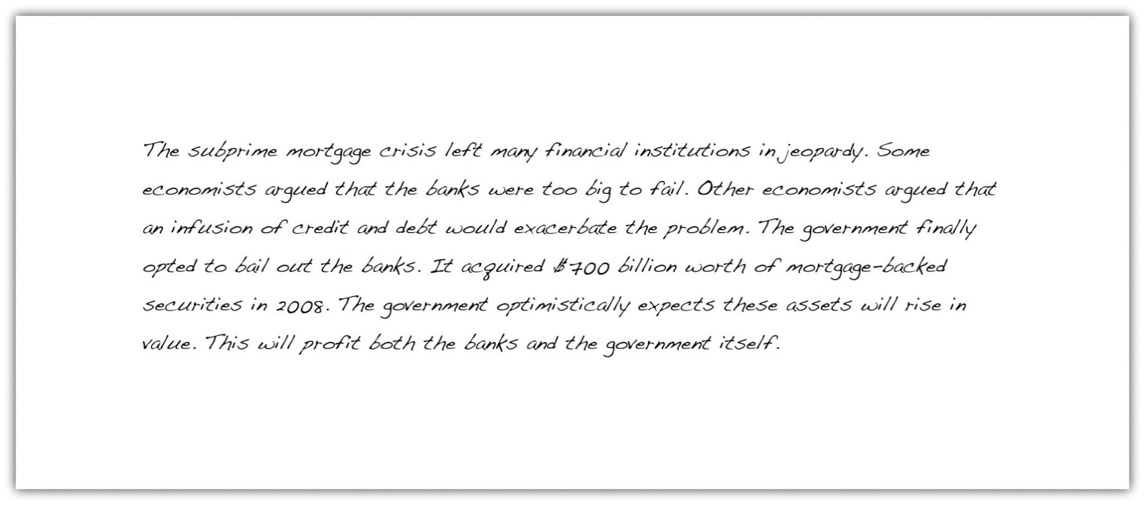
Now read the revised version.
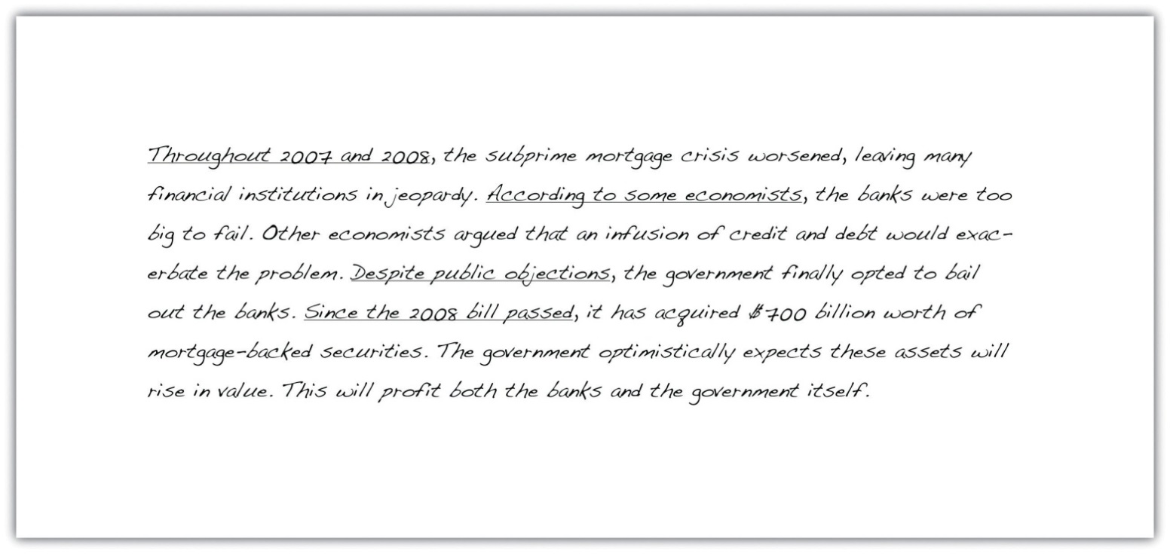
The underlined words are all prepositional phrases. Notice how they add additional information to the text and provide a sense of flow to the essay, making it less choppy and more pleasurable to read.

Unmovable Prepositional Phrases
Not all prepositional phrases can be placed at the beginning of a sentence. Read the following sentence:
I would like a chocolate sundae without whipped cream.
In this sentence, without whipped cream is the prepositional phrase. Because it describes the chocolate sundae, it cannot be moved to the beginning of the sentence. “Without whipped cream I would like a chocolate sundae” does not make as much (if any) sense. To determine whether a prepositional phrase can be moved, we must determine the meaning of the sentence.
Overuse of Prepositional Phrases
Experienced writers often include more than one prepositional phrase in a sentence; however, it is important not to overload your writing. Using too many modifiers in a paragraph may create an unintentionally comical effect as the following example shows:
The treasure lay buried under the old oak tree, behind the crumbling fifteenth-century wall, near the schoolyard, where children played merrily during their lunch hour, unaware of the riches that remained hidden beneath their feet.
A sentence is not necessarily effective just because it is long and complex. If your sentence appears cluttered with prepositional phrases, divide it into two shorter sentences. The previous sentence is far more effective when written as two simpler sentences:
The treasure lay buried under the old oak tree, behind the crumbling fifteenth-century wall. In the nearby schoolyard, children played merrily during their lunch hour, unaware of the riches that remained hidden beneath their feet.

Writing at Work
The overuse of prepositional phrases often occurs when our thoughts are jumbled and we are unsure how concepts or ideas relate to one another. If you are preparing a report or a proposal, take the time to organize your thoughts in an outline before writing a rough draft. Read the draft aloud, either to yourself or to a colleague, and identify areas that are rambling or unclear. If you notice that a particular part of your report contains several sentences over twenty words, you should double check that particular section to make certain that it is coherent and does not contain unnecessary prepositional phrases. Reading aloud sometimes helps detect unclear and wordy sentences. You can also ask a colleague to paraphrase your main points to ensure that the meaning is clear.

Starting a Sentence by Inverting Subject and Verb
As we noted earlier, most writers follow the subject-verb-object sentence structure. In an inverted sentence, the order is reversed so that the subject follows the verb. Read the following sentence pairs:
- A truck was parked in the driveway.
- Parked in the driveway was a truck.
- A copy of the file is attached.
- Attached is a copy of the file.
Notice how the second sentence in each pair places more emphasis on the subject—a truck in the first example and the file in the second. This technique is useful for drawing the reader’s attention to your primary area of focus. We can apply this method to an academic essay. Take another look at Naomi’s paragraph.
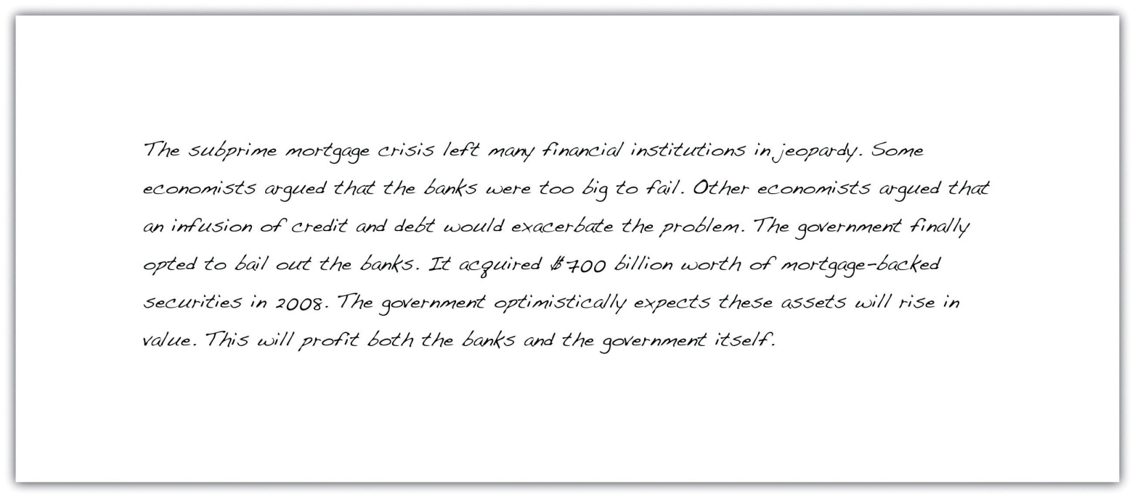
To emphasize the subject in certain sentences, Naomi can invert the traditional sentence structure. Read her revised paragraph:
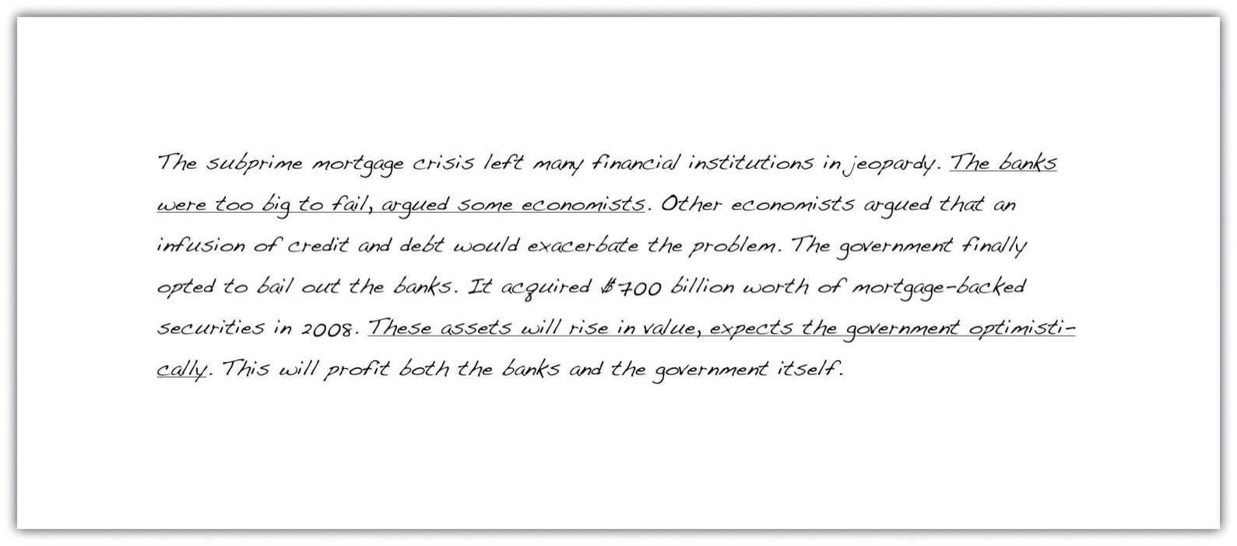
Notice that in the first underlined sentence, the subject (some economists) is placed after the verb (argued). In the second underlined sentence, the subject (the government) is placed after the verb (expects).

Exercise 3
On your own sheet of paper, rewrite the following sentences as inverted sentences.
- Teresa will never attempt to run another marathon.
- A detailed job description is enclosed with this letter.
- Bathroom facilities are across the hall to the left of the water cooler.
- The well-dressed stranger stumbled through the doorway.
- My colleagues remain unconvinced about the proposed merger.
Collaboration
Please share with a classmate and compare your answers.

Connecting Ideas to Increase Sentence Variety
Reviewing and rewriting the beginning of sentences is a good way of introducing sentence variety into your writing. Another useful technique is to connect two sentences using a modifier, a relative clause, or an appositive. This section examines how to connect ideas across several sentences in order to increase sentence variety and improve writing.

Joining Ideas Using an -ing Modifier
Sometimes it is possible to combine two sentences by converting one of them into a modifier using the -ing verb form—singing, dancing, swimming. A modifier is a word or phrase that qualifies the meaning of another element in the sentence. Read the following example:
Original sentences: Steve checked the computer system. He discovered a virus.
Revised sentence: Checking the computer system, Steve discovered a virus.
To connect two sentences using an -ing modifier, add -ing to one of the verbs in the sentences (checking) and delete the subject (Steve). Use a comma to separate the modifier from the subject of the sentence. It is important to make sure that the main idea in your revised sentence is contained in the main clause, not in the modifier. In this example, the main idea is that Steve discovered a virus, not that he checked the computer system.
In the following example, an -ing modifier indicates that two actions are occurring at the same time:
- Noticing the police car, she shifted gears and slowed down.
This means that she slowed down at the same time she noticed the police car.
- Barking loudly, the dog ran across the driveway.
This means that the dog barked as it ran across the driveway.
You can add an -ing modifier to the beginning or the end of a sentence, depending on which fits best.
Beginning: Conducting a survey among her friends, Amanda found that few were happy in their jobs.
End: Maria filed the final report, meeting her deadline.

Dangling Modifiers
A common mistake when combining sentences using the -ing verb form is to misplace the modifier so that it is not logically connected to the rest of the sentence. This creates a dangling modifier. Look at the following example:
Jogging across the parking lot, my breath grew ragged and shallow.
In this sentence, jogging across the parking lot seems to modify my breath. Since breath cannot jog, the sentence should be rewritten so that the subject is placed immediately after the modifier or added to the dangling phrase.
Jogging across the parking lot, I felt my breath grow ragged and shallow.
For more information on dangling modifiers, see Chapter 1 "Writing Basics: What Makes a Good Sentence?".

Joining Ideas Using an -ed Modifier
Some sentences can be combined using an -ed verb form—stopped, finished, played. To use this method, one of the sentences must contain a form of be as a helping verb in addition to the -ed verb form. Take a look at the following example:
Original sentences: The Jones family was delayed by a traffic jam. They arrived several hours after the party started.
Revised sentence: Delayed by a traffic jam, the Jones family arrived several hours after the party started.
In the original version, was acts as a helping verb—it has no meaning by itself, but it serves a grammatical function by placing the main verb (delayed) in the perfect tense.
To connect two sentences using an -ed modifier, drop the helping verb (was) and the subject (the Jones family) from the sentence with an -ed verb form. This forms a modifying phrase (delayed by a traffic jam) that can be added to the beginning or end of the other sentence according to which fits best. As with the -ing modifier, be careful to place the word that the phrase modifies immediately after the phrase in order to avoid a dangling modifier.
Using -ing or -ed modifiers can help streamline your writing by drawing obvious connections between two sentences. Take a look at how Naomi might use modifiers in her paragraph.
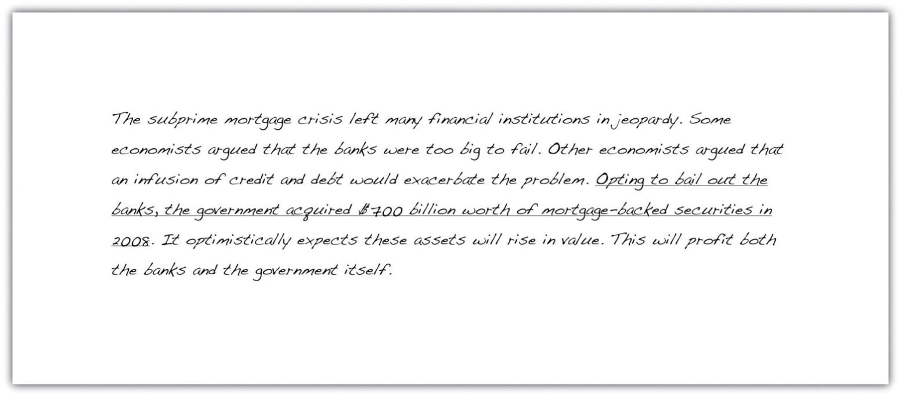
The revised version of the essay uses the -ing modifier opting to draw a connection between the government’s decision to bail out the banks and the result of that decision—the acquisition of the mortgage-backed securities.

Joining Ideas Using a Relative Clause
Another technique that writers use to combine sentences is to join them using a relative clause. A relative clause is a group of words that contains a subject and a verb and describes a noun. Relative clauses function as adjectives by answering questions such as which one? or what kind? Relative clauses begin with a relative pronoun, such as who, which, where, why, or when. Read the following examples:
Original sentences: The managing director is visiting the company next week. He lives in Seattle.
Revised sentence: The managing director, who lives in Seattle, is visiting the company next week.
To connect two sentences using a relative clause, substitute the subject of one of the sentences (he) for a relative pronoun (who). This gives you a relative clause (who lives in Seattle) that can be placed next to the noun it describes (the managing director). Make sure to keep the sentence you want to emphasize as the main clause. For example, reversing the main clause and subordinate clause in the preceding sentence emphasizes where the managing director lives, not the fact that he is visiting the company.
Revised sentence: The managing director, who is visiting the company next week, lives in Seattle.

Relative clauses are a useful way of providing additional, nonessential information in a sentence. Take a look at how Naomi might incorporate relative clauses into her essay.
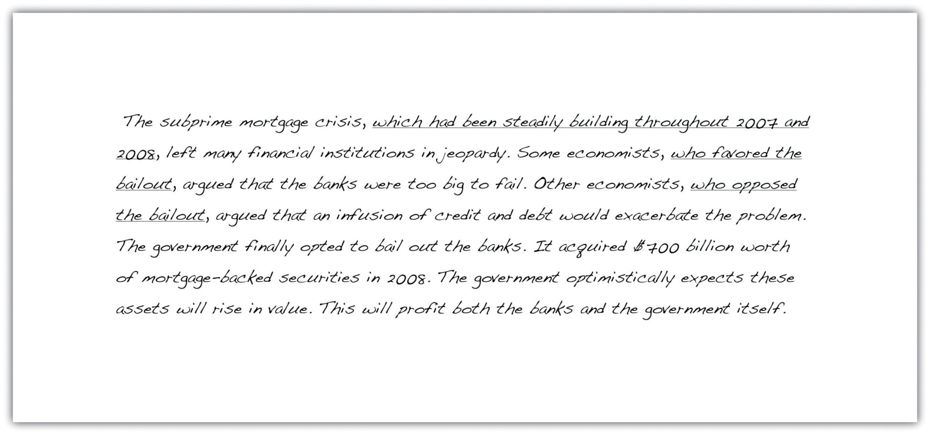
Notice how the underlined relative clauses can be removed from Naomi’s essay without changing the meaning of the sentence.

Tip
To check the punctuation of relative clauses, assess whether or not the clause can be taken out of the sentence without changing its meaning. If the relative clause is not essential to the meaning of the sentence, it should be placed in commas. If the relative clause is essential to the meaning of the sentence, it does not require commas around it.

Joining Ideas Using an Appositive
An appositive is a word or group of words that describes or renames a noun or pronoun. Incorporating appositives into your writing is a useful way of combining sentences that are too short and choppy. Take a look at the following example:
Original sentences: Harland Sanders began serving food for hungry travelers in 1930. He is Colonel Sanders or “the Colonel.”
Revised sentence: Harland Sanders, “the Colonel,” began serving food for hungry travelers in 1930.
In the revised sentence, “the Colonel” is an appositive because it renames Harland Sanders. To combine two sentences using an appositive, drop the subject and verb from the sentence that renames the noun and turn it into a phrase. Note that in the previous example, the appositive is positioned immediately after the noun it describes. An appositive may be placed anywhere in a sentence, but it must come directly before or after the noun to which it refers:
Appositive after noun: Scott, a poorly trained athlete, was not expected to win the race.
Appositive before noun: A poorly trained athlete, Scott was not expected to win the race.
Unlike relative clauses, appositives are always punctuated by a comma or a set commas. Take a look at the way Naomi uses appositives to include additional facts in her essay.
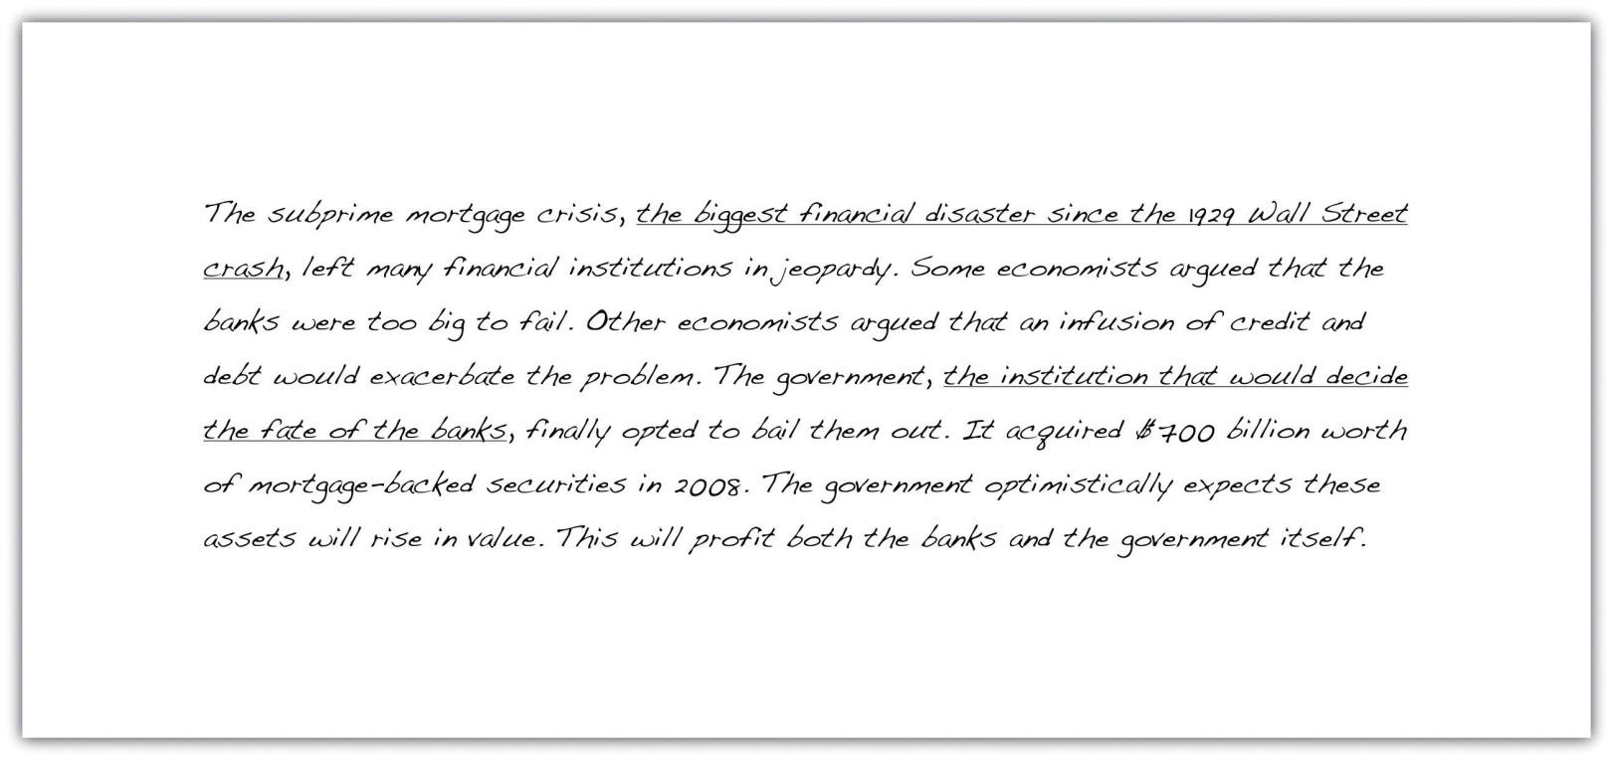

Exercise 4
On your own sheet of paper, rewrite the following sentence pairs as one sentence using the techniques you have learned in this section.
- Baby sharks are called pups. Pups can be born in one of three ways.
- The Pacific Ocean is the world’s largest ocean. It extends from the Arctic in the north to the Southern Ocean in the south.
- Michael Phelps won eight gold medals in the 2008 Olympics. He is a champion swimmer.
- Ashley introduced her colleague Dan to her husband, Jim. She speculated that the two of them would have a lot in common.
- Cacao is harvested by hand. It is then sold to chocolate-processing companies at the Coffee, Sugar, and Cocoa Exchange.

Collaboration
Please share with a classmate and compare your answers.

Writing at Work
In addition to varying sentence structure, consider varying the types of sentences you are using in a report or other workplace document. Most sentences are declarative, but a carefully placed question, exclamation, or command can pique colleagues’ interest, even if the subject material is fairly dry. Imagine that you are writing a budget analysis. Beginning your report with a rhetorical question, such as “Where is our money going?” or “How can we increase sales?” encourages people to continue reading to find out the answers. Although they should be used sparingly in academic and professional writing, questions or commands are effective rhetorical devices.

Key Takeaways
- Sentence variety reduces repetition in a piece of writing and adds emphasis to important points in the text.
- Sentence variety can be introduced to the beginning of sentences by starting a sentence with an adverb, starting a sentence with a prepositional phrase, or by inverting the subject and verb.
- Combine ideas, using modifiers, relative clauses, or appositives, to achieve sentence variety.

6.2 Coordination and Subordination

Learning Objectives
- Identify coordination and subordination in writing.
- Combine sentences and ideas using coordination.
- Combine sentences and ideas using subordination.
In the previous section, we learned how to use different patterns to create sentence variety and to add emphasis to important points in our writing. Next, we will examine two ways in which we can join sentences with related ideas:
- Coordination. Joining two related ideas of equal importance.
- Subordination. Joining two related ideas of unequal importance.
Connecting sentences with coordinate or subordinate clauses creates more coherent paragraphs, and in turn, produces more effective writing. In this section, you will read excerpts from Naomi’s classmate named Joshua, who drafted an essay about wine production. Read this excerpt from Joshua’s essay.
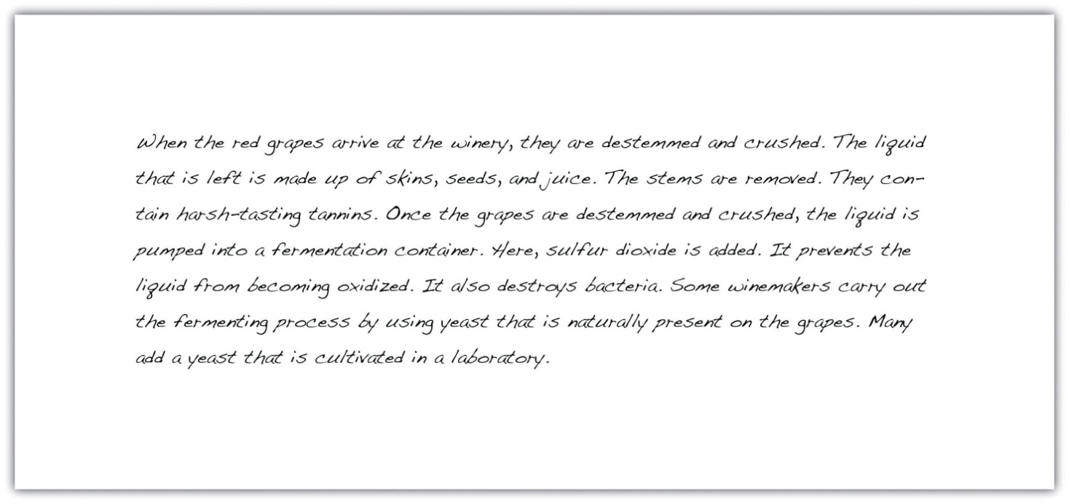
This section examines several ways to combine sentences with coordination and subordination, using Joshua’s essay as an example.

Coordination
Coordination joins two independent clauses that contain related ideas of equal importance.
Original sentences: I spent my entire paycheck last week. I am staying home this weekend.
In their current form, these sentences contain two separate ideas that may or may not be related. Am I staying home this week because I spent my paycheck, or is there another reason for my lack of enthusiasm to leave the house? To indicate a relationship between the two ideas, we can use the coordinating conjunction so:
Revised sentence: I spent my entire paycheck last week, so I am staying home this weekend.
The revised sentence illustrates that the two ideas are connected. Notice that the sentence retains two independent clauses (I spent my entire paycheck; I am staying home this weekend) because each can stand alone as a complete idea.

Coordinating Conjunctions
A coordinating conjunction is a word that joins two independent clauses. The most common coordinating conjunctions are for, and, nor, but, or, yet, and so. Note that a comma precedes the coordinating conjunction when joining two clauses.
Independent Clause | Coordinating Conjunction | Independent Clause | Revised Sentence
I will not be attending the dance. | for (indicates a reason or cause) | I have no one to go with. | I will not be attending the dance, for I have no one to go with.
I plan to stay home. | and (joins two ideas) | I will complete an essay for class. | I plan to stay home, and I will complete an essay for class.
Jessie isn’t going to be at the dance. | nor (indicates a negative) | Tom won’t be there either. | Jessie isn’t going to be at the dance, nor will Tom be there.
The fundraisers are hoping for a record-breaking attendance. | but (indicates a contrast) | I don’t think many people are going. | The fundraisers are hoping for a record-breaking attendance, but I don’t think many people are going.
I might go to the next fundraising event. | or (offers an alternative) | I might donate some money to the cause. | I might go to the next fundraising event, or I might donate some money to the cause.
My parents are worried that I am antisocial. | yet (indicates a reason) | I have many friends at school. | My parents are worried that I am antisocial, yet I have many friends at school.
Buying a new dress is expensive. | so (indicates a result) | By staying home I will save money. | Buying a new dress is expensive, so by staying home I will save money.

Tip
To help you remember the seven coordinating conjunctions, think of the acronym FANBOYS: for, and, nor, but, or, yet, so. Remember that when you use a coordinating conjunction in a sentence, a comma should precede it.

Conjunctive Adverbs
Another method of joining two independent clauses with related and equal ideas is to use a conjunctive adverb and a semicolon (see Chapter 1 "Writing Basics: What Makes a Good Sentence?" for information on semicolon usage). A conjunctive adverb is a linking word that demonstrates a relationship between two clauses. Read the following sentences:
Original sentences: Bridget wants to take part in the next Olympics. She trains every day.
Since these sentences contain two equal and related ideas, they may be joined using a conjunctive adverb. Now, read the revised sentence:
Revised sentence: Bridget wants to take part in the next Olympics; therefore, she trains every day.
The revised sentence explains the relationship between Bridget’s desire to take part in the next Olympics and her daily training. Notice that the conjunctive adverb comes after a semicolon that separates the two clauses and is followed by a comma.
Review the following chart of some common conjunctive adverbs with examples of how they are used:
Function | Conjunctive Adverb | Example
Addition | also, furthermore, moreover, besides | Alicia was late for class and stuck in traffic; furthermore, her shoe heel had broken and she had forgotten her lunch.
Comparison | similarly, likewise | Recycling aluminum cans is beneficial to the environment; similarly, reusing plastic bags and switching off lights reduces waste.
Contrast | instead, however, conversely | Most people do not walk to work; instead, they drive or take the train.
Emphasis | namely, certainly, indeed | The Siberian tiger is a rare creature; indeed, there are fewer than five hundred left in the wild.
Cause and Effect | accordingly, consequently, hence, thus | I missed my train this morning; consequently, I was late for my meeting.
Time | finally, next, subsequently, then | Tim crossed the barrier, jumped over the wall, and pushed through the hole in the fence; finally, he made it to the station.

Take a look at Joshua’s essay on wine production and identify some areas in which he might use coordination.
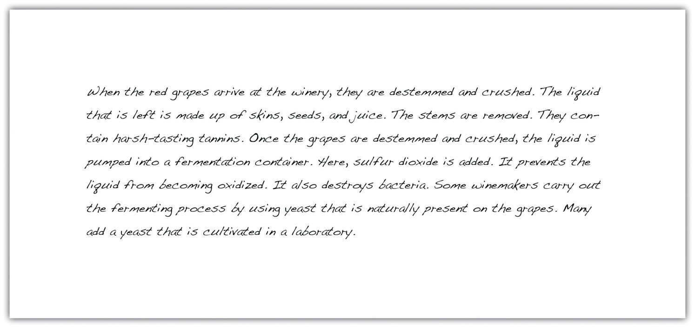
Now look at Joshua’s revised essay. Did you coordinate the same sentences? You may find that your answers are different because there are usually several ways to join two independent clauses.
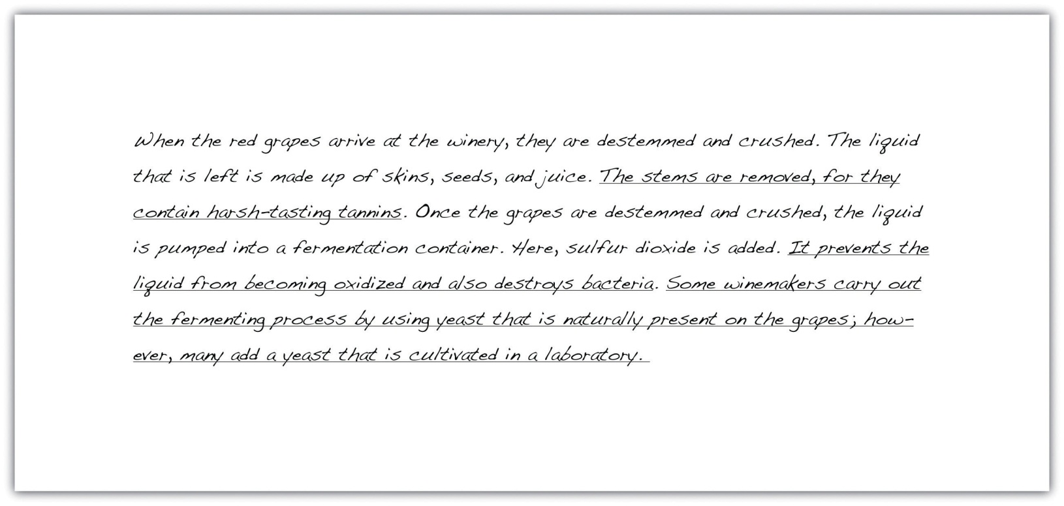

Exercise 1
Combine each sentence pair into a single sentence using either a coordinating conjunction or a conjunctive adverb. Then copy the combined sentence onto your own sheet of paper.
- Pets are not allowed in Mr. Taylor’s building. He owns several cats and a parrot.
- New legislation prevents drivers from sending or reading text messages while driving. Many people continue to use their phones illegally.
- The coroner concluded that the young man had taken a lethal concoction of drugs. By the time his relatives found him, nothing could be done.
- Amphibians are vertebrates that live on land and in the water. Flatworms are invertebrates that live only in water.
- Ashley carefully fed and watered her tomato plants all summer. The tomatoes grew juicy and ripe.
- When he lost his car key, Simon attempted to open the door with a wire hanger, a credit card, and a paper clip. He called the manufacturer for advice.
Collaboration
Please share with a classmate and compare your answers.

Writing at Work
When writing an essay or a report, it is important that you do not use excessive coordination. Workplace documents should be clear and concise, so only join two clauses that are logically connected and can work together to make one main point. If you repeat the same coordinating conjunction several times in a sentence, you are probably including more than one idea. This may make it difficult for readers to pick out the most important information in each sentence.

Subordination
Subordination joins two sentences with related ideas by merging them into a main clause (a complete sentence) and a dependent clause (a construction that relies on the main clause to complete its meaning). Coordination allows a writer to give equal weight to the two ideas that are being combined, and subordination enables a writer to emphasize one idea over the other. Take a look at the following sentences:
Original sentences: Tracy stopped to help the injured man. She would be late for work.
To illustrate that these two ideas are related, we can rewrite them as a single sentence using the subordinating conjunction even though.
Revised sentence: Even though Tracy would be late for work, she stopped to help the injured man.
In the revised version, we now have an independent clause (she stopped to help the injured man) that stands as a complete sentence and a dependent clause (even though Tracy would be late for work) that is subordinate to the main clause. Notice that the revised sentence emphasizes the fact that Tracy stopped to help the injured man, rather than the fact she would be late for work. We could also write the sentence this way:
Revised sentence: Tracy stopped to help the injured man even though she would be late for work.
The meaning remains the same in both sentences, with the subordinating conjunction even though introducing the dependent clause.

Tip
To punctuate sentences correctly, look at the position of the main clause and the subordinate clause. If a subordinate clause precedes the main clause, use a comma. If the subordinate clause follows the main cause, no punctuation is required.

Subordinating Conjunctions
A subordinating conjunction is a word that joins a subordinate (dependent) clause to a main (independent) clause. Review the following chart of some common subordinating conjunctions and examples of how they are used:
Function | Subordinating Conjunction | Example
Concession | although, while, though, whereas, even though | Sarah completed her report even though she had to stay late to get it done.
Condition | if, unless, until | Until we know what is causing the problem, we will not be able to fix it.
Manner | as if, as, though | Everyone in the conference room stopped talking at once, as though they had been stunned into silence.
Place | where, wherever | Rita is in San Jose where she has several important client meetings.
Reason | because, since, so that, in order that | Because the air conditioning was turned up so high, everyone in the office wore sweaters.
Time | after, before, while, once, when | After the meeting had finished, we all went to lunch.

Take a look at the excerpt from Joshua’s essay and identify some areas in which he might use subordination.
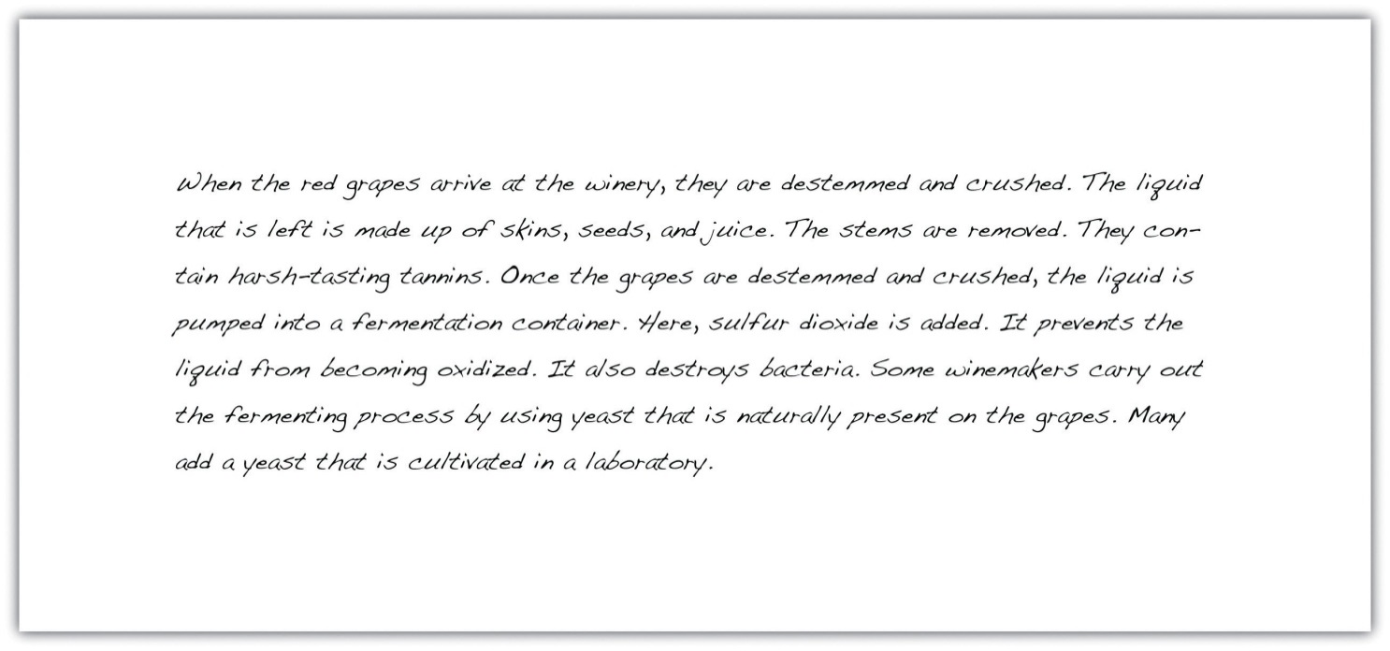
Now look at Joshua’s revised essay and compare your answers. You will probably notice that there are many different ways to subordinate sentences.
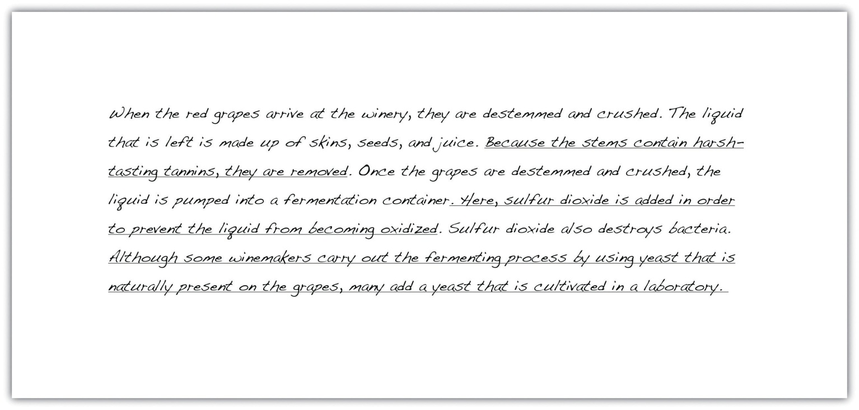

Exercise 2
Combine each sentence pair into a single sentence using a subordinating conjunction and then copy the combined sentence onto your own sheet of paper.
- Jake is going to Mexico. There are beautiful beaches in Mexico.
- A snowstorm disrupted traffic all over the east coast. There will be long delivery delays this week.
- My neighbor had his television volume turned up too high. I banged on his door and asked him to keep the noise down.
- Jessica prepared the potato salad and the sautéed vegetables. Ashley marinated the chicken.
- Romeo poisons himself. Juliet awakes to find Romeo dead and stabs herself with a dagger.

Exercise 3
Copy the paragraph from Joshua’s essay onto your own sheet of paper. Then edit using the techniques you have learned in this section. Join the underlined sentences using coordination or subordination. Check your revised sentences for punctuation.
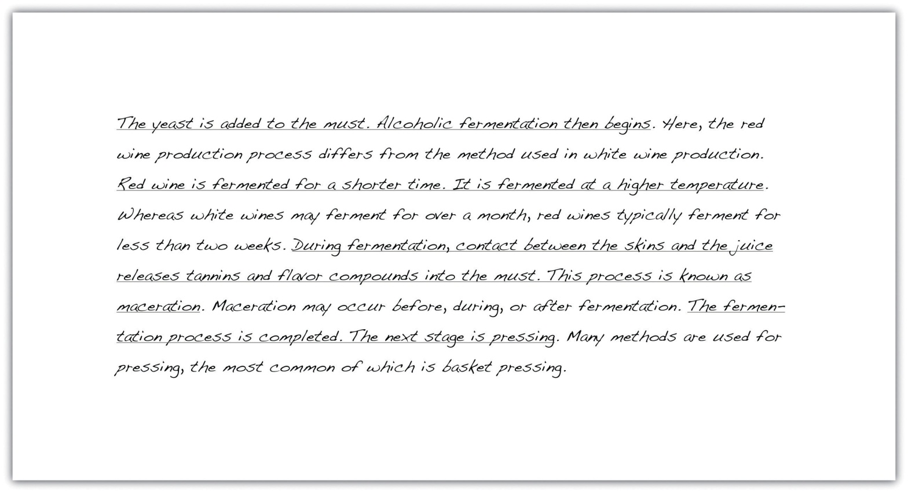

Key Takeaways
- Coordination and subordination join two sentences with related ideas.
- Coordination joins sentences with related and equal ideas, whereas subordination joins sentences with related but unequal ideas.
- Sentences can be coordinated using either a coordinating conjunction and a comma or a conjunctive adverb and a semicolon.
- Subordinate sentences are characterized by the use of a subordinate conjunction.
- In a subordinate sentence, a comma is used to separate the main clause from the dependent clause if the dependent clause is placed at the beginning of the sentence.

6.3 Parallelism

Learning Objectives
- Identify sentences that are parallel and not parallel.
- Identify ways to create parallelism in writing.
- Write and revise sentences using parallelism.
Earlier in this chapter, we learned that increasing sentence variety adds interest to a piece of writing and makes the reading process more enjoyable for others. Using a mixture of sentence lengths and patterns throughout an essay is an important writing technique. However, it is equally important to avoid introducing variation within individual sentences. A strong sentence is composed of balanced parts that all have the same structure. In this section, we will examine how to create a balanced sentence structure by using parallelism.

Using Parallelism
Parallelism is the use of similar structure in related words, clauses, or phrases. It creates a sense of rhythm and balance within a sentence. As readers, we often correct faulty parallelism—a lack of parallel structure—intuitively because an unbalanced sentence sounds awkward and poorly constructed. Read the following sentences aloud:
Faulty parallelism: Kelly had to iron, do the washing, and shopping before her parents arrived.
Faulty parallelism: Driving a car requires coordination, patience, and to have good eyesight.
Faulty parallelism: Ali prefers jeans to wearing a suit.
All of these sentences contain faulty parallelism. Although they are factually correct, the construction is clunky and confusing. In the first example, three different verb forms are used. In the second and third examples, the writer begins each sentence by using a noun (coordination, jeans), but ends with a phrase (to have good eyesight, wearing a suit). Now read the same three sentences that have correct parallelism.
Correct parallelism: Kelly had to do the ironing, washing, and shopping before her parents arrived.
Correct parallelism: Driving a car requires coordination, patience, and good eyesight.
Correct parallelism: Ali prefers wearing jeans to wearing a suit.
When these sentences are written using a parallel structure, they sound more aesthetically pleasing because they are balanced. Repetition of grammatical construction also minimizes the amount of work the reader has to do to decode the sentence. This enables the reader to focus on the main idea in the sentence and not on how the sentence is put together.

Tip
A simple way to check for parallelism in your writing is to make sure you have paired nouns with nouns, verbs with verbs, prepositional phrases with prepositional phrases, and so on. Underline each element in a sentence and check that the corresponding element uses the same grammatical form.

Creating Parallelism Using Coordinating Conjunctions
When you connect two clauses using a coordinating conjunction (for, and, nor, but, or, yet, so), make sure that the same grammatical structure is used on each side of the conjunction. Take a look at the following example:
Faulty parallelism: When I walk the dog, I like to listen to music and talking to friends on the phone.
Correct parallelism: When I walk the dog, I like listening to music and talking to friends on the phone.
The first sentence uses two different verb forms (to listen, talking). In the second sentence, the grammatical construction on each side of the coordinating conjunction (and) is the same, creating a parallel sentence.
The same technique should be used for joining items or lists in a series:
Faulty parallelism: This committee needs to decide whether the company should reduce its workforce, cut its benefits, or lowering workers’ wages.
Correct parallelism: This committee needs to decide whether the company should reduce its workforce, cut its benefits, or lower workers’ wages.
The first sentence contains two items that use the same verb construction (reduce, cut) and a third item that uses a different verb form (lowering). The second sentence uses the same verb construction in all three items, creating a parallel structure.

Exercise 1
On your own sheet of paper, revise each of the following sentences to create parallel structure using coordinating conjunctions.
- Mr. Holloway enjoys reading and to play his guitar at weekends.
- The doctor told Mrs. Franklin that she should either eat less or should exercise more.
- Breaking out of the prison compound, the escapees moved carefully, quietly, and were quick on their feet.
- I have read the book, but I have not watched the movie version.
- Deal with a full inbox first thing in the morning, or by setting aside short periods of time in which to answer e-mail queries.
Collaboration
Please share with a classmate and compare your answers.

Creating Parallelism Using Than or As
When you are making a comparison, the two items being compared should have a parallel structure. Comparing two items without using parallel structure can lead to confusion about what is being compared. Comparisons frequently use the words than or as, and the items on each side of these comparison words should be parallel. Take a look at the following example:
Faulty parallelism: Swimming in the ocean is much tougher than a pool.
Correct parallelism: Swimming in the ocean is much tougher than swimming in a pool.
In the first sentence, the elements before the comparison word (than) are not equal to the elements after the comparison word. It appears that the writer is comparing an action (swimming) with a noun (a pool). In the second sentence, the writer uses the same grammatical construction to create a parallel structure. This clarifies that an action is being compared with another action.
To correct some instances of faulty parallelism, it may be necessary to add or delete words in a sentence.
Faulty parallelism: A brisk walk is as beneficial to your health as going for a run.
Correct parallelism: Going for a brisk walk is as beneficial to your health as going for a run.
In this example, it is necessary to add the verb phrase going for to the sentence in order to clarify that the act of walking is being compared to the act of running.

Exercise 2
On your own sheet of paper, revise each of the following sentences to create parallel structure using than or as.
- I would rather work at a second job to pay for a new car than a loan.
- How you look in the workplace is just as important as your behavior.
- The firefighter spoke more of his childhood than he talked about his job.
- Indian cuisine is far tastier than the food of Great Britain.
- Jim’s opponent was as tall as Jim and he carried far more weight.
Collaboration
Please share with a classmate and compare your answers.

Creating Parallelism Using Correlative Conjunctions
A correlative conjunction is a paired conjunction that connects two equal parts of a sentence and shows the relationship between them. Common correlative conjunctions include the following:
- either…or
- not only…but also
- neither…nor
- whether…or
- rather…than
- both…and
Correlative conjunctions should follow the same grammatical structure to create a parallel sentence. Take a look at the following example:
Faulty parallelism: We can neither wait for something to happen nor can we take evasive action.
Correct parallelism: We can neither wait for something to happen nor take evasive action.
When using a correlative conjunction, the words, phrases, or clauses following each part should be parallel. In the first sentence, the construction of the second part of the sentence does not match the construction of the first part. In the second sentence, omitting needless words and matching verb constructions create a parallel structure. Sometimes, rearranging a sentence corrects faulty parallelism.
Faulty parallelism: It was both a long movie and poorly written.
Correct parallelism: The movie was both long and poorly written.

Tip
To see examples of parallelism in use, read some of the great historical speeches by rhetoricians such as Abraham Lincoln and Martin Luther King Jr. Notice how they use parallel structures to emphasize important points and to create a smooth, easily understandable oration.
Here is a link to text, audio, video, and the music of Martin Luther King’s speech “I Have a Dream”: http://www.mlkonline.net/dream.html.

Writing at Work
Speechwriters use parallelism not only within sentences but also throughout paragraphs and beyond. Repeating particular key phrases throughout a speech is an effective way of tying a paragraph together as a cohesive whole and creating a sense of importance. This technique can be adapted to any piece of writing, but it may be especially useful for creating a proposal or other type of persuasive workplace document.
Note that the spelling and grammar checker on most word processors will not draw attention to faulty parallelism. When proofreading a document, read it aloud and listen for sentences that sound awkward or poorly phrased.

Exercise 3
On your own sheet of paper, revise each of the following sentences to create parallel structure using correlative conjunctions.
- The cyclist owns both a mountain bike and has a racing bike.
- The movie not only contained lots of action, but also it offered an important lesson.
- My current job is neither exciting nor is it meaningful.
- Jason would rather listen to his father than be taking advice from me.
- We are neither interested in buying a vacuum cleaner nor do we want to utilize your carpet cleaning service.
Collaboration
Please share with a classmate and compare your answers.

Exercise 4
Read through the following excerpt from Alex’s essay and revise any instances of faulty parallelism. Rewrite the sentences to create a parallel structure.
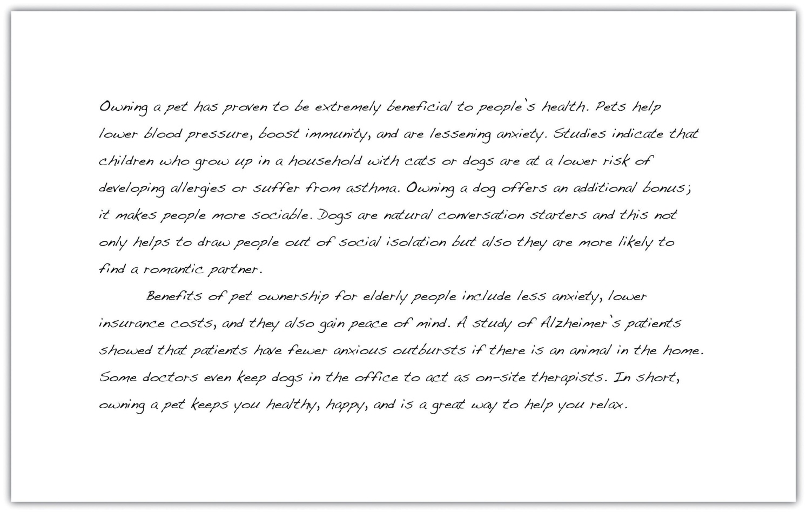

Key Takeaways
- Parallelism creates a sense of rhythm and balance in writing by using the same grammatical structure to express equal ideas.
- Faulty parallelism occurs when elements of a sentence are not balanced, causing the sentence to sound clunky and awkward.
- Parallelism may be created by connecting two clauses or making a list using coordinating conjunctions; by comparing two items using than or as; or by connecting two parts of a sentence using correlative conjunctions.

6.4 Refining Your Writing: End-of-Chapter Exercises

Learning Objectives
- Use the skills you have learned in the chapter.
- Work collaboratively with other students.
- Work with a variety of academic and on-the-job, real-world examples.

Exercises
- Children’s stories are deliberately written in short, simple sentences to avoid confusion. Most sentences are constructed using the standard subject-verb-object format. Choose a children’s story that is suitable for eight- to ten-year-olds. Rewrite a chapter of the story so that it appeals to a slightly older age group, by editing for sentence variety. Experiment with the techniques you learned in Section 6.1 "Sentence Variety", including the three different ways to vary sentence structure at the beginning of a sentence and the three different ways to connect ideas between sentences. Compare the revised chapter with the original version and consider how sentence variety can be used to target a particular audience.
Collaboration
Please share with a classmate and compare your answers.
- Compile a selection of real-life writing samples from the workplace or around the home. You might like to choose one of the following: e-mail, junk mail, personal letter, company report, social networking page, local newspaper, bulletin-board posting, or public notice. Choose two samples that lack sentence variety. Highlight areas of each writing sample that you would edit for sentence variety and explain why. Replace any recognizable name with a pseudonym, or a fictitious name.
Collaboration
Please share with a classmate and compare your answers.
- Group activity. Choose a well-known speech, such as Martin Luther King’s “I Have a Dream” speech, Winston Churchill’s “Blood, Toil, Tears, and Sweat” speech, or Barack Obama’s inaugural address. Make a copy of the speech and, as a group, underline examples of parallelism. Discuss the effects of using parallelism and consider whether it is always used to achieve the same result or whether the writer manipulates parallelism to create a variety of responses among his or her audience.

- Group activity. Working in a small group, select a workplace document or academic essay. Examine each paragraph and identify examples of sentence variety, coordination and subordination, and parallelism. Then, choose one particular paragraph and discuss the following questions:
  - Does the writer use sentence variety effectively?
  - Does the writer connect his or her ideas effectively?
  - Does the writer use subordination and coordination correctly?
  - Does the writer use parallelism to emphasize his or her points?
As a group, identify the weaker areas of the paragraph and rewrite them. Focus on sentence structure and sentence variation. Use coordinating conjunctions and subordinating conjunctions to join sentences.
- Choose a college essay or a recent piece of writing from your work or everyday life. Use the techniques you have learned throughout this chapter to edit your writing for sentence variety, appropriate coordination and subordination, and parallelism. When you have finished, compare the two versions and write a brief analysis of how sentence variety, coordination and subordination, and parallelism help refine a piece of writing.
Collaboration
Please share with a classmate and compare your answers.

Chapter 7 The Writing Process: How Do I Begin?

7.1 Apply Prewriting Models

Learning Objective
- Use prewriting strategies to choose a topic and narrow the focus.
If you think that a blank sheet of paper or a blinking cursor on the computer screen is a scary sight, you are not alone. Many writers, students, and employees find that beginning to write can be intimidating. When faced with a blank page, however, experienced writers remind themselves that writing, like other everyday activities, is a process. Every process, from writing to cooking, bike riding, and learning to use a new cell phone, will get significantly easier with practice.
Just as you need a recipe, ingredients, and proper tools to cook a delicious meal, you also need a plan, resources, and adequate time to create a good written composition. In other words, writing is a process that requires following steps and using strategies to accomplish your goals.
These are the five steps in the writing process:
- Prewriting
- Outlining the structure of ideas
- Writing a rough draft
- Revising
- Editing
Effective writing can be simply described as good ideas that are expressed well and arranged in the proper order. This chapter will give you the chance to work on all these important aspects of writing. Although many more prewriting strategies exist, this chapter covers six: using experience and observations, freewriting, asking questions, brainstorming, mapping, and searching the Internet. Using the strategies in this chapter can help you overcome the fear of the blank page and confidently begin the writing process.

Prewriting
Prewriting is the stage of the writing process during which you transfer your abstract thoughts into more concrete ideas in ink on paper (or in type on a computer screen). Although prewriting techniques can be helpful in all stages of the writing process, the following four strategies are best used when initially deciding on a topic:
- Using experience and observations
- Reading
- Freewriting
- Asking questions
At this stage in the writing process, it is OK if you choose a general topic. Later you will learn more prewriting strategies that will narrow the focus of the topic.

Choosing a Topic
In addition to understanding that writing is a process, writers also understand that choosing a good general topic for an assignment is an essential step. Sometimes your instructor will give you an idea to begin an assignment, and other times your instructor will ask you to come up with a topic on your own. A good topic not only covers what an assignment will be about but also fits the assignment’s purpose and its audience.
In this chapter, you will follow a writer named Mariah as she prepares a piece of writing. You will also be planning one of your own. The first important step is for you to tell yourself why you are writing (to inform, to explain, or some other purpose) and for whom you are writing. Write your purpose and your audience on your own sheet of paper, and keep the paper close by as you read and complete exercises in this chapter.
My purpose: ____________________________________________
My audience: ____________________________________________

Using Experience and Observations
When selecting a topic, you may also want to consider something that interests you or something based on your own life and personal experiences. Even everyday observations can lead to interesting topics. After writers think about their experiences and observations, they often take notes on paper to better develop their thoughts. These notes help writers discover what they have to say about their topic.

Tip
Have you seen an attention-grabbing story on your local news channel? Many current issues appear on television, in magazines, and on the Internet. These can all provide inspiration for your writing.

Reading
Reading plays a vital role in all the stages of the writing process, but it first figures in the development of ideas and topics. Different kinds of documents can help you choose a topic and also develop that topic. For example, a magazine advertising the latest research on the threat of global warming may catch your eye in the supermarket. This cover may interest you, and you may consider global warming as a topic. Or maybe a novel’s courtroom drama sparks your curiosity of a particular lawsuit or legal controversy.
After you choose a topic, critical reading is essential to the development of a topic. While reading almost any document, you evaluate the author’s point of view by thinking about his main idea and his support. When you judge the author’s argument, you discover more about not only the author’s opinion but also your own. If this step already seems daunting, remember that even the best writers need to use prewriting strategies to generate ideas.

Tip
The steps in the writing process may seem time consuming at first, but following these steps will save you time in the future. The more you plan in the beginning by reading and using prewriting strategies, the less time you may spend writing and editing later because your ideas will develop more swiftly.
Prewriting strategies depend on your critical reading skills. Reading prewriting exercises (and outlines and drafts later in the writing process) will further develop your topic and ideas. As you continue to follow the writing process, you will see how Mariah uses critical reading skills to assess her own prewriting exercises.

Freewriting
Freewriting is an exercise in which you write freely about any topic for a set amount of time (usually three to five minutes). During the time limit, you may jot down any thoughts that come to your mind. Try not to worry about grammar, spelling, or punctuation. Instead, write as quickly as you can without stopping. If you get stuck, just copy the same word or phrase over and over until you come up with a new thought.
Writing often comes easier when you have a personal connection with the topic you have chosen. Remember, to generate ideas in your freewriting, you may also think about readings that you have enjoyed or that have challenged your thinking. Doing this may lead your thoughts in interesting directions.
Quickly recording your thoughts on paper will help you discover what you have to say about a topic. When writing quickly, try not to doubt or question your ideas. Allow yourself to write freely and unselfconsciously. Once you start writing with few limitations, you may find you have more to say than you first realized. Your flow of thoughts can lead you to discover even more ideas about the topic. Freewriting may even lead you to discover another topic that excites you even more.
Look at Mariah’s example. The instructor allowed the members of the class to choose their own topics, and Mariah thought about her experiences as a communications major. She used this freewriting exercise to help her generate more concrete ideas from her own experience.

Tip
Some prewriting strategies can be used together. For example, you could use experience and observations to come up with a topic related to your course studies. Then you could use freewriting to describe your topic in more detail and figure out what you have to say about it.
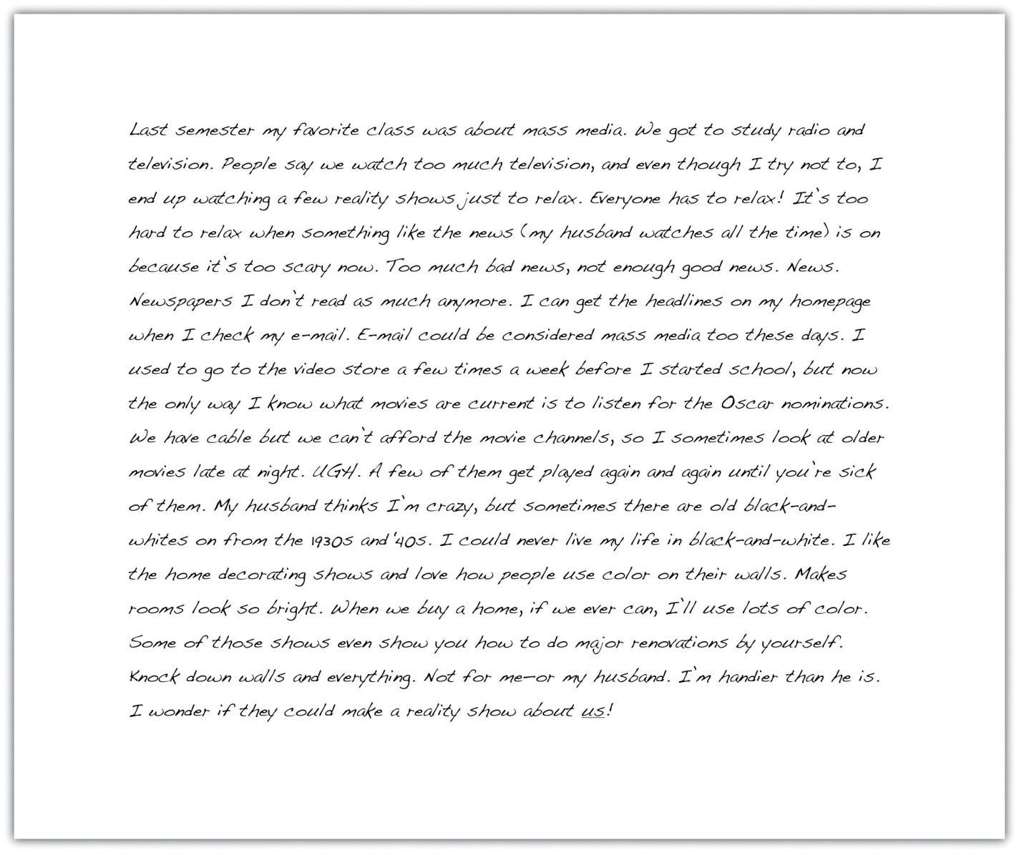

Exercise 1
Freewrite about one event you have recently experienced. With this event in mind, write without stopping for five minutes. After you finish, read over what you wrote. Does anything stand out to you as a good general topic to write about?

Asking Questions
Who? What? Where? When? Why? How? In everyday situations, you pose these kinds of questions to get more information. Who will be my partner for the project? When is the next meeting? Why is my car making that odd noise? Even the title of this chapter begins with the question “How do I begin?”
You seek the answers to these questions to gain knowledge, to better understand your daily experiences, and to plan for the future. Asking these types of questions will also help you with the writing process. As you choose your topic, answering these questions can help you revisit the ideas you already have and generate new ways to think about your topic. You may also discover aspects of the topic that are unfamiliar to you and that you would like to learn more about. All these idea-gathering techniques will help you plan for future work on your assignment.
When Mariah reread her freewriting notes, she found she had rambled and her thoughts were disjointed. She realized that the topic that interested her most was the one she started with, the media. She then decided to explore that topic by asking herself questions about it. Her purpose was to refine media into a topic she felt comfortable writing about. To see how asking questions can help you choose a topic, take a look at the following chart that Mariah completed to record her questions and answers. She asked herself the questions that reporters and journalists use to gather information for their stories. The questions are often called the 5WH questions, after their initial letters.

Figure 7.1 Asking Questions
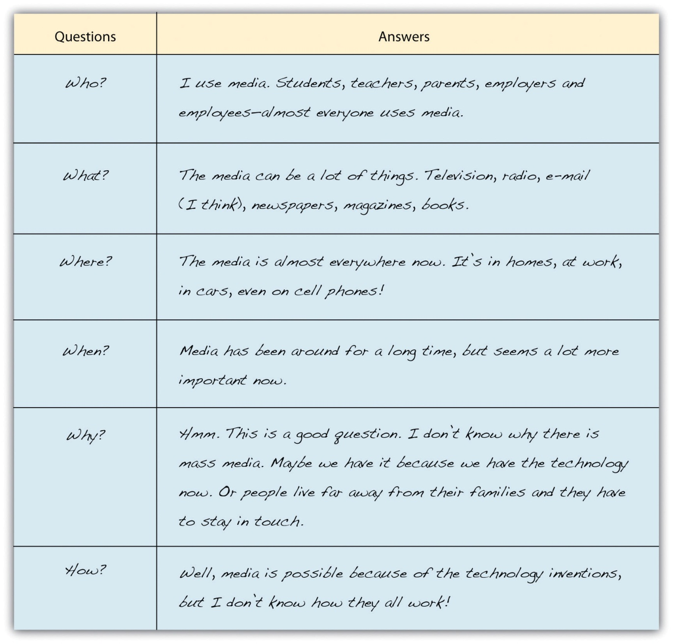

Tip
Prewriting is very purpose driven; it does not follow a set of hard-and-fast rules. The purpose of prewriting is to find and explore ideas so that you will be prepared to write. A prewriting technique like asking questions can help you both find a topic and explore it. The key to effective prewriting is to use the techniques that work best for your thinking process. Freewriting may not seem to fit your thinking process, but keep an open mind. It may work better than you think. Perhaps brainstorming a list of topics might better fit your personal style. Mariah found freewriting and asking questions to be fruitful strategies to use. In your own prewriting, use the 5WH questions in any way that benefits your planning.

Exercise 2
Choose a general topic idea from the prewriting you completed in Note 7.9 "Exercise 1". Then read each question and use your own paper to answer the 5WH questions. As with Mariah when she explored her writing topic for more detail, it is OK if you do not know all the answers. If you do not know an answer, use your own opinion to speculate, or guess. You may also use factual information from books or articles you previously read on your topic. Later in the chapter, you will read about additional ways (like searching the Internet) to answer your questions and explore your guesses.
5WH Questions
- Who?
_____________________________________________________
- What?
_____________________________________________________
- Where?
_____________________________________________________
- When?
_____________________________________________________
- Why?
_____________________________________________________
- How?
_____________________________________________________
Now that you have completed some of the prewriting exercises, you may feel less anxious about starting a paper from scratch. With some ideas down on paper (or saved on a computer), writers are often more comfortable continuing the writing process. After identifying a good general topic, you, too, are ready to continue the process.

Exercise
Write your general topic on your own sheet of paper, under where you recorded your purpose and audience. Choose it from among the topics you listed or explored during the prewriting you have done so far. Make sure it is one you feel comfortable with and feel capable of writing about.
My general topic: ____________________________________________

Tip
You may find that you need to adjust your topic as you move through the writing stages (and as you complete the exercises in this chapter). If the topic you have chosen is not working, you can repeat the prewriting activities until you find a better one.

More Prewriting Techniques
The prewriting techniques of freewriting and asking questions helped Mariah think more about her topic, but the following prewriting strategies can help her (and you) narrow the focus of the topic:
- Brainstorming
- Idea mapping
- Searching the Internet

Narrowing the Focus
Narrowing the focus means breaking up the topic into subtopics, or more specific points. Generating lots of subtopics will help you eventually select the ones that fit the assignment and appeal to you and your audience.
After rereading her syllabus, Mariah realized her general topic, mass media, is too broad for her class’s short paper requirement. Three pages are not enough to cover all the concerns in mass media today. Mariah also realized that although her readers are other communications majors who are interested in the topic, they may want to read a paper about a particular issue in mass media.

Brainstorming
Brainstorming is similar to list making. You can make a list on your own or in a group with your classmates. Start with a blank sheet of paper (or a blank computer document) and write your general topic across the top. Underneath your topic, make a list of more specific ideas. Think of your general topic as a broad category and the list items as things that fit in that category. Often you will find that one item can lead to the next, creating a flow of ideas that can help you narrow your focus to a more specific paper topic.
The following is Mariah’s brainstorming list:
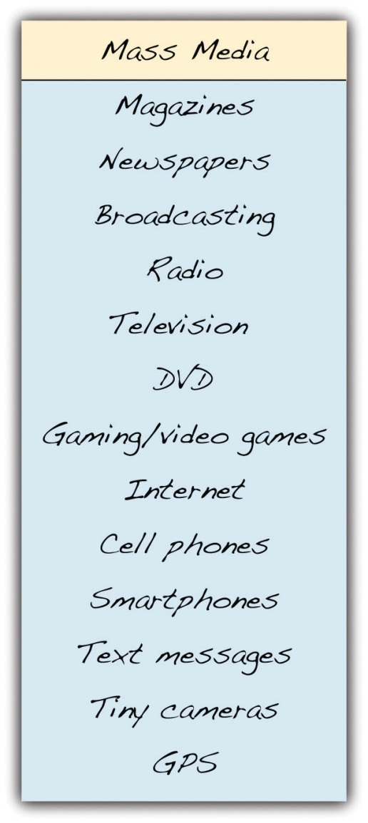
From this list, Mariah could narrow her focus to a particular technology under the broad category of mass media.

Writing at Work
Imagine you have to write an e-mail to your current boss explaining your prior work experience, but you do not know where to start. Before you begin the e-mail, you can use the brainstorming technique to generate a list of employers, duties, and responsibilities that fall under the general topic “work experience.”

Idea Mapping
Idea mapping allows you to visualize your ideas on paper using circles, lines, and arrows. This technique is also known as clustering because ideas are broken down and clustered, or grouped together. Many writers like this method because the shapes show how the ideas relate or connect, and writers can find a focused topic from the connections mapped. Using idea mapping, you might discover interesting connections between topics that you had not thought of before.
To create an idea map, start with your general topic in a circle in the center of a blank sheet of paper. Then write specific ideas around it and use lines or arrows to connect them together. Add and cluster as many ideas as you can think of.
In addition to brainstorming, Mariah tried idea mapping. Review the following idea map that Mariah created:

Figure 7.2 Idea Map
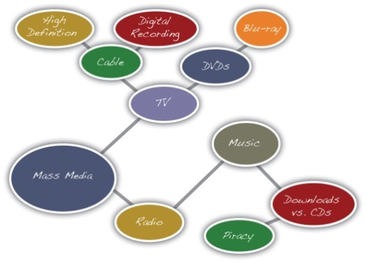
Notice Mariah’s largest circle contains her general topic, mass media. Then, the general topic branches into two subtopics written in two smaller circles: television and radio. The subtopic television branches into even more specific topics: cable and DVDs. From there, Mariah drew more circles and wrote more specific ideas: high definition and digital recording from cable and Blu-ray from DVDs. The radio topic led Mariah to draw connections between music, downloads versus CDs, and, finally, piracy.
From this idea map, Mariah saw she could consider narrowing the focus of her mass media topic to the more specific topic of music piracy.

Searching the Internet
Using search engines on the Internet is a good way to see what kinds of websites are available on your topic. Writers use search engines not only to understand more about the topic’s specific issues but also to get better acquainted with their audience.

Tip
Look back at the chart you completed in Note 7.12 "Exercise 2". Did you guess at any of the answers? Searching the Internet may help you find answers to your questions and confirm your guesses. Be choosy about the websites you use. Make sure they are reliable sources for the kind of information you seek.
When you search the Internet, type some key words from your broad topic or words from your narrowed focus into your browser’s search engine (many good general and specialized search engines are available for you to try). Then look over the results for relevant and interesting articles.
Results from an Internet search show writers the following information:
- Who is talking about the topic
- How the topic is being discussed
- What specific points are currently being discussed about the topic

Tip
If the search engine results are not what you are looking for, revise your key words and search again. Some search engines also offer suggestions for related searches that may give you better results.
Mariah typed the words music piracy from her idea map into the search engine Google.
Figure 7.3 Useful Search Engine Results
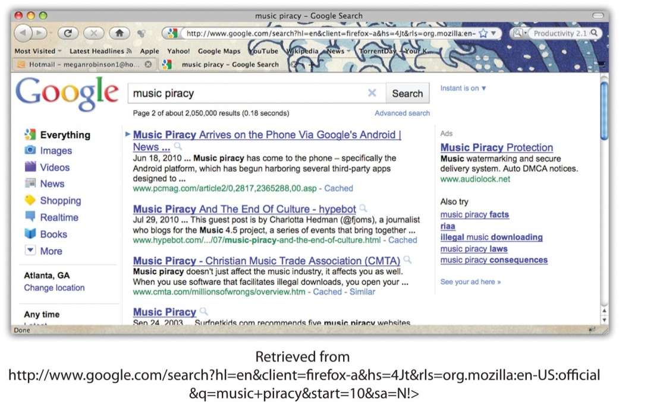
Not all the results online search engines return will be useful or reliable. Give careful consideration to the reliability of an online source before selecting a topic based on it. Remember that factual information can be verified in other sources, both online and in print. If you have doubts about any information you find, either do not use it or identify it as potentially unreliable.
The results from Mariah’s search included websites from university publications, personal blogs, online news sources, and lots of legal cases sponsored by the recording industry. Reading legal jargon made Mariah uncomfortable with the results, so she decided to look further. Reviewing her map, she realized that she was more interested in consumer aspects of mass media, so she refocused her search to media technology and the sometimes confusing array of expensive products that fill electronics stores. Now, Mariah considers a paper topic on the products that have fed the mass media boom in everyday lives.

Exercise 3
In Note 7.12 "Exercise 2", you chose a possible topic and explored it by answering questions about it using the 5WH questions. However, this topic may still be too broad. Here, in Note 7.21 "Exercise 3", choose and complete one of the prewriting strategies to narrow the focus. Use either brainstorming, idea mapping, or searching the Internet.
Collaboration
Please share with a classmate and compare your answers. Share what you found and what interests you about the possible topic(s).
Prewriting strategies are a vital first step in the writing process. First, they help you first choose a broad topic and then they help you narrow the focus of the topic to a more specific idea. An effective topic ensures that you are ready for the next step.

Topic Checklist
Developing a Good Topic
The following checklist can help you decide if your narrowed topic is a good topic for your assignment.
- Am I interested in this topic?
- Would my audience be interested?
- Do I have prior knowledge or experience with this topic? If so, would I be comfortable exploring this topic and sharing my experiences?
- Do I want to learn more about this topic?
- Is this topic specific?
- Does it fit the length of the assignment?
With your narrowed focus in mind, answer the bulleted questions in the checklist for developing a good topic. If you can answer “yes” to all the questions, write your topic on the line. If you answer “no” to any of the questions, think about another topic or adjust the one you have and try the prewriting strategies again.
My narrowed topic: ____________________________________________

Key Takeaways
- All writers rely on steps and strategies to begin the writing process.
- The steps in the writing process are prewriting, outlining, writing a rough draft, revising, and editing.
- Prewriting is the transfer of ideas from abstract thoughts into words, phrases, and sentences on paper.
- A good topic interests the writer, appeals to the audience, and fits the purpose of the assignment.
- Writers often choose a general topic first and then narrow the focus to a more specific topic.

7.2 Outlining

Learning Objectives
- Identify the steps in constructing an outline.
- Construct a topic outline and a sentence outline.
Your prewriting activities and readings have helped you gather information for your assignment. The more you sort through the pieces of information you found, the more you will begin to see the connections between them. Patterns and gaps may begin to stand out. But only when you start to organize your ideas will you be able to translate your raw insights into a form that will communicate meaning to your audience.

Tip
Longer papers require more reading and planning than shorter papers do. Most writers discover that the more they know about a topic, the more they can write about it with intelligence and interest.

Organizing Ideas
When you write, you need to organize your ideas in an order that makes sense. The writing you complete in all your courses exposes how analytically and critically your mind works. In some courses, the only direct contact you may have with your instructor is through the assignments you write for the course. You can make a good impression by spending time ordering your ideas.
Order refers to your choice of what to present first, second, third, and so on in your writing. The order you pick closely relates to your purpose for writing that particular assignment. For example, when telling a story, it may be important to first describe the background for the action. Or you may need to first describe a 3-D movie projector or a television studio to help readers visualize the setting and scene. You may want to group your support effectively to convince readers that your point of view on an issue is well reasoned and worthy of belief.
In longer pieces of writing, you may organize different parts in different ways so that your purpose stands out clearly and all parts of the paper work together to consistently develop your main point.

Methods of Organizing Writing
The three common methods of organizing writing are chronological order, spatial order, and order of importance. You will learn more about these in Chapter 8 "Writing Essays: From Start to Finish"; however, you need to keep these methods of organization in mind as you plan how to arrange the information you have gathered in an outline. An outline is a written plan that serves as a skeleton for the paragraphs you write. Later, when you draft paragraphs in the next stage of the writing process, you will add support to create “flesh” and “muscle” for your assignment.
When you write, your goal is not only to complete an assignment but also to write for a specific purpose—perhaps to inform, to explain, to persuade, or for a combination of these purposes. Your purpose for writing should always be in the back of your mind, because it will help you decide which pieces of information belong together and how you will order them. In other words, choose the order that will most effectively fit your purpose and support your main point.
Table 7.1 "Order versus Purpose" shows the connection between order and purpose.
Table 7.1 Order versus Purpose
Order | Purpose
Chronological Order | To explain the history of an event or a topic
 | To tell a story or relate an experience
 | To explain how to do or make something
 | To explain the steps in a process
Spatial Order | To help readers visualize something as you want them to see it
 | To create a main impression using the senses (sight, touch, taste, smell, and sound)
Order of Importance | To persuade or convince
 | To rank items by their importance, benefit, or significance

Writing a Thesis Statement
One legitimate question readers always ask about a piece of writing is “What is the big idea?” (You may even ask this question when you are the reader, critically reading an assignment or another document.) Every nonfiction writing task—from the short essay to the ten-page term paper to the lengthy senior thesis—needs a big idea, or a controlling idea, as the spine for the work. The controlling idea is the main idea that you want to present and develop.

Tip
For a longer piece of writing, the main idea should be broader than the main idea for a shorter piece of writing. Be sure to frame a main idea that is appropriate for the length of the assignment. Ask yourself, “How many pages will it take for me to explain and explore this main idea in detail?” Be reasonable with your estimate. Then expand or trim it to fit the required length.
The big idea, or controlling idea, you want to present in an essay is expressed in a thesis statement. A thesis statement is often one sentence long, and it states your point of view. The thesis statement is not the topic of the piece of writing but rather what you have to say about that topic and what is important to tell readers.
Table 7.2 "Topics and Thesis Statements" compares topics and thesis statements.

Table 7.2 Topics and Thesis Statements
Topic | Thesis Statement
Music piracy | The recording industry fears that so-called music piracy will diminish profits and destroy markets, but it cannot be more wrong.
The number of consumer choices available in media gear | Everyone wants the newest and the best digital technology, but the choices are extensive, and the specifications are often confusing.
E-books and online newspapers increasing their share of the market | E-books and online newspapers will bring an end to print media as we know it.
Online education and the new media | Someday, students and teachers will send avatars to their online classrooms.

The first thesis statement you write will be a preliminary thesis statement, or a working thesis statement. You will need it when you begin to outline your assignment as a way to organize it. As you continue to develop the arrangement, you can limit your working thesis statement if it is too broad or expand it if it proves too narrow for what you want to say.

Exercise 1
Using the topic you selected in Section 7.1 "Apply Prewriting Models", develop a working thesis statement that states your controlling idea for the piece of writing you are doing. On a sheet of paper, write your working thesis statement.

Tip
You will make several attempts before you devise a working thesis statement that you think is effective. Each draft of the thesis statement will bring you closer to the wording that expresses your meaning exactly.

Writing an Outline
For an essay question on a test or a brief oral presentation in class, all you may need to prepare is a short, informal outline in which you jot down key ideas in the order you will present them. This kind of outline reminds you to stay focused in a stressful situation and to include all the good ideas that help you explain or prove your point.
For a longer assignment, like an essay or a research paper, many college instructors require students to submit a formal outline before writing a major paper as a way to be sure you are on the right track and are working in an organized manner. A formal outline is a detailed guide that shows how all your supporting ideas relate to each other. It helps you distinguish between ideas that are of equal importance and ones that are of lesser importance. You build your paper based on the framework created by the outline.

Tip
Instructors may also require you to submit an outline with your final draft to check the direction of the assignment and the logic of your final draft. If you are required to submit an outline with the final draft of a paper, remember to revise the outline to reflect any changes you made while writing the paper.
There are two types of formal outlines: the topic outline and the sentence outline. You format both types of formal outlines in the same way.
- Place your introduction and thesis statement at the beginning, under roman numeral I.
- Use roman numerals (II, III, IV, V, etc.) to identify main points that develop the thesis statement.
- Use capital letters (A, B, C, D, etc.) to divide your main points into parts.
- Use arabic numerals (1, 2, 3, 4, 5, etc.) if you need to subdivide any As, Bs, or Cs into smaller parts.
- End with the final roman numeral expressing your idea for your conclusion.
Here is what the skeleton of a traditional formal outline looks like. The indention helps clarify how the ideas are related.
- Introduction
Thesis statement
- Main point 1 → becomes the topic sentence of body paragraph 1
  - Supporting detail → becomes a support sentence of body paragraph 1
    - Subpoint
    - Subpoint
  - Supporting detail
    - Subpoint
    - Subpoint
  - Supporting detail
    - Subpoint
    - Subpoint
- Main point 2 → becomes the topic sentence of body paragraph 2
  - Supporting detail
  - Supporting detail
  - Supporting detail
- Main point 3 → becomes the topic sentence of body paragraph 3
  - Supporting detail
  - Supporting detail
  - Supporting detail
- Conclusion

Tip
In an outline, any supporting detail can be developed with subpoints. For simplicity, the model shows them only under the first main point.

Tip
Formal outlines are often quite rigid in their organization. As many instructors will specify, you cannot subdivide one point if it is only one part. For example, for every roman numeral I, there must be a For every A, there must be a B. For every arabic numeral 1, there must be a 2. See for yourself on the sample outlines that follow.

Constructing Topic Outlines
A topic outline is the same as a sentence outline except you use words or phrases instead of complete sentences. Words and phrases keep the outline short and easier to comprehend. All the headings, however, must be written in parallel structure. (For more information on parallel structure, see Chapter 6 "Refining Your Writing: How Do I Improve My Writing Technique?".)
Here is the topic outline that Mariah constructed for the essay she is developing. Her purpose is to inform, and her audience is a general audience of her fellow college students. Notice how Mariah begins with her thesis statement. She then arranges her main points and supporting details in outline form using short phrases in parallel grammatical structure.
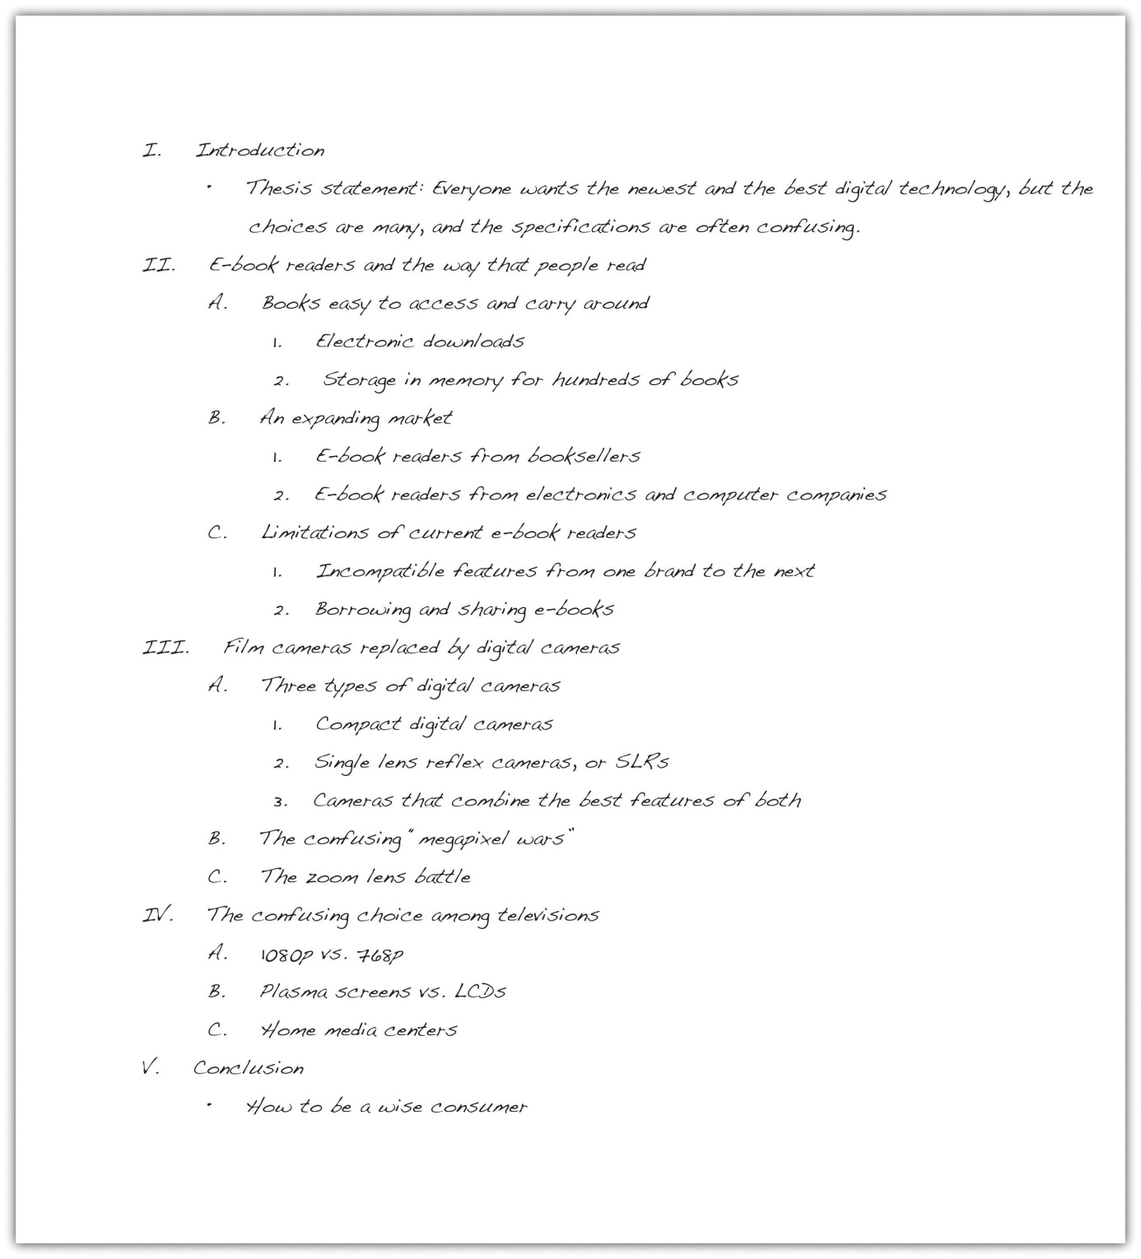

Checklist
Writing an Effective Topic Outline
This checklist can help you write an effective topic outline for your assignment. It will also help you discover where you may need to do additional reading or prewriting.
- Do I have a controlling idea that guides the development of the entire piece of writing?
- Do I have three or more main points that I want to make in this piece of writing? Does each main point connect to my controlling idea?
- Is my outline in the best order—chronological order, spatial order, or order of importance—for me to present my main points? Will this order help me get my main point across?
- Do I have supporting details that will help me inform, explain, or prove my main points?
- Do I need to add more support? If so, where?
- Do I need to make any adjustments in my working thesis statement before I consider it the final version?

Writing at Work
Word processing programs generally have an automatic numbering feature that can be used to prepare outlines. This feature automatically sets indents and lets you use the tab key to arrange information just as you would in an outline. Although in business this style might be acceptable, in college your instructor might have different requirements. Teach yourself how to customize the levels of outline numbering in your word-processing program to fit your instructor’s preferences.

Exercise 2
Using the working thesis statement you wrote in Note 7.32 "Exercise 1" and the reading you did in Section 7.1 "Apply Prewriting Models", construct a topic outline for your essay. Be sure to observe correct outline form, including correct indentions and the use of Roman and arabic numerals and capital letters.
Collaboration
Please share with a classmate and compare your outline. Point out areas of interest from their outline and what you would like to learn more about.

Constructing Sentence Outlines
A sentence outline is the same as a topic outline except you use complete sentences instead of words or phrases. Complete sentences create clarity and can advance you one step closer to a draft in the writing process.
Here is the sentence outline that Mariah constructed for the essay she is developing.
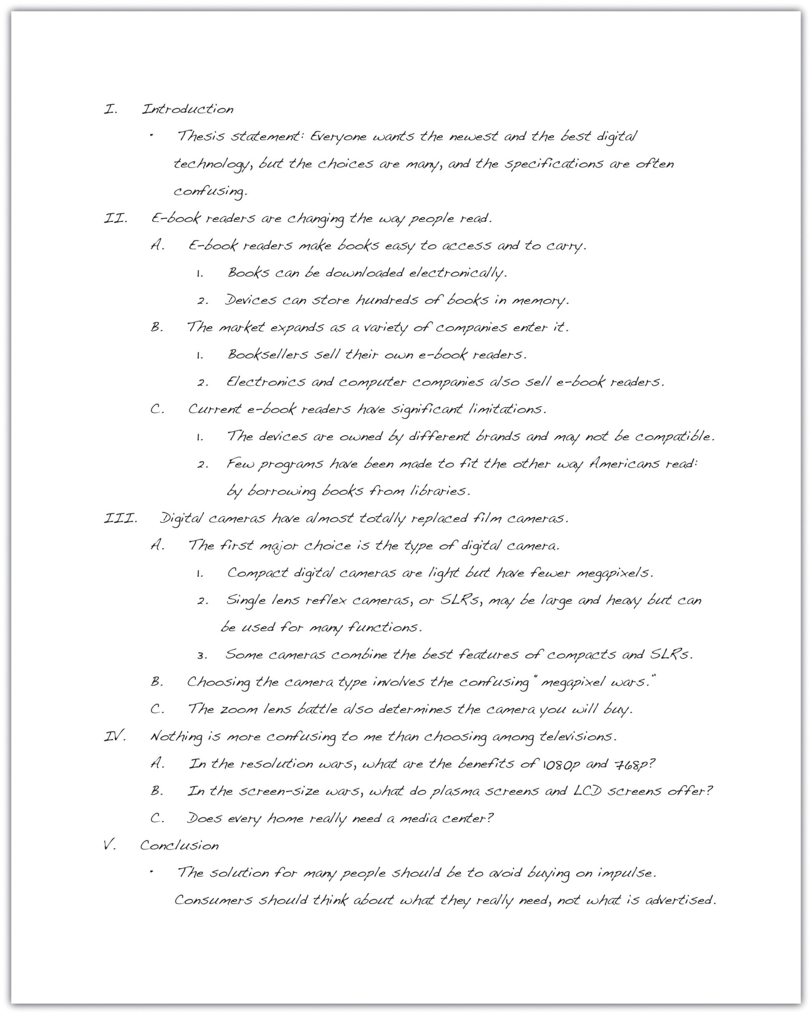

Tip
The information compiled under each roman numeral will become a paragraph in your final paper. In the previous example, the outline follows the standard five-paragraph essay arrangement, but longer essays will require more paragraphs and thus more roman numerals. If you think that a paragraph might become too long or stringy, add an additional paragraph to your outline, renumbering the main points appropriately.

Writing at Work
PowerPoint presentations, used both in schools and in the workplace, are organized in a way very similar to formal outlines. PowerPoint presentations often contain information in the form of talking points that the presenter develops with more details and examples than are contained on the PowerPoint slide.

Exercise 3
Expand the topic outline you prepared in Note 7.41 "Exercise 2" to make it a sentence outline. In this outline, be sure to include multiple supporting points for your main topic even if your topic outline does not contain them. Be sure to observe correct outline form, including correct indentions and the use of Roman and arabic numerals and capital letters.

Key Takeaways
- Writers must put their ideas in order so the assignment makes sense. The most common orders are chronological order, spatial order, and order of importance.
- After gathering and evaluating the information you found for your essay, the next step is to write a working, or preliminary, thesis statement.
- The working thesis statement expresses the main idea that you want to develop in the entire piece of writing. It can be modified as you continue the writing process.
- Effective writers prepare a formal outline to organize their main ideas and supporting details in the order they will be presented.
- A topic outline uses words and phrases to express the ideas.
- A sentence outline uses complete sentences to express the ideas.
- The writer’s thesis statement begins the outline, and the outline ends with suggestions for the concluding paragraph.

7.3 Drafting

Learning Objectives
- Identify drafting strategies that improve writing.
- Use drafting strategies to prepare the first draft of an essay.
Drafting is the stage of the writing process in which you develop a complete first version of a piece of writing.
Even professional writers admit that an empty page scares them because they feel they need to come up with something fresh and original every time they open a blank document on their computers. Because you have completed the first two steps in the writing process, you have already recovered from empty page syndrome. You have hours of prewriting and planning already done. You know what will go on that blank page: what you wrote in your outline.

Getting Started: Strategies For Drafting
Your objective for this portion of Chapter 7 "The Writing Process: How Do I Begin?" is to draft the body paragraphs of a standard five-paragraph essay. A five-paragraph essay contains an introduction, three body paragraphs, and a conclusion. If you are more comfortable starting on paper than on the computer, you can start on paper and then type it before you revise. You can also use a voice recorder to get yourself started, dictating a paragraph or two to get you thinking. In this lesson, Mariah does all her work on the computer, but you may use pen and paper or the computer to write a rough draft.

Making the Writing Process Work for You
What makes the writing process so beneficial to writers is that it encourages alternatives to standard practices while motivating you to develop your best ideas. For instance, the following approaches, done alone or in combination with others, may improve your writing and help you move forward in the writing process:
- Begin writing with the part you know the most about. You can start with the third paragraph in your outline if ideas come easily to mind. You can start with the second paragraph or the first paragraph, too. Although paragraphs may vary in length, keep in mind that short paragraphs may contain insufficient support. Readers may also think the writing is abrupt. Long paragraphs may be wordy and may lose your reader’s interest. As a guideline, try to write paragraphs longer than one sentence but shorter than the length of an entire double-spaced page.
- Write one paragraph at a time and then stop. As long as you complete the assignment on time, you may choose how many paragraphs you complete in one sitting. Pace yourself. On the other hand, try not to procrastinate. Writers should always meet their deadlines.
- Take short breaks to refresh your mind. This tip might be most useful if you are writing a multipage report or essay. Still, if you are antsy or cannot concentrate, take a break to let your mind rest. But do not let breaks extend too long. If you spend too much time away from your essay, you may have trouble starting again. You may forget key points or lose momentum. Try setting an alarm to limit your break, and when the time is up, return to your desk to write.
- Be reasonable with your goals. If you decide to take ten-minute breaks, try to stick to that goal. If you told yourself that you need more facts, then commit to finding them. Holding yourself to your own goals will create successful writing assignments.
- Keep your audience and purpose in mind as you write. These aspects of writing are just as important when you are writing a single paragraph for your essay as when you are considering the direction of the entire essay.
Of all of these considerations, keeping your purpose and your audience at the front of your mind is the most important key to writing success. If your purpose is to persuade, for example, you will present your facts and details in the most logical and convincing way you can.
Your purpose will guide your mind as you compose your sentences. Your audience will guide word choice. Are you writing for experts, for a general audience, for other college students, or for people who know very little about your topic? Keep asking yourself what your readers, with their background and experience, need to be told in order to understand your ideas. How can you best express your ideas so they are totally clear and your communication is effective?

Tip
You may want to identify your purpose and audience on an index card that you clip to your paper (or keep next to your computer). On that card, you may want to write notes to yourself—perhaps about what that audience might not know or what it needs to know—so that you will be sure to address those issues when you write. It may be a good idea to also state exactly what you want to explain to that audience, or to inform them of, or to persuade them about.

Writing at Work
Many of the documents you produce at work target a particular audience for a particular purpose. You may find that it is highly advantageous to know as much as you can about your target audience and to prepare your message to reach that audience, even if the audience is a coworker or your boss. Menu language is a common example. Descriptions like “organic romaine” and “free-range chicken” are intended to appeal to a certain type of customer though perhaps not to the same customer who craves a thick steak. Similarly, mail-order companies research the demographics of the people who buy their merchandise. Successful vendors customize product descriptions in catalogs to appeal to their buyers’ tastes. For example, the product descriptions in a skateboarder catalog will differ from the descriptions in a clothing catalog for mature adults.

Exercise 1
Using the topic for the essay that you outlined in Section 7.2 "Outlining", describe your purpose and your audience as specifically as you can. Use your own sheet of paper to record your responses. Then keep these responses near you during future stages of the writing process.
My purpose: ____________________________________________
____________________________________________
____________________________________________
My audience: ____________________________________________
____________________________________________
____________________________________________

Setting Goals for Your First Draft
A draft is a complete version of a piece of writing, but it is not the final version. The step in the writing process after drafting, as you may remember, is revising. During revising, you will have the opportunity to make changes to your first draft before you put the finishing touches on it during the editing and proofreading stage. A first draft gives you a working version that you can later improve.

Writing at Work
Workplace writing in certain environments is done by teams of writers who collaborate on the planning, writing, and revising of documents, such as long reports, technical manuals, and the results of scientific research. Collaborators do not need to be in the same room, the same building, or even the same city. Many collaborations are conducted over the Internet.
In a perfect collaboration, each contributor has the right to add, edit, and delete text. Strong communication skills, in addition to strong writing skills, are important in this kind of writing situation because disagreements over style, content, process, emphasis, and other issues may arise.
The collaborative software, or document management systems, that groups use to work on common projects is sometimes called groupware or workgroup support systems.
The reviewing tool on some word-processing programs also gives you access to a collaborative tool that many smaller workgroups use when they exchange documents. You can also use it to leave comments to yourself.

Tip
If you invest some time now to investigate how the reviewing tool in your word processor works, you will be able to use it with confidence during the revision stage of the writing process. Then, when you start to revise, set your reviewing tool to track any changes you make, so you will be able to tinker with text and commit only those final changes you want to keep.

Discovering the Basic Elements of a First Draft
If you have been using the information in this chapter step by step to help you develop an assignment, you already have both a formal topic outline and a formal sentence outline to direct your writing. Knowing what a first draft looks like will help you make the creative leap from the outline to the first draft. A first draft should include the following elements:
- An introduction that piques the audience’s interest, tells what the essay is about, and motivates readers to keep reading.
- A thesis statement that presents the main point, or controlling idea, of the entire piece of writing.
- A topic sentence in each paragraph that states the main idea of the paragraph and implies how that main idea connects to the thesis statement.
- Supporting sentences in each paragraph that develop or explain the topic sentence. These can be specific facts, examples, anecdotes, or other details that elaborate on the topic sentence.
- A conclusion that reinforces the thesis statement and leaves the audience with a feeling of completion.
These elements follow the standard five-paragraph essay format, which you probably first encountered in high school. This basic format is valid for most essays you will write in college, even much longer ones. For now, however, Mariah focuses on writing the three body paragraphs from her outline. Chapter 8 "Writing Essays: From Start to Finish" covers writing introductions and conclusions, and you will read Mariah’s introduction and conclusion in Chapter 8 "Writing Essays: From Start to Finish".

The Role of Topic Sentences
Topic sentences make the structure of a text and the writer’s basic arguments easy to locate and comprehend. In college writing, using a topic sentence in each paragraph of the essay is the standard rule. However, the topic sentence does not always have to be the first sentence in your paragraph even if it the first item in your formal outline.

Tip
When you begin to draft your paragraphs, you should follow your outline fairly closely. After all, you spent valuable time developing those ideas. However, as you begin to express your ideas in complete sentences, it might strike you that the topic sentence might work better at the end of the paragraph or in the middle. Try it. Writing a draft, by its nature, is a good time for experimentation.
The topic sentence can be the first, middle, or final sentence in a paragraph. The assignment’s audience and purpose will often determine where a topic sentence belongs. When the purpose of the assignment is to persuade, for example, the topic sentence should be the first sentence in a paragraph. In a persuasive essay, the writer’s point of view should be clearly expressed at the beginning of each paragraph.
Choosing where to position the topic sentence depends not only on your audience and purpose but also on the essay’s arrangement, or order. When you organize information according to order of importance, the topic sentence may be the final sentence in a paragraph. All the supporting sentences build up to the topic sentence. Chronological order may also position the topic sentence as the final sentence because the controlling idea of the paragraph may make the most sense at the end of a sequence.
When you organize information according to spatial order, a topic sentence may appear as the middle sentence in a paragraph. An essay arranged by spatial order often contains paragraphs that begin with descriptions. A reader may first need a visual in his or her mind before understanding the development of the paragraph. When the topic sentence is in the middle, it unites the details that come before it with the ones that come after it.

Tip
As you read critically throughout the writing process, keep topic sentences in mind. You may discover topic sentences that are not always located at the beginning of a paragraph. For example, fiction writers customarily use topic ideas, either expressed or implied, to move readers through their texts. In nonfiction writing, such as popular magazines, topic sentences are often used when the author thinks it is appropriate (based on the audience and the purpose, of course). A single topic sentence might even control the development of a number of paragraphs. For more information on topic sentences, please see Chapter 5 "Writing Paragraphs: Separating Ideas and Shaping Content".
Developing topic sentences and thinking about their placement in a paragraph will prepare you to write the rest of the paragraph.

Paragraphs
The paragraph is the main structural component of an essay as well as other forms of writing. Each paragraph of an essay adds another related main idea to support the writer’s thesis, or controlling idea. Each related main idea is supported and developed with facts, examples, and other details that explain it. By exploring and refining one main idea at a time, writers build a strong case for their thesis.
Paragraph Length
How long should a paragraph be?
One answer to this important question may be “long enough”—long enough for you to address your points and explain your main idea. To grab attention or to present succinct supporting ideas, a paragraph can be fairly short and consist of two to three sentences. A paragraph in a complex essay about some abstract point in philosophy or archaeology can be three-quarters of a page or more in length. As long as the writer maintains close focus on the topic and does not ramble, a long paragraph is acceptable in college-level writing. In general, try to keep the paragraphs longer than one sentence but shorter than one full page of double-spaced text.

Tip
Journalistic style often calls for brief two- or three-sentence paragraphs because of how people read the news, both online and in print. Blogs and other online information sources often adopt this paragraphing style, too. Readers often skim the first paragraphs of a great many articles before settling on the handful of stories they want to read in detail.
You may find that a particular paragraph you write may be longer than one that will hold your audience’s interest. In such cases, you should divide the paragraph into two or more shorter paragraphs, adding a topic statement or some kind of transitional word or phrase at the start of the new paragraph. Transition words or phrases show the connection between the two ideas.
In all cases, however, be guided by what you instructor wants and expects to find in your draft. Many instructors will expect you to develop a mature college-level style as you progress through the semester’s assignments.

Exercise 2
To build your sense of appropriate paragraph length, use the Internet to find examples of the following items. Copy them into a file, identify your sources, and present them to your instructor with your annotations, or notes.
- A news article written in short paragraphs. Take notes on, or annotate, your selection with your observations about the effect of combining paragraphs that develop the same topic idea. Explain how effective those paragraphs would be.
- A long paragraph from a scholarly work that you identify through an academic search engine. Annotate it with your observations about the author’s paragraphing style.

Starting Your First Draft
Now we are finally ready to look over Mariah’s shoulder as she begins to write her essay about digital technology and the confusing choices that consumers face. As she does, you should have in front of you your outline, with its thesis statement and topic sentences, and the notes you wrote earlier in this lesson on your purpose and audience. Reviewing these will put both you and Mariah in the proper mind-set to start.
The following is Mariah’s thesis statement.
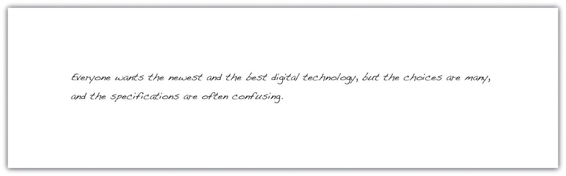

Here are the notes that Mariah wrote to herself to characterize her purpose and audience.
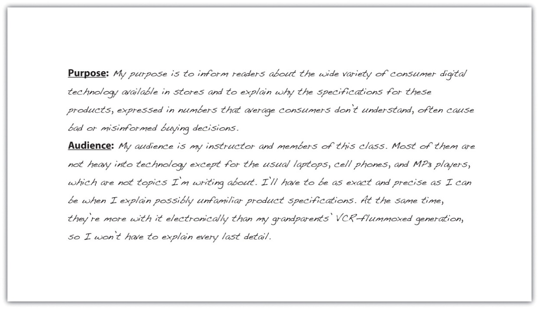
Mariah chose to begin by writing a quick introduction based on her thesis statement. She knew that she would want to improve her introduction significantly when she revised. Right now, she just wanted to give herself a starting point. You will read her introduction again in Section 7.4 "Revising and Editing" when she revises it.

Tip
Remember Mariah’s other options. She could have started directly with any of the body paragraphs.
You will learn more about writing attention-getting introductions and effective conclusions in Chapter 8 "Writing Essays: From Start to Finish".
With her thesis statement and her purpose and audience notes in front of her, Mariah then looked at her sentence outline. She chose to use that outline because it includes the topic sentences. The following is the portion of her outline for the first body paragraph. The roman numeral II identifies the topic sentence for the paragraph, capital letters indicate supporting details, and arabic numerals label subpoints.
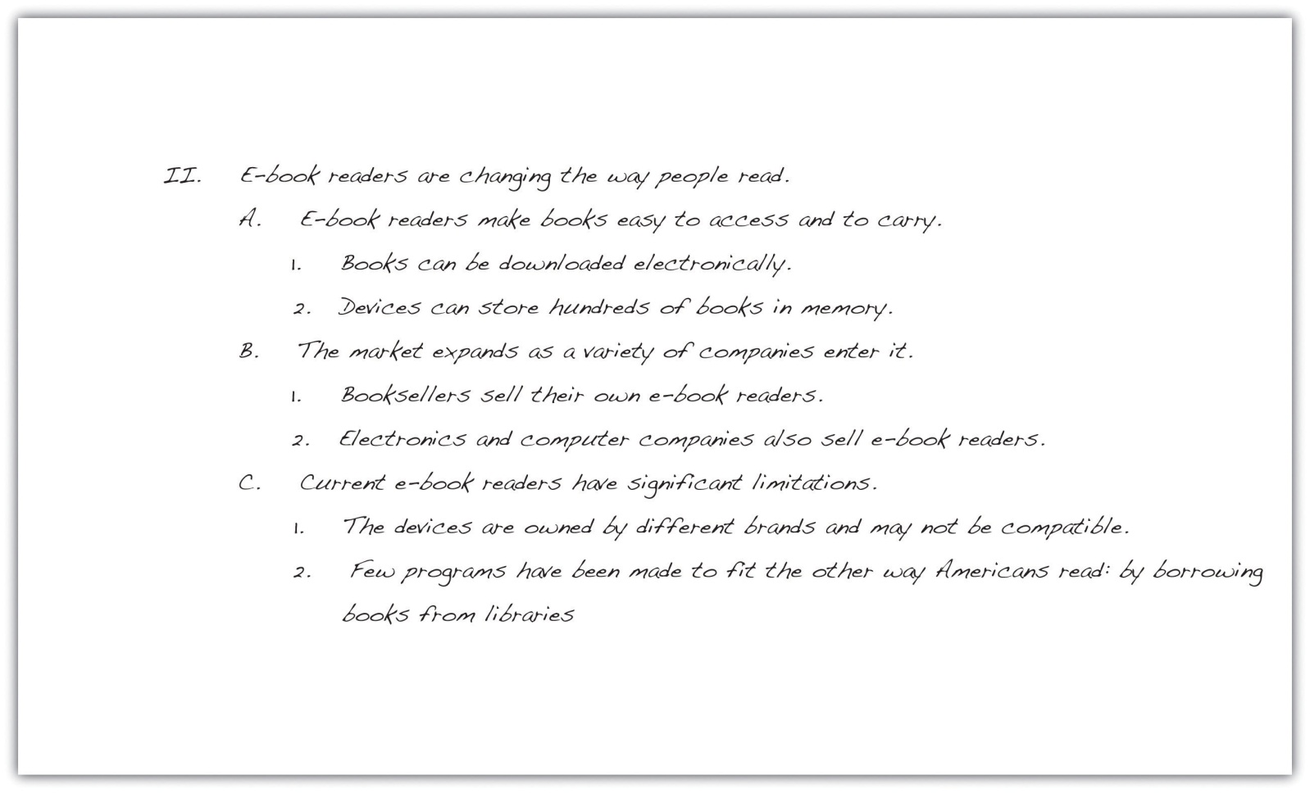

Mariah then began to expand the ideas in her outline into a paragraph. Notice how the outline helped her guarantee that all her sentences in the body of the paragraph develop the topic sentence.
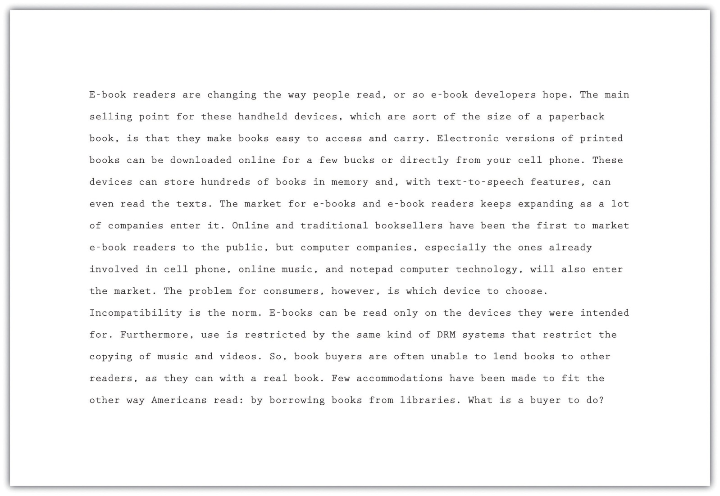

Tip
If you write your first draft on the computer, consider creating a new file folder for each course with a set of subfolders inside the course folders for each assignment you are given. Label the folders clearly with the course names, and label each assignment folder and word processing document with a title that you will easily recognize. The assignment name is a good choice for the document. Then use that subfolder to store all the drafts you create. When you start each new draft, do not just write over the last one. Instead, save the draft with a new tag after the title—draft 1, draft 2, and so on—so that you will have a complete history of drafts in case your instructor wishes you to submit them.
In your documents, observe any formatting requirements—for margins, headers, placement of page numbers, and other layout matters—that your instructor requires.

Exercise 3
Study how Mariah made the transition from her sentence outline to her first draft. First, copy her outline onto your own sheet of paper. Leave a few spaces between each part of the outline. Then copy sentences from Mariah’s paragraph to align each sentence with its corresponding entry in her outline.

Continuing the First Draft
Mariah continued writing her essay, moving to the second and third body paragraphs. She had supporting details but no numbered subpoints in her outline, so she had to consult her prewriting notes for specific information to include.

Tip
If you decide to take a break between finishing your first body paragraph and starting the next one, do not start writing immediately when you return to your work. Put yourself back in context and in the mood by rereading what you have already written. This is what Mariah did. If she had stopped writing in the middle of writing the paragraph, she could have jotted down some quick notes to herself about what she would write next.
Preceding each body paragraph that Mariah wrote is the appropriate section of her sentence outline. Notice how she expanded roman numeral III from her outline into a first draft of the second body paragraph. As you read, ask yourself how closely she stayed on purpose and how well she paid attention to the needs of her audience.
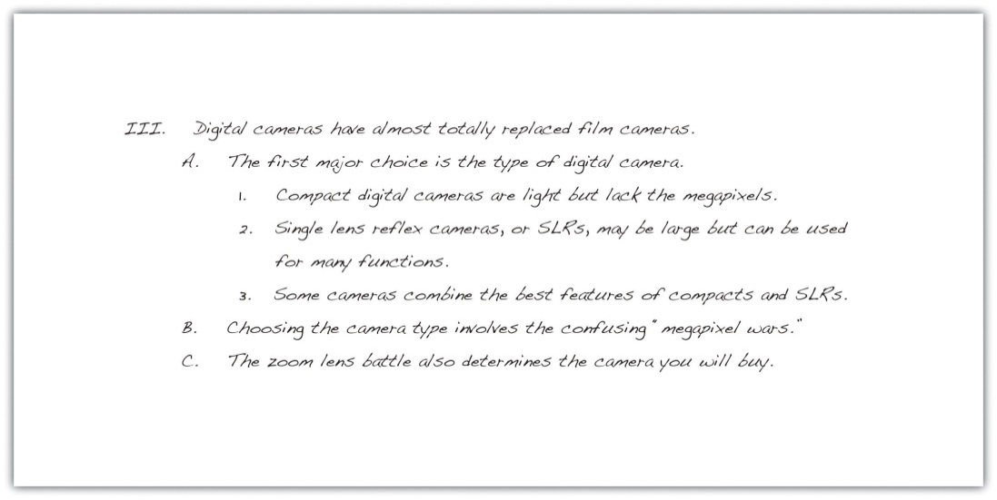
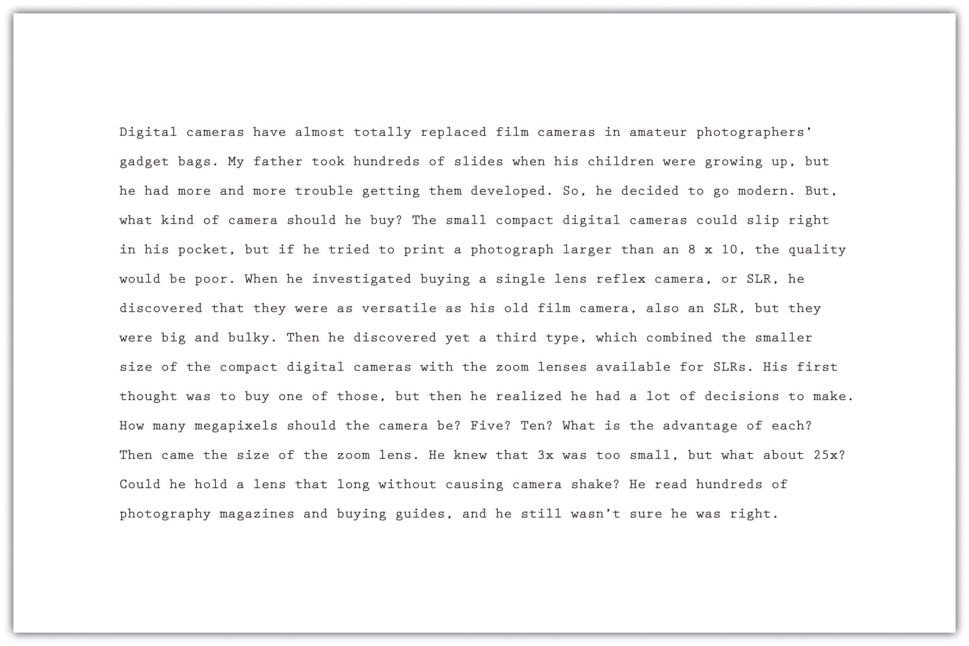

Mariah then began her third and final body paragraph using roman numeral IV from her outline.
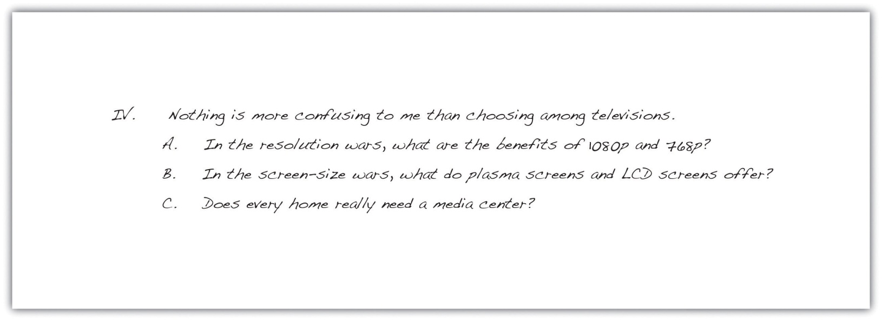
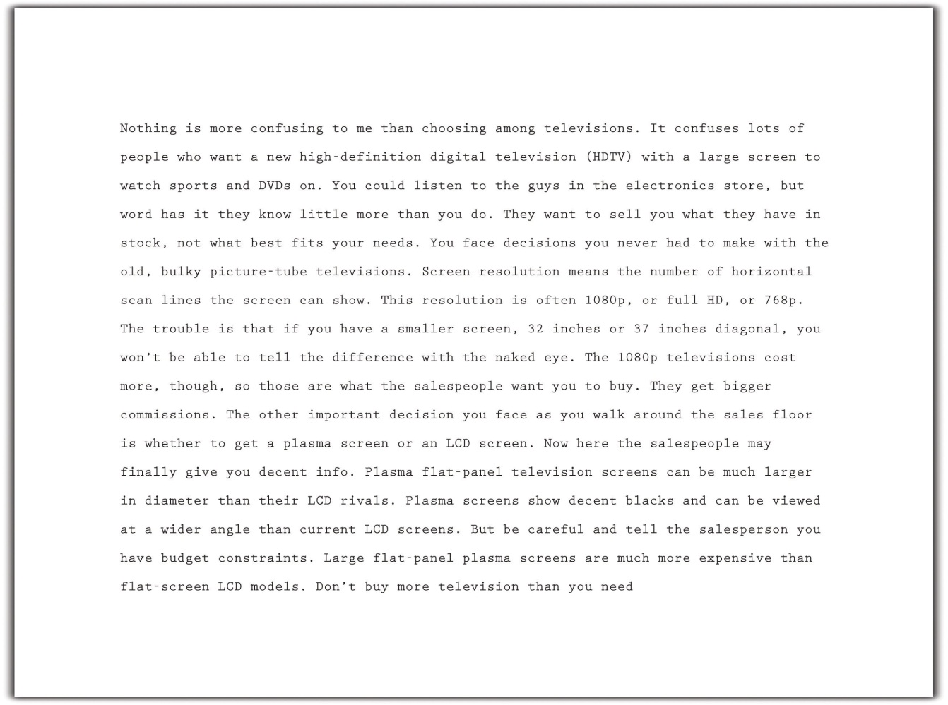

Exercise 4
Reread body paragraphs two and three of the essay that Mariah is writing. Then answer the questions on your own sheet of paper.
- In body paragraph two, Mariah decided to develop her paragraph as a nonfiction narrative. Do you agree with her decision? Explain. How else could she have chosen to develop the paragraph? Why is that better?
- Compare the writing styles of paragraphs two and three. What evidence do you have that Mariah was getting tired or running out of steam? What advice would you give her? Why?
- Choose one of these two body paragraphs. Write a version of your own that you think better fits Mariah’s audience and purpose.

Writing a Title
A writer’s best choice for a title is one that alludes to the main point of the entire essay. Like the headline in a newspaper or the big, bold title in a magazine, an essay’s title gives the audience a first peek at the content. If readers like the title, they are likely to keep reading.
Following her outline carefully, Mariah crafted each paragraph of her essay. Moving step by step in the writing process, Mariah finished the draft and even included a brief concluding paragraph (you will read her conclusion in Chapter 8 "Writing Essays: From Start to Finish"). She then decided, as the final touch for her writing session, to add an engaging title.
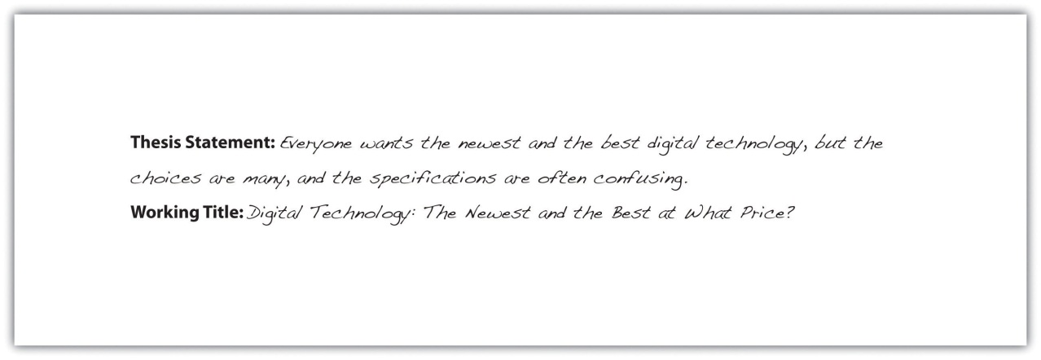

Writing Your Own First Draft
Now you may begin your own first draft, if you have not already done so. Follow the suggestions and the guidelines presented in this section.

Key Takeaways
- Make the writing process work for you. Use any and all of the strategies that help you move forward in the writing process.
- Always be aware of your purpose for writing and the needs of your audience. Cater to those needs in every sensible way.
- Remember to include all the key structural parts of an essay: a thesis statement that is part of your introductory paragraph, three or more body paragraphs as described in your outline, and a concluding paragraph. Then add an engaging title to draw in readers.
- Write paragraphs of an appropriate length for your writing assignment. Paragraphs in college-level writing can be a page long, as long as they cover the main topics in your outline.
- Use your topic outline or your sentence outline to guide the development of your paragraphs and the elaboration of your ideas. Each main idea, indicated by a roman numeral in your outline, becomes the topic of a new paragraph. Develop it with the supporting details and the subpoints of those details that you included in your outline.
- Generally speaking, write your introduction and conclusion last, after you have fleshed out the body paragraphs.

7.4 Revising and Editing

Learning Objectives
- Identify major areas of concern in the draft essay during revising and editing.
- Use peer reviews and editing checklists to assist revising and editing.
- Revise and edit the first draft of your essay and produce a final draft.
Revising and editing are the two tasks you undertake to significantly improve your essay. Both are very important elements of the writing process. You may think that a completed first draft means little improvement is needed. However, even experienced writers need to improve their drafts and rely on peers during revising and editing. You may know that athletes miss catches, fumble balls, or overshoot goals. Dancers forget steps, turn too slowly, or miss beats. For both athletes and dancers, the more they practice, the stronger their performance will become. Web designers seek better images, a more clever design, or a more appealing background for their web pages. Writing has the same capacity to profit from improvement and revision.

Understanding the Purpose of Revising and Editing
Revising and editing allow you to examine two important aspects of your writing separately, so that you can give each task your undivided attention.
- When you revise, you take a second look at your ideas. You might add, cut, move, or change information in order to make your ideas clearer, more accurate, more interesting, or more convincing.
- When you edit, you take a second look at how you expressed your ideas. You add or change words. You fix any problems in grammar, punctuation, and sentence structure. You improve your writing style. You make your essay into a polished, mature piece of writing, the end product of your best efforts.

Tip
How do you get the best out of your revisions and editing? Here are some strategies that writers have developed to look at their first drafts from a fresh perspective. Try them over the course of this semester; then keep using the ones that bring results.
- Take a break. You are proud of what you wrote, but you might be too close to it to make changes. Set aside your writing for a few hours or even a day until you can look at it objectively.
- Ask someone you trust for feedback and constructive criticism.
- Pretend you are one of your readers. Are you satisfied or dissatisfied? Why?
- Use the resources that your college provides. Find out where your school’s writing lab is located and ask about the assistance they provide online and in person.
Many people hear the words critic, critical, and criticism and pick up only negative vibes that provoke feelings that make them blush, grumble, or shout. However, as a writer and a thinker, you need to learn to be critical of yourself in a positive way and have high expectations for your work. You also need to train your eye and trust your ability to fix what needs fixing. For this, you need to teach yourself where to look.

Creating Unity and Coherence
Following your outline closely offers you a reasonable guarantee that your writing will stay on purpose and not drift away from the controlling idea. However, when writers are rushed, are tired, or cannot find the right words, their writing may become less than they want it to be. Their writing may no longer be clear and concise, and they may be adding information that is not needed to develop the main idea.
When a piece of writing has unity, all the ideas in each paragraph and in the entire essay clearly belong and are arranged in an order that makes logical sense. When the writing has coherence, the ideas flow smoothly. The wording clearly indicates how one idea leads to another within a paragraph and from paragraph to paragraph.

Tip
Reading your writing aloud will often help you find problems with unity and coherence. Listen for the clarity and flow of your ideas. Identify places where you find yourself confused, and write a note to yourself about possible fixes.

Creating Unity
Sometimes writers get caught up in the moment and cannot resist a good digression. Even though you might enjoy such detours when you chat with friends, unplanned digressions usually harm a piece of writing.
Mariah stayed close to her outline when she drafted the three body paragraphs of her essay she tentatively titled “Digital Technology: The Newest and the Best at What Price?” But a recent shopping trip for an HDTV upset her enough that she digressed from the main topic of her third paragraph and included comments about the sales staff at the electronics store she visited. When she revised her essay, she deleted the off-topic sentences that affected the unity of the paragraph.
Read the following paragraph twice, the first time without Mariah’s changes, and the second time with them.
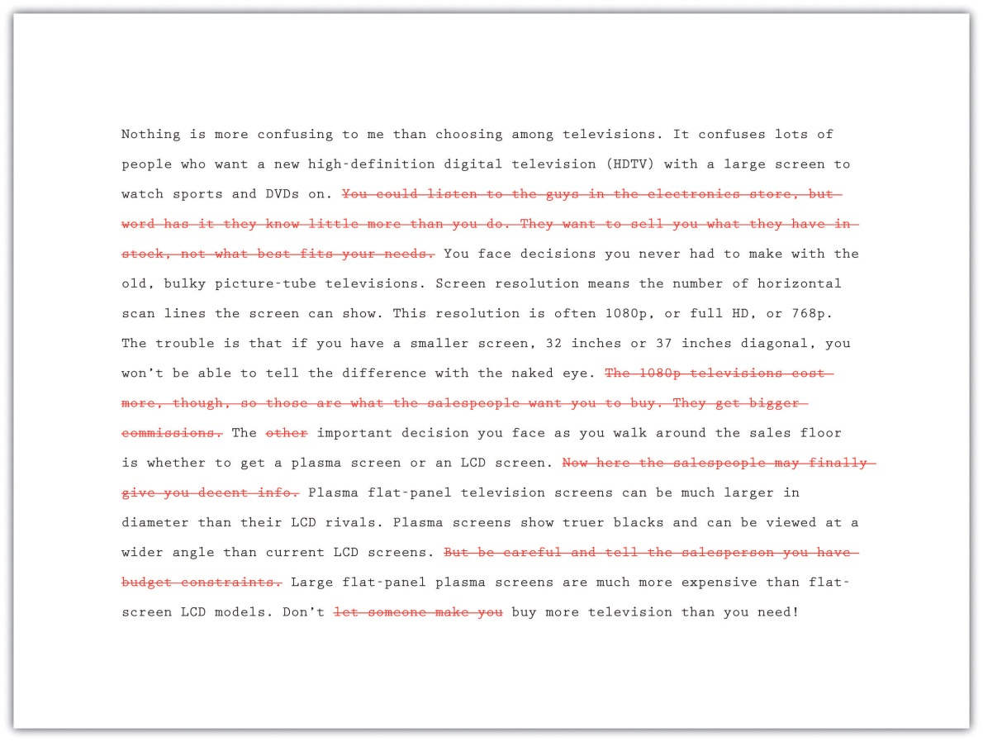

Exercise 1
- Answer the following two questions about Mariah’s paragraph:
  - Do you agree with Mariah’s decision to make the deletions she made? Did she cut too much, too little, or just enough? Explain.
  - Is the explanation of what screen resolution means a digression? Or is it audience friendly and essential to understanding the paragraph? Explain.
Collaboration
Please share with a classmate and compare your answers.
- Now start to revise the first draft of the essay you wrote in Section 7 "Writing Your Own First Draft". Reread it to find any statements that affect the unity of your writing. Decide how best to revise.

Tip
When you reread your writing to find revisions to make, look for each type of problem in a separate sweep. Read it straight through once to locate any problems with unity. Read it straight through a second time to find problems with coherence. You may follow this same practice during many stages of the writing process.

Writing at Work
Many companies hire copyeditors and proofreaders to help them produce the cleanest possible final drafts of large writing projects. Copyeditors are responsible for suggesting revisions and style changes; proofreaders check documents for any errors in capitalization, spelling, and punctuation that have crept in. Many times, these tasks are done on a freelance basis, with one freelancer working for a variety of clients.

Creating Coherence
Careful writers use transitions to clarify how the ideas in their sentences and paragraphs are related. These words and phrases help the writing flow smoothly. Adding transitions is not the only way to improve coherence, but they are often useful and give a mature feel to your essays. Table 7.3 "Common Transitional Words and Phrases" groups many common transitions according to their purpose.
Table 7.3 Common Transitional Words and Phrases
Transitions That Show Sequence or Time
after | before | later
afterward | before long | meanwhile
as soon as | finally | next
at first | first, second, third | soon
at last | in the first place | then
Transitions That Show Position
above | across | at the bottom
at the top | behind | below
beside | beyond | inside
near | next to | opposite
to the left, to the right, to the side | under | where
Transitions That Show a Conclusion
indeed | hence | in conclusion
in the final analysis | therefore | thus
Transitions That Continue a Line of Thought
consequently | furthermore | additionally
because | besides the fact | following this idea further
in addition | in the same way | moreover
looking further | considering…, it is clear that
Transitions That Change a Line of Thought
but | yet | however
nevertheless | on the contrary | on the other hand
Transitions That Show Importance
above all | best | especially
in fact | more important | most important
most | worst
Transitions That Introduce the Final Thoughts in a Paragraph or Essay
finally | last | in conclusion
most of all | least of all | last of all
All-Purpose Transitions to Open Paragraphs or to Connect Ideas Inside Paragraphs
admittedly | at this point | certainly
granted | it is true | generally speaking
in general | in this situation | no doubt
no one denies | obviously | of course
to be sure | undoubtedly | unquestionably
Transitions that Introduce Examples
for instance | for example
Transitions That Clarify the Order of Events or Steps
first, second, third | generally, furthermore, finally | in the first place, also, last
in the first place, furthermore, finally | in the first place, likewise, lastly

After Maria revised for unity, she next examined her paragraph about televisions to check for coherence. She looked for places where she needed to add a transition or perhaps reword the text to make the flow of ideas clear. In the version that follows, she has already deleted the sentences that were off topic.

Tip
Many writers make their revisions on a printed copy and then transfer them to the version on-screen. They conventionally use a small arrow called a caret (^) to show where to insert an addition or correction.
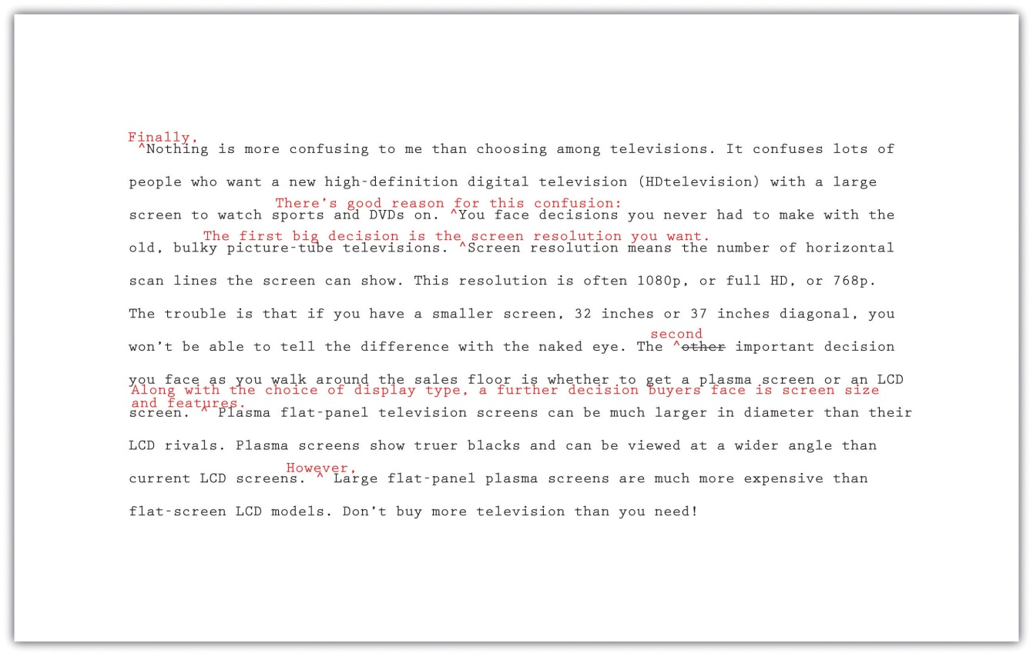

Exercise 2
- Answer the following questions about Mariah’s revised paragraph.
  - Do you agree with the transitions and other changes that Mariah made to her paragraph? Which would you keep and which were unnecessary? Explain.
  - What transition words or phrases did Mariah add to her paragraph? Why did she choose each one?
  - What effect does adding additional sentences have on the coherence of the paragraph? Explain. When you read both versions aloud, which version has a more logical flow of ideas? Explain.
- Now return to the first draft of the essay you wrote in Section 7 "Writing Your Own First Draft" and revise it for coherence. Add transition words and phrases where they are needed, and make any other changes that are needed to improve the flow and connection between ideas.

Being Clear and Concise
Some writers are very methodical and painstaking when they write a first draft. Other writers unleash a lot of words in order to get out all that they feel they need to say. Do either of these composing styles match your style? Or is your composing style somewhere in between? No matter which description best fits you, the first draft of almost every piece of writing, no matter its author, can be made clearer and more concise.
If you have a tendency to write too much, you will need to look for unnecessary words. If you have a tendency to be vague or imprecise in your wording, you will need to find specific words to replace any overly general language.

Identifying Wordiness
Sometimes writers use too many words when fewer words will appeal more to their audience and better fit their purpose. Here are some common examples of wordiness to look for in your draft. Eliminating wordiness helps all readers, because it makes your ideas clear, direct, and straightforward.
- Sentences that begin with There is or There are .
Wordy: There are two major experiments that the Biology Department sponsors.
Revised: The Biology Department sponsors two major experiments.
- Sentences with unnecessary modifiers.
Wordy: Two extremely famous and well-known consumer advocates spoke eloquently in favor of the proposed important legislation.
Revised: Two well-known consumer advocates spoke in favor of the proposed legislation.
- Sentences with deadwood phrases that add little to the meaning. Be judicious when you use phrases such as in terms of, with a mind to, on the subject of, as to whether or not, more or less, as far as…is concerned, and similar expressions. You can usually find a more straightforward way to state your point.
Wordy: As a world leader in the field of green technology, the company plans to focus its efforts in the area of geothermal energy.
A report as to whether or not to use geysers as an energy source is in the process of preparation.
Revised: As a world leader in green technology, the company plans to focus on geothermal energy.
A report about using geysers as an energy source is in preparation.
- Sentences in the passive voice or with forms of the verbto be. Sentences with passive-voice verbs often create confusion, because the subject of the sentence does not perform an action. Sentences are clearer when the subject of the sentence performs the action and is followed by a strong verb. Use strong active-voice verbs in place of forms of to be, which can lead to wordiness. Avoid passive voice when you can.
Wordy: It might perhaps be said that using a GPS device is something that is a benefit to drivers who have a poor sense of direction.
Revised: Using a GPS device benefits drivers who have a poor sense of direction.
- Sentences with constructions that can be shortened.
Wordy: The e-book reader, which is a recent invention, may become as commonplace as the cell phone.
My over-sixty uncle bought an e-book reader, and his wife bought an e-book reader, too.
Revised: The e-book reader, a recent invention, may become as commonplace as the cell phone.
My over-sixty uncle and his wife both bought e-book readers.

Exercise 3
Now return once more to the first draft of the essay you have been revising. Check it for unnecessary words. Try making your sentences as concise as they can be.

Choosing Specific, Appropriate Words
Most college essays should be written in formal English suitable for an academic situation. Follow these principles to be sure that your word choice is appropriate. For more information about word choice, see Chapter 3 "Working with Words: Which Word Is Right?".
- Avoid slang. Find alternatives to bummer, kewl, and rad.
- Avoid language that is overly casual. Write about “men and women” rather than “girls and guys” unless you are trying to create a specific effect. A formal tone calls for formal language.
- Avoid contractions. Use do not in place of don’t, I am in place of I’m, have not in place of haven’t, and so on. Contractions are considered casual speech.
- Avoid clichés. Overused expressions such as green with envy, face the music, better late than never, and similar expressions are empty of meaning and may not appeal to your audience.
- Be careful when you use words that sound alike but have different meanings. Some examples are allusion/illusion, complement/compliment, council/counsel, concurrent/consecutive, founder/flounder, and historic/historical. When in doubt, check a dictionary.
- Choose words with the connotations you want. Choosing a word for its connotations is as important in formal essay writing as it is in all kinds of writing. Compare the positive connotations of the word proud and the negative connotations of arrogant and conceited.
- Use specific words rather than overly general words. Find synonyms for thing, people, nice, good, bad, interesting, and other vague words. Or use specific details to make your exact meaning clear.
Now read the revisions Mariah made to make her third paragraph clearer and more concise. She has already incorporated the changes she made to improve unity and coherence.
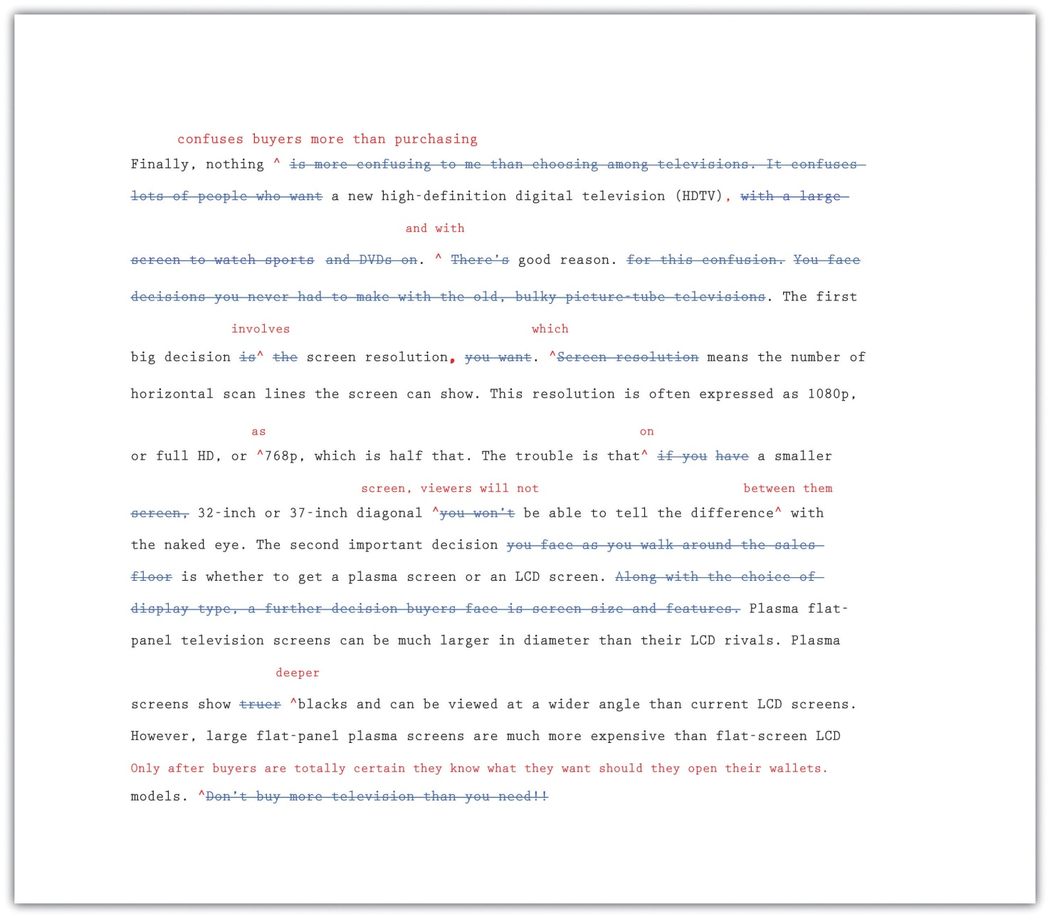

Exercise 4
- Answer the following questions about Mariah’s revised paragraph:
  - Read the unrevised and the revised paragraphs aloud. Explain in your own words how changes in word choice have affected Mariah’s writing.
  - Do you agree with the changes that Mariah made to her paragraph? Which changes would you keep and which were unnecessary? Explain. What other changes would you have made?
  - What effect does removing contractions and the pronoun you have on the tone of the paragraph? How would you characterize the tone now? Why?
- Now return once more to your essay in progress. Read carefully for problems with word choice. Be sure that your draft is written in formal language and that your word choice is specific and appropriate.

Completing a Peer Review
After working so closely with a piece of writing, writers often need to step back and ask for a more objective reader. What writers most need is feedback from readers who can respond only to the words on the page. When they are ready, writers show their drafts to someone they respect and who can give an honest response about its strengths and weaknesses.
You, too, can ask a peer to read your draft when it is ready. After evaluating the feedback and assessing what is most helpful, the reader’s feedback will help you when you revise your draft. This process is called peer review.
You can work with a partner in your class and identify specific ways to strengthen each other’s essays. Although you may be uncomfortable sharing your writing at first, remember that each writer is working toward the same goal: a final draft that fits the audience and the purpose. Maintaining a positive attitude when providing feedback will put you and your partner at ease. The box that follows provides a useful framework for the peer review session.

Questions for Peer Review
Title of essay: ____________________________________________
Date: ____________________________________________
Writer’s name: ____________________________________________
Peer reviewer’s name: _________________________________________
- This essay is about____________________________________________.
- Your main points in this essay are____________________________________________.
- What I most liked about this essay is____________________________________________.
- These three points struck me as your strongest:
  - Point: ____________________________________________
Why: ____________________________________________
  - Point: ____________________________________________
Why: ____________________________________________
  - Point: ____________________________________________
Why: ____________________________________________
- These places in your essay are not clear to me:
  - Where: ____________________________________________
Needs improvement because__________________________________________
  - Where: ____________________________________________
Needs improvement because ____________________________________________
  - Where: ____________________________________________
Needs improvement because ____________________________________________
- The one additional change you could make that would improve this essay significantly is ____________________________________________.

Writing at Work
One of the reasons why word-processing programs build in a reviewing feature is that workgroups have become a common feature in many businesses. Writing is often collaborative, and the members of a workgroup and their supervisors often critique group members’ work and offer feedback that will lead to a better final product.

Exercise 5
Exchange essays with a classmate and complete a peer review of each other’s draft in progress. Remember to give positive feedback and to be courteous and polite in your responses. Focus on providing one positive comment and one question for more information to the author.

Using Feedback Objectively
The purpose of peer feedback is to receive constructive criticism of your essay. Your peer reviewer is your first real audience, and you have the opportunity to learn what confuses and delights a reader so that you can improve your work before sharing the final draft with a wider audience (or your intended audience).
It may not be necessary to incorporate every recommendation your peer reviewer makes. However, if you start to observe a pattern in the responses you receive from peer reviewers, you might want to take that feedback into consideration in future assignments. For example, if you read consistent comments about a need for more research, then you may want to consider including more research in future assignments.

Using Feedback from Multiple Sources
You might get feedback from more than one reader as you share different stages of your revised draft. In this situation, you may receive feedback from readers who do not understand the assignment or who lack your involvement with and enthusiasm for it.
You need to evaluate the responses you receive according to two important criteria:
- Determine if the feedback supports the purpose of the assignment.
- Determine if the suggested revisions are appropriate to the audience.
Then, using these standards, accept or reject revision feedback.

Exercise 6
Work with two partners. Go back to Note 7.81 "Exercise 4" in this lesson and compare your responses to Activity A, about Mariah’s paragraph, with your partners’. Recall Mariah’s purpose for writing and her audience. Then, working individually, list where you agree and where you disagree about revision needs.

Editing Your Draft
If you have been incorporating each set of revisions as Mariah has, you have produced multiple drafts of your writing. So far, all your changes have been content changes. Perhaps with the help of peer feedback, you have made sure that you sufficiently supported your ideas. You have checked for problems with unity and coherence. You have examined your essay for word choice, revising to cut unnecessary words and to replace weak wording with specific and appropriate wording.
The next step after revising the content is editing. When you edit, you examine the surface features of your text. You examine your spelling, grammar, usage, and punctuation. You also make sure you use the proper format when creating your finished assignment.

Tip
Editing often takes time. Budgeting time into the writing process allows you to complete additional edits after revising. Editing and proofreading your writing helps you create a finished work that represents your best efforts. Here are a few more tips to remember about your readers:
- Readers do not notice correct spelling, but they do notice misspellings.
- Readers look past your sentences to get to your ideas—unless the sentences are awkward, poorly constructed, and frustrating to read.
- Readers notice when every sentence has the same rhythm as every other sentence, with no variety.
- Readers do not cheer when you use there, their, and they’re correctly, but they notice when you do not.
- Readers will notice the care with which you handled your assignment and your attention to detail in the delivery of an error-free document..
The first section of this book offers a useful review of grammar, mechanics, and usage. Use it to help you eliminate major errors in your writing and refine your understanding of the conventions of language. Do not hesitate to ask for help, too, from peer tutors in your academic department or in the college’s writing lab. In the meantime, use the checklist to help you edit your writing.

Checklist
Editing Your Writing
Grammar
- Are some sentences actually sentence fragments?
- Are some sentences run-on sentences? How can I correct them?
- Do some sentences need conjunctions between independent clauses?
- Does every verb agree with its subject?
- Is every verb in the correct tense?
- Are tense forms, especially for irregular verbs, written correctly?
- Have I used subject, object, and possessive personal pronouns correctly?
- Have I used who and whom correctly?
- Is the antecedent of every pronoun clear?
- Do all personal pronouns agree with their antecedents?
- Have I used the correct comparative and superlative forms of adjectives and adverbs?
- Is it clear which word a participial phrase modifies, or is it a dangling modifier?
Sentence Structure
- Are all my sentences simple sentences, or do I vary my sentence structure?
- Have I chosen the best coordinating or subordinating conjunctions to join clauses?
- Have I created long, overpacked sentences that should be shortened for clarity?
- Do I see any mistakes in parallel structure?
Punctuation
- Does every sentence end with the correct end punctuation?
- Can I justify the use of every exclamation point?
- Have I used apostrophes correctly to write all singular and plural possessive forms?
- Have I used quotation marks correctly?
Mechanics and Usage
- Can I find any spelling errors? How can I correct them?
- Have I used capital letters where they are needed?
- Have I written abbreviations, where allowed, correctly?
- Can I find any errors in the use of commonly confused words, such as to/too/two?

Tip
Be careful about relying too much on spelling checkers and grammar checkers. A spelling checker cannot recognize that you meant to write principle but wrote principal instead. A grammar checker often queries constructions that are perfectly correct. The program does not understand your meaning; it makes its check against a general set of formulas that might not apply in each instance. If you use a grammar checker, accept the suggestions that make sense, but consider why the suggestions came up.

Tip
Proofreading requires patience; it is very easy to read past a mistake. Set your paper aside for at least a few hours, if not a day or more, so your mind will rest. Some professional proofreaders read a text backward so they can concentrate on spelling and punctuation. Another helpful technique is to slowly read a paper aloud, paying attention to every word, letter, and punctuation mark.
If you need additional proofreading help, ask a reliable friend, a classmate, or a peer tutor to make a final pass on your paper to look for anything you missed.

Formatting
Remember to use proper format when creating your finished assignment. Sometimes an instructor, a department, or a college will require students to follow specific instructions on titles, margins, page numbers, or the location of the writer’s name. These requirements may be more detailed and rigid for research projects and term papers, which often observe the American Psychological Association (APA) or Modern Language Association (MLA) style guides, especially when citations of sources are included.
To ensure the format is correct and follows any specific instructions, make a final check before you submit an assignment.

Exercise 7
With the help of the checklist, edit and proofread your essay.

Key Takeaways
- Revising and editing are the stages of the writing process in which you improve your work before producing a final draft.
- During revising, you add, cut, move, or change information in order to improve content.
- During editing, you take a second look at the words and sentences you used to express your ideas and fix any problems in grammar, punctuation, and sentence structure.
- Unity in writing means that all the ideas in each paragraph and in the entire essay clearly belong together and are arranged in an order that makes logical sense.
- Coherence in writing means that the writer’s wording clearly indicates how one idea leads to another within a paragraph and between paragraphs.
- Transitional words and phrases effectively make writing more coherent.
- Writing should be clear and concise, with no unnecessary words.
- Effective formal writing uses specific, appropriate words and avoids slang, contractions, clichés, and overly general words.
- Peer reviews, done properly, can give writers objective feedback about their writing. It is the writer’s responsibility to evaluate the results of peer reviews and incorporate only useful feedback.
- Remember to budget time for careful editing and proofreading. Use all available resources, including editing checklists, peer editing, and your institution’s writing lab, to improve your editing skills.

7.5 The Writing Process: End-of-Chapter Exercises

Learning Objectives
- Use the skills you have learned in the chapter.
- Work collaboratively with other students.
- Work with a variety of academic and on-the-job, real-world examples.

Exercises
- In this chapter, you have thought and read about the topic of mass media. Starting with the title “The Future of Information: How It Will Be Created, Transmitted, and Consumed,” narrow the focus of the topic until it is suitable for a two- to three-page paper. Then narrow your topic with the help of brainstorming, idea mapping, and searching the Internet until you select a final topic to explore. Keep a journal or diary in which you record and comment on everything you did to choose a final topic. Then record what you will do next to explore the idea and create a thesis statement.
- Write a thesis statement and a formal sentence outline for an essay about the writing process. Include separate paragraphs for prewriting, drafting, and revising and editing. Your audience will be a general audience of educated adults who are unfamiliar with how writing is taught at the college level. Your purpose is to explain the stages of the writing process so that readers will understand its benefits.
Collaboration
Please share with a classmate and compare your answers.
- Pieces of writing in a variety of real-life and work-related situations would benefit from revising and editing. Consider the following list of real-life and work-related pieces of writing: e-mails, greeting card messages, junk mail, late-night television commercials, social networking pages, local newspapers, bulletin-board postings, and public notices. Find and submit at least two examples of writing that needs revision. Explain what changes you would make. Replace any recognizable names with pseudonyms.
- Group activity. At work, an employer might someday ask you to contribute to the research base for an essay such as the one Mariah wrote or the one you wrote while working through this chapter. Choosing either her topic or your own, compile a list of at least five sources. Then, working in a group of four students, bring in printouts or PDF files of Internet sources or paper copies of non-Internet sources for the other group members to examine. In a group report, rate the reliability of each other’s sources.
- Group activity. Working in a peer-review group of four, go to Section 7.3 "Drafting" and reread the draft of the first two body paragraphs of Mariah’s essay, “Digital Technology: The Newest and the Best at What Price?” Review those two paragraphs using the same level of inspection given to the essay’s third paragraph in Section 7.4 "Revising and Editing". Suggest and agree on changes to improve unity and coherence, eliminate unneeded words, and refine word choice. Your purpose is to help Mariah produce two effective paragraphs for a formal college-level essay about her topic.

Chapter 8 Writing Essays: From Start to Finish

8.1 Developing a Strong, Clear Thesis Statement

Learning Objectives
- Develop a strong, clear thesis statement with the proper elements.
- Revise your thesis statement.
Have you ever known a person who was not very good at telling stories? You probably had trouble following his train of thought as he jumped around from point to point, either being too brief in places that needed further explanation or providing too many details on a meaningless element. Maybe he told the end of the story first, then moved to the beginning and later added details to the middle. His ideas were probably scattered, and the story did not flow very well. When the story was over, you probably had many questions.
Just as a personal anecdote can be a disorganized mess, an essay can fall into the same trap of being out of order and confusing. That is why writers need a thesis statement to provide a specific focus for their essay and to organize what they are about to discuss in the body.
Just like a topic sentence summarizes a single paragraph, the thesis statement summarizes an entire essay. It tells the reader the point you want to make in your essay, while the essay itself supports that point. It is like a signpost that signals the essay’s destination. You should form your thesis before you begin to organize an essay, but you may find that it needs revision as the essay develops.

Elements of a Thesis Statement
For every essay you write, you must focus on a central idea. This idea stems from a topic you have chosen or been assigned or from a question your teacher has asked. It is not enough merely to discuss a general topic or simply answer a question with a yes or no. You have to form a specific opinion, and then articulate that into a controlling idea—the main idea upon which you build your thesis.
Remember that a thesis is not the topic itself, but rather your interpretation of the question or subject. For whatever topic your professor gives you, you must ask yourself, “What do I want to say about it?” Asking and then answering this question is vital to forming a thesis that is precise, forceful and confident.
A thesis is one sentence long and appears toward the end of your introduction. It is specific and focuses on one to three points of a single idea—points that are able to be demonstrated in the body. It forecasts the content of the essay and suggests how you will organize your information. Remember that a thesis statement does not summarize an issue but rather dissects it.

A Strong Thesis Statement
A strong thesis statement contains the following qualities.
Specificity. A thesis statement must concentrate on a specific area of a general topic. As you may recall, the creation of a thesis statement begins when you choose a broad subject and then narrow down its parts until you pinpoint a specific aspect of that topic. For example, health care is a broad topic, but a proper thesis statement would focus on a specific area of that topic, such as options for individuals without health care coverage.
Precision. A strong thesis statement must be precise enough to allow for a coherent argument and to remain focused on the topic. If the specific topic is options for individuals without health care coverage, then your precise thesis statement must make an exact claim about it, such as that limited options exist for those who are uninsured by their employers. You must further pinpoint what you are going to discuss regarding these limited effects, such as whom they affect and what the cause is.
Ability to be argued. A thesis statement must present a relevant and specific argument. A factual statement often is not considered arguable. Be sure your thesis statement contains a point of view that can be supported with evidence.
Ability to be demonstrated. For any claim you make in your thesis, you must be able to provide reasons and examples for your opinion. You can rely on personal observations in order to do this, or you can consult outside sources to demonstrate that what you assert is valid. A worthy argument is backed by examples and details.
Forcefulness. A thesis statement that is forceful shows readers that you are, in fact, making an argument. The tone is assertive and takes a stance that others might oppose.
Confidence. In addition to using force in your thesis statement, you must also use confidence in your claim. Phrases such as I feel or I believe actually weaken the readers’ sense of your confidence because these phrases imply that you are the only person who feels the way you do. In other words, your stance has insufficient backing. Taking an authoritative stance on the matter persuades your readers to have faith in your argument and open their minds to what you have to say.

Tip
Even in a personal essay that allows the use of first person, your thesis should not contain phrases such as in my opinion or I believe. These statements reduce your credibility and weaken your argument. Your opinion is more convincing when you use a firm attitude.

Exercise 1
On a separate sheet of paper, write a thesis statement for each of the following topics. Remember to make each statement specific, precise, demonstrable, forceful and confident.
Topics
- Texting while driving
- The legal drinking age in the United States
- Steroid use among professional athletes
- Abortion
- Racism

Examples of Appropriate Thesis Statements
Each of the following thesis statements meets several of the following requirements:
- Specificity
- Precision
- Ability to be argued
- Ability to be demonstrated
- Forcefulness
- Confidence
- The societal and personal struggles of Troy Maxon in the play Fences symbolize the challenge of black males who lived through segregation and integration in the United States.
- Closing all American borders for a period of five years is one solution that will tackle illegal immigration.
- Shakespeare’s use of dramatic irony in Romeo and Juliet spoils the outcome for the audience and weakens the plot.
- J. D. Salinger’s character in Catcher in the Rye, Holden Caulfield, is a confused rebel who voices his disgust with phonies, yet in an effort to protect himself, he acts like a phony on many occasions.
- Compared to an absolute divorce, no-fault divorce is less expensive, promotes fairer settlements, and reflects a more realistic view of the causes for marital breakdown.
- Exposing children from an early age to the dangers of drug abuse is a sure method of preventing future drug addicts.
- In today’s crumbling job market, a high school diploma is not significant enough education to land a stable, lucrative job.

Tip
You can find thesis statements in many places, such as in the news; in the opinions of friends, coworkers or teachers; and even in songs you hear on the radio. Become aware of thesis statements in everyday life by paying attention to people’s opinions and their reasons for those opinions. Pay attention to your own everyday thesis statements as well, as these can become material for future essays.
Now that you have read about the contents of a good thesis statement and have seen examples, take a look at the pitfalls to avoid when composing your own thesis:
- A thesis is weak when it is simply a declaration of your subject or a description of what you will discuss in your essay.
Weak thesis statement: My paper will explain why imagination is more important than knowledge.
- A thesis is weak when it makes an unreasonable or outrageous claim or insults the opposing side.
Weak thesis statement: Religious radicals across America are trying to legislate their Puritanical beliefs by banning required high school books.
- A thesis is weak when it contains an obvious fact or something that no one can disagree with or provides a dead end.
Weak thesis statement: Advertising companies use sex to sell their products.
- A thesis is weak when the statement is too broad.
Weak thesis statement: The life of Abraham Lincoln was long and challenging.

Exercise 2
Read the following thesis statements. On a separate piece of paper, identify each as weak or strong. For those that are weak, list the reasons why. Then revise the weak statements so that they conform to the requirements of a strong thesis.
- The subject of this paper is my experience with ferrets as pets.
- The government must expand its funding for research on renewable energy resources in order to prepare for the impending end of oil.
- Edgar Allan Poe was a poet who lived in Baltimore during the nineteenth century.
- In this essay, I will give you lots of reasons why slot machines should not be legalized in Baltimore.
- Despite his promises during his campaign, President Kennedy took few executive measures to support civil rights legislation.
- Because many children’s toys have potential safety hazards that could lead to injury, it is clear that not all children’s toys are safe.
- My experience with young children has taught me that I want to be a disciplinary parent because I believe that a child without discipline can be a parent’s worst nightmare.

Writing at Work
Often in your career, you will need to ask your boss for something through an e-mail. Just as a thesis statement organizes an essay, it can also organize your e-mail request. While your e-mail will be shorter than an essay, using a thesis statement in your first paragraph quickly lets your boss know what you are asking for, why it is necessary, and what the benefits are. In short body paragraphs, you can provide the essential information needed to expand upon your request.

Thesis Statement Revision
Your thesis will probably change as you write, so you will need to modify it to reflect exactly what you have discussed in your essay. Remember from Chapter 7 "The Writing Process: How Do I Begin?" that your thesis statement begins as a working thesis statement, an indefinite statement that you make about your topic early in the writing process for the purpose of planning and guiding your writing.
Working thesis statements often become stronger as you gather information and form new opinions and reasons for those opinions. Revision helps you strengthen your thesis so that it matches what you have expressed in the body of the paper.

Tip
The best way to revise your thesis statement is to ask questions about it and then examine the answers to those questions. By challenging your own ideas and forming definite reasons for those ideas, you grow closer to a more precise point of view, which you can then incorporate into your thesis statement.

Ways to Revise Your Thesis
You can cut down on irrelevant aspects and revise your thesis by taking the following steps:
- Pinpoint and replace all nonspecific words, such as people, everything, society, or life, with more precise words in order to reduce any vagueness.
Working thesis: Young people have to work hard to succeed in life.
Revised thesis: Recent college graduates must have discipline and persistence in order to find and maintain a stable job in which they can use and be appreciated for their talents.
The revised thesis makes a more specific statement about success and what it means to work hard. The original includes too broad a range of people and does not define exactly what success entails. By replacing those general words like people and work hard, the writer can better focus his or her research and gain more direction in his or her writing.
- Clarify ideas that need explanation by asking yourself questions that narrow your thesis.
Working thesis: The welfare system is a joke.
Revised thesis: The welfare system keeps a socioeconomic class from gaining employment by alluring members of that class with unearned income, instead of programs to improve their education and skill sets.
A joke means many things to many people. Readers bring all sorts of backgrounds and perspectives to the reading process and would need clarification for a word so vague. This expression may also be too informal for the selected audience. By asking questions, the writer can devise a more precise and appropriate explanation for joke. The writer should ask himself or herself questions similar to the 5WH questions. (See Chapter 7 "The Writing Process: How Do I Begin?" for more information on the 5WH questions.) By incorporating the answers to these questions into a thesis statement, the writer more accurately defines his or her stance, which will better guide the writing of the essay.
- Replace any linking verbs with action verbs. Linking verbs are forms of the verb to be, a verb that simply states that a situation exists.
Working thesis: Kansas City schoolteachers are not paid enough.
Revised thesis: The Kansas City legislature cannot afford to pay its educators, resulting in job cuts and resignations in a district that sorely needs highly qualified and dedicated teachers.
The linking verb in this working thesis statement is the word are. Linking verbs often make thesis statements weak because they do not express action. Rather, they connect words and phrases to the second half of the sentence. Readers might wonder, “Why are they not paid enough?” But this statement does not compel them to ask many more questions. The writer should ask himself or herself questions in order to replace the linking verb with an action verb, thus forming a stronger thesis statement, one that takes a more definitive stance on the issue:
  - Who is not paying the teachers enough?
  - What is considered “enough”?
  - What is the problem?
  - What are the results
- Omit any general claims that are hard to support.
Working thesis: Today’s teenage girls are too sexualized.
Revised thesis: Teenage girls who are captivated by the sexual images on MTV are conditioned to believe that a woman’s worth depends on her sensuality, a feeling that harms their self-esteem and behavior.
It is true that some young women in today’s society are more sexualized than in the past, but that is not true for all girls. Many girls have strict parents, dress appropriately, and do not engage in sexual activity while in middle school and high school. The writer of this thesis should ask the following questions:
  - Which teenage girls?
  - What constitutes “too” sexualized?
  - Why are they behaving that way?
  - Where does this behavior show up?
  - What are the repercussions?

Exercise 3
In the first section of Chapter 7 "The Writing Process: How Do I Begin?", you determined your purpose for writing and your audience. You then completed a freewriting exercise about an event you recently experienced and chose a general topic to write about. Using that general topic, you then narrowed it down by answering the 5WH questions. After you answered these questions, you chose one of the three methods of prewriting and gathered possible supporting points for your working thesis statement.
Now, on a separate sheet of paper, write down your working thesis statement. Identify any weaknesses in this sentence and revise the statement to reflect the elements of a strong thesis statement. Make sure it is specific, precise, arguable, demonstrable, forceful, and confident.
Collaboration
Please share with a classmate and compare your answers.

Writing at Work
In your career you may have to write a project proposal that focuses on a particular problem in your company, such as reinforcing the tardiness policy. The proposal would aim to fix the problem; using a thesis statement would clearly state the boundaries of the problem and tell the goals of the project. After writing the proposal, you may find that the thesis needs revision to reflect exactly what is expressed in the body. Using the techniques from this chapter would apply to revising that thesis.

Key Takeaways
- Proper essays require a thesis statement to provide a specific focus and suggest how the essay will be organized.
- A thesis statement is your interpretation of the subject, not the topic itself.
- A strong thesis is specific, precise, forceful, confident, and is able to be demonstrated.
- A strong thesis challenges readers with a point of view that can be debated and can be supported with evidence.
- A weak thesis is simply a declaration of your topic or contains an obvious fact that cannot be argued.
- Depending on your topic, it may or may not be appropriate to use first person point of view.
- Revise your thesis by ensuring all words are specific, all ideas are exact, and all verbs express action.

8.2 Writing Body Paragraphs

Learning Objectives
- Select primary support related to your thesis.
- Support your topic sentences.
If your thesis gives the reader a roadmap to your essay, then body paragraphs should closely follow that map. The reader should be able to predict what follows your introductory paragraph by simply reading the thesis statement.
The body paragraphs present the evidence you have gathered to confirm your thesis. Before you begin to support your thesis in the body, you must find information from a variety of sources that support and give credit to what you are trying to prove.

Select Primary Support for Your Thesis
Without primary support, your argument is not likely to be convincing. Primary support can be described as the major points you choose to expand on your thesis. It is the most important information you select to argue for your point of view. Each point you choose will be incorporated into the topic sentence for each body paragraph you write. Your primary supporting points are further supported by supporting details within the paragraphs.

Tip
Remember that a worthy argument is backed by examples. In order to construct a valid argument, good writers conduct lots of background research and take careful notes. They also talk to people knowledgeable about a topic in order to understand its implications before writing about it.

Identify the Characteristics of Good Primary Support
In order to fulfill the requirements of good primary support, the information you choose must meet the following standards:
- Be specific. The main points you make about your thesis and the examples you use to expand on those points need to be specific. Use specific examples to provide the evidence and to build upon your general ideas. These types of examples give your reader something narrow to focus on, and if used properly, they leave little doubt about your claim. General examples, while they convey the necessary information, are not nearly as compelling or useful in writing because they are too obvious and typical.
- Be relevant to the thesis. Primary support is considered strong when it relates directly to the thesis. Primary support should show, explain, or prove your main argument without delving into irrelevant details. When faced with lots of information that could be used to prove your thesis, you may think you need to include it all in your body paragraphs. But effective writers resist the temptation to lose focus. Choose your examples wisely by making sure they directly connect to your thesis.
- Be detailed. Remember that your thesis, while specific, should not be very detailed. The body paragraphs are where you develop the discussion that a thorough essay requires. Using detailed support shows readers that you have considered all the facts and chosen only the most precise details to enhance your point of view.

Prewrite to Identify Primary Supporting Points for a Thesis Statement
Recall that when you prewrite you essentially make a list of examples or reasons why you support your stance. Stemming from each point, you further provide details to support those reasons. After prewriting, you are then able to look back at the information and choose the most compelling pieces you will use in your body paragraphs.

Exercise 1
Choose one of the following working thesis statements. On a separate sheet of paper, write for at least five minutes using one of the prewriting techniques you learned in Chapter 7 "The Writing Process: How Do I Begin?".
- Unleashed dogs on city streets are a dangerous nuisance.
- Students cheat for many different reasons.
- Drug use among teens and young adults is a problem.
- The most important change that should occur at my college or university is ____________________________________________.

Select the Most Effective Primary Supporting Points for a Thesis Statement
After you have prewritten about your working thesis statement, you may have generated a lot of information, which may be edited out later. Remember that your primary support must be relevant to your thesis. Remind yourself of your main argument, and delete any ideas that do not directly relate to it. Omitting unrelated ideas ensures that you will use only the most convincing information in your body paragraphs. Choose at least three of only the most compelling points. These will serve as the topic sentences for your body paragraphs.

Exercise 2
Refer to the previous exercise and select three of your most compelling reasons to support the thesis statement. Remember that the points you choose must be specific and relevant to the thesis. The statements you choose will be your primary support points, and you will later incorporate them into the topic sentences for the body paragraphs.
Collaboration
Please share with a classmate and compare your answers.
When you support your thesis, you are revealing evidence. Evidence includes anything that can help support your stance. The following are the kinds of evidence you will encounter as you conduct your research:
- Facts. Facts are the best kind of evidence to use because they often cannot be disputed. They can support your stance by providing background information on or a solid foundation for your point of view. However, some facts may still need explanation. For example, the sentence “The most populated state in the United States is California” is a pure fact, but it may require some explanation to make it relevant to your specific argument.
- Judgments.Judgments are conclusions drawn from the given facts. Judgments are more credible than opinions because they are founded upon careful reasoning and examination of a topic.
- Testimony.Testimony consists of direct quotations from either an eyewitness or an expert witness. An eyewitness is someone who has direct experience with a subject; he adds authenticity to an argument based on facts. An expert witness is a person who has extensive experience with a topic. This person studies the facts and provides commentary based on either facts or judgments, or both. An expert witness adds authority and credibility to an argument.
- Personal observation. Personal observation is similar to testimony, but personal observation consists of your testimony. It reflects what you know to be true because you have experiences and have formed either opinions or judgments about them. For instance, if you are one of five children and your thesis states that being part of a large family is beneficial to a child’s social development, you could use your own experience to support your thesis.

Writing at Work
In any job where you devise a plan, you will need to support the steps that you lay out. This is an area in which you would incorporate primary support into your writing. Choosing only the most specific and relevant information to expand upon the steps will ensure that your plan appears well-thought-out and precise.

Tip
You can consult a vast pool of resources to gather support for your stance. Citing relevant information from reliable sources ensures that your reader will take you seriously and consider your assertions. Use any of the following sources for your essay: newspapers or news organization websites, magazines, encyclopedias, and scholarly journals, which are periodicals that address topics in a specialized field.

Choose Supporting Topic Sentences
Each body paragraph contains a topic sentence that states one aspect of your thesis and then expands upon it. Like the thesis statement, each topic sentence should be specific and supported by concrete details, facts, or explanations.
Each body paragraph should comprise the following elements.
topic sentence + supporting details (examples, reasons, or arguments)
As you read in Chapter 7 "The Writing Process: How Do I Begin?", topic sentences indicate the location and main points of the basic arguments of your essay. These sentences are vital to writing your body paragraphs because they always refer back to and support your thesis statement. Topic sentences are linked to the ideas you have introduced in your thesis, thus reminding readers what your essay is about. A paragraph without a clearly identified topic sentence may be unclear and scattered, just like an essay without a thesis statement.

Tip
Unless your teacher instructs otherwise, you should include at least three body paragraphs in your essay. A five-paragraph essay, including the introduction and conclusion, is commonly the standard for exams and essay assignments.
Consider the following the thesis statement:
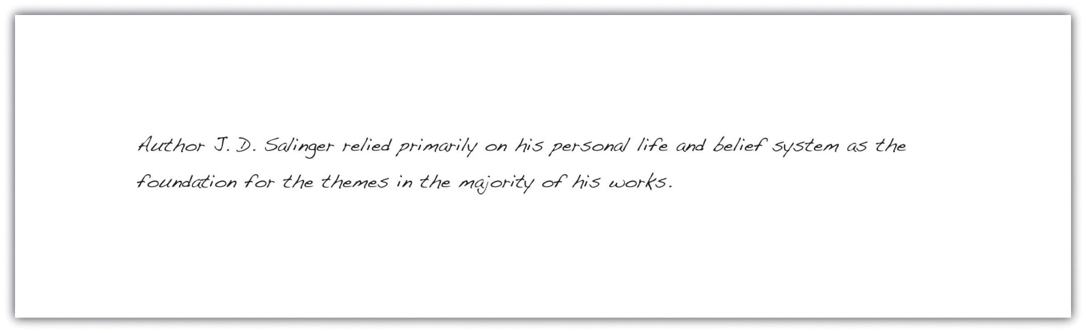
The following topic sentence is a primary support point for the thesis. The topic sentence states exactly what the controlling idea of the paragraph is. Later, you will see the writer immediately provide support for the sentence.
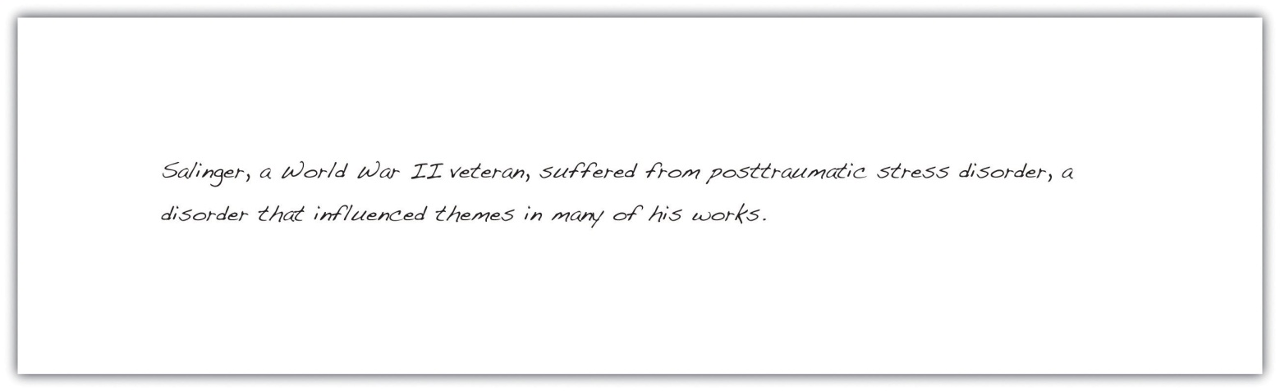

Exercise 3
In Note 8.19 "Exercise 2", you chose three of your most convincing points to support the thesis statement you selected from the list. Take each point and incorporate it into a topic sentence for each body paragraph.
Supporting point 1: ____________________________________________
Topic sentence: ____________________________________________
Supporting point 2: ____________________________________________
Topic sentence: ____________________________________________
Supporting point 3: ____________________________________________
Topic sentence: ____________________________________________
Collaboration
Please share with a classmate and compare your answers.

Draft Supporting Detail Sentences for Each Primary Support Sentence
After deciding which primary support points you will use as your topic sentences, you must add details to clarify and demonstrate each of those points. These supporting details provide examples, facts, or evidence that support the topic sentence.
The writer drafts possible supporting detail sentences for each primary support sentence based on the thesis statement:
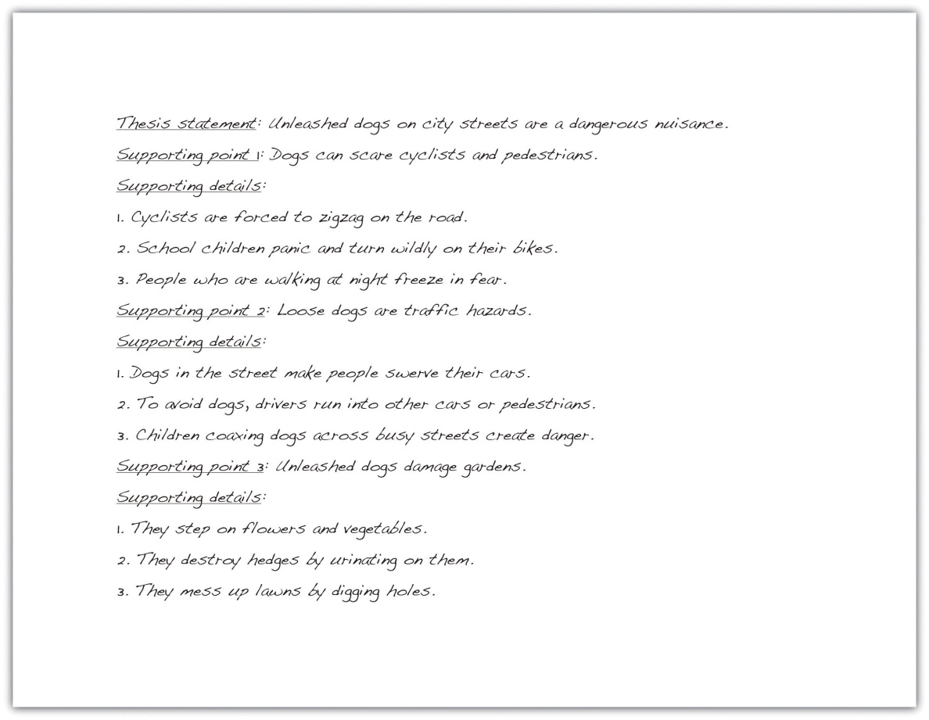
The following paragraph contains supporting detail sentences for the primary support sentence (the topic sentence), which is underlined.
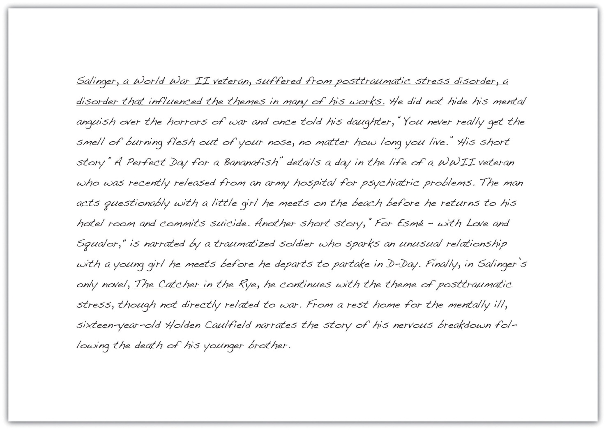

Exercise 4
Using the three topic sentences you composed for the thesis statement in Note 8.18 "Exercise 1", draft at least three supporting details for each point.
Thesis statement: ____________________________________________
Primary supporting point 1: ____________________________________________
Supporting details: ____________________________________________
Primary supporting point 2: ____________________________________________
Supporting details: ____________________________________________
Primary supporting point 3: ____________________________________________
Supporting details: ____________________________________________

Tip
You have the option of writing your topic sentences in one of three ways. You can state it at the beginning of the body paragraph, or at the end of the paragraph, or you do not have to write it at all. This is called an implied topic sentence. An implied topic sentence lets readers form the main idea for themselves. For beginning writers, it is best to not use implied topic sentences because it makes it harder to focus your writing. Your instructor may also want to clearly identify the sentences that support your thesis. For more information on the placement of thesis statements and implied topic statements, see Chapter 7 "The Writing Process: How Do I Begin?".

Tip
Print out the first draft of your essay and use a highlighter to mark your topic sentences in the body paragraphs. Make sure they are clearly stated and accurately present your paragraphs, as well as accurately reflect your thesis. If your topic sentence contains information that does not exist in the rest of the paragraph, rewrite it to more accurately match the rest of the paragraph.

Key Takeaways
- Your body paragraphs should closely follow the path set forth by your thesis statement.
- Strong body paragraphs contain evidence that supports your thesis.
- Primary support comprises the most important points you use to support your thesis.
- Strong primary support is specific, detailed, and relevant to the thesis.
- Prewriting helps you determine your most compelling primary support.
- Evidence includes facts, judgments, testimony, and personal observation.
- Reliable sources may include newspapers, magazines, academic journals, books, encyclopedias, and firsthand testimony.
- A topic sentence presents one point of your thesis statement while the information in the rest of the paragraph supports that point.
- A body paragraph comprises a topic sentence plus supporting details.

8.3 Organizing Your Writing

Learning Objectives
- Understand how and why organizational techniques help writers and readers stay focused.
- Assess how and when to use chronological order to organize an essay.
- Recognize how and when to use order of importance to organize an essay.
- Determine how and when to use spatial order to organize an essay.
The method of organization you choose for your essay is just as important as its content. Without a clear organizational pattern, your reader could become confused and lose interest. The way you structure your essay helps your readers draw connections between the body and the thesis, and the structure also keeps you focused as you plan and write the essay. Choosing your organizational pattern before you outline ensures that each body paragraph works to support and develop your thesis.
This section covers three ways to organize body paragraphs:
- Chronological order
- Order of importance
- Spatial order
When you begin to draft your essay, your ideas may seem to flow from your mind in a seemingly random manner. Your readers, who bring to the table different backgrounds, viewpoints, and ideas, need you to clearly organize these ideas in order to help process and accept them.
A solid organizational pattern gives your ideas a path that you can follow as you develop your draft. Knowing how you will organize your paragraphs allows you to better express and analyze your thoughts. Planning the structure of your essay before you choose supporting evidence helps you conduct more effective and targeted research.

Chronological Order
In Chapter 7 "The Writing Process: How Do I Begin?", you learned that chronological arrangement has the following purposes:
- To explain the history of an event or a topic
- To tell a story or relate an experience
- To explain how to do or to make something
- To explain the steps in a process
Chronological order is mostly used in expository writing, which is a form of writing that narrates, describes, informs, or explains a process. When using chronological order, arrange the events in the order that they actually happened, or will happen if you are giving instructions. This method requires you to use words such as first, second, then, after that, later, and finally. These transition words guide you and your reader through the paper as you expand your thesis.
For example, if you are writing an essay about the history of the airline industry, you would begin with its conception and detail the essential timeline events up until present day. You would follow the chain of events using words such as first, then, next, and so on.

Writing at Work
At some point in your career you may have to file a complaint with your human resources department. Using chronological order is a useful tool in describing the events that led up to your filing the grievance. You would logically lay out the events in the order that they occurred using the key transition words. The more logical your complaint, the more likely you will be well received and helped.

Exercise 1
Choose an accomplishment you have achieved in your life. The important moment could be in sports, schooling, or extracurricular activities. On your own sheet of paper, list the steps you took to reach your goal. Try to be as specific as possible with the steps you took. Pay attention to using transition words to focus your writing.
Keep in mind that chronological order is most appropriate for the following purposes:
- Writing essays containing heavy research
- Writing essays with the aim of listing, explaining, or narrating
- Writing essays that analyze literary works such as poems, plays, or books

Tip
When using chronological order, your introduction should indicate the information you will cover and in what order, and the introduction should also establish the relevance of the information. Your body paragraphs should then provide clear divisions or steps in chronology. You can divide your paragraphs by time (such as decades, wars, or other historical events) or by the same structure of the work you are examining (such as a line-by-line explication of a poem).

Exercise 2
On a separate sheet of paper, write a paragraph that describes a process you are familiar with and can do well. Assume that your reader is unfamiliar with the procedure. Remember to use the chronological key words, such as first, second, then, and finally.

Order of Importance
Recall from Chapter 7 "The Writing Process: How Do I Begin?" that order of importance is best used for the following purposes:
- Persuading and convincing
- Ranking items by their importance, benefit, or significance
- Illustrating a situation, problem, or solution
Most essays move from the least to the most important point, and the paragraphs are arranged in an effort to build the essay’s strength. Sometimes, however, it is necessary to begin with your most important supporting point, such as in an essay that contains a thesis that is highly debatable. When writing a persuasive essay, it is best to begin with the most important point because it immediately captivates your readers and compels them to continue reading.
For example, if you were supporting your thesis that homework is detrimental to the education of high school students, you would want to present your most convincing argument first, and then move on to the less important points for your case.
Some key transitional words you should use with this method of organization are most importantly, almost as importantly, just as importantly, and finally.

Writing at Work
During your career, you may be required to work on a team that devises a strategy for a specific goal of your company, such as increasing profits. When planning your strategy you should organize your steps in order of importance. This demonstrates the ability to prioritize and plan. Using the order of importance technique also shows that you can create a resolution with logical steps for accomplishing a common goal.

Exercise 3
On a separate sheet of paper, write a paragraph that discusses a passion of yours. Your passion could be music, a particular sport, filmmaking, and so on. Your paragraph should be built upon the reasons why you feel so strongly. Briefly discuss your reasons in the order of least to greatest importance.

Spatial Order
As stated in Chapter 7 "The Writing Process: How Do I Begin?", spatial order is best used for the following purposes:
- Helping readers visualize something as you want them to see it
- Evoking a scene using the senses (sight, touch, taste, smell, and sound)
- Writing a descriptive essay
Spatial order means that you explain or describe objects as they are arranged around you in your space, for example in a bedroom. As the writer, you create a picture for your reader, and their perspective is the viewpoint from which you describe what is around you.
The view must move in an orderly, logical progression, giving the reader clear directional signals to follow from place to place. The key to using this method is to choose a specific starting point and then guide the reader to follow your eye as it moves in an orderly trajectory from your starting point.
Pay attention to the following student’s description of her bedroom and how she guides the reader through the viewing process, foot by foot.
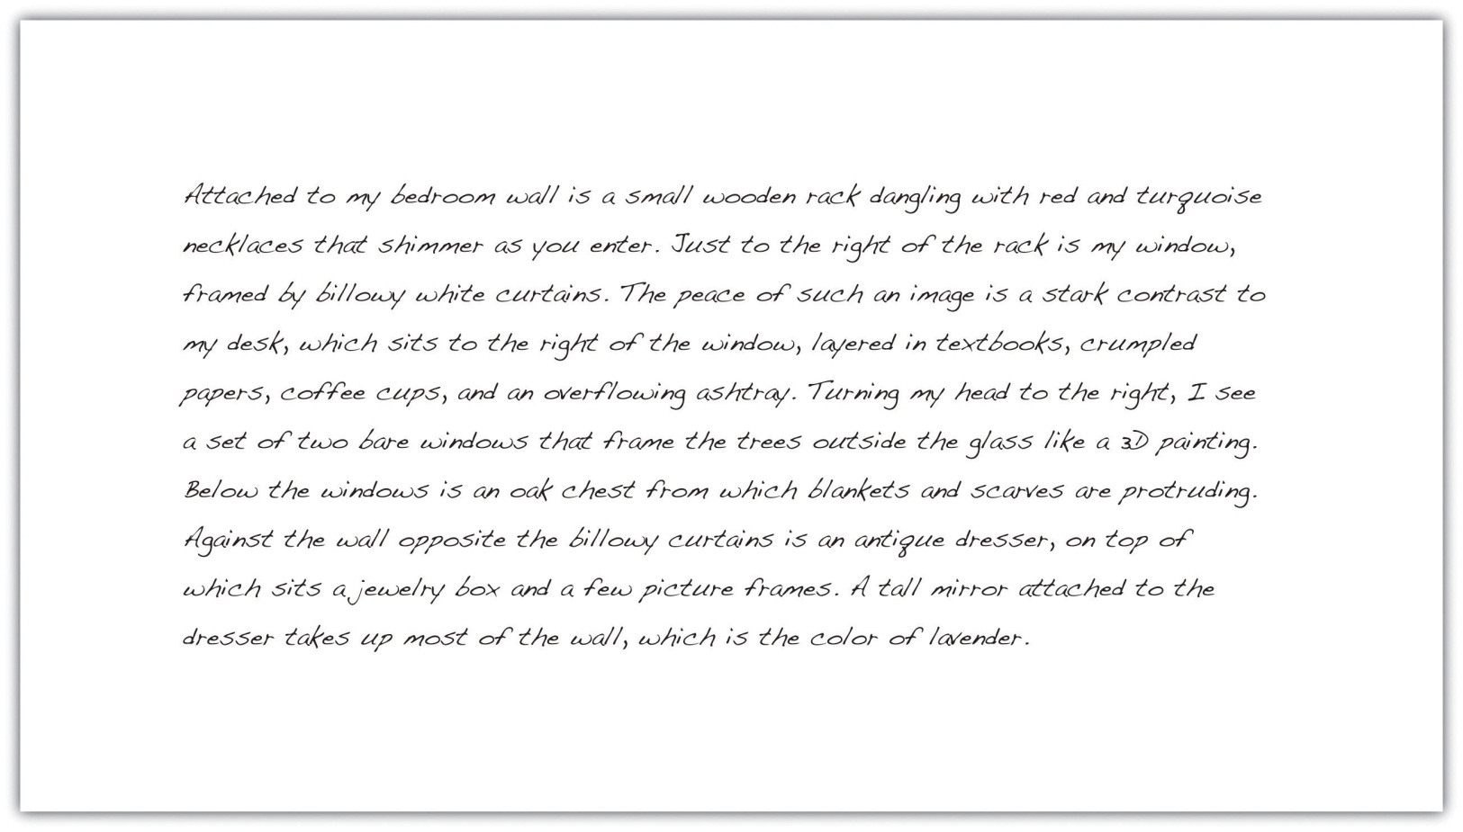
The paragraph incorporates two objectives you have learned in this chapter: using an implied topic sentence and applying spatial order. Often in a descriptive essay, the two work together.
The following are possible transition words to include when using spatial order:
- Just to the left or just to the right
- Behind
- Between
- On the left or on the right
- Across from
- A little further down
- To the south, to the east, and so on
- A few yards away
- Turning left or turning right

Exercise 4
On a separate sheet of paper, write a paragraph using spatial order that describes your commute to work, school, or another location you visit often.
Collaboration
Please share with a classmate and compare your answers.

Key Takeaways
- The way you organize your body paragraphs ensures you and your readers stay focused on and draw connections to, your thesis statement.
- A strong organizational pattern allows you to articulate, analyze, and clarify your thoughts.
- Planning the organizational structure for your essay before you begin to search for supporting evidence helps you conduct more effective and directed research.
- Chronological order is most commonly used in expository writing. It is useful for explaining the history of your subject, for telling a story, or for explaining a process.
- Order of importance is most appropriate in a persuasion paper as well as for essays in which you rank things, people, or events by their significance.
- Spatial order describes things as they are arranged in space and is best for helping readers visualize something as you want them to see it; it creates a dominant impression.

8.4 Writing Introductory and Concluding Paragraphs

Learning Objectives
- Recognize the importance of strong introductory and concluding paragraphs.
- Learn to engage the reader immediately with the introductory paragraph.
- Practice concluding your essays in a more memorable way.
Picture your introduction as a storefront window: You have a certain amount of space to attract your customers (readers) to your goods (subject) and bring them inside your store (discussion). Once you have enticed them with something intriguing, you then point them in a specific direction and try to make the sale (convince them to accept your thesis).
Your introduction is an invitation to your readers to consider what you have to say and then to follow your train of thought as you expand upon your thesis statement.
An introduction serves the following purposes:
- Establishes your voice and tone, or your attitude, toward the subject
- Introduces the general topic of the essay
- States the thesis that will be supported in the body paragraphs
First impressions are crucial and can leave lasting effects in your reader’s mind, which is why the introduction is so important to your essay. If your introductory paragraph is dull or disjointed, your reader probably will not have much interest in continuing with the essay.

Attracting Interest in Your Introductory Paragraph
Your introduction should begin with an engaging statement devised to provoke your readers’ interest. In the next few sentences, introduce them to your topic by stating general facts or ideas about the subject. As you move deeper into your introduction, you gradually narrow the focus, moving closer to your thesis. Moving smoothly and logically from your introductory remarks to your thesis statement can be achieved using a funnel technique, as illustrated in the diagram in Figure 8.1 "Funnel Technique".
Figure 8.1 Funnel Technique
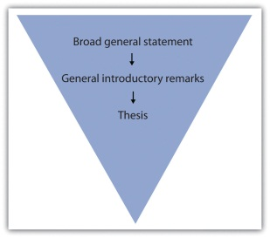

Exercise 1
On a separate sheet of paper, jot down a few general remarks that you can make about the topic for which you formed a thesis in Section 8.1 "Developing a Strong, Clear Thesis Statement".
Immediately capturing your readers’ interest increases the chances of having them read what you are about to discuss. You can garner curiosity for your essay in a number of ways. Try to get your readers personally involved by doing any of the following:
- Appealing to their emotions
- Using logic
- Beginning with a provocative question or opinion
- Opening with a startling statistic or surprising fact
- Raising a question or series of questions
- Presenting an explanation or rationalization for your essay
- Opening with a relevant quotation or incident
- Opening with a striking image
- Including a personal anecdote

Tip
Remember that your diction, or word choice, while always important, is most crucial in your introductory paragraph. Boring diction could extinguish any desire a person might have to read through your discussion. Choose words that create images or express action. For more information on diction, see Chapter 3 "Working with Words: Which Word Is Right?".
In Chapter 7 "The Writing Process: How Do I Begin?", you followed Mariah as she moved through the writing process. In this chapter, Mariah writes her introduction and conclusion for the same essay. Mariah incorporates some of the introductory elements into her introductory paragraph, which she previously outlined in Chapter 7 "The Writing Process: How Do I Begin?". Her thesis statement is underlined.
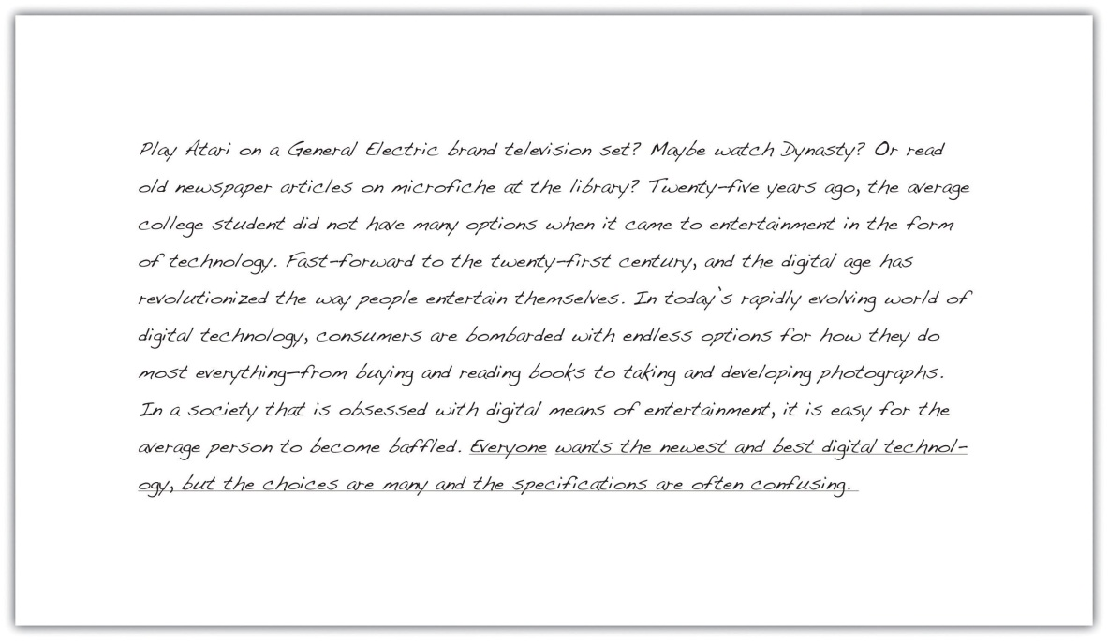

Tip
If you have trouble coming up with a provocative statement for your opening, it is a good idea to use a relevant, attention-grabbing quote about your topic. Use a search engine to find statements made by historical or significant figures about your subject.

Writing at Work
In your job field, you may be required to write a speech for an event, such as an awards banquet or a dedication ceremony. The introduction of a speech is similar to an essay because you have a limited amount of space to attract your audience’s attention. Using the same techniques, such as a provocative quote or an interesting statistic, is an effective way to engage your listeners. Using the funnel approach also introduces your audience to your topic and then presents your main idea in a logical manner.

Exercise 2
Reread each sentence in Mariah’s introductory paragraph. Indicate which techniques she used and comment on how each sentence is designed to attract her readers’ interest.

Writing a Conclusion
It is not unusual to want to rush when you approach your conclusion, and even experienced writers may fade. But what good writers remember is that it is vital to put just as much attention into the conclusion as in the rest of the essay. After all, a hasty ending can undermine an otherwise strong essay.
A conclusion that does not correspond to the rest of your essay, has loose ends, or is unorganized can unsettle your readers and raise doubts about the entire essay. However, if you have worked hard to write the introduction and body, your conclusion can often be the most logical part to compose.

The Anatomy of a Strong Conclusion
Keep in mind that the ideas in your conclusion must conform to the rest of your essay. In order to tie these components together, restate your thesis at the beginning of your conclusion. This helps you assemble, in an orderly fashion, all the information you have explained in the body. Repeating your thesis reminds your readers of the major arguments you have been trying to prove and also indicates that your essay is drawing to a close. A strong conclusion also reviews your main points and emphasizes the importance of the topic.
The construction of the conclusion is similar to the introduction, in which you make general introductory statements and then present your thesis. The difference is that in the conclusion you first paraphrase, or state in different words, your thesis and then follow up with general concluding remarks. These sentences should progressively broaden the focus of your thesis and maneuver your readers out of the essay.
Many writers like to end their essays with a final emphatic statement. This strong closing statement will cause your readers to continue thinking about the implications of your essay; it will make your conclusion, and thus your essay, more memorable. Another powerful technique is to challenge your readers to make a change in either their thoughts or their actions. Challenging your readers to see the subject through new eyes is a powerful way to ease yourself and your readers out of the essay.

Tip
When closing your essay, do not expressly state that you are drawing to a close. Relying on statements such as in conclusion, it is clear that, as you can see, or in summation is unnecessary and can be considered trite.

Tip
It is wise to avoid doing any of the following in your conclusion:
- Introducing new material
- Contradicting your thesis
- Changing your thesis
- Using apologies or disclaimers
Introducing new material in your conclusion has an unsettling effect on your reader. When you raise new points, you make your reader want more information, which you could not possibly provide in the limited space of your final paragraph.
Contradicting or changing your thesis statement causes your readers to think that you do not actually have a conviction about your topic. After all, you have spent several paragraphs adhering to a singular point of view. When you change sides or open up your point of view in the conclusion, your reader becomes less inclined to believe your original argument.
By apologizing for your opinion or stating that you know it is tough to digest, you are in fact admitting that even you know what you have discussed is irrelevant or unconvincing. You do not want your readers to feel this way. Effective writers stand by their thesis statement and do not stray from it.

Exercise 3
On a separate sheet of a paper, restate your thesis from Note 8.52 "Exercise 2" of this section and then make some general concluding remarks. Next, compose a final emphatic statement. Finally, incorporate what you have written into a strong conclusion paragraph for your essay.
Collaboration
Please share with a classmate and compare your answers
Mariah incorporates some of these pointers into her conclusion. She has paraphrased her thesis statement in the first sentence.
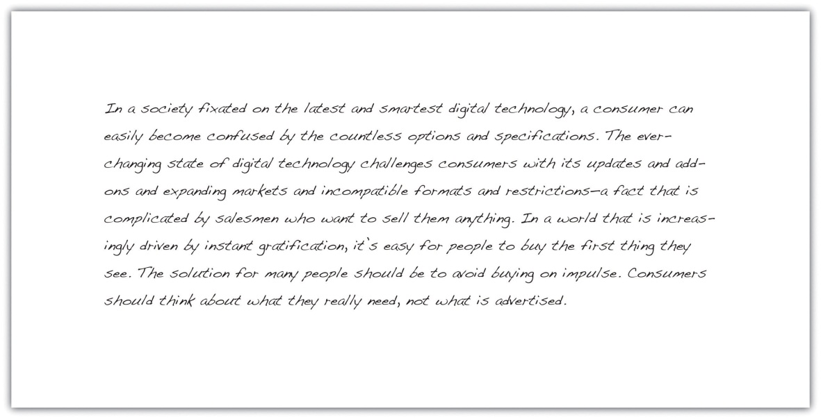

Tip
Make sure your essay is balanced by not having an excessively long or short introduction or conclusion. Check that they match each other in length as closely as possible, and try to mirror the formula you used in each. Parallelism strengthens the message of your essay.

Writing at Work
On the job you will sometimes give oral presentations based on research you have conducted. A concluding statement to an oral report contains the same elements as a written conclusion. You should wrap up your presentation by restating the purpose of the presentation, reviewing its main points, and emphasizing the importance of the material you presented. A strong conclusion will leave a lasting impression on your audience.

Key Takeaways
- A strong opening captures your readers’ interest and introduces them to your topic before you present your thesis statement.
- An introduction should restate your thesis, review your main points, and emphasize the importance of the topic.
- The funnel technique to writing the introduction begins with generalities and gradually narrows your focus until you present your thesis.
- A good introduction engages people’s emotions or logic, questions or explains the subject, or provides a striking image or quotation.
- Carefully chosen diction in both the introduction and conclusion prevents any confusing or boring ideas.
- A conclusion that does not connect to the rest of the essay can diminish the effect of your paper.
- The conclusion should remain true to your thesis statement. It is best to avoid changing your tone or your main idea and avoid introducing any new material.
- Closing with a final emphatic statement provides closure for your readers and makes your essay more memorable.

8.5 Writing Essays: End-of-Chapter Exercises

Exercises
- On a separate sheet of paper, choose one of the examples of a proper thesis statement from this chapter (one that interests you) and form three supporting points for that statement. After you have formed your three points, write a topic sentence for each body paragraph. Make sure that your topic sentences can be backed up with examples and details.
- Group activity. Choose one of the topics from Note 8.5 "Exercise 1" in Section 8.1 "Developing a Strong, Clear Thesis Statement" and form a yes-or-no question about that topic. Then, take a survey of the people in your class to find out how they feel about the subject. Using the majority vote, ask those people to write on slips of paper the reasons for their opinion. Using the data you collect, form a thesis statement based on your classmates’ perspectives on the topic and their reasons.
- On a separate sheet of a paper, write an introduction for an essay based on the thesis statement from the group activity using the techniques for introductory paragraphs that you learned in this chapter.
- Start a journal in which you record “spoken” thesis statements. Start listening closely to the opinions expressed by your teachers, classmates, friends, and family members. Ask them to provide at least three reasons for their opinion and record them in the journal. Use this as material for future essays.
- Open a magazine and read a lengthy article. See if you can pinpoint the thesis statement as well as the topic sentence for each paragraph and its supporting details.

Chapter 9 Effective Business Writing
However great…natural talent may be, the art of writing cannot be learned all at once.
Jean-Jacques Rousseau
Read, read, read…Just like a carpenter who works as an apprentice and studies the master.
William Faulkner
You only learn to be a better writer by actually writing.
Doris Lessing

Getting Started

Introductory Exercises
- Take a moment to write three words that describe your success in writing.
- Make a list of words that you associate with writing. Compare your list with those of your classmates.
- Briefly describe your experience writing and include one link to something you like to read in your post.
Something we often hear in business is, “Get it in writing.” This advice is meant to prevent misunderstandings based on what one person thought the other person said. But does written communication—getting it in writing—always prevent misunderstandings?
According to a Washington Post news story, a written agreement would have been helpful to an airline customer named Mike. A victim of an airport mishap, Mike was given vouchers for $7,500 worth of free travel. However, in accordance with the airline’s standard policy, the vouchers were due to expire in twelve months. When Mike saw that he and his wife would not be able to do enough flying to use the entire amount before the expiration date, he called the airline and asked for an extension. He was told the airline would extend the deadline, but later discovered they were willing to do so at only 50 percent of the vouchers’ value. An airline spokesman told the newspaper, “If [Mike] can produce a letter stating that we would give the full value of the vouchers, he should produce it.” ^{[1]}
Yet, as we will see in this chapter, putting something in writing is not always a foolproof way to ensure accuracy and understanding. A written communication is only as accurate as the writer’s knowledge of the subject and audience, and understanding depends on how well the writer captures the reader’s attention.

This chapter addresses the written word in a business context. We will also briefly consider the symbols, design, font, timing, and related nonverbal expressions you make when composing a page or document. Our discussions will focus on effective communication of your thoughts and ideas through writing that is clear, concise, and efficient.
[1] Oldenburg, D. (2005, April 12). Old adage holds: Get it in writing. Washington Post, p. C10. Retrieved from http://www.washingtonpost.com/wp-dyn/articles/A45309-2005Apr11.html

9.1 Oral versus Written Communication

Learning Objective
- Explain how written communication is similar to oral communication, and how it is different.
The written word often stands in place of the spoken word. People often say “it was good to hear from you” when they receive an e-mail or a letter, when in fact they didn’t hear the message, they read it. Still, if they know you well, they may mentally “hear” your voice in your written words. Writing a message to friends or colleagues can be as natural as talking to them. Yet when we are asked to write something, we often feel anxious and view writing as a more effortful, exacting process than talking would be.
Oral and written forms of communication are similar in many ways. They both rely on the basic communication process, which consists of eight essential elements: source, receiver, message, channel, receiver, feedback, environment, context, and interference. Table 9.1 "Eight Essential Elements of Communication" summarizes these elements and provides examples of how each element might be applied in oral and written communication.

Table 9.1 Eight Essential Elements of Communication
Element of Communication | Definition | Oral Application | Written Application
1. Source | A source creates and communicates a message. | Jay makes a telephone call to Heather. | Jay writes an e-mail to Heather.
2. Receiver | A receiver receives the message from the source. | Heather listens to Jay. | Heather reads Jay’s e-mail.
3. Message | The message is the stimulus or meaning produced by the source for the receiver. | Jay asks Heather to participate in a conference call at 3:15. | Jay’s e-mail asks Heather to participate in a conference call at 3:15.
4. Channel | A channel is the way a message travels between source and receiver. | The channel is the telephone. | The channel is e-mail.
5. Feedback | Feedback is the message the receiver sends in response to the source. | Heather says yes. | Heather replies with an e-mail saying yes.
6. Environment | The environment is the physical atmosphere where the communication occurs. | Heather is traveling by train on a business trip when she receives Jay’s phone call. | Heather is at her desk when she receives Jay’s e-mail.
7. Context | The context involves the psychological expectations of the source and receiver. | Heather expects Jay to send an e-mail with the call-in information for the call. Jay expects to do so, and does. | Heather expects Jay to dial and connect the call. Jay expects Heather to check her e-mail for the call-in information so that she can join the call.
8. Interference | Also known as noise, interference is anything that blocks or distorts the communication process. | Heather calls in at 3:15, but she has missed the call because she forgot that she is in a different time zone from Jay. | Heather waits for a phone call from Jay at 3:15, but he doesn’t call.

As you can see from the applications in this example, at least two different kinds of interference have the potential to ruin a conference call, and the interference can exist regardless of whether the communication to plan the call is oral or written. Try switching the “Context” and “Interference” examples from Oral to Written, and you will see that mismatched expectations and time zone confusion can happen by phone or by e-mail. While this example has an unfavorable outcome, it points out a way in which oral and written communication processes are similar.
Another way in which oral and written forms of communication are similar is that they can be divided into verbal and nonverbal categories. Verbal communication involves the words you say, and nonverbal communication involves how you say them—your tone of voice, your facial expression, body language, and so forth. Written communication also involves verbal and nonverbal dimensions. The words you choose are the verbal dimension. How you portray or display them is the nonverbal dimension, which can include the medium (e-mail or a printed document), the typeface or font, or the appearance of your signature on a letter. In this sense, oral and written communication are similar in their approach even as they are quite different in their application.
The written word allows for a dynamic communication process between source and receiver, but is often asynchronous, meaning that it occurs at different times. When we communicate face-to-face, we get immediate feedback, but our written words stand in place of that interpersonal interaction and we lack that immediate response. Since we are often not physically present when someone reads what we have written, it is important that we anticipate the reader’s needs, interpretation, and likely response to our written messages.
Suppose you are asked to write a message telling clients about a new product or service your company is about to offer. If you were speaking to one of them in a relaxed setting over coffee, what would you say? What words would you choose to describe the product or service, and how it may fulfill the client’s needs? As the business communicator, you must focus on the words you use and how you use them. Short, simple sentences, in themselves composed of words, also communicate a business style. In your previous English classes you may have learned to write eloquently, but in a business context, your goal is clear, direct communication. One strategy to achieve this goal is to write with the same words and phrases you use when you talk. However, since written communication lacks the immediate feedback that is present in an oral conversation, you need to choose words and phrases even more carefully to promote accuracy, clarity, and understanding.

Key Takeaway
Written communication involves the same eight basic elements as oral communication, but it is often asynchronous.

Exercises
- Review the oral and written applications in Table 9.1 "Eight Essential Elements of Communication" and construct a different scenario for each. What could Jay and Heather do differently to make the conference call a success?
- Visit a business Web site that has an “About Us” page. Read the “About Us” message and write a summary in your own words of what it tells you about the company. Compare your results with those of your classmates.
- You are your own company. What words describe you? Design a logo, create a name, and present your descriptive words in a way that gets attention. Share and compare with classmates.

9.2 How Is Writing Learned?

Learning Objective
- Explain how reading, writing, and critical thinking contribute to becoming a good writer.
You may think that some people are simply born better writers than others, but in fact writing is a reflection of experience and effort. If you think about your successes as a writer, you may come up with a couple of favorite books, authors, or teachers that inspired you to express yourself. You may also recall a sense of frustration with your previous writing experiences. It is normal and natural to experience a sense of frustration at the perceived inability to express oneself. The emphasis here is on your perception of yourself as a writer as one aspect of how you communicate. Most people use oral communication for much of their self-expression, from daily interactions to formal business meetings. You have a lifetime of experience in that arena that you can leverage to your benefit in your writing. Reading out loud what you have written is a positive technique we’ll address later in more depth.
Martin Luther King Jr.’s statement, “Violence is the language of the unheard” emphasizes the importance of finding one’s voice, of being able to express one’s ideas. Violence comes in many forms, but is often associated with frustration born of the lack of opportunity to communicate. You may read King’s words and think of the Civil Rights movement of the 1960s, or perhaps of the violence of the 9/11 terrorist attacks, or of wars happening in the world today. Public demonstrations and fighting are expressions of voice, from individual to collective. Finding your voice, and learning to listen to others, is part of learning to communicate.
You are your own best ally when it comes to your writing. Keeping a positive frame of mind about your journey as a writer is not a cliché or simple, hollow advice. Your attitude toward writing can and does influence your written products. Even if writing has been a challenge for you, the fact that you are reading this sentence means you perceive the importance of this essential skill. This text and our discussions will help you improve your writing, and your positive attitude is part of your success strategy.
There is no underestimating the power of effort when combined with inspiration and motivation. The catch then is to get inspired and motivated. That’s not all it takes, but it is a great place to start. You were not born with a key pad in front of you, but when you want to share something with friends and text them, the words (or abbreviations) come almost naturally. So you recognize you have the skills necessary to begin the process of improving and harnessing your writing abilities for business success. It will take time and effort, and the proverbial journey starts with a single step, but don’t lose sight of the fact that your skillful ability to craft words will make a significant difference in your career.

Reading
Reading is one step many writers point to as an integral step in learning to write effectively. You may like Harry Potter books or be a Twilight fan, but if you want to write effectively in business, you need to read business-related documents. These can include letters, reports, business proposals, and business plans. You may find these where you work or in your school’s writing center, business department, or library; there are also many Web sites that provide sample business documents of all kinds. Your reading should also include publications in the industry where you work or plan to work, such as Aviation Week, InfoWorld, Journal of Hospitality, International Real Estate Digest, or Women’s Wear Daily, to name just a few. You can also gain an advantage by reading publications in fields other than your chosen one; often reading outside your niche can enhance your versatility and help you learn how other people express similar concepts. Finally, don’t neglect general media like the business section of your local newspaper, and national publications like the Wall Street Journal, Fast Company, and the Harvard Business Review. Reading is one of the most useful lifelong habits you can practice to boost your business communication skills.
In the “real world” when you are under a deadline and production is paramount, you’ll be rushed and may lack the time to do adequate background reading for a particular assignment. For now, take advantage of your business communication course by exploring common business documents you may be called on to write, contribute to, or play a role in drafting. Some documents have a degree of formula to them, and your familiarity with them will reduce your preparation and production time while increasing your effectiveness. As you read similar documents, take notes on what you observe. As you read several sales letters, you may observe several patterns that can serve you well later on when it’s your turn. These patterns are often called conventions, or conventional language patterns for a specific genre.

Writing
Never lose sight of one key measure of the effectiveness of your writing: the degree to which it fulfills readers’ expectations. If you are in a law office, you know the purpose of a court brief is to convince the judge that certain points of law apply to the given case. If you are at a newspaper, you know that an editorial opinion article is supposed to convince readers of the merits of a certain viewpoint, whereas a news article is supposed to report facts without bias. If you are writing ad copy, the goal is to motivate consumers to make a purchase decision. In each case, you are writing to a specific purpose, and a great place to start when considering what to write is to answer the following question: what are the readers’ expectations?
When you are a junior member of the team, you may be given clerical tasks like filling in forms, populating a database, or coordinating appointments. Or you may be assigned to do research that involves reading, interviewing, and note taking. Don’t underestimate these facets of the writing process; instead, embrace the fact that writing for business often involves tasks that a novelist might not even recognize as “writing.” Your contribution is quite important and in itself is an on-the-job learning opportunity that shouldn’t be taken for granted.
When given a writing assignment, it is important to make sure you understand what you are being asked to do. You may read the directions and try to put them in your own words to make sense of the assignment. Be careful, however, not to lose sight of what the directions say versus what you think they say. Just as an audience’s expectations should be part of your consideration of how, what, and why to write, the instructions given by your instructor, or in a work situation by your supervisor, establish expectations. Just as you might ask a mentor more about a business writing assignment at work, you need to use the resources available to you to maximize your learning opportunity. Ask the professor to clarify any points you find confusing, or perceive more than one way to interpret, in order to better meet the expectations.
Before you write an opening paragraph, or even the first sentence, it is important to consider the overall goal of the assignment. The word assignment can apply equally to a written product for class or for your employer. You might make a list of the main points and see how those points may become the topic sentences in a series of paragraphs. You may also give considerable thought to whether your word choice, your tone, your language, and what you want to say is in line with your understanding of your audience. We briefly introduced the writing process previously, and will visit it in depth later in our discussion, but for now writing should about exploring your options. Authors rarely have a finished product in mind when they start, but once you know what your goal is and how to reach it, you writing process will become easier and more effective.

Constructive Criticism and Targeted Practice
Mentors can also be important in your growth as a writer. Your instructor can serve as a mentor, offering constructive criticism, insights on what he or she has written, and life lessons about writing for a purpose. Never underestimate the mentors that surround you in the workplace, even if you are currently working in a position unrelated to your desired career. They can read your rough draft and spot errors, as well as provide useful insights. Friends and family can also be helpful mentors—if your document’s meaning is clear to someone not working in your business, it will likely also be clear to your audience.
The key is to be open to criticism, keeping in mind that no one ever improved by repeating bad habits over and over. Only when you know what your errors are—errors of grammar or sentence structure, logic, format, and so on—can you correct your document and do a better job next time. Writing can be a solitary activity, but more often in business settings it is a collective, group, or team effort. Keep your eyes and ears open for opportunities to seek outside assistance before you finalize your document.
Learning to be a successful business writer comes with practice. Targeted practice, which involves identifying your weak areas and specifically working to improve them, is especially valuable. In addition to reading, make it a habit to write, even if it is not a specific assignment. The more you practice writing the kinds of materials that are used in your line of work, the more writing will come naturally and become an easier task—even on occasions when you need to work under pressure.

Critical Thinking
Critical thinking means becoming aware of your thinking process. It’s a human trait that allows us to step outside what we read or write and ask ourselves, “Does this really make sense?” “Are there other, perhaps better, ways to explain this idea?” Sometimes our thinking is very abstract and becomes clear only through the process of getting thoughts down in words. As a character in E. M. Forster’s Aspects of the Novel said, “How can I tell what I think till I see what I say?” ^{[1]} Did you really write what you meant to, and will it be easily understood by the reader? Successful writing forms a relationship with the audience, reaching the reader on a deep level that can be dynamic and motivating. In contrast, when writing fails to meet the audience’s expectations, you already know the consequences: they’ll move on.
Learning to write effectively involves reading, writing, critical thinking, and hard work. You may have seen The Wizard of Oz and recall the scene when Dorothy discovers what is behind the curtain. Up until that moment, she believed the Wizard’s powers were needed to change her situation, but now she discovers that the power is her own. Like Dorothy, you can discover that the power to write successfully rests in your hands. Excellent business writing can be inspiring, and it is important to not lose that sense of inspiration as we deconstruct the process of writing to its elemental components.
You may be amazed by the performance of Tony Hawk on a skateboard ramp, Mia Hamm on the soccer field, or Michael Phelps in the water. Those who demonstrate excellence often make it look easy, but nothing could be further from the truth. Effort, targeted practice, and persistence will win the day every time. When it comes to writing, you need to learn to recognize clear and concise writing while looking behind the curtain at how it is created. This is not to say we are going to lose the magic associated with the best writers in the field. Instead, we’ll appreciate what we are reading as we examine how it was written and how the writer achieved success.

Key Takeaway
Success in writing comes from good habits: reading, writing (especially targeted practice), and critical thinking.

Exercises
- Interview one person whose job involves writing. This can include writing e-mails, reports, proposals, invoices, or any other form of business document. Where did this person learn to write? What would they include as essential steps to learning to write for success in business? Share your results with a classmate.
- For five consecutive days, read the business section of your local newspaper or another daily paper. Write a one-page summary of the news that makes the most impression on you. Review your summaries and compare them with those of your classmates.
- Practice filling out an online form that requires writing sentences, such as a job application for a company that receives applications online. How does this kind of writing compare with the writing you have done for other courses in the past? Discuss your thoughts with your classmates.

9.3 Good Writing

Learning Objectives
- Identify six basic qualities that characterize good business writing.
- Identify and explain the rhetorical elements and cognate strategies that contribute to good writing.
One common concern is to simply address the question, what is good writing? As we progress through our study of written business communication we’ll try to answer it. But recognize that while the question may be simple, the answer is complex. Edward P. Bailey ^{[1]} offers several key points to remember.
Good business writing
- follows the rules,
- is easy to read, and
- attracts the reader.
Let’s examine these qualities in more depth.
Bailey’s first point is one that generates a fair amount of debate. What are the rules? Do “the rules” depend on audience expectations or industry standards, what your English teacher taught you, or are they reflected in the amazing writing of authors you might point to as positive examples? The answer is “all of the above,” with a point of clarification. You may find it necessary to balance audience expectations with industry standards for a document, and may need to find a balance or compromise. Bailey ^{[2]} points to common sense as one basic criterion of good writing, but common sense is a product of experience. When searching for balance, reader understanding is the deciding factor. The correct use of a semicolon may not be what is needed to make a sentence work. Your reading audience should carry extra attention in everything you write because, without them, you won’t have many more writing assignments.
When we say that good writing follows the rules, we don’t mean that a writer cannot be creative. Just as an art student needs to know how to draw a scene in correct perspective before he can “break the rules” by “bending” perspective, so a writer needs to know the rules of language. Being well versed in how to use words correctly, form sentences with proper grammar, and build logical paragraphs are skills the writer can use no matter what the assignment. Even though some business settings may call for conservative writing, there are other areas where creativity is not only allowed but mandated. Imagine working for an advertising agency or a software development firm; in such situations success comes from expressing new, untried ideas. By following the rules of language and correct writing, a writer can express those creative ideas in a form that comes through clearly and promotes understanding.

Similarly, writing that is easy to read is not the same as “dumbed down” or simplistic writing. What is easy to read? For a young audience, you may need to use straightforward, simple terms, but to ignore their use of the language is to create an artificial and unnecessary barrier. An example referring to Miley Cyrus may work with one reading audience and fall flat with another. Profession-specific terms can serve a valuable purpose as we write about precise concepts. Not everyone will understand all the terms in a profession, but if your audience is largely literate in the terms of the field, using industry terms will help you establish a relationship with your readers.
The truly excellent writer is one who can explain complex ideas in a way that the reader can understand. Sometimes ease of reading can come from the writer’s choice of a brilliant illustrative example to get a point across. In other situations, it can be the writer’s incorporation of definitions into the text so that the meaning of unfamiliar words is clear. It may also be a matter of choosing dynamic, specific verbs that make it clear what is happening and who is carrying out the action.
Bailey’s third point concerns the interest of the reader. Will they want to read it? This question should guide much of what you write. We increasingly gain information from our environment through visual, auditory, and multimedia channels, from YouTube to streaming audio, and to watching the news online. Some argue that this has led to a decreased attention span for reading, meaning that writers need to appeal to readers with short, punchy sentences and catchy phrases. However, there are still plenty of people who love to immerse themselves in reading an interesting article, proposal, or marketing piece.
Perhaps the most universally useful strategy in capturing your reader’s attention is to state how your writing can meet the reader’s needs. If your document provides information to answer a question, solve a problem, or explain how to increase profits or cut costs, you may want to state this in the beginning. By opening with a “what’s in it for me” strategy, you give your audience a reason to be interested in what you’ve written.

More Qualities of Good Writing
To the above list from Bailey, let’s add some additional qualities that define good writing. Good writing
- meets the reader’s expectations,
- is clear and concise,
- is efficient and effective.
To meet the reader’s expectations, the writer needs to understand who the intended reader is. In some business situations, you are writing just to one person: your boss, a coworker in another department, or an individual customer or vendor. If you know the person well, it may be as easy for you to write to him or her as it is to write a note to your parent or roommate. If you don’t know the person, you can at least make some reasonable assumptions about his or her expectations, based on the position he or she holds and its relation to your job.
In other situations, you may be writing a document to be read by a group or team, an entire department, or even a large number of total strangers. How can you anticipate their expectations and tailor your writing accordingly? Naturally you want to learn as much as you can about your likely audience. How much you can learn and what kinds of information will vary with the situation. If you are writing Web site content, for example, you may never meet the people who will visit the site, but you can predict why they would be drawn to the site and what they would expect to read there. Beyond learning about your audience, your clear understanding of the writing assignment and its purpose will help you to meet reader expectations.
Our addition of the fifth point concerning clear and concise writing reflects the increasing tendency in business writing to eliminate error. Errors can include those associated with production, from writing to editing, and reader response. Your twin goals of clear and concise writing point to a central goal across communication: fidelity. This concept involves our goal of accurately communicating all the intended information with a minimum of signal or message breakdown or misinterpretation. Designing your documents, including writing and presentation, to reduce message breakdown is an important part of effective business communication.
This leads our discussion to efficiency. There are only twenty-four hours in a day and we are increasingly asked to do more with less, with shorter deadlines almost guaranteed. As a writer, how do you meet ever-increasing expectations? Each writing assignment requires a clear understanding of the goals and desired results, and when either of these two aspects is unclear, the efficiency of your writing can be compromised. Rewrites require time that you may not have, but will have to make if the assignment was not done correctly the first time.
As we have discussed previously, making a habit of reading similar documents prior to beginning your process of writing can help establish a mental template of your desired product. If you can see in your mind’s eye what you want to write, and have the perspective of similar documents combined with audience’s needs, you can write more efficiently. Your written documents are products and will be required on a schedule that impacts your coworkers and business. Your ability to produce effective documents efficiently is a skill set that will contribute to your success.
Our sixth point reinforces this idea with an emphasis on effectiveness. What is effective writing? It is writing that succeeds in accomplishing its purpose. Understanding the purpose, goals, and desired results of your writing assignment will help you achieve this success. Your employer may want an introductory sales letter to result in an increase in sales leads, or potential contacts for follow-up leading to sales. Your audience may not see the document from that perspective, but will instead read with the mindset of, “How does this help me solve X problem?” If you meet both goals, your writing is approaching effectiveness. Here, effectiveness is qualified with the word “approaching” to point out that writing is both a process and a product, and your writing will continually require effort and attention to revision and improvement.

Rhetorical Elements and Cognate Strategies
Another approach to defining good writing is to look at how it fulfills the goals of two well-known systems in communication. One of these systems comprises the three classical elements of rhetoric, or the art of presenting an argument. These elements are logos (logic), ethos (ethics and credibility), and pathos (emotional appeal), first proposed by the ancient Greek teacher Aristotle. Although rhetoric is often applied to oral communication, especially public speaking, it is also fundamental to good writing.
A second set of goals involves what are called cognate strategies, or ways of promoting understanding, ^{[3]} developed in recent decades by Charles Kostelnick and David Rogers. Like rhetorical elements, cognate strategies can be applied to public speaking, but they are also useful in developing good writing. Table 9.2 "Rhetorical Elements and Cognate Strategies" describes these goals, their purposes, and examples of how they may be carried out in business writing.

Table 9.2 Rhetorical Elements and Cognate Strategies
Aristotle’s Rhetorical Elements | Cognate Strategies | Focus | Example in Business Writing
Logos | Clarity | Clear understanding | An announcement will be made to the company later in the week, but I wanted to tell you personally that as of the first of next month, I will be leaving my position to accept a three-year assignment in our Singapore office. As soon as further details about the management of your account are available, I will share them with you.
 | Conciseness | Key points | In tomorrow’s conference call Sean wants to introduce the new team members, outline the schedule and budget for the project, and clarify each person’s responsibilities in meeting our goals.
 | Arrangement | Order, hierarchy, placement | Our department has matrix structure. We have three product development groups, one for each category of product. We also have a manufacturing group, a finance group, and a sales group; different group members are assigned to each of the three product categories. Within the matrix, our structure is flat, meaning that we have no group leaders. Everyone reports to Beth, the department manager.
Ethos | Credibility | Character, trust | Having known and worked with Jesse for more than five years, I can highly recommend him to take my place as your advisor. In addition to having superb qualifications, Jesse is known for his dedication, honesty, and caring attitude. He will always go the extra mile for his clients.
 | Expectation | Norms and anticipated outcomes | As is typical in our industry, we ship all merchandise FOB our warehouse. Prices are exclusive of any federal, state, or local taxes. Payment terms are net 30 days from date of invoice.
 | Reference | Sources and frames of reference | According to an article in Business Week dated October 15, 2009, Doosan is one of the largest business conglomerates in South Korea.
Pathos | Tone | Expression | I really don’t have words to express how grateful I am for all the support you’ve extended to me and my family in this hour of need. You guys are the best.
 | Emphasis | Relevance | It was unconscionable for a member of our organization to shout an interruption while the president was speaking. What needs to happen now—and let me be clear about this—is an immediate apology.
 | Engagement | Relationship | Faithful soldiers pledge never to leave a fallen comrade on the battlefield.

Key Takeaway
Good writing is characterized by correctness, ease of reading, and attractiveness; it also meets reader expectations and is clear, concise, efficient, and effective. Rhetorical elements (logos, ethos, and pathos) and cognate strategies (clarity, conciseness, arrangement, credibility, expectation, reference, tone, emphasis, and engagement) are goals that are achieved in good business writing.

Exercises
- Choose a piece of business writing that attracts your interest. What made you want to read it? Share your thoughts with your classmates.
- Choose a piece of business writing and evaluate it according to the qualities of good writing presented in this section. Do you think the writing qualifies as “good”? Why or why not? Discuss your opinion with your classmates.
- Identify the ethos, pathos, and logos in a document. Share and compare with classmates.

[1] Bailey, E. (2008). Writing and speaking. New York, NY: McGraw-Hill.
[2] Bailey, E. (2008). Writing and speaking. New York, NY: McGraw-Hill.
[3] Kostelnick, C., & Roberts, D. (1998). Designing visual language: Strategies for professional communicators (p. 14). Needham Heights, MA: Allyn & Bacon.

9.4 Style in Written Communication

Learning Objectives
- Describe and identify three styles of writing.
- Demonstrate the appropriate use of colloquial, casual, and formal writing in at least one document of each style.
One way to examine written communication is from a structural perspective. Words are a series of symbols that communicate meaning, strung together in specific patterns that are combined to communicate complex and compound meanings. Nouns, verbs, adjectives, adverbs, prepositions, and articles are the building blocks you will use when composing written documents. Misspellings of individual words or grammatical errors involving misplacement or incorrect word choices in a sentence, can create confusion, lose meaning, and have a negative impact on the reception of your document. Errors themselves are not inherently bad, but failure to recognize and fix them will reflect on you, your company, and limit your success. Self-correction is part of the writing process.
Another way to examine written communication is from a goals perspective, where specific documents address stated (or unstated) goals and have rules, customs, and formats that are anticipated and expected. Violations of these rules, customs, or formats—whether intentional or unintentional—can also have a negative impact on the way your document is received.
Colloquial, casual, and formal writing are three common styles that carry their own particular sets of expectations. Which style you use will depend on your audience, and often whether your communication is going to be read only by those in your company (internal communications) or by those outside the organization, such as vendors, customers or clients (external communications). As a general rule, external communications tend to be more formal, just as corporate letterhead and business cards—designed for presentation to the “outside world”—are more formal than the e-mail and text messages that are used for everyday writing within the organization.
Style also depends on the purpose of the document and its audience. If your writing assignment is for Web page content, clear and concise use of the written word is essential. If your writing assignment is a feature interest article for an online magazine, you may have the luxury of additional space and word count combined with graphics, pictures, embedded video or audio clips, and links to related topics. If your writing assignment involves an introductory letter represented on a printed page delivered in an envelope to a potential customer, you won’t have the interactivity to enhance your writing, placing an additional burden on your writing and how you represent it.

Colloquial
Colloquial language is an informal, conversational style of writing. It differs from standard business English in that it often makes use of colorful expressions, slang, and regional phrases. As a result, it can be difficult to understand for an English learner or a person from a different region of the country. Sometimes colloquialism takes the form of a word difference; for example, the difference between a “Coke,” a “tonic,” a “pop, and a “soda pop” primarily depends on where you live. It can also take the form of a saying, as Roy Wilder Jr. discusses in his book You All Spoken Here: Southern Talk at Its Down-Home Best. ^{[1]} Colloquial sayings like “He could mess up a rainstorm” or “He couldn’t hit the ground if he fell” communicate the person is inept in a colorful, but not universal way. In the Pacific Northwest someone might “mosey,” or walk slowly, over to the “café,” or bakery, to pick up a “maple bar”—a confection known as a “Long John doughnut” to people in other parts of the United States.
Colloquial language can be reflected in texting:
“ok fwiw i did my part n put it in where you asked but my ? is if the group does not participate do i still get credit for my part of what i did n also how much do we all have to do i mean i put in my opinion of the items in order do i also have to reply to the other team members or what? Thxs”
We may be able to grasp the meaning of the message, and understand some of the abbreviations and codes, but when it comes to business, this style of colloquial text writing is generally suitable only for one-on-one internal communications between coworkers who know each other well (and those who do not judge each other on spelling or grammar). For external communications, and even for group communications within the organization, it is not normally suitable, as some of the codes are not standard, and may even be unfamiliar to the larger audience.
Colloquial writing may be permissible, and even preferable, in some business contexts. For example, a marketing letter describing a folksy product such as a wood stove or an old-fashioned popcorn popper might use a colloquial style to create a feeling of relaxing at home with loved ones. Still, it is important to consider how colloquial language will appear to the audience. Will the meaning of your chosen words be clear to a reader who is from a different part of the country? Will a folksy tone sound like you are “talking down” to your audience, assuming that they are not intelligent or educated enough to appreciate standard English? A final point to remember is that colloquial style is not an excuse for using expressions that are sexist, racist, profane, or otherwise offensive.

Casual
Casual language involves everyday words and expressions in a familiar group context, such as conversations with family or close friends. The emphasis is on the communication interaction itself, and less about the hierarchy, power, control, or social rank of the individuals communicating. When you are at home, at times you probably dress in casual clothing that you wouldn’t wear in public—pajamas or underwear, for example. Casual communication is the written equivalent of this kind of casual attire. Have you ever had a family member say something to you that a stranger or coworker would never say? Or have you said something to a family member that you would never say in front of your boss? In both cases, casual language is being used. When you write for business, a casual style is usually out of place. Instead, a respectful, professional tone represents you well in your absence.

Formal
In business writing, the appropriate style will have a degree of formality. Formal language is communication that focuses on professional expression with attention to roles, protocol, and appearance. It is characterized by its vocabulary and syntax, or the grammatical arrangement of words in a sentence. That is, writers using a formal style tend to use a more sophisticated vocabulary—a greater variety of words, and more words with multiple syllables—not for the purpose of throwing big words around, but to enhance the formal mood of the document. They also tend to use more complex syntax, resulting in sentences that are longer and contain more subordinate clauses.
The appropriate style for a particular business document may be very formal, or less so. If your supervisor writes you an e-mail and you reply, the exchange may be informal in that it is fluid and relaxed, without much forethought or fanfare, but it will still reflect the formality of the business environment. Chances are you will be careful to use an informative subject line, a salutation (“Hi [supervisor’s name]” is typical in e-mails), a word of thanks for whatever information or suggestion she provided you, and an indication that you stand ready to help further if need be. You will probably also check your grammar and spelling before you click “send.”
A formal document such as a proposal or an annual report will involve a great deal of planning and preparation, and its style may not be fluid or relaxed. Instead, it may use distinct language to emphasize the prestige and professionalism of your company. Let’s say you are going to write a marketing letter that will be printed on company letterhead and mailed to a hundred sales prospects. Naturally you want to represent your company in a positive light. In a letter of this nature you might write a sentence like “The Widget 300 is our premium offering in the line; we have designed it for ease of movement and efficiency of use, with your success foremost in our mind.” But in an e-mail or a tweet, you might use an informal sentence instead, reading “W300—good stapler.”
Writing for business often involves choosing the appropriate level of formality for the company and industry, the particular document and situation, and the audience.

Key Takeaway
The best style for a document may be colloquial, casual, informal, or formal, depending on the audience and the situation.

Exercises
- Refer back to the e-mail or text message example in this section. Would you send that message to your professor? Why or why not? What normative expectations concerning professor-student communication are there and where did you learn them? Discuss your thoughts with your classmates.
- Select a business document and describe its style. Is it formal, informal, or colloquial? Can you rewrite it in a different style? Share your results with a classmate.
- List three words or phrases that you would say to your friends. List three words or phrases that communicate similar meanings that you would say to an authority figure. Share and compare with classmates.
- When is it appropriate to write in a casual tone? In a formal tone? Write a one- to two-page essay on this topic and discuss it with a classmate.
- How does the intended audience influence the choice of words and use of language in a document? Think of a specific topic and two specific kinds of audiences. Then write a short example (250–500 words) of how this topic might be presented to each of the two audiences.

[1] Wilde, J., Jr. (2003). You all spoken here: Southern talk at its down-home best. Athens: University of Georgia Press.

9.5 Principles of Written Communication

Learning Objectives
- Understand the rules that govern written language.
- Understand the legal implications of business writing.
You may not recall when or where you learned all about nouns, verbs, adjectives, adverbs, prepositions, articles, and phrases, but if you understand this sentence we’ll take for granted that you have a firm grasp of the basics. But even professional writers and editors, who have spent a lifetime navigating the ins and outs of crafting correct sentences, have to use reference books to look up answers to questions of grammar and usage that arise in the course of their work. Let’s examine how the simple collection of symbols called a word can be such a puzzle.

Words Are Inherently Abstract
There is no universally accepted definition for love, there are many ways to describe desire, and there are countless ways to draw patience. Each of these terms is a noun, but it’s an abstract noun, referring to an intangible concept.
While there are many ways to define a chair, describe a table, or draw a window, they each have a few common characteristics. A chair may be made from wood, crafted in a Mission style, or made from plastic resin in one solid piece in nondescript style, but each has four legs and serves a common function. A table and a window also have common characteristics that in themselves form a basis for understanding between source and receiver. The words “chair,” “table,” and “window” are concrete terms, as they describe something we can see and touch.
Concrete terms are often easier to agree on, understand, or at least define the common characteristics of. Abstract terms can easily become even more abstract with extended discussions, and the conversational partners may never agree on a common definition or even a range of understanding.
In business communication, where the goal is to be clear and concise, limiting the range of misinterpretation, which type of word do you think is preferred? Concrete terms serve to clarify your writing and more accurately communicate your intended meaning to the receiver. While all words are abstractions, some are more so than others. To promote effective communication, choose words that can be easily referenced and understood.

Words Are Governed by Rules
Perhaps you like to think of yourself as a free spirit, but did you know that all your communication is governed by rules? You weren’t born knowing how to talk, but learned to form words and sentences as you developed from infancy. As you learned language, you learned rules. You learned not only what a word means in a given context, and how to pronounce it; you also learned the social protocol of when to use it and when not to. When you write, your words represent you in your absence. The context may change from reader to reader, and your goal as an effective business communicator is to get your message across (and some feedback) regardless of the situation.
The better you know your audience and context, the better you can anticipate and incorporate the rules of how, what, and when to use specific words and terms. And here lies a paradox. You may think that, ideally, the best writing is writing that is universally appealing and understood. Yet the more you design a specific message to a specific audience or context, the less universal the message becomes. Actually, this is neither a good or bad thing in itself. In fact, if you didn’t target your messages, they wouldn’t be nearly as effective. By understanding this relationship of a universal or specific appeal to an audience or context, you can look beyond vocabulary and syntax and focus on the reader. When considering a communication assignment like a sales letter, knowing the intended audience gives you insight to the explicit and implicit rules.
All words are governed by rules, and the rules are vastly different from one language and culture to another. A famous example is the decision by Chevrolet to give the name “Nova” to one of its cars. In English, nova is recognized as coming from Latin meaning “new”; for those who have studied astronomy, it also refers to a type of star. When the Chevy Nova was introduced in Latin America, however, it was immediately ridiculed as the “car that doesn’t go.” Why? Because “no va” literally means “doesn’t go” in Spanish.
By investigating sample names in a range of markets, you can quickly learn the rules surrounding words and their multiple meaning, much as you learned about subjects and objects, verbs and nouns, adjectives and adverbs when you were learning language. Long before you knew formal grammar terms, you observed how others communicate and learned by trial and error. In business, error equals inefficiency, loss of resources, and is to be avoided. For Chevrolet, a little market research in Latin America would have gone a long way.

Words Shape Our Reality
Aristotle is famous for many things, including his questioning of whether the table you can see, feel, or use is real. ^{[1]} This may strike you as strange, but imagine that we are looking at a collection of antique hand tools. What are they? They are made of metal and wood, but what are they used for? The words we use help us to make sense of our reality, and we often use what we know to figure out what we don’t know. Perhaps we have a hard time describing the color of the tool, or the table, as we walk around it. The light itself may influence our perception of its color. We may lack the vocabulary to accurately describe to the color, and instead say it is “like a” color, but not directly describe the color itself. ^{[2]} The color, or use of the tool, or style of the table are all independent of the person perceiving them, but also a reflection of the person perceiving the object.
In business communication, our goal of clear and concise communication involves anticipation of this inability to label a color or describe the function of an antique tool by constructing meaning. Anticipating the language that the reader may reasonably be expected to know, as well as unfamiliar terms, enables the writer to communicate in a way that describes with common reference points while illustrating the new, interesting, or unusual. Promoting understanding and limiting misinterpretations are key goals of the effective business communicator.
Your letter introducing a new product or service relies, to an extent, on your preconceived notions of the intended audience and their preconceived notions of your organization and its products or services. By referencing common ground, you form a connection between the known and the unknown, the familiar and the new. People are more likely to be open to a new product or service if they can reasonably relate it to one they are familiar with, or with which they have had good experience in the past. Your initial measure of success is effective communication, and your long term success may be measured in the sale or new contract for services.

Words and Your Legal Responsibility
Your writing in a business context means that you represent yourself and your company. What you write and how you write it can be part of your company’s success, but can also expose it to unintended consequences and legal responsibility. When you write, keep in mind that your words will keep on existing long after you have moved on to other projects. They can become an issue if they exaggerate, state false claims, or defame a person or legal entity such as a competing company. Another issue is plagiarism, using someone else’s writing without giving credit to the source. Whether the “cribbed” material is taken from a printed book, a Web site, or a blog, plagiarism is a violation of copyright law and may also violate your company policies. Industry standards often have legal aspects that must be respected and cannot be ignored. For the writer this can be a challenge, but it can be a fun challenge with rewarding results.
The rapid pace of technology means that the law cannot always stay current with the realities of business communication. Computers had been in use for more than twenty years before Congress passed the Digital Millennium Copyright Act of 1998, the first federal legislation to “move the nation’s copyright law into the digital age.” ^{[3]} Think for a moment about the changes in computer use that have taken place since 1998, and you will realize how many new laws are needed to clarify what is fair and ethical, what should be prohibited, and who owns the rights to what.
For example, suppose your supervisor asks you to use your Facebook page or Twitter account to give an occasional “plug” to your company’s products. Are you obligated to comply? If you later change jobs, who owns your posts or tweets—are they yours, or does your now-former employer have a right to them? And what about your network of “friends”? Can your employer use their contact information to send marketing messages? These and many other questions remain to be answered as technology, industry practices, and legislation evolve. ^{[4]}
“Our product is better than X company’s product. Their product is dangerous and you would be a wise customer to choose us for your product solutions.”
What’s wrong with these two sentences? They may land you and your company in court. You made a generalized claim of one product being better than another, and you stated it as if it were a fact. The next sentence claims that your competitor’s product is dangerous. Even if this is true, your ability to prove your claim beyond a reasonable doubt may be limited. Your claim is stated as fact again, and from the other company’s perspective, your sentences may be considered libel or defamation.
Libel is the written form of defamation, or a false statement that damages a reputation. If a false statement of fact that concerns and harms the person defamed is published—including publication in a digital or online environment—the author of that statement may be sued for libel. If the person defamed is a public figure, they must prove malice or the intention to do harm, but if the victim is a private person, libel applies even if the offense cannot be proven to be malicious. Under the First Amendment you have a right to express your opinion, but the words you use and how you use them, including the context, are relevant to their interpretation as opinion versus fact. Always be careful to qualify what you write and to do no harm.

Key Takeaway
Words are governed by rules and shape our reality. Writers have a legal responsibility to avoid plagiarism and libel.

Exercises
- Define the word “chair.” Describe what a table is. Draw a window. Share, compare, and contrast results with classmates
- Define love. Describe desire. Draw patience.
- Identify a target audience and indicate at least three words that you perceive would be appropriate and effective for that audience. Identify a second audience (distinct from the first) and indicate three words that you perceive would be appropriate and effective. How are the audiences and their words similar or different? Compare your results with those of your classmates.
- Create a sales letter for an audience that comes from a culture other than your own. Identify the culture and articulate how your message is tailored to your perception of your intended audience. Share and compare with classmates.
- Do an online search on “online libel cases” and see what you find. Discuss your results with your classmates.
- In other examples beyond the grammar rules that guide our use of words, consider the online environment. Conduct a search on the word “netiquette” and share your findings.

[1] Aristotle. (1941). De anima. In R. McKeon (Ed.), The basic works of Aristotle (J. A. Smith, Trans.). New York, NY: Random House.
[2] Russell, B. (1962). The problems of philosophy (28th ed., p. 9). Oxford, UK: Oxford University Press. (Original work published 1912)
[3] United States Copyright Office (1998). Executive summary: Digital millennium copyright act. Washington, DC: U.S. Government Printing Office. Retrieved from http://www.copyright.gov/reports/studies/dmca/dmca_executive.html
[4] Tahmincioglu, E. (2009, October 11). Your boss wants you on Twitter: Companies recognizing value of having workers promote products. MSNBC Careers. Retrieved from http://www.msnbc.msn.com/id/33090717/ns/business-careers
Top of Form
Bottom of Form

9.6 Overcoming Barriers to Effective Written Communication

Learning Objective
- Describe some common barriers to written communication and how to overcome them.
In almost any career or area of business, written communication is a key to success. Effective writing can prevent wasted time, wasted effort, aggravation, and frustration. The way we communicate with others both inside of our business and on the outside goes a long way toward shaping the organization’s image. If people feel they are listened to and able to get answers from the firm and its representatives, their opinion will be favorable. Skillful writing and an understanding of how people respond to words are central to accomplishing this goal.
How do we display skillful writing and a good understanding of how people respond to words? Following are some suggestions.

Do Sweat the Small Stuff
Let us begin with a college student’s e-mail to a professor:
“i am confused as to why they are not due intil 11/10 i mean the calender said that they was due then so thats i did them do i still get credit for them or do i need to due them over on one tape? please let me know thanks. also when are you grading the stuff that we have done?”
What’s wrong with this e-mail? What do you observe that may act as a barrier to communication? Let’s start with the lack of formality, including the fact that the student neglected to tell the professor his or her name, or which specific class the question referred to. Then there is the lack of adherence to basic vocabulary and syntax rules. And how about the lower case “i’s” and the misspellings?
One significant barrier to effective written communication is failure to sweat the small stuff. Spelling errors and incorrect grammar may be considered details, but they reflect poorly on you and, in a business context, on your company. They imply either that you are not educated enough to know you’ve made mistakes or that you are too careless to bother correcting them. Making errors is human, but making a habit of producing error-filled written documents makes negative consequences far more likely to occur. When you write, you have a responsibility to self-edit and pay attention to detail. In the long run, correcting your mistakes before others see them will take less time and effort than trying to make up for mistakes after the fact.

Get the Target Meaning
How would you interpret this message?
“You must not let inventory build up. You must monitor carrying costs and keep them under control. Ship any job lots of more than 25 to us at once.”
Bypassing involves the misunderstanding that occurs when the receiver completely misses the source’s intended meaning. Words mean different things to different people in different contexts. All that difference allows for both source and receiver to completely miss one another’s intended goal.
Did you understand the message in the example? Let’s find out. Jerry Sullivan, in his article Bypassing in Managerial Communication, ^{[1]} relates the story of Mr. Sato, a manager from Japan who is new to the United States. The message came from his superiors at Kumitomo America, a firm involved with printing machinery for the publishing business in Japan. Mr. Sato delegated the instructions (in English as shown above) to Ms. Brady, who quickly identified there were three lots in excess of twenty-five and arranged for prompt shipment.
Six weeks later Mr. Sato received a second message:
“Why didn’t you do what we told you? Your quarterly inventory report indicates you are carrying 40 lots which you were supposed to ship to Japan. You must not violate our instructions.”
What’s the problem? As Sullivan relates, it is an example of one word, or set of words, having more than one meaning. ^{[2]} According to Sullivan, in Japanese “more than x” includes the reference number twenty-five. In other words, Kumitomo wanted all lots with twenty-five or more to be shipped to Japan. Forty lots fit that description. Ms. Brady interpreted the words as written, but the cultural context had a direct impact on the meaning and outcome.
You might want to defend Ms. Brady and understand the interpretation, but the lesson remains clear. Moreover, cultural expectations differ not only internationally, but also on many different dimensions from regional to interpersonal.
Someone raised in a rural environment in the Pacific Northwest may have a very different interpretation of meaning from someone from New York City. Take, for example, the word “downtown.” To the rural resident, downtown refers to the center or urban area of any big city. To a New Yorker, however, downtown may be a direction, not a place. One can go uptown or downtown, but when asked, “Where are you from?” the answer may refer to a borough (“I grew up in Manhattan”) or a neighborhood (“I’m from the East Village”).
This example involves two individuals who differ by geography, but we can further subdivide between people raised in the same state from two regions, two people of the opposite sex, or two people from different generations. The combinations are endless, as are the possibilities for bypassing. While you might think you understand, requesting feedback and asking for confirmation and clarification can help ensure that you get the target meaning.
Sullivan also notes that in stressful situations we often think in terms of either/or relationships, failing to recognize the stress itself. This kind of thinking can contribute to source/receiver error. In business, he notes that managers often incorrectly assume communication is easier than it is, and fail to anticipate miscommunication. ^{[3]}
As writers, we need to keep in mind that words are simply a means of communication, and that meanings are in people, not the words themselves. Knowing which words your audience understands and anticipating how they will interpret them will help you prevent bypassing.

Consider the Nonverbal Aspects of Your Message
Let’s return to the example at the beginning of this section of an e-mail from a student to an instructor. As we noted, the student neglected to identify himself or herself and tell the instructor which class the question referred to. Format is important, including headers, contact information, and an informative subject line.
This is just one example of how the nonverbal aspects of a message can get in the way of understanding. Other nonverbal expressions in your writing may include symbols, design, font, and the timing of delivering your message.
Suppose your supervisor has asked you to write to a group of clients announcing a new service or product that directly relates to a service or product that these clients have used over the years. What kind of communication will your document be? Will it be sent as an e-mail or will it be a formal letter printed on quality paper and sent by postal mail? Or will it be a tweet, or a targeted online ad that pops up when these particular clients access your company’s Web site? Each of these choices involves an aspect of written communication that is nonverbal. While the words may communicate a formal tone, the font may not. The paper chosen to represent your company influences the perception of it. An e-mail may indicate that it is less than formal and be easily deleted.
As another example, suppose you are a small business owner and have hired a new worker named Bryan. You need to provide written documentation of asking Bryan to fill out a set of forms that are required by law. Should you send an e-mail to Bryan’s home the night before he starts work, welcoming him aboard and attaching links to IRS form W-4 and Homeland Security form I-9? Or should you wait until he has been at work for a couple of hours, then bring him the forms in hard copy along with a printed memo stating that he needs to fill them out? There are no right or wrong answers, but you will use your judgment, being aware that these nonverbal expressions are part of the message that gets communicated along with your words.

Review, Reflect, and Revise
Do you review what you write? Do you reflect on whether it serves its purpose? Where does it miss the mark? If you can recognize it, then you have the opportunity to revise.
Writers are often under deadlines, and that can mean a rush job where not every last detail is reviewed. This means more mistakes, and there is always time to do it right the second time. Rather than go through the experience of seeing all the mistakes in your “final” product and rushing off to the next job, you may need to focus more on the task at hand and get it done correctly the first time. Go over each step in detail as you review.
A mental review of the task and your performance is often called reflection. Reflection is not procrastination. It involves looking at the available information and, as you review the key points in your mind, making sure each detail is present and perfect. Reflection also allows for another opportunity to consider the key elements and their relationship to each other.
When you revise your document, you change one word for another, make subtle changes, and improve it. Don’t revise simply to change the good work you’ve completed, but instead look at it from the perspective of the reader—for example, how could this be clearer to them? What would make it visually attractive while continuing to communicate the message? If you are limited to words only, then does each word serve the article or letter? No extras, but just about right.

Key Takeaway
To overcome barriers to communication, pay attention to details; strive to understand the target meaning; consider your nonverbal expressions; and review, reflect, and revise.

Exercises
- Review the example of a student’s e-mail to a professor in this section, and rewrite it to communicate the message more clearly.
- Write a paragraph of 150–200 words on a subject of your choice. Experiment with different formats and fonts to display it and, if you wish, print it. Compare your results with those of your classmates.
- How does the purpose of a document define its format and content? Think of a specific kind of document with a specific purpose and audience. Then create a format or template suitable to that document, purpose, and audience. Show your template to the class or post it on a class bulletin board.
- Write one message of at least three sentences with at least three descriptive terms and present it to at least three people. Record notes about how they understand the message, and to what degree their interpretations are the same of different. Share and compare with classmates.

[1] Sullivan, J., Kameda, N., & Nobu, T. (1991). Bypassing in managerial communication. Business Horizons, 34(1), 71–80.
[2] Sullivan, J., Kameda, N., & Nobu, T. (1991). Bypassing in managerial communication. Business Horizons, 34(1), 71–80.
[3] Sullivan, J., Kameda, N., & Nobu, T. (1991). Bypassing in managerial communication. Business Horizons, 34(1), 71–80.

9.7 Additional Resources
Visit AllYouCanRead.com for a list of the top ten business magazines. http://www.allyoucanread.com/top-10-business-magazines
The Wall Street Executive Library presents a comprehensive menu of business Web sites, publications, and other resources. http://www.executivelibrary.com
The Web site 4hb.com (For Home Business) provides many sample business documents, as well as other resources for the small business owner. http://www.4hb.com/index.html
The Business Owner’s Toolkit provides sample documents in more than a dozen categories from finance to marketing to worker safety. http://www.toolkit.com/tools/index.aspx
Words mean different things to different people—especially when translated from one language to another. Visit this site for a list of car names “que no va” (that won’t go) in foreign languages. http://www.autoblog.com/2008/04/30/nissan-360-the-otti-and-the-moco
Visit “Questions and Quandaries,” the Writer’s Digest blog by Brian Klems, for a potpourri of information about writing. http://blog.writersdigest.com/qq
Appearance counts. Read an article by communications expert Fran Lebo on enhancing the nonverbal aspects of your document. http://ezinearticles.com/?The-Second-Law-of-Business-Writing---Appearance-Counts&id=3039288
Visit this site to access the Sullivan ^{[1]} article on bypassing in managerial communication. http://findarticles.com/p/articles/mi_m1038/is_n1_v34/ai_10360317

[1] Sullivan, J., Kameda, N., & Nobu, T. (1991). Bypassing in managerial communication. Business Horizons, 34(1), 71–80.

Chapter 10 Writing Preparation
Before you write, think.
William Arthur Ward

Getting Started

Introductory Exercises
- Identify a career you are interested in pursuing and do an online search for information about it, taking note of the number of results returned and a couple of the top ten sources. Compare your results with those of your classmates.
- Visit your college or university library. Familiarize yourself with the resources available to business writers and choose one resource that you find especially valuable. Write a short summary of the resource to share with your classmates, explaining why you chose this resource.
- In a business setting, describe some circumstances where it would it be appropriate to send a message by instant messaging, or by e-mail, or in a printed memo. Ask some colleagues or coworker what they consider the best option and why, and share the results with the class.
No matter who you are, you were not born speaking English (or any other language), and were certainly not born writing. You learned to speak and to write and, like all humans, your skill in speaking and writing can continue to improve and adapt across your lifetime. The awareness of this simple fact should encourage you. If your writing has been well received in the past, congratulations. It may be that your skill in producing college-level essays has served you well. Still, the need for learning to produce clear, concise business writing may be a new skill for you. Even seasoned professional business communicators find it a challenge to present complex and dynamic relationships in a way that the audience can grasp at a glance, on a first read, or with minimal effort. If your writing has not been as well received in the past as you would like, this chapter will help you see the process from a perspective where attention to specific steps can lead to overall success.
In addition to your previous experiences, you will necessarily draw on the writing of others as you prepare for your writing effort. If you have ever fallen asleep on your textbook, you know that trying to absorb many pages of reading in a single session is not the best strategy for studying. In the same way, as you prepare to write a business document, you know that using the first search result listed on Google or Yahoo! is not the best strategy for success. You may be tempted to gather only the information that is most readily available, or that which confirms your viewpoint, but you will sell yourself short and may produce an inferior piece of writing.

Instead, you need to determine the purpose of your writing project; search for information, facts, and statistics to support your purpose; and remain aware of information that contradicts the message you are aiming to convey. Think of it as an exercise program. If you only do the easy exercises, and nothing else, you may develop a single muscle group, but will never gain real strength. What kinds of skills, or strengths, will you need in order to write well enough to succeed in your career? Solid research skills combined with effective preparation for writing involve a range of skill sets that require time and practice. The degree to which you make the extra effort will pay dividends throughout your career.

10.1 Think, Then Write: Writing Preparation

Learning Objectives
- Explain why preparation is important in business writing.
- Think critically and employ strategies to overcome common fears of writing.
“How do I prepare myself for writing?” is a common question and one that has no single correct answer. When do you do your best work? Whatever your work or task may be, it doesn’t have to be writing. Some people work best in the morning, others only after their daily dose of coffee. Still others burn the midnight oil and work well late into the night while their colleagues lose their productive edge as the sun sets. “To thine own self be true,” is a great idea when you have the freedom to choose when you work, but increasingly our lives are governed by schedules and deadlines that we do not control. You may have a deadline that requires you to work late at night when you recognize that you are far more productive early in the morning. If you can, consider one important step to writing success: know when you are most productive. If you cannot choose your timing, then dedication and perseverance are required. The job must be completed and the show must go on. Your effort demonstrates self-control and forbearance (as opposed to impatience and procrastination) and implies professionalism.
To be productive, you have to be alert, ready to work, and can accomplish tasks with relative ease. You will no doubt recognize that sometimes tasks take a lot longer, the solution is much harder to find, and you may find work more frustrating at other times. If you have the option, try to adjust your schedule so the writing tasks before you can be tackled at times when you are most productive, where you ability to concentrate is best, and when you are your most productive. If you don’t have the option, focus clearly on the task before you.
Every individual is different, and what works for one person may be ineffective for someone else. One thing that professional writers agree on, however, is that you don’t need to be in the “right mood” to write—and that, in fact, if you wait for the right mood to strike, you will probably never get started at all. Ernest Hemingway, who wrote some of the most famous novels of the twentieth century as well as hundreds of essays, articles, and short stories, advised writers to “work every day. No matter what has happened the day or night before, get up and bite on the nail.” ^{[1]}
In order for your work to be productive, you will need to focus your attention on your writing. The stereotype of the writer tucked away in an attic room or a cabin in the woods, lost in the imaginary world created by the words as they flow onto the page, is only a stereotype. Our busy lives involve constant interruption. In a distraction-prone business environment, much of your writing will be done while colleagues are talking on the phone, having face-to-face conversations as they walk by, and possibly stopping at your desk to say hello or ask a question. Your phone may ring or you may have incoming instant messages (IMs) that need to be answered quickly. These unavoidable interruptions make it even more important to develop a habit of concentrating when you write.
The mind has been likened to a brace of wild horses; if you have ever worked with horses, you know they each have a mind of their own. Taken individually they can be somewhat manageable, but together they can prove to be quite a challenge. Our minds can multitask and perform several tasks simultaneously, but we can also get easily distracted. We can get sidetracked and lose valuable time away from our designated task. Our ability to concentrate is central to our ability to write effectively, whether we work alone or as part of a team.
In many business situations, you may not be writing solo but instead collaborating on a document with various coworkers, vendors, or customers. The ability to concentrate is perhaps even more important in these group writing situations. ^{[2]} In this discussion, we’ll consider the writing process from a singular perspective, where you are personally responsible for planning, researching, and producing a product of writing. In other areas of this text we also consider the collaborative process, its strengths and weaknesses, and how to negotiate and navigate the group writing process.

Thinking Critically
As you approach your writing project, it is important to practice the habit of thinking critically. Critical thinking can be defined as “self-directed, self-disciplined, self-monitored, and self-corrective thinking.” ^{[3]} It is the difference between watching television in a daze versus analyzing a movie with attention to its use of lighting, camera angles, and music to influence the audience. One activity requires very little mental effort, while the other requires attention to detail, the ability to compare and contrast, and sharp senses to receive all the stimuli.
As a habit of mind, critical thinking requires established standards and attention to their use, effective communication, problem solving, and a willingness to acknowledge and address our own tendency for confirmation bias, egocentrism, and sociocentrism. We’ll use the phrase “habit of mind” because clear, critical thinking is a habit that requires effort and persistence. People do not start an exercise program, a food and nutrition program, or a stop-smoking program with 100 percent success the first time. In the same way, it is easy to fall back into lazy mental short cuts, such as “If it costs a lot, it must be good,” when in fact the statement may very well be false. You won’t know until you gather information that supports (or contradicts) the assertion.
As we discuss getting into the right frame of mind for writing, keep in mind that the same recommendations apply to reading and research. If you only pay attention to information that reinforces your existing beliefs and ignore or discredit information that contradicts your beliefs, you are guilty of confirmation bias. ^{[4]} As you read, research, and prepare for writing, make an effort to gather information from a range of reliable sources, whether or not this information leads to conclusions you didn’t expect. Remember that those who read your writing will be aware of, or have access to, this universe of data as well and will have their own confirmation bias. Reading and writing from an audience-centered view means acknowledging your confirmation bias and moving beyond it to consider multiple frames of references, points of view, and perspectives as you read, research, and write.

Egocentrism and sociocentrism are related concepts to confirmation bias. Egocentrism can be defined as the use of self-centered standards to determine what to believe and what to reject. Similarly, sociocentrism involves the use of society-centered standards. ^{[5]} Both ways of thinking create an “us versus them” relationship that can undermine your credibility and alienate readers who don’t share your viewpoint.
This leads to confirmation bias and groupthink, resulting in false conclusions with little or no factual support for a belief. If a person believes the earth is flat and never questions that belief, it serves as an example of egocentric thinking. The person believes it is true even though he has never questioned why he believes it. If the person decides to look for information but only finds information that supports his pre-existing belief, ignoring or discrediting information that contradicts that belief, he is guilty of confirmation bias. If he believes the earth is flat because everyone in his group or community believes it, even though he himself has never questioned or confirmed the belief, he is guilty of sociocentrism.
In each case, the false thinking strategy leads to poor conclusions. Watch out for your tendency to read, write, and believe that which reflects only what you think you know without solid research and clear, critical thinking.

Overcoming Fear of Writing
For many people, one of the most frightening things in life is public speaking. For similar reasons, whether rational or irrational, writing often generates similar fears. There is something about exposing one’s words to possible criticism that can be truly terrifying. In this chapter, we are going to break down the writing process into small, manageable steps that, in turn, will provide you with a platform for success. To take advantage of these steps, you need to acknowledge any reluctance or fear that may be holding you back, and bring your interests and enthusiasm to this discussion on writing.
Having a positive attitude about writing in general, and your effort, is also a key ingredient to your success. If you approach a writing assignment with trepidation and fear, you will spend your valuable time and attention in ways that do not contribute positively to your writing. People often fear the writing process because of three main reasons:
- Negative orientation
- Risk of failure
- Fear of the unknown
Let’s take each reason in turn. Negative orientation means the writer has a pre-existing negative association or view of the task or activity. We tend to like people who like us, ^{[6]} tend to pursue activities where we perceive rewards and appreciation for our efforts, and are more likely to engage in activities where we perceive we are successful. Conversely, we tend to not like people who we perceive as not like us, tend to ignore or avoid activities where we perceive we are not appreciated or are not rewarded, and are less likely to engage in activities where we perceive we are not successful. For some writers, previous experiences have led to a pre-existing association with writing. That association may be positive if they have been encouraged, affirmed, or rewarded as they demonstrated measurable gain. That association may also be negative if efforts have been met with discouraging feedback, a lack of affirmation, or negative reinforcement.
Effective business writing is a highly valued skill, and regardless of the degree to which writing will be a significant aspect of your designated job duties, your ability to do it well will be a boost to your career. If you have a negative orientation toward writing, admitting this fact is an important first step. Next, we need to actively seek ways to develop your skills in ways that will demonstrate measurable gain and lead to positive affirmation. Not everyone develops in the same way on the same schedule, and measurable gain means that from one writing assignment to the next you can demonstrate positive progress. In an academic setting, measurable gain is one of your clear goals as a writer. In a business or industry setting, you may lack the time to revise and improve, meaning that you will need to get it right the first time. Take advantage of the academic setting to set positive, realistic goals to improve your writing. Surround yourself with resources, including people who will help you reach your goal. If your college or university has a writing center, take advantage of it. If it does not, seek out assistance from those whose writing has been effective and well received.
It is a given that you do not want to fail. Risk of failure is a common fear across public speaking and writing situations, producing predictable behavioral patterns we can recognize, address, and resolve. In public speaking, our minds may go blank at the start of a presentation as we confront our fear of failure. In writing, we may experience a form of blankness often referred to as “writer’s block”—the overwhelming feeling of not knowing what to write or where to start—and sit helplessly waiting for our situation to change.
But we have the power to change our circumstances and to overcome our risk of failure. You may be familiar with the concept of a rough draft, but it may compete in your mind with a desire for perfection. Writing is a dynamic process, a reflection of the communication process itself. It won’t be perfect the first time you attempt it. Awareness that your rough draft serves a purpose, but doesn’t represent your final product, should serve in the same way a rehearsal for a speech serves a speaker. You get a second (or third) chance to get it right. Use this process to reduce your fear of failure and let go of your perfectionist tendencies, if only for a moment. Your desire for perfection will serve you well when it comes to polishing your finished document, but everything has its time and place. Learning where and when to place your effort is part of writing preparation.
Finally, we often fear the unknown. It is part of being human, and is reflected across all contexts, including public speaking and writing. If you have never given a speech before, your first time on stage can be quite an ordeal. If you have never written a formal business report, your fear of the unknown is understandable. How can you address this fear? Make the unknown known. If we take the mystery out of the process and product, we can see it for its essential components, its organizational pattern, and start to see how our product may look before we even start to produce it. In many organizations, you can ask your supervisor or coworkers for copies of similar documents to the one you have been assigned, even if the content is quite different. If this is not an option, simply consider the way most documents in your company are written—even something as basic as an interoffice e-mail will provide some clues. Your goal is to become familiar with the type of document and to examine several successful examples. Once you see a couple of reports, you will have a better feel for what you have to produce and the unknown will be far less mysterious.

Key Takeaway
There are several reasons why people fear writing, but there are also several strategies to reduce or eliminate those fears.

Exercises
- How would you describe your orientation to writing? Where does this orientation come from? Discuss your thoughts with a classmate.
- If you could identify one aspect of your writing you would like to improve, what would it be and why? Write a one- two-page essay on this subject.
- What kinds of writing do you like? Dislike? Explain why and provide an example of each. Share and compare with the class.
- Who is your favorite author? What do you like about her or his writing? Discuss your opinion with a classmate.

[1] Hemingway, E. (1999). Ernest Hemingway on writing (L. W. Phillips, Ed.). New York, NY: Simon & Schuster Adult Publishing Group.
[2] Nickerson, R. S., Perkins, D. N., & Smith, E. E. (1985). The teaching of thinking. Hillsdale, NJ: Lawrence Erbaum Associates.
[3] Paul, R., & Elder, L. (2007). The miniature guide to critical thinking: Concepts and tools. Dillon Beach, CA: The Foundation for Critical Thinking Press.
[4] Gilovich, T. (1993). How we know what isn’t so: The fallibility of human reason in everyday life. New York, NY: The Free Press.

10.2 A Planning Checklist for Business Messages

Learning Objectives
- Understand who, what, where, when, why, and how as features of writing purpose.
- Describe the planning process and essential elements of a business document.
John Thill and Courtland Bovee, ^{[1]} two leading authors in the field of business communication, have created a checklist for planning business messages. The following twelve-item checklist, adapted here, serves as a useful reminder of the importance of preparation in the writing process:
- Determine your general purpose: are you trying to inform, persuade, entertain, facilitate interaction, or motivate a reader?
- Determine your specific purpose (the desired outcome).
- Make sure your purpose is realistic.
- Make sure your timing is appropriate.
- Make sure your sources are credible.
- Make sure the message reflects positively on your business.
- Determine audience size.
- Determine audience composition.
- Determine audience knowledge and awareness of topic.
- Anticipate probable responses.
- Select the correct channel.
- Make sure the information provided is accurate, ethical, and pertinent.
Throughout this chapter we will examine these various steps in greater detail.

Determining Your Purpose
Preparation for the writing process involves purpose, research and investigation, reading and analyzing, and adaptation. In the first section we consider how to determine the purpose of a document, and how that awareness guides the writer to effective product.
While you may be free to create documents that represent yourself or your organization, your employer will often have direct input into their purpose. All acts of communication have general and specific purposes, and the degree to which you can identify these purposes will influence how effective your writing is. General purposes involve the overall goal of the communication interaction: to inform, persuade, entertain, facilitate interaction, or motivate a reader. The general purpose influences the presentation and expectation for feedback. In an informative message—the most common type of writing in business—you will need to cover several predictable elements:
- Who
- What
- When
- Where
- How
- Why (optional)
Some elements may receive more attention than others, and they do not necessarily have to be addressed in the order you see here. Depending on the nature of your project, as a writer you will have a degree of input over how you organize them.
Note that the last item, Why, is designated as optional. This is because business writing sometimes needs to report facts and data objectively, without making any interpretation or pointing to any cause-effect relationship. In other business situations, of course, identifying why something happened or why a certain decision is advantageous will be the essence of the communication.
In addition to its general purpose (e.g., to inform, persuade, entertain, or motivate), every piece of writing also has at least one specific purpose, which is the intended outcome; the result that will happen once your written communication has been read.
For example, imagine that you are an employee in a small city’s housing authority and have been asked to draft a letter to city residents about radon. Radon is a naturally occurring radioactive gas that has been classified by the United States Environmental Protection Agency as a health hazard. In the course of a routine test, radon was detected in minimal levels in an apartment building operated by the housing authority. It presents a relatively low level of risk, but because the incident was reported in the local newspaper, the mayor has asked the housing authority director to be proactive in informing all the city residents of the situation.
The general purpose of your letter is to inform, and the specific purpose is to have a written record of informing all city residents about how much radon was found, when, and where; where they can get more information on radon; and the date, time, and place of the meeting. Residents may read the information and attend or they may not even read the letter. But once the letter has been written, signed, and distributed, your general and specific purposes have been accomplished.
Now imagine that you begin to plan your letter by applying the above list of elements. Recall that the letter informs residents on three counts: (1) the radon finding, (2) where to get information about radon, and (3) the upcoming meeting. For each of these pieces of information, the elements may look like the following:
- Radon Finding
  - Who: The manager of the apartment building (give name)
  - What: Discovered a radon concentration of 4.1 picocuries per liter (pCi/L) and reported it to the housing authority director, who informed the city health inspector, environmental compliance office, and mayor
  - When: During the week of December 15
  - Where: In the basement of the apartment building located at (give address)
  - How: In the course of performing a routine annual test with a commercially available do-it-yourself radon test kit

- Information about radon
  - Who: According to the city health inspector and environmental compliance officer
  - What: Radon is a naturally occurring radioactive gas that results from the breakdown of uranium in soil; a radon test level above 4.0 pCi/L may be cause for concern
  - When: Radon levels fluctuate from time to time, so further testing will be done; in past years, test results were below 4.0 pCi/L
  - Where: More information is available from the U.S. Environmental Protection Agency or the state radon office
  - How: By phone, mail, or on the Internet (provide full contact information for both sources)
  - Why: To become better informed and avoid misunderstandings about radon, its health risks, and the meaning of radon test results
- City meeting about radon
  - Who: All city residents are welcome
  - What: Attend an informational meeting where the mayor, director of the housing authority, city health inspector, and city environmental compliance officer will speak and answer questions
  - When: Monday, January 7, at 7 p.m.
  - Where: City hall community room
  - Why: To become better informed and avoid misunderstandings about radon, its health risks, and the meaning of radon test results
Once you have laid out these elements of your informative letter, you have an outline from which it will be easy to write the actual letter.
Your effort serves as a written record of correspondence informing them that radon was detected, which may be one of the specific or primary purposes. A secondary purpose may be to increase attendance at the town hall meeting, but you will need feedback from that event to determine the effectiveness of your effort.
Now imagine that instead of being a housing authority employee, you are a city resident who receives that informative letter, and you happen to operate a business as a certified radon mitigation contractor. You may decide to build on this information and develop a persuasive message. You may draft a letter to the homeowners and landlords in the neighborhood near the building in question. To make your message persuasive, you may focus on the perception that radiation is inherently dangerous and that no amount of radon has been declared safe. You may cite external authorities that indicate radon is a contributing factor to several health ailments, and even appeal to emotions with phrases like “protect your children” and “peace of mind.” Your letter will probably encourage readers to check with the state radon office to verify that you are a certified contractor, describe the services you provide, and indicate that friendly payment terms can be arranged.

Credibility, Timing, and Audience
At this point in the discussion, we need to visit the concept of credibility. Credibility, or the perception of integrity of the message based on an association with the source, is central to any communication act. If the audience perceives the letter as having presented the information in an impartial and objective way, perceives the health inspector’s and environmental compliance officer’s expertise in the field as relevant to the topic, and generally regards the housing authority in a positive light, they will be likely to accept your information as accurate. If, however, the audience does not associate trust and reliability with your message in particular and the city government in general, you may anticipate a lively discussion at the city hall meeting.
In the same way, if the reading audience perceives the radon mitigation contractor’s letter as a poor sales pitch without their best interest or safety in mind, they may not respond positively to its message and be unlikely to contact him about any possible radon problems in their homes. If, however, the sales letter squarely addresses the needs of the audience and effectively persuades them, the contractor may look forward to a busy season.
Returning to the original housing authority scenario, did you consider how your letter might be received, or the fear it may have generated in the audience? In real life you don’t get a second chance, but in our academic setting, we can go back and take more time on our assignment, using the twelve-item checklist we presented earlier. Imagine that you are the mayor or the housing authority director. Before you assign an employee to send a letter to inform residents about the radon finding, take a moment to consider how realistic your purpose is. As a city official, you may want the letter to serve as a record that residents were informed of the radon finding, but will that be the only outcome? Will people be even more concerned in response to the letter than they were when the item was published in the newspaper? Would a persuasive letter serve the city’s purposes better than an informative one?
Another consideration is the timing. On the one hand, it may be important to get the letter sent as quickly as possible, as the newspaper report may have already aroused concerns that the letter will help calm. On the other hand, given that the radon was discovered in mid-December, many people are probably caught up in holiday celebrations. If the letter is mailed during the week of Christmas, it may not get the attention it deserves. After January 1, everyone will be paying more attention to their mail as they anticipate the arrival of tax-related documents or even the dreaded credit card statement. If the mayor has scheduled the city hall meeting for January 7, people may be unhappy if they only learn about the meeting at the last minute. Also consider your staff; if many of them will be gone over the holidays, there may not be enough staff in place to respond to phone calls that will likely come in response to the letter, even though the letter advises residents to contact the state radon office and the Environmental Protection Agency.
Next, how credible are the sources cited in the letter? If you as a housing authority employee have been asked to draft it, to whom should it go once you have it written? The city health inspector and environmental compliance officer are mentioned as sources; will they each read and approve the letter before it is sent? Is there someone at the county, state, or even the federal level who can, or should, check the information before it is sent?
The next item on the checklist is to make sure the message reflects positively on your business. In our hypothetical case, the “business” is city government. The letter should acknowledge that city officials and employees are servants of the taxpayers. “We are here to serve you” should be expressed, if not in so many words, in the tone of the letter.
The next three items on the checklist are associated with the audience profile: audience size, composition, knowledge, and awareness of the topic. Since your letter is being sent to all city residents, you likely have a database from which you can easily tell how many readers constitute your audience. What about audience composition? What else do you know about the city’s residents? What percentage of households includes children? What is the education level of most of the residents? Are there many residents whose first language is not English; if so, should your letter be translated into any other languages? What is the range of income levels in the city? How well informed are city residents about radon? Has radon been an issue in any other buildings in the city in recent years? The answers to these questions will help determine how detailed the information in your letter should be.
Finally, anticipate probable responses. Although the letter is intended to inform, could it be misinterpreted as an attempt to “cover up” an unacceptable condition in city housing? If the local newspaper were to reprint the letter, would the mayor be upset? Is there someone in public relations who will be doing media interviews at the same time the letter goes out? Will the release of information be coordinated, and if so by whom?
One additional point that deserves mention is the notion of decision makers. Even if your overall goal is to inform or persuade, the basic mission is to simply communicate. Establishing a connection is a fundamental aspect of the communication audience, and if you can correctly target key decision makers you increase your odds for making the connection with those you intend to inform or persuade. Who will open the mail, or e-mail? Who will act upon it? The better you can answer those questions, the more precise you can be in your writing efforts.
In some ways this is similar to asking your professor to write a letter of recommendation for you, but to address it to “to whom it may concern.” If you can provide a primary contact name for the letter of recommendation it will increase its probable impact on the evaluation process. If your goal is to get a scholarship or a job offer, you want to take the necessary steps to increase your positive impact on the audience.

Communication Channels
Purpose is closely associated with channel. We need to consider the purpose when choosing a channel. From source to receiver, message to channel, feedback to context, environment, and interference, all eight components play a role in the dynamic process. While writing often focuses on an understanding of the receiver (as we’ve discussed) and defining the purpose of the message, the channel—or the “how” in the communication process—deserves special mention.
So far, we have discussed a simple and traditional channel of written communication: the hardcopy letter mailed in a standard business envelope and sent by postal mail. But in today’s business environment, this channel is becoming increasingly rare as electronic channels become more widely available and accepted.
When is it appropriate to send an instant message (IM) or text message versus a conventional e-mail or fax? What is the difference between a letter and a memo? Between a report and a proposal? Writing itself is the communication medium, but each of these specific channels has its own strengths, weaknesses, and understood expectations that are summarized in Table 10.1 "Written Communication Channels".
Table 10.1 Written Communication Channels
Channel | Strengths |  | Weaknesses |  | Expectations | When to Choose
IM or Text Message | - Very fast  - Good for rapid exchanges of small amounts of information  - Inexpensive |  | - Informal  - Not suitable for large amounts of information  - Abbreviations lead to misunderstandings |  | Quick response | - Informal use among peers at similar levels within an organization  - You need a fast, inexpensive connection with a colleague over a small issue and limited amount of information
Channel | Strengths | Weaknesses |  | Expectations |  | When to Choose
E-mail | - Fast  - Good for relatively fast exchanges of information  - “Subject” line allows compilation of many messages on one subject or project  - Easy to distribute to multiple recipients  - Inexpensive | - May hit “send” prematurely  - May be overlooked or deleted without being read  - “Reply to all” error  - “Forward” error  - Large attachments may cause the e-mail to be caught in recipient’s spam filter |  | Normally a response is expected within 24 hours, although norms vary by situation and organizational culture |  | - You need to communicate but time is not the most important consideration  - You need to send attachments (provided their file size is not too big)
Fax | - Fast  - Provides documentation | - Receiving issues (e.g., the receiving machine may be out of paper or toner)  - Long distance telephone charges apply  - Transitional telephone-based technology losing popularity to online information exchange |  | Normally, a long (multiple page) fax is not expected |  | - You want to send a document whose format must remain intact as presented, such as a medical prescription or a signed work order  - Allows use of letterhead to represent your company
Memo | - Official but less formal than a letter  - Clearly shows who sent it, when, and to whom | - Memos sent through e-mails can get deleted without review  - Attachments can get removed by spam filters |  | Normally used internally in an organization to communicate directives from management on policy and procedure, or documentation |  | You need to communicate a general message within an organization
Letter | - Formal  - Letterhead represents your company and adds credibility | - May get filed or thrown away unread  - Cost and time involved in printing, stuffing, sealing, affixing postage, and travel through the postal system |  | Specific formats associated with specific purposes |  | You need to inform, persuade, deliver bad news or negative message, and document the communication
Report | Significant time for preparation and production | Requires extensive research and documentation |  | Specific formats for specific purposes; generally reports are to inform |  | You need to document the relationship(s) between large amounts of data to inform an internal or external audience
Proposal | Significant time for preparation and production | Requires extensive research and documentation |  | Specific formats for specific purposes; generally proposals are to persuade |  | You need to persuade an audience with complex arguments and data

By choosing the correct channel for a message, you can save yourself many headaches and increase the likelihood that your writing will be read, understood, and acted upon in the manner you intended.
Our discussion of communication channels would not be complete without mentioning the issues of privacy and security in electronic communications. The American Management Association ^{[2]} estimates that about two thirds of employers monitor their employees’ electronic communications or Internet use. When you call and leave a voice message for a friend or colleague at work, do you know where your message is stored? There was a time when the message may have been stored on an analog cassette in an answering machine, or even on a small pink handwritten note which a secretary deposited in your friend’s in-box. Today the “where” is irrelevant, as the in-box is digital and can be accessed from almost anywhere on the planet. That also means the message you left, with the representation of your voice, can be forwarded via e-mail as an attachment to anyone. Any time you send an IM, text, or e-mail or leave a voice message, your message is stored on more than one server, and it can be intercepted or forwarded to persons other than the intended receiver. Are you ready for your message to be broadcast to the world? Do your words represent you and your business in a positive light?
Newsweek columnist Jennifer Ordoñez raises this question when she writes, “For desk jockeys everywhere, it has become as routine as a tour of the office-supply closet: the consent form attesting that you understand and accept that any e-mails you write, Internet sites you visit or business you conduct on your employer’s computer network are subject to inspection.” ^{[3]} As you use MySpace, update your Facebook page, get LinkedIn, Twitter, text, and IM, you leave an electronic trail of “bread crumbs” that merge personal and professional spheres, opening up significant issues of privacy. In our discussion we address research for specific business document production, and all the electronic research conducted is subject to review. While the case law is evolving as the technology we use to interface expands, it is wise to consider that anything you write or record can and will be stored for later retrieval by people for whom your message was not initially intended.
In terms of writing preparation, you should review any electronic communication before you send it. Spelling and grammatical errors will negatively impact your credibility. With written documents we often take time and care to get it right the first time, but the speed of IM, text, or e-mail often deletes this important review cycle of written works. Just because the document you prepare in IM is only one sentence long doesn’t mean it can’t be misunderstood or expose you to liability. Take time when preparing your written messages, regardless of their intended presentation, and review your work before you click “send.”

Key Takeaway
Choose the most effective channel for your document and consider the possible ramifications of what you have written before you send it.

Exercises
- Write a one-page letter to a new customer introducing a new product or service. Compare your result to the letters your classmates wrote. What do the letters have in common? How do they differ from one another?
- Write a memo that addresses a new norm or protocol, such as the need to register with a new company that will be handling all the organization’s business-related travel, with specific expectations including what information is needed, when, and to whom.
- Make a list of the written communication that you read, skim, or produce in a one day. Please share your results with the class.

[1] Thill, J. V., & Bovee, C. L. (2004). Business communication today (8th ed.). Upper Saddle River, NJ: Prentice Hall.
[2] American Management Association. (2007). Electronic monitoring & surveillance survey: Over half of all employers combined fire workers for e-mail & Internet abuse. Retrieved from http://press.amanet.org/press-releases/177/2007-electronic-monitoring-surveillance-survey
[3] Ordoñez, J. (2008, July 14). The technologist: They can’t hide their pryin’ eyes. Retrieved from http://www.newsweek.com/id/143737

10.3 Research and Investigation: Getting Started

Learning Objectives
- Compare and contrast ways of knowing your reading audience.
- Conduct research and investigation to gather information.
Clearly, not every piece of business writing requires research or investigation. If you receive an e-mail asking for the correct spelling of your boss’s name and her official title, you will probably be able to answer without having to look anything up. But what if the sender of the e-mail wants to know who in your company is the decision maker for purchasing a certain supply item? Unless you work for a very small company, you will likely have to look through the organizational chart, and possibly make a phone call or two, before you are able to write an e-mail answering this question. There—you have just done the research for a piece of business writing.
Even if you need to write something much more complex than an e-mail, such as a report or proposal, research does not have to be all about long hours at a library. Instead, start by consulting with business colleagues who have written similar documents and ask what worked, what didn’t work, what was well received by management and the target audience. Your efforts will need to meet similar needs. Your document will not stand alone but will exist within a larger agenda. How does your proposed document fit within this agenda at your place of work, within the larger community, or with the target audience? It’s worth noting that the word “investigation” contains the word “invest.” You will need to invest your time and effort to understand the purpose and goal of your proposed document.
Before you go to the library, look over the information sources you already have in hand. Do you regularly read a magazine that relates to the topic? Was there an article in the newspaper you read that might work? Is there a book, CD-ROM or mp3 that has information you can use? Think of what you want the audience to know and how you could show it to them. Perhaps a famous quote or a line from a poem may make an important contribution to your document. You might even know someone that has experience in the area you want to research, someone who has been involved with skydiving locally for his or her whole life. Consider how you are going to tell and show your audience what your document is all about.
Once you have an assignment or topic, know your general and specific purposes, and have good idea of your reader’s expectations, it’s time to gather information. Your best sources may be all around you, within your business or organization. Information may come from reports from the marketing department or even from a trusted and well-versed colleague, but you will still need to do your homework. After you have written several similar documents for your organization, you may have your collection of sample documents, but don’t be tempted to take shortcuts and “repurpose” existing documents to meet a tight deadline. Creating an original work specifically tailored to the issue and audience at hand is the best approach to establish credibility, produce a more effective document, and make sure no important aspect of your topic is left out.

Narrowing Your Topic
By now you have developed an idea of your topic, but even with a general and specific purpose, you may still have a broad subject that will be a challenge to cover within the allotted time before the deadline. You might want to revisit your purpose and ask yourself, how specific is my topic?
Imagine that you work for a local skydiving training facility. Your boss has assembled a list of people who might be candidates for skydiving and asks you to write a letter to them. Your general purpose is to persuade, and your specific purpose is to increase the number of students enrolled in classes. You’ve decided that skydiving is your topic area and you are going to tell your audience how exhilarating the experience is, discuss the history and basic equipment, cover the basic requirements necessary to go on a first jump, and provide reference information on where your audience could go to learn more (links and Web sites, for example).
But at this point you might find that a one-page letter simply is not enough space for the required content. Rather than expand the letter to two pages and risk losing the reader, consider your audience and what they might want to learn. How can you narrow your topic to better consider their needs? As you edit your topic, considering what the essential information is and what can be cut, you’ll come to focus on the key points naturally and reduce the pressure on yourself to cover too much information in a limited space environment.
Perhaps starting with a testimony about a client’s first jump, followed by basic equipment and training needed, and finally a reference to your organization may help you define your document. While the history may be fascinating, and may serve as a topic in itself for another day, it may add too much information in this persuasive letter. Your specific purpose may be to increase enrollment, but your general goal will be to communicate goodwill and establish communication. If you can get your audience to view skydiving in a positive light and consider the experience for themselves, or people they know, you have accomplished your general purpose.

Focus on Key Points
As a different example, let’s imagine that you are the office manager for a pet boarding facility that cares for dogs and cats while their owners are away. The general manager has asked you to draft a memo to remind employees about safety practices. Your general purpose is twofold: to inform employees about safety concerns and to motivate them to engage in safe work practices. Your specific purpose is also twofold: to prevent employees from being injured or infected with diseases on the job, and to reduce the risk of the animal patients being injured or becoming sick while in your care.
You are an office manager, not a veterinary or medical professional, and clearly there are volumes written about animal injuries and illnesses, not to mention entire schools devoted to teaching medicine to doctors who care for human patients. In a short memo you cannot hope to cover all possible examples of injury or illness. Instead, focus on the following behaviors and situations you observe:
- Do employees wash their hands thoroughly before and after contact with each animal?
- Are hand-washing facilities kept clean and supplied with soap and paper towels?
- When cleaning the animals’ cages, do employees wear appropriate protection such as gloves?
- What is the procedure for disposing of animal waste, and do all employees know and follow the procedure?
- When an animal is being transferred from one cage to another, are there enough staff members present to provide backup assistance in case the animal becomes unruly?
- What should an employee do if he or she is bitten or scratched?
- What if an animal exhibits signs of being ill?
- Have there been any recent incidents that raised concerns about safety?
Once you have posed and answered questions like these, it should be easier to narrow down the information so that the result is a reasonably brief, easy to read memo that will get employees’ attention and persuade them to adopt safe work practices.

Planning Your Investigation for Information
Now let’s imagine that you work for a small accounting firm whose president would like to start sending a monthly newsletter to clients and prospective clients. He is aware of newsletter production service vendors that provide newsletters to represent a particular accounting firm. He has asked you to compile a list of such services, their prices and practices, so that the firm can choose one to employ.
If you are alert, you will begin your planning immediately, while your conversation with the president is still going on, as you will need more information before you can gauge the scope of the assignment. Approximately how many newsletter vendors does your president want to know about—is three or four enough? Would twenty be too many? Is there a set budget figure that the newsletter cost must not exceed? How soon does your report need to be done?
Once you have these details, you will be able to plan when and where to gather the needed information. The smartest place to begin is right in your office. If the president has any examples of newsletters he has seen from other businesses, you can examine them and note the contact information of the companies that produced them. You may also have an opportunity to ask coworkers if they know or even have copies of any such newsletters.
Assuming that your president wants to consider more than just a couple of vendors, you will need to expand your search. The next logical place to look is the Internet. In some companies, employees have full Internet access from their office computers; other companies provide only a few terminals with Internet access. Some workplaces allow no Internet access; if this is the case, you can visit your nearest public library.
As anyone who has spent an entire evening aimlessly Web surfing can attest, the Internet is a great place to find loads and loads of interesting but irrelevant information. Knowing what questions you are seeking to answer will help you stay focused on your report’s topic, and knowing the scope of the report will help you to decide how much research time to plan in your schedule.

Staying Organized
Once you open up a Web browser such as Google and type in a search parameter like “newsletter production,” you will have a wealth of information to look at. Much of it may be irrelevant, but even the information that fits with your project will be so much that you will be challenged to keep track of it.
Perhaps the most vital strategy for staying organized while doing online research is to open a blank page in your word processor and title it “Sources.” Each time you find a Web page that contains what you believe may be useful and relevant information, copy the URL and paste it on this Sources page. Under the URL, copy and paste a paragraph or two as an example of the information you found on this Web page. Err on the side of listing too many sources; if in doubt about a source, list it for the time being—you can always discard it later. Having these source URLs and snippets of information all in one place will save you a great deal of time and many headaches later on.
As you explore various Web sites of companies that provide newsletter production services, you will no doubt encounter new questions that your president did not answer in the original conversation:
- Does the newsletter need to be printed on paper and mailed? Or would an e-mail newsletter be acceptable, or even preferable?
- Does your firm want the newsletter vendor to write all of the content customized to your firm, provide a menu of pre-existing articles for your firm to choose from, or let your firm provide some—or even all—of the content?
- What are the advantages and disadvantages of these various options?
You also realize that in order to get any cost estimates, even when the above questions are settled, you will need to know the desired length of the newsletter (in pages or in words), and how many recipients are on your firm’s mailing list. At this point in your research and investigation, it may make sense to give your president an informal interim report, summarizing what you have found out and what additional questions need to be answered.
Having a well-organized list of the information you have assembled, the new questions that have arisen, and the sources where you found your information will allow you to continue researching effectively as soon as you have gotten answers and more specific direction from your president.

Key Takeaway
To make a writing project manageable, narrow your topic, focus on key points, plan your investigation for information, and stay organized as you go along.

Exercises
- Think of a time when someone asked you to gather information to make a decision, whether for work, school, or in your personal life. How specific was the request? What did you need to know before you could determine how much and what kind of information to gather? Discuss your answer with those of your classmates.
- Make a list of all the ways you procrastinate, noting how much time is associated with each activity or distraction. Share and compare your results with a classmate.
- You are the manager. Write an e-mail requesting an employee to gather specific information on a topic. Give clear directions and due date(s). Please share your results with the class.
- How do you prepare yourself for a writing project? How do others? What strategies work best for you? Survey ten colleagues or coworkers and compare your results with your classmates.

10.4 Ethics, Plagiarism, and Reliable Sources

Learning Objective
- Understand how to be ethical, avoid plagiarism, and use reputable sources in your writing.
Unlike writing for personal or academic purposes, your business writing will help determine how well your performance is evaluated in your job. Whether you are writing for colleagues within your workplace or outside vendors or customers, you will want to build a solid, well-earned favorable reputation for yourself with your writing. Your goal is to maintain and enhance your credibility, and that of your organization, at all times.
Make sure as you start your investigation that you always question the credibility of the information. Sources may have no reviews by peers or editor, and the information may be misleading, biased, or even false. Be a wise information consumer.

Business Ethics
Many employers have a corporate code of ethics; even if your employer does not, it goes without saying that there are laws governing how the company can and cannot conduct business. Some of these laws apply to business writing. As an example, it would be not only unethical but also illegal to send out a promotional letter announcing a special sale on an item that ordinarily costs $500, offering it for $100, if in fact you have only one of this item in inventory. When a retailer does this, the unannounced purpose of the letter is to draw customers into the store, apologize for running out of the sale item, and urge them to buy a similar item for $400. Known as “bait and switch,” this is a form of fraud and is punishable by law.
Let’s return to our previous newsletter scenario to examine some less clear-cut issues of business ethics. Suppose that, as you confer with your president and continue your research on newsletter vendors, you remember that you have a cousin who recently graduated from college with a journalism degree. You decide to talk to her about your project. In the course of the conversation, you learn that she now has a job working for a newsletter vendor. She is very excited to hear about your firm’s plans and asks you to make her company “look good” in your report.
You are now in a situation that involves at least two ethical questions:
- Did you breach your firm’s confidentiality by telling your cousin about the plan to start sending a monthly newsletter?
- Is there any ethical way you can comply with your cousin’s request to show her company in an especially favorable light?
On the question of confidentiality, the answer may depend on whether you signed a confidentiality agreement as a condition of your employment at the accounting firm, or whether your president specifically told you to keep the newsletter plan confidential. If neither of these safeguards existed, then your conversation with your cousin would be an innocent, unintentional and coincidental sharing of information in which she turned out to have a vested interest.
As for representing her company in an especially favorable light—you are ethically obligated to describe all the candidate vendors according to whatever criteria your president asked to see. The fact that your cousin works for a certain vendor may be an asset or a liability in your firm’s view, but it would probably be best to inform them of it and let them make that judgment.
As another example of ethics in presenting material, let’s return to the skydiving scenario we mentioned earlier. Because you are writing a promotional letter whose goal is to increase enrollment in your skydiving instruction, you may be tempted to avoid mentioning information that could be perceived as negative. If issues of personal health condition or accident rates in skydiving appear to discourage rather than encourage your audience to consider skydiving, you may be tempted to omit them. But in so doing, you are not presenting an accurate picture and may mislead your audience.
Even if your purpose is to persuade, deleting the opposing points presents a one-sided presentation. The audience will naturally consider not only what you tell them but also what you are not telling them, and will raise questions. Instead, consider your responsibility as a writer to present information you understand to be complete, honest, and ethical. Lying by omission can also expose your organization to liability. Instead of making a claim that skydiving is completely safe, you may want to state that your school complies with the safety guidelines of the United States Parachute Association. You might also state how many jumps your school has completed in the past year without an accident.

Giving Credit to Your Sources
You have photos of yourself jumping but they aren’t very exciting. Since you are wearing goggles to protect your eyes and the image is at a distance, who can really tell if the person in the picture is you or not? Why not find a more exciting photo on the Internet and use it as an illustration for your letter? You can download it from a free site and the “fine print” at the bottom of the Web page states that the photos can be copied for personal use.
Not so fast—do you realize that a company’s promotional letter does not qualify as personal use? The fact is that using the photo for a commercial purpose without permission from the photographer constitutes an infringement of copyright law; your employer could be sued because you decided to liven up your letter by taking a shortcut. Furthermore, falsely representing the more exciting photo as being your parachute jump will undermine your company’s credibility if your readers happen to find the photo on the Internet and realize it is not yours.
Just as you wouldn’t want to include an image more exciting than yours and falsely state that it is your jump, you wouldn’t want to take information from sources and fail to give them credit. Whether the material is a photograph, text, a chart or graph, or any other form of media, taking someone else’s work and representing it as your own is plagiarism. Plagiarism is committed whether you copy material verbatim, paraphrase its wording, or even merely take its ideas—if you do any of these things—without giving credit to the source.
This does not mean you are forbidden to quote from your sources. It’s entirely likely that in the course of research you may find a perfect turn of phrase or a way of communicating ideas that fits your needs perfectly. Using it in your writing is fine, provided that you credit the source fully enough that your readers can find it on their own. If you fail to take careful notes, or the sentence is present in your writing but later fails to get accurate attribution, it can have a negative impact on you and your organization. That is why it is important that when you find an element you would like to incorporate in your document, in the same moment as you copy and paste or make a note of it in your research file, you need to note the source in a complete enough form to find it again.
Giving credit where credit is due will build your credibility and enhance your document. Moreover, when your writing is authentically yours, your audience will catch your enthusiasm, and you will feel more confident in the material you produce. Just as you have a responsibility in business to be honest in selling your product of service and avoid cheating your customers, so you have a responsibility in business writing to be honest in presenting your idea, and the ideas of others, and to avoid cheating your readers with plagiarized material.

Challenges of Online Research
Earlier in the chapter we have touched on the fact that the Internet is an amazing source of information, but for that very reason, it is a difficult place to get information you actually need. In the early years of the Internet, there was a sharp distinction between a search engine and a Web site. There were many search engines competing with one another, and their home pages were generally fairly blank except for a search field where the user would enter the desired search keywords or parameters. There are still many search sites, but today, a few search engines have come to dominate the field, including Google and Yahoo! Moreover, most search engines’ home pages offer a wide range of options beyond an overall Web search; buttons for options such as news, maps, images, and videos are typical. Another type of search engine performs a metasearch, returning search results from several search engines at once.
When you are looking for a specific kind of information, these relatively general searches can still lead you far away from your desired results. In that case, you may be better served by an online dictionary, encyclopedia, business directory, or phone directory. There are also specialized online databases for almost every industry, profession, and area of scholarship; some are available to anyone, others are free but require opening an account, and some require paying a subscription fee. For example, http://www.zillow.com allows for in-depth search and collation of information concerning real estate and evaluation, including the integration of public databases that feature tax assessments and ownership transfers. Table 10.2 "Some Examples of Internet Search Sites" provides a few examples of different kinds of search sites.

Table 10.2 Some Examples of Internet Search Sites
Description | URL
General Web searches that can also be customized according to categories like news, maps, images, video | - http://altavista.com  - http://www.google.com  - http://go.com  - http://www.itools.com/research-it  - http://www.live.com  - http://www.yahoo.com
Metasearch engines | - http://www.dogpile.com  - http://www.info.com  - http://www.metacrawler.com  - http://www.search.com  - http://www.webcrawler.com
Dictionaries and encyclopedias | - http://www.britannica.com  - http://dictionary.reference.com  - http://encarta.msn.com  - http://www.encyclopedia.com  - http://www.merriam-webster.com  - http://en.wikipedia.org/wiki/Main_Page
Very basic information on a wide range of topics | - http://www.about.com  - http://www.answers.com  - http://wiki.answers.com
To find people or businesses in white pages or yellow pages listings | - http://www.anywho.com  - http://www.peoplelookup.com  - http://www.switchboard.com  - http://www.whitepages.com  - http://www.yellowpages.com
Specialized databases—may be free, require registration, or require a paid subscription | - http://www.apa.org/psycinfo  - http://clinicaltrials.gov/ct/screen/AdvancedSearch  - http://medline.cos.com  - http://www.northernlight.com  - http://www.zillow.com

At the end of this chapter, under “Additional Resources,” you will find a list of many Web sites that may be useful for business research.

Evaluating Your Sources
One aspect of Internet research that cannot be emphasized enough is the abundance of online information that is incomplete, outdated, misleading, or downright false. Anyone can put up a Web site; once it is up, the owner may or may not enter updates or corrections on a regular basis. Anyone can write a blog on any subject, whether or not that person actually has any expertise on that subject. Anyone who wishes to contribute to a Wikipedia article can do so—although the postings are moderated by editors who have to register and submit their qualifications. In the United States, the First Amendment of the Constitution guarantees freedom of expression. This freedom is restricted by laws prohibiting libel (false accusations against a person) and indecency, especially child pornography, but those laws are limited in scope and sometimes difficult to enforce. Therefore, it is always important to look beyond the surface of a site to assess who sponsors it, where the information displayed came from, and whether the site owner has a certain agenda.
When you write for business and industry you will want to draw on reputable, reliable sources—printed as well as electronic ones—because they reflect on the credibility of the message and the messenger. Analyzing and assessing information is an important skill in the preparation of writing, and here are six main points to consider when evaluating a document, presentation, or similar source of information. ^{[1]} In general, documents that represent quality reasoning have the following traits:
- A clearly articulated purpose and goal
- A question, problem, or issue to address
- Information, data, and evidence that is clearly relevant to the stated purpose and goals
- Inferences or interpretations that lead to conclusions based on the presented information, data, and evidence
- A frame of reference or point of view that is clearly articulated
- Assumptions, concepts, and ideas that are clearly articulated
An additional question that is central to your assessment of your sources is how credible the source is. This question is difficult to address even with years of training and expertise. You may have heard of academic fields called “disciplines,” but may not have heard of each field’s professors called “disciples.” Believers, keepers of wisdom, and teachers of tomorrow’s teachers have long played a valuable role establishing, maintaining, and perpetuating credibility. Academics have long cultivated an understood acceptance of the role of objective, impartial use of the scientific method to determine validity and reliability. But as research is increasingly dependent on funding, and funding often brings specific points of view and agendas with it, pure research can be—and has been—compromised. You can no longer simply assume that “studies show” something without awareness of who conducted the study, how was it conducted, and who funded the effort. This may sound like a lot of investigation and present quite a challenge, but again it is worth the effort.
Information literacy is an essential skill set in the process of writing. As you learn to spot key signs of information that will not serve to enhance your credibility and contribute to your document, you can increase your effectiveness as you research and analyze your resources. For example, if you were researching electronic monitoring in the workplace, you might come upon a site owned by a company that sells workplace electronic monitoring systems. The site might give many statistics illustrating what percentage of employers use electronic monitoring, what percentage of employees use the Internet for nonwork purposes during work hours, what percentage of employees use company e-mail for personal messages, and so on. But the sources of these percentage figures may not be credited. As an intelligent researcher, you need to ask yourself, did the company that owns the site perform its own research to get these numbers? Most likely it did not—so why are the sources not cited? Moreover, such a site would be unlikely to mention any court rulings about electronic monitoring being unnecessarily invasive of employees’ privacy. Less biased sources of information would be the American Management Association, the U.S. Department of Labor, and other not-for-profit organizations that study workplace issues.
The Internet also encompasses thousands of interactive sites where readers can ask and answer questions. Some sites, like Askville by Amazon.com, WikiAnswers, and Yahoo! Answers, are open to almost any topic. Others, like ParentingQuestions and WebMD, deal with specific topics. Chat rooms on bridal Web sites allow couples who are planning a wedding to share advice and compare prices for gowns, florists, caterers, and so on. Reader comment sites like Newsvine facilitate discussions about current events. Customer reviews are available for just about everything imaginable, from hotels and restaurants to personal care products, home improvement products, and sports equipment. The writers of these customer reviews, the chat room participants, and the people who ask and answer questions on many of these interactive sites are not experts, nor do they pretend to be. Some may have extreme opinions that are not based in reality. Then, too, it is always possible for a vendor to “plant” favorable customer reviews on the Internet to make its product look good. Although the “terms of use” which everyone registering for interactive sites must agree to usually forbid the posting of advertisements, profanity, or personal attacks, some sites do a better job than others in monitoring and deleting such material. Nevertheless, if your business writing project involves finding out how the “average person” feels about an issue in the news, or whether a new type of home exercise device really works as advertised, these comment and customer review sites can be very useful indeed.
It may seem like it’s hard work to assess your sources, to make sure your information is accurate and truthful, but the effort is worth it. Business and industry rely on reputation and trust (just as we individuals do) in order to maintain healthy relationships. Your document, regardless of how small it may appear in the larger picture, is an important part of that reputation and interaction.

Key Takeaway
Evaluating your sources is a key element of the preparation process in business writing. To avoid plagiarism, always record your sources so that you can credit them in your writing.

Exercises
- Before the Internet improved information access, how did people find information? Are the strategies they used still valid and how might they serve you as a business writer? Interview several people who are old enough to have done research in the “old days” and report your findings.
- Visit the Web site of the United States Copyright Office at http://www.copyright.gov. Find something on the Web site that you did not know before reviewing it and share it with your classmates.
- On the United States Copyright Office Web site at http://www.copyright.gov view the multimedia presentation for students and teachers, “Taking the Mystery out of Copyright.” Download the “Copyright Basics” document and discuss it with your class.
- Look over the syllabus for your business communication course and assess the writing assignments you will be completing. Is all the information you are going to need for these assignments available in electronic form? Why or why not?
- Does the fact that Internet search results are often associated with advertising influence your research and investigation? Why or why not? Discuss with a classmate.
- Find an example of a bogus or less than credible Web site. Indicate why you perceive it to be untrustworthy, and share it with your classmates.
- Visit the parody Web site The Onion at http://www.theonion.com and find one story that you think has plausible or believable elements. Share your findings with the class.

[1] Adapted from Paul, R., & Elder, L. (2007). The miniature guide to critical thinking: Concepts and tools. Dillon Beach, CA: The Foundation for Critical Thinking Press.

10.5 Completing Your Research and Investigation

Learning Objective
- Demonstrate your ability to manage your time and successfully conduct research and investigation for a writing assignment.
Once you become immersed in your sources, it can be easy to get carried away in the pursuit of information and lose sight of why you are doing all this research and investigation. As a responsible writer, you will need to plan not only how you will begin your information gathering, but also how you will bring it to a conclusion.

Managing Your Time
Given the limited time for research involved in most business writing, how can you make the most of your information-gathering efforts? Part of learning to write effectively involves learning to read quickly and efficiently while conducting research. You are not required to read each word, and if you did, you would slow yourself down greatly. At the same time, if you routinely skip large sections of print and only focus on the bullet lists, you may miss valuable examples that could inspire you in your writing.
How can you tell when to skim and when to pay attention to detail? One strategy is to look for abstracts (or brief summaries of information) before you commit time to reading an article all the way through. Look for indexes to identify key terms you might want to cover before eliminating them as you narrow your topic.
As we mentioned earlier in this chapter, it is smart to make a list of your sources as you search; you may also want to bookmark pages with you Web browser. Sometimes a source that does not look very promising may turn out to offer key information that will drive home an important point in your document. If you have done a good job of recording your sources, it will be easy to go back to a site or source that at first you passed over, but now think may make a relevant contribution.

Compiling Your Information
Patricia Andrews, James Andrews, and Glen Williams ^{[1]} provide a useful outline of a process to consider when compiling your information. Compiling involves composing your document out of materials from other documents or sources. This process has seven major steps, adapted from the Andrews, Andrews, and Williams ^{[2]} model, which we will consider: sensitivity, exposure, assimilation and accommodation, incubation, incorporation, production and revision.
Let’s say your letter introducing skydiving to a new audience was relatively successful and the regional association asks you to write a report on the status of skydiving services in your region, with the hope that the comprehensive guide may serve to direct and enhance class enrollment across the region. Your task has considerably expanded and involves more research, but given the opportunity this assignment presents, you are excited at the challenge. As you begin to research, plan, and design the document, you will touch on the process of compiling information. If you are aware of each step, your task can be accomplished effectively and efficiently.
Sensitivity refers to your capacity to respond to stimulation, being excited, responsive or susceptible to new information. This starts with a self-inventory of your current or past interests and activities. If you are intrigued by a topic or area of interest, your enthusiasm will carry through to your document and make it more stimulating for your reading audience. You may not have considered, or even noticed elements or ideas associated with your topic, but now that you have begun the process of investigation, you see them everywhere. For example, have you ever heard someone say a word or phrase that you never heard before, but now that you are familiar with it, you hear it everywhere? This same principle applies to your sensitivity to ideas related to your topic. You’ll notice information and it will help you as you develop your awareness of your topic and the many directions you could take the speech. Cognitive psychologist use the term priming to refer to this excited state of awareness. ^{[3]}
Exposure involves your condition of being presented views, ideas, or experiences made known to you through direct experience. If you are going to select a topic on flying but have never flown before, your level of exposure may be low. Your level of awareness may be high, however, in terms of the importance of security on airplanes after reading about, watching on television, or hearing on the radio stories after the events of September 11, 2001. You may decide to expose yourself to more information through a range of sources as you investigate the topic of airline security. And the more you become exposed to the issues, processes, and goals of your topic, the more likely you are to see areas of interest, new ideas that might fit in your speech, and form patterns of awareness you did not perceive earlier. We have previously discussed at length the importance of selection as a stage in the perceptual process, and selective exposure is one way you gain awareness. You may want to revisit this chapter as you develop your topic or choose where to look for information or decide what kinds of information to expose yourself to as you research your topic.
Assimilation and accommodation refer to the processes by which you assimilate (or integrate) new ideas into your thinking patterns and accommodate (or adopt, adapt, or filter out) new sources of information as they relate to your goal. You may have had preconceived notions or ideas about airline security before you began your investigation, but new information has changed the way you view your topic. You might also find issues (e.g., right to privacy) that may be points of conflict with your beliefs as you review information. This stage is important to the overall process of developing your topic, and it takes time. You need time to be able to contemplate, review, and reflect on how the new information fits or fails to connect clearly to your chosen topic.
Incubation is the process by which you cause an idea or ideas to develop in your mind. This might not happen all at once, and you might spend time thinking about the new information, directions, or ways you might develop or focus your topic. Consider the meaning of the word as it relates to chickens and eggs. An egg may be produced, but it needs time and a warm environment to develop. You might have an idea, but you need to create an environment for it to develop. This might involve further investigation and exploration, or it may involve removing yourself from active research to “digest” or “incubate” what you have already learned. You may feel stuck on an idea or perceive an inability to move on in the development of your ideas or topic, and giving it a rest may be the best course of action. You may also find that just when you least expect it, an idea, fully formed, flashes in your mind and you think, “Why didn’t I see that before?” Before the idea escapes you, write it down and make sure you can refer to it later.
Incorporation refers to the process by which you bring the information into a whole or complete topic. By now you have investigated, chosen some information over others, and have started to see how the pieces will come together. Your perceptions of how the elements come together will form the basis for your development of the organization of your document. It will contribute to the logos, or logic, of your thought and its representation in your document, and help you produce a coherent, organized message that your audience can follow clearly.
Production involves the act of creating your document from the elements you have gathered. You may start to consider what comes first, what goes last, and how you will link your ideas and examples together. You may find that you need additional information and need to go back to your notes that you have taken to find the source quickly and easily. You may also start to communicate with friends, sharing some of the elements or even practicing the first drafts of your document, learning where the connections are clear and where they need work.
Revision is the process by which you look over again in order to correct or improve your message. You will notice elements that need further investigation, development, or additional examples and visual aids as you produce your document. This is an important step to the overall production of your message, much like revising an essay for an English course. The first time you said, thought, or wrote something it may have made sense to you, but upon reflection and after trying an idea out, you need it to be revised in order to work effectively as part of your document. You may revisit the place in which you started (and start all speeches) by reconsidering the rhetorical situation and see if what you have produces is in line with the expectations of the audience. Your awareness of the content, audience, and purpose of the rhetorical situation will guide you through the revision process and contribute to the production of a more effective document.
Once you have gathered what you think is enough material—or, perhaps, once your eyes begin to glaze over—take a step back and return to the general and specific purpose of the document you set out to write. Look again at the basic elements (i.e., who, what, when, etc.) and fill in the “answers” based on what you have found. It is not unusual at this stage to have some “holes” in the information that require more research to fill. You may also realize that your research findings have disproved part or even all of your original agenda, making it necessary to change your message significantly.
Leave enough time before your deadline so that you can sketch out a detailed outline and rough draft of your document and leave it alone for at least a day. When you look at it again, it will probably be clear which additional details need more support, and you can perform targeted research to fill in those gaps.

Key Takeaway
Be mindful of your result and your time frame as you conduct your research and investigation. Allow enough time to let the writing rest before you return to it and make revisions.

Exercises
- Choose a topic related to a career that interests you and think about how you would research that topic on the Internet. Set a timer for fifteen minutes. Ready, set, go! At the end of fifteen minutes, review the sources you have recorded in your list and think about the information you have found. How well did you use your limited time? Could you do better next time? Try it again.
- Complete an Internet search of your name and report your findings to the class.
- Complete an Internet search of your favorite product or service and report your findings to the class.
- You’ve been assigned to a marketing team tasked to engage an audience just like you. Make a list of what services or products your target audience would find attractive. Pick one and develop a slogan that is sure to get attention. Share your results with the class.

[1] Andrews, P. H., Andrews, J., & Williams, G. (1999). Public speaking: Connecting you and your audience. Boston, MA: Houghton Mifflin Company.
[2] Andrews, P. H., Andrews, J., & Williams, G. (1999). Public speaking: Connecting you and your audience. Boston, MA: Houghton Mifflin Company.
[3] Yaniv, I., & Meyer, D. (1987). Activation and metacognition of inaccessible stored information: potential bases for incubation effects in problem loving. Journal of Experimental Psychology: Learning, Memory, and Cognition, 13, 187–205.

10.6 Reading and Analyzing

Learning Objectives
- Understand different types of reading and analyzing that business documents encounter.
- Demonstrate how to write for skimming and for analytical reading in at least one written document of each kind.
When you read, do you read each and every word? Do you skim over the document and try to identify key terms and themes? Do you focus on numbers and statistics, or ignore the text and go straight to the pictures or embedded video? Because people read in many diverse ways, you as a writer will want to consider how your audience may read and analyze your document.
Ever since Benjamin Franklin said that “time is money,” ^{[1]} business managers have placed a high value on getting work done quickly. Many times, as a result, a document will be skimmed rather than read in detail. This is true whether the communication is a one-paragraph e-mail or a twenty-page proposal. If you anticipate that your document will be skimmed, it behooves you to make your main points stand out for the reader.
In an e-mail, use a “subject” line that tells the reader the gist of your message before he or she opens it. For example, the subject line “3 p.m. meeting postponed to 4 p.m.” conveys the most important piece of information; in the body of the e-mail you may explain that Wednesday’s status meeting for the XYZ project needs to be postponed to 4 p.m. because of a conflict with an offsite luncheon meeting involving several XYZ project team members. If you used the subject line “Wednesday meeting” instead, recipients might glance at their in-box, think, “Oh, I already know I’m supposed to attend that meeting,” and not read the body of the message. As a result, they will not find out that the meeting is postponed.
For a longer piece of writing such as a report or proposal, here are some techniques you can use to help the reader grasp key points.
- Present a quick overview, or “executive summary,” at the beginning of the document.
- Use boldface headings as signposts for the main sections and their subsections.
- Where possible, make your headings informative; for example, a heading like “Problem Began in 1992” is more informative than one that says “Background.”
- Within each section, begin each paragraph with a topic sentence that indicates what the paragraph discusses.
- When you have a list of points, questions, or considerations, format them with bullets rather than listing them in sentences.
- The “bottom line,” generally understood to mean the total cost of a given expenditure or project, can also refer to the conclusions that the information in the report leads to. As the expression indicates, these conclusions should be clearly presented at the end of the document, which is the place where the time-pressed reader will often turn immediately after reading the first page.
Imagine how unhappy you would be if you submitted a report and your audience came away with a message completely different from what you had intended. For example, suppose your manager is considering adopting a specific new billing system in your office and has asked you to report on the pros and cons of this system. You worked hard, gathered plenty of information, and wrote a detailed report which, in your opinion, gave strong support for adopting the new system.
However, the first few pages of your report described systems other than the one under consideration. Next, you presented the reasons not to implement the new system. Throughout the report, embedded in the body of several different paragraphs, you mentioned the advantages offered by the new system; but they were not grouped together so that you could emphasize them with a heading or other signpost for the reader. At the end of the report, you reviewed the current billing system and stated that few problems were encountered with it.
When you delivered your report, the manager and colleagues who received it missed your most important information and decided not to consider the new system any further. Worse, your manager later criticized you for spending too much time on the report, saying it was not very informative. Situations like this can be avoided if you provide a clear organizational framework to draw your reader’s attention to your main points.
Analyzing is distinct from reading. When you read, you attempt to grasp the author’s meaning via words and symbols, and you may come away with a general emotional feeling about what the writer has written instead of an arsenal of facts. When you analyze a document, you pay more attention to how the author assembled the information to present a coherent message. Business writing often involves communication via words and symbols in ways that meet audience expectations; in many cases, the audience needs to be able to analyze the content, and reading is secondary. For this reason, a solid organizational pattern will greatly enhance your document’s effectiveness.

Key Takeaway
Logical organization is important to promote reader understanding and analysis.

Exercises
- Take a news article and mark it up to reveal its organizational structure. Does it have an informative opening paragraph? Does each additional paragraph begin with a topic sentence? Does it use subheadings? Is there a conclusion that follows logically from the information presented?
- Find an article that you do not like and review it. State specific reasons why you dislike it and share your opinion with your classmates.
- Find an article that you do like and review it. State specific reasons why you like it and share your opinion with your classmates.
- You’ve been assigned to a sales team that has not been performing at optimal levels. Develop an incentive program to improve the team’s performance. Present your idea to the class.

[1] Franklin, B. (1748). Advice to a young tradesman, written by an old one. Philadelphia, PA: B. Franklin and D. Hall.

10.7 Additional Resources
The Library of Congress is the nation’s oldest federal cultural institution and serves as the research arm of the U.S. Congress. It is also the largest library in the world, with millions of books, recordings, photographs, maps, and manuscripts in its collections. http://www.loc.gov/index.html
The Copyright Office of the Library of Congress offers a wide variety of resources for understanding copyright law and how to avoid plagiarism. http://www.copyright.gov
The Learning Center is designed to help educators and students develop a better sense of what plagiarism means in the information age, and to teach the planning, organizational, and citation skills essential for producing quality writing and research. http://www.plagiarism.org/learning_center/home.html
The New York Public Library’s Science, Industry, and Business Library (SIBL) is the nation’s largest public information center devoted solely to science and business. http://www.nypl.org/research/sibl
The Lippincott Library serves the Wharton School of the University of Pennsylvania, one of the world’s top business schools. http://www.library.upenn.edu/lippincott
Thunderbird School of Global Management operates Thunderbird Knowledge Network, an interactive forum on contemporary business issues delivered in stories, columns, videos, podcasts, and blogs. http://knowledgenetwork.thunderbird.edu/research
The Wall Street Journal is one of the most widely read sources of business news. http://online.wsj.com/home-page
Personalize your business news and analysis with Business Week’s member service, Business Exchange. http://bx.businessweek.com
INSEAD: The Business School for the World, one of the largest and most highly regarded schools for MBA, Executive MBA, and PhD degrees in business, makes its library resources available online. http://www.insead.edu/library/index.cfm
As an example of an industry trade association, the Association of Construction Project Managers (ACPM) is a voluntary association of specialist project management professionals working in the built environment. http://www.acpm.co.za
The United States Government’s Small Business Administration has a mandate to aid, counsel, assist and protect the interests of small business concerns, to preserve free competitive enterprise, and to maintain and strengthen the overall economy of our nation. http://www.sba.gov
The U.S. Department of Labor’s Occupational Safety and Health Administration (OSHA) sets the standards and conducts inspections to ensure safety and prevent accidents in the workplace. http://www.osha.gov
The Society for Human Resource Management is a key source of news and information on HR topics. http://www.shrm.org/Pages/default.aspx
The Chicago Board of Trade, the world’s oldest futures and options exchange, trades treasury bonds, corn, soybean, wheat, gold, silver, and other commodities. http://www.cbot.com
Yahoo! Finance is a useful site for tracking the Dow, S&P 500, and other major stock indices in the United States and abroad; it also has areas for financial news, investing, and personal finance. http://finance.yahoo.com
The Occupational Outlook Handbook, published every two years by the U.S. Bureau of Labor Statistics, describes hundreds of different types of jobs, the training and education each job requires, the typical earnings in that job, and more. http://www.bls.gov/OCO
CareerBuilder.com, which describes itself as the largest online job search site, offers a vast online and print network to help job seekers connect with employers. http://www.careerbuilder.com
According to its Web site, Fast Company “sets the agenda, charting the evolution of business through a unique focus on the most creative individuals sparking change in the marketplace.” http://www.fastcompany.com
LinkedIn, which has been described as the professional counterpart to social networking sites such as Facebook and MySpace, is an interconnected network of experienced professionals from around the world, representing 170 industries and 200 countries. http://www.linkedin.com
Intuit, maker of QuickBooks, Quicken, TurboTax, and other accounting software, provides a small business information center on its Web site. What would you expect to find here that is different from the resources a noncommercial source would offer? http://smallbusiness.intuit.com

Chapter 11 Writing
Although I usually think I know what I’m going to be writing about, what I’m going to say, most of the time it doesn’t happen that way at all. At some point I get misled down a garden path, I get surprised by an idea that I hadn’t anticipated getting, which is a little bit like being in a laboratory.
Lewis Thomas

Getting Started

Introductory Exercises
1. Match each statement in the left column with the most appropriate mode of communication in the right column, and note why.
___ 1. Need the sales figures for the last month available in three days | A. Text message or instant message (IM)
___ 2. Inform department employees of face-to-face (F2F) meeting next month | B. E-mail
___ 3. International client requests price quote | C. Fax
___ 4. Assigned to investigate partnership with supplier to codevelop a new product | D. Report
___ 5. Need to inform employee of a discrepancy in their expense report | E. Proposal
___ 6. Need to facilitate meeting with two department managers from two distinct time zones. | F. Face-to-face (F2F) meeting, interpersonal interaction
___ 7. Need to follow up with customer post sale | G. F2F meeting, group or team
___ 8. Need to contact new prospective customer | H. Meeting (mediated), teleconference or videoconference
There are no right or wrong answers to this matching exercise, but there are strengths and weaknesses associated with each mode. Does the information need to be received as soon as possible? Will the document require time and preparation? Will the result be comprehensive and require visual representation of data, trends, and their relationships(s)? Associate each statement with what you consider the most appropriate model of communication and note why. Discuss your responses with your classmates.

Introductory Exercises (cont.)
2. These sentences focus on some of the most common errors in English. Can you fill in the blanks correctly?
1. accept or except | The office will _______ applications until 5 p.m. on the 31st. | accept | Attendance is required for all employees _______ supervisors. | except
2. affect or effect | To _______ the growth of plants, we can regulate the water supply. | affect | A lack of water has a predictable _______ on most plants. | effect
3. e.g. or i.e. | Please order 2,000 imprinted giveaways (_______, pens or coffee mugs) | e.g. | Charge them to my account (_______, account #98765). | i.e.
4. its or it’s | The department surpassed _______ previous sales record this quarter. | its | _______ my opinion that we reached peak oil in 2008. | It’s
5. lay or lie | Please _______ the report on the desk. | lay | The doctor asked him to _______ down on the examination table. | lie
6. pressure or pressurize | We need to _______ the liquid nitrogen tanks. | pressurize | It might be possible to _______ him to resign. | pressure
7. principle or principal | It’s the basic _________ of farming: no water, no food. | principle | The _______ reason for the trip is to attend the sales meeting. | principal
8. regardless or irregardless | _______ of what we do, gas prices are unlikely to go back down. | Regardless | _______ of your beliefs, please try to listen with an open mind. | Regardless (irregardless is not a standard word; see your dictionary)
9. than or then | This year’s losses were worse _______ last year’s. | than | If we can cut our costs, _______ it might be possible to break even. | then
10. that or which | _______ type of marketing data did you need? | Which | Karen misplaced the report, _______ caused a delay in making a decision. | which
 | There are several kinds of data _______ could be useful. | that
11. there their, or they’re | The report is _________, in the top file drawer. | there | __________ strategic advantage depends on a wide distribution network. | Their
 | __________ planning to attend the sales meeting in Pittsburgh. | They’re
12. to too, or two | Customers need _______ drive slower if they want to save gas. | to | After sales meeting, you should visit customers in the Pittsburgh area _______. | too
 | In fact, the _______ of you should make some customer visits together. | two
13. uninterested or disinterested | He would be the best person to make a decision, since he isn’t biased and is relatively _______ in the outcome. | disinterested | The sales manager tried to speak dynamically, but the sales reps were simply _______ in what he had to say. | uninterested
14. who, whom, who’s, or whose | __________ truck is that? | Whose | __________ going to pay for the repairs? | Who’s
 | __________ will go to the interview? | Who | To __________ should we address the thank-you note? | whom
15 your or you’re | My office is bigger than _______ cubicle. | your | _______ going to learn how to avoid making these common mistakes in English. | You’re

If all the world is a stage then you, as a business writer, must be the script writer, correct? Actually, those who employ you, specify your job duties, manage the business, and designate which problems you are to solve are more like the script writers, directors, and producers. So what role does that leave you as a business writer? Actor. You may not be seen “on stage” by the suppliers you write, the departments you inform with your reports, or the customers you serve, but your writing represents you and your organization. As an actor must learn his or her lines, you too must learn the role of a business writer within the context of your business or organization. It may well be that you are allowed a degree of improvisation and creativity when you interpret your role, or it could be the case that many of the written documents you will produce follow a standard template, much like a script, that designates your lines before the writing process begins. Knowing your place on stage and how it relates to your business is an important aspect of business writing best not ignored.
This chapter focuses on several strategies for success when it comes to the creative process of writing, and your awareness of these skills will prove invaluable as your responsibility increases and your ability to shape documents develops. Never lose sight of the fact that each document exists with a universe of relationships and interaction; it does not stand alone. Also remember that what you write today, particularly if you “publish” it on the Internet, will be there for years to come. Always consider how your words will represent you and your organization when you are not there to clarify, defend, or correct them. Your audience will have expectations of you, as will your employer, and as an effective business writer you know that one key to success is meeting these expectations.
Creative writing for exposition, narration, and self-expression is an important part of writing, but in the business context you have a role, job duties, and responsibilities both internal and external to your organization. Your mastery of clear and concise writing will directly affect the interpretation, and misinterpretation, of your message. Your goal remains to reduce misunderstandings through the effective and efficient use of words in business documents, and the well-known mandate to “Omit needless words” ^{[1]} stands true. Up to this point you have been preparing to write, but now the moment has come for performance.

[1] Strunk, W., Jr., & White, E. B. (1979). The elements of style (3rd ed.). New York, NY: Macmillian.
Top of Form

11.1 Organization

Learning Objectives
- Understand how to develop and organize content in patterns that are appropriate for your document and audience.
- Demonstrate your ability to order, outline, and emphasize main points in one or more written assignments.
- Demonstrate how to compose logically organized paragraphs, sentences, and transitions in one or more written assignments.
The purpose of business writing is to communicate facts and ideas. In order to accomplish that purpose, each document has key components that need to be present in order for your reading audience to understand the message. These elements may seem simple to the point that you may question how any writer could neglect them. But if you take note of how often miscommunication and misunderstanding happen, particularly in written communications, you will realize that it happens all the time. Omission or neglect may be intentional, but it is often unintentional; the writer assumes (wrongly) that the reader will easily understand a concept, idea, or the meaning of the message. From background to language, culture to education, there are many variables that come into play and make effective communication a challenge. The degree to which you address these basic elements will increase the effectiveness of your documents. Each document must address the following:
- Who
- What
- When
- Where
- How
- (and sometimes) Why
If you have these elements in mind as you prepare your document, it will be easier to decide what to write and in what order. They will also be useful when you are reviewing your document before delivering it. If your draft omits any one of these elements or addresses it in an unclear fashion, you will know what you need to do to fix it.
Another way to approach organizing your document is with the classical proofs known as ethos, logos, and pathos. Ethos, or your credibility, will come through with your choice of sources and authority on the subject(s). Your logos, or the logic of your thoughts represented across the document, will allow the reader to come to understand the relationships among who, what, where, when, and so forth. If your readers cannot follow your logic they will lose interest, fail to understand your message, and possibly not even read it at all. Finally, your pathos, or passion and enthusiasm, will be reflected in your design and word choices. If your document fails to convey enthusiasm for the subject, how can you expect the reader to be interested? Every document, indeed every communication, represents aspects of these classical elements.

General Purpose and Thesis Statements
No matter what your business writing project involves, it needs to convey some central idea. To clarify the idea in your mind and make sure it comes through to your audience, write a thesis statement. A thesis statement, or central idea, should be short, specific, and to the point. Steven Beebe and Susan Beebe ^{[1]} recommend five guiding principles when considering your thesis statement. The thesis statement should
- be a declarative statement;
- be a complete sentence;
- use specific language, not vague generalities;
- be a single idea;
- reflect consideration of the audience.
This statement is key to the success of your document. If your audience has to work to find out what exactly you are talking about, or what your stated purpose or goal is, they will be less likely to read, be influenced, or recall what you have written. By stating your point clearly in your introduction, and then referring back to it in the body of the document and at the end, you will help your readers to understand and remember your message.

Organizing Principles
Once you know the basic elements of your message, you need to decide in what order to present them to your audience. A central organizing principle will help you determine a logical order for your information. One common organizing principle is chronology, or time: the writer tells what happened first, then what happened next, then what is happening now, and, finally, what is expected to happen in the future. Another common organizing principle is comparison: the writer describes one product, an argument on one side of an issue, or one possible course of action; and then compares it with another product, argument, or course of action.
As an example, let’s imagine that you are a business writer within the transportation industry and you have been assigned to write a series of informative pieces about an international initiative called the “TransAmerica Transportation System Study.” Just as the First Transcontinental Railroad once unified the United States from east to west, which was further reinforced by the Interstate Highway System, the proposed TransAmerica Transportation System will facilitate integrating the markets of Mexico, the United States, and Canada from north to south. Rail transportation has long been an integral part of the transportation and distribution system for goods across the Americas, and its role will be important in this new system.
In deciding how to organize your report, you have several challenges and many possibilities of different organizing principles to use. Part of your introduction will involve a historical perspective, and a discussion of the events that led from the First Transcontinental Railroad to the TransAmerica Transportation System proposal. Other aspects will include comparing the old railroad and highway systems to the new ones, and the transformative effect this will have on business and industry. You will need to acknowledge the complex relationships and challenges that collaboration has overcome, and highlight the common benefits. You will be called on to write informative documents as part of a public relations initiative, persuasive essays to underscore the benefits for those who prefer the status quo, and even write speeches for celebrations and awards.
Table 11.1 "Organizing Principles" lists seventeen different organizing principles and how they might be applied to various pieces you would write about the TransAmerican Transportation System. The left column provides the name of the organizing principle. The center column explains the process of organizing a document according to each principle, and the third column provides an example.
Table 11.1 Organizing Principles
Organizing Principle | Explanation of Process | Example
1. Time (Chronological) | Structuring your document by time shows a series of events or steps in a process, which typically has a beginning, middle, and end. “Once upon a time stories” follow a chronological pattern. | Before the First Transcontinental Railroad, the events that led to its construction, and its impact on early America. Additional examples may include the national highway projects and the development of reliable air freight.  Now we can consider the TransAmerica Transportation System and the similar and distinct events that led us to today.
2. Comparison | Structuring your document by comparison focuses on the similarities and/or differences between points or concepts. | A comparison of pre– and post–First Transcontinental Railroad America, showing how health and life expectancy improved with the increased access to goods and services.  Another example could be drawn from air freight, noting that organ donation in one part of the country can now save a life in another state or on the opposite coast.  In a similar way, the TransAmerica Transportation System will improve the lives of the citizens of Mexico, the United States, and Canada.
3. Contrast | Structuring your document by using contrasting points highlights the differences between items and concepts. | A contrast of pre– and post–First Transcontinental Railroad America showing how much time it took to communicate via letter, or how long it took to move out West. Just in time delivery and the modern highway system and trucking may serve as an example for contrast.  The TransAmerica Transportation System will reduce customs clearing time while increasing border security along the distribution network.
4. Cause and Effect | Structuring your document by cause and effect structuring establishes a relationship between two events or situations, making the connection clear. | The movement of people and goods out West grew considerably from 1750 to 1850. With the availability of a new and faster way to go West, people generally supported its construction. Both the modern highway and air transportation systems may serve as examples, noting how people, goods, and services can be delivered in drastically reduced time frames. Citizens of all three countries involved have increasingly been involved in trade, and movement across common borders through the TransAmerica Transportation System will enable the movement of goods and services with great efficiency.
5. Problem and Solution | Structuring your document by problem and solution means you state the problem and detail how it was solved. This approach is effective for persuasive speeches. | Manufacturers were producing better goods for less money at the start of the Industrial Revolution, but they lacked a fast and effective method of getting their goods to growing markets. The First Transcontinental Railroad gave them speed, economy, and access to new markets. Highways and air routes have dramatically increased this trend. In a similar way, this new system is the next evolutionary step in the integration and growth of our common marketplaces.
6. Classification (Categorical) | Structuring your document by classification establishes categories. | At the time the United States considered the First Transcontinental Railroad, there were three main types of transportation: by water, by horse, and by foot.  Now rail, road, and air transportation are the norm across business and industry.
7. Biographical | Structuring your document by biography means examining specific people as they relate to the central topic. | - 1804: Lewis and Clark travel 4,000 miles in over two years across America  - 1862: President Lincoln signs the Pacific Railroad Act  - 1876: The Transcontinental Express from New York arrives in San Francisco with a record-breaking time of 83 hours and 39 minutes  - 2009: President Obama can cross America by plane in less than 5 hours  - So why shouldn’t the ratio of time from import to consumer be reduced?
8. Space (Spatial) | Structuring your document by space involves the parts of something and how they fit to form the whole. | A train uses a heat source to heat water, create steam, and turn a turbine, which moves a lever, causing a wheel to move on a track. A package picked up from an office in New York in the morning is delivered to another in Los Angeles in the afternoon. From a Pacific port in Northern Mexico to a market in Chicago or Canada, this system unifies the movement of goods and services.
9. Ascending and Descending | Structuring your document by ascending or descending order involves focusing on quantity and quality. One good story (quality) leads to the larger picture, or the reverse. | A day in the life of a traveler in 1800. Incremental developments in transportation to the present, expressed through statistics, graphs, maps, and charts. A day in the life of a traveler in 1960, 1980, or even 2000, with visual examples of changes and trends may also contribute to the document. A day in the life of a traveler in 2009 compared to the relatively slow movement of goods and services, constrained by an antiquated transportation network that negatively impacts efficiency.
10. Psychological | It is also called “Monroe’s Motivated Sequence.” ^{[2]}  Structuring your document on the psychological aspects of the audience involves focusing on their inherent needs and wants. See Maslow ^{[3]} and Schutz. ^{[4]} The author calls attention to a need, then focuses on the satisfaction of the need, visualization of the solution, and ends with a proposed or historical action. Useful for a persuasive message. | When families in the year 1800 went out West, they rarely returned to see family and friends. The country as a whole was an extension of this distended family, separated by time and distance. The railroad, the highways, and air travel brought families and the country together. In the same way, common markets already exist across the three countries, but remain separated by time, distance, and an antiquated system scheduled for significant improvement.
11. Elimination | Structuring your document using the process of elimination involves outlining all the possibilities. | The First Transcontinental Railroad helped pave the way for the destruction of the Native American way of life in 1870. After examining treaties, relocation and reservations, loss of the buffalo, disease, and war, the railroad can be accurately considered the catalyst for the end of an era.  From the lessons of history we can learn to protect and preserve our distinct cultures, languages, and sovereign territories as we integrate a common transportation system for our mutual benefit and security.
12. Example | Structuring your document by example involves providing vivid, specific examples (as opposed to abstract representations of data) to support main points. | Just as it once took weeks, even months, for a simple letter to move from coast to coast, goods and services have had a long and arduous process from importation to market. For example, the popular Christmas toy X, imported to Mexico from China in September, may well not be on store shelves by December 25 under the old system. Now it can move from importation to market in under two weeks.
13. Process and Procedure | Structuring your document by process and procedure is similar to the time (chronological) organizational pattern with the distinction of steps or phases that lead to a complete end goal. This is often referred to as the “how-to” organizational pattern. | From conception to design, manufacturing to packaging, to transportation and inspection, to sales and sales support, let’s examine how the new transportation system facilitates increased efficiency in delivery to market and product support.
14. Point Pattern | Structuring your document in a series of points allows for the presentation of diverse assertions to be aligned in a cohesive argument with clear support. | The TransAmerica Transportation System offers several advantages: security, speed, efficiency, and cost reduction.
15. Definition | Structuring your document with a guiding definition allows for a clear introduction of terms and concepts while reducing the likelihood of misinterpretation. | The TransAmerica Transportation System can be defined by its purpose, its integrated components, and its impact on the secure movement of goods and services across common borders.
16. Testimonial | Structuring your document around a testimony, or first person account of an experience, can be an effective way to make an abstract concept clearer to an audience. | According to Ms. X, owner of InterCountry Trading Company, it previously took 12 weeks to import, clear, and deliver a product from Mexico to the United States, and an additional four weeks to take delivery in Canada. Now the process takes less than two weeks.
17. Ceremonial (Events, Ceremonies, or Celebrations) | Structuring your document by focusing on the following:  - Thanking dignitaries and representatives  - The importance of the event  - The relationship of the event to the audience  - Thanking the audience for participation in the event, ceremony, or celebration | Thanking the representatives, builders, and everyone involved with the construction of the TransAmerica Transportation System. The railroad will unite America, and bring us closer in terms of trade, communication, and family. Thank you for participating in today’s dedication.

Outlines
Chances are you have learned the basic principles of outlining in English writing courses: an outline is a framework that organizes main ideas and subordinate ideas in a hierarchical series of roman numerals and alphabetical letters. The right column of Table 11.2 "Outline 1" presents a generic outline in a classical style. In the left column, the three main structural elements of an informative document are tied to the outline. Your task is to fill in the right column outline with the actual ideas and points you are making in your writing project. Feel free to adapt and tailor it to your needs, depending on the specifics of your report, letter, or other document.
Table 11.2 Outline 1
Introduction | Main Idea
Body | I. Main idea: Point 1  Subpoint 1  A.1 specific information 1  A.2 specific information 2
Body | II. Main idea: Point 2  Subpoint 1  B.1 specific information 1  B.2 specific information 2
III. Main idea: Point 3
Subpoint 1
C.1 specific information 1
C.2 specific information 2
Conclusion | Summary: Main points 1–3

Table 11.3 "Outline 2" presents an alternate outline form that may be more suitable for brief documents like letters and e-mails. You can use this format as a model or modify it as needed.
Table 11.3 Outline 2
1 | Introduction | General purpose, statement, or thesis statement
2 | Body | Point 1:
 |  | Point 2:
 |  | Point 3:
3 | Conclusion | Summarize main points

Paragraphs
Paragraphs are how we package information in business communication, and the more efficient the package, the easier the meaning can be delivered.
You may wish to think of each paragraph as a small essay within a larger information platform, defined by a guiding thesis and an organizing principle. The standard five-paragraph essay format used on college term papers is mirrored in individual paragraphs. Often college essays have minimum or maximum word counts, but paragraphs hardly ever have established limits. Each paragraph focuses on one central idea. It can be as long or as short as it needs to be to get the message across, but remember your audience and avoid long, drawn-out paragraphs that may lose your reader’s attention.
Just as a document generally has an introduction, body, and conclusion, so does a paragraph. Each paragraph has one idea, thought, or purpose that is stated in an introductory sentence. This is followed by one or more supporting sentences and concluded with a summary statement and transition or link to the next idea, or paragraph. Let’s address each in turn:
- The topic sentence states the main thesis, purpose, or topic of the paragraph; it defines the subject matter to be addressed in that paragraph.
- Body sentences support the topic sentence and relate clearly to the subject matter of the paragraph and overall document. They may use an organizing principle similar to that of the document itself (chronology, contrast, spatial) or introduce a related organizing principle (point by point, process or procedure).
- The conclusion sentence brings the paragraph to a close; it may do this in any of several ways. It may reinforce the paragraph’s main point, summarize the relationships among the body sentences, and/or serve as a transition to the next paragraph.

Effective Sentences
We have talked about the organization of documents and paragraphs, but what about the organization of sentences? You have probably learned in English courses that each sentence needs to have a subject and a verb; most sentences also have an object. There are four basic types of sentences: declarative, imperative, interrogative, and exclamatory. Here are some examples:
- Declarative – You are invited to join us for lunch.
- Imperative – Please join us for lunch.
- Interrogative – Would you like to join us for lunch?
- Exclamatory – I’m so glad you can join us!
Declarative sentences make a statement, whereas interrogative sentences ask a question. Imperative sentences convey a command, and exclamatory sentences express a strong emotion. Interrogative and exclamatory sentences are easy to identify by their final punctuation, a question mark and an exclamation point, respectively. In business writing, declarative and imperative sentences are more frequently used.
There are also compound and complex sentences, which may use two or more of the four basic types in combination:
- Simple sentence. Sales have increased.
- Compound sentence. Sales have increased and profits continue to grow.
- Complex sentence. Sales have increased and we have the sales staff to thank for it.
- Compound complex sentence. Although the economy has been in recession, sales have increased, and we have sales staff to thank for it.
In our simple sentence, “sales” serves as the subject and “have increased” serves as the verb. The sentence can stand alone because it has the two basic parts that constitute a sentence. In our compound sentence we have two independent clauses that could stand alone; they are joined by the conjunction “and.” In our complex sentence, we have an independent clause, which can stand on its own, combined with a fragment (not a sentence) or dependent clause which, if it were not joined to the independent clause, would not make any sense. The fragment “and we have the sales staff to thank” on its own would have us asking “for what?” as the subject is absent. Complex compound sentences combine a mix of independent and dependent clauses, and at least one of the clauses must be dependent.
The ability to write complete, correct sentences is like any other skill—it comes with practice. The more writing you do, as you make an effort to use correct grammar, the easier it will become. Reading audiences, particularly in a business context, will not waste their time on poor writing and will move on. Your challenge as an effective business writer is to know what you are going to write and then to make it come across, via words, symbols, and images, in a clear and concise manner.
Sentences should avoid being vague and focus on specific content. Each sentence should convey a complete thought; a vague sentence fails to meet this criteria. The reader is left wondering what the sentence was supposed to convey.
- Vague – We can facilitate solutions in pursuit of success by leveraging our core strengths.
- Specific – By using our knowledge, experience, and capabilities, we can achieve the production targets for the coming quarter.
Effective sentences also limit the range and scope of each complete thought, avoiding needless complexity. Sometimes writers mistakenly equate long, complex sentences with excellence and skill. Clear, concise, and often brief sentences serve to communicate ideas and concepts in effective and efficient ways that complex, hard-to-follow sentences do not.
- Complex. Air transportation features speed of delivery in ways few other forms of transportation can match, including tractor-trailer and rail, and is readily available to the individual consumer and the corporate client alike.
- Clear. Air transportation is accessible and faster than railroad or trucking.
Effective sentences are complete, containing a subject and a verb. Incomplete sentences—also known as sentence fragments—demonstrate a failure to pay attention to detail. They often invite misunderstanding, which is the opposite of our goal in business communication.
- Fragments – Although air transportation is fast. Costs more than trucking.
- Complete – Although air transportation is fast, it costs more than trucking.
Effective business writing avoids bureaucratic language and phrase that are the hallmark of decoration. Decoration is a reflection of ritual, and ritual has its role. If you are the governor of a state, and want to make a resolution declaring today as HIV/AIDS Awareness Day, you are allowed to start the document with “Whereas” because of its ritual importance. Similarly, if you are writing a legal document, tradition calls for certain standard phrases such as “know all men by these presents.” However, in standard business writing, it is best to refrain from using bureaucratic phrases and ritualistic words that decorate and distract the reader from your clear, essential meaning. If the customer, client, or supplier does not understand the message the first time, each follow-up attempt to clarify the meaning through interaction is a cost. Table 11.4 "Bureaucratic Phrases and Standard Alternatives" presents a few examples of common bureaucratic phrases and standard English alternatives.
Table 11.4 Bureaucratic Phrases and Standard Alternatives
Bureaucratic Phrase | Standard English Alternatives
At the present time | Now, today
Concerning the matter of | Regarding, about
Despite the fact that | Although, while, even though
Due to the fact that | Because, since, as
Implement an investigation of | Find out, investigate
Inasmuch as | Because, since, as
It has been suggested | [name of person or organization] has suggested, said, or stated
It is believed that | [name of person or organization] believes, thinks, or says that
It is the opinion of the author | I believe, I think, in my opinion
Until such time as | Until, when
With the exception of | Except, apart from

In oral communication, repetition can be an effective strategy to reinforce a message, but in written communication it adds needless length to a document and impairs clarity.
- Redundant – In this day and age air transportation by air carrier is the clear winner over alternative modes of conveyance for speed and meeting tight deadlines.
- Clear – Today air transportation is faster than other methods.
When a writer states that something is a “true fact,” a group achieved a “consensus of opinion,” or that the “final outcome” was declared, the word choices reflect an unnecessary redundancy. A fact, consensus, or outcome need not be qualified with words that state similar concepts. If it is fact, it is true. A consensus, by definition, is formed in a group from diverse opinions. An outcome is the final result, so adding the word “final” repeats the fact unnecessarily.
In business writing we seek clear and concise writing that speaks for itself with little or no misinterpretation. The more complex a sentence becomes, the easier it is to lose track of its meaning. When we consider that it may read by someone for whom English is a second language, the complex sentence becomes even more problematic. If we consider its translation, we add another layer of complexity that can lead to miscommunication. Finally, effective sentences follow the KISS formula for success: Keep It Simple—Simplify!

Transitions
If you were going to build a house, you would need a strong foundation. Could you put the beams to hold your roof in place without anything to keep them in place? Of course not; they would fall down right away. In the same way, the columns or beams are like the main ideas of your document. They need to have connections to each other so that they become interdependent and stay where you want them so that your house, or your writing, doesn’t come crashing down.
Transitions involve words or visual devices that help the audience follow the author’s ideas, connect the main points to each other, and see the relationships you’ve created in the information you are presenting. They are often described as bridges between ideas, thought or concepts, providing some sense of where you’ve been and where you are going with your document. Transitions guide the audience in the progression from one significant idea, concept, or point to the next. They can also show the relationships between the main point and the support you are using to illustrate your point, provide examples for it, or refer to outside sources. Table 11.5 "Types of Transitions in Writing" is a summary of fourteen different types of transitions. Consider them as you contemplate how to bring together your information and make notes on your outline.
Table 11.5 Types of Transitions in Writing
Type | Definition | Examples
1. Internal Previews | An internal preview is a brief statement referring to a point you are going to make. It can forecast or foreshadow a main point in your document. | If we look ahead to, next we’ll examine, now we can focus our attention on, first we’ll look at, then we’ll examine
2. Signposts | A signpost alerts the audience you are moving from one topic to the next. Sign posts or signal words draw attention to themselves and focus the audience’s attention. | Stop and consider, we can now address, turning from/to, another, this reminds me of, I would like to emphasize
3. Internal Summaries | An internal summary briefly covers information or alludes to information introduced previously. It can remind an audience of a previous point and reinforce information covered in your document. | As I have said, as we have seen, as mentioned earlier, in any event, in conclusion, in other words, in short, on the whole, therefore, to summarize, as a result, as has been noted previously,
4. Sequence | A sequence transition outlines a hierarchical order or series of steps in your document. It can illustrate order or steps in a logical process. | First…second…third, furthermore, next, last, still, also, and then, besides, finally
5. Time | A time transition focuses on the chronological aspects of your order. Particularly useful in an article utilizing a story, this transition can illustrate for the audience progression of time. | Before, earlier, immediately, in the meantime, in the past, lately, later, meanwhile, now, presently, shortly, simultaneously, since, so far, soon as long as, as soon as, at last, at length, at that time, then, until, afterward
6. Addition | An addition or additive transition contributes to a previous point. This transition can build on a previous point and extend the discussion. | Additionally, not to mention, in addition to, furthermore, either, neither, besides, on, in fact, as a matter of fact, actually, not only, but also, as well as
7. Similarity | A transition by similarity draws a parallel between two ideas, concepts or examples. It can indicate a common area between points for the audience. | In the same way, by the same token, equally, similarly, just as we have seen, in the same vein
8. Comparison | A transition by comparison draws a distinction between two ideas, concepts or examples. It can indicate a common or divergent area between points for the audience. | Like, in relation to, bigger than, the fastest, larger than, than any other, is bigger than, both, either…or, likewise
9. Contrast | A transition by contrast draws a distinction of difference, opposition, or irregularity between two ideas, concepts or examples. This transition can indicate a key distinction between points for the audience. | But, neither…nor, however on the other hand, although, despite, even though, in contrast, in spite of, on the contrary conversely, unlike, while instead, nevertheless, nonetheless, regardless, still, though, yet, although
Type | Definition | Examples
10. Cause and Effect, Result | A transition by cause and effect or result illustrates a relationship between two ideas, concepts or examples and may focus on the outcome or result. It can illustrate a relationship between points for the audience. | As a result, because, consequently, for this purpose, accordingly, so, then, therefore, thereupon, thus, to this end, for this reason, as a result, because , therefore, consequently, as a consequence, and the outcome was
11. Examples | A transition by example illustrates a connection between a point and an example or examples. You may find visual aids work well with this type of transition. | In fact, as we can see, after all, even, for example, for instance, of course, specifically, such as, in the following example, to illustrate my point
12. Place | A place transition refers to a location, often in a spatially organized essay, of one point of emphasis to another. Again, visual aids work well when discussing physical location with the reading audience. | opposite to, there, to the left, to the right, above, adjacent to, elsewhere, far, farther on, below, beyond, closer to, here, near, nearby, next to
13. Clarification | A clarification transition restates or further develops a main idea or point. It can also serve as a signal to a key point. | To clarify, that is, I mean, in other words, to put it another way that is to say, to rephrase it, in order to explain, this means
14. Concession | A concession transition indicates knowledge of contrary information. It can address a perception the audience may hold and allow for clarification. | We can see that while, although it is true that, granted that, while it may appear that, naturally, of course, I can see that, I admit that while

Key Takeaway
Organization is the key to clear writing. Organize your document using key elements, an organizing principle, and an outline. Organize your paragraphs and sentences so that your audience can understand them, and use transitions to move from one point to the next.

Exercises
- What functions does organization serve in a document? Can they be positive or negative? Explain and discuss with a classmate.
- Create an outline from a sample article or document. Do you notice an organizational pattern? Explain and discuss with a classmate.
- Which of the following sentences are good examples of correct and clear business English? For sentences needing improvement, describe what is wrong and write a sentence that corrects the problem. Discuss your answers with your classmates.
  - Marlys has been chosen to receive a promotion next month.
  - Because her work is exemplary.
  - At such time as it becomes feasible, it is the intention of our department to facilitate a lunch meeting to congratulate Marlys
  - As a result of budget allocation analysis and examination of our financial condition, it is indicated that salary compensation for Marlys can be increased to a limited degree.
  - When will Marlys’s promotion be official?
  - I am so envious!
  - Among those receiving promotions, Marlys, Bob, Germaine, Terry, and Akiko.
  - The president asked all those receiving promotions come to the meeting.
  - Please attend a meeting for all employees who will be promoted next month.
  - Marlys intends to use her new position to mentor employees joining the firm, which will encourage commitment and good work habits.
- Find an example of a poor sentence or a spelling or grammar error that was published online or in print and share your finding with the class.

[1] Beebe, S. [Steven], & Beebe, S. [Susan]. (1997). Public speaking: An audience-centered approach (3rd ed., pp. 121–122). Boston, MA: Allyn & Bacon.
[2] Ayres, J., & Miller, J. (1994). Effective public speaking (4th ed., p. 274). Madison, WI: Brown & Benchmark.
[3] Maslow, A. (1970). Motivation and personality (2nd ed.). New York, NY: Harper & Row.
[4] Schutz, W. (1966). The interpersonal underworld. Palo Alto, CA: Science and Behavior Books.
Top of Form

11.2 Writing Style

Learning Objective
- Demonstrate your ability to prepare and present information using a writing style that will increase understanding, retention, and motivation to act.
You are invited to a business dinner at an expensive restaurant that has been the top-rated dining establishment in your town for decades. You are aware of the restaurant’s dress code, which forbids casual attire such as jeans, T-shirts, and sneakers. What will you wear? If you want to fit in with the other guests and make a favorable impression on your hosts, you will choose a good quality suit or dress (and appropriately dressy shoes and accessories). You will avoid calling undue attention to yourself with clothing that is overly formal—an evening gown or a tuxedo, for example—or that would distract from the business purpose of the occasion by being overly revealing or provocative. You may feel that your freedom to express yourself by dressing as you please is being restricted, or you may appreciate the opportunity to look your best. Either way, adhering to these style conventions will serve you well in a business context.
The same is true in business writing. Unlike some other kinds of writing such as poetry or fiction, business writing is not an opportunity for self-expression. Instead it calls for a fairly conservative and unadorned style. Writing style, also known as voice or tone, is the manner in which a writer addresses the reader. It involves qualities of writing such as vocabulary and figures of speech, phrasing, rhythm, sentence structure, and paragraph length. Developing an appropriate business writing style will reflect well on you and increase your success in any career.

Formal versus Informal
There was a time when many business documents were written in third person to give them the impression of objectivity. This formal style was often passive and wordy. Today it has given way to active, clear, concise writing, sometimes known as “Plain English.” ^{[1]} As business and industry increasingly trade across borders and languages, writing techniques that obscure meaning or impede understanding can cause serious problems. Efficient writing styles have become the norm. Still, you will experience in your own writing efforts this “old school versus new school” writing debate over abbreviations, contractions, and the use of informal language in what was once considered a formal business context. Consider the following comparison of informal versus formal and bureaucratic styles.
Bureaucratic: Attached is the latest delivery data represented in topographical forms pursuant to the directive ABC123 of the air transportation guide supplied by the Federal Aviation Administration in September of 2008.
- Formal – Please note the attached delivery data for July 2009.
- Informal – Here’s the delivery data for last month.
While it is generally agreed that bureaucratic forms can obscure meaning, there is a debate on the use of formal versus informal styles in business communication. Formal styles often require more detail, adhere to rules of etiquette, and avoid shortcuts like contractions and folksy expressions. Informal styles reflect everyday speech patterns and may include contractions and colloquial expressions. Many managers prefer not to see contractions in a formal business context. Others will point out that a comma preceding the last item in a series (known as the “serial comma”) is the standard, not the exception. Some will make a general recommendation that you should always “keep it professional.” Here lies the heart of the debate: what is professional writing in a business context? If you answered “it depends,” you are correct.
Keep in mind that audiences have expectations and your job is to meet them. Some business audiences prefer a fairly formal tone. If you include contractions or use a style that is too casual, you may lose their interest and attention; you may also give them a negative impression of your level of expertise. If, however, you are writing for an audience that expects informal language, you may lose their interest and attention by writing too formally; your writing may also come across as arrogant or pompous. It is not that one style is better than the other, but simply that styles of writing vary across a range of options. Business writing may need to meet legal standards and include references, as we see in the bureaucratic example above, but that is generally not the norm for communications within an organization. The skilled business writer will know his or her audience and will adapt the message to best facilitate communication. Choosing the right style can make a significant impact on how your writing is received.
You may hear reference to a conversational tone in writing as one option in business communication. A conversational tone, as the name implies, resembles oral communication in style, tone, and word choice. It can be appropriate for some audiences, and may serve you well in specific contexts, but it can easily come across as less than professional.
If you use expressions that imply a relationship or a special awareness of information such as “you know,” or “as we discussed,” without explaining the necessary background, your writing may be seen as overly familiar, intimate, or even secretive. Trust is the foundation for all communication interactions and a careless word or phrase can impair trust.
If you want to use humor, think carefully about how your audience will interpret it. Humor is a fragile form of communication that requires an awareness of irony, of juxtaposition, or a shared sense of attitudes, beliefs, and values. Different people find humor in different situations, and what is funny to one person may be dull, or even hurtful, to someone else.
Although there are business situations such as an interview or a performance self-evaluation where you need to state your accomplishments, in general business writing it is best to avoid self-referential comments that allude to your previous successes. These can come across as selfish or arrogant. Instead, be generous in giving credit where credit is due. Take every opportunity to thank your colleagues for their efforts and to acknowledge those who contributed good ideas.
Jargon is a vocabulary that has been developed by people in a particular group, discipline, or industry, and it can be a useful shorthand as long as the audience knows its meaning. For example, when writing for bank customers, you could refer to “ATM transactions” and feel confident that your readers would know what you meant. It would be unnecessary and inappropriate to write “Automated Teller Machine transactions.” Similarly, if you were working in a hospital, you would probably use many medical terms in your interactions with other medical professionals. However, if you were a hospital employee writing to a patient, using medical jargon would be inappropriate, as it would not contribute to the patient’s understanding.
Finally, in a business context, remember that conversational style is not an excuse to use poor grammar, disrespectful or offensive slang, or profanity. Communication serves as the bridge between minds and your written words will represent you in your absence. One strategy when trying to use a conversation tone is to ask yourself, “Would I say it in this way to their face?” A follow-up question to consider is, “Would I say it in this way in front of everyone?” Your professional use of language is one the hallmark skills in business, and the degree to which you master its use will reflect itself in your success. Take care, take time, and make sure what you write communicates a professional tone that positively represents you and your organization.

Introductions: Direct and Indirect
Sometimes the first sentence is the hardest to write. When you know the two main opening strategies it may not make it any easier, but it will give a plan and form a framework. Business documents often incorporate one of two opening strategies regardless of their organizational pattern. The direct pattern states the main purpose directly, at the beginning, and leaves little room for misinterpretation. The indirect pattern, where you introduce your main idea after the opening paragraph, can be useful if you need a strong opening to get the attention of what you perceive may be an uninterested audience. Normally, if you expect a positive response from the reader you will choose a direct opening, being clear from the first sentence about your purpose and goal. If you do not expect a positive reception, or have to deliver bad news, you may want to be less direct. Each style has its purpose and use; the skilled business writer will learn to be direct and be able to present bad news with a positive opening paragraph.

Adding Emphasis
There are times when you will want to add emphasis to a word, phrase, or statistic so that it stands out from the surrounding text. The use of visual aids in your writing can be an excellent option, and can reinforce the written discussion. For example, if you write that sales are up 4 percent over this time last year, the number alone may not get the attention it deserves. If, however, near the text section you feature a bar graph demonstrating the sales growth figures, the representation of the information in textual and graphical way may reinforce its importance.
As you look across the top of your word processing program you may notice bold, italics, underline, highlights, your choice of colors, and a host of interesting fonts. Although it can be entertaining to experiment with these visual effects, do not use them just for the sake of decoration. Consistency and branding are important features of your firm’s public image, so you will want the visual aspects of your writing to support that image. Still, when you need to highlight an important fact or emphasize a key question in a report, your readers will appreciate your use of visual effects to draw their attention. Consider the following examples:
- Bullets can be effective when used with discretion.
Take care when using the following:
- Numbers
- With subheadings
- In serial lists
- As they can get
- A bit overwhelming to the point where
- The reader loses his or her interest
Emphasis can be influenced by your choice of font. Serif fonts, such as Times New Roman and Garamond, have decorative ends that make the font easy to read. Sans serif fonts, like Arial, lack these visual cues and often serve better as headers.
You can also vary the emphasis according to where you place information within a sentence:
- Maximum emphasis. Sales have increased across the United States because of our latest promotion efforts in our largest and most successful market.
- Medium emphasis. Because of our latest promotion efforts in our largest and most successful market, sales have increased across the United States.
- Minimum emphasis. The United States, which has experienced a sales increase, is our largest and most successful market.
The information at end of the sentence is what people often recall, and is therefore normally considered the location of maximum emphasis. The second best position for recall is the beginning of the sentence, while the middle of the sentence is the area with the least recall. If you want to highlight a point, place it at the beginning or end of the sentence, and if you want to deemphasize a point, the middle is your best option. ^{[2]}

Active versus Passive Voice
You want your writing to be engaging. Which sentence would you rather read?
- A – All sales orders are processed daily by Mackenzie.
- B – Mackenzie processes all sales orders daily.
Most readers prefer sentence B, but why? You’ll recall that all sentences have a subject and a verb, but you may not have paid much attention to their functions. Let’s look at how the subject and verb function in these two sentences. In sentence A, the subject is “Mackenzie,” and the subject is the doer of the action expressed by the verb (processes). In sentence A, the subject is “sales orders,” and the subject is the receiver of the action expressed by the verb (are processed). Sentence A is written in active voice—a sentence structure in which the subject carries out the action. Sentence B is written in passive voice—a sentence structure in which the subject receives the action.
Active sentences tend to be shorter, more precise, and easier to understand. This is especially true because passive sentences can be written in ways that do not tell the reader who the doer of the action is. For example, “All sales orders are processed daily” is a complete and correct sentence in passive voice.
Active voice is the clear choice for a variety of contexts, but not all. When you want to deemphasize the doer of the action, you may write, “Ten late arrivals were recorded this month” and not even mention who was late. The passive form doesn’t place blame or credit, so it can be more diplomatic in some contexts. Passive voice allows the writer to avoid personal references or personal pronouns (he, she, they) to create a more objective tone. There are also situations where the doer of the action is unknown, as in “graffiti was painted on the side of our building last night.”
Overall, business communication resources tend to recommend active voice as the preferred style. Still, the styles themselves are not the problem or challenge, but it is how we use them that matters. A skilled business writer will see both styles as options within a range of choices and learn to distinguish when each style is most appropriate to facilitate communication.

Commonly Confused Words
The sentences in Table 11.6 "Common Errors in English" focus on some of the most common errors in English. You may recall this exercise from the introduction of this chapter. How did you do? Visit the “Additional Resources” section at the end of the chapter for some resources on English grammar and usage.
Table 11.6 Common Errors in English
1. accept or except | The office will _______ applications until 5 p.m. on the 31st. | accept | Attendance is required for all employees _______ supervisors. | except
2. affect or effect | To _______ the growth of plants, we can regulate the water supply. | affect | A lack of water has a predictable _______ on most plants. | effect
3. e.g. or i.e. | Please order 2,000 imprinted giveaways (_______, pens or coffee mugs) | e.g. | Charge them to my account (_______, account #98765). | i.e.
4. its or it’s | The department surpassed _______ previous sales record this quarter. | its | _______ my opinion that we reached peak oil in 2008. | It’s
5. lay or lie | Please _______ the report on the desk. | lay | The doctor asked him to _______ down on the examination table. | lie
6. pressure or pressurize | We need to _______ the liquid nitrogen tanks. | pressurize | It might be possible to _______ him to resign. | pressure
7. principle or principal | It’s the basic _________ of farming: no water, no food. | principle | The _______ reason for the trip is to attend the sales meeting. | principal
8. regardless or irregardless | _______ of what we do, gas prices are unlikely to go back down. | Regardless | _______ of your beliefs, please try to listen with an open mind. | Regardless (Irregardless is not a standard word; see your dictionary)
9. than or then | This year’s losses were worse _______ last year’s. | than | If we can cut our costs, _______ it might be possible to break even. | then
10. that or which | _______ type of marketing data did you need? | Which | Karen misplaced the report, _______ caused a delay in making a decision. | which
 | There are several kinds of data _______ could be useful. | that
11 there their, or they’re | The report is _________, in the top file drawer. | there | __________ strategic advantage depends on a wide distribution network. | Their
 | __________ planning to attend the sales meeting in Pittsburgh. | They’re
12. to, too, or two | Customers need _______ drive slower if they want to save gas. | to | After sales meeting, you should visit customers in the Pittsburgh area _______. | too
 | In fact, the _______ of you should make some customer visits together. | two
13. uninterested or disinterested | He would be the best person to make a decision, since he isn’t biased and is relatively _______ in the outcome. | disinterested | The sales manager tried to speak dynamically, but the sales reps were simply _______ in what he had to say. | uninterested
14. who, whom, who’s, or whose | __________ truck is that? | Whose | __________ going to pay for the repairs? | Who’s
 | __________ will go to the interview? | Who | To __________ should we address the thank-you note? | whom
15 your or you’re | My office is bigger than _______ cubicle. | your | _______ going to learn how to avoid making these common mistakes in English. | You’re

Making Errors at the Speed of Light
In business and industry there is increasing pressure to produce under deadlines that in some respects have been artificially accelerated by the immediacy inherent in technological communication devices. If you receive an e-mail or text message while you are in the middle of studying a complex problem, you may be tempted to “get it out of the way” by typing out a quick reply, but in your haste you may fail to qualify, include important information, or even check to make sure you have hit “Reply” and not “Reply to All” or even “Delete.” Take care to pause and review your text message, e-mail, or document before you consider it complete. Here is a quick electronic communication do/don’t list to keep in mind before you click “send.”
Do remember the following:
- Everything you access via an employer’s system is subject to inspection.
- Everything you write or record reflects you and your business or organization, even if it is stored in a Google or Yahoo! account.
- Respect personal space by not forwarding every e-mail you think is funny.
- Use a concise but relevant and informative phrase for the subject line.
- E-mail the receiver before sending large attachments, as they may exceed the limit of the receiver’s in-box.
- Attach your intended attachments.

Key Takeaway
An appropriate business writing style can be formal or informal, depending on the context, but it should always reflect favorably on the writer and the organization.

Exercises
- Select at least three examples of writing from different kinds of sources, such as a government Web site, a textbook, a popular magazine, and a novel. According to the style characteristics discussed in this section, how would you characterize the style of each? Select a paragraph to rewrite in a different style—for example, if the style is formal, make it informal; if the selection is written in active voice, make it passive. Discuss your results with your classmates.
- What are some qualities of a good business writing style? What makes certain styles more appropriate for business than others? Discuss your thoughts with a classmate.
- Find an example of formal writing and write an informal version. Please share with your classmates.
- Find an example of informal writing and write a formal version. Please share with your classmates
- You are assigned to a work team that has to come up with a formal declaration and an informal explanation for the declaration. The declaration could be a memo indicating that your business will be observing a holiday (each team should have a different holiday).
- How would you characterize your writing style? Do you need to make modifications to make your style suitable for business writing? Write a one- to two-page essay on this subject.

[1] Bailey, E. P. (2008). Plain English at work: A guide to business writing and speaking. New York, NY: McGraw-Hill.
[2] McLean, S. (2003). The basics of speech communication. Boston, MA: Allyn & Bacon.

Top of Form

11.3 Making an Argument

Learning Objectives
- Demonstrate how to form a clear argument with appropriate support to persuade your audience.
- Recognize and understand inherent weaknesses in fallacies.
According to the famous satirist Jonathan Swift, “Argument is the worst sort of conversation.” You may be inclined to agree. When people argue, they are engaged in conflict and it’s usually not pretty. It sometimes appears that way because people resort to fallacious arguments or false statements, or they simply do not treat each other with respect. They get defensive, try to prove their own points, and fail to listen to each other.
But this should not be what happens in written argument. Instead, when you make an argument in your writing, you will want to present your position with logical points, supporting each point with appropriate sources. You will want to give your audience every reason to perceive you as ethical and trustworthy. Your audience will expect you to treat them with respect, and to present your argument in a way that does not make them defensive. Contribute to your credibility by building sound arguments and using strategic arguments with skill and planning.
In this section we will briefly discuss the classic form of an argument, a more modern interpretation, and finally seven basic arguments you may choose to use. Imagine that these are tools in your toolbox and that you want to know how each is effectively used. Know that the people who try to persuade you—from telemarketers to politicians—usually have these tools at hand.
Let’s start with a classical rhetorical strategy. It asks the rhetorician, speaker, or author to frame arguments in the following steps:
Table 11.7 Classical Rhetorical Strategy
1. Exordium | Prepares the audience to consider your argument
2. Narration | Provides the audience with the necessary background or context for your argument
3. Proposition | Introduces your claim being argued in the document
4. Confirmation | Offers the audience evidence to support your argument
5. Refutation | Introduces to the audience and then discounts or refutes the counterarguments or objections
6. Peroration | Your conclusion of your argument
This is a standard pattern in rhetoric and you will probably see it in both speech and English courses. The pattern is useful to guide you in preparing your document and can serve as a valuable checklist to insure you are prepared. While this formal pattern has distinct advantages, you may not see it used exactly as indicated here on a daily basis. What may be more familiar to you is Stephen Toulmin’s rhetorical strategy, which focuses on three main elements (see Table 11.8 "Toulmin’s Three-Part Rhetorical Strategy"). ^{[1]}
Table 11.8 Toulmin’s Three-Part Rhetorical Strategy
Element | Description | Example
1. Claim | Your statement of belief or truth | It is important to spay or neuter your pet.
2. Data | Your supporting reasons for the claim | Millions of unwanted pets are euthanized every year.
3. Warrant | You create the connection between the claim and the supporting reasons | Pets that are spayed or neutered do not reproduce, preventing the production of unwanted animals.
Toulmin’s rhetorical strategy is useful in that it makes the claim explicit, clearly illustrates the relationship between the claim and the data, and allows the reader to follow the writer’s reasoning. You may have a good idea or point, but your audience will want to know how you arrived at that claim or viewpoint. The warrant addresses the inherent and often unsaid question, “Why is this data so important to your topic?” In so doing, it helps you to illustrate relationships between information for your audience.

Effective Argumentation Strategies: GASCAP/T
Here is a useful way of organizing and remembering seven key argumentative strategies:
- Argument by Generalization
- Argument by Analogy
- Argument by Sign
- Argument by Consequence
- Argument by Authority
- Argument by Principle
- Argument by Testimony
Richard Fulkerson notes that a single strategy is sufficient to make an argument some of the time, but it is often better to combine several strategies to make an effective argument. ^{[2]} He organized the argumentative strategies in this way to compare the differences, highlight the similarities, and allow for their discussion. This model, often called by its acronym GASCAP, is a useful strategy to summarize six key arguments and is easy to remember. Here we have adapted it, adding one argument that is often used in today’s speeches and presentations, the argument by testimony. Table 11.9 "GASCAP/T Strategies" presents each argument, provides a definition of the strategy and an example, and examines ways to evaluate each approach.
Table 11.9 GASCAP/T Strategies
 | Argument by | Claim | Example | Evaluation
G | Generalization | Whatever is true of a good example or sample will be true of everything like it or the population it came from. | If you can vote, drive, and die for your country, you should also be allowed to buy alcohol. | STAR System: For it to be reliable, we need a (S) sufficient number of (T) typical, (A) accurate, and (R) reliable examples.
A | Analogy | Two situations, things or ideas are alike in observable ways and will tend to be alike in many other ways | Alcohol is a drug. So is tobacco. They alter perceptions, have an impact physiological and psychological systems, and are federally regulated substances. | Watch for adverbs that end in “ly,” as they qualify, or lessen the relationship between the examples. Words like “probably,” “maybe,” “could, “may,” or “usually” all weaken the relationship.
S | Sign | Statistics, facts, or cases indicate meaning, much like a stop sign means “stop.” | Motor vehicle accidents involving alcohol occur at significant rates among adults of all ages in the United States. | Evaluate the relationship between the sign and look for correlation, where the presenter says what the facts “mean.” Does the sign say that? Does it say more? What is not said? Is it relevant?
C | Cause | If two conditions always appear together, they are causally related. | The U.S. insurance industry has been significantly involved in state and national legislation requiring proof of insurance, changes in graduated driver’s licenses, and the national change in the drinking age from age 18 to age 21. | Watch out for “after the fact, therefore because of the fact” (post hoc, ergo propter hoc) thinking. There might not be a clear connection, and it might not be the whole picture. Mothers Against Drunk Driving might have also been involved with each example of legislation.
A | Authority | What a credible source indicates is probably true. | According to the National Transportation Safety Board, older drivers are increasingly involved in motor vehicle accidents. | Is the source legitimate and is their information trustworthy? Institutes, boards, and people often have agendas and distinct points of view.
P | Principle | An accepted or proper truth | The change in the drinking age was never put to a vote. It’s not about alcohol, it’s about our freedom of speech in a democratic society. | Is the principle being invoked generally accepted? Is the claim, data or warrant actually related to the principle stated? Are there common exceptions to the principle? What are the practical consequences of following the principle in this case?
T | Testimony | Personal experience | I’ve lost friends from age 18 to 67 to alcohol. It impacts all ages, and its effects are cumulative. Let me tell you about two friends in particular. | Is the testimony authentic? Is it relevant? Is it representative of other’s experiences? Use the STAR system to help evaluate the use of testimony.

Evidence
Now that we’ve clearly outlined several argument strategies, how do you support your position with evidence or warrants? If your premise or the background from which you start is valid, and your claim is clear and clearly related, the audience will naturally turn their attention to “prove it.” This is where the relevance of evidence becomes particularly important. Here are three guidelines to consider in order to insure your evidence passes the “so what?” test of relevance in relation to your claim. Make sure your evidence has the following traits:
- Supportive. Examples are clearly representative, statistics are accurate, testimony is authoritative, and information is reliable.
- Relevant. Examples clearly relate to the claim or topic, and you are not comparing “apples to oranges.”
- Effective. Examples are clearly the best available to support the claim, quality is preferred to quantity, there are only a few well-chosen statistics, facts, or data.

Appealing to Emotions
While we’ve highlighted several points to consider when selecting information to support your claim, know that Aristotle strongly preferred an argument based in logic over emotion. Can the same be said for your audience, and to what degree is emotion and your appeal to it in your audience a part of modern life?
Emotions are a psychological and physical reaction, such as fear or anger, to stimuli that we experience as a feeling. Our feelings or emotions directly impact our own point of view and readiness to communicate, but also influence how, why, and when we say things. Emotions influence not only how you say or what you say, but also how you hear or what you hear. At times, emotions can be challenging to control. Emotions will move your audience, and possibly even move you, to change or act in certain ways.
Aristotle thought the best and most preferable way to persuade an audience was through the use of logic, free of emotion. He also recognized that people are often motivated, even manipulated, by the exploitation of their emotions. In a business context, we still engage in this debate, demanding to know the facts separate from personal opinion or agenda, but see the use of emotional appeal to sell products.
Marketing experts are famous for creating a need or associating an emotion with a brand or label in order to sell it. You will speak the language of your audience in your document, and may choose to appeal to emotion, but you need to consider how the strategy works, as it may be considered a tool that has two edges.
If we think of the appeal to emotion as a knife, we can see it has two edges. One edge can cut your audience, and the other can cut you. If you advance an appeal to emotion in your document on spaying and neutering pets, and discuss the millions of unwanted pets that are killed each year, you may elicit an emotional response. If you use this approach repeatedly, your audience may grow weary of this approach, and it will lose its effectiveness. If you change your topic to the use of animals in research, the same strategy may apply, but repeated attempts to elicit an emotional response may backfire (i.e., in essence “cutting” you) and produce a negative response called “emotional resistance.”
Emotional resistance involves getting tired, often to the point of rejection, of hearing messages that attempt to elicit an emotional response. Emotional appeals can wear out the audience’s capacity to receive the message. As Aristotle outlined, ethos (credibility), logos (logic), and pathos (passion, enthusiasm, and emotional response) constitute the building blocks of any document. It’s up to you to create a balanced document, where you may appeal to emotion, but choose to use it judiciously.
On a related point, the use of an emotional appeal may also impair your ability to write persuasively or effectively. For example, if you choose to present an article about suicide to persuade people against committing it and you start showing a photo of your brother or sister that you lost to suicide, your emotional response may cloud your judgment and get in the way of your thinking. Never use a personal story, or even a story of someone you do not know, if the inclusion of that story causes you to lose control. While it’s important to discuss relevant topics, you need to assess your relationship to the message. Your documents should not be an exercise in therapy. Otherwise, you will sacrifice ethos and credibility, even your effectiveness, if you “lose it” because you are really not ready to discuss the issue.

Recognizing Fallacies
“Fallacy” is another way of saying false logic. Fallacies or rhetorical tricks deceive your audience with their style, drama, or pattern, but add little to your document in terms of substance. They are best avoided because they can actually detract from your effectiveness. There are several techniques or “tricks” that allow the writer to rely on style without offering substantive argument, to obscure the central message, or twist the facts to their own gain. Table 11.10 "Fallacies" examines the eight classical fallacies. Learn to recognize them so they can’t be used against you, and learn to avoid using them with your audience.
Table 11.10 Fallacies
Fallacy | Definition | Example
1. Red Herring | Any diversion intended to distract attention from the main issue, particularly by relating the issue to a common fear. | It’s not just about the death penalty; it’s about the victims and their rights. You wouldn’t want to be a victim, but if you were, you’d want justice.
2. Straw Man | A weak argument set up to easily refute and distract attention from stronger arguments. | Look at the idea that criminals who commit murder should be released after a few years of rehabilitation. Think of how unsafe our streets would be then!
3. Begging the Question | Claiming the truth of the very matter in question, as if it were already an obvious conclusion. | We know that they will be released and unleashed on society to repeat their crimes again and again.
4. Circular Argument | The proposition is used to prove itself. Assumes the very thing it aims to prove. Related to begging the question. | Once a killer, always a killer.
5. Ad Populum | Appeals to a common belief of some people, often prejudicial, and states everyone holds this belief. Also called the bandwagon fallacy, as people “jump on the bandwagon” of a perceived popular view. | Most people would prefer to get rid of a few “bad apples” and keep our streets safe.
6. Ad Hominem or “Argument against the Man” | Argument against the man instead of his message. Stating that someone’s argument is wrong solely because of something about the person rather than about the argument itself. | Our representative is a drunk and philanderer. How can we trust him on the issues of safety and family?
7. Non Sequitur or “It Does Not Follow” | The conclusion does not follow from the premises. They are not related. | Since the liberal 1960s, we’ve seen an increase in convicts who got let off death row.
8. Post Hoc Ergo Propter Hoc or “After This, Therefore because of This” | It is also called a coincidental correlation. | Violent death rates went down once they started publicizing executions.

Ethical Considerations in Persuasion
In his book Ethics in Human Communication, Richard Johannesen offers eleven points to consider when communicating. Although they are related to public speaking, they are also useful in business writing. You may note that many of his cautions are clearly related to the fallacies we’ve discussed. His main points reiterate many of the points across this chapter and should be kept in mind as you prepare, and present, your persuasive message. ^{[3]}
Do not
- use false, fabricated, misrepresented, distorted, or irrelevant evidence to support arguments or claims;
- intentionally use unsupported, misleading, or illogical reasoning;
- represent yourself as informed or an “expert” on a subject when you are not;
- use irrelevant appeals to divert attention from the issue at hand;
- ask your audience to link your idea or proposal to emotion-laden values, motives, or goals to which it is actually not related;
- deceive your audience by concealing your real purpose, your self-interest, the group you represent, or your position as an advocate of a viewpoint;
- distort, hide, or misrepresent the number, scope, intensity, or undesirable features of consequences or effects;
- use emotional appeals that lack a supporting basis of evidence or reasoning;
- oversimplify complex, gradation-laden situations into simplistic, two-valued, either-or, polar views or choices;
- pretend certainty where tentativeness and degrees of probability would be more accurate;
- advocate something that you yourself do not believe in.
Aristotle said the mark of a good person, well spoken, was a clear command of the faculty of observing in any given case the available means of persuasion. He discussed the idea of perceiving the various points of view related to a topic and their thoughtful consideration. While it’s important to be able to perceive the complexity of a case, you are not asked to be a lawyer and defend a client.
In your message to persuade, consider honesty and integrity as you assemble your arguments. Your audience will appreciate your thoughtful consideration of more than one view and your understanding of the complexity of the issue, thus building your ethos, or credibility, as you present your document. Be careful not to stretch the facts, or assemble them only to prove your point; instead, prove the argument on its own merits. Deception, coercion, intentional bias, manipulation and bribery should have no place in your message to persuade.

Key Takeaway
The art of argument in writing involves presenting supportive, relevant, effective evidence for each point and doing it in a respectful and ethical manner.

Exercises
- Select a piece of persuasive writing such as a newspaper op-ed essay, a magazine article, or a blog post. Examine the argument, the main points, and how the writer supports them. Which strategies from the foregoing section does the writer use? Does the writer use any fallacies or violate any ethical principles? Discuss your results with your classmates.
- Find one slogan or logo that you perceive as persuasive and share it with your classmates.
- Find an example of a piece of writing that appears to want to be persuasive, but doesn’t get the job done. Write a brief review and share it with classmates.
- In what ways might the choice of how to organize a document involve ethics? Explain your response and discuss it with your class.

[1] Toulmin, S. (1958). The uses of argument. New York, NY: Cambridge University Press.
[2] Fulkerson, R. (1996). The Toulmin model of argument and the teaching of composition. In E. Barbara, P. Resch, & D. Tenney (Eds.), Argument revisited: argument redefined: negotiating meaning the composition classroom (pp. 45–72). Thousand Oaks, CA: Sage.
[3] Johannesen, R. (1996). Ethics in human communication (4th ed.). Prospect Heights, IL: Waveland Press.

Bottom of Form

11.4 Paraphrase and Summary versus Plagiarism

Learning Objectives
- Understand the difference between paraphrasing or summarizing and plagiarism.
- Demonstrate how to give proper credit to sources that are quoted verbatim, and sources whose ideas are paraphrased or summarized.
- Demonstrate your ability to paraphrase in one or more written assignments.
Even if you are writing on a subject you know well, you will usually get additional information from other sources. How you represent others’ ideas, concepts, and words is critical to your credibility and the effectiveness of your document. Let’s say you are reading a section of a document and find a point that relates well to your current writing assignment. How do you represent what you have read in your work? You have several choices.
One choice is simply to reproduce the quote verbatim, or word for word, making sure that you have copied all words and punctuation accurately. In this case, you will put quotation marks around the quoted passage (or, if it is more than about fifty words long, inset it with wider margins than the body of your document) and give credit to the source. The format you use for your source citation will vary according to the discipline or industry of your audience; common formats include APA (American Psychological Association), MLA (Modern Language Association), and CMS (Chicago Manual of Style).
Another common strategy in business writing is to paraphrase, or rewrite the information in your own words. You will relate the main point, but need to take care not to copy the original. You will give credit where credit is due, but your citation will be more informal, such as “A Wall Street Journal article dated July 8, 2009, described some of the disagreements among G-8 nations about climate change.” Here are several steps that can help you paraphrase a passage while respecting its original author:
- Read the passage out loud, paying attention to the complete thought rather than the individual words.
- Explain the concept in your own words to a friend or colleague, out loud, face-to-face.
- Write the concept in your own words, and add one or more illustrative examples of the concept that are meaningful to you.
- Reread the original passage and see how your version compares with it in terms of grammar, word choice, example, and conveyance of meaning.
- If your writing parrots the original passage or merely substitutes synonyms for words in the original, return to step one and start over, remembering that your goal is to express the central concepts, not to “translate” one word into another.
- When you are satisfied that your expression of the concept can stand on its own merit, include it in your document and cite the original author as the source of the idea.
Summarizing information is another common way of integrating information into your original work that requires care and attention to detail. To summarize is to reduce a concept, idea, or data set to its most basic point or element. You may have a literature survey to summarize related information in the field under consideration, or a section on background to serve a similar purpose. Suppose you are reporting on a business situation and it occurs to you that one of Shakespeare’s plays has a plot that resembles your situation. You may wish to summarize the Shakespeare play in a few sentences before drawing parallels between it and your current situation. This may help readers to remember and understand your report. Regardless of how or where you incorporate a summary within your document, give attention to its original context and retain its essential meaning free of distortion in the new context of your writing.
Because summarizing is an act of reductionism, some of the original richness in detail that surrounds the original will be necessarily lost. Think of a photograph you have taken in the past that featured several people you know. Using a software program that allows you to modify and manipulate the image, draw a box around only one face. Delete the rest of the contents of the photo so only the information in the box remains. Part of the photo is intact, and one person has become the focal point for the image, but the context has been lost. In the same way, if you focus on one statistic, one quote, or one idea and fail to capture its background you will take the information out of context. Context is one of the eight components of communication, and without it, the process breaks down. While you cannot retain all the definition and detail of the original context in a brief summary, effort to represent the essential point within its context is essential or you risk distortion of the original meaning.
Unlike quoting or paraphrasing, summarizing is something you can—and will—also do to the material you have written. You may start your document with a summary of the background that gives the document purpose. Formal business reports often begin with an executive summary, and scientific articles usually begin with an abstract; both of these serve as a brief preview of the information in the full document. You may write a brief internal summary after each main discussion point in a lengthy document; this will serve to remind your reader of the discussion to date and to establish the context for the upcoming point. Finally, a summary is a very common, and often effective, way to conclude a document. Ending your writing with a summary helps your reader to remember your main points.
Plagiarism is neither paraphrasing nor summarizing information from other works. Plagiarism is representing another’s work as your own. Professional standards, which are upheld in all fields from architecture to banking to zoology, all involve the elements of authenticity and credibility. Credit is given where credit is due, authorities in the field are appropriately cited or referenced, and original writing is expected to be exactly that. Patch writing, or the verbatim cut-and-paste insertion of fragments, snippets, or small sections of other publications into your own writing without crediting the sources, is plagiarism. Wholesale copying of other works is also plagiarism. Both destroy your professional credibility, and fail to uphold common professional standards.
Colleges and universities have policies against plagiarism, and within business and industry, the negative impact on credibility and careers often exceeds any academic punishment. There is no shame in quoting someone else’s work while giving credit, nor in paraphrasing a point correctly or summarizing the research results of a study you did not perform; but there are significant consequences to representing other’s ideas as your own.
Aside from the fear of punishment, a skilled business writer should recognize that intellectual theft is wrong. You may be tempted to borrow a sentence; however, know your document will be represented in many ways across time, and more than one career has been destroyed by plagiarism discovered years after the fact. The accomplished business writer should take as a compliment the correct citation and reference of their work. The novice business writer should learn by example but refrain from cut and paste strategies to complete a document.
In a world where most modern documents are accessible in some form online, the ability to cross-reference information with a couple of key strokes makes plagiarism a self-defeating solution when better alternatives exist. Quote and give credit, link to related documents with permission, paraphrase and summarize with citation, but do not plagiarize.

Key Takeaway
There is nothing wrong with quoting, paraphrasing, and summarizing with credit to your original source, but presenting someone else’s work as if it were your own is plagiarism.

Exercises
- Select a piece of writing such as an essay from a Web site, a book chapter, or a newspaper or magazine article. Write a paraphrase of a portion of it. Write a brief summary of the entire piece. Note the difference between the two techniques. Giving credit to the original piece, discuss your paraphrase and summary with your classmates.
- Find an example of an advertisement you perceive as particularly effective and write a one-sentence summary. Share the advertisement and your one-sentence summary with the class.
- Find an example of an advertisement you perceive as particularly ineffective and write a one-sentence summary. Share the advertisement and your one sentence review with the class.
- Find a case where plagiarism or misrepresentation had consequences in the business world. Share your findings and discuss with classmates.

11.5 Additional Resources
Read an informative article about outlines and get a sample outline template. http://www.essaywritinghelp.com/outline.htm
This Writing Tutorials site from John Jay College of Criminal Justice offers a menu of tools for composing a thesis statement, an outline, well-constructed paragraphs, and more. http://resources.jjay.cuny.edu/erc/writing/index.php.
This RefDesk.com page offers a compendium of different resources for English grammar and usage. http://www.refdesk.com/factgram.html
Read an article on avoiding bureaucratic language by marketing strategist David Meerman Scott. http://www.econtentmag.com/Articles/ArticleReader.aspx?ArticleID=14538&ContextSubtypeID=12
Garbl’s Wordy Phrases presents a list of bureaucratic phrases to avoid and their standard English alternatives. http://home.comcast.net/~garbl/stylemanual/phrases.htm
This University of North Carolina site provides a handout on writing arguments. http://www.unc.edu/depts/wcweb/handouts/argument.html
Read about logic in argumentative writing on Purdue University’s Online Writing Lab (OWL). http://owl.english.purdue.edu/owl/resource/659/01
The College Board Web site provides a robust guide for how to avoid plagiarism. http://www.collegeboard.com/student/plan/college-success/10314.html

Chapter 12 Revising and Presenting Your Writing
I’m not a very good writer, but I’m an excellent rewriter.
James A. Michener
Half my life is an act of revision.
John Irving

Getting Started

Introductory Exercises
- Find an article you read online and review it, noting at least one area that would benefit from revision. Please share your results with classmates.
- Exchange draft revisions of a document prepared for a class or work assignment with a classmate or colleague. Note at least one strength and one area for improvement, Provide feedback to the writer.
One of the hardest tests to pass is the one of peer review. In the academic environment, professors conduct research, learn lessons, and share their findings by contributing articles for professional journals. Each academic journal article undergoes peer review, or evaluation by colleagues in the same field as the professor who wrote the article. These evaluations, often conducted by leaders in each field, do not only consider the value of the writer’s findings. They also evaluate the mechanics of the document (spelling and grammar) and its presentation, organization, and design. The first time a scholar submits an article for peer review, he or she can expect rejections and liberal use of the red pen.
You may not experience such a rigorous and vigorous review of your writing, but in many ways the world of business is equally challenging. Academic publications ultimately value solid findings that contribute to the field or discipline. Business writing ultimately values writing that produces results or outcomes in environments where you do not have the luxury of controlling the variables, designing the context, or limiting the scope of your inquiry. Your business document will be evaluated by people you never met or even anticipated would read it, and errors will have a negative impact on its performance.
In every career, industry, and profession, today’s business climate is a results-oriented environment. Regardless of what you write, there exists the possibility, even probability, that misunderstandings and miscommunications can and will occur. Although you will not always have control over the importance of the ideas you are assigned to communicate in your writing, there is one thing you can control: errors. If you avoid mistakes, both in the document itself and in the way your audience interprets your message, your document will have its best chance of success. To this end a thorough revision is an important part of your writing process.
As you review and evaluate documents, those written by you and others, you will need to keep in mind the three goals of being correct, clear, and concise. Next you will have to focus on effectiveness and efficiency, recognizing that in a climate of increasing demands and limited resources like time, you need to get it right the first time.
The environment of a business writer can be stressful, but it can also be rewarding. Recognition from your peers—suppliers, internal department colleagues, or customers—can make it all worthwhile. Still, the reward in terms of acknowledgement may come in the form of silence. When your document clearly meets expectations and accomplishes its goal, the outcome may be the absence of error or misinterpretation, a rare occasion that often goes unheralded. As a business writer you need to value your work and note what works. When it does, take pride in your hard work in effort. You may not always be celebrated for your error-free documents that communicate concepts and ideas clearly, but know that they are successful, and their success is your success.

12.1 General Revision Points to Consider

Learning Objectives
- Discuss the process of revision
- List three general elements of every document that require revision
Just when you think the production of your document is done, the revision process begins. Runners often refer to “the wall,” where the limits of physical exertion are met and exhaustion is imminent. The writing process requires effort, from overcoming writer’s block to the intense concentration composing a document often involves. It is only natural to have a sense of relief when your document is drafted from beginning to end. This relief is false confidence, though. Your document is not complete, and in its current state it could, in fact, do more harm than good. Errors, omissions, and unclear phrases may lurk within your document, waiting to reflect poorly on you when it reaches your audience. Now is not time to let your guard down, prematurely celebrate, or to mentally move on to the next assignment. Think of the revision process as one that hardens and strengthens your document, even though it may require the sacrifice of some hard-earned writing.
General revision requires attention to content, organization, style, and readability. These four main categories should give you a template from which to begin to explore details in depth. A cursory review of these elements in and of itself is insufficient for even the briefest review. Across this chapter we will explore ways to expand your revision efforts to cover the common areas of weakness and error. You may need to take some time away from your document to approach it again with a fresh perspective. Writers often juggle multiple projects that are at different stages of development. This allows the writer to leave one document and return to another without losing valuable production time. Overall, your goal is similar to what it was during your writing preparation and production: a clear mind.

Evaluate Content
Content is only one aspect of your document. Let’s say you were assigned a report on the sales trends for a specific product in a relatively new market. You could produce a one-page chart comparing last year’s results to current figures and call it a day, but would it clearly and concisely deliver content that is useful and correct? Are you supposed to highlight trends? Are you supposed to spotlight factors that contributed to the increase or decrease? Are you supposed to include projections for next year? Our list of questions could continue, but for now let’s focus on content and its relationship to the directions. Have you included the content that corresponds to the given assignment, left any information out that may be necessary to fulfill the expectations, or have you gone beyond the assignment directions? Content will address the central questions of who, what, where, when, why and how within the range and parameters of the assignment.

Evaluate Organization
Organization is another key aspect of any document. Standard formats that include an introduction, body, and conclusion may be part of your document, but did you decide on a direct or indirect approach? Can you tell? A direct approach will announce the main point or purpose at the beginning, while an indirect approach will present an introduction before the main point. Your document may use any of a wide variety of organizing principles, such as chronological, spatial, compare/contrast. Is your organizing principle clear to the reader?
Beyond the overall organization, pay special attention to transitions. Readers often have difficulty following a document if the writer makes the common error of failing to make one point relevant to the next, or to illustrate the relationships between the points. Finally, your conclusion should mirror your introduction and not introduce new material.

Evaluate Style
Style is created through content and organization, but also involves word choice and grammatical structures. Is your document written in an informal or formal tone, or does it present a blend, a mix, or an awkward mismatch? Does it provide a coherent and unifying voice with a professional tone? If you are collaborating on the project with other writers or contributors, pay special attention to unifying the document across the different authors’ styles of writing. Even if they were all to write in a professional, formal style, the document may lack a consistent voice. Read it out loud—can you tell who is writing what? If so, that is a clear clue that you need to do more revising in terms of style.

Evaluate Readability
Readability refers to the reader’s ability to read and comprehend the document. A variety of tools are available to make an estimate of a document’s reading level, often correlated to a school grade level. If this chapter has a reading level of 11.8, it would be appropriate for most readers in the eleventh grade. But just because you are in grade thirteen, eighteen, or twenty-one doesn’t mean that your audience, in their everyday use of language, reads at a postsecondary level. As a business writer, your goal is to make your writing clear and concise, not complex and challenging.
You can often use the “Tools” menu of your word processing program to determine the approximate reading level of your document. The program will evaluate the number of characters per word, add in the number of words per sentence, and come up with a rating. It may also note the percentage of passive sentences, and other information that will allow you to evaluate readability. Like any computer-generated rating, it should serve you as one point of evaluation, but not the only point. Your concerted effort to choose words you perceive as appropriate for the audience will serve you better than any computer evaluation of your writing.

Key Takeaway
The four main categories—content, organization, style, and readability—provide a template for general revision.

Exercises
- Select a document, such as an article from a Web site, newspaper, magazine, or a piece of writing you have completed for a course. Evaluate the document according to the four main categories described in this section. Could the document benefit from revision in any of these areas? Discuss your findings with your classmates.
- Interview a coworker or colleague and specifically ask how much time and attention they dedicate to the revision process of their written work. Compare your results with classmates.
- Find a particularly good example of writing according to the above criteria. Review it and share it with your classmates.
- Find a particularly bad example of writing according to the above criteria. Review it and share it with your classmates.

12.2 Specific Revision Points to Consider

Learning Objective
- List six specific elements of every document to check for revision
When revising your document, it can be helpful to focus on specific points. When you consider each point in turn, you will be able to break down the revision process into manageable steps. When you have examined each point, you can be confident that you have avoided many possible areas for errors. Specific revision requires attention to the following:
- Format
- Facts
- Names
- Spelling
- Punctuation
- Grammar
Let’s examine these characteristics one by one.

Format
Format is an important part of the revision process. Format involves the design expectations of author and audience. If a letter format normally designates a date at the top, or the sender’s address on the left side of the page before the salutation, the information should be in the correct location. Formatting that is messy or fails to conform to the company style will reflect poorly on you before the reader even starts to read it. By presenting a document that is properly formatted according to the expectations of your organization and your readers, you will start off making a good impression.

Facts
Another key part of the revision process is checking your facts. Did you know that news organizations and magazines employ professional fact-checkers? These workers are responsible for examining every article before it gets published and consulting original sources to make sure the information in the article is accurate. This can involve making phone calls to the people who were interviewed for the article—for example, “Mr. Diaz, our report states that you are thirty-nine years old. Our article will be published on the fifteenth. Will that be your correct age on that date?” Fact checking also involves looking facts up in encyclopedias, directories, atlases, and other standard reference works; and, increasingly, in online sources.

While you can’t be expected to have the skills of a professional fact-checker, you do need to reread your writing with a critical eye to the information in it. Inaccurate content can expose you and your organization to liability, and will create far more work than a simple revision of a document. So, when you revise a document, ask yourself the following:
- Does my writing contain any statistics or references that need to be verified?
- Where can I get reliable information to verify it?
It is often useful to do independent verification—that is, look up the fact in a different source from the one where you first got it. For example, perhaps a colleague gave you a list of closing averages for the Dow Jones Industrial on certain dates. You still have the list, so you can make sure your document agrees with the numbers your colleague provided. But what if your colleague made a mistake? The Web sites of the Wall Street Journal and other major newspapers list closings for “the Dow,” so it is reasonably easy for you to look up the numbers and verify them independently.

Names
There is no more embarrassing error in business writing than to misspell someone’s name. To the writer, and to some readers, spelling a name “Michelle” instead of “Michele” may seem like a minor matter, but to Michele herself it will make a big difference. Attribution is one way we often involve a person’s name, and giving credit where credit is due is essential. There are many other reasons for including someone’s name, but regardless of your reasons for choosing to focus on them, you need to make sure the spelling is correct. Incorrect spelling of names is a quick way to undermine your credibility; it can also have a negative impact on your organization’s reputation, and in some cases it may even have legal ramifications.

Spelling
Correct spelling is another element essential for your credibility, and errors will be glaringly obvious to many readers. The negative impact on your reputation as a writer, and its perception that you lack attention to detail or do not value your work, will be hard to overcome. In addition to the negative personal consequences, spelling errors can become factual errors and destroy the value of content. This may lead you to click the “spell check” button in your word processing program, but computer spell-checking is not enough. Spell checkers have improved in the years since they were first invented, but they are not infallible. They can and do make mistakes.
Typically, your incorrect word may in fact be a word, and therefore, according to the program, correct. For example, suppose you wrote, “The major will attend the meeting” when you meant to write “The mayor will attend the meeting.” The program would miss this error because “major” is a word, but your meaning would be twisted beyond recognition.

Punctuation
Punctuation marks are the traffic signals, signs, and indications that allow us to navigate the written word. They serve to warn us in advance when a transition is coming or the complete thought has come to an end. A period indicates the thought is complete, while a comma signals that additional elements or modifiers are coming. Correct signals will help your reader follow the thoughts through sentences and paragraphs, and enable you to communicate with maximum efficiency while reducing the probability of error. ^{[1]}
Table 12.1 "Punctuation Marks" lists twelve punctuation marks that are commonly used in English in alphabetical order along with an example of each.

Table 12.1 Punctuation Marks
Symbol |  | Example
Apostrophe | ’ | Michele’s report is due tomorrow.
Colon | : | This is what I think: you need to revise your paper.
Comma | , | The report advised us when to sell, what to sell, and where to find buyers.
Dash | — | This is more difficult than it seems—buyers are scarce when credit is tight.
Ellipsis | … | Lincoln spoke of “a new nation…dedicated to the proposition that all men are created equal.”
Exclamation Point | ! | How exciting!
Hyphen | - | The question is a many-faceted one.
Parentheses | ( ) | To answer it (or at least to begin addressing it) we will need more information.
Period | . | The answer is no. Period. Full stop.
Question Mark | ? | Can I talk you into changing your mind?
Quotation Marks | “ ” | The manager told him, “I will make sure Renée is available to help you.”
Semicolon | ; | Theresa was late to the meeting; her computer had frozen and she was stuck at her desk until a tech rep came to fix it.

It may be daunting to realize that the number of possible punctuation errors is as extensive as the number of symbols and constructions available to the author. Software program may catch many punctuation errors, but again it is the committed writer that makes the difference. Here we will provide details on how to avoid mistakes with three of the most commonly used punctuation marks: the comma, the semicolon, and the apostrophe.

Commas
The comma is probably the most versatile of all punctuation marks. This means you as a writer can use your judgment in many cases as to whether you need a comma or not. It also means that the possible errors involving commas are many. Commas are necessary some of the time, but careless writers often place a comma in a sentence where it is simply not needed.
Commas are used to separate two independent clauses joined by a conjunction like “but,” “and,” and “or.”
Example
The advertising department is effective, but don’t expect miracles in this business climate.
Commas are not used simply to join two independent clauses. This is known as the comma splice error, and the way to correct it is to insert a conjunction after the comma.
Examples
The advertising department is effective, the sales department needs to produce more results.
The advertising department is effective, but the sales department needs to produce more results.
Commas are used for introductory phrases and to offset clauses that are not essential to the sentence. If the meaning would remain intact without the phrase, it is considered nonessential.
Examples
After the summary of this year’s sales, the sales department had good reason to celebrate.
The sales department, last year’s winner of the most productive award, celebrated their stellar sales success this year.
The sales department celebrated their stellar sales success this year.
Commas are used to offset words that help create unity across a sentence like “however” and “therefore.”
Examples
The sales department discovered, however, that the forecast for next year is challenging.
However, the sales department discovered that the forecast for next year is challenging.
Commas are often used to separate more than one adjective modifying a noun.
Example
The sales department discovered the troublesome, challenging forecast for next year.
Commas are used to separate addresses, dates, and titles; they are also used in dialogue sequences.
Examples
John is from Ancud, Chile.
Katy was born on August 2, 2002.
Mackenzie McLean, D. V., is an excellent veterinarian.
Lisa said, “When writing, omit needless words.”

Semicolons
Semicolons have two uses. First, they indicate relationships among groups of items in a series when the individual items are separated by commas. Second, a semicolon can be used to join two independent clauses; this is another way of avoiding the comma splice error mentioned above. Using a semicolon this way is often effective if the meaning of the two independent clauses is linked in some way, such as a cause-effect relationship.
Examples
Merchandise on order includes women’s wear such as sweaters, skirts, and blouses; men’s wear such as shirts, jackets, and slacks; and outwear such as coats, parkas, and hats.
The sales campaign was successful; without its contributions our bottom line would have been dismal indeed.

Apostrophes
The apostrophe, like the semicolon, has two uses: it replaces letters omitted in a contraction, and it often indicates the possessive.
Because contractions are associated with an informal style, they may not be appropriate for some professional writing. The business writer will—as always—evaluate the expectations and audience of the given assignment.
Examples
It’s great news that sales were up. It is also good news that we’ve managed to reduce our advertising costs.
When you indicate possession, pay attention to the placement of the apostrophe. Nouns commonly receive “’s” when they are made possessive. But plurals that end in “s” receive a hanging apostrophe when they are made possessive, and the word “it” forms the possessive (“its”) with no apostrophe at all.
Examples
Mackenzie’s sheep are ready to be sheared.
The parents’ meeting is scheduled for Thursday.
We are willing to adopt a dog that has already had its shots.

Grammar
Learning to use good, correct standard English grammar is more of a practice than an event, or even a process. Grammar involves the written construction of meaning from words and involves customs that evolve and adapt to usage over time. Because grammar is always evolving, none of us can sit back and rest assured that we “know” how to write with proper grammar. Instead, it is important to write and revise with close attention to grammar, keeping in mind that grammatical errors can undermine your credibility, reflect poorly on your employer, and cause misunderstandings.
Jean Wyrick has provided a list of common errors in grammar to watch out for, which we have adapted here for easy reference. ^{[2]} In each case, the error is in italics and the [correct form] is italicized within square bracket.

Subject-Verb Agreement
The subject and verb should agree on the number under consideration. In faulty writing, a singular subject is sometimes mismatched with a plural verb form, or vice versa.
Examples
Sales have not been consistent and they doesn’t [do not] reflect your hard work and effort.
The president appreciates your hard work and wish [wishes] to thank you.

Verb Tense
Verb tense refers to the point in time where action occurs. The most common tenses are past, present, and future. There is nothing wrong with mixing tenses in a sentence if the action is intended to take place at different times. In faulty or careless writing, however, they are often mismatched illogically.
Examples
Sharon was under pressure to finish the report, so she uses [used] a shortcut to paste in the sales figures.
The sales department holds a status meeting every week, and last week’s meeting will be [was] at the Garden Inn.

Split Infinitive
The infinitive form of verb is one without a reference to time, and in its standard form it includes the auxiliary word “to,” as in “to write is to revise.” It has been customary to keep the “to” next to the verb; to place an adverb between them is known as splitting the infinitive. Some modern writers do this all the time (for example, “to boldly go…”), and since all grammar is essentially a set of customs that govern the written word, you will need to understand what the custom is where you work. If you are working with colleagues trained across the last fifty years, they may find split infinitives annoying. For this reason, it’s often best to avoid splitting an infinitive wherever you can do so without distorting the meaning of the sentence.
Examples
The Marketing Department needs assistance to accurately understand our readers [to understand our readers accurately].
David pondered how to best revise [how best to revise] the sentence.

Double Negative
A double negative uses two negatives to communicate a single idea, duplicating the negation. In some languages, such as Spanish, when the main action in the sentence is negative, it is correct to express the other elements in the sentence negatively as well. However, in English, this is incorrect. In addition to sounding wrong (you can often hear the error if you read the sentence out loud), a double negative in English causes an error in logic, because two negatives cancel each other out and yield a positive. In fact, the wording of ballot measures is often criticized for confusing voters with double negatives.
Examples
John doesn’t need no [any] assistance with his sales presentation. [Or John needs no assistance with his sales presentation.]
Jeri could not find no [any] reason to approve the request. [Or Jeri could find no reason to approve the request.]

Irregular Verbs
Most verbs represent the past with the addition of the suffix “ed,” as in “ask” becomes “asked.” Irregular verbs change a vowel or convert to another word when representing the past tense. Consider the irregular verb “to go”; the past tense is “went,” not “goed.”
Examples
The need arised [arose] to seek additional funding.
Katy leaped [leapt] onto the stage to introduce the presentation.

Commas in a Series
A comma is used to separate the items in a series, but in some writing styles the comma is omitted between the final two items of the series, where the conjunction joins the last and next-to-last items. The comma in this position is known as the “serial comma.” The serial comma is typically required in academic writing and typically omitted in journalism. Other writers omit the serial comma if the final two items in the series have a closer logical connection than the other items. In business writing, you may use it or omit it according to the prevailing style in your organization or industry. Know your audience and be aware of the rule.
Examples
Lisa is an amazing wife, mother, teacher, gardener, and editor.
Lisa is an amazing wife, mother teacher, gardener and editor.
Lisa is an amazing teacher, editor, gardener, wife and mother.

Faulty Comparisons
When comparing two objects by degree, there should be no mention of “est,” as in “biggest” as all you can really say is that one is bigger than the other. If you are comparing three or more objects, then “est” will accurately communicate which is the “biggest” of them all.
Examples
Between the twins, Mackenzie is the fastest [faster] of the two.
Among our three children, Mackenzie is the tallest.

Dangling Modifiers
Modifiers describe a subject in a sentence or indicate how or when the subject carried out the action. If the subject is omitted, the modifier intended for the subject is left dangling or hanging out on its own without a clear relationship to the sentence. Who is doing the seeing in the first sentence?
Examples
Seeing the light at the end of the tunnel, celebrations were in order.
Seeing the light at the end of the tunnel, we decided that celebrations were in order.

Misplaced Modifiers
Modifiers that are misplaced are not lost, they are simply in the wrong place. Their unfortunate location is often far from the word or words they describe, making it easy for readers to misinterpret the sentence.
Examples
Trying to avoid the deer, the tree hit my car.
My car hit the tree when I tried to avoid a deer in the road.

Key Takeaway
By revising for format, facts, names, spelling, punctuation, and grammar, you can increase your chances of correcting many common errors in your writing.

Exercises
- Select a news article from a news Web site, newspaper, or magazine. Find as many facts in the article as you can that could require fact-checking. Then check as many of these facts as you can, using sources available to you in the library and on the Internet. Did you find any errors in the article? Discuss your findings with your classmates.
- Find an example of an assertion without attribution and share it with classmates.
- Find an example of an error in a published document and share it with classmates.
- Interview a coworker or colleague and specifically ask them to share a story where an error got past them during the revision process and made it to print or publication. How did they handle it? How much time did it take to correct? What did they learn from the experience? Compare your results with classmates.

[1] Strunk, W., Jr., & White, E. B. (1979). The elements of style (3rd ed.). New York, NY: Macmillian.
[2] Wyrick, J. (2008). Steps to writing well (10th ed.). Boston, MA: Thomson Wadsworth.
Top of Form

Top of Form
Top of Form
Top of Form
Top of Form
Top of Form
Top of Form
Top of Form
Top of Form
Top of Form
Top of Form
Top of Form
Top of Form
Top of Form
Top of Form
Top of Form
Top of Form
Top of Form
Top of Form
Top of Form
Top of Form
Top of Form
Top of Form
Top of Form
Top of Form
Top of Form
Top of Form
Top of Form
Top of Form
Top of Form
Top of Form

12.3 Style Revisions

Learning Objective
- Discuss and demonstrate the use of twelve points to consider for style revisions.
You know the difference between cloudy and clear water, but can you tell when your writing is cloudy, when meaning is hidden in shadows, when the message you are trying to communicate is obscured by the style you use to present it? Water filtration involves removing particulates, harmful inorganic and organic materials, and clarifying the water. In the same way, the revision process requires filtration. You may come across word choices you thought were appropriate at the time or notice words you thought you wrote but are absent, and the revision process will start to produce results. Some words and sentence constructions will be harmful to the effective delivery and require attention. Some transitions fail to show the connections between thoughts and need to be changed.
Another way of conceptualizing the revision process in general and the clarifying process specifically is the common reference to a diamond in the rough. Like muddy water, diamonds do not come to have significant value until they have had their rough edges removed, have received expert polish, and been evaluated for clarity. Your attention to this important process will bring the value quotient of your writing up as it begins to more accurately communicate intended meaning. As we’ve discussed before, now is not the time to lose momentum. Just the opposite, now is the time to make your writing shine.
Here we will discuss several strategies to help clarify your writing style. If you have made wise word choices, the then next step to clarifying your document is to take it sentence by sentence. Each sentence should stand on its own, but each sentence is also interdependent on all other sentences in your document. These strategies will require significant attention to detail and an awareness of grammar that might not be your area of strength, but the more you practice them the more they will become good habits that will enhance your writing.

Break Up Long Sentences
By revising long sentences you can often increase the overall clarity of your document. To do this, let’s start off with one strategy that will produce immediate results. Count the number of conjunctions in your document. Word processing programs will often perform a search for a specific a word and for our use, “and” will do just fine. Simple sentences often become compound and complex through the use of the word “and.” The further the subject, the action, and the modifiers or descriptions are from one another is directly related to the complexity of the sentence, increasing the probability of reader error and misunderstandings. Look for the word “and” and evaluate whether the sentence has two complete thoughts or ideas. Does it try to join two dissimilar ideas or ones better off on their own?
In prose, and your expository writing classes, you may have learned that complex sentences can communicate emotions, settings, and scenes that evoke a sense of place and time with your reading audience. In business writing, our goals aim more toward precision and the elimination of error; a good business document won’t read like a college essay. A professor may have advised you to avoid short, choppy writing. Are we asking you to do something along those lines? No. Choppy writing is hard to follow, but simple, clear writing does the job with a minimum of fuss and without decoration.
In their best-selling book The Elements of Style, William Strunk Jr. and E. B. White ^{[1]} emphasize clarity as a central goal. However, the following is one of their rules: “Do not break sentences in two.” As effective business writers we would agree with this rule, and while it may seem to contradict the preceding paragraph, let’s consider what they mean by that rule. They encourage writers to avoid sentence fragments by refraining from using a period where the sentence needs a comma. That means that an independent clause should be connected to a dependent clause when necessary, and as we’ve discussed previously, a comma and a conjunction are appropriate for the task. The sentence fragment cannot stand alone, so we would agree with the rule as written.
But we would also qualify its use: when you have two long and awkward independent clauses that form an unwieldy sentence, it may indeed be better to divide the clauses into two independent sentences. Your skill as a business writer is required to balance the needs of the sentence to communicate meaning with your understanding of audience expectations, and clarity often involves concise sentences.

Revise Big Words and Long Phrases
Big words can clutter your writing with needless jargon that may be a barrier to many readers. Even if you know your audience has significant education and training in a field, you may need to include definitions and examples as effective strategies to communicate meaning. Don’t confuse simple writing with simplistic writing. Your task will almost certainly not require an elementary approach for new readers, but it may very well require attention to words and the degree to which they contribute to, or detract from, the communication of your intended message. Long noun sequences, often used as descriptive phrases, can be one example of how writing can reduce clarity. If you need to describe a noun, use a phrase that modifies the noun clearly, with commas to offset for example, to enhance clarity.
Another long phrase to watch out for is often located in the introduction. Long preambles can make the sentence awkward and will require revision. Sentences that start with “It is” or “There are” can often be shortened or made clearer through revision.

Evaluate Long Prepositional Phrases
A prepositional phrase is a phrase composed of a preposition (a “where” word; a word that indicates location) and its object, which may be a noun, a pronoun, or a clause. Some examples of simple prepositional phrases include “with Tom,” “before me,” and “inside the building security perimeter.”
Prepositional phrases are necessary—it would be difficult to write without them—but some add to the bottom line word count without adding much to the sentence. Bureaucratic writing often uses this technique in an attempt to make a sentence sound important, but the effort usually has the undesirable dual effects of obscuring meaning and sounding pompous.
Examples
The 1040 Form will in all certainty serve the majority of our customers.
The 1040 Form will certainly serve the majority of our customers.
The revision places an adverb in place of a long prepositional phrase and allows for a reduction in the word count while strengthening the sentence.

Delete Repetitious Words
Some level of repetition is to be expected and can be beneficial. It is also important to be consistent in your use of words when precise terminology is appropriate. However, needless repetition can make your document less than vigorous and discourage readers. For example, use of the word “said” when attributing dialogue is acceptable a couple of times, but if it is the only word you use, it will lose its impact quickly. People can “indicate,” “point out,” “share,” and “mention” as easily as they can “say” words or phrases. Synonyms are useful in avoiding the boredom of repetition.

Eliminate Archaic Expressions or References
Some writing has been ritualized to the point of cliché and has lost its impact. For example, consider “Heretofore, we have discussed the goal of omitting needless words.” Heretofore is an outdated word that could easily be cut from the previous sentence. Another example is “as per your request for documents that emphasize clarity and reduce reader error.” Feel free to eliminate as per your request from your word choices.
Similar to outdated words and phrases, some references are equally outdated. While it is important to recognize leaders in a field, and this text does include references to pioneers in the field of communication, it also focuses on current research and concepts. Without additional clarification and examples, readers may not understand references to an author long since passed even though he or she made an important contribution to the field. For example, Shannon and Weaver pioneered the linear model of communication that revolutionized our understanding of interaction and contributed to computer interfaces as we know them today. ^{[2]} However, if we mention them without explaining how their work relates to our current context, we may lose our readers. Similarly, references to films like My Fair Lady may well be less understood than the use of The Princess Diaries as an example of the transformative process the lead characters undergo, from rough, street-smart women to formally educated, polished members of the elite.

Avoid Fillers
Like, you know, like, you know what I mean, ahh, umm, and all the fillers you may use or hear in oral communication have, well, little or no place in the written representation of the spoken word. Review your writing for extra words that serve the written equivalent of “like” and omit them. They do not serve you as an author, and do not serve the reading audience.

Eliminate Slang
Many college professors can give examples of e-mails they have received from students that use all the modern characteristics of instant message and text abbreviation combined with a complete disregard for any norms of grammar or spelling, resulting in nearly incomprehensible messages. If your goal is to be professional, and the audience expectations do not include the use of slang, then it is inappropriate to include it in your document. Eliminate slang as you would a jargon term that serves as a barrier to understanding meaning. Not everyone will understand your slang word no more than they would a highly specialized term, and it will defeat your purpose. Norms for capitalization and punctuation that are routinely abandoned in efficient text messages or tweets are necessary and required in professional documents. Finally, there is no place in reputable business writing for offensive slang or profanity.

Evaluate Clichés
Clichés are words or phrases that through their overuse have lost their impact. That definition does not imply they have lost their meaning, and sometimes a well-placed cliché can communicate a message effectively. “Actions speak louder than words” is a cliché, but its five words speak volumes that many of your readers will recognize. This appeal to familiarity can be an effective strategy to communicate, but use it carefully. Excessive reliance on clichés will make your writing trite, while eliminating them altogether may not serve you well either. As an effective business writer, you will need to evaluate your use of clichés for their impact versus detraction from your message.

Emphasize Precise Words
Concrete words that are immediately available to your audience are often more effective than abstract terms that require definitions, examples, and qualifications. All these strategies have their place, but excessive use of abstractions will make your document less than precise, requiring additional clarification that can translate to work for you as the author and, more importantly, for your readers. Qualifiers deserve special mention here. Some instructors may indicate that words like “may,” “seems,” or “apparently” make your writing weak. Words are just words and it is how we use them that creates meaning. Some qualifiers are necessary, particularly if the document serves as record or may be the point of discussion in a legal issue. In other cases direct language is required, and qualifiers must be eliminated. Too many qualifiers can weaken your writing, but too few can expose you to liability. As a business writer, your understanding of audience expectations and assignment requirements will guide you to the judicious use of qualifiers.

Evaluate Parallel Construction
When you are writing in a series or have more than one idea to express, it is important to present them in similar ways to preserve and promote unity across your document. Parallel construction refers to the use of same grammatical pattern; it can be applied to words, phrases, and sentences. For example, “We found the seminar interesting, entertaining, and inspiring” is a sentence with parallel construction, whereas “We found the seminar interesting, entertaining, and it inspired us” is not. If your sentences do not seem to flow well, particularly when you read them out loud, look for misplaced parallels and change them to make the construction truly parallel.

Obscured Verbs
Business writing should be clear and concise. If the meaning is obscured, then revision is required. One common problem is the conversion of verbs into nouns with the addition of suffixes like: -ant,-ent, -ion, -tion, -sion, -ence, -ance, and ing. Instead of hiding meaning within the phrase “through the consolidation of,” consider whether to use the verb forms “consolidated” or “consolidating.” Similarly, instead of “the inclusion of,” consider using “including,” which will likely make the sentence more active and vigorous.

The “Is It Professional?” Test
Finally, when revising your document with an attention to detail, you simply need to ask the question: is it professional? If a document is too emphatic, it may seem like an attempt at cheerleading. If it uses too much jargon, it may be appropriate for “nerds” but may limit access to the information by a nontechnical audience. If the document appears too simplistic, it may seem to be “talking down” to the audience, treating the readers more like children than adults. Does your document represent you and your organization in a professional manner? Will you be proud of the work a year from now? Does it accomplish its mission, stated objectives, and the audience’s expectations? Business writing is not expository, wordy, or decorative, and the presence of these traits may obscure meaning. Business writing is professional, respectful, and clearly communicates a message with minimal breakdown.

Key Takeaway
Revising for style can increase a document’s clarity, conciseness, and professionalism.

Exercises
- Which of the following sentences are examples of good business writing in standard English? For the sentences needing improvement, make revisions as you see fit and explain what was wrong with the original sentence. Discuss your results with your classmates.
  - Caitlin likes gardening, golfing, hiking, and to swim.
  - At any given point in time, well, there is a possibility that we could, like, be called upon for help.
  - The evaluation of writing can be done through the examination and modification of each sentence.
  - While in the meeting, the fire alarm rang.
  - Children benefit from getting enough sleep, eating a balanced diet, and outdoor playtime.
  - Yee has asked us to maximize the department’s ka-ching by enhancing the bling-bling of our merchandise; if we fail to do this the darn president may put the kibosh on our project.
  - Ortega’s memo stated in no uncertain terms that all employees need to arrive for work on time every day.
  - Although there are many challenges in today’s market and stock values have dropped considerably since last year, but we can hope to benefit from strategic thinking and careful decision making.
  - If you are unable to attend the meeting, please let Steve or I know as soon as possible.
  - One of the shipping containers are open.
- Find an example of a good example of effective business writing, review it, and share it with your classmates.
- Find an example of a bad example of effective business writing, review it, and share it with your classmates.
- Revision requires attention to detail, and you may be under pressure to produce quality results within a deadline. How do you communicate your need for time for the revision process to those who are waiting on you to complete the document? Share and discuss your responses with your classmates.

[1] Strunk, W., Jr., & White, E. B. (1979). The elements of style (3rd ed.). New York, NY: Macmillian.
[2] McLean, S. (2005). The basics of interpersonal communication. Boston, MA: Allyn & Bacon.
Bottom of Form
Bottom of Form
Bottom of Form
Bottom of Form
Bottom of Form
Bottom of Form
Bottom of Form

12.4 Evaluating the Work of Others

Learning Objectives
- Describe five elements of critical analysis to use in evaluating someone else’s writing.
- Demonstrate how to deliver an evaluation constructively and respectfully.
As an experienced business writer, you may be called upon to review others’ work. Having a clear understanding of the process will help you be efficient in your review, producing constructive advice that would benefit the essay while resisting change for change’s sake.

Five Steps in Evalution
By following a sequence of orderly steps, you can increase the likelihood that your evaluation of someone else’s writing will be fair, constructive, and useful. Below are the five steps in evaluation:
- Understand the assignment.
- Evaluate how well the writing carries out the assignment.
- Evaluate assertions.
- Check facts.
- Look for errors.
First, review the instructions that were given to the writer. Make sure you understand the assignment and the target audience. What resources did the writer have access to, and how much time was allotted for completing the assignment? What purpose did the document need to fulfill, and what role will this document have in future business activities or decisions?
Second, evaluate how well the document fulfills its stated goals. As a reader, do you see the goals carried out in the document? If you didn’t know the writer and you were to find the document next year in a file where you were searching for information, would it provide you with the information it aims to convey? For example, suppose the document refers to the sales history of the past five years. Does the writer provide the sales history for the reader’s reference, or indicate where the reader can get this information?
Evaluate the assertions made in the document. An assertion is a declaration, statement, or claim of fact. Suppose the writer indicates that the sales history for the past five years is a significant factor. Does the writer explain why this history is significant? Is the explanation logical and sufficient?
Evaluate the facts cited in the document. Does the writer credit the sources of facts, statistics, and numbers? For example, suppose the writer mentions that the population of the United States is approximately three hundred million. Obviously, the writer did not count all U.S. residents to arrive at this number. Where did it come from? If you have access to sources where you can independently verify the accuracy of these details, look them up and note any discrepancies.
Finally, check the document for proper format and for errors in spelling, punctuation, and grammar. Word processing spell checkers do not catch all errors.

Delivering the Evaluation
If you are asked to evaluate someone else’s written work, keep in mind that not everyone can separate process from product, or product from personality. Many authors, particularly those new to the writing process, see the written word as an extension of self. To help the recipient receive your evaluation as professional advice, rather than as personal criticism, use strategies to be tactful and diplomatic.
Until you know the author and have an established relationship, it is best to use “I” statements, as in “I find this sentence difficult to understand.” The sentence places the emphasis on the speaker rather than the sentence, and further distances the author from the sentence. If you were to say, “This sentence is awful,” all the author may hear is, “I am an awful writer” and fail to pay attention to your message, the sentence under examination, or ways to improve it. Business writing produces products, and all products can be improved, but not all authors can separate messenger from message.
Avoid the use of the word you in your evaluation, oral or written, as it can put the recipient on the defensive. This will inhibit listening and decrease the probability of effective communication. ^{[1]} If you phrase an evaluation point as, “Why did you include this word here?” it can be interpreted as a personal attack. Just as speakers are often quite self-conscious of their public speaking abilities, writers are often quite attached to the works they have produced. Anticipating and respecting this relationship and the anxiety it sometimes carries can help you serve as a better evaluator.
Phrasing disagreement as a question is often an effective response strategy. Let’s rephrase that previous question to, “What is this sentence intended to communicate?” This places the emphasis on the sentence, not the author, and allows for dialogue. Phrasing your evaluation as a question emphasizes your need to understand, and provides the author with space to respond in a collaborative fashion.
Focus on the document as a product, an “it,” and avoid associating the author or authors with it. There may be times when the social rank or status of the individual involved with work requires respectful consideration, and choosing to focus on the document as a work in progress, distinct from authors themselves, can serve you well. This also means that at times you may notice a glaring error but be reluctant to challenge the author directly as you anticipate a less than collaborative response. By treating the document as a product, and focusing on ways to strengthen it, keeping in mind our goals of clear and concise as reference points, you can approach issues without involving personalities.

Key Takeaway
When evaluating the work of others, make sure you understand the assignment, evaluate how well the writing carries out the assignment, evaluate assertions, check facts, and watch for errors. Deliver your evaluation with tact and diplomacy.

Exercises
- Select a piece of writing from a Web site, book, newspaper, or magazine. Imagine that you are delivering an evaluation to the author of the piece. Using the strategies in this section, write a tactful and diplomatic critique. Your instructor may choose to make this a class exercise, asking students to exchange papers and evaluate each others’ writing.
- Select a piece of writing from a Web site, book, newspaper, or magazine. Imagine that you are editing it half its original length. Share the article and your revised copy with your classmates.
- What responsibility do you have to point out the need for correction in a document when the author or team leader outranks you at work? Does it make a difference if you anticipate they will take the feedback negatively? How do you reconcile these concerns with your responsibility to the organization? Share and discuss your responses with your classmates.
Bottom of Form
[1] McLean, S. (2005). The basics of interpersonal communication. Boston, MA: Allyn & Bacon.
Bottom of Form

Bottom of Form
Bottom of Form
Bottom of Form
Bottom of Form
Bottom of Form
Bottom of Form
Bottom of Form
Bottom of Form
Bottom of Form
Bottom of Form
Bottom of Form
Bottom of Form
Bottom of Form
Bottom of Form
Bottom of Form

12.5 Proofreading and Design Evaluation

Learning Objectives
- Understand the difference between revising and proofreading, and how to use proofreading marks.
- Describe six design elements for evaluation.
In traditional publishing, proofreading and design are the final stages a book undergoes before it is published. If the earlier steps of research, organizing, writing, revising, and formatting have been done carefully, proofreading and design should go smoothly. Now is not the time to go back and revise a document’s content, or to experiment with changes in format. Instead, the emphasis is on catching any typographical errors that have slipped through the revision process, and “pouring” the format into a design that will enhance the writer’s message.

Proofreading
By now you have completed a general and specific review of the document, with attention to detail. You may have made changes, and most word processing programs will allow you to track those changes across several versions and authors.
If you work in an environment where a document exists as a hard copy during the revision process, you may use or see handwritten proofreading symbols. Professional proofreaders often use standard markings that serve to indicate where changes needed to be made on a physical document. Some of today’s word processing programs incorporate many proofreading symbols in their menus. It is useful to be familiar with the various proofreading marks that were traditionally used to review and revise hard copy documents. Even if you never use the symbols in a document, your awareness of them—and the points of emphasis under review—will serve you well. Do you need to insert a word, delete a word, capitalize a letter, or start a new paragraph? There are specific symbols for each of these actions because the review and revision process has common and consistent elements that need to be addressed.

Design Evaluation
If you are asked to review a document, design an element that deserves consideration. While most of our attention has focused on words (i.e., sentence construction and common errors), design can have a strong impact on the representation and presentation of information.

Framing
Framing refers to how information is presented, including margins, line justifications, and template expectations. Just as frame creates a border around a painting, highlighting part of the image while hiding the margins, the frame of a page influences how information is received. Margins create space around the edge and help draw attention to the content. One-inch margins are standard, but differences in margin widths will depend on the assignment requirements. A brief letter, for example, may have margins as wide as two inches so that the body of the letter fills up the stationery in a more balanced fashion. Template expectations are distinct from audience expectation, though they are often related. Most software programs have templates for basic documents, including letters, reports, and résumés.
Templates represent the normative expectations for a specific type of document. Templates have spaces that establish where a date should be indicated and where personal contact information should be represented. They also often allow you to “fill in the blank,” reflecting each document’s basic expectations of where information is presented.
For example, line justification involves where the text lines up on the page. Letters often have a left justify, lining up the text on the left side of the page while allowing the ends of each line on the right side to be “ragged,” or not aligned. This creates even spaces between words and gives the appearance of organization while promoting white space, the space on the page free of text. Balance between text (often black) and white space creates contrast and allows for areas of emphasis. Left justify often produces the appearance of balance, as the words are evenly spaced, while left and right justify can produce large gaps between words, making the sentences appear awkward and hard to read.

Typefaces
Typeface refers to design of symbols, including letters and numbers. ^{[1]} The creation of the face of the type, as in a typing machine or printing press, has long been both an art and a science. In past centuries, carvings of the face of the type in copperplate, where ink was applied and then pressed to paper, created intricate and intriguing images designed to communicate style, prestige, status, and formality with the communication of words and symbols. We no longer use copper or hot lead type, but the typeface still exists as a medium for communication in addition to the word itself.
There are two general categories of typeface: serif and sans serif. “Sans” means without, so the emphasis here is on whether the face of the type has a serif or not. A serif is a small cross line, often perpendicular to the stroke of the letter, that is decorative but also serves the useful purpose of differentiating characters that could otherwise look similar (e.g., “m” and “rn,” “d” and “cl,” or “3” and “8”). For this reason, serif typefaces, such as Times New Roman and Garamond, are often easier to read, especially when the font size is small. Sans serif fonts, such as Arial and Helvetica, lack the serif and can be harder to read in long text sequences. They are most commonly used for headings. However, when text is to be read electronically (on the screen of a computer or other device), serifs can tend to break up, so sans serif typefaces can be a better choice.
The rule of thumb, or common wisdom, is to limit your document to two typefaces, contrasting sans serif (headings) with text (serif). Take care not to use a font that is hard to read, creating an unnecessary barrier for your reader. Also, use a font that conveys the tone of your professional message to enhance your effectiveness.

Paragraphs
Paragraphs are the basic organizational unit for presenting and emphasizing the key points in a document. Effective paragraphs can provide an effective emphasis strategy, but the placement within the page can also influence recall and impact. The first point presented is often the second in importance, the second point is the least important, and the third point in a series of three is often the most important. People generally recall the last point presented, and tend to forget or ignore the content in the middle of a sequence. Use this strategy to place your best point in the most appropriate location.
A lengthy document that consists of paragraph after paragraph can become monotonous, making reading a chore and obscuring pieces of information that need to stand out. To give the document visual variety and to emphasize key information, consider the following strategies:
- Bullets
- Numbers
- Boldface
- Italics
- Underlining
- Capitalization (all caps)
Remember, however, that using all caps (all capitals) for body text (as opposed to headings) is often considered rude, like shouting, particularly in electronic communications.

Visual Aids
If you have the luxury of including visual aids, such as graphics and pictures, in your document, take care to make sure that the verbal and visual messages complement each other. The visual should illustrate the text, and should be placed near the words so that the relationship is immediately clear. Sometimes during editing, a photograph will get pushed to the next page, leaving the relevant text behind and creating discontinuity. This creates a barrier for your reader, so avoid it if possible.

Designing Interactive Documents
Finally, documents increasingly have an interactivity component that can lead the reader in many directions. Providing links can facilitate interactivity, and that depth of resources can be a distinct advantage when writing documents to be read on a computer. However, be careful when integrating a web link within your document, as your audience may leave your message behind and not return. If you create a link associated with clicking on a photograph or icon, make sure that the scroll-over message is clear and communicates whether the reader will leave the current page. As we have seen in many design elements, there are strengths and weaknesses associated with each option and it requires a skilled business writer to create and deliver an effective message.

Key Takeaway
Proofreading and design put the finishing touches on a completed document.

Exercises
- Using proofreading marks, mark the errors in the following paragraph:
I never wanted to bacome a writer, but when I decidedon a career in sales, I found out that being able to write was a skill that would help me. So much of my daily work involved Writing that I sometimes thought i’d fallen asleep and woken up in someone else’s life. Messages, about actual sales, were the least of it. In order to attract customers, I have to send notes to people I already knew, asking them for sales leads. Then when I got a lead, I’ld write to the contact asking for a few munutes of their time.If I got to meet with them or even have a phote conversation, my next task was to write them a thank—you not. Oh, and the reports-I was always filing out reports; for my sales manager, tracking my progress with each customer and each lead. If someone had tell me how much writing sails would involve, I think I would of paid more attention to my writing courses en school.
- With a writing assignment in draft form from your class, swap with a classmate and review the spelling, grammar, and punctuation, using proofreading marks where applicable.
Bottom of Form

[1] Kostelnick, C., & Roberts, D. (1998). Designing visual language: Strategies for professional communicators. Needham Heights, MA: Allyn & Bacon.
Bottom of Form
Bottom of Form
Bottom of Form
Bottom of Form
Bottom of Form
Bottom of Form
Bottom of Form
Bottom of Form

12.6 Additional Resources
Online Writing Laboratory (OWL) at Purdue University provides a comprehensive guide to the revision process. OWL is open access, free, and an excellence resource for any writer. Please feel free to consult it anytime during our discussion to go more in depth on a grammatical point or writing tip. http://owl.english.purdue.edu/owl/resource/561/05
Visit this YourDictionary.com page for a useful article about punctuation marks. http://www.yourdictionary.com/grammar-rules/Fourteen-Punctuation-Marks.html
Visit this site for a useful list of irregular verbs in English. http://www.englishpage.com/irregularverbs/irregularverbs.html
This site from Capital Community College in Connecticut provides a menu of English grammar resources. http://grammar.ccc.commnet.edu/grammar
EnglishClub.com is dedicated to English learners and those for whom English is a second language—but it can be useful for all of us. http://www.englishclub.com/grammar
The original (1918) edition of the famous style guide The Elements of Style is available online at Bartleby.com. http://www.bartleby.com/141
The Writers and Editors site presents an article on tact and tone in editing the work of others. http://www.writersandeditors.com/tips_on_tact_and_tone_30805.htm
Merriam-Webster provides a chart of proofreader’s marks and their meanings. http://www.merriam-webster.com/mw/table/proofrea.htm
Visit this About.com site for information on designing a document. http://desktoppub.about.com/od/designprinciples/Principles_of_Design.htm
For in-depth information on how to present visuals effectively, visit the Web site of Edward Tufte, a Professor Emeritus at Yale University, where he taught courses in statistical evidence, information design, and interface design. http://www.edwardtufte.com/tufte/index
For a wealth of articles and information about typefaces and other aspects of document design, explore the Web site of AIGA, the professional association for design. http://www.aiga.org/content.cfm/about

Chapter 13 Business Writing in Action
If you call failures experiments, you can put them in your résumé and claim them as achievements.
Mason Cooley
Volunteer—not so you can build your résumé, but so you can build yourself.
Author Unknown

Getting Started

Introductory Exercises
- Review the different kinds of common business communication writing covered by the main headings in this chapter. Make a note of which kinds of documents you have produced in the past and which you have not. For example, have you written many memos but not a business report? Share and compare with classmates.
- Conduct an online search for job descriptions associated with your chosen career and think about what tasks are accomplished in a typical day or week. If possible, also talk to someone who is employed in that career. Note the kinds of writing skills that are involved in carrying out job duties or tasks. Share your results with the class.
Business communication in written form requires skill and expertise. From text messages to reports, how you represent yourself with the written word counts. Writing in an online environment requires tact and skill, and an awareness that what you write may be there forever. From memos to letters, from business proposals to press releases, your written business communication represents you and your company: your goal is to make it clear, concise, and professional.

13.1 Text, E-mail, and Netiquette

Learning Objectives
- Discuss the role of text messaging in business communication.
- Write effective e-mails for both internal and external communication.
- Demonstrate the appropriate use of netiquette.
Text messages and e-mails are part of our communication landscape, and skilled business communicators consider them a valuable tool to connect. Netiquette refers to etiquette, or protocols and norms for communication, on the Internet.

Texting
Whatever digital device you use, written communication in the form of brief messages, or texting, has become a common way to connect. It is useful for short exchanges, and is a convenient way to stay connected with others when talking on the phone would be cumbersome. Texting is not useful for long or complicated messages, and careful consideration should be given to the audience.
It is often said that you can tell how old someone is by how he or she inputs a phone number on a cell phone. If the person uses his or her thumb while holding the digital device, that person may have been raised on video games and be adept at one-handed interfaces. If he holds the digital device with one hand and inputs the number with the other, he may be over thirty, or may be less comfortable with some technological devices. Of course, there is no actual correlation between input and age, but it is a useful example to use when considering who your audience is when writing a text message. If the person is a one-hander, and knows all the abbreviations common to texting, you may be able to use similar codes to communicate effectively. If the person is a two-hander, you are better off using fewer words and spelling them out. Texting can be a great tool for connecting while on the go, but consider your audience and your company, and choose words, terms, or abbreviations that will deliver your message.

Tips for Effective Business Texting
- Know your recipient; “? % dsct” may be an understandable way to ask a close associate what the proper discount is to offer a certain customer, but if you are writing a text to your boss, it might be wiser to write, “what % discount does Murray get on $1K order?”
- Anticipate unintentional misinterpretation. Texting often uses symbols and codes to represent thoughts, ideas, and emotions. Given the complexity of communication, and the useful but limited tool of texting, be aware of its limitation and prevent misinterpretation with brief messages.
- Contacting someone too frequently can border on harassment. Texting is a tool. Use it when appropriate but don’t abuse it.
- Unplug yourself once in awhile. Do you feel constantly connected? Do you feel lost or “out of it” if you don’t have your cell phone and cannot connect to people, even for fifteen minutes? Sometimes being unavailable for a time can be healthy—everything in moderation, including texting.
- Don’t text and drive. Research shows that the likelihood of an accident increases dramatically if the driver is texting behind the wheel. ^{[1]} Being in an accident while conducting company business would reflect poorly on your judgment as well as on your employer.

E-mail
Electronic mail, usually called e-mail, is quite familiar to most students and workers. It may be used like text, or synchronous chat, and it can be delivered to a cell phone. In business, it has largely replaced print hard copy letters for external (outside the company) correspondence, as well as taking the place of memos for internal (within the company) communication. ^{[2]} E-mail can be very useful for messages that have slightly more content than a text message, but it is still best used for fairly brief messages.
Many businesses use automated e-mails to acknowledge communications from the public, or to remind associates that periodic reports or payments are due. You may also be assigned to “populate” a form e-mail in which standard paragraphs are used but you choose from a menu of sentences to make the wording suitable for a particular transaction.
E-mails may be informal in personal contexts, but business communication requires attention to detail, awareness that your e-mail reflects you and your company, and a professional tone so that it may be forwarded to any third party if needed. E-mail often serves to exchange information within organizations. Although e-mail may have an informal feel, remember that when used for business, it needs to convey professionalism and respect. Never write or send anything that you wouldn’t want read in public or in front of your company president.

Tips for Effective Business E-mails
- Proper salutations should demonstrate respect and avoid mix-ups in case a message is accidentally sent to the wrong recipient. For example, use a salutation like “Dear Ms. X” (external) or “Hi Barry” (internal).
- Subject lines should be clear, brief, and specific. This helps the recipient understand the essence of the message. For example, “Proposal attached” or “Your question of 10/25.”
- Close with a signature. Identify yourself by creating a signature block that automatically contains your name and business contact information.
- Avoid abbreviations. An e-mail is not a text message, and the audience may not find your wit cause to ROTFLOL (roll on the floor laughing out loud).
- Be brief. Omit unnecessary words.
- Use a good format. Include line breaks between sentences or divide your message into brief paragraphs for ease of reading. A good e-mail should get to the point and conclude in three small paragraphs or less.
- Reread, revise, and review. Catch and correct spelling and grammar mistakes before you press “send.” It will take more time and effort to undo the problems caused by a hasty, poorly written e-mail than to get it right the first time.
- Reply promptly. Watch out for an emotional response—never reply in anger—but make a habit of replying to all e-mails within twenty-four hours, even if only to say that you will provide the requested information in forty-eight or seventy-two hours.
- Use “Reply All” sparingly. Do not send your reply to everyone who received the initial e-mail unless your message absolutely needs to be read by the entire group.
- Avoid using all caps. Capital letters are used on the Internet to communicate emphatic emotion or yelling and are considered rude.
- Test links. If you include a link, test it to make sure it is complete.
- E-mail ahead of time if you are going to attach large files (audio and visual files are often quite large) to prevent exceeding the recipient’s mailbox limit or triggering the spam filter.
- Give feedback or follow up. If you don’t get a response in twenty-four hours, e-mail or call. Spam filters may have intercepted your message, so your recipient may never have received it.
Let’s look at two examples of business e-mail. In Figure 13.1, we have an e-mail form. In Figure 13.2, we have a letter written specifically for the situation and audience.
Figure 13.1
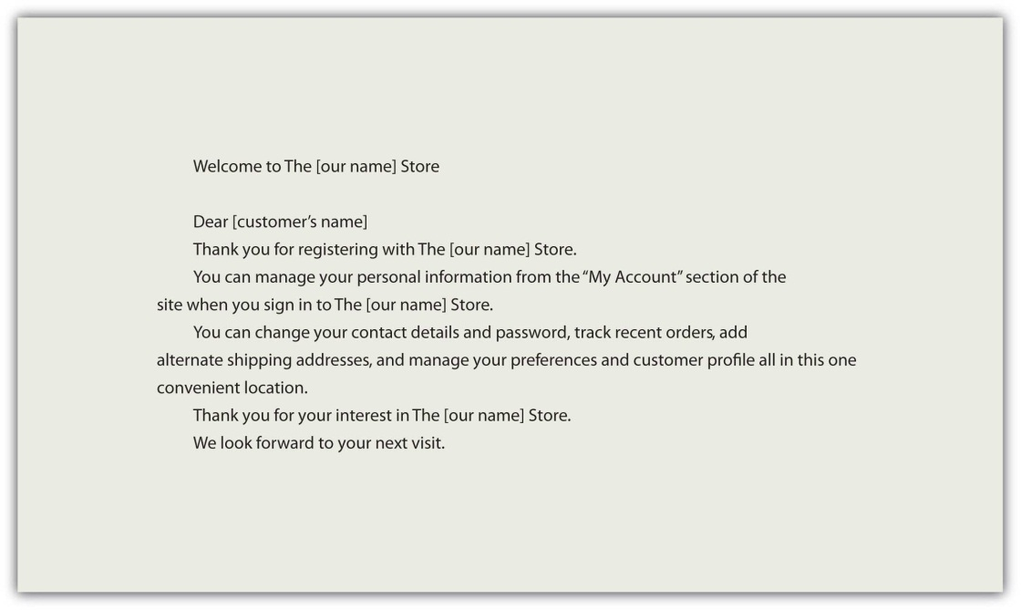

Figure 13.2
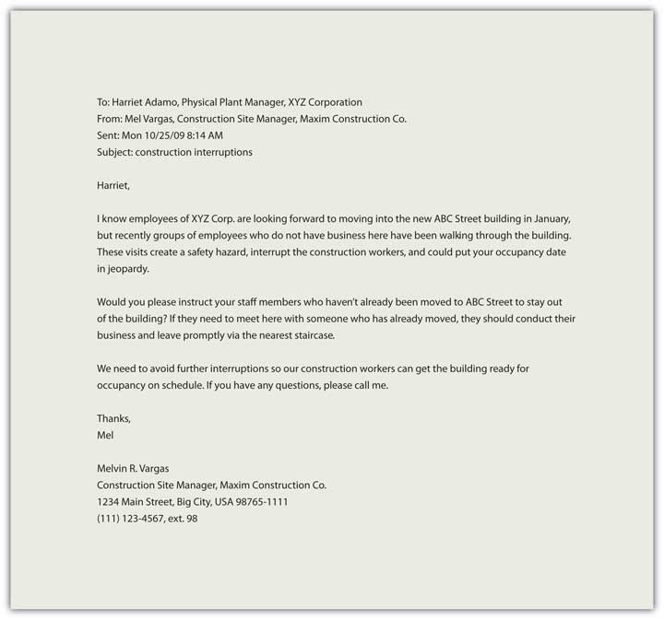

Netiquette
We create personal pages, post messages, and interact via mediated technologies as a normal part of our careers, but how we conduct ourselves can leave a lasting image, literally. The photograph you posted on your MySpace page may have been seen by your potential employer, or that nasty remark in a post may come back to haunt you later. Some fifteen years ago, when the Internet was a new phenomenon, Virginia Shea laid out a series of ground rules for communication online that continue to serve us today.

Virginia Shea’s Rules of Netiquette
- Remember the human on the other side of the electronic communication.
- Adhere to the same standards of behavior online that you follow in real life.
- Know where you are in cyberspace.
- Respect other people’s time and bandwidth.
- Make yourself look good online.
- Share expert knowledge.
- Keep flame wars under control.
- Respect other people’s privacy.
- Don’t abuse your power.
- Be forgiving of other people’s mistakes. ^{[3]}
Her rules speak for themselves and remind us that the golden rule (treat others as you would like to be treated) is relevant wherever there is human interaction.

Key Takeaways
- A text message is a brief written message sent and received using a digital device. It is useful for informal, brief, time-sensitive communication.
- E-mail is useful for both internal and external business communications. The content and formatting of an e-mail message should reflect professionalism and follow the rules of netiquette.
- Social customs that exist in traditional, live, human interaction also influence the rules and customs by which we interact with each other in the online environment.

Exercises
- Write a text message in your normal use of language. It should use all your normal abbreviations (e.g., FWIW, IMHO, LOL), even if not everyone understands them.
- Find an example of an e-mail that you wish you had never sent or received. Rewrite it to eliminate the characteristics that you find problematic. Share it with your classmates.
- Choose at least three e-mails you have sent or received that are good examples of business communication. What makes them good examples? Could they be improved in any way? Share your suggestions with classmates.
- When is e-mail inappropriate? Why?
- Find a “flame war,” or heated discussion in an online forum and note how it is handled. Compare the results with your classmates.
- In your experience, how do people behave when they interact online? Share your observations with your classmates.

[1] Houston Chronicle. (2009, September 23). Deadly distraction: Texting while driving, twice as risky as drunk driving, should be banned. Houston Chronicle (3 STAR R.O. ed.), p. B8. Retrieved from http://www.chron.com/CDA/archives/archive.mpl?id=2009_4791006
[2] Guffey, M. (2008). Essentials of business communication (7th ed.). Mason, OH: Thomson/Wadsworth.
[3] Shea, V. (1994). Netiquette. San Francisco, CA: Albion Books.

13.2 Memorandums and Letters

Learning Objectives
- Discuss the purpose and format of a memo.
- Understand effective strategies for business memos.
- Describe the fifteen parts of a standard business letter.
- Access sample business letters and write a sample business letter.

Memos
A memo (or memorandum, meaning “reminder”) is normally used for communicating policies, procedures, or related official business within an organization. It is often written from a one-to-all perspective (like mass communication), broadcasting a message to an audience, rather than a one-on-one, interpersonal communication. It may also be used to update a team on activities for a given project, or to inform a specific group within a company of an event, action, or observance.

Memo Purpose
A memo’s purpose is often to inform, but it occasionally includes an element of persuasion or a call to action. All organizations have informal and formal communication networks. The unofficial, informal communication network within an organization is often called the grapevine, and it is often characterized by rumor, gossip, and innuendo. On the grapevine, one person may hear that someone else is going to be laid off and start passing the news around. Rumors change and transform as they are passed from person to person, and before you know it, the word is that they are shutting down your entire department.
One effective way to address informal, unofficial speculation is to spell out clearly for all employees what is going on with a particular issue. If budget cuts are a concern, then it may be wise to send a memo explaining the changes that are imminent. If a company wants employees to take action, they may also issue a memorandum. For example, on February 13, 2009, upper management at the Panasonic Corporation issued a declaration that all employees should buy at least $1,600 worth of Panasonic products. The company president noted that if everyone supported the company with purchases, it would benefit all. ^{[1]}
While memos do not normally include a call to action that requires personal spending, they often represent the business or organization’s interests. They may also include statements that align business and employee interest, and underscore common ground and benefit.

Memo Format
A memo has a header that clearly indicates who sent it and who the intended recipients are. Pay particular attention to the title of the individual(s) in this section. Date and subject lines are also present, followed by a message that contains a declaration, a discussion, and a summary.
In a standard writing format, we might expect to see an introduction, a body, and a conclusion. All these are present in a memo, and each part has a clear purpose. The declaration in the opening uses a declarative sentence to announce the main topic. The discussion elaborates or lists major points associated with the topic, and the conclusion serves as a summary.
Let’s examine a sample memo.
Figure 13.3
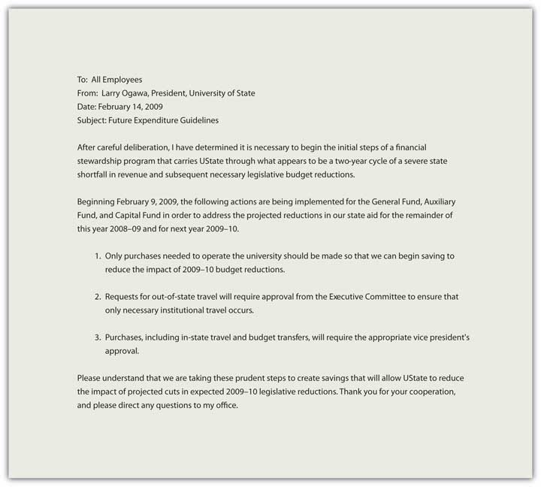

Five Tips for Effective Business Memos

Audience Orientation
Always consider the audience and their needs when preparing a memo. An acronym or abbreviation that is known to management may not be known by all the employees of the organization, and if the memo is to be posted and distributed within the organization, the goal is clear and concise communication at all levels with no ambiguity.

Professional, Formal Tone
Memos are often announcements, and the person sending the memo speaks for a part or all of the organization. While it may contain a request for feedback, the announcement itself is linear, from the organization to the employees. The memo may have legal standing as it often reflects policies or procedures, and may reference an existing or new policy in the employee manual, for example.

Subject Emphasis
The subject is normally declared in the subject line and should be clear and concise. If the memo is announcing the observance of a holiday, for example, the specific holiday should be named in the subject line—for example, use “Thanksgiving weekend schedule” rather than “holiday observance.”

Direct Format
Some written business communication allows for a choice between direct and indirect formats, but memorandums are always direct. The purpose is clearly announced.

Objectivity
Memos are a place for just the facts, and should have an objective tone without personal bias, preference, or interest on display. Avoid subjectivity.

Letters
Letters are brief messages sent to recipients that are often outside the organization. ^{[2]} They are often printed on letterhead paper, and represent the business or organization in one or two pages. Shorter messages may include e-mails or memos, either hard copy or electronic, while reports tend to be three or more pages in length.
While e-mail and text messages may be used more frequently today, the effective business letter remains a common form of written communication. It can serve to introduce you to a potential employer, announce a product or service, or even serve to communicate feelings and emotions. We’ll examine the basic outline of a letter and then focus on specific products or writing assignments.
All writing assignments have expectations in terms of language and format. The audience or reader may have their own idea of what constitutes a specific type of letter, and your organization may have its own format and requirements. This chapter outlines common elements across letters, and attention should be directed to the expectations associated with your particular writing assignment. There are many types of letters, and many adaptations in terms of form and content, but in this chapter, we discuss the fifteen elements of a traditional block-style letter.
Letters may serve to introduce your skills and qualifications to prospective employers, deliver important or specific information, or serve as documentation of an event or decision. Regardless of the type of letter you need to write, it can contain up to fifteen elements in five areas. While you may not use all the elements in every case or context, they are listed in Table 13.1 "Elements of a Business Letter".
Table 13.1 Elements of a Business Letter
Content | Guidelines
1. Return Address | This is your address where someone could send a reply. If your letter includes a letterhead with this information, either in the header (across the top of the page) or the footer (along the bottom of the page), you do not need to include it before the date.
2. Date | The date should be placed at the top, right or left justified, five lines from the top of the page or letterhead logo.
3. Reference (Re:) | Like a subject line in an e-mail, this is where you indicate what the letter is in reference to, the subject or purpose of the document.
4. Delivery (Optional) | Sometimes you want to indicate on the letter itself how it was delivered. This can make it clear to a third party that the letter was delivered via a specific method, such as certified mail (a legal requirement for some types of documents).
5. Recipient Note (Optional) | This is where you can indicate if the letter is personal or confidential.
6. Salutation | A common salutation may be “Dear Mr. (full name).” But if you are unsure about titles (i.e., Mrs., Ms., Dr.), you may simply write the recipient’s name (e.g., “Dear Cameron Rai”) followed by a colon. A comma after the salutation is correct for personal letters, but a colon should be used in business. The salutation “To whom it may concern” is appropriate for letters of recommendation or other letters that are intended to be read by any and all individuals. If this is not the case with your letter, but you are unsure of how to address your recipient, make every effort to find out to whom the letter should be specifically addressed. For many, there is no sweeter sound than that of their name, and to spell it incorrectly runs the risk of alienating the reader before your letter has even been read. Avoid the use of impersonal salutations like “Dear Prospective Customer,” as the lack of personalization can alienate a future client.
7. Introduction | This is your opening paragraph, and may include an attention statement, a reference to the purpose of the document, or an introduction of the person or topic depending on the type of letter. An emphatic opening involves using the most significant or important element of the letter in the introduction. Readers tend to pay attention to openings, and it makes sense to outline the expectations for the reader up front. Just as you would preview your topic in a speech, the clear opening in your introductions establishes context and facilitates comprehension.
8. Body | If you have a list of points, a series of facts, or a number of questions, they belong in the body of your letter. You may choose organizational devices to draw attention, such as a bullet list, or simply number them. Readers may skip over information in the body of your letter, so make sure you emphasize the key points clearly. This is your core content, where you can outline and support several key points. Brevity is important, but so is clear support for main point(s). Specific, meaningful information needs to be clear, concise, and accurate.
9. Conclusion | An emphatic closing mirrors your introduction with the added element of tying the main points together, clearly demonstrating their relationship. The conclusion can serve to remind the reader, but should not introduce new information. A clear summary sentence will strengthen your writing and enhance your effectiveness. If your letter requests or implies action, the conclusion needs to make clear what you expect to happen. It is usually courteous to conclude by thanking the recipient for his or her attention, and to invite them to contact you if you can be of help or if they have questions. This paragraph reiterates the main points and their relationship to each other, reinforcing the main point or purpose.
10. Close | “Sincerely” or “Cordially” are standard business closing statements. (“Love,” “Yours Truly,” and “BFF” are closing statements suitable for personal correspondence, but not for business.) Closing statements are normally placed one or two lines under the conclusion and include a hanging comma, as in Sincerely,
11. Signature | Five lines after the close, you should type your name (required) and, on the line below it, your title (optional).
12. Preparation Line | If the letter was prepared, or word-processed, by someone other than the signatory (you), then inclusion of initials is common, as in MJD or abc.
13. Enclosures/Attachments | Just like an e-mail with an attachment, the letter sometimes has additional documents that are delivered with it. This line indicates what the reader can look for in terms of documents included with the letter, such as brochures, reports, or related business documents.
14. Courtesy Copies or “CC” | The abbreviation “CC” once stood for carbon copies but now refers to courtesy copies. Just like a “CC” option in an e-mail, it indicates the relevant parties that will also receive a copy of the document.
15. Logo/Contact Information | A formal business letter normally includes a logo or contact information for the organization in the header (top of page) or footer (bottom of page).

Strategies for Effective Letters
Remember that a letter has five main areas:
- The heading, which establishes the sender, often including address and date
- The introduction, which establishes the purpose
- The body, which articulates the message
- The conclusion, which restates the main point and may include a call to action
- The signature line, which sometimes includes the contact information
A sample letter is shown in Figure 13.5 "Sample Business Letter".
Figure 13.5 Sample Business Letter
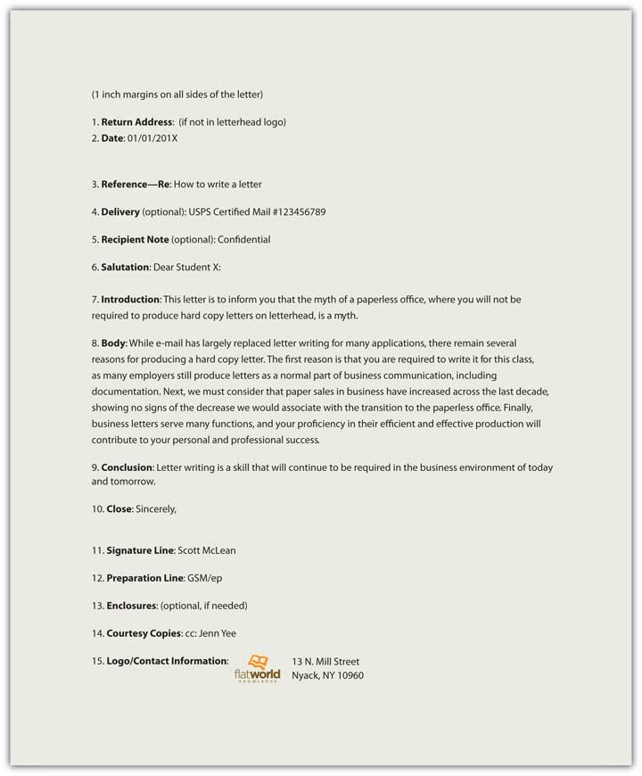
Always remember that letters represent you and your company in your absence. In order to communicate effectively and project a positive image,
- be clear, concise, specific, and respectful;
- each word should contribute to your purpose;
- each paragraph should focus on one idea;
- the parts of the letter should form a complete message;
- the letter should be free of errors.

Key Takeaways
- Memos are brief business documents usually used internally to inform or persuade employees concerning business decisions on policy, procedure, or actions.
- Letters are brief, print messages often used externally to inform or persuade customers, vendors, or the public.
- A letter has fifteen parts, each fulfilling a specific function.

Exercises
- Find a memo from your work or business, or borrow one from someone you know. Share it with your classmates, observing confidentiality by blocking out identifying details such as the name of the sender, recipient, and company. Compare and contrast.
- Create a draft letter introducing a product or service to a new client. Post and share with classmates.
- Write a memo informing your class that an upcoming holiday will be observed. Post and share with classmates.
- Find a business letter (for example, an offer you received from a credit card company or a solicitation for a donation) and share it with your classmates. Look for common elements and points of difference.
- Now that you have reviewed a sample letter, and learned about the five areas and fifteen basic parts of any business letter, write a business letter that informs a prospective client or customer of a new product or service.

[1] Lewis, L. (2009, February 13). Panasonic orders staff to buy £1,000 in products. Retrieved from http://business.timesonline.co.uk/tol/business/markets/japan/article5723942.ece
[2] Bovee, C., & Thill, J. (2010). Business communication essentials: a skills-based approach to vital business English (4th ed.). Upper Saddle River, NJ: Prentice Hall.

13.3 Business Proposal

Learning Objectives
- Describe the basic elements of a business proposal.
- Discuss the main goals of a business proposal.
- Identify effective strategies to use in a business proposal.
An effective business proposal informs and persuades efficiently. It features many of the common elements of a report, but its emphasis on persuasion guides the overall presentation.
Let’s say you work in a health care setting. What types of products or services might be put out to bid? If your organization is going to expand and needs to construct a new wing, it will probably be put out to bid. Everything from office furniture to bedpans could potentially be put out to bid, specifying a quantity, quality, and time of delivery required. Janitorial services may also be bid on each year, as well as food services, and even maintenance. Using the power of bidding to lower contract costs for goods and services is common practice.
In order to be successful in business and industry, you should be familiar with the business proposal. Much like a report, with several common elements and persuasive speech, a business proposal makes the case for your product or service. Business proposals are documents designed to make a persuasive appeal to the audience to achieve a defined outcome, often proposing a solution to a problem.

Common Proposal Elements

Idea
Effective business proposals are built around a great idea or solution. While you may be able to present your normal product, service, or solution in an interesting way, you want your document and its solution to stand out against the background of competing proposals. What makes your idea different or unique? How can you better meet the needs of the company that other vendors? What makes you so special? If the purchase decision is made solely on price, it may leave you little room to underscore the value of service, but the sale follow-through has value. For example, don’t consider just the cost of the unit but also its maintenance. How can maintenance be a part of your solution, distinct from the rest? In addition, your proposal may focus on a common product where you can anticipate several vendors at similar prices. How can you differentiate yourself from the rest by underscoring long-term relationships, demonstrated ability to deliver, or the ability to anticipate the company’s needs? Business proposals need to have an attractive idea or solution in order to be effective.

Traditional Categories
You can be creative in many aspects of the business proposal, but follow the traditional categories. Businesses expect to see information in a specific order, much like a résumé or even a letter. Each aspect of your proposal has its place and it is to your advantage to respect that tradition and use the categories effectively to highlight your product or service. Every category is an opportunity to sell, and should reinforce your credibility, your passion, and the reason why your solution is simply the best.
Table 13.2 Business Proposal Format
Cover Page | Title page with name, title, date, and specific reference to request for proposal if applicable.
Executive Summary | Like an abstract in a report, this is a one- or two-paragraph summary of the product or service and how it meets the requirements and exceeds expectations.
Background | Discuss the history of your product, service, and/or company and consider focusing on the relationship between you and the potential buyer and/or similar companies.
Proposal | The idea. Who, what, where, when, why, and how. Make it clear and concise. Don’t waste words, and don’t exaggerate. Use clear, well-supported reasoning to demonstrate your product or service.
Market Analysis | What currently exists in the marketplace, including competing products or services, and how does your solution compare?
Benefits | How will the potential buyer benefit from the product or service? Be clear, concise, specific, and provide a comprehensive list of immediate, short, and long-term benefits to the company.
Timeline | A clear presentation, often with visual aids, of the process, from start to finish, with specific, dated benchmarks noted.
Marketing Plan | Delivery is often the greatest challenge for Web-based services—how will people learn about you? If you are bidding on a gross lot of food service supplies, this may not apply to you, but if an audience is required for success, you will need a marketing plan.
Finance | What are the initial costs, when can revenue be anticipated, when will there be a return on investment (if applicable)? Again, the proposal may involve a one-time fixed cost, but if the product or service is to be delivered more than once, and extended financial plan noting costs across time is required.
Conclusion | Like a speech or essay, restate your main points clearly. Tie them together with a common them and make your proposal memorable.

Ethos, Pathos, and Logos
Ethos refers to credibility, pathos to passion and enthusiasm, and logos to logic or reason. All three elements are integral parts of your business proposal that require your attention. Who are you and why should we do business with you? Your credibility may be unknown to the potential client and it is your job to reference previous clients, demonstrate order fulfillment, and clearly show that your product or service is offered by a credible organization. By association, if your organization is credible the product or service is often thought to be more credible.
In the same way, if you are not enthusiastic about the product or service, why should the potential client get excited? How does your solution stand out in the marketplace? Why should they consider you? Why should they continue reading? Passion and enthusiasm are not only communicated through “!” exclamation points. Your thorough understanding, and your demonstration of that understanding, communicates dedication and interest.
Each assertion requires substantiation, each point clear support. It is not enough to make baseless claims about your product or service—you have to show why the claims you make are true, relevant, and support your central assertion that your product or service is right for this client. Make sure you cite sources and indicate “according to” when you support your points. Be detailed and specific.

Professional
A professional document is a base requirement. If it is less than professional, you can count on its prompt dismissal. There should be no errors in spelling or grammar, and all information should be concise, accurate, and clearly referenced when appropriate. Information that pertains to credibility should be easy to find and clearly relevant, including contact information. If the document exists in a hard copy form, it should be printed on a letterhead. If the document is submitted in an electronic form, it should be in a file format that presents your document as you intended. Word processing files may have their formatting changed or adjusted based on factors you cannot control—like screen size—and information can shift out of place, making it difficult to understand. In this case, a portable document format (PDF)—a format for electronic documents—may be used to preserve content location and avoid any inadvertent format changes when it is displayed.
Effective, persuasive proposals are often brief, even limited to one page. “The one-page proposal has been one of the keys to my business success, and it can be invaluable to you too. Few decision-makers can ever afford to read more than one page when deciding if they are interested in a deal or not. This is even more true for people of a different culture or language,” said Adnan Khashoggi, a successful multibillionaire. ^{[1]} Clear and concise proposals serve the audience well and limit the range of information to prevent confusion.

Two Types of Business Proposals

Solicited
If you have been asked to submit a proposal it is considered solicited. The solicitation may come in the form of a direct verbal or written request, but normally solicitations are indirect, open-bid to the public, and formally published for everyone to see. A request for proposal (RFP), request for quotation (RFQ), and invitation for bid (IFB) are common ways to solicit business proposals for business, industry, and the government.
RFPs typically specify the product or service, guidelines for submission, and evaluation criteria. RFQs emphasize cost, though service and maintenance may be part of the solicitation. IRBs are often job-specific in that they encompass a project that requires a timeline, labor, and materials. For example, if a local school district announces the construction of a new elementary school, they normally have the architect and engineering plans on file, but need a licensed contractor to build it.

Unsolicited
Unsolicited proposals are the “cold calls” of business writing. They require a thorough understanding of the market, product and/or service, and their presentation is typically general rather than customer-specific. They can, however, be tailored to specific businesses with time and effort, and the demonstrated knowledge of specific needs or requirement can transform an otherwise generic, brochure-like proposal into an effective sales message. Getting your tailored message to your target audience, however, is often a significant challenge if it has not been directly or indirectly solicited. Unsolicited proposals are often regarded as marketing materials, intended more to stimulate interest for a follow-up contact than make direct sales. Sue Baugh and Robert Hamper encourage you to resist the temptation to “shoot at every target and hope you hit at least one.” ^{[2]} A targeted proposal is your most effective approach, but recognize the importance of gaining company, service, or brand awareness as well as its limitations.

Sample Business Proposal
The Writing Help Tools Center is a commercial enterprise, and offers a clear (and free) example of a business proposal here:
http://www.writinghelptools.com/proposal-sample.html

Key Takeaway
Business proposals need to target a specific audience.

Exercises
- Click on this link to see a sample request for proposal from the American Institute of Public Accounts.
http://www.aicpa.org/audcommctr/toolkitsnpo/SampleRFP_for_CPA_Services.htm
- Prepare a business proposal in no more than two pages. Follow the guidelines provided in the sample letter for CPA services on the American Institute of Public Accountants Web site. Do not include actual contact information. Just as the example has employees named after colors, your (imaginary) company should have contact information that does not directly link to real businesses or you as an individual. Do not respond to point 12.
- Search for an RFP (request for proposal) or similar call to bid, and post it to your class. Compare the results with your classmates, focusing on what is required to apply or bid.
- Identify a product or service you would like to produce or offer. List three companies that you would like to sell your product or service to and learn more about them. Post your findings, making the link between your product or service and company needs. You may find the Web site on creating a business plan (http://www.myownbusiness.org/s2/#3) useful when completing this exercise.

[1] Riley, P. G. (2002). The one-page proposal: How to get your business pitch onto one persuasive page (p. 2). New York, NY: HarperCollins.
[2] Baugh, L. S., & Hamper, R. J. (1995). Handbook for writing proposals (p. 3). New York, NY: McGraw-Hill.

13.4 Report

Learning Objectives
- Discuss the main parts of a report.
- Understand the different types of reports.
- Write a basic report.

What Is a Report?
Reports are documents designed to record and convey information to the reader. Reports are part of any business or organization; from credit reports to police reports, they serve to document specific information for specific audiences, goals, or functions. The type of report is often identified by its primary purpose or function, as in an accident report, a laboratory report, a sales report, or even a book report. Reports are often analytical, or involve the rational analysis of information. Sometimes they simply “report the facts” with no analysis at all, but still need to communicate the information in a clear and concise format. Other reports summarize past events, present current data, and forecast future trends. While a report may have conclusions, propositions, or even a call to action, the demonstration of the analysis is the primary function. A sales report, for example, is not designed to make an individual sale. It is, however, supposed to report sales to date, and may forecast future sales based on previous trends. This chapter is designed to introduce you to the basics of report writing.

Types of Reports
Reports come in all sizes, but are typically longer than a page and somewhat shorter than a book. The type of report depends on its function. The function of the report is its essential purpose, often indicated in the thesis or purpose statement. The function will also influence the types of visual content or visual aids, representing words, numbers, and their relationships to the central purpose in graphic, representational ways that are easy for the reader to understand. The function may also contribute to parameters like report length (page or word count) or word choice and readability. “Focusing on the content of your longer business documents is not only natural but necessary because doing so helps ensure complete, correct information.” ^{[1]}
Reports vary by function, and they also vary by style and tradition. Within your organization, there may be employer-specific expectations that need to be addressed to meet audience expectations. This chapter discusses reports in general terms, focusing on common elements and points of distinction, but reference to similar documents where you work or additional examination of specific sample reports may serve you well as you prepare your own report.

Informational or Analytical Report?
There are two main categories for reports, regardless of their specific function or type. An informational report informs or instructs and presents details of events, activities, individuals, or conditions without analysis. An example of this type of “just the facts” report is a police accident report. The report will note the time, date, place, contributing factors like weather, and identification information for the drivers involved in an automobile accident. It does not establish fault or include judgmental statements. You should not see “Driver was falling down drunk” in a police accident report. Instead, you would see “Driver failed sobriety tests and breathalyzer test and was transported to the station for a blood sample.” The police officer is not a trained medical doctor and is therefore not licensed to make definitive diagnoses, but can collect and present relevant information that may contribute to that diagnosis.
The second type of report is called an analytical report. An analytical report presents information with a comprehensive analysis to solve problems, demonstrate relationships, or make recommendations. An example of this report may be a field report by a Center for Disease Control (CDC) physician from the site of an outbreak of the H1N1 virus, noting symptoms, disease progression, steps taken to arrest the spread of the disease, and to make recommendations on the treatment and quarantine of subjects.
Table 13.3 "Types of Reports and Their Functions" includes common reports that, depending on the audience needs, may be informational or analytical.
Table 13.3 Types of Reports and Their Functions
Type | Function
1. Laboratory Report | Communicate the procedures and results of laboratory activities
2. Research Report | Study problems scientifically by developing hypotheses, collecting data, analyzing data, and indicating findings or conclusions
3. Field Study Report | Describe one-time events, such as trips, conferences, seminars, as well as reports from branch offices, industrial and manufacturing plants
4. Progress Report | Monitor and control production, sales, shipping, service, or related business process
5. Technical Report | Communication process and product from a technical perspective
6. Financial Report | Communication status and trends from a finance perspective
7. Case Study | Represent, analyze, and present lessons learned from a specific case or example
8. Needs Assessment Report | Assess the need for a service or product
9. Comparative Advantage Report | Discuss competing products or services with an analysis of relative advantages and disadvantages
10. Feasibility Study | Analyze problems and predict whether current solutions or alternatives will be practical, advisable, or produced the desired outcome(s)
11. Instruction Manuals | Communicate step-by-step instructions on the use of a product or service
12. Compliance Report | Document and indicate the extent to which a product or service is within established compliance parameters or standards
13. Cost-Benefit Analysis Report | Communicate costs and benefits of products or services.
14. Decision Report | Make recommendations to management and become tools to solve problems and make decisions
15. Benchmark Report | Establish criteria and evaluate alternatives by measuring against the establish benchmark criteria
16. Examination Report | Report or record data obtained from an examination of an item or conditions, including accidents and natural disasters
17. Physical Description report | Describe the physical characteristics of a machine, a device, or object
18. Literature Review | Present summaries of the information available on a given subject

How Are Reports Organized?
Reports vary by size, format, and function. You need to be flexible and adjust to the needs of the audience while respecting customs and guidelines. Reports are typically organized around six key elements:
- Whom the report is about and/or prepared for
- What was done, what problems were addressed, and the results, including conclusions and/or recommendations
- Where the subject studied occurred
- When the subject studied occurred
- Why the report was written (function), including under what authority, for what reason, or by whose request
- How the subject operated, functioned, or was used
Pay attention to these essential elements when you consider your stakeholders, or those who have an interest in the report. That may include the person(s) the report is about, whom it is for, and the larger audience of the business, organization, or industry. Ask yourself who the key decision makers are who will read your report, who the experts or technicians will be, and how executives and workers may interpret your words and images. While there is no universal format for a report, there is a common order to the information. Each element supports the main purpose or function in its own way, playing an important role in the representation and transmission of information.
Table 13.4 Ten Common Elements of a Report
Page | Element | Function | Example
1. Cover | Title and image | Like the cover of a book, sometimes a picture, image, or logo is featured to introduce the topic to the reader.
2. Title Fly | Title only | This page is optional. | Feasibility Study of Oil Recovery from the X Tarpit Sands Location
3. Title Page | Label, report, features title, author, affiliation, date, and sometimes for whom the report was prepared |  | Feasibility Study of Oil Recovery from the X Tarpit Sands Location Peak Oilman, X Energy Corporation Prepared for X
4. Table of Contents | A list of the main parts of the report and their respective page numbers |  | - Abstract……1  - Introduction……2  - Background……3
5. Abstract | - Informational abstract: highlight topic, methods, data, and results  - Descriptive abstract: (All of the above without statements of conclusion or recommendations) |  | This report presents the current status of the X tarpit sands, the study of oil recoverability, and the findings of the study with specific recommendations.
6. Introduction | Introduces the topic of the report |  | Oil sands recovery processes include ways to extract and separate the bitumen from the clay, sand, and water that make up the tar sands. This study analyzes the feasibility of extraction and separation, including a comprehensive cost/benefits analysis, with specific recommendations.
7. Body | Key elements of body include:  - Background  - Methodology  - Results  - Analysis and Recommendations |  | - Background: History of oil extraction and separation from tarpit sands.  - Methodology: Specific analysis of the site based on accepted research methods.  - Results: Data from the feasibility study.  - Analysis and Recommendations: Analysis of the data and recommendations based on that analysis.
8. Conclusion | Concise presentation of findings | This portion clearly indicates the main results and their relation to recommended action or outcome.
9. References | Bibliography or Works Cited | This part contains a list of citations.
10. Appendix | Related supporting materials | This may include maps, analysis of soil samples, and field reports.

Here is a checklist for ensuring that a report fulfills its goals.
- Report considers the audience’s needs
- Format follows function of report
- Format reflects institutional norms and expectations
- Information is accurate, complete, and documented
- Information is easy to read
- Terms are clearly defined
- Figures, tables, and art support written content
- Figures, tables, and art are clear and correctly labeled
- Figures, tables, and art are easily understood without text support
- Words are easy to read (font, arrangement, organization)
- Results are clear and concise
- Recommendations are reasonable and well-supported
- Report represents your best effort
- Report speaks for itself without your clarification or explanation

Key Takeaway
Informational and analytical reports require organization and a clear purpose.

Exercises
- Find an annual report for a business you would like to learn more about. Review it with the previous reading in mind and provide examples. Share and compare with classmates.
- Write a report on a trend in business that you’ve observed, and highlight at least the main finding. Draw from your experience as you bring together sources of information to illustrate a trend. Share and compare with classmates.

[1] Bovee, C., & Thill, J. (2010). Business communication essentials: A skills-based approach to vital business English (4th ed.). Upper Saddle River, NJ: Prentice Hall.

13.5 Résumé

Learning Objectives
- Describe the differences among functional, reverse chronological, combination, targeted, and scannable résumés.
- Discuss what features are required in each type of résumé.
- Prepare a one-page résumé.
A résumé is a document that summarizes your education, skills, talents, employment history, and experiences in a clear and concise format for potential employers. The résumé serves three distinct purposes that define its format, design, and presentation:
- To represent your professional information in writing
- To demonstrate the relationship between your professional information and the problem or challenge the potential employer hopes to solve or address, often represented in the form of a job description or duties
- To get you an interview by clearly demonstrating you meet the minimum qualifications and have the professional background help the organization meet its goals
An online profile page is similar to a résumé in that it represents you, your background and qualifications, and adds participation to the publication. People network, link, and connect in new ways via online profiles or professional sites like LinkedIn. In many ways, your online profile is an online version of your résumé with connections and friends on public display. Your MySpace and Facebook pages are also often accessible to the public, so never post anything you wouldn’t want your employer (current or future) to read, see, or hear. This chapter covers a traditional résumé, as well as the more popular scannable features, but the elements and tips could equally apply to your online profile.

Main Parts of a Résumé
Regardless of the format, employers have expectations for your résumé. They expect it to be clear, accurate, and up to date. ^{[1]} This document represents you in your absence, and you want it to do the best job possible. You don’t want to be represented by spelling or grammatical errors, as they may raise questions about your education and attention to detail. Someone reading your résumé with errors will only wonder what kind of work you might produce that will poorly reflect on their company. There is going to be enough competition that you don’t want to provide an easy excuse to toss your résumé at the start of the process. Do your best work the first time.
Résumés have several basic elements that employers look for, including your contact information, objective or goal, education and work experience, and so on. Each résumé format may organize the information in distinct ways based on the overall design strategy, but all information should be clear, concise, and accurate. ^{[2]}

Contact Information
This section is often located at the top of the document. The first element of the contact information is your name. You should use your full, legal name even if you go by your middle name or use a nickname. There will plenty of time later to clarify what you prefer to be called, but all your application documents, including those that relate to payroll, your social security number, drug screenings, background checks, fingerprint records, transcripts, certificates or degrees, should feature your legal name. Other necessary information includes your address, phone number(s), and e-mail address. If you maintain two addresses (e.g., a campus and a residential address), make it clear where you can be contacted by indicating the primary address. For business purposes, do not use an unprofessional e-mail address like sexiluvr93@hotmale.com or tutifruti@yafoo.com. Create a new e-mail account if needed with an address suitable for professional use.
Figure 13.7 Sample Contact Information

Objective
This is one part of your résumé that is relatively simple to customize for an individual application. Your objective should reflect the audience’s need to quickly understand how you will help the organization achieve its goals.
Figure 13.8 Sample Objective
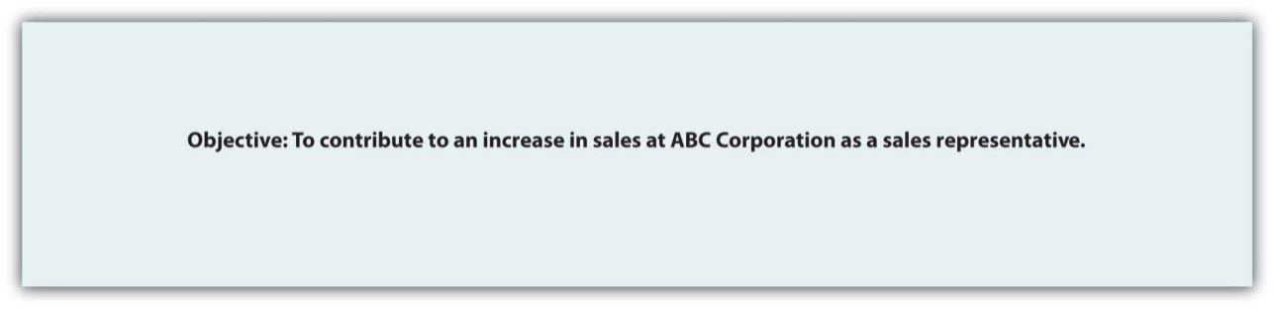

Education
You need to list your education in reverse chronological order, with your most recent degree first. List the school, degree, and grade point average (GPA). If there is a difference between the GPA in your major courses and your overall GPA, you may want to list them separately to demonstrate your success in your chosen field. You may also want to highlight relevant coursework that directly relate to the position.
Figure 13.9 Sample Education Field
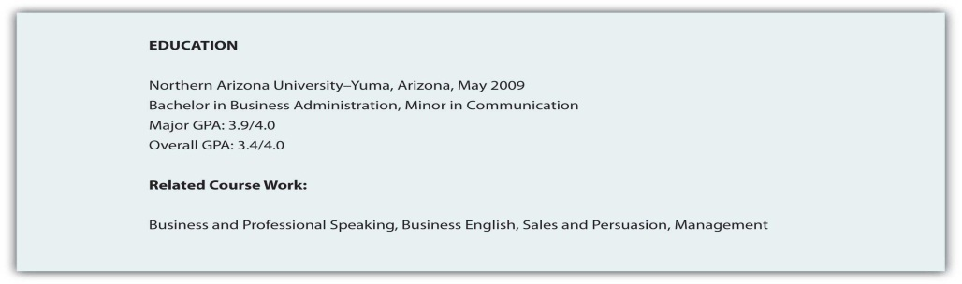

Work Experience
List in reverse chronological order your employment history, including the positions, companies, locations, dates, duties and skills demonstrated or acquired. You may choose to use active, descriptive sentences or bullet lists, but be consistent. Emphasize responsibilities that involved budgets, teamwork, supervision, and customer service when applying for positions in business and industry, but don’t let emphasis become exaggeration. This document represents you in your absence, and if information is false, at a minimum you could lose your job.
Figure 13.10 Sample Work Experience
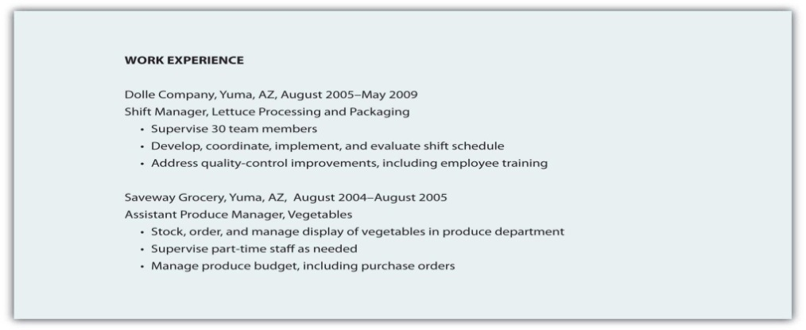

Table 13.5 Types of Résumés
Type | Function | Advantage | Disadvantage
1. Reverse Chronological | Reverse chronological résumés (also called reverse time order) focus on work history. | Demonstrates a consistent work history | It may be difficult to highlight skills and experience.
2. Functional | Functional résumés (also called competency-based résumés) focus on skills. | Demonstrates skills that can clearly link to job functions or duties | It is often associated with people who have gaps in their employment history.
3. Combination | A combination résumé lists your skills and experience first, then employment history and education. | Highlights the skills you have that are relevant to the job and provides a reverse chronological work history | Some employers prefer a reverse chronological order.
4. Targeted | A targeted résumé is a custom document that specifically highlights the experience and skills that are relevant to the job. | Points out to the reader how your qualifications and experience clearly match the job duties | Custom documents take additional time, preparation, analysis of the job announcement, and may not fit the established guidelines.
5. Scannable | A scannable résumé is specifically formatted to be read by a scanner and converted to digital information. | Increasingly used to facilitate search and retrieval, and to reduce physical storage costs | Scanners may not read the résumé correctly.

You may choose to include references at the end of your résumé, though “references upon request” is common. You may also be tempted to extend your résumé to more than one page, but don’t exceed that limit unless the additional page will feature specific, relevant information that represents several years of work that directly relates to the position. The person reading your résumé may be sifting through many applicants and will not spend time reading extra pages. Use the one-page format to put your best foot forward, remembering that you may never get a second chance to make a good first impression.

Maximize Scannable Résumé Content

Use Key Words
Just as there are common search terms, and common words in relation to each position, job description, or description of duties, your scannable résumé needs to mirror these common terms. Use of nonstandard terms may not stand out, and your indication of “managed employees” may not get the same attention as the word “supervision” or “management.”

Follow Directions
If a job description uses specific terms, refers to computer programs, skills, or previous experience, make sure you incorporate that language in your scannable résumé. You know that when given a class assignment, you are expected to follow directions; similarly, the employer is looking for specific skills and experience. By mirroring the employer’s language and submitting your application documents in accord with their instructions, you convey a spirit of cooperation and an understanding of how to follow instructions.

Insert a Key Word Section
Consider a brief section that lists common words associated with the position as a skills summary: customer service, business communication, sales, or terms and acronyms common to the business or industry.

Make It Easy to Read
You need to make sure your résumé is easy to read by a computer, including a character recognition program. That means no italics, underlining, shading, boxes, or lines. Choose a sans serif (without serif, or decorative end) font like Arial or Tahoma that won’t be misread. Simple, clear fonts that demonstrate no points at which letters may appear to overlap will increase the probability of the computer getting it right the first time. In order for the computer to do this, you have to consider your audience—a computer program that will not be able to interpret your unusual font or odd word choice. A font size of eleven or twelve is easier to read for most people, and while the computer doesn’t care about font size, the smaller your font, the more likely the computer is to make the error of combining adjacent letters.

Printing, Packaging and Delivery
Use a laser printer to get crisp letter formation. Inkjet printers can have some “bleed” between characters that may make them overlap, and therefore be misunderstood. Folds can make it hard to scan your document. E-mail your résumé as an attachment if possible, but if a paper version is required, don’t fold it. Use a clean, white piece of paper with black ink; colors will only confuse the computer. Deliver the document in a nine-by-twelve-inch envelope, stiffened with a sheet of cardstock (heavy paper or cardboard) to help prevent damage to the document.

Figure 13.11 Sample Format for Chronological Résumé
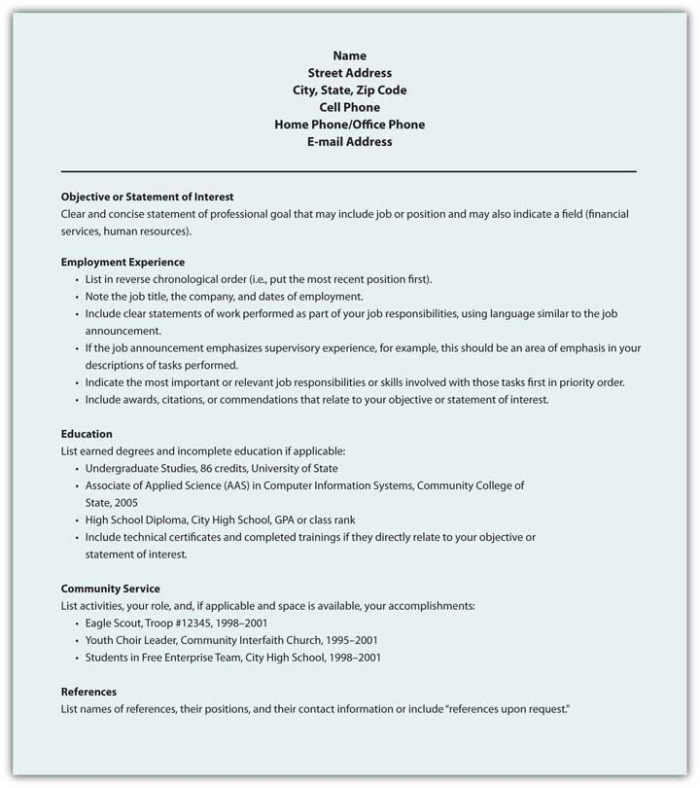

Figure 13.12 Sample Format for Functional Résumé
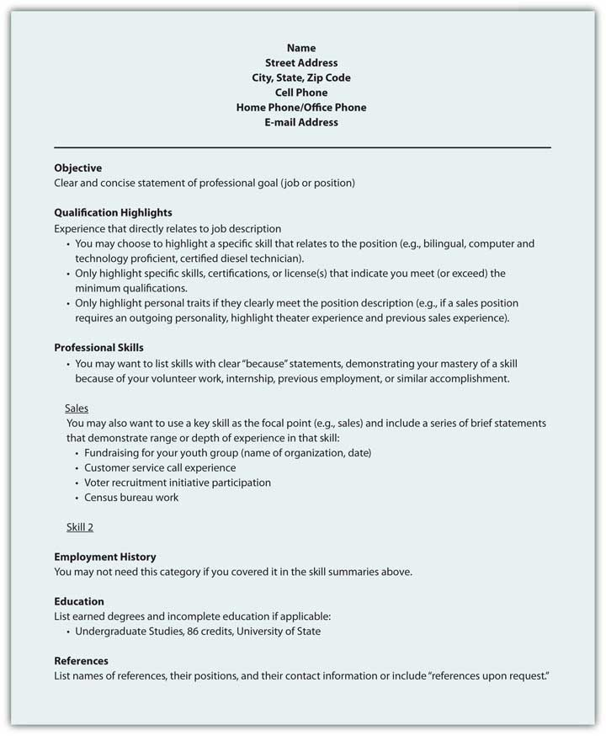
Figure 13.13 Sample Format for Scannable Résumé
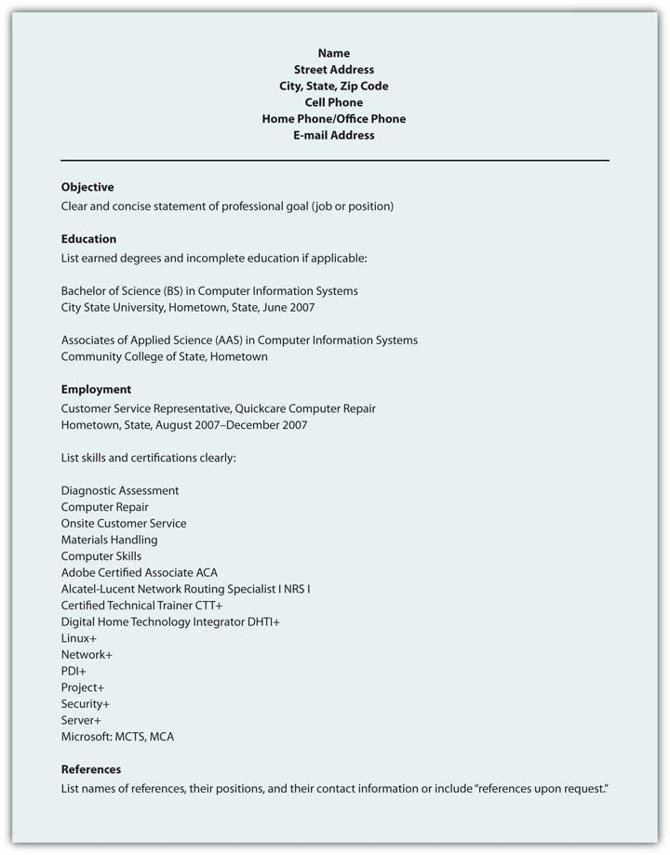

Key Takeaway
A résumé will represent your skills, education, and experience in your absence. Businesses increasingly scan résumés into searchable databases.

Exercises
- Find a job announcement with specific duties that represents a job that you will be prepared for upon graduation. Choose a type of résumé and prepare your résumé to submit to the employer as a class assignment. Your instructor may also request a scannable version of your résumé.
- Conduct an online search for a functional or chronological résumé. Please post and share with your classmates.
- Conduct an online search for job advertisements that detail positions you would be interested in, and note the key job duties and position requirements. Please post one example and share with your classmates.
- When is a second page of your résumé justified? Explain.
- Conduct an online search for resources to help you prepare your own résumé. Please post one link and a brief review of the Web site, noting what features you found useful and at least one recommendation for improvement.

[1] Bennett, S. A. (2005). The elements of résumé style: Essential rules and eye-opening advice for writing résumés and cover letters that work. AMACOM.
[2] Simons, W., & Curtis, R. (2004). The Résumé.com guide to writing unbeatable résumés. New York, NY: McGraw-Hill.

13.6 Sales Message

Learning Objectives
- Discuss a basic sales message and identify its central purpose
- Detail the main parts of a sales message and understand strategies for success
A sales message is the central persuasive message that intrigues, informs, persuades, calls to action, and closes the sale. Not every sales message will make a direct sale, but the goal remains. Whether your sales message is embedded in a letter, represented in a proposal, or broadcast across radio or television, the purpose stays the same.
Sales messages are often discussed in terms of reason versus emotion. Every message has elements of ethos, or credibility; pathos, or passion and enthusiasm; and logos, or logic and reason. If your sales message focuses exclusively on reason with cold, hard facts and nothing but the facts, you may appeal to some audience, but certainly not the majority. Buyers make purchase decisions on emotion as well as reason, and even if they have researched all the relevant facts about competing products, the decision may still come down to impulse, emotion, and desire. If your sales message focuses exclusively on emotion, with little or no substance, it may not be taken seriously. Finally, if your sales message does not appear to have credibility, the message will be dismissed. In the case of the sales message, you need to meet the audience’s needs that vary greatly.
In general, appeals to emotion pique curiosity and get our attention, but some attention to reason and facts should also be included. That doesn’t mean we need to spell out the technical manual on the product on the opening sale message, but basic information about design or features, in specific, concrete ways can help an audience make sense of your message and the product or service. Avoid using too many abstract terms or references, as not everyone will understand these. You want your sales message to do the work, not the audience.

Format for a Common Sales Message
A sales message has the five main parts of any persuasive message.

Table 13.6 Five Main Parts of a Persuasive Message
Attention Statement | Use humor, novelty, surprise, or the unusual to get attention.
Introduction | Build interest by appealing to common needs and wants, and include a purpose statement to set up expectations.
Body | Establish credibility, discuss attractive features, and compare with competitors, addressing concerns or potential questions before they are even considered.
Conclusion | Sum it up and offer solution steps or calls to action, motivating the audience to take the next step. The smaller the step, the more likely the audience will comply. Set up your audience for an effective closing.
Residual Message | Make the sale, make them remember you, and make sure your final words relate to the most important information, like a contact phone number.

Getting Attention
Your sales message will compete with hundreds of other messages and you want it to stand out. ^{[1]} One effective way to do that is to make sure your attention statement(s) and introduction clearly state how the reader or listener will benefit.
- Will the product or service save time or money?
- Will it make them look good?
- Will it entertain them?
- Will it satisfy them?
Regardless of the product or service, the audience is going to consider first what is in it for them. A benefit is what the buyer gains with the purchase and is central to your sales message. They may gain social status, popularity, sex appeal, or even reduce or eliminate something they don’t want. Your sales message should clearly communicate the benefits of your product or service. ^{[2]}

Sales Message Strategies for Success
Your product or service may sell itself, but if you require a sales message, you may want to consider these strategies for success:
- Start with your greatest benefit. Use it in the headline, subject line, caption, or attention statement. Audiences tend to remember the information from the beginning and end of a message, but have less recall about the middle points. Make your first step count by highlighting the best feature first.
- Take baby steps. One thing at a time. Promote, inform, and persuade on one product or service at a time. You want to hear “yes” and make the associated sale, and if you confuse the audience with too much information, too many options, steps to consider, or related products or service, you are more likely to hear “no” as a defensive response as the buyer tries not to make a mistake. Avoid confusion and keep it simple.
- Know your audience. The more background research you can do on your buyer, the better you can anticipate their specific wants and needs and individualize your sales message to meet them.
- Lead with emotion, follow with reason. Gain the audience’s attention with drama, humor, or novelty and follow with specific facts that establish your credibility, provide more information about the product or service, and lead to your call to action to make the sale.
These four steps can help improve your sales message, and your sales. Invest your time in planning and preparation, and consider the audience’s needs as you prepare your sales message.
Figure 13.14 Sample E-mail Sales Message
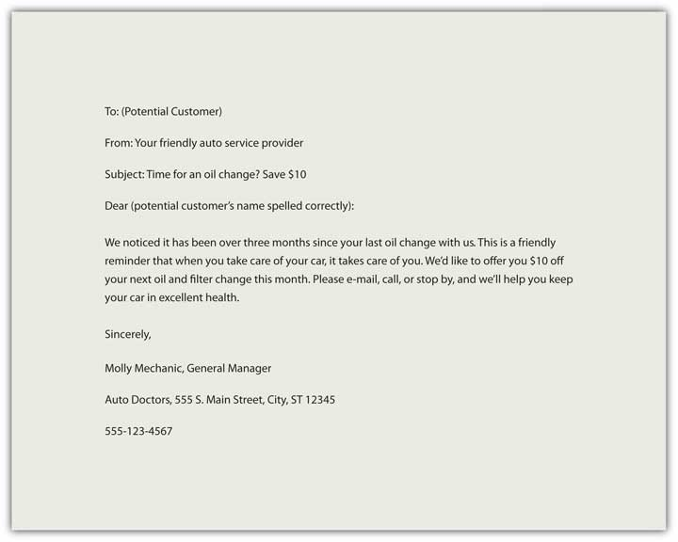

Key Takeaway
A sales message combines emotion and reason, and reinforces credibility, to create interest in a product or service that leads to a sale.

Exercises
- Create your own e-mail sales message in a hundred words or less. Share it with the class.
- Identify one sales message you consider to be effective. Share it with classmates and discuss why you perceive it to be effective.
- Please consider one purchase you made recently. What motivated you to buy and why did you choose to complete the purchase? Share the results with your classmates.
- Are you more motivated by emotion or reason? Ask ten friends that question and post your results.

[1] Price, D. (2005, October 30). How to communicate your sales message so buyers take action now! Retrieved June 14, 2009, from ezinearticles.com: http://ezinearticles.com/?How-To-Communicate-Your-Sales-Message-So-Buyers-Take-Action-Now!&id=89569
[2] Winston, W., & Granat, J. (1997). Persuasive advertising for entrepreneurs and small business owners: How to create more effective sales messages. New York, NY: Routledge.

13.7 Additional Resources
Visit NetLingo for some common texting abbreviations. http://www.netlingo.com/acronyms.php
The Online Writing Lab (OWL) at Purdue University includes an area on e-mail etiquette. http://owl.english.purdue.edu/owl/resource/636/01
Shea’s Netiquette online is another useful source. http://www.albion.com/netiquette/book/index.html
The New York Times blog “Gadgetwise: Getting Smart About Personal Technology” discusses an ever-changing variety of questions related to netiquette. http://gadgetwise.blogs.nytimes.com
The OWL at Purdue also includes pages on memo writing and a sample memo. http://owl.english.purdue.edu/owl/resource/590/01; http://owl.english.purdue.edu/owl/resource/590/04
For 642 sample letters, from cover letters to complaints, go to this site. http://www.4hb.com/letters
Visit this Negotiations.com page for information on writing a request for proposal, quotation, and information. http://www.negotiations.com/articles/procurement-terms
Visit this site for additional proposal writing tips. http://www.4hb.com/0350tipwritebizproposal.html
TechSoup offers a sample Request for Proposal. http://www.techsoup.org/toolkits/rfp/RFP_client_mgmt2.pdf
Your online profile counts as much as your résumé. http://www.npr.org/templates/story/story.php?storyId=105483848&sc=nl&cc=es-20090628
Read a Forbes article on “Ten Ways to Torpedo Your Sales Pitch.” http://www.forbes.com/2007/08/01/microsoft-ebay-symantec-ent-sales-cx_mf_0801byb07_torpedo.html
Direct mail and other sales copy written by Susanna Hutcheson. http://www.powerwriting.com/port.html
Visit this site for tips on how to write a public service announcement (PSA). http://www.essortment.com/all/tiphowtowrite_rjbk.htm
The National Institute of Justice provides guidelines on writing a PSA. http://www.ojp.usdoj.gov/nij/topics/courts/restorative-justice/marketing-media/psa.htm
The AdCouncil provides a range of examples. http://www.adcouncil.org/default.aspx?id=15

Chapter 14 APA and MLA Documentation and Formatting

14.1 Formatting a Research Paper

Learning Objectives
- Identify the major components of a research paper written using American Psychological Association (APA) style.
- Apply general APA style and formatting conventions in a research paper.
In this chapter, you will learn how to use APA style, the documentation and formatting style followed by the American Psychological Association, as well as MLA style, from the Modern Language Association. There are a few major formatting styles used in academic texts, including AMA, Chicago, and Turabian:
- AMA (American Medical Association) for medicine, health, and biological sciences
- APA (American Psychological Association) for education, psychology, and the social sciences
- Chicago—a common style used in everyday publications like magazines, newspapers, and books
- MLA (Modern Language Association) for English, literature, arts, and humanities
- Turabian—another common style designed for its universal application across all subjects and disciplines
While all the formatting and citation styles have their own use and applications, in this chapter we focus our attention on the two styles you are most likely to use in your academic studies: APA and MLA.
If you find that the rules of proper source documentation are difficult to keep straight, you are not alone. Writing a good research paper is, in and of itself, a major intellectual challenge. Having to follow detailed citation and formatting guidelines as well may seem like just one more task to add to an already-too-long list of requirements.
Following these guidelines, however, serves several important purposes. First, it signals to your readers that your paper should be taken seriously as a student’s contribution to a given academic or professional field; it is the literary equivalent of wearing a tailored suit to a job interview. Second, it shows that you respect other people’s work enough to give them proper credit for it. Finally, it helps your reader find additional materials if he or she wishes to learn more about your topic.
Furthermore, producing a letter-perfect APA-style paper need not be burdensome. Yes, it requires careful attention to detail. However, you can simplify the process if you keep these broad guidelines in mind:
- Work ahead whenever you can.Chapter 10 "Writing Preparation" includes tips for keeping track of your sources early in the research process, which will save time later on.
- Get it right the first time. Apply APA guidelines as you write, so you will not have much to correct during the editing stage. Again, putting in a little extra time early on can save time later.
- Use the resources available to you. In addition to the guidelines provided in this chapter, you may wish to consult the APA website at http://www.apa.org or the Purdue University Online Writing lab at http://owl.english.purdue.edu, which regularly updates its online style guidelines.

General Formatting Guidelines
This chapter provides detailed guidelines for using the citation and formatting conventions developed by the American Psychological Association, or APA. Writers in disciplines as diverse as astrophysics, biology, psychology, and education follow APA style. The major components of a paper written in APA style are listed in the following box.
These are the major components of an APA-style paper:
- Title page
- Abstract
- Body, which includes the following:
  - Headings and, if necessary, subheadings to organize the content
  - In-text citations of research sources
- References page
All these components must be saved in one document, not as separate documents.

Title Page
The title page of your paper includes the following information:
- Title of the paper
- Author’s name
- Name of the institution with which the author is affiliated
- Header at the top of the page with the paper title (in capital letters) and the page number (If the title is lengthy, you may use a shortened form of it in the header.)
List the first three elements in the order given in the previous list, centered about one third of the way down from the top of the page. Use the headers and footers tool of your word-processing program to add the header, with the title text at the left and the page number in the upper-right corner. Your title page should look like the following example.
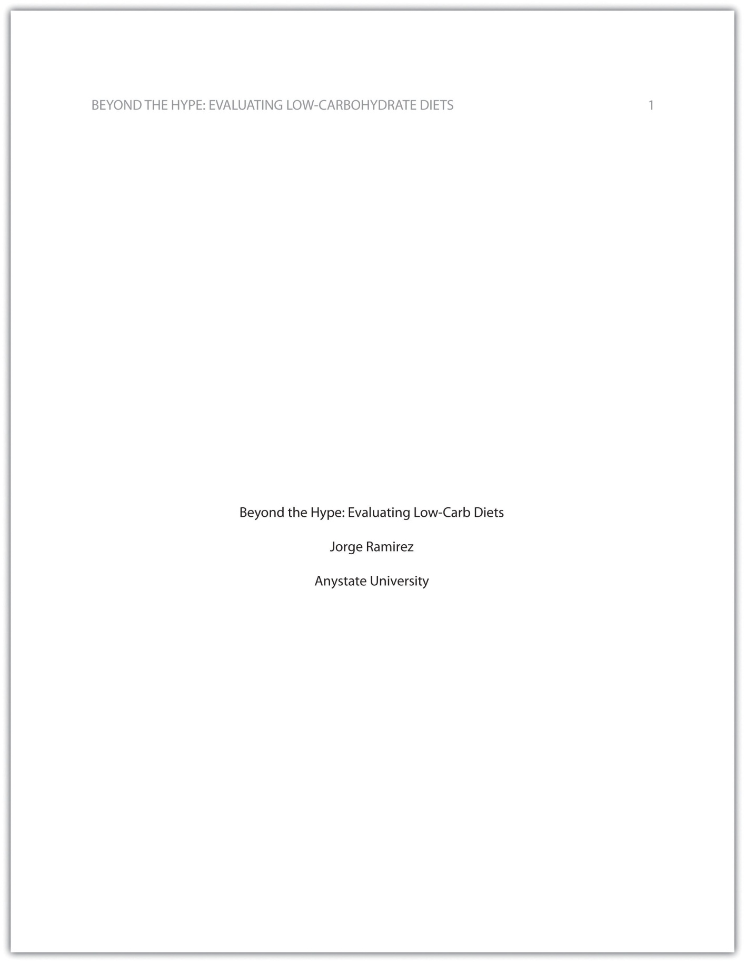

Abstract
The next page of your paper provides an abstract, or brief summary of your findings. An abstract does not need to be provided in every paper, but an abstract should be used in papers that include a hypothesis. A good abstract is concise—about one hundred to one hundred fifty words—and is written in an objective, impersonal style. Your writing voice will not be as apparent here as in the body of your paper. When writing the abstract, take a just-the-facts approach, and summarize your research question and your findings in a few sentences.
In Chapter 11 "Writing", you read a paper written by a student named Jorge, who researched the effectiveness of low-carbohydrate diets. Read Jorge’s abstract. Note how it sums up the major ideas in his paper without going into excessive detail.
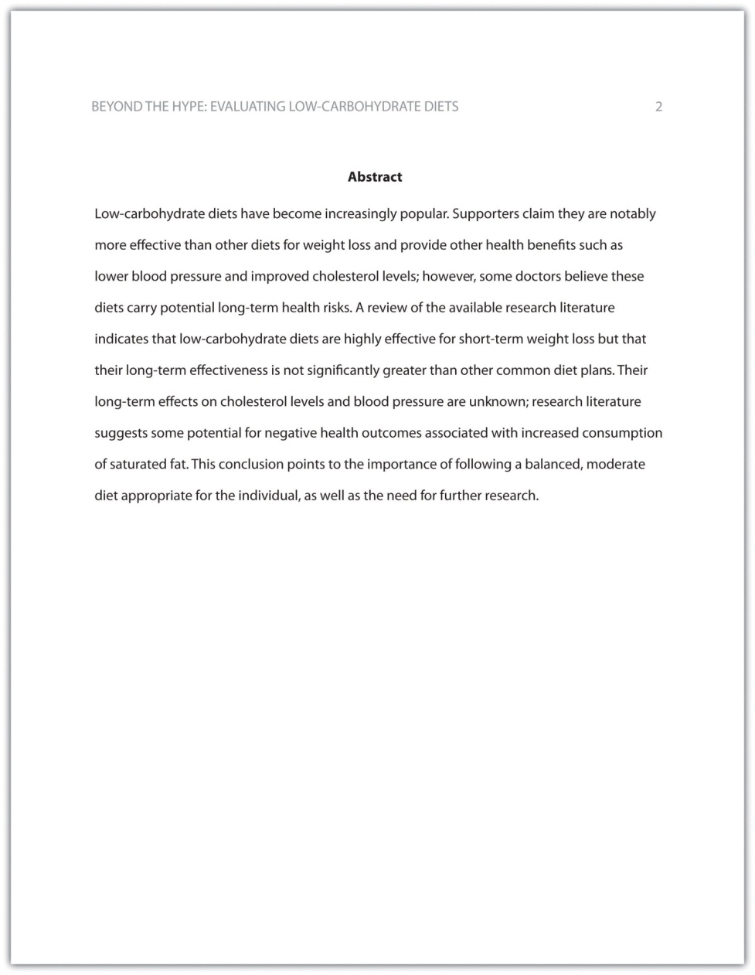

Exercise 1
Write an abstract summarizing your paper. Briefly introduce the topic, state your findings, and sum up what conclusions you can draw from your research. Use the word count feature of your word-processing program to make sure your abstract does not exceed one hundred fifty words.

Tip
Depending on your field of study, you may sometimes write research papers that present extensive primary research, such as your own experiment or survey. In your abstract, summarize your research question and your findings, and briefly indicate how your study relates to prior research in the field.

Margins, Pagination, and Headings
APA style requirements also address specific formatting concerns, such as margins, pagination, and heading styles, within the body of the paper. Review the following APA guidelines.
Use these general guidelines to format the paper:
- Set the top, bottom, and side margins of your paper at 1 inch.
- Use double-spaced text throughout your paper.
- Use a standard font, such as Times New Roman or Arial, in a legible size (10- to 12-point).
- Use continuous pagination throughout the paper, including the title page and the references section. Page numbers appear flush right within your header.
- Section headings and subsection headings within the body of your paper use different types of formatting depending on the level of information you are presenting. Additional details from Jorge’s paper are provided.
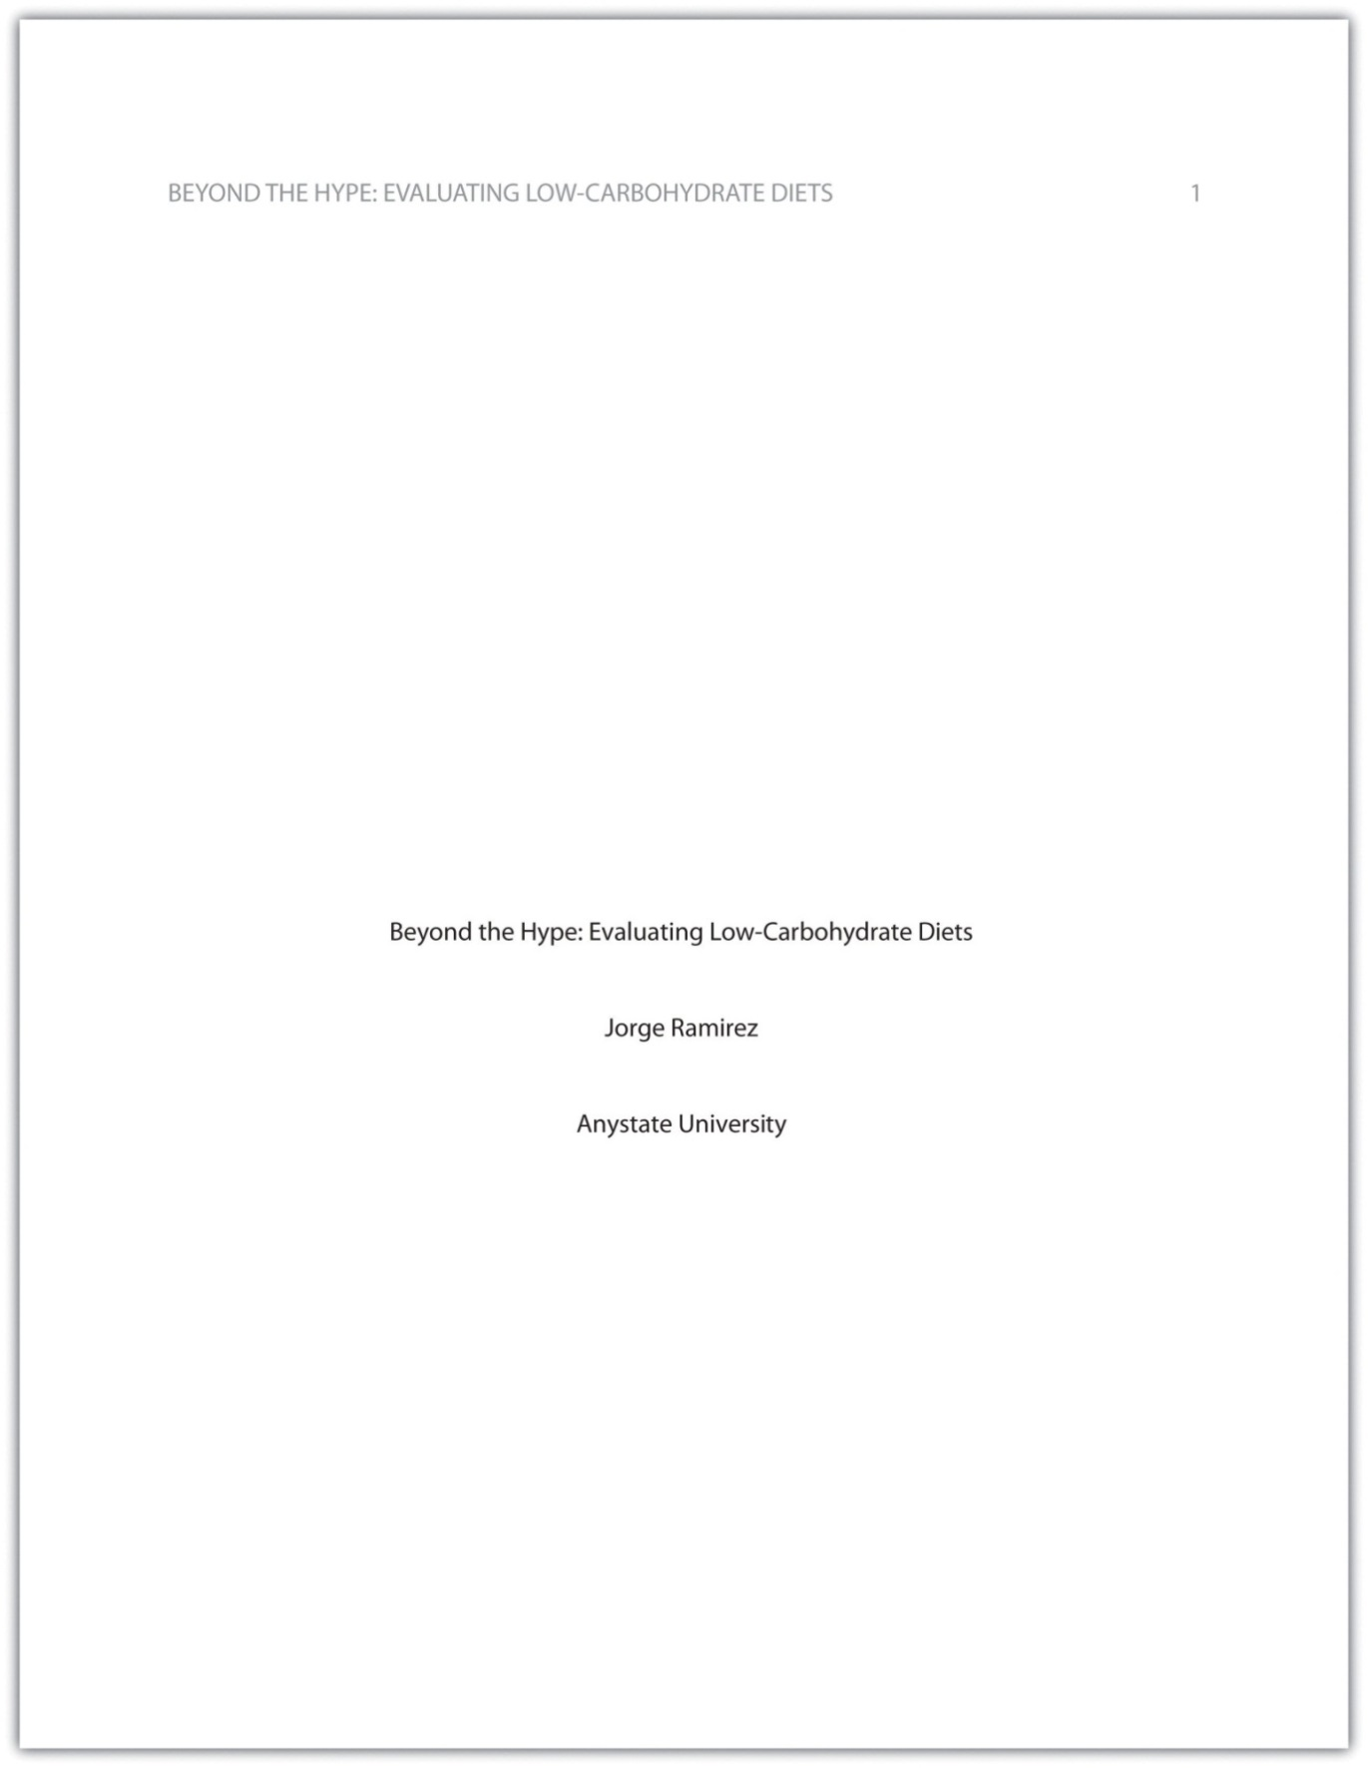
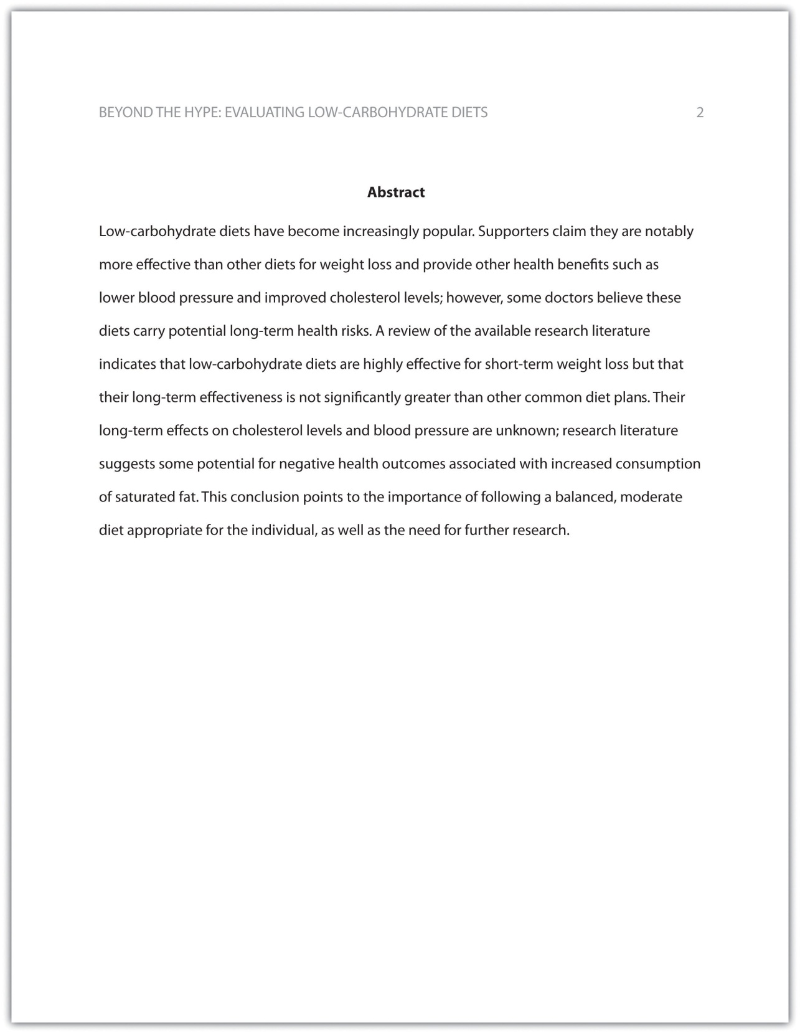

Exercise 2
Begin formatting the final draft of your paper according to APA guidelines. You may work with an existing document or set up a new document if you choose. Include the following:
- Your title page
- The abstract you created in Note 14.8 "Exercise 1"
- Correct headers and page numbers for your title page and abstract

Headings
APA style uses section headings to organize information, making it easy for the reader to follow the writer’s train of thought and to know immediately what major topics are covered. Depending on the length and complexity of the paper, its major sections may also be divided into subsections, sub-subsections, and so on. These smaller sections, in turn, use different heading styles to indicate different levels of information. In essence, you are using headings to create a hierarchy of information.
The following heading styles used in APA formatting are listed in order of greatest to least importance:
- Section headings use centered, boldface type. Headings use title case, with important words in the heading capitalized.
- Subsection headings use left-aligned, boldface type. Headings use title case.
- The third level uses left-aligned, indented, boldface type. Headings use a capital letter only for the first word, and they end in a period.
- The fourth level follows the same style used for the previous level, but the headings are boldfaced and italicized.
- The fifth level follows the same style used for the previous level, but the headings are italicized and not boldfaced.
Visually, the hierarchy of information is organized as indicated in Table 14.1 "Section Headings".
Table 14.1 Section Headings
Level of Information | Text Example
Level 1 | Heart Disease
Level 2 | Lifestyle Factors That Reduce Heart Disease Risk
Level 3 | Exercising regularly.
Level 4 | Aerobic exercise.
Level 5 | Country line dancing.

A college research paper may not use all the heading levels shown in Table 14.1 "Section Headings", but you are likely to encounter them in academic journal articles that use APA style. For a brief paper, you may find that level 1 headings suffice. Longer or more complex papers may need level 2 headings or other lower-level headings to organize information clearly. Use your outline to craft your major section headings and determine whether any subtopics are substantial enough to require additional levels of headings.

Exercise 3
Working with the document you developed in Note 14.11 "Exercise 2", begin setting up the heading structure of the final draft of your research paper according to APA guidelines. Include your title and at least two to three major section headings, and follow the formatting guidelines provided above. If your major sections should be broken into subsections, add those headings as well. Use your outline to help you.
Because Jorge used only level 1 headings, his Exercise 3 would look like the following:
Level of Information | Text Example
Level 1 | Purported Benefits of Low-Carbohydrate Diets
Level 1 | Research on Low-Carbohydrate Diets and Weight Loss
Level 1 | Other Long-Term Health Outcomes
Level 1 | Conclusion

Citation Guidelines

In-Text Citations
Throughout the body of your paper, include a citation whenever you quote or paraphrase material from your research sources. As you learned in Chapter 10 "Writing Preparation", the purpose of citations is twofold: to give credit to others for their ideas and to allow your reader to follow up and learn more about the topic if desired. Your in-text citations provide basic information about your source; each source you cite will have a longer entry in the references section that provides more detailed information.
In-text citations must provide the name of the author or authors and the year the source was published. (When a given source does not list an individual author, you may provide the source title or the name of the organization that published the material instead.) When directly quoting a source, it is also required that you include the page number where the quote appears in your citation.
This information may be included within the sentence or in a parenthetical reference at the end of the sentence, as in these examples.
Epstein (2010) points out that “junk food cannot be considered addictive in the same way that we think of psychoactive drugs as addictive” (p. 137).
Here, the writer names the source author when introducing the quote and provides the publication date in parentheses after the author’s name. The page number appears in parentheses after the closing quotation marks and before the period that ends the sentence.
Addiction researchers caution that “junk food cannot be considered addictive in the same way that we think of psychoactive drugs as addictive” (Epstein, 2010, p. 137).
Here, the writer provides a parenthetical citation at the end of the sentence that includes the author’s name, the year of publication, and the page number separated by commas. Again, the parenthetical citation is placed after the closing quotation marks and before the period at the end of the sentence.
As noted in the book Junk Food, Junk Science (Epstein, 2010, p. 137), “junk food cannot be considered addictive in the same way that we think of psychoactive drugs as addictive.”
Here, the writer chose to mention the source title in the sentence (an optional piece of information to include) and followed the title with a parenthetical citation. Note that the parenthetical citation is placed before the comma that signals the end of the introductory phrase.
David Epstein’s book Junk Food, Junk Science (2010) pointed out that “junk food cannot be considered addictive in the same way that we think of psychoactive drugs as addictive” (p. 137).
Another variation is to introduce the author and the source title in your sentence and include the publication date and page number in parentheses within the sentence or at the end of the sentence. As long as you have included the essential information, you can choose the option that works best for that particular sentence and source.
Citing a book with a single author is usually a straightforward task. Of course, your research may require that you cite many other types of sources, such as books or articles with more than one author or sources with no individual author listed. You may also need to cite sources available in both print and online and nonprint sources, such as websites and personal interviews. Chapter 14 "APA and MLA Documentation and Formatting", Section 14.2 "Citing and Referencing Techniques" and Section 14.3 "Creating a References Section" provide extensive guidelines for citing a variety of source types.

Writing at Work
APA is just one of several different styles with its own guidelines for documentation, formatting, and language usage. Depending on your field of interest, you may be exposed to additional styles, such as the following:
- MLA style. Determined by the Modern Languages Association and used for papers in literature, languages, and other disciplines in the humanities.
- Chicago style. Outlined in the Chicago Manual of Style and sometimes used for papers in the humanities and the sciences; many professional organizations use this style for publications as well.
- Associated Press (AP) style. Used by professional journalists.

References List
The brief citations included in the body of your paper correspond to the more detailed citations provided at the end of the paper in the references section. In-text citations provide basic information—the author’s name, the publication date, and the page number if necessary—while the references section provides more extensive bibliographical information. Again, this information allows your reader to follow up on the sources you cited and do additional reading about the topic if desired.
The specific format of entries in the list of references varies slightly for different source types, but the entries generally include the following information:
- The name(s) of the author(s) or institution that wrote the source
- The year of publication and, where applicable, the exact date of publication
- The full title of the source
- For books, the city of publication
- For articles or essays, the name of the periodical or book in which the article or essay appears
- For magazine and journal articles, the volume number, issue number, and pages where the article appears
- For sources on the web, the URL where the source is located
The references page is double spaced and lists entries in alphabetical order by the author’s last name. If an entry continues for more than one line, the second line and each subsequent line are indented five spaces. Review the following example. (Chapter 14 "APA and MLA Documentation and Formatting", Section 14.3 "Creating a References Section" provides extensive guidelines for formatting reference entries for different types of sources.)
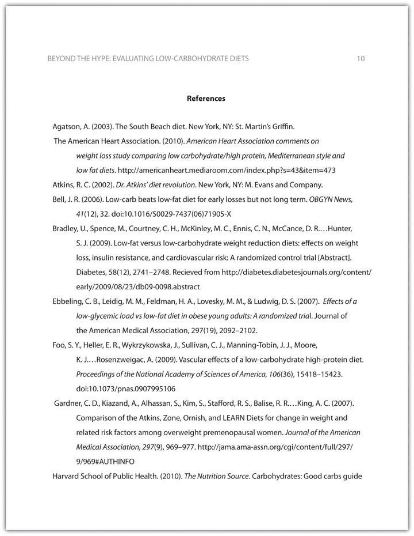
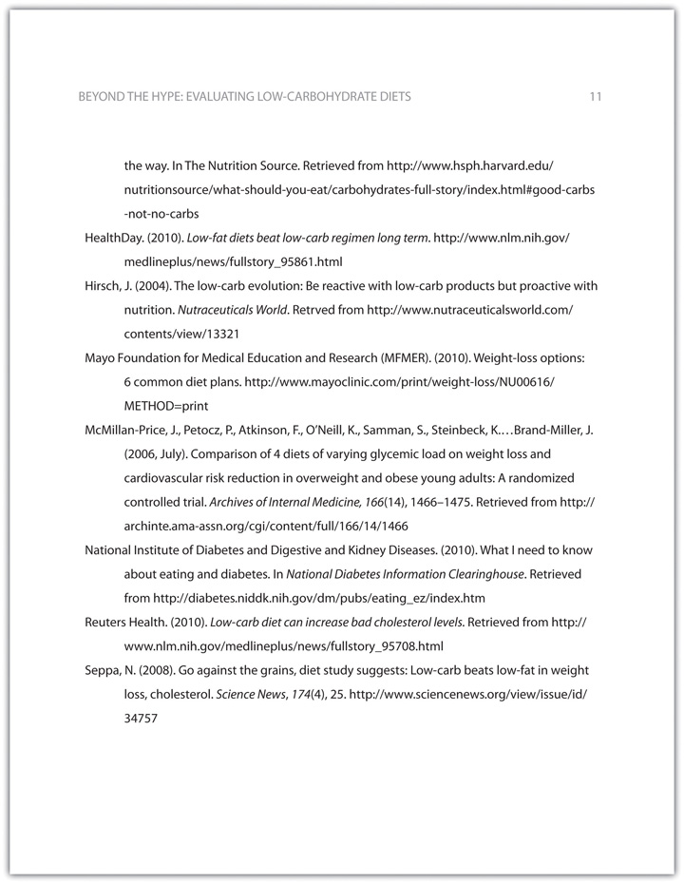
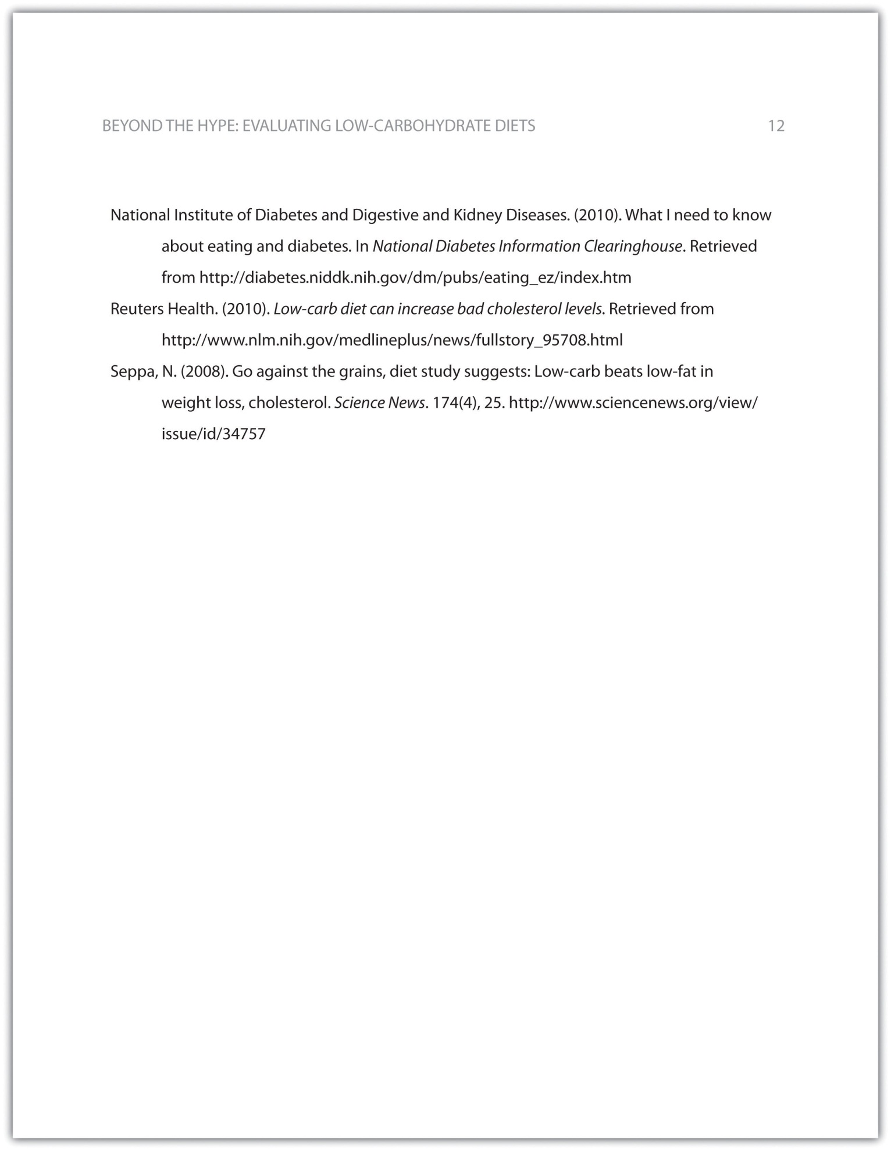

Tip
In APA style, book and article titles are formatted in sentence case, not title case. Sentence case means that only the first word is capitalized, along with any proper nouns.

Key Takeaways
- Following proper citation and formatting guidelines helps writers ensure that their work will be taken seriously, give proper credit to other authors for their work, and provide valuable information to readers.
- Working ahead and taking care to cite sources correctly the first time are ways writers can save time during the editing stage of writing a research paper.
- APA papers usually include an abstract that concisely summarizes the paper.
- APA papers use a specific headings structure to provide a clear hierarchy of information.
- In APA papers, in-text citations usually include the name(s) of the author(s) and the year of publication.
- In-text citations correspond to entries in the references section, which provide detailed bibliographical information about a source.

14.2 Citing and Referencing Techniques

Learning Objective
- Apply American Psychological Association (APA) style formatting guidelines for citations.
This section covers the nitty-gritty details of in-text citations. You will learn how to format citations for different types of source materials, whether you are citing brief quotations, paraphrasing ideas, or quoting longer passages. You will also learn techniques you can use to introduce quoted and paraphrased material effectively. Keep this section handy as a reference to consult while writing the body of your paper.

Formatting Cited Material: The Basics
As noted in previous sections of this book, in-text citations usually provide the name of the author(s) and the year the source was published. For direct quotations, the page number must also be included. Use past-tense verbs when introducing a quote—“Smith found…” and not “Smith finds.…”

Formatting Brief Quotations
For brief quotations—fewer than forty words—use quotation marks to indicate where the quoted material begins and ends, and cite the name of the author(s), the year of publication, and the page number where the quotation appears in your source. Remember to include commas to separate elements within the parenthetical citation. Also, avoid redundancy. If you name the author(s) in your sentence, do not repeat the name(s) in your parenthetical citation. Review following the examples of different ways to cite direct quotations.
Chang (2008) emphasized that “engaging in weight-bearing exercise consistently is one of the single best things women can do to maintain good health” (p. 49).
The author’s name can be included in the body of the sentence or in the parenthetical citation. Note that when a parenthetical citation appears at the end of the sentence, it comes after the closing quotation marks and before the period. The elements within parentheses are separated by commas.
Weight Training for Women (Chang, 2008) claimed that “engaging in weight-bearing exercise consistently is one of the single best things women can do to maintain good health” (p. 49).
Weight Training for Women claimed that “engaging in weight-bearing exercise consistently is one of the single best things women can do to maintain good health” (Chang, 2008, p. 49).
Including the title of a source is optional.
In Chang’s 2008 text Weight Training for Women, she asserts, “Engaging in weight-bearing exercise is one of the single best things women can do to maintain good health” (p. 49).
The author’s name, the date, and the title may appear in the body of the text. Include the page number in the parenthetical citation. Also, notice the use of the verb asserts to introduce the direct quotation.
“Engaging in weight-bearing exercise,” Chang asserts, “is one of the single best things women can do to maintain good health” (2008, p. 49).
You may begin a sentence with the direct quotation and add the author’s name and a strong verb before continuing the quotation.

Formatting Paraphrased and Summarized Material
When you paraphrase or summarize ideas from a source, you follow the same guidelines previously provided, except that you are not required to provide the page number where the ideas are located. If you are summing up the main findings of a research article, simply providing the author’s name and publication year may suffice, but if you are paraphrasing a more specific idea, consider including the page number.
Read the following examples.
Chang (2008) pointed out that weight-bearing exercise has many potential benefits for women.
Here, the writer is summarizing a major idea that recurs throughout the source material. No page reference is needed.
Chang (2008) found that weight-bearing exercise could help women maintain or even increase bone density through middle age and beyond, reducing the likelihood that they will develop osteoporosis in later life (p. 86).
Although the writer is not directly quoting the source, this passage paraphrases a specific detail, so the writer chose to include the page number where the information is located.

Tip
Although APA style guidelines do not require writers to provide page numbers for material that is not directly quoted, your instructor may wish you to do so when possible.
Check with your instructor about his or her preferences.

Formatting Longer Quotations
When you quote a longer passage from a source—forty words or more—use a different format to set off the quoted material. Instead of using quotation marks, create a block quotation by starting the quotation on a new line and indented five spaces from the margin. Note that in this case, the parenthetical citation comes after the period that ends the sentence. Here is an example:
In recent years, many writers within the fitness industry have emphasized the ways in which women can benefit from weight-bearing exercise, such as weightlifting, karate, dancing, stair climbing, hiking, and jogging. Chang (2008) found that engaging in weight-bearing exercise regularly significantly reduces women’s risk of developing osteoporosis. Additionally, these exercises help women maintain muscle mass and overall strength, and many common forms of weight-bearing exercise, such as brisk walking or stair climbing, also provide noticeable cardiovascular benefits. (p. 93)

Exercise 1
Review the places in your paper where you cited, quoted, and paraphrased material from a source with a single author. Edit your citations to ensure that
- each citation includes the author’s name, the date of publication, and, where appropriate, a page reference;
- parenthetical citations are correctly formatted;
- longer quotations use the block-quotation format.
If you are quoting a passage that continues into a second paragraph, indent five spaces again in the first line of the second paragraph. Here is an example:
In recent years, many writers within the fitness industry have emphasized the ways in which women can benefit from weight-bearing exercise, such as weightlifting, karate, dancing, stair climbing, hiking, and jogging. Chang (2008) found that engaging in weight-bearing exercise regularly significantly reduces women’s risk of developing osteoporosis. Additionally, these exercises help women maintain muscle mass and overall strength, and many common forms of weight-bearing exercise, such as brisk walking or stair climbing, also provide noticeable cardiovascular benefits.
It is important to note that swimming cannot be considered a weight-bearing exercise, since the water supports and cushions the swimmer. That doesn’t mean swimming isn’t great exercise, but it should be considered one part of an integrated fitness program. (p. 93)

Tip
Be wary of quoting from sources at length. Remember, your ideas should drive the paper, and quotations should be used to support and enhance your points. Make sure any lengthy quotations that you include serve a clear purpose. Generally, no more than 10–15 percent of a paper should consist of quoted material.

Introducing Cited Material Effectively
Including an introductory phrase in your text, such as “Jackson wrote” or “Copeland found,” often helps you integrate source material smoothly. This citation technique also helps convey that you are actively engaged with your source material. Unfortunately, during the process of writing your research paper, it is easy to fall into a rut and use the same few dull verbs repeatedly, such as “Jones said,” “Smith stated,” and so on.
Punch up your writing by using strong verbs that help your reader understand how the source material presents ideas. There is a world of difference between an author who “suggests” and one who “claims,” one who “questions” and one who “criticizes.” You do not need to consult your thesaurus every time you cite a source, but do think about which verbs will accurately represent the ideas and make your writing more engaging. The following chart shows some possibilities.
Strong Verbs for Introducing Cited Material
ask | suggest | question
explain | assert | claim
recommend | compare | contrast
propose | hypothesize | believe
insist | argue | find
determine | measure | assess
evaluate | conclude | study
warn | point out | sum up

Exercise 2
Review the citations in your paper once again. This time, look for places where you introduced source material using a signal phrase in your sentence.
- Highlight the verbs used in your signal phrases, and make note of any that seem to be overused throughout the paper.
- Identify at least three places where a stronger verb could be used.
- Make the edits to your draft.

Writing at Work
It is important to accurately represent a colleague’s ideas or communications in the workplace. When writing professional or academic papers, be mindful of how the words you use to describe someone’s tone or ideas carry certain connotations. Do not say a source argues a particular point unless an argument is, in fact, presented. Use lively language, but avoid language that is emotionally charged. Doing so will ensure you have represented your colleague’s words in an authentic and accurate way.

Formatting In-Text Citations for Other Source Types
These sections discuss the correct format for various types of in-text citations. Read them through quickly to get a sense of what is covered, and then refer to them again as needed.

Print Sources
This section covers books, articles, and other print sources with one or more authors.

A Work by One Author
For a print work with one author, follow the guidelines provided in Chapter 14 "APA and MLA Documentation and Formatting", Section 14.1 "Formatting a Research Paper". Always include the author’s name and year of publication. Include a page reference whenever you quote a source directly. (See also the guidelines presented earlier in this chapter about when to include a page reference for paraphrased material.)
Chang (2008) emphasized that “engaging in weight-bearing exercise consistently is one of the single best things women can do to maintain good health” (p. 49).
Chang (2008) pointed out that weight-bearing exercise has many potential benefits for women.

Two or More Works by the Same Author
At times, your research may include multiple works by the same author. If the works were published in different years, a standard in-text citation will serve to distinguish them. If you are citing multiple works by the same author published in the same year, include a lowercase letter immediately after the year. Rank the sources in the order they appear in your references section. The source listed first includes an a after the year, the source listed second includes a b, and so on.
Rodriguez (2009a) criticized the nutrition-supplement industry for making unsubstantiated and sometimes misleading claims about the benefits of taking supplements. Additionally, he warned that consumers frequently do not realize the potential harmful effects of some popular supplements (Rodriguez, 2009b).

Tip
If you have not yet created your references section, you may not be sure which source will appear first. See Chapter 14 "APA and MLA Documentation and Formatting", Section 14.3 "Creating a References Section" for guidelines—or assign each source a temporary code and highlight the in-text citations so you remember to double-check them later on.

Works by Authors with the Same Last Name
If you are citing works by different authors with the same last name, include each author’s initials in your citation, whether you mention them in the text or in parentheses. Do so even if the publication years are different.
J. S. Williams (2007) believes nutritional supplements can be a useful part of some diet and fitness regimens. C. D. Williams (2008), however, believes these supplements are overrated.
According to two leading researchers, the rate of childhood obesity exceeds the rate of adult obesity (K. Connelley, 2010; O. Connelley, 2010).
Studies from both A. Wright (2007) and C. A. Wright (2008) confirm the benefits of diet and exercise on weight loss.

A Work by Two Authors
When two authors are listed for a given work, include both authors’ names each time you cite the work. If you are citing their names in parentheses, use an ampersand (&) between them. (Use the word and, however, if the names appear in your sentence.)
As Garrison and Gould (2010) pointed out, “It is never too late to quit smoking. The health risks associated with this habit begin to decrease soon after a smoker quits” (p. 101).
As doctors continue to point out, “It is never too late to quit smoking. The health risks associated with this habit begin to decrease soon after a smoker quits” (Garrison & Gould, 2010, p. 101).

A Work by Three to Five Authors
If the work you are citing has three to five authors, list all the authors’ names the first time you cite the source. In subsequent citations, use the first author’s name followed by the abbreviation et al. (Et al. is short for et alia, the Latin phrase for “and others.”)
Henderson, Davidian, and Degler (2010) surveyed 350 smokers aged 18 to 30.
One survey, conducted among 350 smokers aged 18 to 30, included a detailed questionnaire about participants’ motivations for smoking (Henderson, Davidian, & Degler, 2010).
Note that these examples follow the same ampersand conventions as sources with two authors. Again, use the ampersand only when listing authors’ names in parentheses.
As Henderson et al. (2010) found, some young people, particularly young women, use smoking as a means of appetite suppression.
Disturbingly, some young women use smoking as a means of appetite suppression (Henderson et al., 2010).
Note how the phrase et al. is punctuated. No period comes after et, but al. gets a period because it is an abbreviation for a longer Latin word. In parenthetical references, include a comma after et al. but not before. Remember this rule by mentally translating the citation to English: “Henderson and others, 2010.”

A Work by Six or More Authors
If the work you are citing has six or more authors, list only the first author’s name, followed by et al., in your in-text citations. The other authors’ names will be listed in your references section.
Researchers have found that outreach work with young people has helped reduce tobacco use in some communities (Costello et al., 2007).

A Work Authored by an Organization
When citing a work that has no individual author(s) but is published by an organization, use the organization’s name in place of the author’s name. Lengthy organization names with well-known abbreviations can be abbreviated. In your first citation, use the full name, followed by the abbreviation in square brackets. Subsequent citations may use the abbreviation only.
It is possible for a patient to have a small stroke without even realizing it (American Heart Association [AHA], 2010).
Another cause for concern is that even if patients realize that they have had a stroke and need medical attention, they may not know which nearby facilities are best equipped to treat them (AHA, 2010).

Exercise 3
- Review the places in your paper where you cited material from a source with multiple authors or with an organization as the author. Edit your citations to ensure that each citation follows APA guidelines for the inclusion of the authors’ names, the use of ampersands and et al., the date of publication, and, where appropriate, a page reference.
- Mark any additional citations within your paper that you are not sure how to format based on the guidelines provided so far. You will revisit these citations after reading the next few sections.

A Work with No Listed Author
If no author is listed and the source cannot be attributed to an organization, use the title in place of the author’s name. You may use the full title in your sentence or use the first few words—enough to convey the key ideas—in a parenthetical reference. Follow standard conventions for using italics or quotations marks with titles:
- Use italics for titles of books or reports.
- Use quotation marks for titles of articles or chapters.
“Living With Diabetes: Managing Your Health” (2009) recommends regular exercise for patients with diabetes.
Regular exercise can benefit patients with diabetes (“Living with Diabetes,” 2009).
Rosenhan (1973) had mentally healthy study participants claim to be experiencing hallucinations so they would be admitted to psychiatric hospitals.

A Work Cited within Another Work
To cite a source that is referred to within another secondary source, name the first source in your sentence. Then, in parentheses, use the phrase as cited in and the name of the second source author.
Rosenhan’s study “On Being Sane in Insane Places” (as cited in Spitzer, 1975) found that psychiatrists diagnosed schizophrenia in people who claimed to be experiencing hallucinations and sought treatment—even though these patients were, in fact, imposters.

Two or More Works Cited in One Reference
At times, you may provide more than one citation in a parenthetical reference, such as when you are discussing related works or studies with similar results. List the citations in the same order they appear in your references section, and separate the citations with a semicolon.
Some researchers have found serious flaws in the way Rosenhan’s study was conducted (Dawes, 2001; Spitzer, 1975).
Both of these researchers authored works that support the point being made in this sentence, so it makes sense to include both in the same citation.

A Famous Text Published in Multiple Editions
In some cases, you may need to cite an extremely well-known work that has been repeatedly republished or translated. Many works of literature and sacred texts, as well as some classic nonfiction texts, fall into this category. For these works, the original date of publication may be unavailable. If so, include the year of publication or translation for your edition. Refer to specific parts or chapters if you need to cite a specific section. Discuss with your instructor whether he or she would like you to cite page numbers in this particular instance.
In New Introductory Lectures on Psycho-Analysis, Freud explains that the “manifest content” of a dream—what literally takes place—is separate from its “latent content,” or hidden meaning (trans. 1965, lecture XXIX).
Here, the student is citing a classic work of psychology, originally written in German and later translated to English. Since the book is a collection of Freud’s lectures, the student cites the lecture number rather than a page number.

An Introduction, Foreword, Preface, or Afterword
To cite an introduction, foreword, preface, or afterword, cite the author of the material and the year, following the same format used for other print materials.

Electronic Sources
Whenever possible, cite electronic sources as you would print sources, using the author, the date, and where appropriate, a page number. For some types of electronic sources—for instance, many online articles—this information is easily available. Other times, however, you will need to vary the format to reflect the differences in online media.

Online Sources without Page Numbers
If an online source has no page numbers but you want to refer to a specific portion of the source, try to locate other information you can use to direct your reader to the information cited. Some websites number paragraphs within published articles; if so, include the paragraph number in your citation. Precede the paragraph number with the abbreviation for the word paragraph and the number of the paragraph (e.g., para. 4).
As researchers have explained, “Incorporating fresh fruits and vegetables into one’s diet can be a challenge for residents of areas where there are few or no easily accessible supermarkets” (Smith & Jones, 2006, para. 4).
Even if a source does not have numbered paragraphs, it is likely to have headings that organize the content. In your citation, name the section where your cited information appears, followed by a paragraph number.
The American Lung Association (2010) noted, “After smoking, radon exposure is the second most common cause of lung cancer” (What Causes Lung Cancer? section, para. 2).
This student cited the appropriate section heading within the website and then counted to find the specific paragraph where the cited information was located.
If an online source has no listed author and no date, use the source title and the abbreviation n.d. in your parenthetical reference.
It has been suggested that electromagnetic radiation from cellular telephones may pose a risk for developing certain cancers (“Cell Phones and Cancer,” n.d.).

Personal Communication
For personal communications, such as interviews, letters, and e-mails, cite the name of the person involved, clarify that the material is from a personal communication, and provide the specific date the communication took place. Note that while in-text citations correspond to entries in the references section, personal communications are an exception to this rule. They are cited only in the body text of your paper.
J. H. Yardley, M.D., believes that available information on the relationship between cell phone use and cancer is inconclusive (personal communication, May 1, 2009).

Writing at Work
At work, you may sometimes share information resources with your colleagues by photocopying an interesting article or forwarding the URL of a useful website. Your goal in these situations and in formal research citations is the same. The goal is to provide enough information to help your professional peers locate and follow up on potentially useful information. Provide as much specific information as possible to achieve that goal, and consult with your professor as to what specific style he or she may prefer.

Exercise 4
Revisit the problem citations you identified in Note 14.55 "Exercise 3"—for instance, sources with no listed author or other oddities. Review the guidelines provided in this section and edit your citations for these kinds of sources according to APA guidelines.

Key Takeaways
- In APA papers, in-text citations include the name of the author(s) and the year of publication whenever possible.
- Page numbers are always included when citing quotations. It is optional to include page numbers when citing paraphrased material; however, this should be done when citing a specific portion of a work.
- When citing online sources, provide the same information used for print sources if it is available.
- When a source does not provide information that usually appears in a citation, in-text citations should provide readers with alternative information that would help them locate the source material. This may include the title of the source, section headings and paragraph numbers for websites, and so forth.
- When writing a paper, discuss with your professor what particular standards he or she would like you to follow.

14.3 Creating a References Section

Learning Objective
- Apply American Psychological Association (APA) style and formatting guidelines for a references section.
This section provides detailed information about how to create the references section of your paper. You will review basic formatting guidelines and learn how to format bibliographical entries for various types of sources. This section of Chapter 14 "APA and MLA Documentation and Formatting", like the previous section, is meant to be used as a reference tool while you write.

Formatting the References Section: The Basics
At this stage in the writing process, you may already have begun setting up your references section. This section may consist of a single page for a brief research paper or may extend for many pages in professional journal articles. As you create this section of your paper, follow the guidelines provided here.

Formatting the References Section
To set up your references section, use the insert page break feature of your word-processing program to begin a new page. Note that the header and margins will be the same as in the body of your paper, and pagination continues from the body of your paper. (In other words, if you set up the body of your paper correctly, the correct header and page number should appear automatically in your references section.) See additional guidelines below.

Formatting Reference Entries
Reference entries should include the following information:
- The name of the author(s)
- The year of publication and, where applicable, the exact date of publication
- The full title of the source
- For books, the city of publication
- For articles or essays, the name of the periodical or book in which the article or essay appears
- For magazine and journal articles, the volume number, issue number, and pages where the article appears
- For sources on the web, the URL where the source is located
See the following examples for how to format a book or journal article with a single author.

Sample Book Entry
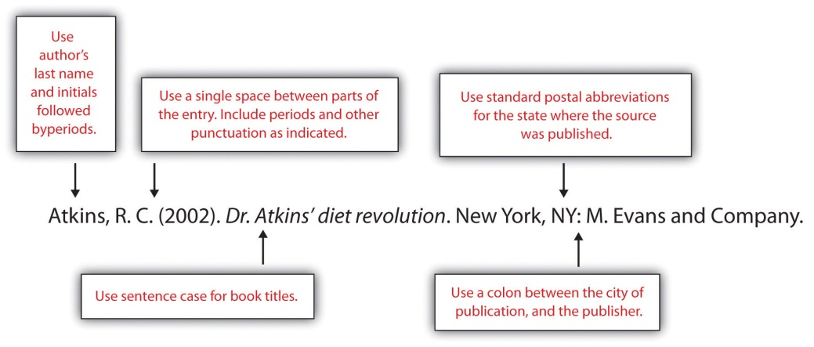

Sample Journal Article Entry
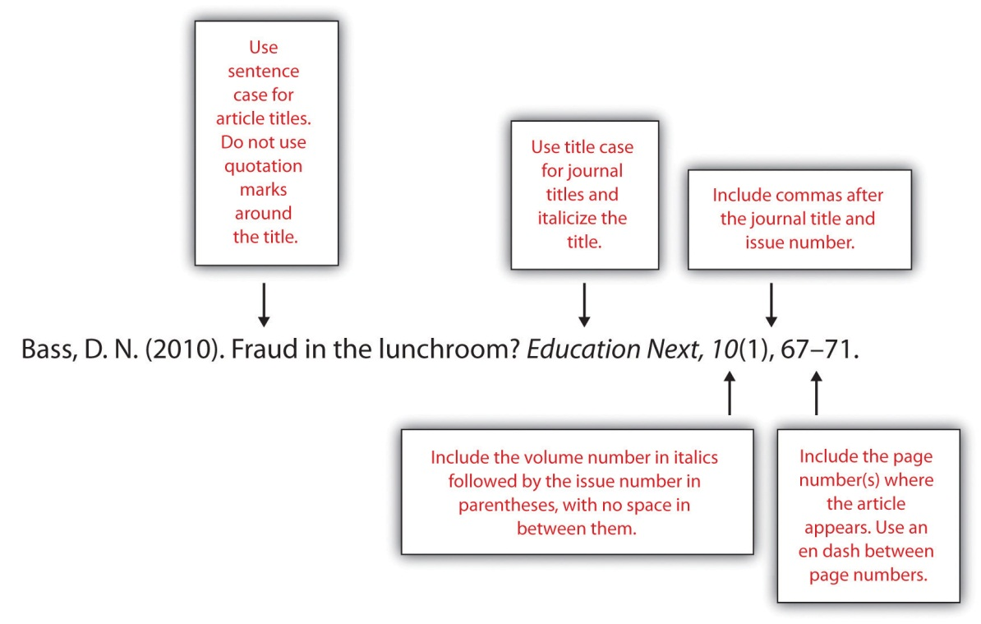
The following box provides general guidelines for formatting the reference page. For the remainder of this chapter, you will learn about how to format bibliographical entries for different source types, including multiauthor and electronic sources.

Formatting the References Section: APA General Guidelines
- Include the heading References, centered at the top of the page. The heading should not be boldfaced, italicized, or underlined.
- Use double-spaced type throughout the references section, as in the body of your paper.
- Use hanging indentation for each entry. The first line should be flush with the left margin, while any lines that follow should be indented five spaces. Note that hanging indentation is the opposite of normal indenting rules for paragraphs.
- List entries in alphabetical order by the author’s last name. For a work with multiple authors, use the last name of the first author listed.
- List authors’ names using this format: Smith, J. C.
- For a work with no individual author(s), use the name of the organization that published the work or, if this is unavailable, the title of the work in place of the author’s name.
- For works with multiple authors, follow these guidelines:
  - For works with up to seven authors, list the last name and initials for each author.
  - For works with more than seven authors, list the first six names, followed by ellipses, and then the name of the last author listed.
  - Use an ampersand before the name of the last author listed.
- Use title case for journal titles. Capitalize all important words in the title.
- Use sentence case for all other titles—books, articles, web pages, and other source titles. Capitalize the first word of the title. Do not capitalize any other words in the title except for the following:
  - Proper nouns
  - First word of a subtitle
  - First word after a colon or dash
- Use italics for book and journal titles. Do not use italics, underlining, or quotation marks for titles of shorter works, such as articles.

Exercise 1
Set up the first page of your references section and begin adding entries, following the APA formatting guidelines provided in this section.
- If there are any simple entries that you can format completely using the general guidelines, do so at this time.
- For entries you are unsure of how to format, type in as much information as you can, and highlight the entries so you can return to them later.

Formatting Reference Entries for Different Source Types
As is the case for in-text citations, formatting reference entries becomes more complicated when you are citing a source with multiple authors, citing various types of online media, or citing sources for which you must provide additional information beyond the basics listed in the general guidelines. The following guidelines show how to format reference entries for these different situations.

Print Sources: Books
For book-length sources and shorter works that appear in a book, follow the guidelines that best describes your source.

A Book by Two or More Authors
List the authors’ names in the order they appear on the book’s title page. Use an ampersand before the last author’s name.
Campbell, D. T., & Stanley, J. C. (1963). Experimental and quasi-experimental designs for research. Boston, MA: Houghton Mifflin.

An Edited Book with No Author
List the editor or editors’ names in place of the author’s name, followed by Ed. or Eds. in parentheses.
Myers, C., & Reamer, D. (Eds.). (2009). 2009 nutrition index. San Francisco, CA: HealthSource, Inc.

An Edited Book with an Author
List the author’s name first, followed by the title and the editor or editors. Note that when the editor is listed after the title, you list the initials before the last name.
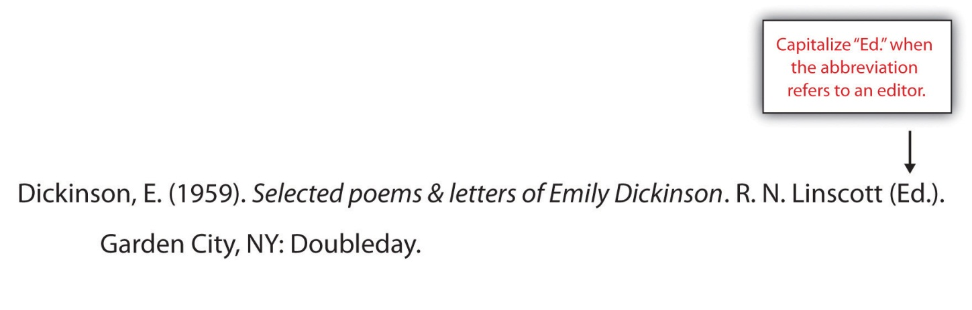

Tip
The previous example shows the format used for an edited book with one author—for instance, a collection of a famous person’s letters that has been edited. This type of source is different from an anthology, which is a collection of articles or essays by different authors. For citing works in anthologies, see the guidelines later in this section.

A Translated Book
Include the translator’s name after the title, and at the end of the citation, list the date the original work was published. Note that for the translator’s name, you list the initials before the last name.
Freud, S. (1965). New introductory lectures on psycho-analysis (J. Strachey, Trans.). New York, NY: W. W. Norton. (Original work published 1933).

A Book Published in Multiple Editions
If you are using any edition other than the first edition, include the edition number in parentheses after the title.
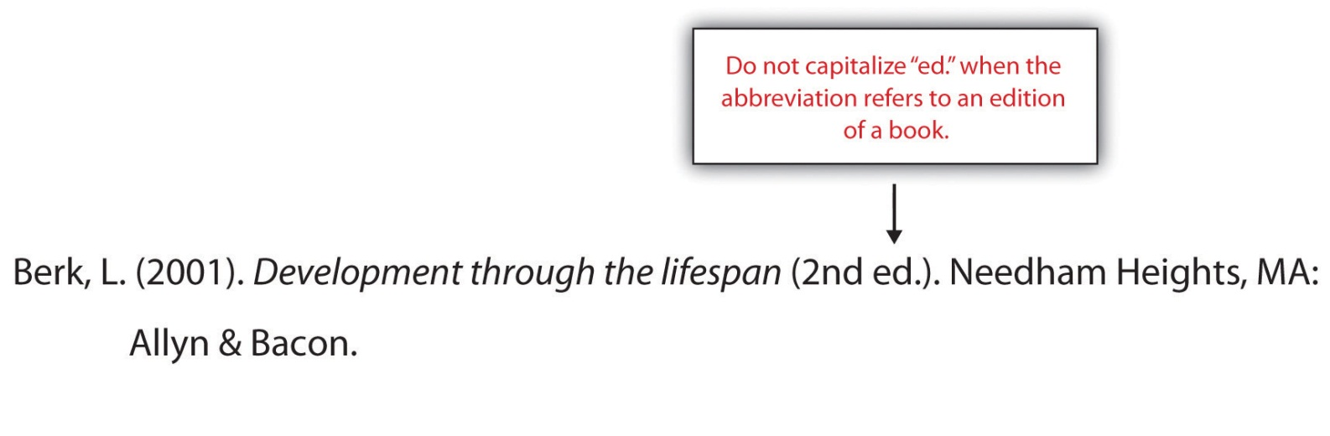

A Chapter in an Edited Book
List the name of the author(s) who wrote the chapter, followed by the chapter title. Then list the names of the book editor(s) and the title of the book, followed by the page numbers for the chapter and the usual information about the book’s publisher.
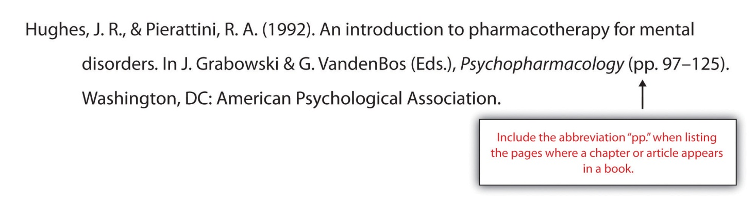

A Work That Appears in an Anthology
Follow the same process you would use to cite a book chapter, substituting the article or essay title for the chapter title.
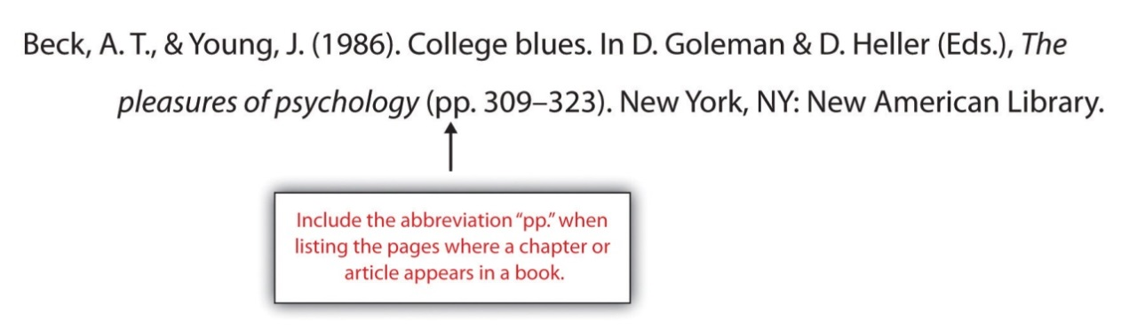

An Article in a Reference Book
List the author’s name if available; if no author is listed, provide the title of the entry where the author’s name would normally be listed. If the book lists the name of the editor(s), include it in your citation. Indicate the volume number (if applicable) and page numbers in parentheses after the article title.
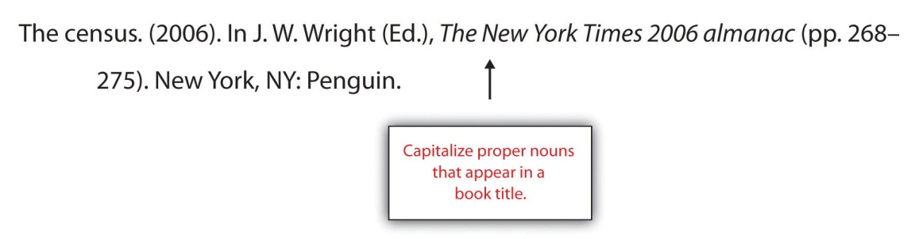

Two or More Books by the Same Author
List the entries in order of their publication year, beginning with the work published first.
Swedan, N. (2001). Women’s sports medicine and rehabilitation. Gaithersburg, MD: Aspen Publishers.
Swedan, N. (2003). The active woman’s health and fitness handbook. New York, NY: Perigee.
If two books have multiple authors, and the first author is the same but the others are different, alphabetize by the second author’s last name (or the third or fourth, if necessary).
Carroll, D., & Aaronson, F. (2008). Managing type II diabetes. Chicago, IL: Southwick Press.
Carroll, D., & Zuckerman, N. (2008). Gestational diabetes. Chicago, IL: Southwick Press.

Books by Different Authors with the Same Last Name
Alphabetize entries by the authors’ first initial.
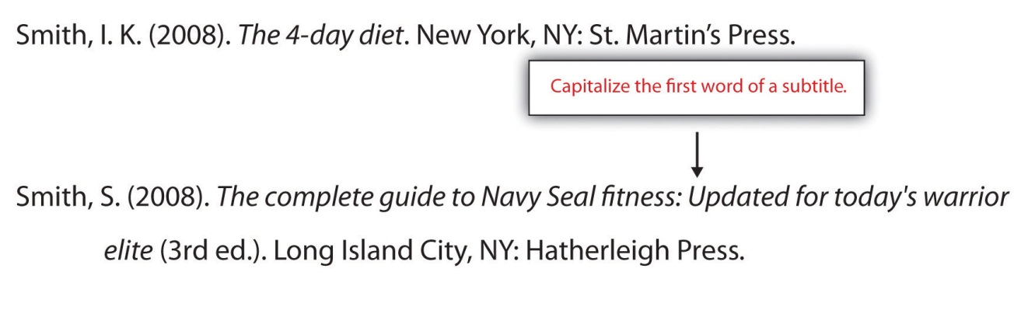

A Book Authored by an Organization
Treat the organization name as you would an author’s name. For the purposes of alphabetizing, ignore words like The in the organization’s name. (That is, a book published by the American Heart Association would be listed with other entries whose authors’ names begin with A.)
American Psychiatric Association. (1994). Diagnostic and statistical manual of mental disorders DSM-IV (4th ed.). Arlington, VA: American Psychiatric Publishing.

A Book-Length Report
Format technical and research reports as you would format other book-length sources. If the organization that issued the report assigned it a number, include the number in parentheses after the title. (See also the guidelines provided for citing works produced by government agencies.)
Jameson, R., & Dewey, J. (2009). Preliminary findings from an evaluation of the president’s physical fitness program in Pleasantville school district. Pleasantville, WA: Pleasantville Board of Education.

A Book Authored by a Government Agency
Treat these as you would a book published by a nongovernment organization, but be aware that these works may have an identification number listed. If so, include it in parentheses after the publication year.
U.S. Census Bureau. (2002). The decennial censuses from 1790 to 2000 (Publication No. POL/02-MA). Washington, DC: US Government Printing Offices.

Exercise 2
Revisit the references section you began to compile in Note 14.73 "Exercise 1". Use the guidelines provided to format any entries for book-length print sources that you were unable to finish earlier.
Review how Jorge formatted these book-length print sources:
Atkins, R. C. (2002). Dr. Atkins’ diet revolution. New York, NY: M. Evans and Company.
Agatson, A. (2003). The South Beach diet. New York, NY: St. Martin’s Griffin.

Print Sources: Periodicals

An Article in a Scholarly Journal
Include the following information:
- Author or authors’ names
- Publication year
- Article title (in sentence case, without quotation marks or italics)
- Journal title (in title case and in italics)
- Volume number (in italics)
- Issue number (in parentheses)
- Page number(s) where the article appears
DeMarco, R. F. (2010). Palliative care and African American women living with HIV. Journal of Nursing Education, 49(5), 1–4.

An Article in a Journal Paginated by Volume
In these types of journals, page numbers for one volume continue across all the issues in that volume. For instance, the winter issue may begin with page 1, and in the spring issue that follows, the page numbers pick up where the previous issue left off. (If you have ever wondered why a print journal did not begin on page 1, or wondered why the page numbers of a journal extend into four digits, this is why.) Omit the issue number from your reference entry.
Wagner, J. (2009). Rethinking school lunches: A review of recent literature. American School Nurses’ Journal, 47, 1123–1127.

An Abstract of a Scholarly Article
At times you may need to cite an abstract—the summary that appears at the beginning—of a published article. If you are citing the abstract only, and it was published separately from the article, provide the following information:
- Publication information for the article
- Information about where the abstract was published (for instance, another journal or a collection of abstracts)
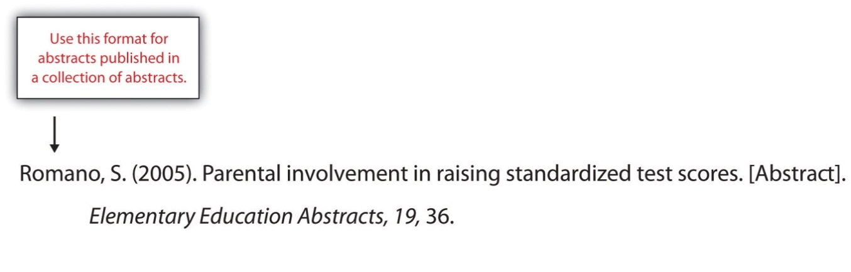
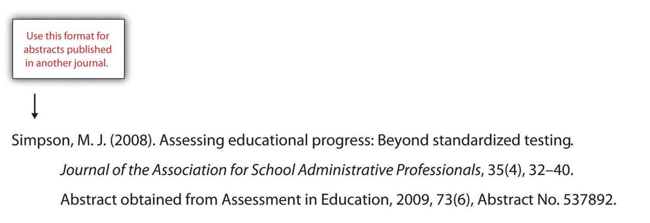

A Journal Article with Two to Seven Authors
List all the authors’ names in the order they appear in the article. Use an ampersand before the last name listed.
Barker, E. T., & Bornstein, M. H. (2010). Global self-esteem, appearance satisfaction, and self-reported dieting in early adolescence. Journal of Early Adolescence, 30(2), 205–224.
Tremblay, M. S., Shields, M., Laviolette, M., Craig, C. L., Janssen, I., & Gorber, S. C. (2010). Fitness of Canadian children and youth: Results from the 2007–2009 Canadian Health Measures Survey. Health Reports, 21(1), 7–20.

A Journal Article with More Than Seven Authors
List the first six authors’ names, followed by a comma, an ellipsis, and the name of the last author listed. The article in the following example has sixteen listed authors; the reference entry lists the first six authors and the sixteenth, omitting the seventh through the fifteenth.
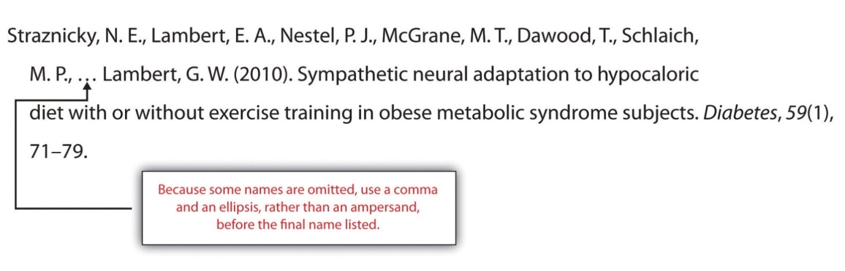

Writing at Work
The idea of an eight-page article with sixteen authors may seem strange to you—especially if you are in the midst of writing a ten-page research paper on your own. More often than not, articles in scholarly journals list multiple authors. Sometimes, the authors actually did collaborate on writing and editing the published article. In other instances, some of the authors listed may have contributed to the research in some way while being only minimally involved in the process of writing the article. Whenever you collaborate with colleagues to produce a written product, follow your profession’s conventions for giving everyone proper credit for their contribution.

A Magazine Article
After the publication year, list the issue date. Otherwise, treat these as you would journal articles. List the volume and issue number if both are available.
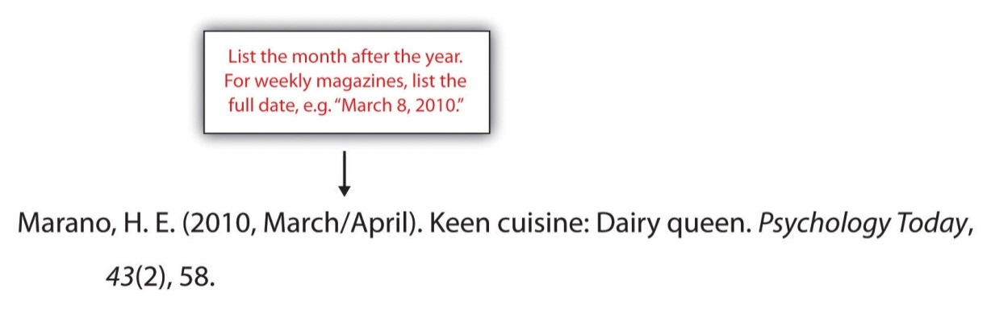

A Newspaper Article
Treat these as you would magazine and journal articles, with one important difference: precede the page number(s) with the abbreviation p. (for a single-page article) or pp. (for a multipage article). For articles whose pagination is not continuous, list all the pages included in the article. For example, an article that begins on page A1 and continues on pages A4 would have the page reference A1, A4. An article that begins on page A1 and continues on pages A4 and A5 would have the page reference A1, A4–A5.
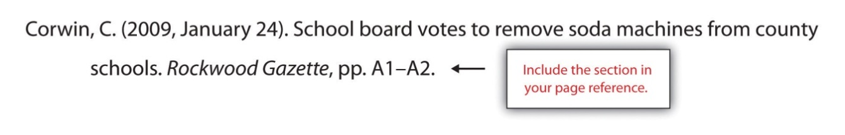

A Letter to the Editor
After the title, indicate in brackets that the work is a letter to the editor.
Jones, J. (2009, January 31). Food police in our schools [Letter to the editor]. Rockwood Gazette, p. A8.

A Review
After the title, indicate in brackets that the work is a review and state the name of the work being reviewed. (Note that even if the title of the review is the same as the title of the book being reviewed, as in the following example, you should treat it as an article title. Do not italicize it.)
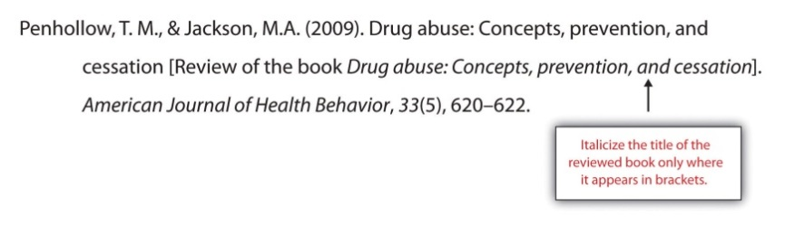

Exercise 3
Revisit the references section you began to compile in Note 14.73 "Exercise 1". Use the guidelines provided above to format any entries for periodicals and other shorter print sources that you were unable to finish earlier.

Electronic Sources

Citing Articles from Online Periodicals: URLs and Digital Object Identifiers (DOIs)
Whenever you cite online sources, it is important to provide the most up-to-date information available to help readers locate the source. In some cases, this means providing an article’s URL, or web address. (The letters URL stand for uniform resource locator.) Always provide the most complete URL possible. Provide a link to the specific article used, rather than a link to the publication’s homepage.
As you know, web addresses are not always stable. If a website is updated or reorganized, the article you accessed in April may move to a different location in May. The URL you provided may become a dead link. For this reason, many online periodicals, especially scholarly publications, now rely on DOIs rather than URLs to keep track of articles.
A DOI is a Digital Object Identifier—an identification code provided for some online documents, typically articles in scholarly journals. Like a URL, its purpose is to help readers locate an article. However, a DOI is more stable than a URL, so it makes sense to include it in your reference entry when possible. Follow these guidelines:
- If you are citing an online article with a DOI, list the DOI at the end of the reference entry.
- If the article appears in print as well as online, you do not need to provide the URL. However, include the words Electronic version after the title in brackets.
- In other respects, treat the article as you would a print article. Include the volume number and issue number if available. (Note, however, that these may not be available for some online periodicals).

An Article from an Online Periodical with a DOI
List the DOI if one is provided. There is no need to include the URL if you have listed the DOI.
Bell, J. R. (2006). Low-carb beats low-fat diet for early losses but not long term. OBGYN News, 41(12), 32. doi:10.1016/S0029-7437(06)71905-X

An Article from an Online Periodical with No DOI
List the URL. Include the volume and issue number for the periodical if this information is available. (For some online periodicals, it may not be.)
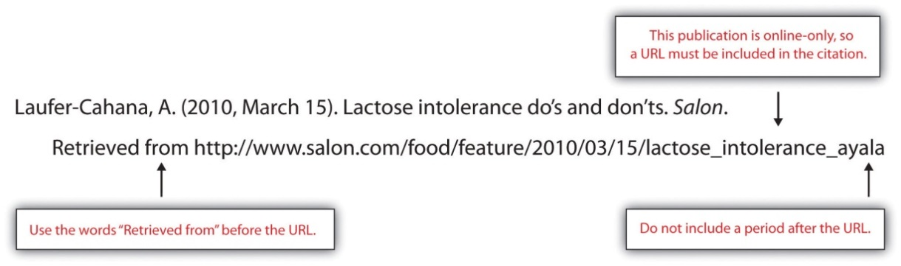
Note that if the article appears in a print version of the publication, you do not need to list the URL, but do indicate that you accessed the electronic version.
Robbins, K. (2010, March/April). Nature’s bounty: A heady feast [Electronic version]. Psychology Today, 43(2), 58.

A Newspaper Article
Provide the URL of the article.
McNeil, D. G. (2010, May 3). Maternal health: A new study challenges benefits of vitamin A for women and babies. The New York Times. Retrieved from http://www.nytimes.com/2010/05/04/health/04glob.html?ref=health

An Article Accessed through a Database
Cite these articles as you would normally cite a print article. Provide database information only if the article is difficult to locate.

Tip
APA style does not require writers to provide the item number or accession number for articles retrieved from databases. You may choose to do so if the article is difficult to locate or the database is an obscure one. Check with your professor to see if this is something he or she would like you to include.

An Abstract of an Article
Format these as you would an article citation, but add the word Abstract in brackets after the title.
Bradley, U., Spence, M., Courtney, C. H., McKinley, M. C., Ennis, C. N., McCance, D. R.…Hunter, S. J. (2009). Low-fat versus low-carbohydrate weight reduction diets: Effects on weight loss, insulin resistance, and cardiovascular risk: A randomized control trial [Abstract]. Diabetes, 58(12), 2741–2748. http://diabetes.diabetesjournals.org/content/early/2009/08/23/db00098.abstract

A Nonperiodical Web Document
The ways you cite different nonperiodical web documents may vary slightly from source to source, depending on the information that is available. In your citation, include as much of the following information as you can:
- Name of the author(s), whether an individual or organization
- Date of publication (Use n.d. if no date is available.)
- Title of the document
- Address where you retrieved the document
If the document consists of more than one web page within the site, link to the homepage or the entry page for the document.
American Heart Association. (2010). Heart attack, stroke, and cardiac arrest warning signs. Retrieved from http://www.americanheart.org/presenter.jhtml?identifier=3053

An Entry from an Online Encyclopedia or Dictionary
Because these sources often do not include authors’ names, you may list the title of the entry at the beginning of the citation. Provide the URL for the specific entry.
Addiction. (n.d.) In Merriam-Webster’s online dictionary. Retrieved from http://www.merriam-webster.com/dictionary/addiction

Data Sets
If you cite raw data compiled by an organization, such as statistical data, provide the URL where you retrieved the information. Provide the name of the organization that sponsors the site.
US Food and Drug Administration. (2009). Nationwide evaluation of X-ray trends: NEXT surveys performed [Data file]. Retrieved from http://www.fda.gov/Radiation-EmittingProducts/RadiationSafety/NationwideEvaluationofX- RayTrendsNEXT/ucm116508.htm

Graphic Data
When citing graphic data—such as maps, pie charts, bar graphs, and so on—include the name of the organization that compiled the information, along with the publication date. Briefly describe the contents in brackets. Provide the URL where you retrieved the information. (If the graphic is associated with a specific project or document, list it after your bracketed description of the contents.)
US Food and Drug Administration. (2009). [Pie charts showing the percentage breakdown of the FDA’s budget for fiscal year 2005]. 2005 FDA budget summary. Retrieved from mhttp://www.fda.gov/AboutFDA/ReportsManualsForms/Reports/BudgetReports/2005FDABudgetSummary/ucm117231.htm

An Online Interview (Audio File or Transcript)
List the interviewer, interviewee, and date. After the title, include bracketed text describing the interview as an “Interview transcript” or “Interview audio file,” depending on the format of the interview you accessed. List the name of the website and the URL where you retrieved the information. Use the following format.
Davies, D. (Interviewer), & Pollan, M. (Interviewee). (2008). Michael Pollan offers president food for thought [Interview transcript]. Retrieved from National Public Radio website: http://www.npr.org/templates/transcript/transcript.php?storyId=100755362

An Electronic Book
Electronic books may include books available as text files online or audiobooks. If an electronic book is easily available in print, cite it as you would a print source. If it is unavailable in print (or extremely difficult to find), use the format in the example. (Use the words Available from in your citation if the book must be purchased or is not available directly.)
Chisholm, L. (n.d.). Celtic tales. Retrieved from http://www.childrenslibrary.org/icdl/BookReader?bookid= chicelt_00150014&twoPage=false&route=text&size=0&fullscreen=false&pnum1=1&lang= English&ilang=English

A Chapter from an Online Book or a Chapter or Section of a Web Document
These are treated similarly to their print counterparts with the addition of retrieval information. Include the chapter or section number in parentheses after the book title.
Hart, A. M. (1895). Restoratives—Coffee, cocoa, chocolate. In Diet in sickness and in health (VI). Retrieved from http://www.archive.org/details/dietinsicknessin00hartrich

A Dissertation or Thesis from a Database
Provide the author, date of publication, title, and retrieval information. If the work is numbered within the database, include the number in parentheses at the end of the citation.
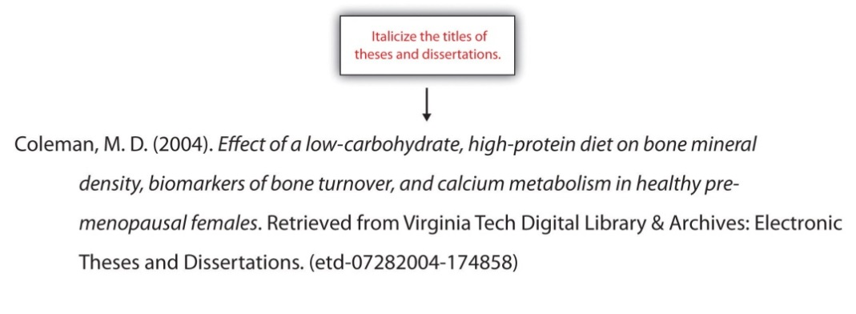

Computer Software
For commonly used office software and programming languages, it is not necessary to provide a citation. Cite software only when you are using a specialized program, such as the nutrition tracking software in the following example. If you download software from a website, provide the version and the year if available.
Internet Brands, Inc. (2009). FitDay PC (Version 2) [Software]. Available from http://www.fitday.com/Pc/PcHome.html?gcid=14

A Post on a Blog or Video Blog
Citation guidelines for these sources are similar to those used for discussion forum postings. Briefly describe the type of source in brackets after the title.
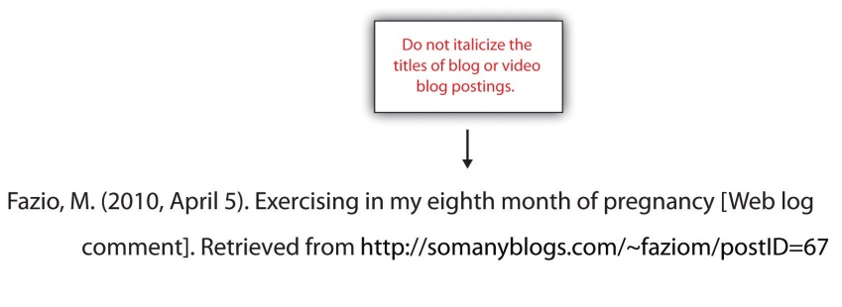

Writing at Work
Because the content may not be carefully reviewed for accuracy, discussion forums and blogs should not be relied upon as a major source of information. However, it may be appropriate to cite these sources for some types of research. You may also participate in discussion forums or comment on blogs that address topics of personal or professional interest. Always keep in mind that when you post, you are making your thoughts public—and in many cases, available through search engines. Make sure any posts that can easily be associated with your name are appropriately professional, because a potential employer could view them.

A Television or Radio Broadcast
Include the name of the producer or executive producer; the date, title, and type of broadcast; and the associated company and location.
West, Ty. (Executive producer). (2009, September 24). PBS special report: Health care reform [Television broadcast]. New York, NY, and Washington, DC: Public Broadcasting Service.

A Television or Radio Series or Episode
Include the producer and the type of series if you are citing an entire television or radio series.
Couture, D., Nabors, S., Pinkard, S., Robertson, N., & Smith, J. (Producers). (1979). The Diane Rehm show [Radio series]. Washington, DC: National Public Radio.
To cite a specific episode of a radio or television series, list the name of the writer or writers (if available), the date the episode aired, its title, and the type of series, along with general information about the series.
Bernanke, J., & Wade, C. (2010, January 10). Hummingbirds: Magic in the air [Television series episode]. In F. Kaufman (Executive producer), Nature. New York, NY: WNET.

A Motion Picture
Name the director or producer (or both), year of release, title, country of origin, and studio.
Spurlock, M. (Director/producer), Morley, J. (Executive producer), & Winters. H. M. (Executive producer). (2004). Super size me. United States: Kathbur Pictures in association with Studio on Hudson.

A Recording
Name the primary contributors and list their role. Include the recording medium in brackets after the title. Then list the location and the label.
Smith, L. W. (Speaker). (1999). Meditation and relaxation [CD]. New York, NY: Earth, Wind, & Sky Productions.
Székely, I. (Pianist), Budapest Symphony Orchestra (Performers), & Németh, G. (Conductor). (1988). Chopin piano concertos no. 1 and 2 [CD]. Hong Kong: Naxos.

A Podcast
Provide as much information as possible about the writer, director, and producer; the date the podcast aired; its title; any organization or series with which it is associated; and where you retrieved the podcast.
Kelsey, A. R. (Writer), Garcia, J. (Director), & Kim, S. C. (Producer). (2010, May 7). Lies food labels tell us. Savvy consumer podcasts [Audio podcast]. Retrieved from http://www.savvyconsumer.org/podcasts/050710

Exercise 4
Revisit the references section you began to compile in Note 14.73 "Exercise 1".
- Use the APA guidelines provided in this section to format any entries for electronic sources that you were unable to finish earlier.
- If your sources include a form of media not covered in the APA guidelines here, consult with a writing tutor or review a print or online reference book. You may wish to visit the website of the American Psychological Association at http://www.apa.org or the Purdue University Online Writing lab at http://owl.english.purdue.edu, which regularly updates its online style guidelines.
- Give your paper a final edit to check the references section.

Key Takeaways
- In APA papers, entries in the references section include as much of the following information as possible:
  - Print sources. Author(s), date of publication, title, publisher, page numbers (for shorter works), editors (if applicable), and periodical title (if applicable).
  - Online sources (text-based). Author(s), date of publication, title, publisher or sponsoring organization, and DOI or URL (if applicable).
  - Electronic sources (non-text-based). Provide details about the creator(s) of the work, title, associated company or series, and date the work was produced or broadcast. The specific details provided will vary depending on the medium and the information that is available.
  - Electronic sources (text-based). If an electronic source is also widely available in print form, it is sometimes unnecessary to provide details about how to access the electronic version. Check the guidelines for the specific source type.

14.4 Using Modern Language Association (MLA) Style

Learning Objectives
- Identify the major components of a research paper written using MLA style.
- Apply general Modern Language Association (MLA) style and formatting conventions in a research paper.
We have addressed American Psychological Association (APA) style, as well as the importance of giving credit where credit is due, so now let’s turn our attention to the formatting and citation style of the Modern Language Association, known as MLA style.
MLA style is often used in the liberal arts and humanities. Like APA style, it provides a uniform framework for consistency across a document in several areas. MLA style provides a format for the manuscript text and parenthetical citations, or in-text citations. It also provides the framework for the works cited area for references at the end of the essay. MLA style emphasizes brevity and clarity. As a student writer, it is to your advantage to be familiar with both major styles, and this section will outline the main points of MLA as well as offer specific examples of commonly used references. Remember that your writing represents you in your absence. The correct use of a citation style demonstrates your attention to detail and ability to produce a scholarly work in an acceptable style, and it can help prevent the appearance or accusations of plagiarism.
If you are taking an English, art history, or music appreciation class, chances are that you will be asked to write an essay in MLA format. One common question goes something like “What’s the difference?” referring to APA and MLA style, and it deserves our consideration. The liberal arts and humanities often reflect works of creativity that come from individual and group effort, but they may adapt, change, or build on previous creative works. The inspiration to create something new, from a song to a music video, may contain elements of previous works. Drawing on your fellow artists and authors is part of the creative process, and so is giving credit where credit is due.
A reader interested in your subject wants not only to read what you wrote but also to be aware of the works that you used to create it. Readers want to examine your sources to see if you know your subject, to see if you missed anything, or if you offer anything new and interesting. Your new or up-to-date sources may offer the reader additional insight on the subject being considered. It also demonstrates that you, as the author, are up-to-date on what is happening in the field or on the subject. Giving credit where it is due enhances your credibility, and the MLA style offers a clear format to use.
Uncredited work that is incorporated into your own writing is considered plagiarism. In the professional world, plagiarism results in loss of credibility and often compensation, including future opportunities. In a classroom setting, plagiarism results in a range of sanctions, from loss of a grade to expulsion from a school or university. In both professional and academic settings, the penalties are severe. MLA offers artists and authors a systematic style of reference, again giving credit where credit is due, to protect MLA users from accusations of plagiarism.
MLA style uses a citation in the body of the essay that links to the works cited page at the end. The in-text citation is offset with parentheses, clearly calling attention to itself for the reader. The reference to the author or title is like a signal to the reader that information was incorporated from a separate source. It also provides the reader with information to then turn to the works cited section of your essay (at the end) where they can find the complete reference. If you follow the MLA style, and indicate your source both in your essay and in the works cited section, you will prevent the possibility of plagiarism. If you follow the MLA guidelines, pay attention to detail, and clearly indicate your sources, then this approach to formatting and citation offers a proven way to demonstrate your respect for other authors and artists.

Five Reasons to Use MLA Style
- To demonstrate your ability to present a professional, academic essay in the correct style
- To gain credibility and authenticity for your work
- To enhance the ability of the reader to locate information discussed in your essay
- To give credit where credit is due and prevent plagiarism
- To get a good grade or demonstrate excellence in your writing
Before we transition to specifics, please consider one word of caution: consistency. If you are instructed to use the MLA style and need to indicate a date, you have options. For example, you could use an international or a US style:
- International style: 18 May 1980 (day/month/year)
- US style: May 18, 1980 (month/day/year)
If you are going to the US style, be consistent in its use. You’ll find you have the option on page 83 of the MLA Handbook for Writers of Research Papers, 7th edition. You have many options when writing in English as the language itself has several conventions, or acceptable ways of writing particular parts of speech or information. For example, on the next page our MLA Handbook addresses the question:
Which convention is preferred in MLA style:
- twentieth century
- Twentieth Century
- 20th century
- 20th Century
You are welcome to look in the MLA Handbook and see there is one preferred style or convention (you will also find the answer at end of this section marked by an asterisk [*]). Now you may say to yourself that you won’t write that term and it may be true, but you will come to a term or word that has more than one way it can be written. In that case, what convention is acceptable in MLA style? This is where the MLA Handbook serves as an invaluable resource. Again, your attention to detail and the professional presentation of your work are aspects of learning to write in an academic setting.
Now let’s transition from a general discussion on the advantages of MLA style to what we are required to do to write a standard academic essay. We will first examine a general “to do” list, then review a few “do not” suggestions, and finally take a tour through a sample of MLA features. Links to sample MLA papers are located at the end of this section.

General MLA List
- Use standard white paper (8.5 × 11 inches).
- Double space the essay and quotes.
- Use Times New Roman 12-point font.
- Use one-inch margins on all sides
- Indent paragraphs (five spaces or 1.5 inches).
- Include consecutive page numbers in the upper-right corner.
- Use italics to indicate a title, as in Writing for Success.
- On the first page, place your name, course, date, and instructor’s name in the upper-left corner.
- On the first page, place the title centered on the page, with no bold or italics and all words capitalized.
- On all pages, place the header, student’s name + one space + page number, 1.5 inches from the top, aligned on the right.

Tip
Depending on your field of study, you may sometimes write research papers in either APA or MLA style. Recognize that each has its advantages and preferred use in fields and disciplines. Learn to write and reference in both styles with proficiency.

Title Block Format
You never get a second chance to make a first impression, and your title block (not a separate title page; just a section at the top of the first page) makes an impression on the reader. If correctly formatted with each element of information in its proper place, form, and format, it says to the reader that you mean business, that you are a professional, and that you take your work seriously, so it should, in turn, be seriously considered. Your title block in MLA style contributes to your credibility. Remember that your writing represents you in your absence, and the title block is the tailored suit or outfit that represents you best. That said, sometimes a separate title page is necessary, but it is best both to know how to properly format a title block or page in MLA style and to ask your instructor if it is included as part of the assignment.
Your name
Instructor
Course number
Date
Title of Paper

Paragraphs and Indentation
Make sure you indent five spaces (from the left margin). You’ll see that the indent offsets the beginning of a new paragraph. We use paragraphs to express single ideas or topics that reinforce our central purpose or thesis statement. Paragraphs include topic sentences, supporting sentences, and conclusion or transitional sentences that link paragraphs together to support the main focus of the essay.

Tables and Illustrations
Place tables and illustrations as close as possible to the text they reinforce or complement. Here’s an example of a table in MLA.
Table 14.2
Sales Figures by Year | Sales Amount ($)
2007 | 100,000
2008 | 125,000
2009 | 185,000
2010 | 215,000

As we can see in Table 14.2, we have experienced significant growth since 2008.
This example demonstrates that the words that you write and the tables, figures, illustrations, or images that you include should be next to each other in your paper.

Parenthetical Citations
You must cite your sources as you use them. In the same way that a table or figure should be located right next to the sentence that discusses it (see the previous example), parenthetical citations, or citations enclosed in parenthesis that appear in the text, are required. You need to cite all your information. If someone else wrote it, said it, drew it, demonstrated it, or otherwise expressed it, you need to cite it. The exception to this statement is common, widespread knowledge. For example, if you search online for MLA resources, and specifically MLA sample papers, you will find many similar discussions on MLA style. MLA is a style and cannot be copyrighted because it is a style, but the seventh edition of the MLA Handbook can be copyright protected. If you reference a specific page in that handbook, you need to indicate it. If you write about a general MLA style issue that is commonly covered or addressed in multiple sources, you do not. When in doubt, reference the specific resource you used to write your essay.
Your in-text, or parenthetical, citations should do the following:
- Clearly indicate the specific sources also referenced in the works cited
- Specifically identify the location of the information that you used
- Keep the citation clear and concise, always confirming its accuracy

Works Cited Page
After the body of your paper comes the works cited page. It features the reference sources used in your essay. List the sources alphabetically by last name, or list them by title if the author is not known as is often the case of web-based articles. You will find links to examples of the works cited page in several of the sample MLA essays at the end of this section.

As a point of reference and comparison to our APA examples, let’s examine the following three citations and the order of the information needed.
Citation Type | MLA Style | APA Style
Website | Author’s Last Name, First Name. Title of the website. Publication Date. Name of Organization (if applicable). Date you accessed the website. <URL>. | Author’s Last Name, First Initial. (Date of publication). Title of document. Retrieved from URL
Online article | Author’s Last Name, First Name. “Title of Article.” Title of the website. Date of publication. Organization that provides the website. Date you accessed the website. | Author’s Last name, First Initial. (Date of publication). Title of article. Title of Journal, Volume(Issue). Retrieved from URL
Book | Author’s Last Name, First Name. Title of the Book. Place of Publication: Publishing Company, Date of publication. | Author’s Last Name, First Initial. (Date of publication). Title of the book. Place of Publication: Publishing Company.

Note: The items listed include proper punctuation and capitalization according to the style’s guidelines.

Exercise 1
In Chapter 14 "APA and MLA Documentation and Formatting", Section 14.1 "Formatting a Research Paper", you created a sample essay in APA style. After reviewing this section and exploring the resources linked at the end of the section (including California State University–Sacramento’s clear example of a paper in MLA format), please convert your paper to MLA style using the formatting and citation guidelines. You may find it helpful to use online applications that quickly, easily, and at no cost convert your citations to MLA format.

Exercise 2
Please convert the APA-style citations to MLA style. You may find that online applications can quickly, easily, and at no cost convert your citations to MLA format. There are several websites and applications available free (or as a free trial) that will allow you to input the information and will produce a correct citation in the style of your choice. Consider these two sites:
- http://www.noodletools.com
- http://citationmachine.net
Hint: You may need access to the Internet to find any missing information required to correctly cite in MLA style. This demonstrates an important difference between APA and MLA style—the information provided to the reader.
 | Sample Student Reference List in APA Style
1 | Brent, D. A., Poling, K. D., & Goldstein, T. R. (2010). Treating depressed and suicidal adolescents: A clinician’s guide. New York, NY: Guilford Press.
MLA
2 | Dewan, S. (2007, September 17). Using crayons to exorcise Katrina. The New York Times. Retrieved from http://www.nytimes.com/2007/09/17/arts/design/17ther.html
MLA
3 | Freud, S. (1955). Beyond the pleasure principle. In The Complete Works of Sigmund Freud. (Vol. XVII, pp. 3–66). London, England: Hogarth.
MLA
4 | Henley, D. (2007). Naming the enemy: An art therapy intervention for children with bipolar and comorbid disorders. Art Therapy: Journal of the American Art Therapy Association, 24(3), 104–110.
MLA
5 | Hutson, M. (2008). Art therapy: The healing arts. Psychology Today. Retrieved from http://www.psychologytoday.com/articles/200705/art-therapy-the-healing-arts
MLA
6 | Isis, P. D., Bus, J., Siegel, C. A., & Ventura, Y. (2010). Empowering students through creativity: Art therapy in Miami-Dade County Public Schools. Art Therapy: Journal of the American Art Therapy Association, 27(2), 56–61.
MLA
7 | Johnson, D. (1987). The role of the creative arts therapies in the diagnosis and treatment of psychological trauma. The Arts in Psychotherapy, 14, 7–13.
MLA
8 | Malchiodi, C. (2006). Art therapy sourcebook. New York, NY: McGraw-Hill.
MLA
9 | Markel, R. (Producer). (2010). I’m an artist [Motion picture]. United States: Red Pepper Films.
MLA
10 | Kelley, S. J. (1984). The use of art therapy with sexually abused children. Journal of Psychosocial Nursing and Mental Health, 22(12), 12–28.
MLA
11 | Pifalo, T. (2008). Why art therapy? Darkness to light: Confronting child abuse with courage. Retrieved from http://www.darkness2light.org/KnowAbout/articles_art_therapy.asp
MLA
12 | Rubin, J. A. (2005). Child art therapy (25th ed.). New York, NY: Wiley.
MLA
13 | Schimek, J. (1975). A critical re-examination of Freud’s concept of unconscious mental representation. International Review of Psychoanalysis, 2, 171–187.
MLA
14 | Strauss, M. B. (1999). No talk therapy for children and adolescents. New York, NY: Norton.
MLA
15 | Thompson, T. (2008). Freedom from meltdowns: Dr. Thompson’s solutions for children with autism. Baltimore, MD: Paul H. Brookes.
MLA

Useful Sources of Examples of MLA Style
- Arizona State University Libraries offers an excellent resource with clear examples.
  - http://libguides.asu.edu/content.php?pid=122697&sid=1132964
- Purdue Online Writing Lab includes sample pages and works cited.
  - http://owl.english.purdue.edu/owl/resource/747/01
- California State University–Sacramento’s Online Writing Lab has an excellent visual description and example of an MLA paper.
  - http://www.csus.edu/owl/index/mla/mla_format.htm
- SUNY offers an excellent, brief, side-by-side comparison of MLA and APA citations.
  - http://www.sunywcc.edu/LIBRARY/research/MLA_APA_08.03.10.pdf
- Cornell University Library provides comprehensive MLA information on its Citation Management website.
  - http://www.library.cornell.edu/resrch/citmanage/mla
- The University of Kansas Writing Center is an excellent resource.
  - http://www.writing.ku.edu/guides
* (a) is the correct answer to the question at the beginning of this section. The MLA Handbook prefers “twentieth century.”

Key Takeaways
- MLA style is often used in the liberal arts and humanities.
- MLA style emphasizes brevity and clarity.
- A reader interested in your subject wants not only to read what you wrote but also to be informed of the works you used to create it.
- MLA style uses a citation in the body of the essay that refers to the works cited section at the end.
- If you follow MLA style, and indicate your source both in your essay and in the works cited section, you will prevent the possibility of plagiarism.

14.5 APA and MLA Documentation and Formatting: End-of-Chapter Exercises

Exercises
- In this chapter, you learned strategies for using APA and MLA style documentation and formatting in a research paper. Locate a source that uses APA or MLA style, such as an article in a professional journal in the sciences or social sciences. Identify these key components of an APA or MLA paper in your example: the abstract, section heads, in-text citations, and references list.
- Check one of your assignments for correct APA or MLA formatting and citations. (You may wish to conduct this activity in two sessions—one to edit the body of the paper and one to edit the references section.) Check for the following:
  - All components of an APA or MLA paper are included.
  - The title page (or title block) and body of the paper are correctly formatted.
  - In-text, or parenthetical, citations are complete and correctly formatted.
  - Sources cited within the paper match the sources listed in the references or works cited section.
  - The references or works cited section uses correct formatting and lists entries in alphabetical order.
- As electronic media continually change, guidelines for citing electronic sources are continually updated. Identify three new or emerging forms of electronic media not listed in this text—for instance, virtual communities, such as Second Life, or social networking sites, such as LinkedIn, Facebook, and MySpace. Answer the following questions:
  - Under what circumstances would this media be a useful source of information for a research paper? How might students use these sources to conduct research five or ten years from now?
  - What information would a student need to provide if citing this source? Why?
  - Develop brief guidelines for how to cite the emerging media source types you identified.

